Appendix 1—List of the reviewed articles (with author, title and source) sorted by the year of publication

Authors | Title | Source title | Year
Thomson I., Bebbington J. | It doesn't matter what you teach? | Critical Perspectives on Accounting | 2004
Solomon J.F., Darby L. | Is private social, ethical and environmental reporting mythicizing or demythologizing reality? | Accounting Forum | 2005
Coulson A.B., Thomson I. | Accounting and sustainability, encouraging a dialogical approach; Integrating learning activities, delivery mechanisms and assessment strategies | Accounting Education | 2006
Bebbington J., Brown J., Frame B. | Accounting technologies and sustainability assessment models | Ecological Economics | 2007
Bebbington J., Brown J., Frame B., Thomson I. | Theorizing engagement: The potential of a critical dialogic approach | Accounting, Auditing and Accountability Journal | 2007
Frame B., Brown J. | Developing post-normal technologies for sustainability | Ecological Economics | 2008
Brown J. | Democracy, sustainability and dialogic accounting technologies: Taking pluralism seriously | Critical Perspectives on Accounting | 2009
Forsberg P., Lind M. | The need for accounting in dialects: Making the special competitive culture in family-run companies sustainable | Organizational Communication and Sustainable Development: ICTs for Mobility | 2009
Matilal S., HÃ¶pfl H. | Accounting for the Bhopal disaster: Footnotes and photographs | Accounting, Auditing and Accountability Journal | 2009
Oakes H., Berry A. | Accounting colonization: Three case studies in further education | Critical Perspectives on Accounting | 2009
Alewine H.C. | A model for conducting experimental environmental accounting research | Sustainability Accounting, Management and Policy Journal | 2010
Brown J. | Accounting and visual cultural studies: Potentialities, challenges and prospects | Accounting, Auditing and Accountability Journal | 2010
James K. | " Who am I? Where are we? Where do we go from here?" Marxism, voice, representation, and synthesis | Critical Perspectives on Accounting | 2010
McPhail K. | Board diversity, the logic of difference & the logic of equivalence: A critical study of the emergence of corporate democracy | Revista de Contabilidad-Spanish Accounting Review | 2010
SÃ¶derbaum P., Brown J. | Democratizing economics: Pluralism as a path toward sustainability | Annals of the New York Academy of Sciences | 2010
Tillema S., ter Bogt H.J. | Performance auditing. Improving the quality of political and democratic processes? | Critical Perspectives on Accounting | 2010
Andrew J., Cortese C. | Accounting for climate change and the self-regulation of carbon disclosures | Accounting Forum | 2011
Colquhoun P. | Intergenerational equity in municipal accounting: New zealand in the early 20th century | Accounting History Review | 2011
Dillard J., Roslender R. | Taking pluralism seriously: Embedded moralities in management accounting and control systems | Critical Perspectives on Accounting | 2011
Gibbon J., Angier P. | Towards better understandings of relationships in fair trade finance: Shared interest society and social accounting | Dialogues in Critical Management Studies | 2011
Graham C., Shearer T. | Developing the research of Norman Macintosh | Critical Perspectives on Accounting | 2011
Molisa P. | A spiritual reflection on emancipation and accounting | Critical Perspectives on Accounting | 2011
Davies A., Mullin S. | Sustainability impacts and grassroots enterprises | Advances in Ecopolitics | 2012
Dillard J., Brown J. | Agonistic pluralism and imagining CSEAR into the future | Social and Environmental Accountability Journal | 2012
Fraser M. | Fleshing out an engagement with a social accounting technology | Accounting, Auditing and Accountability Journal | 2012
Gray R., Laughlin R. | It was 20 years ago today: Sgt Pepper, Accounting, Auditing &Accountability Journal, green accounting and the Blue Meanies | Accounting, Auditing and Accountability Journal | 2012
Lowe A., Locke J., Lymer A. | The SEC's retail investor 2.0: Interactive data and the rise of calculative accountability | Critical Perspectives on Accounting | 2012
Mitchell M., Curtis A., Davidson P. | Can triple bottom line reporting become a cycle for "double loop" learning and radical change? | Accounting, Auditing and Accountability Journal | 2012
Molisa P., Vandangombo D., Brown J. | Social and environmental accounting in developing countries - challenges, conflicts and contradictions | Handbook of Accounting and Development | 2012
Nyamori R.O., Lawrence S.R., Perera H.B. | Revitalising local democracy: A social capital analysis in the context of a New Zealand local authority | Critical Perspectives on Accounting | 2012
SÃ¶derbaum P., Brown J. | Making actors, paradigms, and ideologies visible in global governance for sustainability | Sustainability Analysis: An Interdisciplinary Approach | 2012
Brown J., Dillard J. | Agonizing over engagement: SEA and the "death of environmentalism" debates | Critical Perspectives on Accounting | 2013
Brown J., Dillard J. | Critical accounting and communicative action: On the limits of consensual deliberation | Critical Perspectives on Accounting | 2013
Cooper D.J., Morgan W. | Meeting the evolving corporate reporting needs of government and society: Arguments for a deliberative approach to accounting rule making | Accounting and Business Research | 2013
Correa C., Laine M. | Struggling against like-minded conformity in order to enliven sear: A call for passion | Social and Environmental Accountability Journal | 2013
Correa Ruiz C. | A Commentary on 'Integrated Reporting: A Review of Developments and their Implications for the Accounting Curriculum' | Accounting Education | 2013
Dillard J., Yuthas K. | Critical dialogics, agonistic pluralism, and accounting information systems | International Journal of Accounting Information Systems | 2013
Farjaudon A.-L., Morales J. | In search of consensus: The role of accounting in the definition and reproduction of dominant interests | Critical Perspectives on Accounting | 2013
Gray R. | Back to basics: What do we mean by environmental (and social) accounting and what is it for?-A reaction to Thornton | Critical Perspectives on Accounting | 2013
Lange E.A., Kerr S.G. | Accounting and incentives for sustainability in higher education: An interdisciplinary analysis of a needed revolution | Social Responsibility Journal | 2013
MÃ¤kelÃ¤ H. | On the ideological role of employee reporting | Critical Perspectives on Accounting | 2013
Moreno M.L.P. | Assessment of the impact of business activity in sustainability terms. Empirical confirmation of its determination in Spanish companies | Sustainability (Switzerland) | 2013
Moreno M.L.P. | Assessment of the impact of business activity in sustainability terms: Empirical confirmation of its determination in Spanish companies | Methods and Analysis on Tourism and Environment | 2013
Rinaldi L. | Stakeholder engagement | Integrated Reporting: Concepts and Cases that Redefine Corporate Accountability | 2013
Blackburn N., Brown J., Dillard J., Hooper V. | A dialogical framing of AIS-SEA design | International Journal of Accounting Information Systems | 2014
Boyce G. | Professionalism, the public interest, and social accounting | Accounting for the Public Interest: Perspectives on Accountability, Professionalism and Role in Society | 2014
Brown J., Dillard J. | Integrated reporting: On the need for broadening out and opening up | Accounting, Auditing and Accountability Journal | 2014
Bryer A.R. | Participation in budgeting: A critical anthropological approach | Accounting, Organizations and Society | 2014
Davies J. | Full cost accounting: Integrating biodiversity | Accounting for Biodiversity | 2014
Dillard J., Brown J. | Taking pluralism seriously within an ethic of accountability | Accounting for the Public Interest: Perspectives on Accountability, Professionalism and Role in Society | 2014
Dixon K., Gaffikin M. | Accounting practices as social technologies of colonialistic outreach from London, Washington, et Cetera | Critical Perspectives on Accounting | 2014
Leong S., Hazelton J., Taplin R., Timms W., Laurence D. | Mine site-level water reporting in the macquarie and lachlan catchments: A study of voluntary and mandatory disclosures and their value for community decision-making | Journal of Cleaner Production | 2014
Nolan T., Varey R.J. | Towards transition: Resourcing socially learned decisions | International Journal of Sustainable Development | 2014
Passetti E., Cinquini L., Marelli A., Tenucci A. | Sustainability accounting in action: Lights and shadows in the Italian context | British Accounting Review | 2014
Pesci C., Costa E. | Content analysis of social and environmental reports of Italian Cooperative Banks: Methodological issues | Social and Environmental Accountability Journal | 2014
Young J.J. | Separating the political and technical: Accounting standard-setting and purification | Contemporary Accounting Research | 2014
Brown J., Dillard J. | Dialogic Accountings for Stakeholders: On Opening Up and Closing Down Participatory Governance | Journal of Management Studies | 2015
Brown J., Dillard J. | Opening Accounting to Critical Scrutiny: Towards Dialogic Accounting for Policy Analysis and Democracy | Journal of Comparative Policy Analysis: Research and Practice | 2015
Brown J., Dillard J., Hopper T. | Accounting, accountants and accountability regimes in pluralistic societies: Taking multiple perspectives seriously | Accounting, Auditing and Accountability Journal | 2015
Byrch C., Milne M., Morgan R., Kearins K. | Seeds of hope? Exploring business actorsâ€™ diverse understandings of sustainable development | Accounting, Auditing and Accountability Journal | 2015
Cho C.H., Giordano-Spring S. | Critical perspectives on social and environmental accounting | Critical Perspectives on Accounting | 2015
Contrafatto M., Thomson I., Monk E.A. | Peru, mountains and los niÃ±os: Dialogic action, accounting and sustainable transformation | Critical Perspectives on Accounting | 2015
Dillard J., Brown J. | Broadening out and opening up: An agonistic attitude toward progressive social accounting | Sustainability Accounting, Management and Policy Journal | 2015
Gallhofer S., Haslam J., Yonekura A. | Accounting as differentiated universal for emancipatory praxis: Accounting delineation and mobilisation for emancipation(s) recognising democracy and difference | Accounting, Auditing and Accountability Journal | 2015
Hahn T., AragÃ³n-Correa J.A. | Toward Cognitive Plurality on Corporate Sustainability in Organizations: The Role of Organizational Factors | Organization and Environment | 2015
Harun H., Van-Peursem K., Eggleton I.R.C. | Indonesian public sector accounting reforms: Dialogic aspirations a step too far? | Accounting, Auditing and Accountability Journal | 2015
Lamberton G. | Accounting and happiness | Critical Perspectives on Accounting | 2015
Michelon G., Pilonato S., Ricceri F. | CSR reporting practices and the quality of disclosure: An empirical analysis | Critical Perspectives on Accounting | 2015
Mitchell R.K., Van Buren H.J., III, Greenwood M., Freeman R.E. | Stakeholder Inclusion and Accounting for Stakeholders | Journal of Management Studies | 2015
Modell S. | Making institutional accounting research critical: Dead end or new beginning? | Accounting, Auditing and Accountability Journal | 2015
Rambaud A., Richard J. | The "Triple Depreciation Line" instead of the "Triple Bottom Line": Towards a genuine integrated reporting | Critical Perspectives on Accounting | 2015
Roberts R.W., Wallace D.M. | Sustaining diversity in social and environmental accounting research | Critical Perspectives on Accounting | 2015
SÃ¶derbaum P. | Varieties of ecological economics: Do we need a more open and radical version of ecological economics? | Ecological Economics | 2015
Schneider A. | Reflexivity in Sustainability Accounting and Management: Transcending the Economic Focus of Corporate Sustainability | Journal of Business Ethics | 2015
Shore C., Wright S. | Audit culture revisited: Rankings, ratings, and the reassembling of society | Current Anthropology | 2015
Thomson I., Dey C., Russell S. | Activism, arenas and accounts in conflicts over tobacco control | Accounting, Auditing and Accountability Journal | 2015
Wittbom E.E. | Management control for gender mainstreaming - A quest of transformative norm breaking | Journal of Accounting and Organizational Change | 2015
Zografos C. | Value deliberation in ecological economics | Handbook of Ecological Economics | 2015
Arunachalam M., Singh-Ladhar J., McLachlan A. | Advancing environmental sustainability via deliberative democracy: Analysis of planning and policy processes for the protection of Lake Taupo | Sustainability Accounting, Management and Policy Journal | 2016
Barbera C., Borgonovi E., Steccolini I. | Popular reporting and public governance: The case of â€œBilancio in Arancioâ€ in Milan Municipality | Studies in Public and Non-Profit Governance | 2016
Catchpowle L., Smyth S. | Accounting and social movements: An exploration of critical accounting praxis | Accounting Forum | 2016
Dillard J., Yuthas K., Baudot L. | Dialogic framing of accounting information systems in social and environmental accounting domains: Lessons from, and for, microfinance | International Journal of Accounting Information Systems | 2016
Holdaway M. | Using CLA to deconstruct current scholarly views on corporate accountability to community | Journal of Futures Studies | 2016
Hrasky S., Jones M. | Lake Pedder: Accounting, environmental decision-making, nature and impression management | Accounting Forum | 2016
Lewis A. | A critical race theory discussion of neutrality and colorblindness in accounting | Advances in Public Interest Accounting | 2016
Li Y., McKernan J. | Human rights, accounting, and the dialectic of equality and inequality | Accounting, Auditing and Accountability Journal | 2016
Manetti G., Bellucci M. | The use of social media for engaging stakeholders in sustainability reporting | Accounting, Auditing and Accountability Journal | 2016
Vinnari E., Dillard J. | (ANT)agonistics: Pluralistic politicization of, and by, accounting and its technologies | Critical Perspectives on Accounting | 2016
Alawattage C., Fernando S. | Postcoloniality in corporate social and environmental accountability | Accounting, Organizations and Society | 2017
Arnaboldi M., Busco C., Cuganesan S. | Accounting, accountability, social media and big data: revolution or hype? | Accounting, Auditing and Accountability Journal | 2017
Bellucci M., Manetti G. | Facebook as a tool for supporting dialogic accounting? Evidence from large philanthropic foundations in the United States | Accounting, Auditing and Accountability Journal | 2017
Brown J. | Democratizing accounting: Reflections on the politics of â€œoldâ€ and â€œnewâ€ pluralisms | Critical Perspectives on Accounting | 2017
Brown J. | Positional analysis in relation to other pluralistic accounting practices | Positional Analysis for Sustainable Development: Reconsidering Policy, Economics and Accounting | 2017
Brown J. | On the need for broadening out and opening up accounting | Positional Analysis for Sustainable Development: Reconsidering Policy, Economics and Accounting | 2017
Brown J., Tregidga H. | Re-politicizing social and environmental accounting through RanciÃ¨re: On the value of dissensus | Accounting, Organizations and Society | 2017
Caperchione E., Demirag I., Grossi G. | Public sector reforms and public private partnerships: Overview and research agenda | Accounting Forum | 2017
Deegan C. | Twenty five years of social and environmental accounting research within Critical Perspectives of Accounting: Hits, misses and ways forward | Critical Perspectives on Accounting | 2017
Denedo M., Thomson I., Yonekura A. | International advocacy NGOs, counter accounting, accountability and engagement | Accounting, Auditing and Accountability Journal | 2017
Dillard J., Pullman M. | Cattle, Land, People, and Accountability Systems: The Makings of a Values-based Organisation | Social and Environmental Accountability Journal | 2017
Dillard J., Vinnari E. | A case study of critique: Critical perspectives on critical accounting | Critical Perspectives on Accounting | 2017
Feger C., Mermet L. | A blueprint towards accounting for the management of ecosystems | Accounting, Auditing and Accountability Journal | 2017
Geobey S., Callahan J. | Managing impact portfolios: A conceptual view of scale | ACRN Journal of Finance and Risk Perspectives | 2017
Irvine H., Moerman L. | Gambling with the public sphere: Accounting's contribution to debate on social issues | Critical Perspectives on Accounting | 2017
Laine M., Vinnari E. | The transformative potential of counter accounts: a case study of animal rights activism | Accounting, Auditing and Accountability Journal | 2017
Lee B., Cassell C. | Facilitative reforms, democratic accountability, social accounting and learning representative initiatives | Critical Perspectives on Accounting | 2017
Lehman G., Kuruppu S.C. | A framework for social and environmental accounting research | Accounting Forum | 2017
Manetti G., Bellucci M., Bagnoli L. | Stakeholder Engagement and Public Information Through Social Media: A Study of Canadian and American Public Transportation Agencies | American Review of Public Administration | 2017
Masquefa B., Gallhofer S., Haslam J. | Developing appreciation of micro-organizational processes of accounting change and indicating pathways to more â€˜Enabling Accountingâ€™ in a micro-organizational domain of research and development | Critical Perspectives on Accounting | 2017
McDonald-Kerr L. | Water, water, everywhere: Using silent accounting to examine accountability for a desalination project | Sustainability Accounting, Management and Policy Journal | 2017
Morales J., Sponem S. | You too can have a critical perspective! 25 years of Critical Perspectives on Accounting | Critical Perspectives on Accounting | 2017
Russell S., Milne M.J., Dey C. | Accounts of nature and the nature of accounts: Critical reflections on environmental accounting and propositions for ecologically informed accounting | Accounting, Auditing and Accountability Journal | 2017
Söderbaum P. | Fundamentals of sustainability economics and positional analysis | Positional Analysis for Sustainable Development: Reconsidering Policy, Economics and Accounting | 2017
Smyth S., Whitfield D. | Maintaining market principles: Government auditors, PPP equity sales and hegemony | Accounting Forum | 2017
Toms S., Shepherd A. | Accounting and social conflict: Profit and regulated working time in the British Industrial Revolution | Critical Perspectives on Accounting | 2017
Tregidga H. | â€œSpeaking truth to powerâ€: analysing shadow reporting as a form of shadow accounting | Accounting, Auditing and Accountability Journal | 2017
Aleksandrov E., Bourmistrov A., Grossi G. | Participatory budgeting as a form of dialogic accounting in Russia: Actorsâ€™ institutional work and reflexivity trap | Accounting, Auditing and Accountability Journal | 2018
Aleksandrov E., Timoshenko K. | Translating participatory budgeting in Russia: the roles of inscriptions and inscriptors | Journal of Accounting in Emerging Economies | 2018
Bebbington J., Unerman J. | Achieving the United Nations Sustainable Development Goals: An enabling role for accounting research | Accounting, Auditing and Accountability Journal | 2018
Brennan N.M., Merkl-Davies D.M. | Do firms effectively communicate with financial stakeholders? A conceptual model of corporate communication in a capital market context | Accounting and Business Research | 2018
Bryer A.R. | Assembling a practice of social belonging: The politics of budgeting in an alternative organization | Accounting, Auditing and Accountability Journal | 2018
Christensen M., Greiling D., Christiaens J. | Governmental accounting practitioners: cardigan removed, research agenda revealed | Accounting, Auditing and Accountability Journal | 2018
Corsi K., Arru B. | Exploring the effects of sustainability on accounting information systems: The role of SBSC | Lecture Notes in Information Systems and Organisation | 2018
de Villiers C., Hsiao P.-C.K. | A review of accounting research in Australasia | Accounting and Finance | 2018
Denedo M., Thomson I., Yonekura A. | Accountability, maps and inter-generational equity: evaluating the Nigerian oil spill monitor | Public Money and Management | 2018
Denedo M., Thomson I., Yonekura A. | Ecological damage, human rights and oil: Local advocacy NGOs dialogic action and alternative accounting practices | Accounting Forum | 2018
DenktaÅŸ-Åžakar G., SÃ¼rÃ¼cÃ¼ E. | Stakeholder engagement via social media: an analysis of third-party logistics companies [ç¤¾ä¼šåª’ä½“ä¸‹çš„åˆ©ç›Šç›¸å…³è€…å‚ä¸Žï¼šç¬¬ä¸‰æ–¹ç‰©æµä¼ä¸šçš„åˆ†æž] | Service Industries Journal | 2018
Gallhofer S. | Going beyond western dualism: towards corporate nature responsibility reporting | Accounting, Auditing and Accountability Journal | 2018
Gendron Y. | On the elusive nature of critical (accounting) research | Critical Perspectives on Accounting | 2018
Gendron Y. | Beyond conventional boundaries: Corporate governance as inspiration for critical accounting research | Critical Perspectives on Accounting | 2018
Gold S., Heikkurinen P. | Transparency fallacy: Unintended consequences of stakeholder claims on responsibility in supply chains | Accounting, Auditing and Accountability Journal | 2018
Goncharenko G. | The accountability of advocacy NGOs: Insights from the online community of practice | Accounting Forum | 2018
Holdaway M. | Field work in potential gas fields, middle ground or war zone: enhancing accountability by shining a light on difference | Foresight | 2018
Lamm F., Lips-Wiersma M. | A disaster waiting to happen: Silently silencing stakeholders at the Pike River Coal Mine | Journal of Industrial Relations | 2018
Lodhia S. | Is the medium the message?: Advancing the research agenda on the role of communication media in sustainability reporting | Meditari Accountancy Research | 2018
Mia P., Hazelton J., Guthrie J. | Measuring for climate actions: a disclosure study of ten megacities | Meditari Accountancy Research | 2018
Murphy D., Moerman L. | SLAPPing accountability out of the public sphere | Accounting, Auditing and Accountability Journal | 2018
Onkila T., MÃ¤kelÃ¤ M., JÃ¤rvenpÃ¤Ã¤ M. | Employee Sensemaking on the Importance of Sustainability Reporting in Sustainability Identity Change | Sustainable Development | 2018
Patelli L. | Properties of performance measurement and management systems used dialogically between parent companies and foreign subsidiaries | Advances in Management Accounting | 2018
Pellinen J., MÃ¤ttÃ¶ T., Sippola K., Rautiainen A. | Blame game or dialogue? Financial, professional and democratic accountabilities in a complex health care setting | Accounting, Auditing and Accountability Journal | 2018
Sales de Aguiar T.R., Paterson A.S. | Sustainability on campus: knowledge creation through social and environmental reporting | Studies in Higher Education | 2018
Sungurov A.Y., Tiniakov D.K. | Russian administrative reform: Better outcomes through broader participation | Public Administration Issues | 2018
Tregidga H., Milne M.J., Kearins K. | Ramping Up Resistance: Corporate Sustainable Development and Academic Research | Business and Society | 2018
Alawattage C., Azure J.D.-C. | Behind the World Bank's ringing declarations of â€œsocial accountabilityâ€: Ghana's public financial management reform | Critical Perspectives on Accounting | 2019
Andrew J., Baker M. | The radical potential of leaks in the shadow accounting project: The case of US oil interests in Nigeria | Accounting, Organizations and Society | 2019
Andrew J., Cooper C., Gendron Y. | Addressing the English language hegemony problem in academia: An ongoing experiment and preliminary policy | Critical Perspectives on Accounting | 2019
Bartocci L., Grossi G., Mauro S.G. | Towards a hybrid logic of participatory budgeting | International Journal of Public Sector Management | 2019
Baudot L., Dillard J., Pencle N. | The emergence of benefit corporations: A cautionary tale | Critical Perspectives on Accounting | 2019
Bellucci M., Biagi S., Manetti G. | Dialogic accounting and stakeholder engagement through social media: The case of top-ranked universities | Review of Higher Education | 2019
Bellucci M., Simoni L., Acuti D., Manetti G. | Stakeholder engagement and dialogic accounting: Empirical evidence in sustainability reporting | Accounting, Auditing and Accountability Journal | 2019
Brown J., Dillard J. | Accounting education, democracy and sustainability: Taking divergent perspectives seriously | International Journal of Pluralism and Economics Education | 2019
Chang W.F., Amran A., Iranmanesh M., Foroughi B. | Drivers of sustainability reporting quality: financial institution perspective | International Journal of Ethics and Systems | 2019
Chatzivgeri E., Chew L., Crawford L., Gordon M., Haslam J. | Transparency and accountability for the global good? The UK's implementation of EU law requiring country-by-country reporting of payments to governments by extractives | Critical Perspectives on Accounting | 2019
Chen W., Van Assche K.A.M., Hynes S., Bekkyby T., Christie H.C., Gundersen H. | Ecosystem accounting's potential to support coastal and marine governance | Marine Policy | 2019
Christensen M., Newberry S., Potter B.N. | Enabling global accounting change: Epistemic communities and the creation of a â€˜more business-likeâ€™ public sector | Critical Perspectives on Accounting | 2019
Daddi T., Ceglia D., Bianchi G., de Barcellos M.D. | Paradoxical tensions and corporate sustainability: A focus on circular economy business cases | Corporate Social Responsibility and Environmental Management | 2019
Deegan C.M. | Legitimacy theory: Despite its enduring popularity and contribution, time is right for a necessary makeover | Accounting, Auditing and Accountability Journal | 2019
Dillard J., Vinnari E. | Critical dialogical accountability: From accounting-based accountability to accountability-based accounting | Critical Perspectives on Accounting | 2019
Galiano-Coronil A., MierTerÃ¡n-Franco J.J. | The use of social digital networks by NGDO from a social marketing perspective | Social Sciences | 2019
Gallhofer S., Haslam J. | Some reflections on the construct of emancipatory accounting: Shifting meaning and the possibilities of a new pragmatism | Critical Perspectives on Accounting | 2019
Glimmerveen L., Ybema S., Nies H. | Engaged yet excluded: The processual, dispersed, and political dynamics of boundary work | Human Relations | 2019
Goncharenko G., Khadaroo I. | Disciplining human rights organisations through an accounting regulation: A case of the â€˜foreign agentsâ€™ law in Russia | Critical Perspectives on Accounting | 2019
Gray R. | Sustainability accounting and education: Conflicts and possibilities | Incorporating Sustainability in Management Education: An Interdisciplinary Approach | 2019
Grisard C., Annisette M., Graham C. | Performative agency and incremental change in a CSR context | Accounting, Organizations and Society | 2019
Holdaway M. | Crossing disciplines: Exploring the contribution of a critical futures approach to democratising community engagement with a focus on the gas industry | Pacific Accounting Review | 2019
Kingston K.L., Furneaux C., de Zwaan L., Alderman L. | From monologic to dialogic: Accountability of nonprofit organisations on beneficiariesâ€™ terms | Accounting, Auditing and Accountability Journal | 2019
Leung T.C.-H., Snell R.S. | Strategies for Social and Environmental Disclosure: The Case of Multinational Gambling Companies | Journal of Business Ethics | 2019
Manetti G., Bellucci M., Como E., Bagnoli L. | Motivations for Issuing Social Reports in Italian Voluntary Organizations | Nonprofit and Voluntary Sector Quarterly | 2019
Marrone M., Hazelton J. | The disruptive and transformative potential of new technologies for accounting, accountants and accountability: A review of current literature and call for further research | Meditari Accountancy Research | 2019
Masiero E., Arkhipova D., Massaro M., Bagnoli C. | Corporate accountability and stakeholder connectivity. A case study | Meditari Accountancy Research | 2019
McGuigan N., Ghio A. | Art, accounting and technology: unravelling the paradoxical â€œin-betweenâ€ | Meditari Accountancy Research | 2019
Moll J., Yigitbasioglu O. | The role of internet-related technologies in shaping the work of accountants: New directions for accounting research | British Accounting Review | 2019
Oâ€™Dochartaigh A. | No more fairytales: a quest for alternative narratives of sustainable business | Accounting, Auditing and Accountability Journal | 2019
Oakes H., Oakes S. | An Overture for Organisational Transformation with accounting and music | Critical Perspectives on Accounting | 2019
Passetti E., Bianchi L., Battaglia M., Frey M. | When Democratic Principles are not Enough: Tensions and Temporalities of Dialogic Stakeholder Engagement | Journal of Business Ethics | 2019
Peda P., Vinnari E. | The discursive legitimation of profit in public-private service delivery | Critical Perspectives on Accounting | 2019
Perkiss S., Dean B., Gibbons B. | Crowdsourcing Corporate Transparency through Social Accounting: Conceptualising the â€˜Spotlight Accountâ€™ | Social and Environmental Accountability Journal | 2019
Puroila J., MÃ¤kelÃ¤ H. | Matter of opinion: Exploring the socio-political nature of materiality disclosures in sustainability reporting | Accounting, Auditing and Accountability Journal | 2019
Rajala T., Laihonen H. | Managerial choices in orchestrating dialogic performance management | Baltic Journal of Management | 2019
She C., Michelon G. | Managing stakeholder perceptions: Organized hypocrisy in CSR disclosures on Facebook | Critical Perspectives on Accounting | 2019
Sher-Hadar N. | Pick and Roll: Expanded roles for a state auditor | Financial Accountability and Management | 2019
SpanÃ² R., Caldarelli A., Ferri L., Maffei M. | Context, culture and control: a case study on accounting change in an Italian regional health service | Journal of Management and Governance | 2019
Steccolini I. | Accounting and the post-new public management: Re-considering publicness in accounting research | Accounting, Auditing and Accountability Journal | 2019
SuÃ¡rez-Rico Y.M., GarcÃa-Benau M.A., GÃ³mez-Villegas M. | CSR communication through Facebook in the Latin American integrated market (MILA): Disclosure, interactivity and legitimacy | Meditari Accountancy Research | 2019
Tapaninaho R., Kujala J. | Reviewing the Stakeholder Value Creation Literature: Towards a Sustainability Approach | World Sustainability Series | 2019
Topal C. | Coexistence of continuity and change in institutional work | Baltic Journal of Management | 2019
Warren R., Carter D.B., Napier C.J. | Opening up the politics of standard setting through discourse theory: the case of IFRS for SMEs | Accounting, Auditing and Accountability Journal | 2019

Appendix 2—Bibliometric map with a year-of-publication overlay: wide and zoomed visualizations

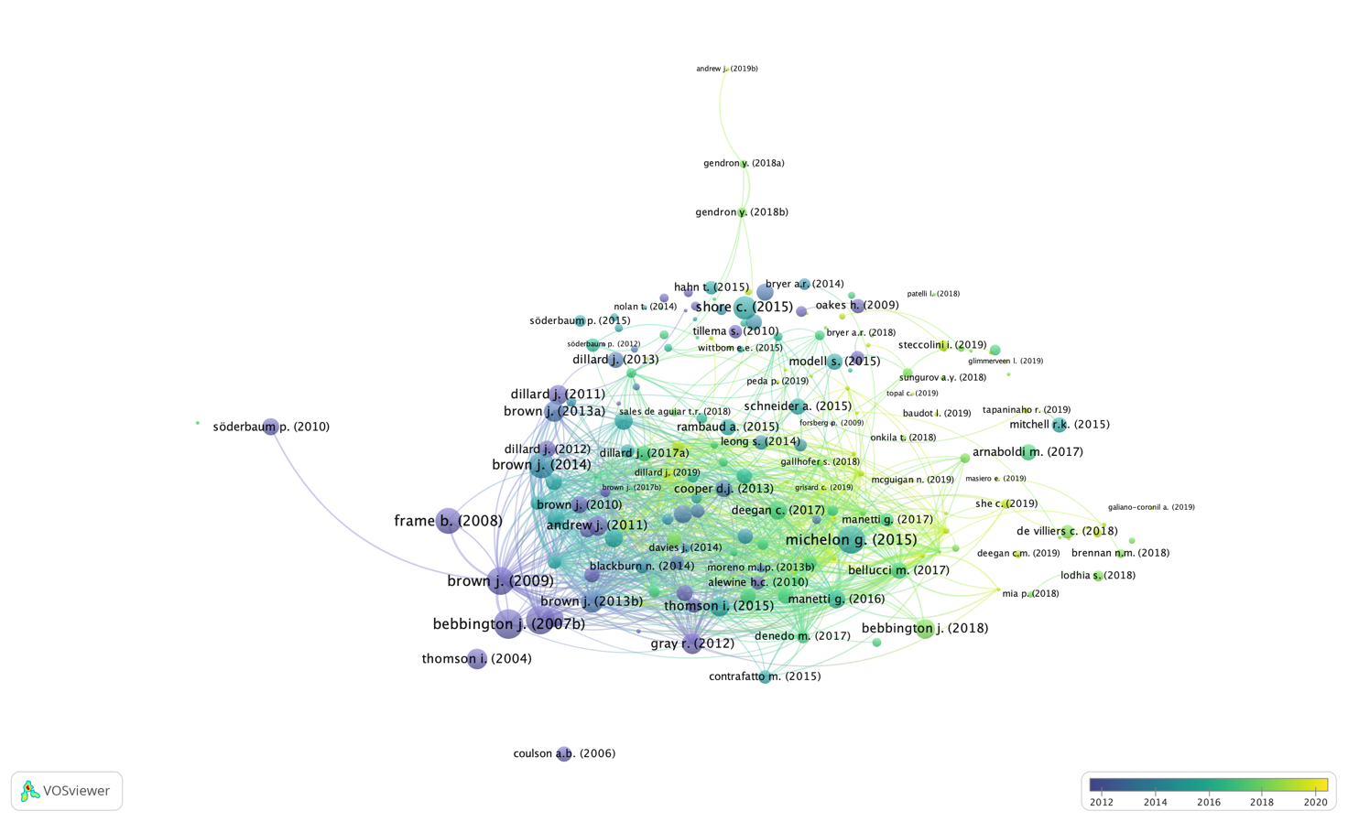

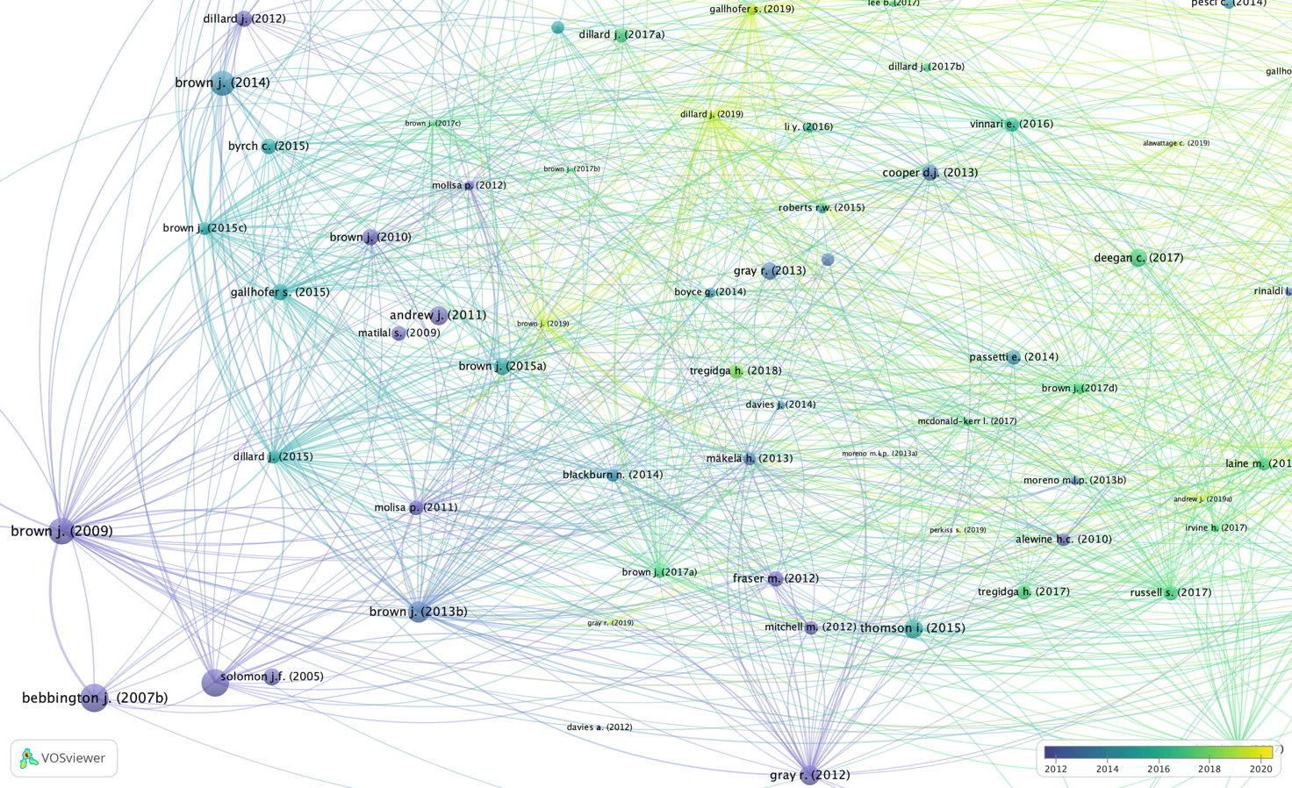

Appendix 3—Cooccurrence analysis of the authors’ keywords (heat map version)

