Exploratory SDN-DDoD2025 Dataset Analysis

The CIC-DDoS2019 dataset is an invaluable resource for researchers and cybersecurity professionals working to understand and detect modern DDoS attacks. This dataset includes both benign network traffic and a complete collection of 13 different and modern DDoS attack methods, such as NTP, DNS, LDAP, MSSQL, NetBIOS, SNMP, SSDP, UDP, UDP-Lag, WebDDoS, SYN, TFTP, and PortScan. The data is delivered in two formats: raw packet capture (PCAP), which allows for detailed packet examination, and processed Comma-Separated Value (CSV), which makes it easier to analyze using various data science and Artificial Intelligence (AI) approaches. Notably, the dataset includes an abstraction of 25 distinct users’ behavioral patterns based on their interactions with common internet protocols such as HTTP, HTTPS, FTP, SSH, and email, potentially allowing for the study of how DDoS attacks may impact or originate from normal user activity. The execution of these attacks over two days most likely adds a time component that can be used to examine the evolution and endurance of various attack routes [1].

The CIC-DDoS2019 features provide a comprehensive statistical profile of network traffic, covering everything from basic flow identifiers like IP addresses and port numbers to complex temporal metrics like Flow Inter-Arrival Time (IAT) and packet length variations. The dataset, which documents the behavior of both TCP and UDP protocols across various attack vectors, including Reflection and Exploitation-based attacks, enables researchers to analyze traffic at a granular level, focusing on packet headers, payload sizes, and bidirectional flow characteristics.

A key strength of the CIC-DDoS2019 feature set is its ability to represent the "burstiness" and stateful nature of network communication using sub-flow and bulk metrics. Initial TCP window sizes, flag counts (SYN, ACK, PSH), and segment sizes can be used as digital fingerprints to distinguish between automated botnet activity and legitimate user behavior. Furthermore, the dataset’s emphasis on statistical distributions calculating the mean, standard deviation, and extreme values of packet flows provides the variance required by deep learning models to distinguish between high-volume floods and low-rate "slow-and-slow" attacks. This high-dimensional feature space ensures that detection systems trained on this data are resilient against a wide variety of evolving cyber threats.
The SDN-DDoS2025 and CIC-DDoS2019 datasets share a common timestamp feature, while maintaining distinct feature sets, 38 unique attributes in SDN-DDoS2025 and 87 in CIC-DDoS2019. The generated SDN-DDoD2025 dataset includes both port-level and flow-level statistics. Port statistics encompass metrics such as the number of transmitted and received packets and bytes, along with error statistics. Flow statistics include packet and byte counts, flow duration, and actions taken on each flow. These features offer a detailed representation of traffic behavior and network performance within the SDN environment.
Figure 1 illustrates a breakdown of the new (39) extracted features captured in the SDN-DDoS2025 dataset. For effective DDoS detection in SDN, 14 key attributes have been identified as particularly indicative, showing significant variations during attack scenarios:

1. rx-packets (Received Packets): A sudden, significant increase in received packets can indicate a flood of incoming traffic, a characteristic of DDoS attacks.
2. tx-packets (Transmitted Packets): An abnormal pattern or a significant increase in transmitted packets can also indicate a DDoS attack, as the network might be trying to respond to a flood of requests.
3. rx-bytes (Received Bytes): Similar to rx-packets, a surge in received bytes can indicate a large volume of incoming traffic.
4. tx-bytes (Transmitted Bytes): Monitoring the transmitted bytes can help detect anomalies in outgoing traffic patterns.
5. rx-dropped (Dropped Received Packets): During a DDoS attack, the network may drop many packets due to overwhelming traffic, making this a critical feature.
6. tx-dropped (Dropped Transmitted Packets): A high number of dropped transmitted packets can also indicate network congestion caused by a DDoS attack.
7. rx-errors (Received Errors): Errors can increase during a DDoS attack due to the network’s inability to handle the surge in traffic.
8. tx-errors (Transmitted Errors): Errors can increase during a DDoS attack due to the network’s inability to handle the surge in traffic.
9. Collisions (Collisions): The number of collisions might increase if the network is congested due to an attack.
10. CPU-util (CPU Utilization): DDoS attacks often cause a significant increase in CPU utilization as the network devices try to process the large volume of traffic.
11. Entropy (Entropy): Entropy measures the randomness in the traffic patterns. DDoS attacks can either increase or decrease entropy, depending on the nature of the attack.
12. active-flows (Active Flows): A sudden increase in the number of active flows can be a sign of a DDoS attack, as it may indicate numerous simultaneous connections being attempted.
13. duration-sec (Duration of Flows in Seconds): During a DDoS attack, the duration of flows might show unusual patterns, either very short-lived flows or long-lasting ones, depending on the attack type.
14. duration-nsec (Duration of Flows in Nanoseconds): During a DDoS attack, the duration of flows might show unusual patterns, either very short-lived flows or long-lasting ones, depending on the attack type.
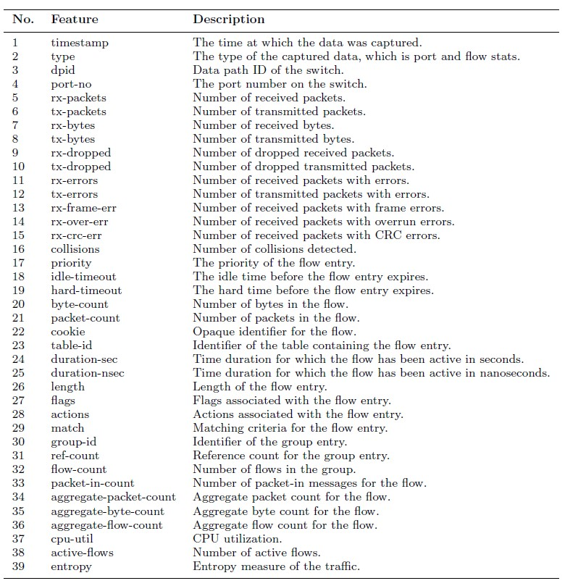
Figure 1. Features breakdown of the proposed SDN-DDoS2025 dataset

Exploratory Data Analysis (EDA) is a vital preliminary step in understanding the structural and statistical properties of a dataset. It facilitates the identification of data quality issues, outliers, and informative features for deep learning applications [2,3]. EDA employs visual and statistical techniques such as histograms, scatter plots, box plots, heatmaps, and distribution metrics to examine feature relationships, central tendencies, skewness, variability, and correlations.
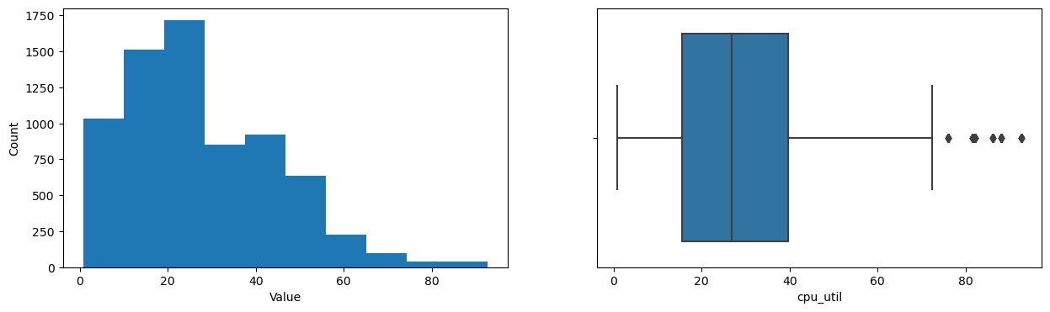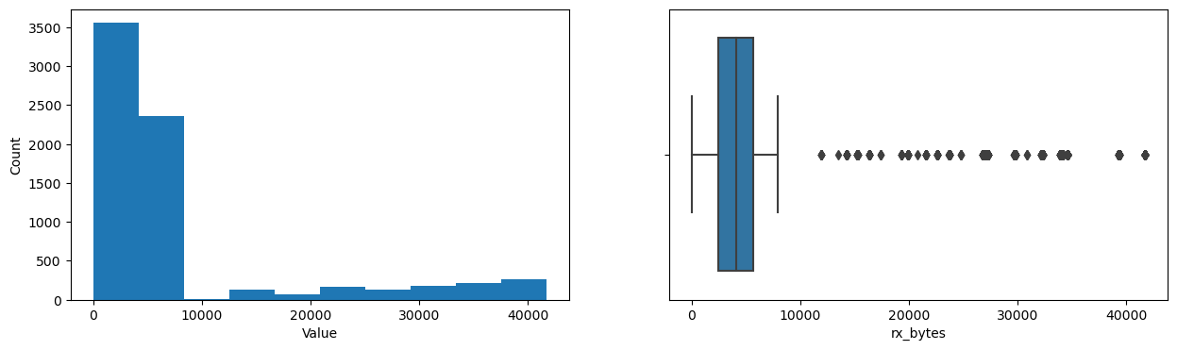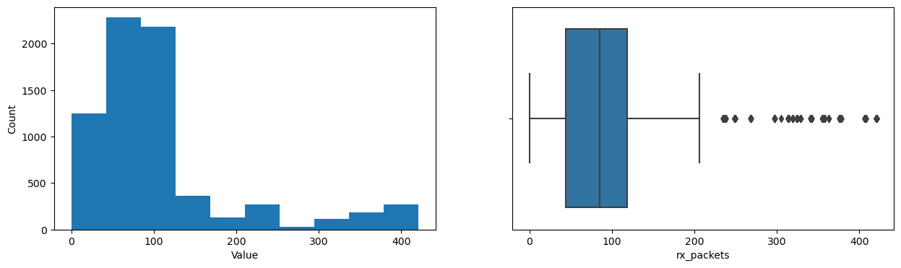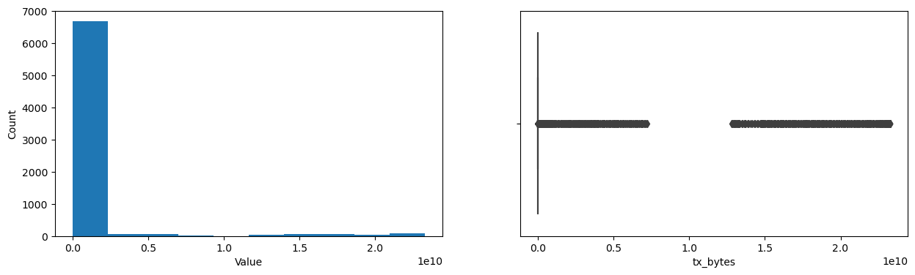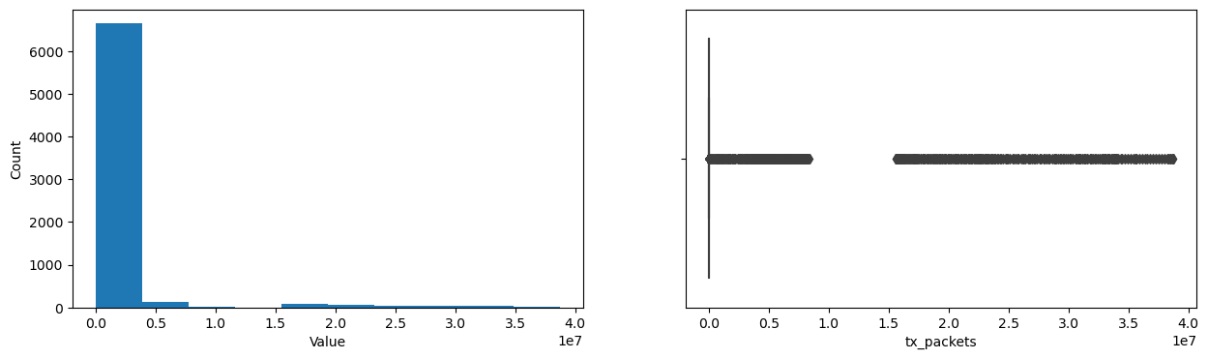
Figure 2. Boxplots and histograms of SDN traffic features in the SDN-DDoS2025 dataset

Figures 2, 3, 4, and 5 represent the histograms and box plots for the top (14) key features of the generated SDN-DDoS2025 dataset that reveal significant information on their description, central tendency, variability, skewness and outlier, data distribution, and data spread. Some features exhibit wide ranges and numerous outliers, while others remain nearly constant. Boxplots show the distribution and statistical properties of a single variable, including outliers, central tendency, variability, and skewness. The boxplot analysis of the SDN features in this DDoS traffic dataset reveals key characteristics indicative of an ongoing attack. A boxplot represents a specific feature’s statistical spread, including the median, quartiles, whiskers, and outliers [4]. The histogram is used to visualize the distribution of a single numerical variable.
In Figure 2, features like rx-packets, tx-packets, rx-bytes, and tx-bytes show a heavily skewed distribution with most values clustering in the lower range, while extreme outliers indicate high-traffic bursts. Additionally, the CPU-util metric fluctuates significantly, with occasional spikes above 60%, reflecting high network demand. These traffic surges and CPU variability suggest volumetric DDoS activity, stressing network resources.

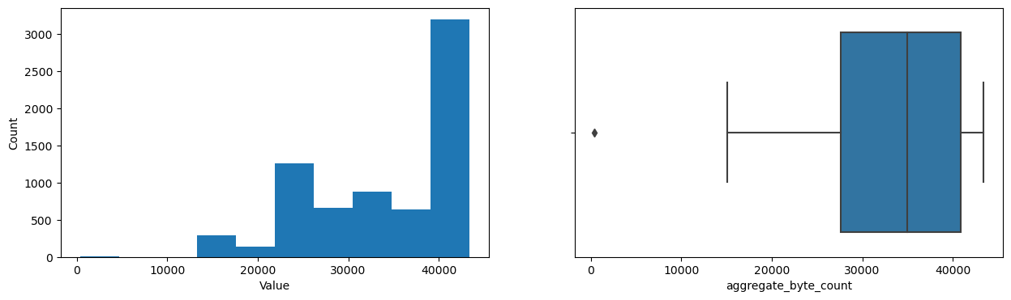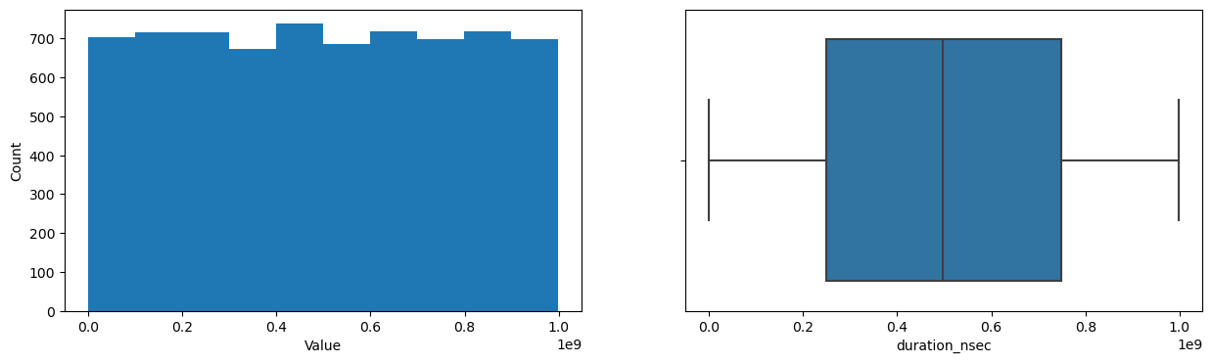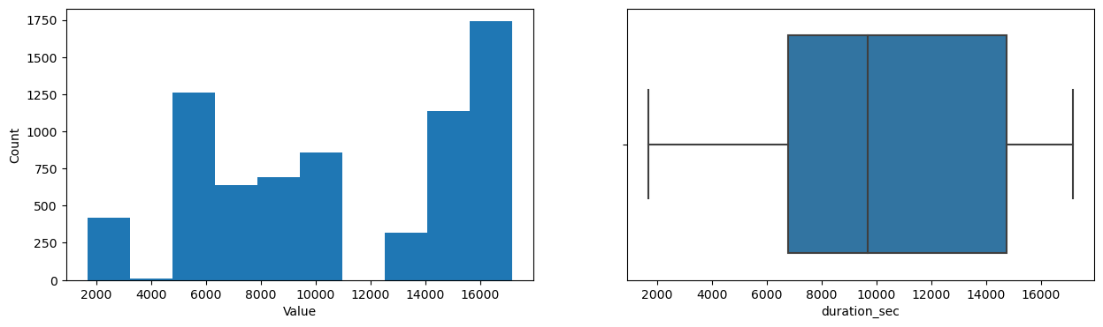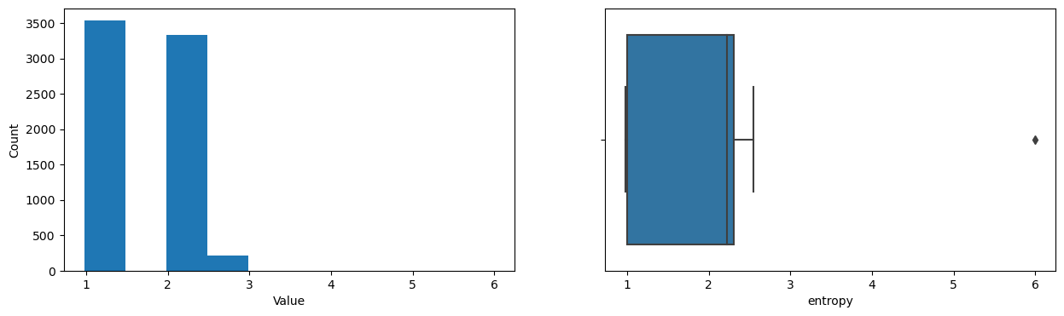
Figure 3. Boxplot and histogram analysis of SDN flow duration and traffic anomalies in the SDN-DDoS2025 dataset

Figure 3 shows that duration-related metrics, e.g., duration sec and duration-nsec, generally follow a normal distribution with long right tails, suggesting that some flows persist significantly longer than others. This may be due to attack traffic overwhelming the network and causing delayed processing. Meanwhile, features like aggregate-packet-count and entropy exhibit moderate distributions but contain occasional high outliers, indicating sporadic unpredictability in network traffic. They reveal anomalies, implying irregular traffic patterns likely caused by attack behavior.
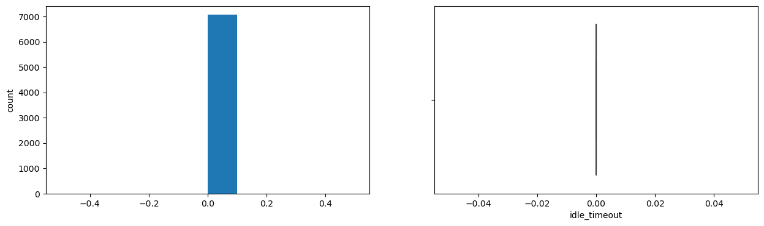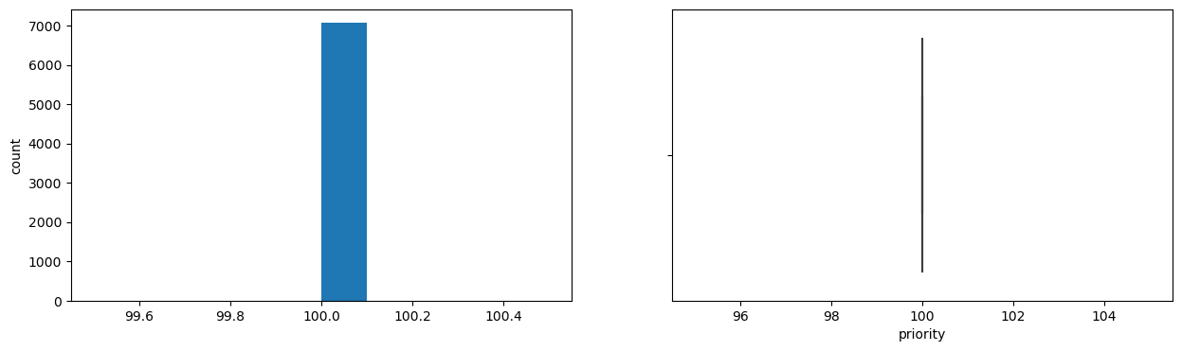
Figure 4. Analysis of constant-value features in the SDNDDoS2025 dataset

Conversely, in Figure 4, several features, including priority, idle timeout, hard timeout, table id, and error-related metrics like rx-dropped and tx-dropped, appear nearly constant across observations. They may be redundant for analysis and could be candidates for removal. Constant values in features, such as priority, idle timeout, and various error counters, suggest that they may not contribute significantly to distinguishing attack traffic. Overall, the analysis confirms that this dataset contains DDoS traffic characterized by high packet bursts, extreme byte counts, fluctuating cpu-utilization, and an anomalous flow duration.
Figure 5 demonstrates the analysis of traffic-based features in SDN-DDoS2025. Packet-count is an important signal because a big increase indicates a sudden spike in traffic. This is a common feature of volumetric DDoS attacks, in which attackers transmit a large number of tiny packets to overwhelm the network. Similarly, byte-count can help identify excessive data transmission rates, which are frequently associated with application-layer attacks in which huge payloads drain server resources. Another important feature is aggregate-packet-count, which indicates an increase in simultaneous flows. This increase is often a symptom of botnet-driven attacks in which numerous infected devices send packets at the same time. Similarly, aggregate flow count rises when a large number of short-lived flows are generated, overwhelming SDN controllers and reducing network performance. Packet-in count is an important measure in SDN, as an excessive amount of ”packet-in” signals can overload the controller, delaying traffic processing and causing network disturbances. Monitoring these features allows network administrators to efficiently detect and mitigate DDoS attacks.
Figure 6 presents the heatmap correlation matrix of the most considered (14) key features, in addition to the timestamp, within the SDN-DDoS2025 dataset. The heatmap offers insights into potential DDoS attack patterns. It visually shows which features in the dataset are strongly correlated (either positively or negatively). This helps identify potential relationships between features that might influence feature selection [5] for DDoS detection performance. High positive correlations are observed between (rx-packets, rx-bytes) and (tx-packets, tx-bytes), indicating that the expected relationships between packet counts and byte volumes are in the same direction.
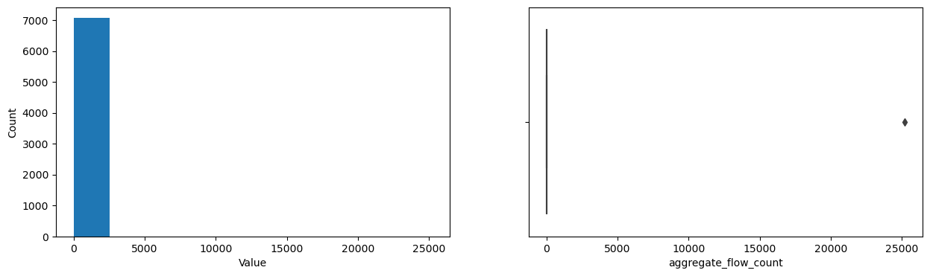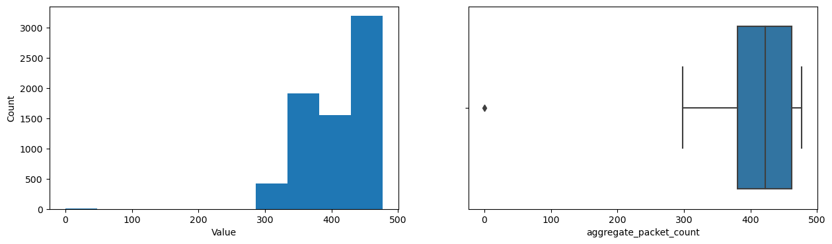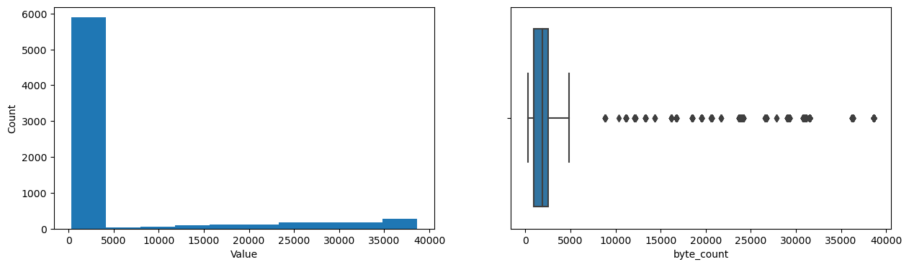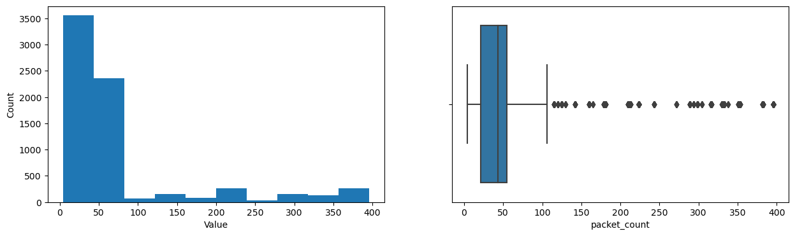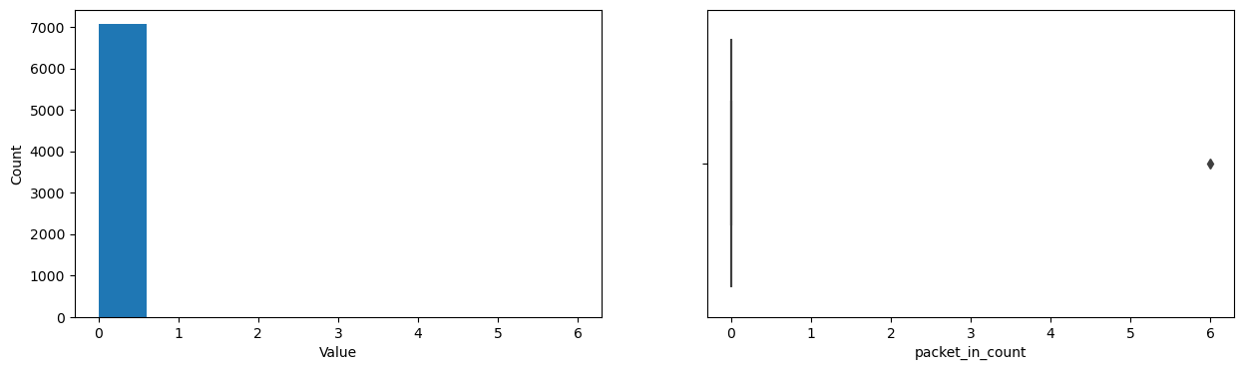
Figure 5. Analysis of traffic-based features in the SDN-DDoS2025 Dataset
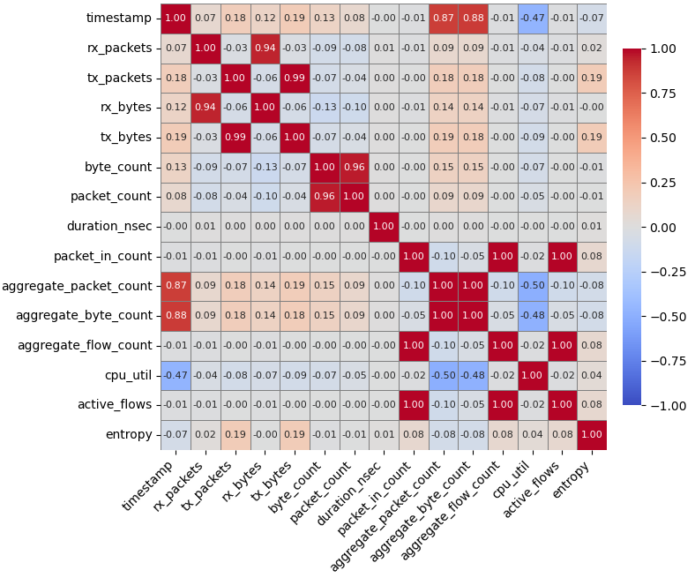
Figure 6. Heatmap of 15 Features in the SDN-DDoS2025 dataset

Notably, the timestamp shows a strong positive correlation with aggregate packet count and aggregate byte count, suggesting an increasing trend in overall traffic volume over time. This is a common characteristic of volumetric DDoS attacks. The high correlation between byte count and packet count further reinforces this observation.
Conversely, CPU-util exhibits a strong negative correlation with timestamp, aggregate-packet-count, and aggregate-byte-count, implying that as traffic volume increases, CPU-utilization decreases. This is possibly due to the overwhelming nature of the attack hindering effective processing. Interestingly, entropy shows relatively weak correlations with most features. While traffic volume and packet characteristics might be indicative of a DDoS attack, the randomness or predictability of the traffic patterns, as measured by entropy, might not be as directly influential in this specific dataset.
Overall, the heatmap highlights the importance of monitoring traffic volume and packet characteristics over time for detecting DDoS attacks. Also, indicating CPU utilization and entropy might offer supplementary insights.

References
- I. Sharafaldin, A. Habibi Lashkari, I. Sahib, and A. Ghorbani, “Developing realistic Distributed Denial of Service (DDoS) attack dataset and taxonomy,”
- Schwertman NC, Owens MA, Adnan R. A simple more general boxplot method for identifying outliers. Comput Stat Data Anal. 2004;47(1):165–74. Available from: https://www.sciencedirect.com/science/article/pii/S0167947303002469
- Rao AS, Vardhan BV, Shaik H. Role of exploratory data analysis in data science. In: 2021 6th International Conference on Communication and Electronics Systems (ICCES); 2021; pp. 1457–1461.
- Schwertman NC, Owens MA, Adnan R. A simple more general boxplot method for identifying outliers. Comput Stat Data Anal. 2004;47(1):165–74. Available from: https://www.sciencedirect.com/science/article/pii/S0167947303002469
- Metsalu T, Vilo J. ClustVis: a web tool for visualizing clustering of multivariate data using principal component analysis and heatmap. Nucleic Acids Res. 2015 May;43(W1):W566–70. Available from: https://doi.org/10.1093/nar/gkv468

