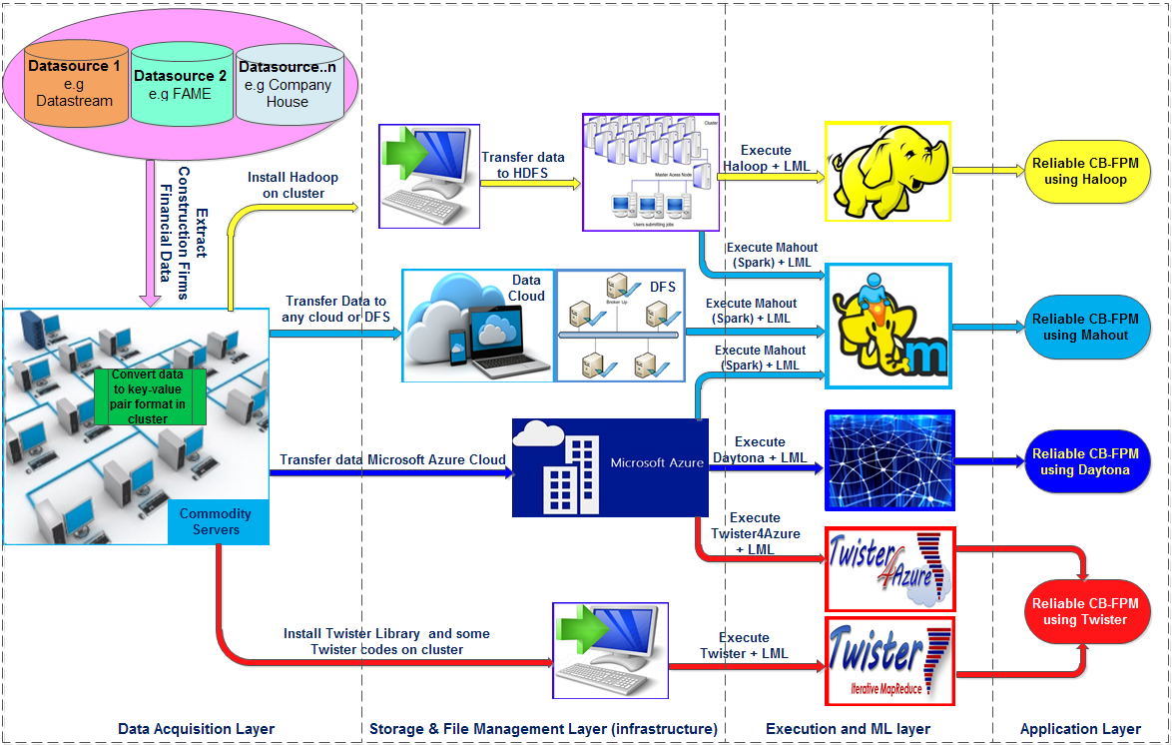
Annex 1 Figure: A framework architecture for developing a BDA CB-FPM
Note: DFS = Distributed File system

