Supplementary information for

Ultra-low corrosiveness molten LiCl-KCl-Li salt solution with dissolved metallic Li component

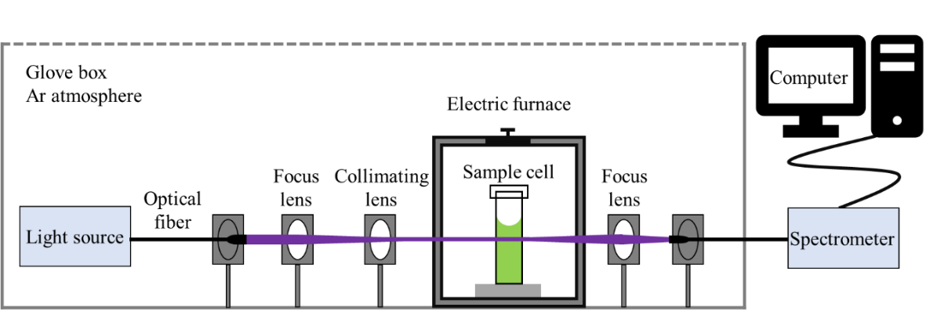
Fig. S1. Schematic diagram of high-temperature UV-vis spectroscopy experimental setup.

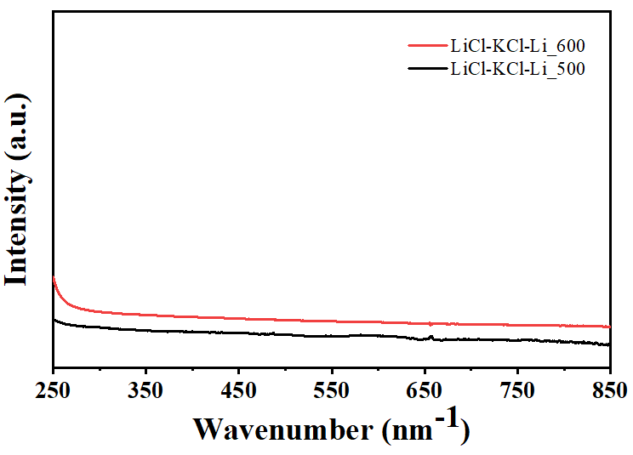
Fig. S2. UV-vis spectra of LiCl-KCl-Li_500 and LiCl-KCl-Li_600.

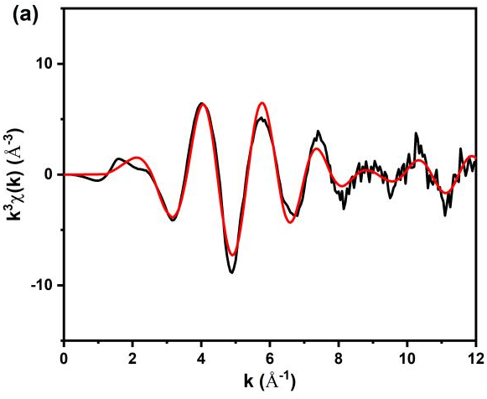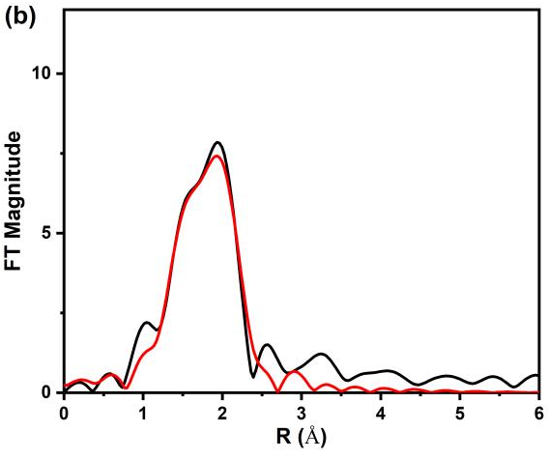
Fig. S3. The k³-weighted Ni K-edge experimental EXAFS signal (black) with fitting result (red) for the LiCl-KCl-Ni_600 sample collected on the seventh day; (b) Corresponding Fourier transform of the experimental EXAFS signal (black) and fitting result (red) for the LiCl-KCl-Ni_600 sample collected on the seventh day.

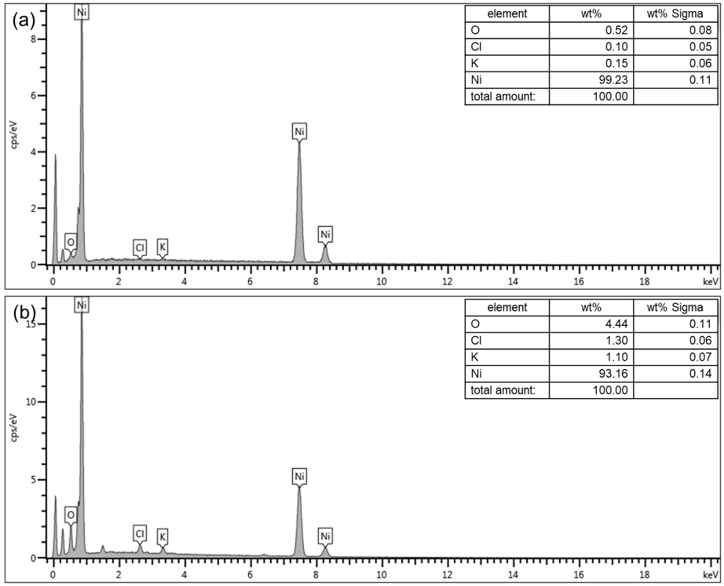
Fig. S4. EDS spectrum of the Ni sheet after reacting with (a) LiCl-KCl and (b) LiCl-KCl-Li at 600 ℃ for 7 days.

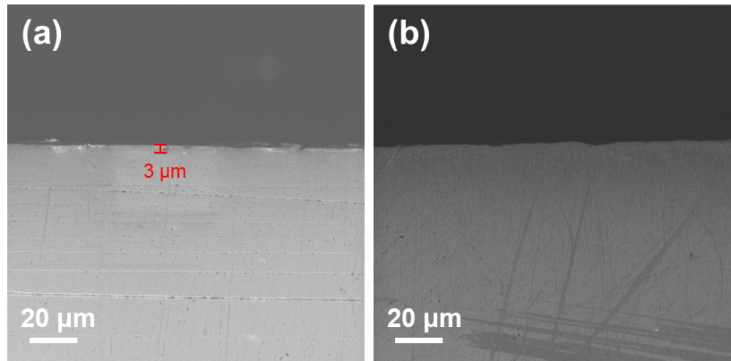
Fig. S5. Cross-sectional SEM images of the post-corroded Ni sheets in (a) LiCl-KCl and (b) LiCl-KCl-Li at 600 ℃ for 7 days.

Table S1. The Ni content in LiCl-KCl, LiCl-KCl-Li, LiCl-KCl-Ni_600 and LiCl-KCl-Li-Ni_600.
Samples | Ni content (ppm, by weight)
LiCl-KCl | < 0.002 (-0.17)
LiCl-KCl-Li | < 0.002 (-0.15)
LiCl-KCl-Ni_600 collected on the first day | 1.25 ± 0.04
LiCl-KCl-Ni_600 collected on the seventh day | 150.76 ± 0.01
LiCl-KCl-Li-Ni_600 collected on the first day | < 0.002 (-0.16)
LiCl-KCl-Li-Ni_600 collected on the seventh day | < 0.002 (-0.17)

