Supplementary File
Figure A.1.1.: The evolution of annual earnings by entry year, experience, and country of birth
a) EU15 b) rEU
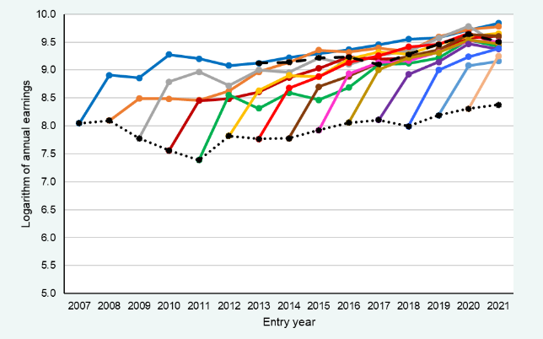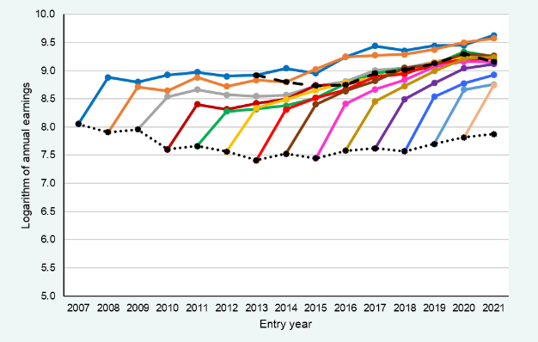
c) Latin America d) Asia
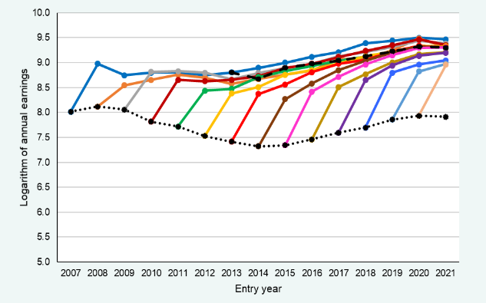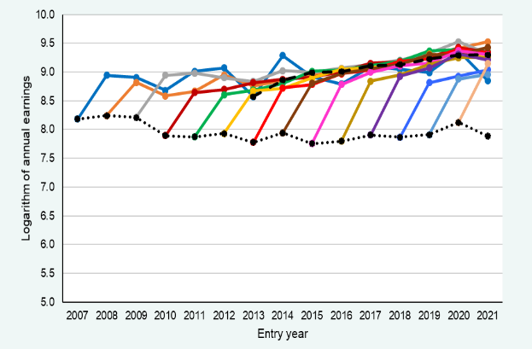
e) Africa
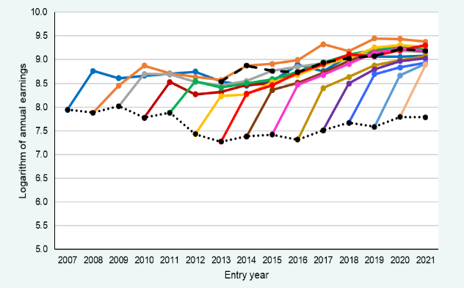
Source: own elaboration using the CSWH.

Figure A.1.2.: The evolution of average monthly earnings by entry year, experience, and country of birth
a) EU15 b) rEU
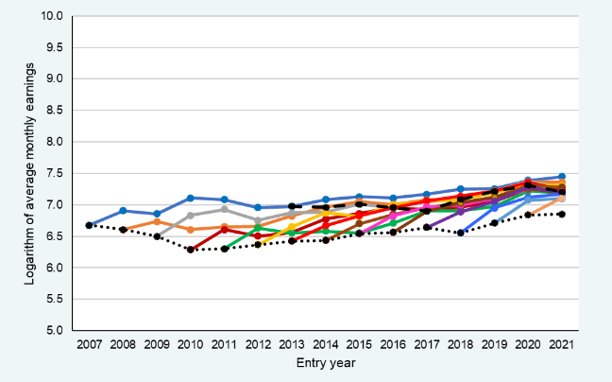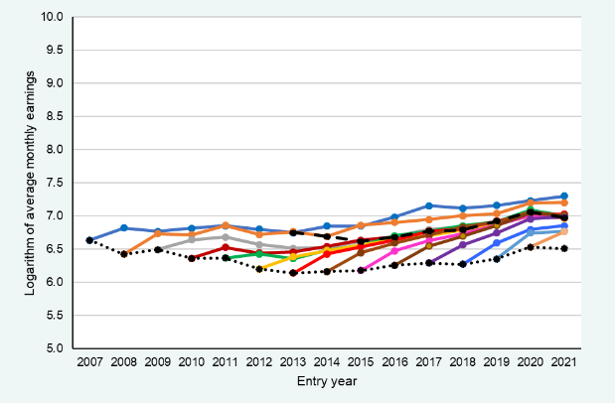
c) Latin America d) Asia
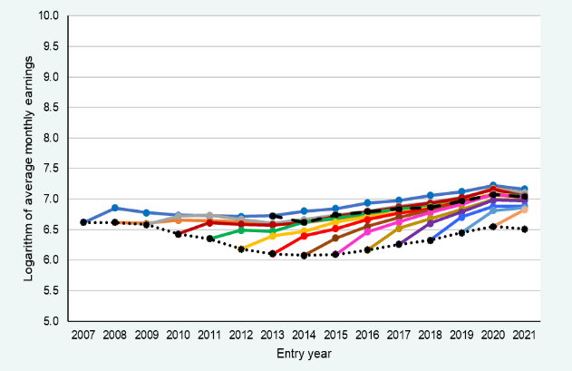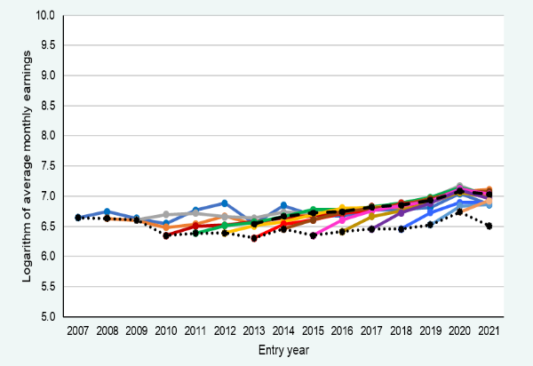
e) Africa
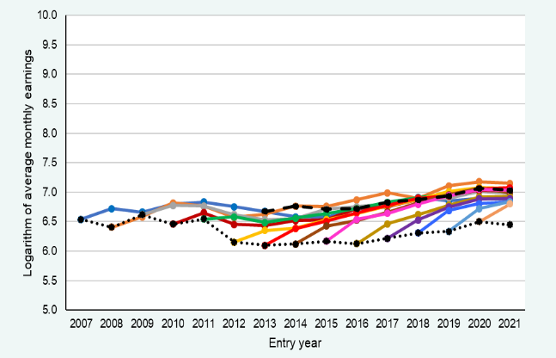
Source: own elaboration using the CSWH.

Figure A.1.3.: The evolution of October earnings by entry year, experience, and country of birth
a) EU15 b) rEU
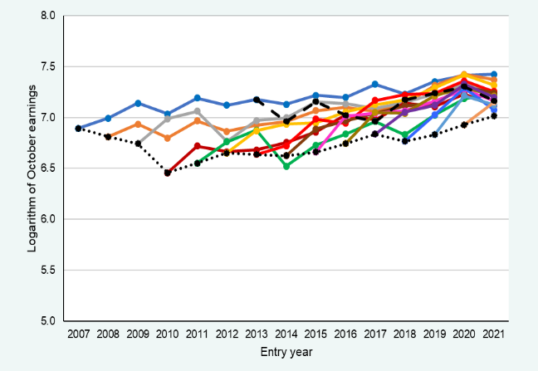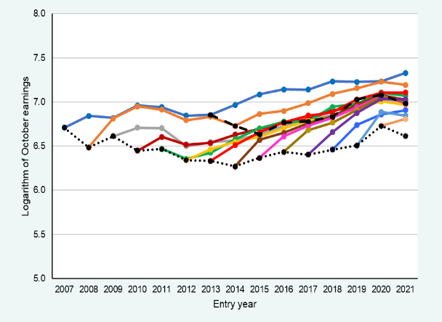
c) Latin America d) Asia
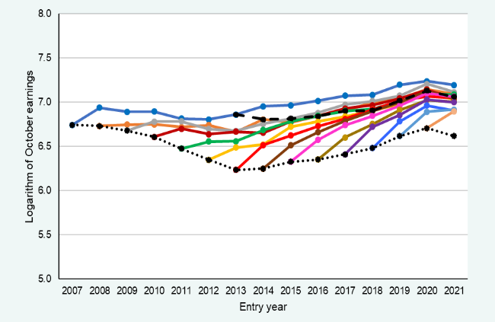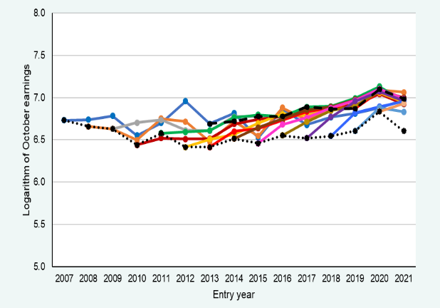
e) Africa
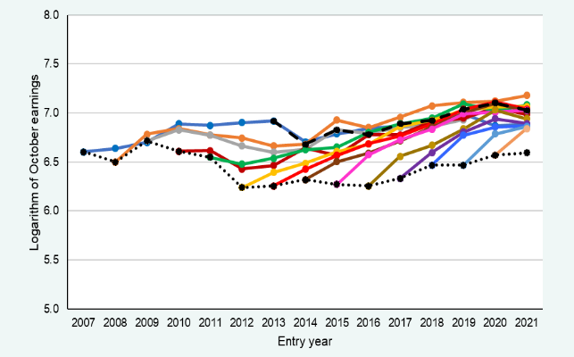
Source: own elaboration using the CSWH.

Table A.2.1. Impact of a 1-percent increase in unemployment rate on annual earnings of immigrants by country of birth
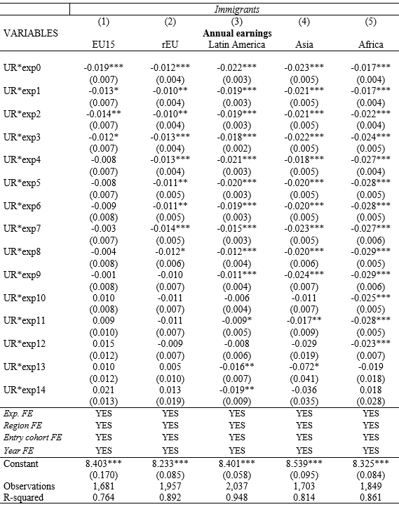
Robust standard errors in parentheses. *** p<0.01, ** p<0.05, * p<0.1
Source: own elaboration using the CSWH.

Table A.2.2. Impact of a 1-percent increase in unemployment rate on average monthly earnings of immigrants by country of birth
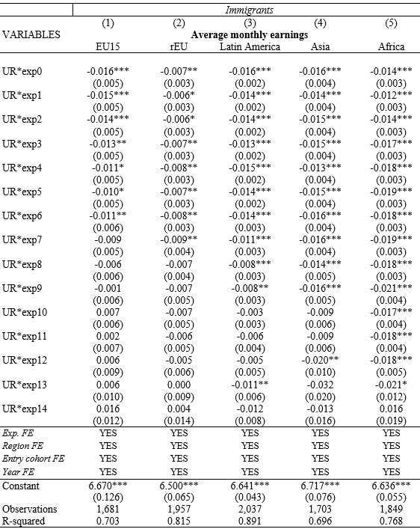
Robust standard errors in parentheses. *** p<0.01, ** p<0.05, * p<0.1

Source: own elaboration using the CSWH.

Table A.2.3. Impact of a 1-percent increase in unemployment rate on October earnings of immigrants by country of birth
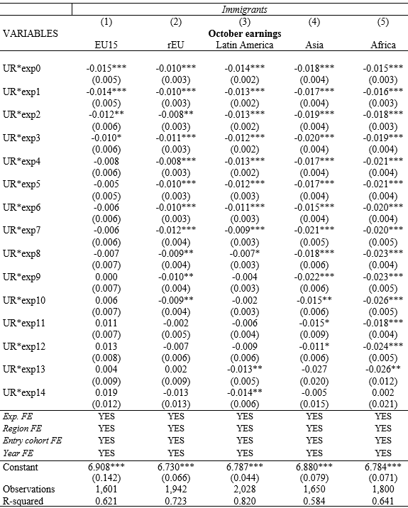
Robust standard errors in parentheses. *** p<0.01, ** p<0.05, * p<0.1

Source: own elaboration using the CSWH.

Table A.3.1. Impact of a 1-percent increase in unemployment rate on prob. employment in any month of immigrants by country of birth
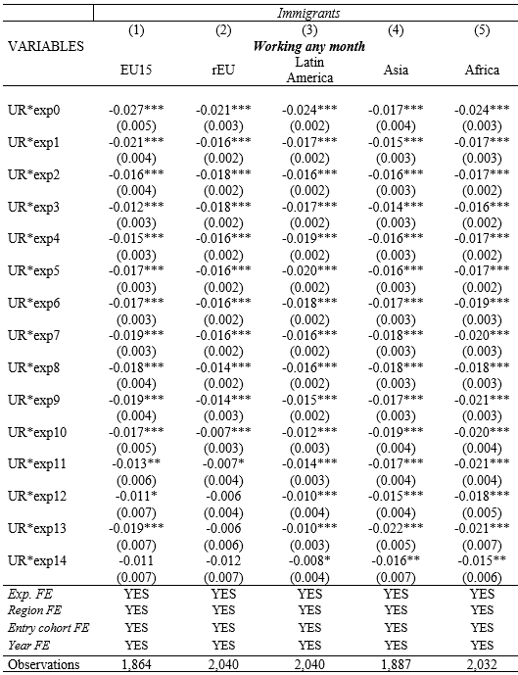
Robust standard errors in parentheses. *** p<0.01, ** p<0.05, * p<0.1

Source: own elaboration using the CSWH.

Table A.3.2. Impact of a 1-percent increase in unemployment rate on prob. employment at least 6 months of immigrants by country of birth
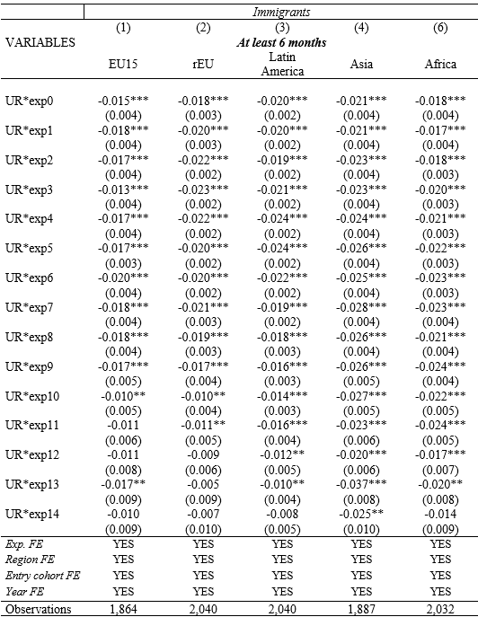
Robust standard errors in parentheses. *** p<0.01, ** p<0.05, * p<0.1

Source: own elaboration using the CSWH.

Table A.3.3. Impact of a 1-percent increase in unemployment on the number of months employed (in log terms) of immigrants by country of birth
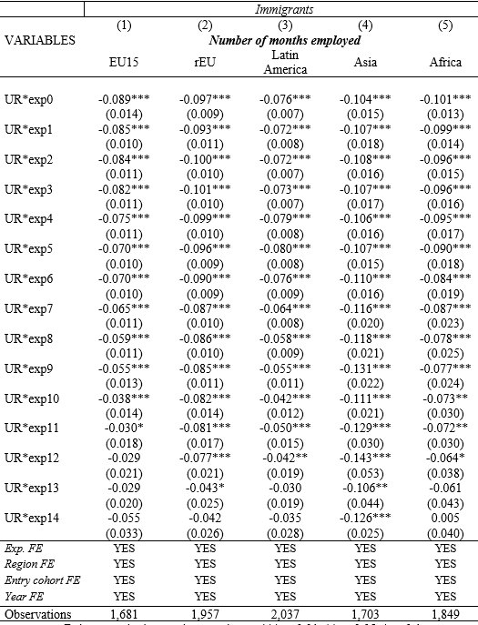
Robust standard errors in parentheses. *** p<0.01, ** p<0.05, * p<0.1

Source: own elaboration using the CSWH.

Table A.3.4. Impact of a 1-percent increase in unemployment on prob. employment in October month of immigrants by country of birth
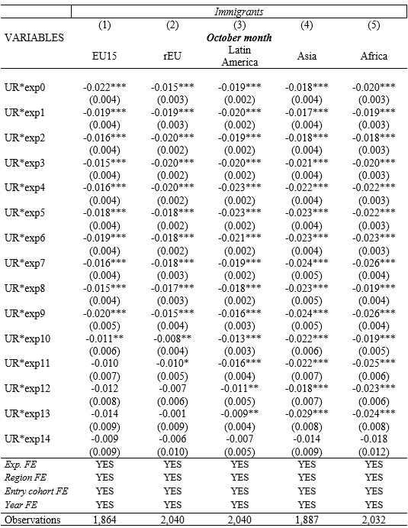
Robust standard errors in parentheses. *** p<0.01, ** p<0.05, * p<0.1
Source: own elaboration using the CSWH.

Table A.4.1. Impact of a 1-percent increase in unemployment rate on average monthly earnings of natives and immigrants by educational level
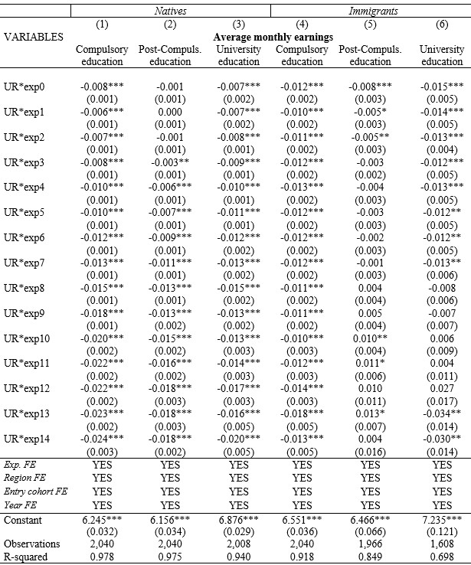
Robust standard errors in parentheses. *** p<0.01, ** p<0.05, * p<0.1
Source: own elaboration using the CSWH.

Table A.4.2. Impact of a 1-percent increase in unemployment rate on prob. employment in any month of natives and immigrants by educational level
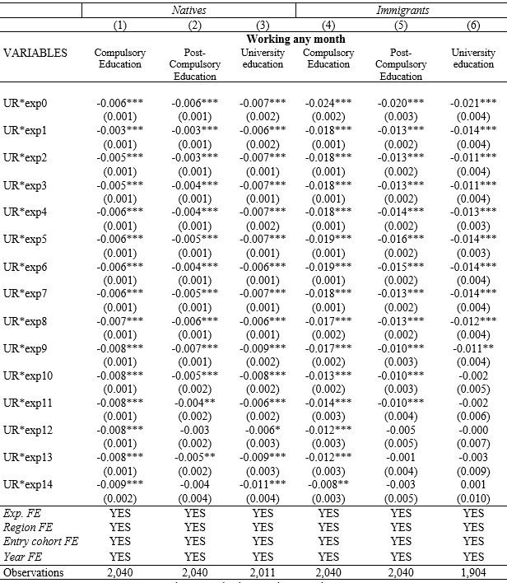
Robust standard errors in parentheses
*** p<0.01, ** p<0.05, * p<0.1
Source: own elaboration using the CSWH.

Table A.5.1. Impact of a 1-percent increase in unemployment rate on annual earnings of natives and immigrants by gender
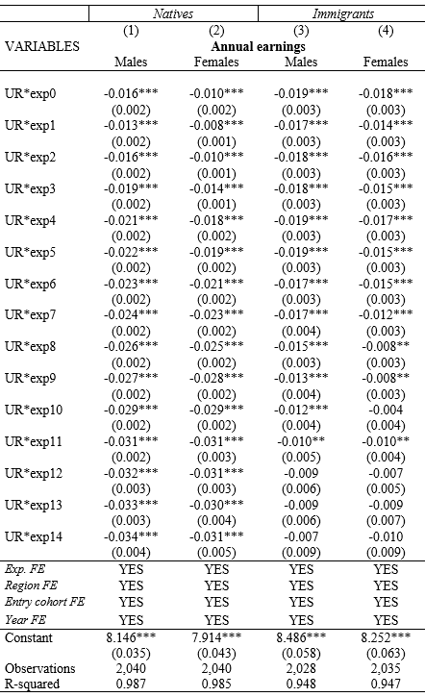
Robust standard errors in parentheses
*** p<0.01, ** p<0.05, * p<0.1
Source: own elaboration using the CSWH.

Table A.5.2. Impact of a 1-percent increase in unemployment rate on prob. employment in any month of natives and immigrants by gender
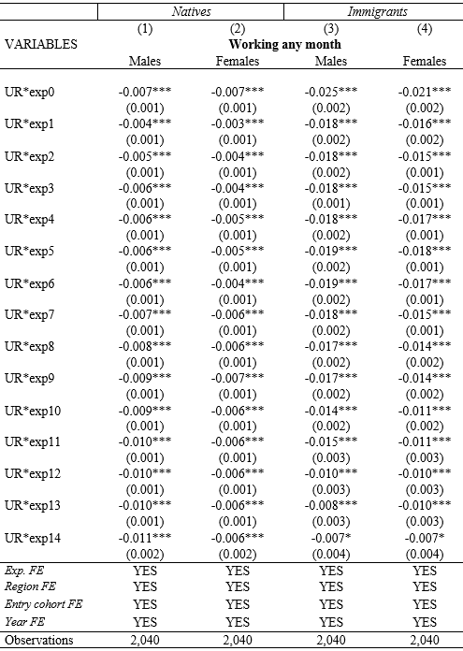
Robust standard errors in parentheses
*** p<0.01, ** p<0.05, * p<0.1
Source: own elaboration using the CSWH.

Table A.6.1. Impact of a 1-percent increase in unemployment rate on annual earnings of natives and immigrants by age of entry

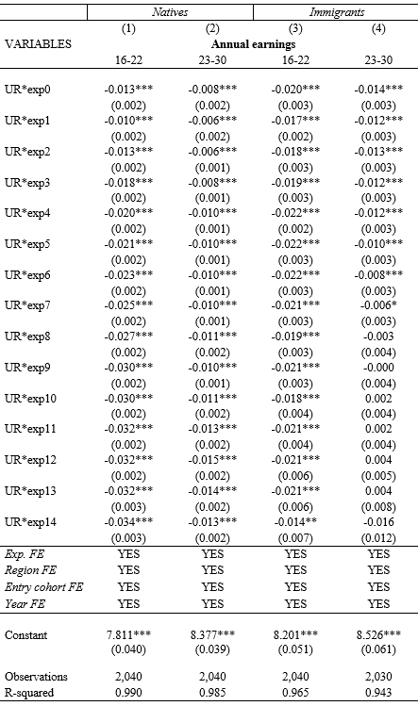
Robust standard errors in parentheses. *** p<0.01, ** p<0.05, * p<0.1
Source: own elaboration using the CSWH.

Table A.6.2. Impact of a 1-percent increase in unemployment rate on prob. employment in any month of natives and immigrants by age of entry

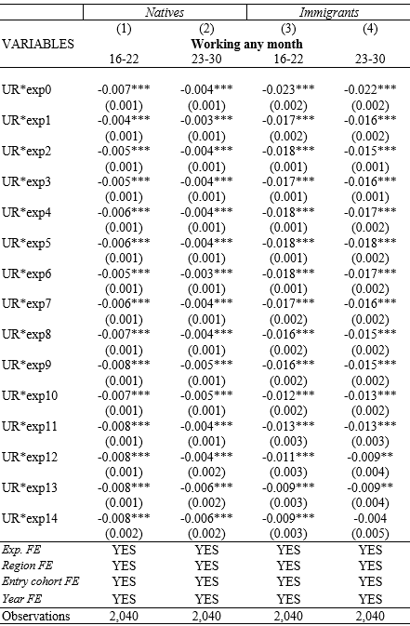
Robust standard errors in parentheses. *** p<0.01, ** p<0.05, * p<0.1
Source: own elaboration using the CSWH.

