Appendix
Functions in Section 2.2’s simulation study
Model (A1) is the one for estimation; Equations (A2), (A3), (A4), and (A5) are true functions of four surfaces, where subscripts of $S$ distinguish the functions.
$y=S_{1}\left(x_{1}, x_{2}\right)+S_{2}\left(x_{3}, x_{4}\right)+S_{3}\left(x_{5}, x_{6}\right)+S_{4}\left(x_{7}, x_{8}\right)+ε^{'}, ε^{'}\sim N\left(0,{σ^{'}}^{2}I\right)$ (A1)
$S_{1}\left(x_{1}, x_{2}\right)=\sin\left(2πx_{1}\right)+ \cos\left(2πx_{2}\right)$, (A2)
$S_{2}\left(x_{3}, x_{4}\right)=\cos\left[2π\sqrt{{\left(x_{3}-0.5\right)}^{2}+{\left(x_{4}-0.5\right)}^{2}}\right],$ (A3)
$S_{3}\left(x_{5}, x_{6}\right)=\sin\left(2πx_{5}\right)+ \cos\left(2πx_{6}\right)+\sin\left[2π\left(x_{6}-x_{5}\right)\right]$, (A4)
$S_{4}\left(x_{7}, x_{8}\right)=2x_{7}\sin\left(4πx_{8}\right)$. (A5)

Table A1 Results of parameter tuning for Support Vector Machines (SVM) and Artificial Neural Networks (ANN) in simulation study. (Source: figure/table created by authors)
Method | Parameter list | Search space | Simulation study
Support Vector Machine | cost | {1, 2, 3, 4, 5, 6, 7, 8, 9, 10} | 8
Support Vector Machine | gamma | {0.1, 0.2, 0.3, 0.4, 0.5, 0.6, 0.7, 0.8, 0.9, 1.0} | 0.1
 | learning rate | {0.001, 0.002, 0.004, 0.0065, 0.008, 0.016, 0.032, 0.064, 0.08, 0.12} | 0.12
Artificial Neural Networks | batch size | {8, 16, 24, 32, 40, 48} | 48
 | $$L_{2}$$ | {0.0001, 0.001, 0.01, 0.1} | 0.01
 | number of neurons/hidden layer | {5, 6, 7, 8, 9, 10, 11, 12, 13, 14, 15, 16, 1} | 15
 | epochs | {20, 40, 50, 100} | 100
 | seed value (random selection) | {0, 4, 5, 50, 99} | 4

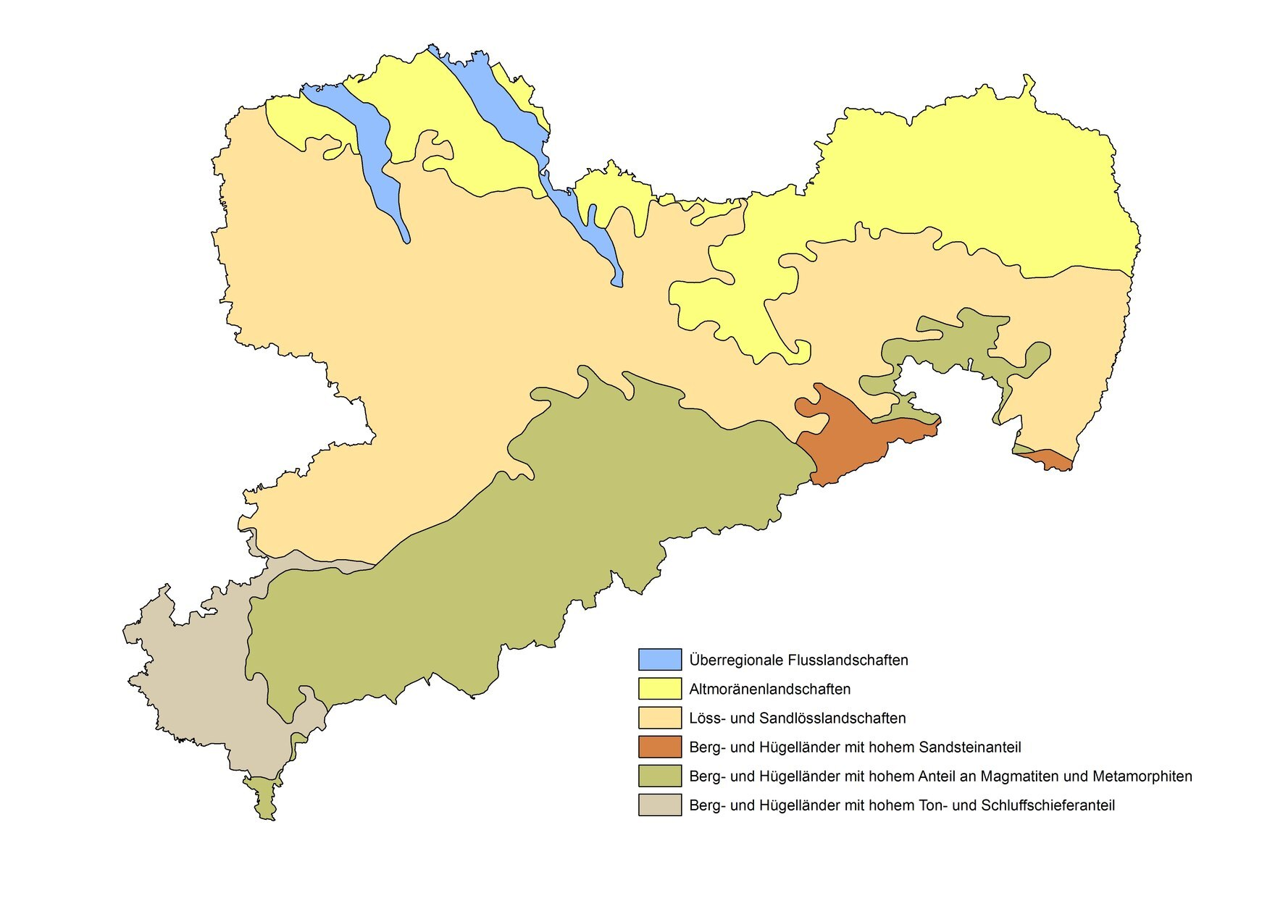
Figure A1 Soil regions in Saxony © LfULG (Source: figure/table created by Sächsisches Landesamt für Umwelt, Landwirtschaft und Geologie)
Note: This map is from https://www.boden.sachsen.de/boden-in-sachsen-17953.html, where more information about soil conditions in Saxony is provided.

Table A2 Results of parameter tuning for Support Vector Machines (SVM) and Artificial Neural Networks (ANN) in an empirical study of winter barley (Source: figure/table created by authors)
Method | Parameter list | Search space | ND | ED | OD
Support Vector Machine | cost | {1, 2, 3, 4, 5, 6, 7, 8, 9, 10} | 1 | 8 | 3
Support Vector Machine | gamma | {0.1, 0.2, 0.3, 0.4, 0.5, 0.6, 0.7, 0.8, 0.9, 1} | 0.1 | 0.1 | 0.8
 | learning rate | {0.001, 0.002, 0.004, 0.0065, 0.008, 0.016, 0.032, 0.064, 0.08, 0.12} | 0.064 | 0.008 | 0.047
Artificial Neural Networks | batch size | {8, 16, 24, 32, 40, 48} | 40 | 16 | 27
 | $$L_{2}$$ | {0.0001, 0.001, 0.01, 0.1} | 0.0001 | 0.001 | 0.04
 | number of neurons/hidden layer | {4, 8, 16} or  {8, 16, 32} | 16 | 16 | 12
 | epochs | {20, 40, 50, 100} | 100 | 40 | 58
 | seed value (random selection) | {0, 4, 5, 50, 99} | 0 | 5 | 5
Note: ND, ED, and OD are abbreviations for non-division, expert-division, and optimal-division.

Table A3 Descriptive statistics of yield data of rapeseed (Source: figure/table created by authors)
 | Yield (dt/ha) | Detrended yield (dt/ha) | Yield deviations(dt/ha)
Mean | 38.02 | 36.65 | 0
Standard deviation | 10.10 | 8.26 | 8.26
Minimum | 0 | 2.58 | -34.00
Maximum | 89.16 | 79.14 | 42.56
Note: In our rapeseed yield data set, there are a total of two observations of no yields.

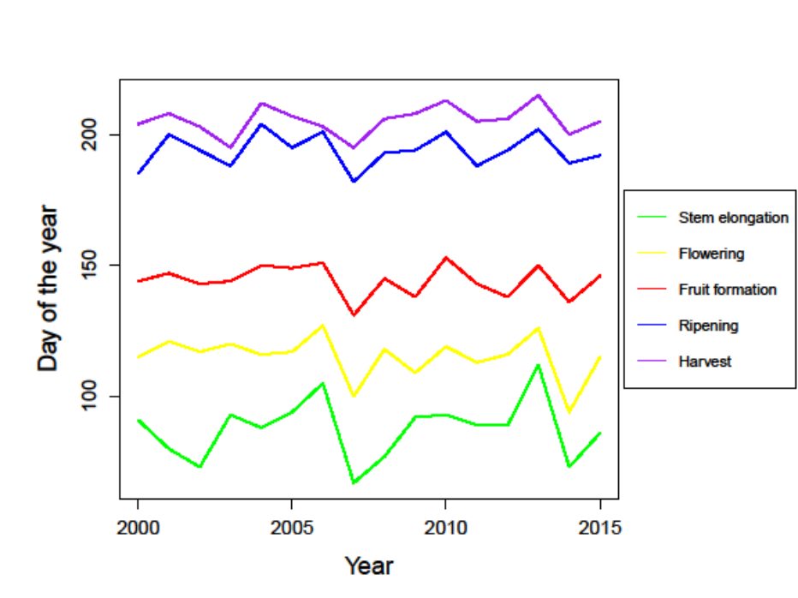
Figure A2 Day of the year (DOY) of phenological phenomenon timing of rapeseed (Source: figure/table created by authors)
Note: Under optimal division, the number of possible combinations is $k=70,300$ for rapeseed given that the phenology information is different from that of winter barley.

Table A4 Descriptive statistics of time series of Growing Degree Days (GDD) (in degree Celsius) and Cumulative Rainfall (CR) (in mm) for non-division (ND) and expert-division (ED) models of rapeseed (Source: figure/table created by authors)
 | ND-GDD | ED-GDD₁ | ED-GDD₂ | ED-GDD₃ | ED-GDD₄ | ND-CR | ED-CR₁ | ED-CR₂ | ED-CR₃ | ED-CR₄
Mean | 1909.31 | 338.98 | 370.42 | 831.34 | 413.34 | 322.67 | 74.80 | 55.79 | 135.58 | 62.34
Standard deviation | 135.47 | 65.10 | 42.05 | 60.81 | 39.06 | 76.62 | 37.60 | 25.01 | 56.67 | 33.63
Minimum | 1436.90 | 159.31 | 247.91 | 609.74 | 288.11 | 118.89 | 19.90 | 10.09 | 30.06 | 4.08
Maximum | 2231.80 | 508.25 | 486.53 | 985.99 | 506.34 | 635.21 | 235.12 | 161.17 | 387.90 | 210.04

Table A5 $\left({\ddot{sd}}_{2}, {\ddot{sd}}_{3}, {\ddot{sd}}_{4}\right)$, $RMSE$, and adjusted $R^{2}$ of ND, ED, and OD models of rapeseed (Source: figure/table created by authors)
Method | ND | $$RMSE$$ | $$Adj. R^{2}$$ | ED | $$RMSE$$ | $$Adj. R^{2}$$ | OD | $$RMSE$$ | $$Adj. R^{2}$$
PR |  | 8.09 | 0.04 |  | 7.17 | 0.24 | (127, 150, 204) | 6.85 | 0.31
GAM |  | 8.01 | 0.06 |  | 6.95 | 0.29 | (93, 120, 196) | 6.65 | 0.35
RF | - | - | - | (116, 144, 194) | 6.86 | 0.31 | (81, 116, 201) | 6.78 | 0.32
SVM |  | 7.88 | 0.09 | (116, 144, 194) | 5.98 | 0.47 | (115, 145, 195) | 5.80 | 0.51
ANN |  | 8.11 | 0.04 |  | 6.61 | 0.36 | (111, 157, 199) | 6.35 | 0.41
Note: ND, ED, and OD are abbreviations for non-division, expert-division, and optimal-division. PR, GAM, RF, SVM, and ANN are abbreviations for Polynomial Regression, Generalized Additive Model, Random Forest, Support Vector Machines, and Artificial Neural Networks, respectively. For ANN, activation function “sigmoid” was selected for rapeseed data sets considering the stability of results.

Table A6 ED and OD phase lengths (in days) of rapeseed (Source: figure/table created by authors)
Division model | Stage 1 | Stage 2 | Stage 3 | Stage 4
ED | 50 | 29 | 51 | 22
OD-PR | 61 | 24 | 55 | 12
OD-GAM | 27 | 28 | 77 | 20
OD-RF | 15 | 36 | 86 | 15
OD-SVM | 49 | 31 | 51 | 21
OD-ANN | 45 | 47 | 43 | 17
Note: ED and OD are abbreviations for expert-division and optimal-division. PR, GAM, RF, SVM, and ANN are abbreviations for Polynomial Regression, Generalized Additive Model, Random Forest, Support Vector Machines, and Artificial Neural Networks, respectively.

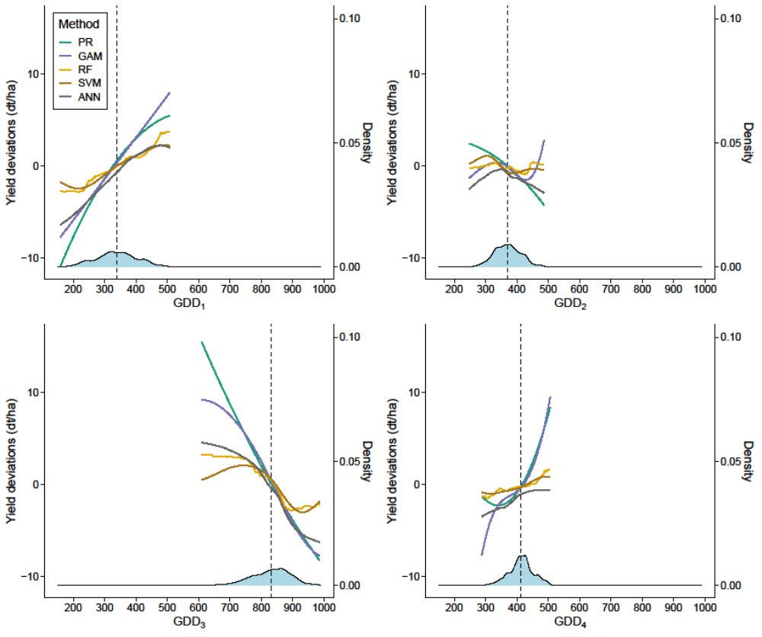
Figure A3 Partial dependence plots of Growing Degree Days (GDD) in four growth stages of rapeseed (Source: figure/table created by authors)
Note: The notation under the X-axis refers to the weather index of each phase, e.g., GDD₁ corresponds to phase 1 (from “stem elongation” to “flowering”). The dashed line indicates the mean value of GDD at each stage. PR, GAM, RF, SVM, and ANN are abbreviations for Polynomial Regression, Generalized Additive Model, Random Forest, Support Vector Machines, and Artificial Neural Networks, respectively.
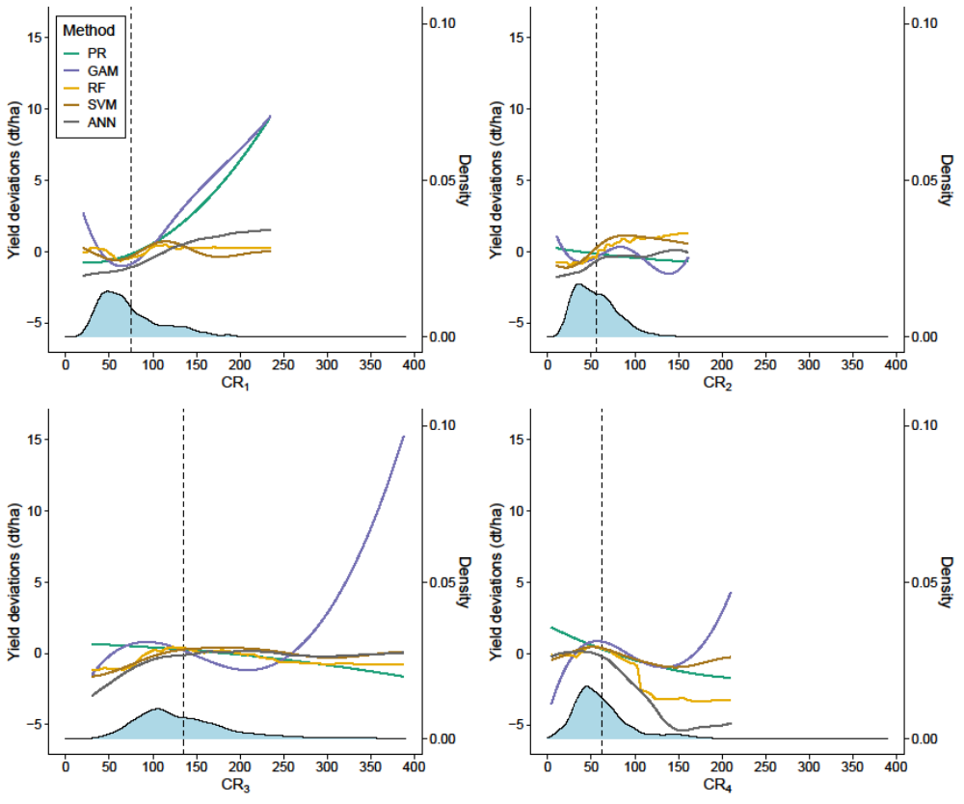

Figure A4 Partial dependence plots of CR in each growth stage of rapeseed (Source: figure/table created by authors)
Note: The notation under the X-axis refers to the weather index of each phase, e.g., CR₁ corresponds to phase 1 (from “stem elongation” to “flowering”). The dashed line indicates the mean value of CR at each stage. PR, GAM, RF, SVM, and ANN are abbreviations for Polynomial Regression, Generalized Additive Model, Random Forest, Support Vector Machines, and Artificial Neural Networks, respectively.

Table A7 Results of parameter tuning for Support Vector Machines (SVM) and Artificial Neural Networks (ANN) in an empirical study of rapeseed (Source: figure/table created by authors)
Method | Parameter list | Search space | ND | ED | OD
Support Vector Machine | cost | {1, 2, 3, 4, 5, 6, 7, 8, 9, 10} | 3 | 1 | 1
Support Vector Machine | gamma | {0.1, 0.2, 0.3, 0.4, 0.5, 0.6, 0.7, 0.8, 0.9, 1} | 0.8 | 0.4 | 0.6
 | learning rate | {0.001, 0.002, 0.004, 0.0065, 0.008, 0.016, 0.032, 0.064, 0.08, 0.12} | 0.12 | 0.12 | 0.09
Artificial Neural Networks | batch size | {8, 16, 24, 32, 40, 48} | 24 | 24 | 16
 | $$L_{2}$$ | {0.0001, 0.001, 0.01, 0.1} | 0.1 | 0.0001 | 0.034
 | number of neurons/hidden layer | {4, 8, 16} or  {8, 16, 32} | 16 | 32 | 21
 | epochs | {20, 40, 50, 100} | 100 | 50 | 58
 | seed value (random selection) | {0, 4, 5, 50, 99} | 0 | 5 | 5

Note: ND, ED, and OD are abbreviations for non-division, expert-division, and optimal-division, respectively.

