Figure A.1. Statistical Significance of the Difference in Indemnity Payments between Baseline and Alternative Coverage Plans, Corn
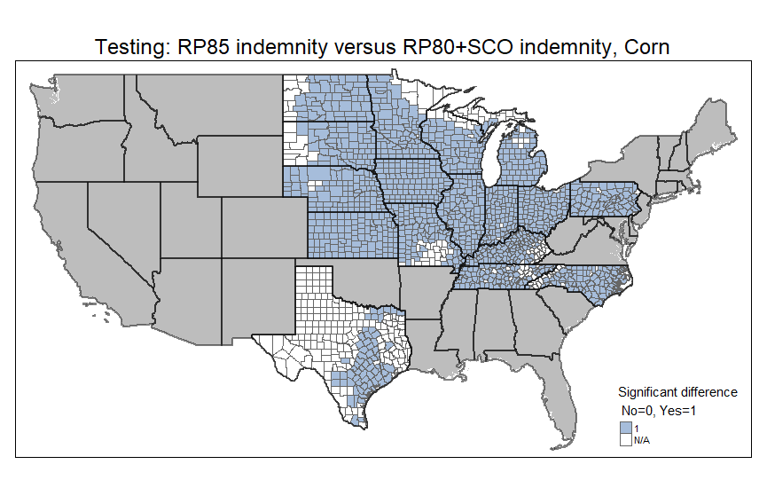 | 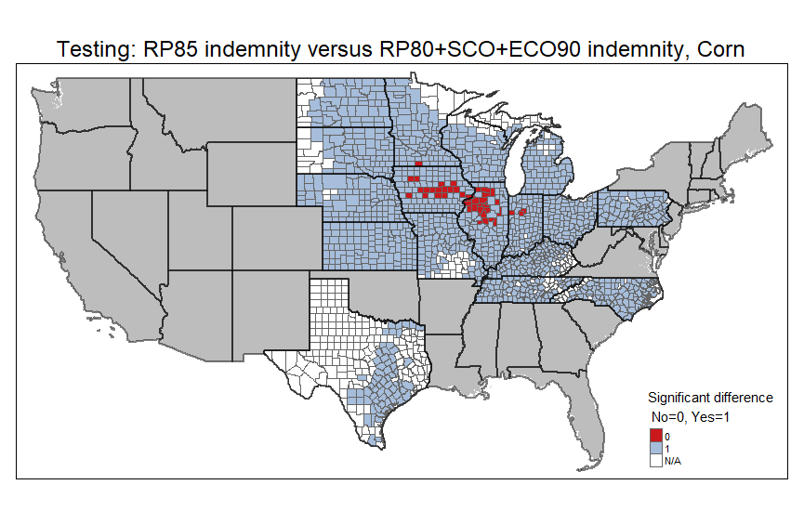
- RP at 85% vs. RP at 80%+SCO | - RP at 85% vs. RP at 80%+SCO+ECO at 90%
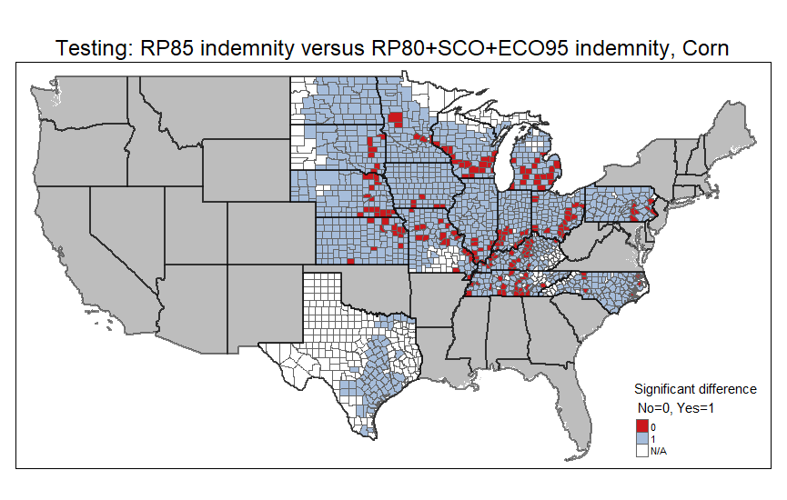
- RP at 85% vs. RP at 80%+SCO+ECO at 95%

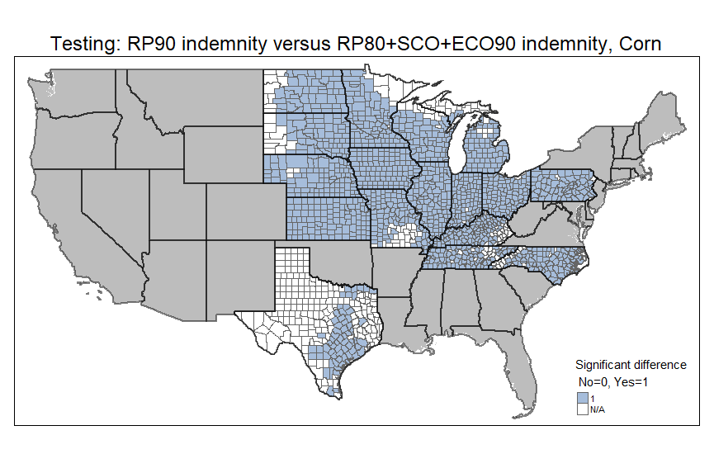 | 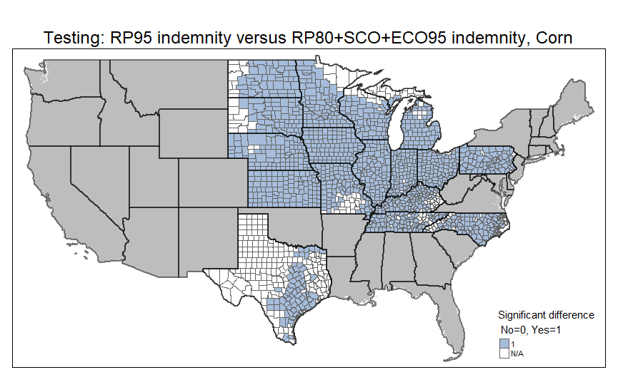
(d) RP at 90% vs. RP at 80%+SCO+ECO at 90% | (e) RP at 95% vs. RP at 80%+SCO+ECO at 95%
(Source: figure created by authors)
Figure A.2. Statistical Significance of the Difference in Indemnity Payments between Baseline and Alternative Coverage Plans, Soybean
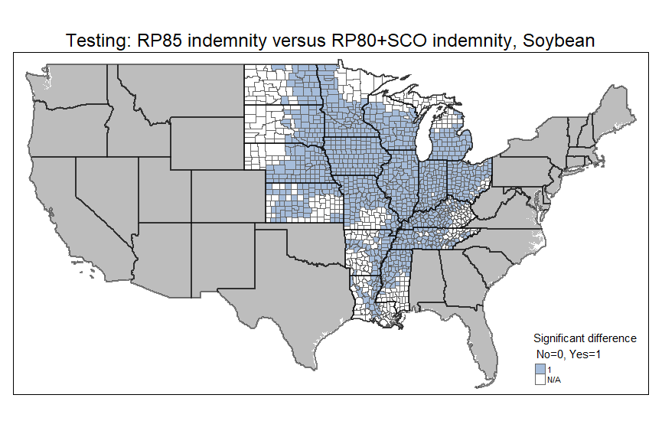 | 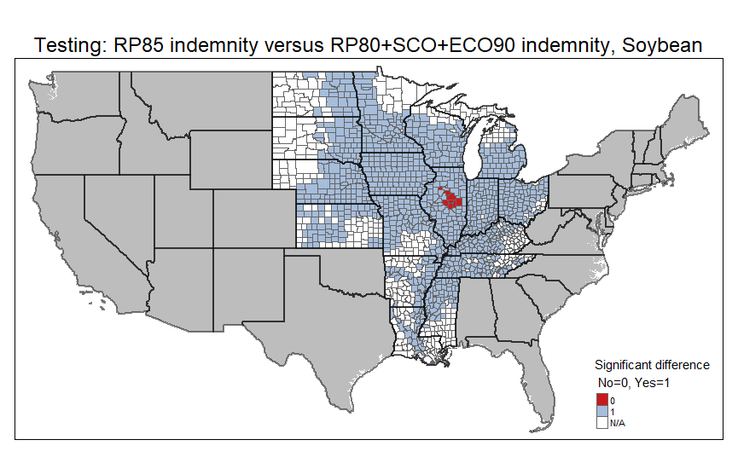
- RP at 85% vs. RP at 80%+SCO | - RP at 85% vs. RP at 80%+SCO+ECO at 90%
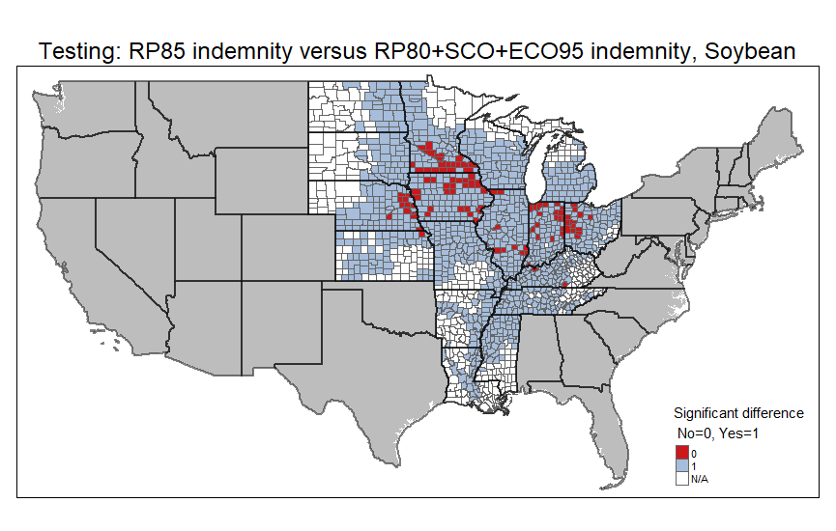
- RP at 85% vs. RP at 80%+SCO+ECO at 95%

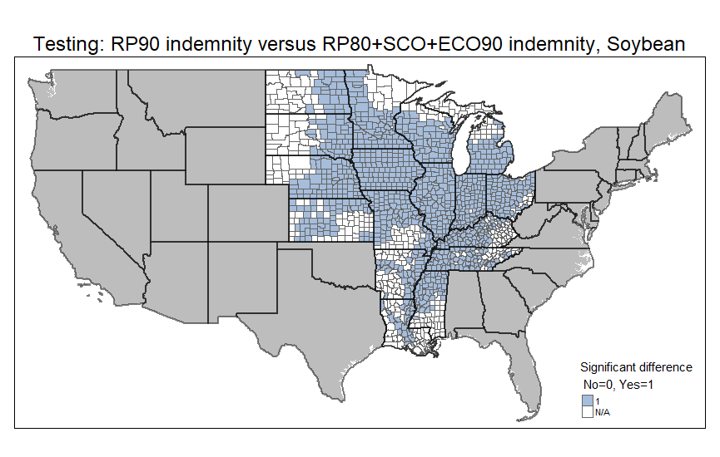 | 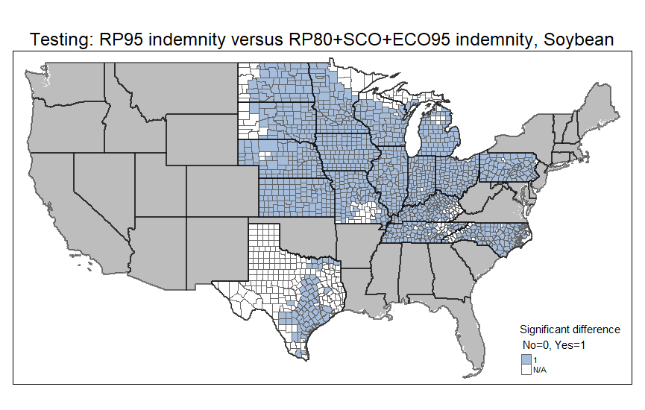
(d) RP at 90% vs. RP at 80%+SCO+ECO at 90% | (e) RP at 95% vs. RP at 80%+SCO+ECO at 95%
(Source: figure created by authors)
Figure A.3. False Negative Probability Estimates, High APH Yield Scenario
T-APH yields set at 125% of baseline
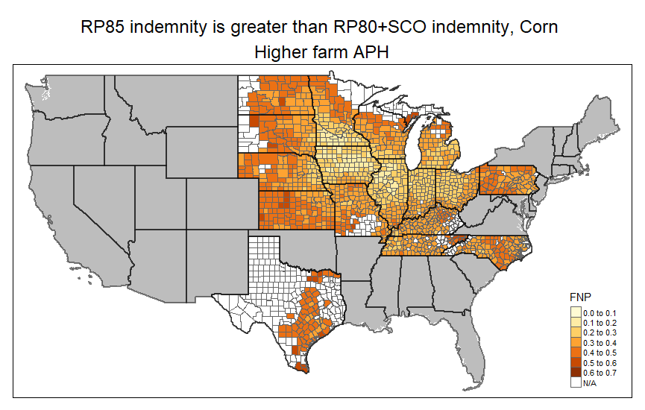 | 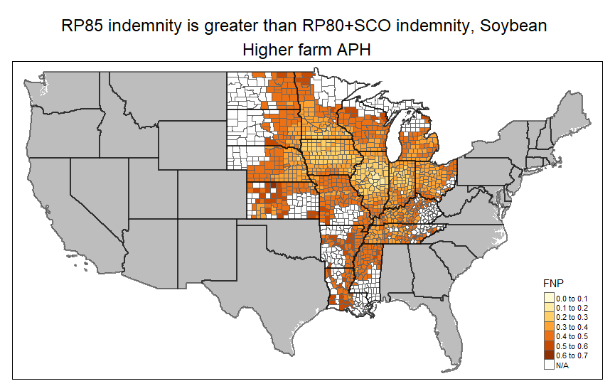
(a) | (b)
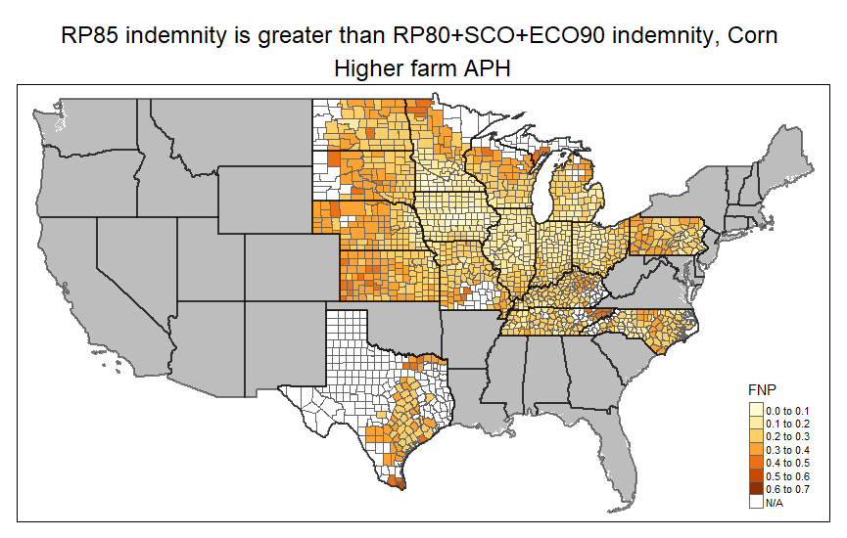 | 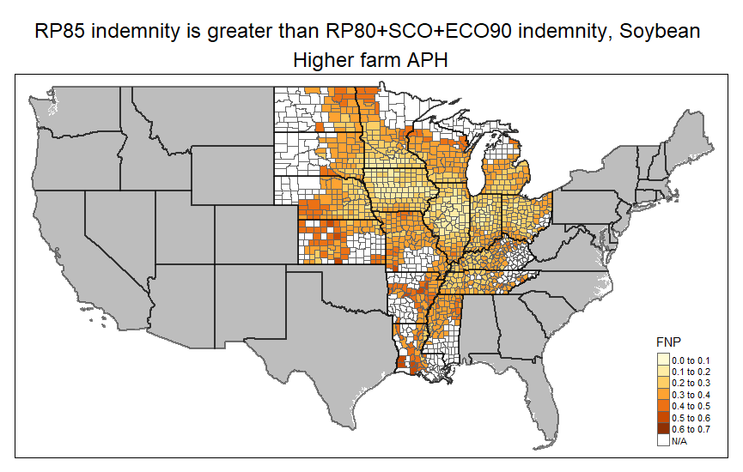
(c) | (d)
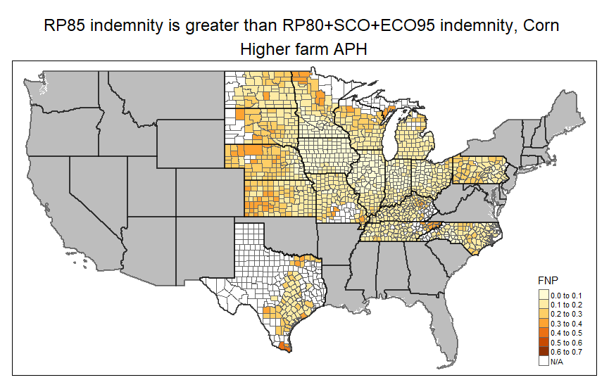 | 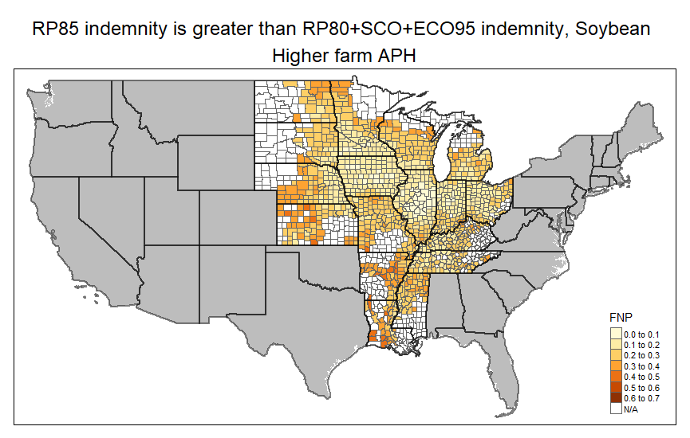
(e) | (f)
(Source: figure created by authors)

Figure A.4. False Positive Probability Estimates, High APH Yield Scenario
T-APH yields set at 125% of baseline
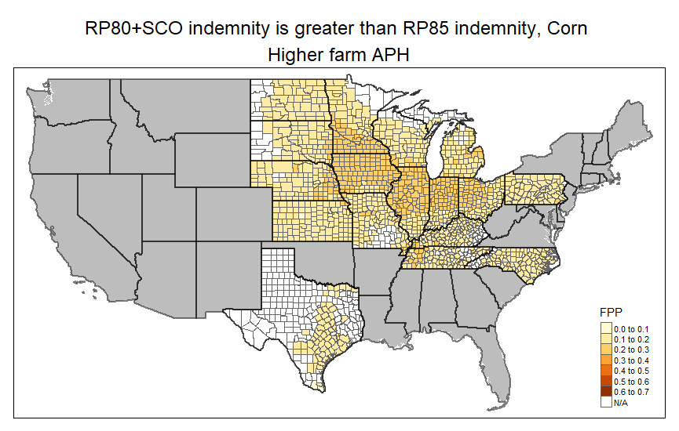 | 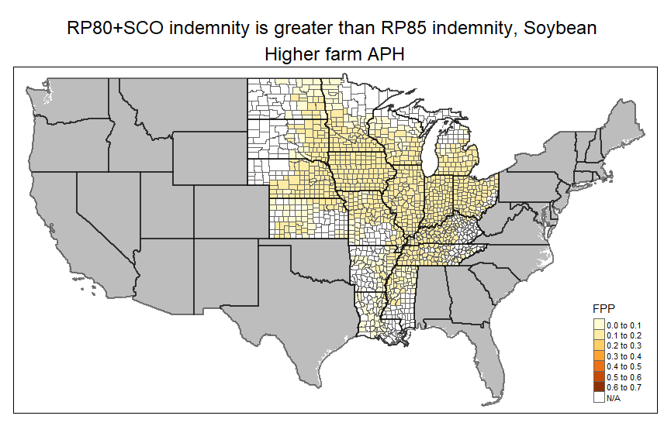
(a) | (b)
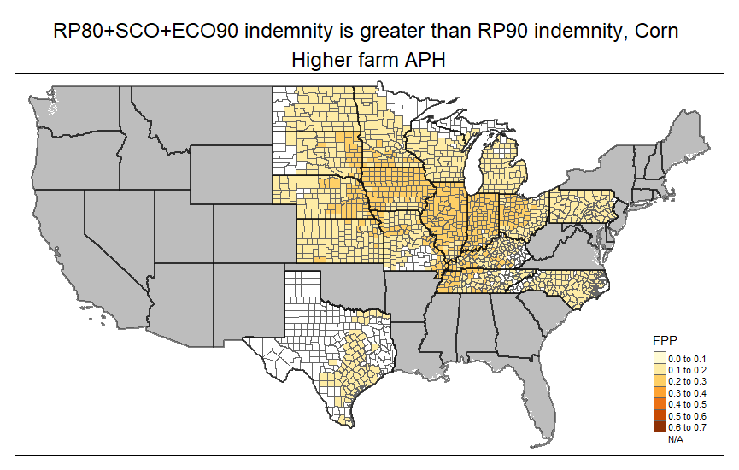 | 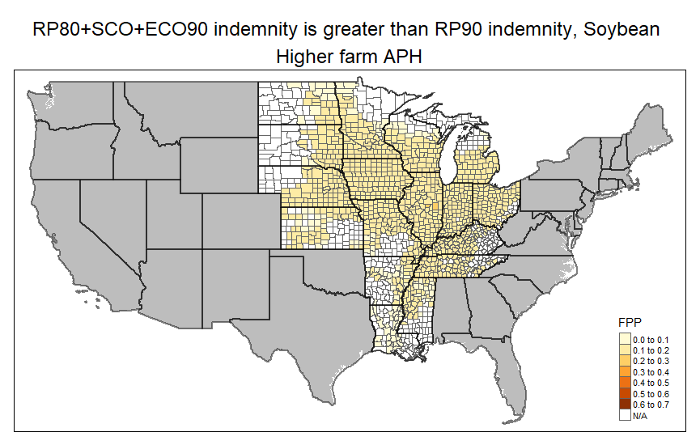
(c) | (d)
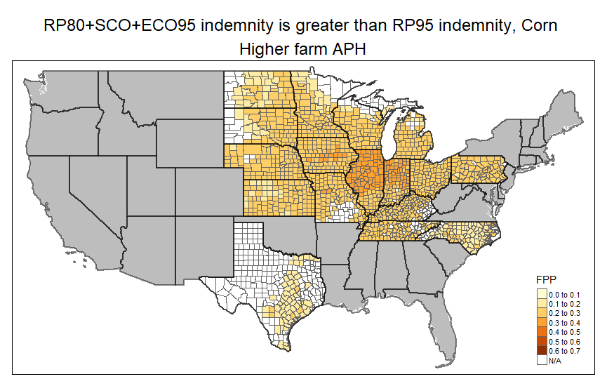 | 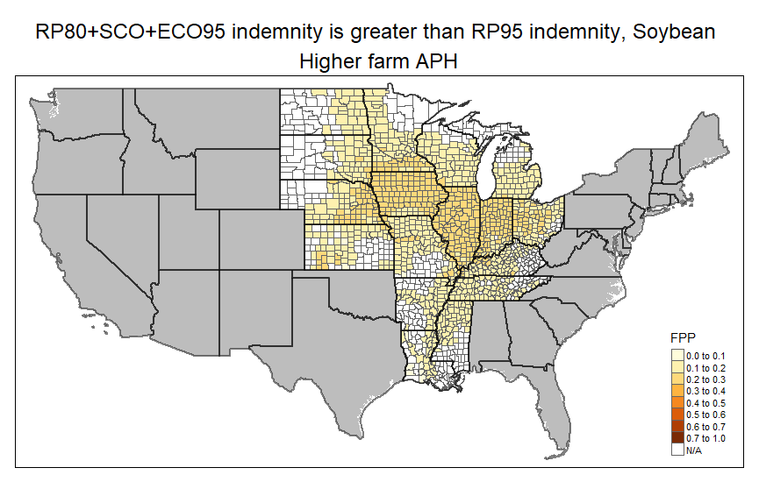
(e) | (f)
(Source: figure created by authors)

Figure A.5. False Negative Probability Estimates, Low APH Yield Scenario
T-APH yields set at 75% of baseline
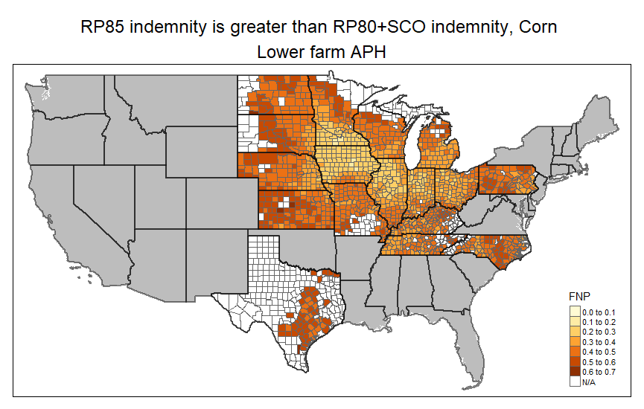 | 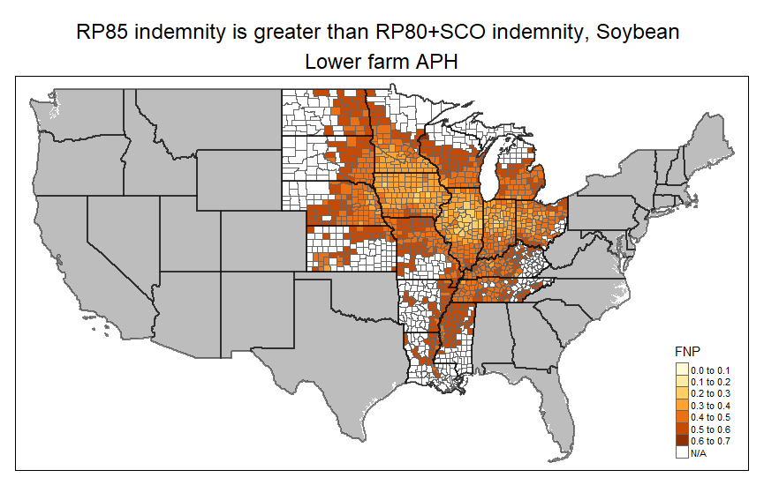
(a) | (b)
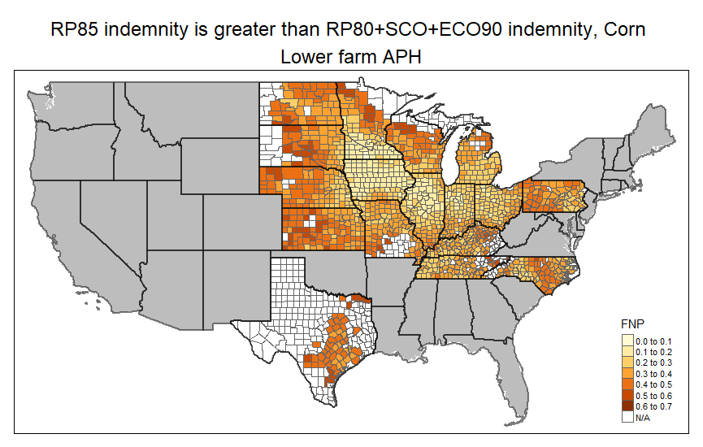 | 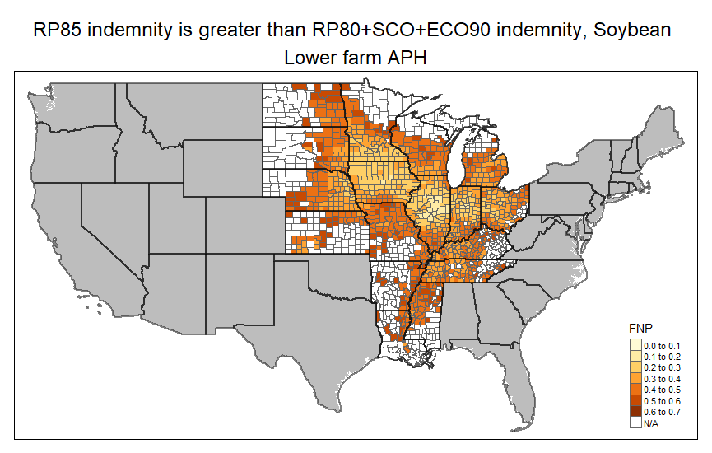
(c) | (d)
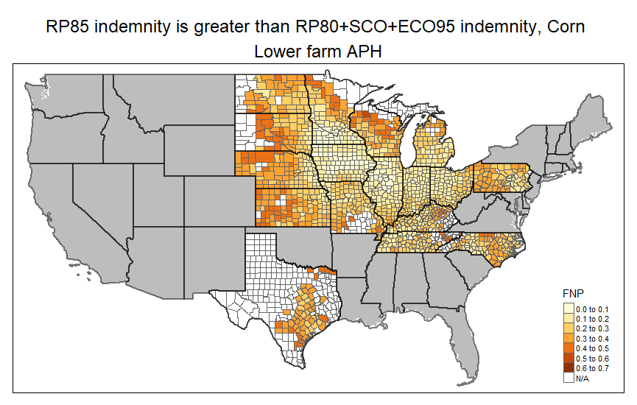 | 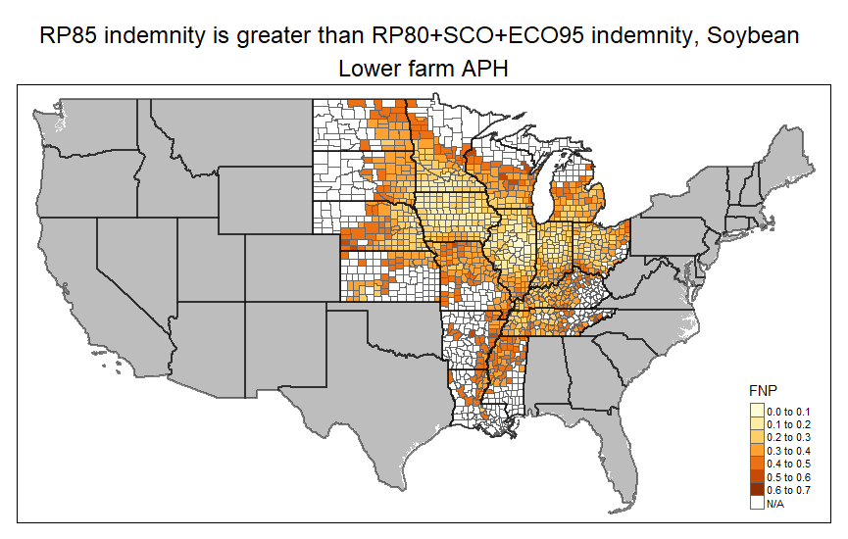
(e) | (f)
(Source: figure created by authors)
Figure A.6. False Positive Probability Estimates, Low APH Yield Scenario
T-APH yields set at 75% of baseline
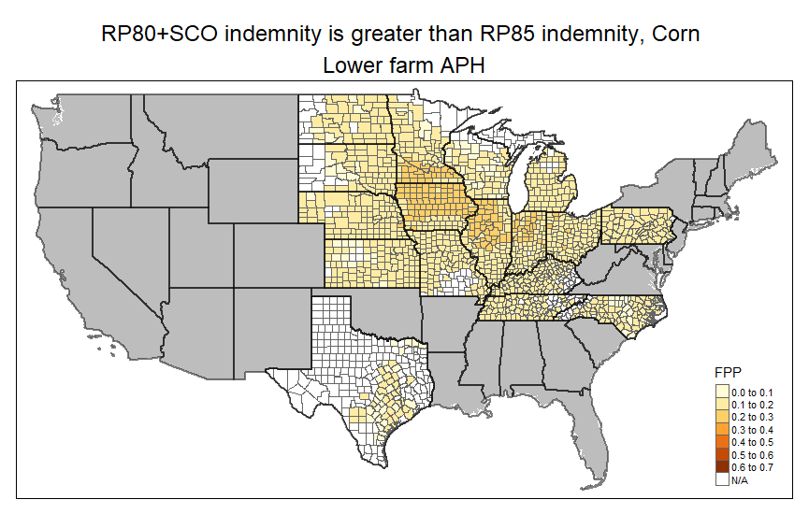 | 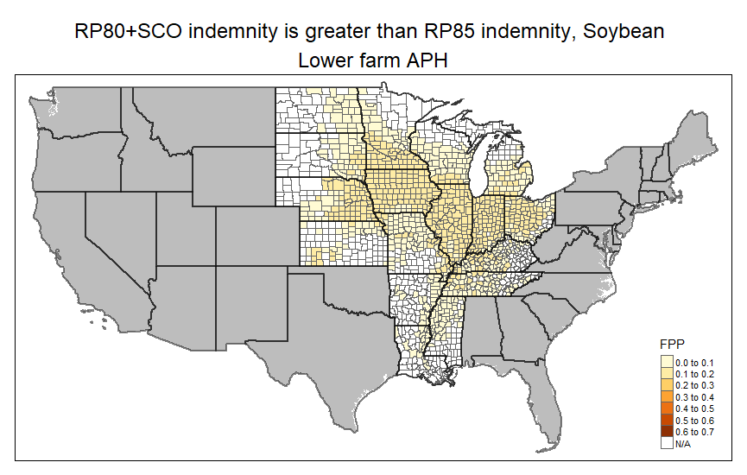
(a) | (b)
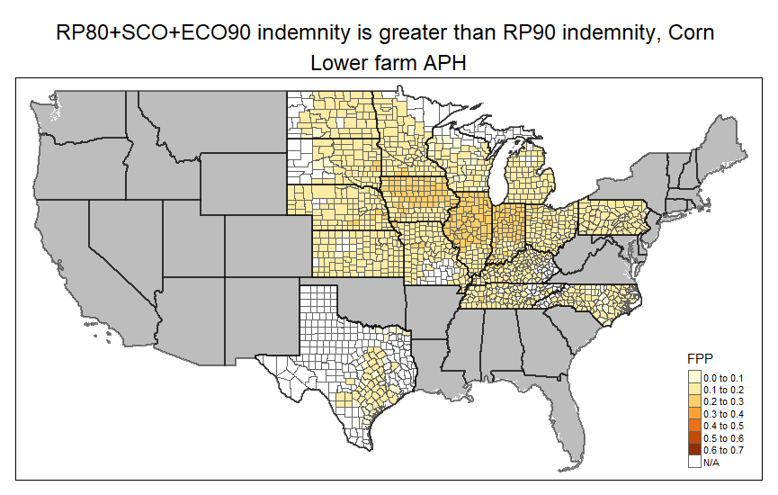 | 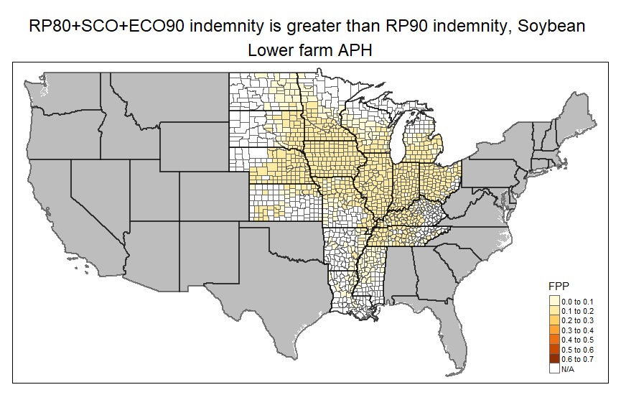
(c) | (d)
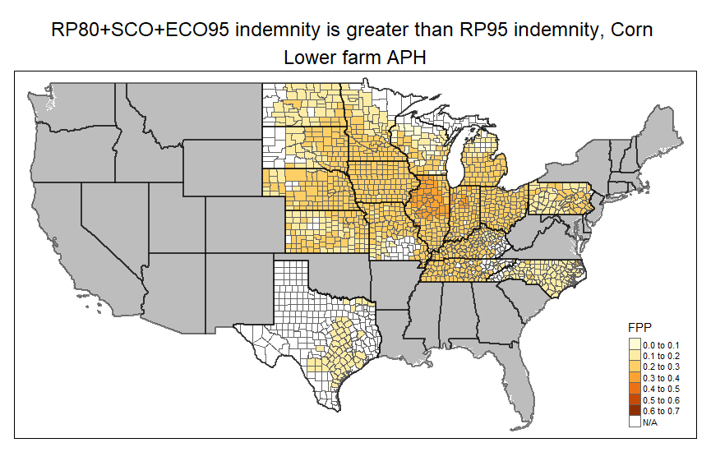 | 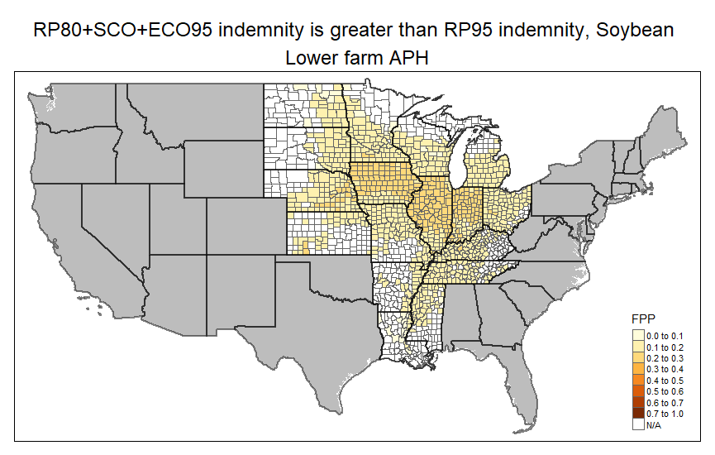
(e) | (f)
(Source: figure created by authors)

Figure A.7. False Negative Probability Estimates, High Price Volatility Scenario
Corn price volatility: 0.29; Soybean price volatility: 0.23
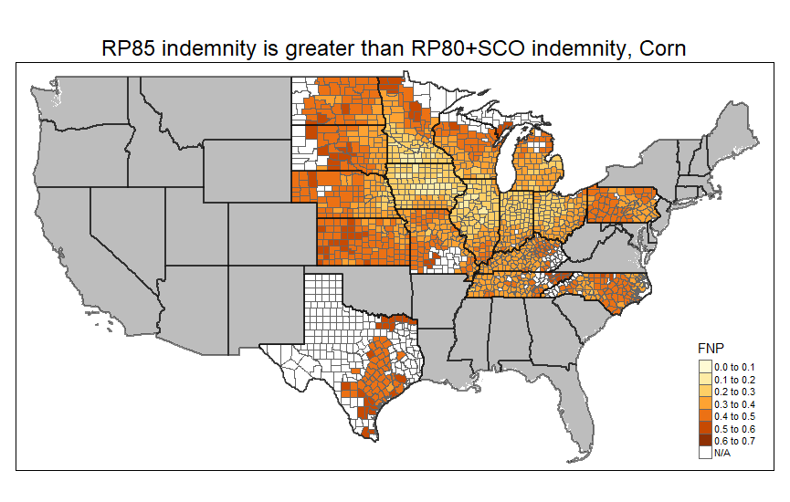 | 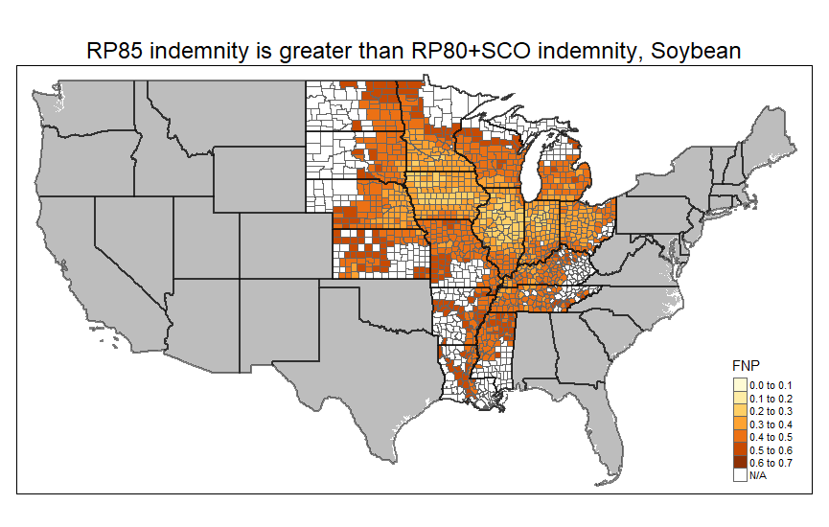
(a) | (b)
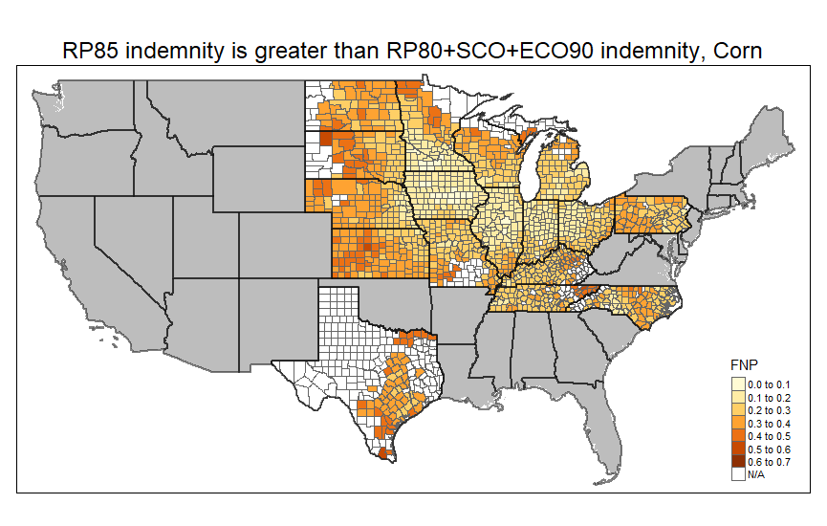 | 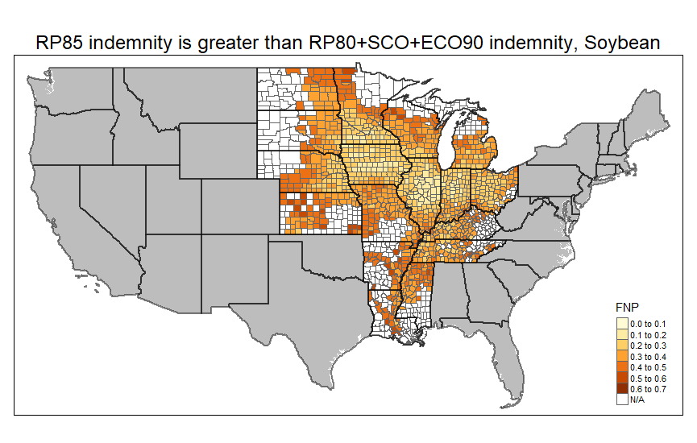
(c) | (d)
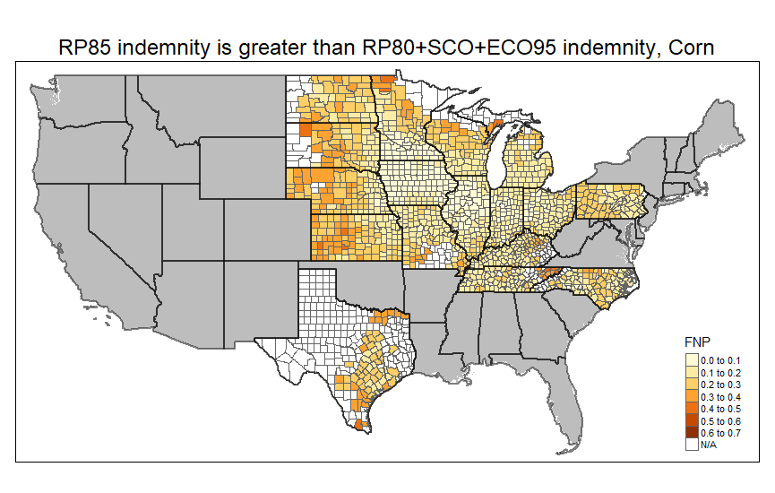 | 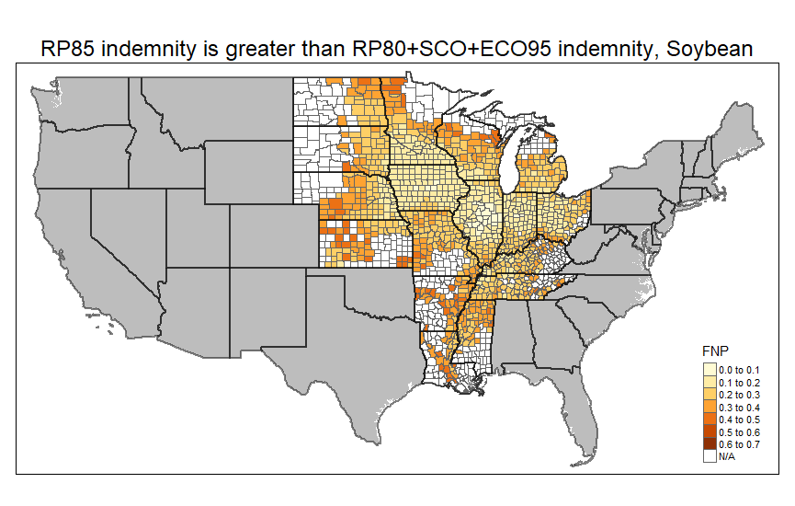
(e) | (f)
(Source: figure created by authors)
Figure A.8. False Positive Probability Estimates, High Price Volatility Scenario
Corn price volatility: 0.29; Soybean price volatility: 0.23
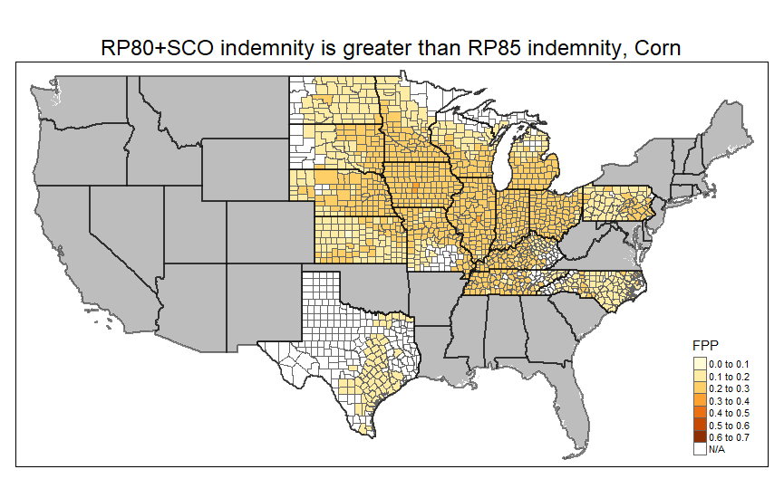 | 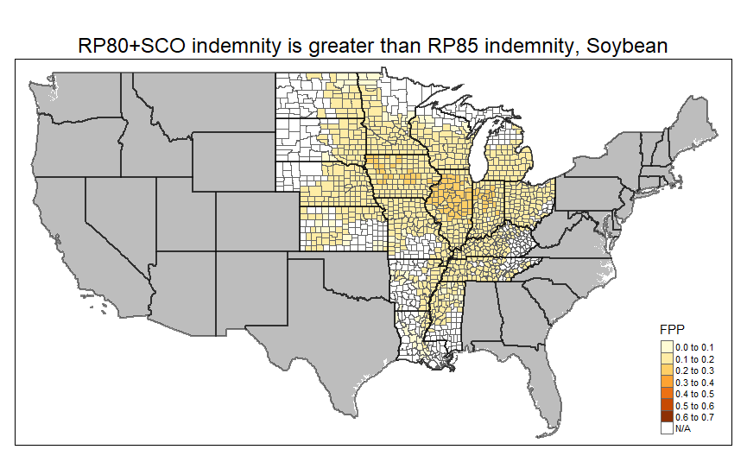
(a) | (b)
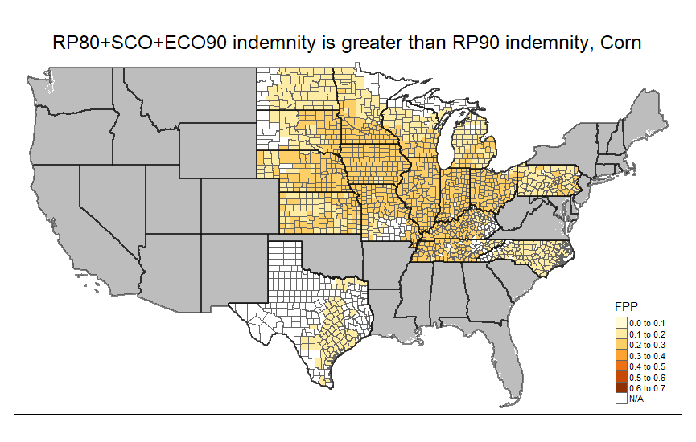 | 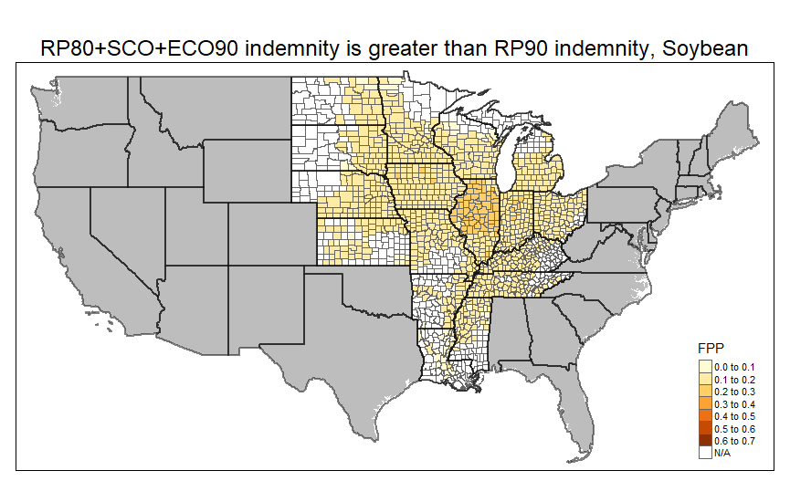
(c) | (d)
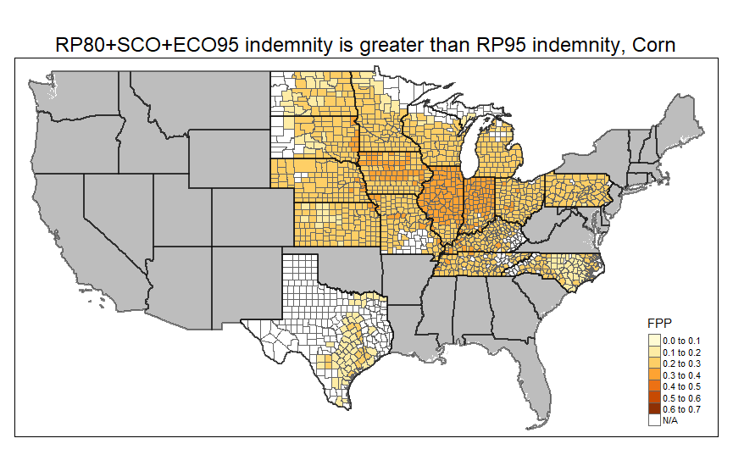 | 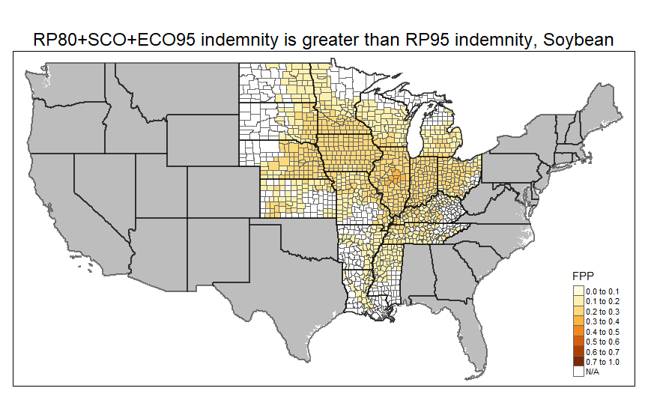
(e) | (f)
(Source: figure created by authors)

Figure A.9. False Negative Probability Estimates, Low Price Volatility Scenario
Corn price volatility: 0.15; Soybean price volatility: 0.12
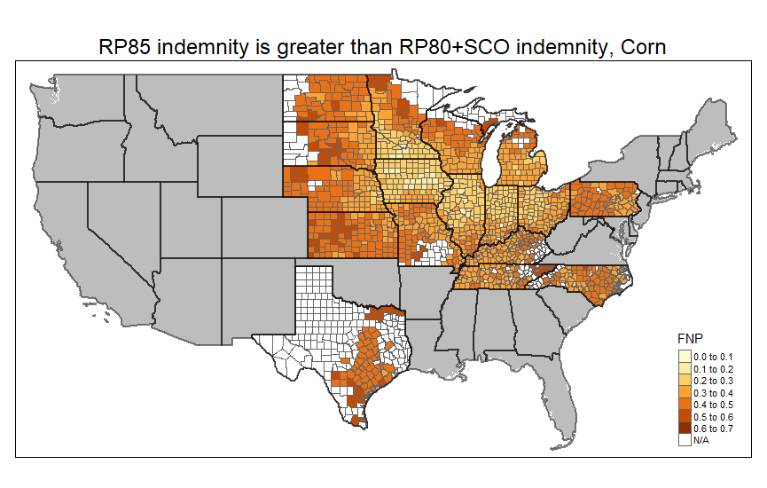 | 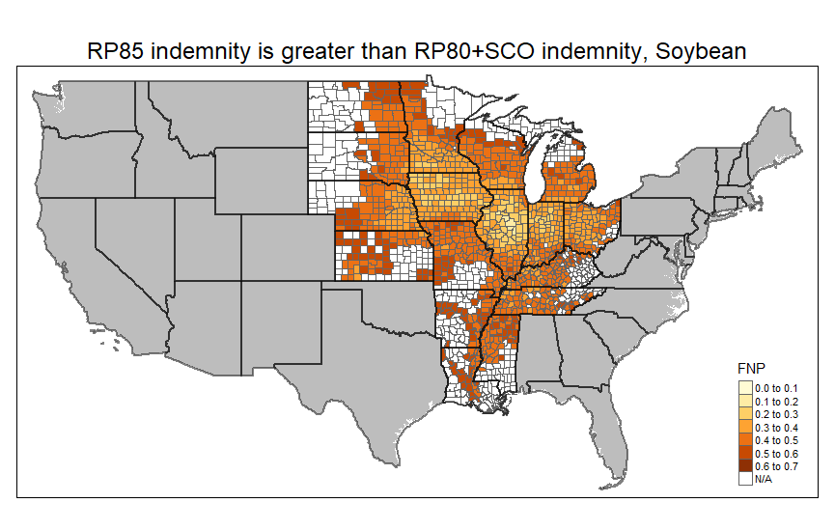
(a) | (b)
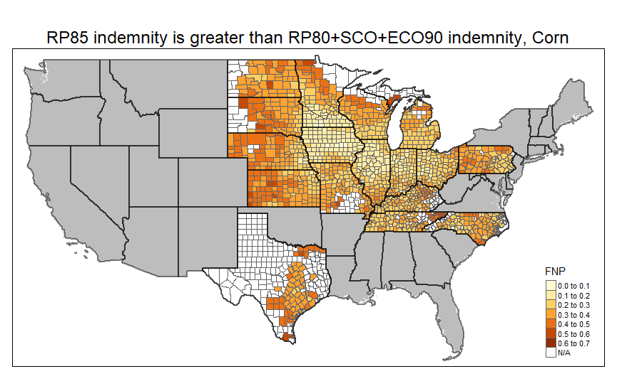 | 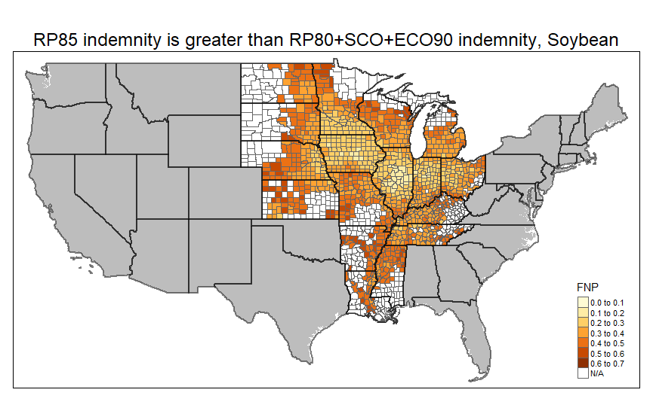
(c) | (d)
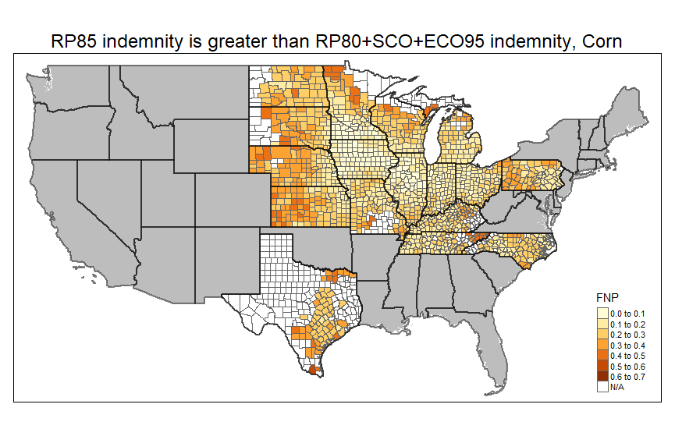 | 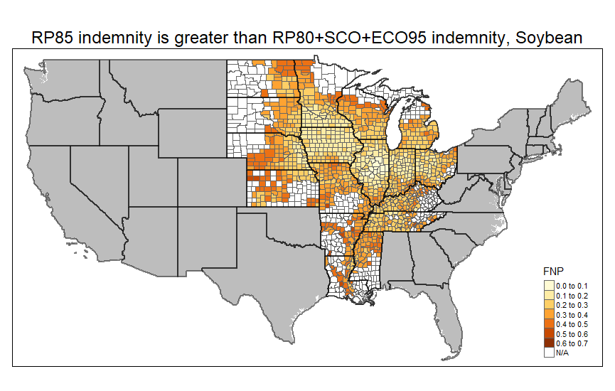
(e) | (f)
(Source: figure created by authors)

Figure A.10. False Positive Probability Estimates, Low Price Volatility Scenario
Corn price volatility: 0.15; Soybean price volatility: 0.12
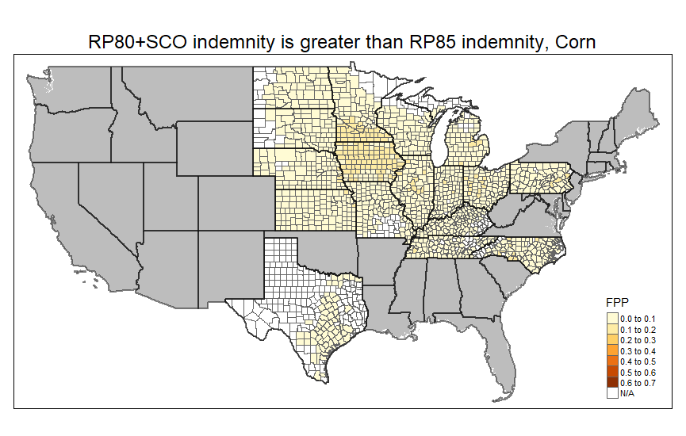 | 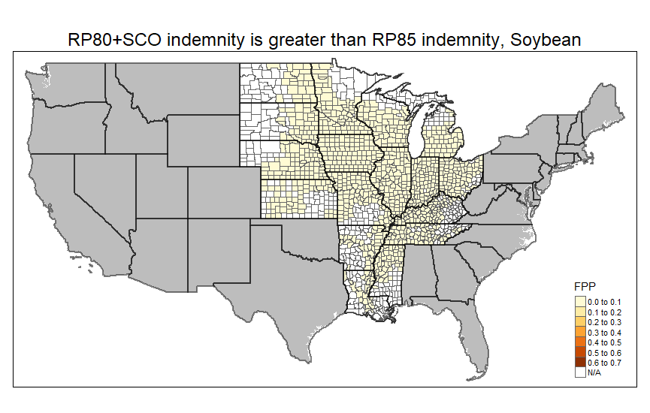
(a) | (b)
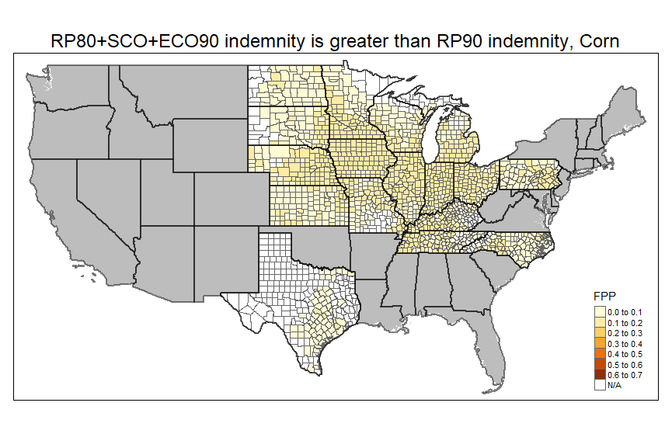 | 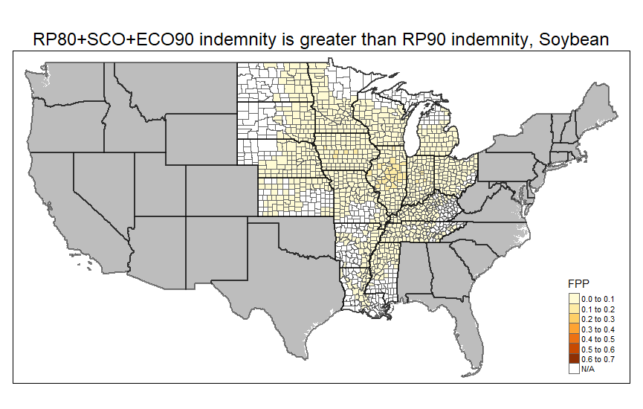
(c) | (d)
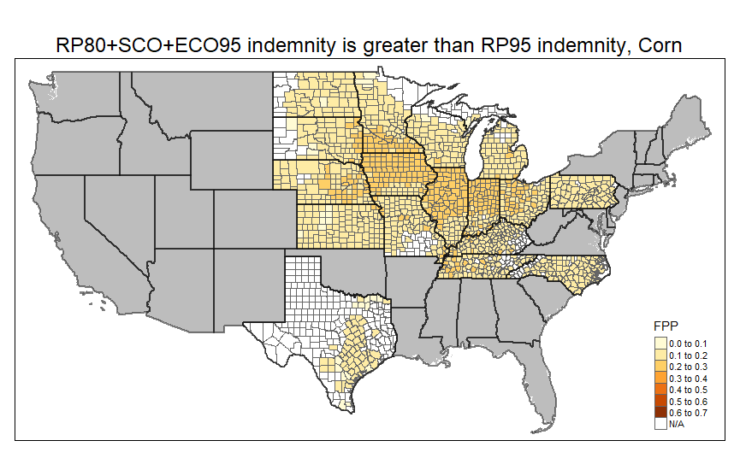 | 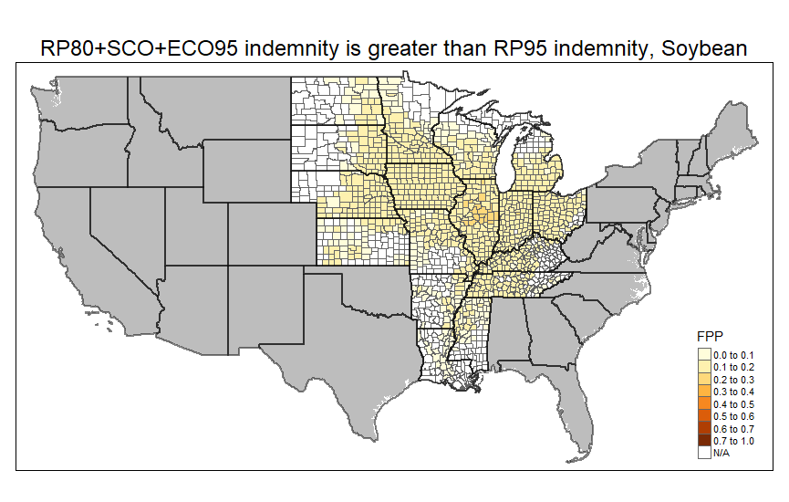
(e) | (f)
(Source: figure created by authors)

Table A.I. FNP Estimates by Scenario, RP80+SCO+ECO90 vs. RP85, State-level Averages
 |  | FNP Difference = Alternative – Baseline
 | Baseline FNP | Low yield correlation | High APH | Low APH | High price volatility | Low price volatility
CORN
Illinois | 0.21 | 0.02 | -0.03 | 0.04 | -0.01 | 0.02
Indiana | 0.22 | 0.02 | -0.03 | 0.04 | -0.01 | 0.02
Iowa | 0.15 | 0.03 | -0.02 | 0.03 | -0.01 | 0.02
Kansas | 0.35 | 0.01 | -0.05 | 0.06 | -0.01 | 0.02
Kentucky | 0.29 | 0.01 | -0.04 | 0.05 | -0.01 | 0.02
Michigan | 0.27 | 0.01 | -0.04 | 0.04 | -0.01 | 0.03
Minnesota | 0.22 | 0.02 | -0.03 | 0.04 | -0.01 | 0.02
Missouri | 0.30 | 0.01 | -0.04 | 0.06 | -0.01 | 0.02
Nebraska | 0.31 | 0.01 | -0.03 | 0.05 | -0.01 | 0.03
North Carolina | 0.28 | 0.02 | -0.05 | 0.06 | -0.01 | 0.02
North Dakota | 0.34 | 0.01 | -0.05 | 0.06 | -0.01 | 0.02
Ohio | 0.23 | 0.02 | -0.03 | 0.04 | -0.01 | 0.02
Pennsylvania | 0.31 | 0.01 | -0.04 | 0.06 | -0.01 | 0.03
South Dakota | 0.34 | 0.00 | -0.05 | 0.05 | -0.01 | 0.02
Tennessee | 0.30 | 0.01 | -0.04 | 0.04 | -0.01 | 0.02
Texas | 0.37 | 0.01 | -0.05 | 0.06 | -0.01 | 0.02
Wisconsin | 0.29 | 0.01 | -0.04 | 0.08 | -0.01 | 0.03
SOYBEANS
Arkansas | 0.46 | 0.00 | -0.04 | 0.04 | -0.01 | 0.02
Illinois | 0.26 | 0.01 | -0.03 | 0.05 | -0.01 | 0.02
Indiana | 0.29 | 0.01 | -0.03 | 0.05 | -0.01 | 0.03
Iowa | 0.25 | 0.01 | -0.03 | 0.05 | -0.01 | 0.03
Kansas | 0.43 | 0.00 | -0.04 | 0.03 | -0.01 | 0.02
Kentucky | 0.36 | 0.00 | -0.04 | 0.06 | -0.01 | 0.03
Louisiana | 0.43 | 0.00 | -0.03 | 0.04 | -0.01 | 0.02
Michigan | 0.36 | 0.00 | -0.04 | 0.06 | -0.01 | 0.03
Minnesota | 0.31 | 0.01 | -0.04 | 0.04 | -0.01 | 0.03
Mississippi | 0.42 | 0.00 | -0.05 | 0.07 | -0.01 | 0.02
Missouri | 0.39 | 0.00 | -0.04 | 0.06 | -0.01 | 0.03
Nebraska | 0.34 | 0.00 | -0.04 | 0.05 | -0.01 | 0.03
North Dakota | 0.40 | 0.00 | -0.05 | 0.07 | -0.01 | 0.02
Ohio | 0.31 | 0.01 | -0.03 | 0.06 | -0.01 | 0.03
South Dakota | 0.37 | 0.00 | -0.04 | 0.06 | -0.01 | 0.02
Tennessee | 0.36 | 0.00 | -0.04 | 0.06 | -0.02 | 0.03
Wisconsin | 0.38 | 0.00 | -0.05 | 0.06 | -0.01 | 0.02
Note: FNP estimates are the frequency with which the RP85 benchmark indemnities exceed alternative coverage indemnities. (Source: table created by authors)
Table A.II. FNP Estimates by Scenario, RP80+SCO+ECO95 vs. RP85, State-level Averages
 |  | FNP Difference = Alternative – Baseline
 | Baseline FNP | Low yield correlation | High APH | Low APH | High price volatility | Low price volatility
CORN
Illinois | 0.13 | 0.04 | -0.02 | 0.04 | -0.01 | 0.02
Indiana | 0.14 | 0.03 | -0.02 | 0.04 | -0.01 | 0.02
Iowa | 0.09 | 0.04 | -0.02 | 0.02 | -0.01 | 0.01
Kansas | 0.25 | 0.03 | -0.05 | 0.07 | -0.01 | 0.03
Kentucky | 0.20 | 0.03 | -0.04 | 0.05 | -0.01 | 0.02
Michigan | 0.19 | 0.02 | -0.03 | 0.04 | -0.01 | 0.02
Minnesota | 0.15 | 0.03 | -0.03 | 0.03 | -0.01 | 0.02
Missouri | 0.20 | 0.04 | -0.04 | 0.06 | -0.01 | 0.02
Nebraska | 0.24 | 0.01 | -0.03 | 0.05 | -0.01 | 0.03
North Carolina | 0.19 | 0.04 | -0.04 | 0.06 | -0.01 | 0.02
North Dakota | 0.24 | 0.03 | -0.05 | 0.07 | -0.01 | 0.02
Ohio | 0.15 | 0.03 | -0.03 | 0.04 | -0.01 | 0.02
Pennsylvania | 0.21 | 0.03 | -0.04 | 0.06 | -0.01 | 0.02
South Dakota | 0.25 | 0.02 | -0.05 | 0.06 | -0.01 | 0.03
Tennessee | 0.20 | 0.03 | -0.04 | 0.04 | -0.01 | 0.03
Texas | 0.27 | 0.03 | -0.06 | 0.07 | -0.01 | 0.02
Wisconsin | 0.21 | 0.02 | -0.04 | 0.10 | -0.01 | 0.03
SOYBEANS
Arkansas | 0.38 | 0.00 | -0.05 | 0.05 | -0.02 | 0.03
Illinois | 0.18 | 0.03 | -0.03 | 0.05 | -0.01 | 0.02
Indiana | 0.21 | 0.02 | -0.03 | 0.05 | -0.01 | 0.03
Iowa | 0.16 | 0.03 | -0.03 | 0.04 | -0.01 | 0.02
Kansas | 0.34 | 0.01 | -0.05 | 0.03 | -0.01 | 0.02
Kentucky | 0.27 | 0.02 | -0.05 | 0.07 | -0.01 | 0.03
Louisiana | 0.35 | 0.02 | -0.03 | 0.05 | -0.02 | 0.03
Michigan | 0.28 | 0.02 | -0.05 | 0.07 | -0.01 | 0.03
Minnesota | 0.23 | 0.03 | -0.04 | 0.04 | -0.01 | 0.02
Mississippi | 0.33 | 0.02 | -0.06 | 0.08 | -0.01 | 0.03
Missouri | 0.31 | 0.01 | -0.05 | 0.07 | -0.01 | 0.03
Nebraska | 0.27 | 0.01 | -0.04 | 0.06 | -0.01 | 0.03
North Dakota | 0.32 | 0.02 | -0.06 | 0.08 | -0.02 | 0.03
Ohio | 0.23 | 0.02 | -0.04 | 0.06 | -0.01 | 0.03
South Dakota | 0.28 | 0.02 | -0.05 | 0.07 | -0.01 | 0.03
Tennessee | 0.26 | 0.03 | -0.05 | 0.07 | -0.01 | 0.03
Wisconsin | 0.29 | 0.02 | -0.05 | 0.07 | -0.01 | 0.03
Note: FNP estimates are the frequency with which the RP85 benchmark indemnities exceed alternative coverage indemnities. (Source: table created by authors)
Table A.III. FPP Estimates by Scenario, RP80+SCO+ECO90 vs. RP90, State-level Averages
 |  | FPP Difference = Alternative – Baseline
 | Baseline FPP | Low yield correlation | High APH | Low APH | High price volatility | Low price volatility
CORN
Illinois | 0.22 | 0.03 | 0.01 | -0.01 | 0.04 | -0.09
Indiana | 0.21 | 0.03 | 0.01 | 0.00 | 0.04 | -0.09
Iowa | 0.20 | 0.03 | 0.01 | 0.00 | 0.03 | -0.07
Kansas | 0.16 | 0.05 | 0.01 | -0.01 | 0.04 | -0.07
Kentucky | 0.18 | 0.04 | 0.01 | -0.01 | 0.04 | -0.08
Michigan | 0.16 | 0.04 | 0.01 | 0.00 | 0.03 | -0.06
Minnesota | 0.17 | 0.04 | 0.01 | 0.00 | 0.03 | -0.06
Missouri | 0.18 | 0.05 | 0.01 | -0.01 | 0.04 | -0.08
Nebraska | 0.19 | 0.02 | 0.01 | -0.01 | 0.03 | -0.07
North Carolina | 0.13 | 0.06 | 0.01 | -0.01 | 0.03 | -0.04
North Dakota | 0.14 | 0.05 | 0.01 | -0.01 | 0.03 | -0.05
Ohio | 0.19 | 0.04 | 0.01 | -0.01 | 0.03 | -0.07
Pennsylvania | 0.15 | 0.05 | 0.01 | -0.01 | 0.03 | -0.06
South Dakota | 0.17 | 0.04 | 0.01 | -0.01 | 0.04 | -0.07
Tennessee | 0.18 | 0.04 | 0.01 | -0.01 | 0.03 | -0.08
Texas | 0.12 | 0.07 | 0.02 | -0.01 | 0.03 | -0.04
Wisconsin | 0.17 | 0.03 | 0.01 | -0.05 | 0.03 | -0.07
SOYBEANS
Arkansas | 0.10 | 0.04 | 0.01 | -0.01 | 0.02 | -0.05
Illinois | 0.17 | 0.03 | 0.00 | -0.01 | 0.03 | -0.08
Indiana | 0.15 | 0.03 | 0.00 | -0.01 | 0.03 | -0.07
Iowa | 0.15 | 0.04 | 0.00 | -0.01 | 0.03 | -0.07
Kansas | 0.11 | 0.06 | 0.01 | 0.00 | 0.03 | -0.05
Kentucky | 0.12 | 0.05 | 0.01 | -0.01 | 0.02 | -0.05
Louisiana | 0.07 | 0.06 | 0.00 | -0.01 | 0.02 | -0.03
Michigan | 0.12 | 0.05 | 0.00 | -0.01 | 0.02 | -0.05
Minnesota | 0.12 | 0.05 | 0.01 | -0.01 | 0.03 | -0.05
Mississippi | 0.09 | 0.06 | 0.01 | -0.01 | 0.02 | -0.04
Missouri | 0.12 | 0.05 | 0.00 | -0.01 | 0.03 | -0.06
Nebraska | 0.14 | 0.03 | 0.00 | -0.01 | 0.03 | -0.06
North Dakota | 0.09 | 0.06 | 0.01 | -0.01 | 0.02 | -0.04
Ohio | 0.13 | 0.04 | 0.00 | -0.01 | 0.03 | -0.06
South Dakota | 0.12 | 0.05 | 0.01 | -0.01 | 0.03 | -0.05
Tennessee | 0.12 | 0.05 | 0.01 | -0.01 | 0.03 | -0.05
Wisconsin | 0.11 | 0.05 | 0.01 | -0.01 | 0.02 | -0.05
Note: FPP estimates are the frequency with which the alternative coverage indemnities exceed RP90 benchmark indemnities. (Source: table created by authors)
Table A.IV. FPP Estimates by Scenario, RP80+SCO+ECO95 vs. RP95, State-level Averages
 |  | FPP Difference = Alternative – Baseline
 | Baseline FPP | Low yield correlation | High APH | Low APH | High price volatility | Low price volatility
CORN
Illinois | 0.29 | 0.03 | 0.01 | -0.01 | 0.03 | -0.08
Indiana | 0.28 | 0.03 | 0.01 | -0.01 | 0.03 | -0.07
Iowa | 0.27 | 0.04 | 0.01 | -0.01 | 0.03 | -0.06
Kansas | 0.21 | 0.05 | 0.02 | -0.01 | 0.03 | -0.07
Kentucky | 0.24 | 0.04 | 0.01 | -0.01 | 0.03 | -0.07
Michigan | 0.22 | 0.05 | 0.01 | -0.00 | 0.02 | -0.05
Minnesota | 0.23 | 0.04 | 0.01 | -0.00 | 0.02 | -0.05
Missouri | 0.24 | 0.05 | 0.02 | -0.01 | 0.03 | -0.08
Nebraska | 0.24 | 0.03 | 0.01 | -0.01 | 0.02 | -0.06
North Carolina | 0.18 | 0.06 | 0.02 | -0.01 | 0.02 | -0.04
North Dakota | 0.18 | 0.06 | 0.01 | -0.01 | 0.02 | -0.05
Ohio | 0.25 | 0.04 | 0.01 | -0.01 | 0.03 | -0.06
Pennsylvania | 0.21 | 0.05 | 0.02 | -0.01 | 0.03 | -0.05
South Dakota | 0.23 | 0.05 | 0.02 | -0.01 | 0.03 | -0.07
Tennessee | 0.24 | 0.05 | 0.02 | -0.01 | 0.03 | -0.07
Texas | 0.15 | 0.07 | 0.02 | -0.01 | 0.02 | -0.04
Wisconsin | 0.22 | 0.04 | 0.01 | -0.02 | 0.02 | -0.06
SOYBEANS
Arkansas | 0.14 | 0.05 | 0.01 | -0.01 | 0.02 | -0.04
Illinois | 0.24 | 0.04 | 0.00 | -0.01 | 0.03 | -0.07
Indiana | 0.22 | 0.04 | 0.00 | -0.01 | 0.02 | -0.06
Iowa | 0.22 | 0.05 | 0.01 | -0.01 | 0.02 | -0.06
Kansas | 0.15 | 0.06 | 0.01 | 0.00 | 0.02 | -0.05
Kentucky | 0.17 | 0.05 | 0.01 | -0.02 | 0.02 | -0.05
Louisiana | 0.10 | 0.07 | 0.00 | -0.01 | 0.02 | -0.03
Michigan | 0.17 | 0.06 | 0.01 | -0.02 | 0.02 | -0.05
Minnesota | 0.17 | 0.06 | 0.01 | -0.01 | 0.02 | -0.05
Mississippi | 0.13 | 0.06 | 0.01 | -0.02 | 0.02 | -0.04
Missouri | 0.17 | 0.05 | 0.01 | -0.02 | 0.02 | -0.06
Nebraska | 0.19 | 0.04 | 0.01 | -0.01 | 0.02 | -0.05
North Dakota | 0.13 | 0.06 | 0.01 | -0.02 | 0.02 | -0.04
Ohio | 0.19 | 0.05 | 0.01 | -0.01 | 0.03 | -0.05
South Dakota | 0.17 | 0.06 | 0.01 | -0.01 | 0.02 | -0.05
Tennessee | 0.17 | 0.06 | 0.01 | -0.02 | 0.02 | -0.05
Wisconsin | 0.15 | 0.06 | 0.01 | -0.02 | 0.02 | -0.05
Note: FPP estimates are the frequency with which the alternative coverage indemnities exceed RP95 benchmark indemnities. (Source: table created by authors)
Table A.V. Ratio of implied farm level yield variability to historical county level yield variability
State | Corn Ratio | Soybean Ratio
Arkansas | n/a | 6.17
Illinois | 2.19 | 3.08
Indiana | 2.44 | 3.68
Iowa | 1.97 | 3.09
Kansas | 3.12 | 3.84
Kentucky | 2.88 | 4.18
Louisiana | n/a | 4.53
Michigan | 3.35 | 4.33
Minnesota | 2.95 | 3.66
Mississippi | n/a | 4.45
Missouri | 2.66 | 4.16
Nebraska | 4.58 | 5.14
North Carolina | 2.51 | n/a
North Dakota | 3.28 | 4.25
Ohio | 2.77 | 4.10
Pennsylvania | 3.11 | n/a
South Dakota | 3.23 | 3.80
Tennessee | 3.08 | 3.76
Texas | 2.79 | n/a
Wisconsin | 3.80 | 4.11
(Source: table created by authors)

Table A.VI. Estimated Probabilities of Simultaneous Losses for RP85 and Alternative Combinations, State-level Averages for Corn.
 | RP85 vs. RP80+SCO |  | RP85 vs. RP80+SCO+ECO90 |  | RP85 vs. RP80+SCO+ECO95
Farm-County Yield Correlation | 0.8 | 0.4 | 0.8 | 0.4 | 0.8 | 0.4
Illinois | 0.36 | 0.36 | 0.37 | 0.37 | 0.39 | 0.39
Indiana | 0.37 | 0.37 | 0.38 | 0.38 | 0.40 | 0.39
Iowa | 0.34 | 0.34 | 0.36 | 0.35 | 0.37 | 0.36
Kansas | 0.47 | 0.47 | 0.48 | 0.48 | 0.48 | 0.48
Kentucky | 0.42 | 0.42 | 0.43 | 0.43 | 0.44 | 0.44
Michigan | 0.42 | 0.41 | 0.42 | 0.42 | 0.43 | 0.43
Minnesota | 0.39 | 0.38 | 0.40 | 0.39 | 0.41 | 0.40
Missouri | 0.43 | 0.44 | 0.44 | 0.44 | 0.45 | 0.45
Nebraska | 0.43 | 0.43 | 0.43 | 0.43 | 0.44 | 0.44
North Carolina | 0.45 | 0.45 | 0.45 | 0.45 | 0.46 | 0.45
North Dakota | 0.47 | 0.47 | 0.47 | 0.47 | 0.48 | 0.48
Ohio | 0.39 | 0.39 | 0.40 | 0.39 | 0.41 | 0.40
Pennsylvania | 0.45 | 0.45 | 0.45 | 0.45 | 0.46 | 0.46
South Dakota | 0.45 | 0.45 | 0.46 | 0.46 | 0.47 | 0.47
Tennessee | 0.43 | 0.43 | 0.44 | 0.44 | 0.45 | 0.45
Texas | 0.50 | 0.50 | 0.51 | 0.51 | 0.51 | 0.51
Wisconsin | 0.42 | 0.42 | 0.43 | 0.43 | 0.44 | 0.44
(Source: table created by authors)

Table A.VII. Estimated Probabilities of Simultaneous Losses for RP85 and Alternative Combinations, State-level Averages for Soybean.
 | RP85 vs. RP80+SCO |  | RP85 vs. RP80+SCO+ECO90 |  | RP85 vs. RP80+SCO+ECO95
Farm-County Yield Correlation | 0.8 | 0.4 | 0.8 | 0.4 | 0.8 | 0.4
Arkansas | 0.52 | 0.52 | 0.52 | 0.52 | 0.52 | 0.52
Illinois | 0.35 | 0.36 | 0.37 | 0.37 | 0.38 | 0.38
Indiana | 0.38 | 0.38 | 0.39 | 0.39 | 0.40 | 0.40
Iowa | 0.36 | 0.36 | 0.37 | 0.37 | 0.38 | 0.38
Kansas | 0.50 | 0.50 | 0.50 | 0.51 | 0.51 | 0.51
Kentucky | 0.45 | 0.45 | 0.46 | 0.45 | 0.46 | 0.46
Louisiana | 0.51 | 0.51 | 0.52 | 0.51 | 0.52 | 0.52
Michigan | 0.45 | 0.45 | 0.45 | 0.46 | 0.46 | 0.46
Minnesota | 0.42 | 0.42 | 0.43 | 0.42 | 0.44 | 0.43
Mississippi | 0.49 | 0.50 | 0.50 | 0.50 | 0.50 | 0.51
Missouri | 0.47 | 0.47 | 0.48 | 0.48 | 0.48 | 0.48
Nebraska | 0.43 | 0.43 | 0.43 | 0.43 | 0.44 | 0.44
North Dakota | 0.49 | 0.49 | 0.49 | 0.49 | 0.50 | 0.50
Ohio | 0.41 | 0.41 | 0.42 | 0.42 | 0.43 | 0.43
South Dakota | 0.46 | 0.46 | 0.46 | 0.47 | 0.47 | 0.47
Tennessee | 0.45 | 0.45 | 0.46 | 0.46 | 0.47 | 0.46
Wisconsin | 0.47 | 0.47 | 0.47 | 0.47 | 0.48 | 0.48
(Source: table created by authors)

