Figure 1. TIDieR checklist results (Hoffman et al 2014)

Source: Authors own work

Figure 2. PRISMA flow diagram detailing scoping review study selection process
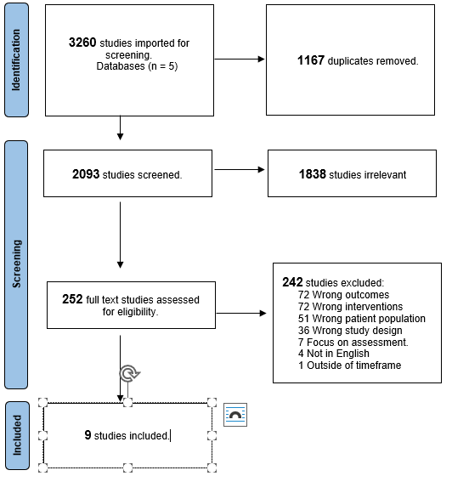
Source: Authors own work

