Appendix A. Included Empirical Studies

Panel A: Included Studies
No | Studies | Country | Sample Size
1 | Mathur & Dulla (2014) | India | 55
2 | Indahwati & Afiah (2014) | Indonesia | 60
3 | Adeboye (2016) | USA | 219
4 | Chauhan & Jaiswal (2016) | India | 324
5 | Alharbi (2017) | Saudi Arabia | 219
6 | Omotunde & Omotunde (2017) | Nigeria | 78
7 | Kishore & Sequeira (2016) | India | 959
8 | Alam et al. (2018) | Bangladesh | 201
9 | Ibrahim et al. (2018) | Malaysia | 382
10 | Alam & Uddin (2019) | Bangladesh | 235
11 | Uddin et al. (2019) | Bangladesh | 225
12 | Haleem (2020) | Sri Lanka | 354
13 | Kholid et al. (2020) | Indonesia | 148
14 | Jaradat et al. (2020) | Jordan | 412
15 | Queiroz et al. (2020) | Brazil | 184
16 | Matar et al. (2020) | Jordan | 153
17 | Handoko & Prianto (2020) | Indonesia | 105
18 | Zaini et al. (2020) | Jordan | 210
19 | Al-Okaily et al. (2020) | Jordan | 270
20 | Cokins et al. (2020) | Romania | 401
21 | Sanjeetha et al. (2020) | Sri Lanka | 469
22 | Najib et al. (2021) | Indonesia | 184
23 | Amron et al. (2021) | Malaysia | 351
24 | Zongjun (2021) | Malaysia | 220
25 | Chang et al. (2022) | Korea | 537
26 | Khan et al. (2022) | United Arab Emirates | 300
27 | Matar et al. (2022) – Study a | Jordan | 153
28 | Matar et al. (2022) – Study b | Jordan | 107
29 | Matar et al. (2022) – Study c | Jordan | 46
30 | Pieters et al. (2021) | Netherlands | 242
31 | Chitakala & Phirri (2022) | Zambia | 100
32 | Faizal et al. (2022) | Malaysia | 380
33 | Sobti (2019) | India | 640
34 | Queiroz & Wamba (2019) - Study a | India | 344
35 | Queiroz & Wamba (2019) - Study b | USA | 394
36 | Lutfi (2021) | Jordan | 117
37 | Rahi et al. (2019) | Pakistan | 398
38 | Nguyen et al. (2020) | Vietnam | 241
39 | Naheb et al. (2017) | Libya | 240
40 | Olaleye & Sanusi (2019) | Nigeria | 216
41 | Pourghanbari et al. (2022) | Iran | 200
42 | Sheel & Nath (2022) | India | 360
43 | Sheel & Nath (2020) | India | 363
44 | Jain et al. (2022) | India | 365
45 | Tang et al. (2021) | Malaysia | 383
46 | Cao et al. (2021) | UK | 269
47 | Andwika et al. (2020) | Indonesia | 37
Source(s): Authors’ own work

Panel B: Article Quartile Distribution
Quartile | No. of Articles | Percentage (%)
Q1 | 9 | 19
Q2 | 6 | 13
Q3 | 5 | 11
Q4 | 5 | 11
Not Indexed/Other | 22 | 46
Total | 47 | 100
Source(s): Authors’ own work

References
Adeboye, A. (2016), “Perceived use and acceptance of cloud Enterprise Resource Planning (ERP) implementation in the manufacturing Industries”, International Journal of Strategic Information Technology and Applications, Vol. 7 No. 3, pp. 24–40.
Alam, M.S., Uddin, K.M.K. and Uddin, M.A. (2018), “End users’ behavioral intention to use an Enterprise Resource Planning (ERP) system: An empirical explanation of the UTAUT model”, The Comilla University Journal of Business Studies, Vol. 5 No. 1, pp. 73–86.
Alam, M.S. and Uddin, M.A. (2019), “Adoption and Implementation of Enterprise Resource Planning (ERP): An Empirical Study”, Journal of Management and Research, Vol. 6 No. 1, pp. 1–33.
Alharbi, S. (2017), “An empirical investigation on the impact of trust mediated determinants and moderating factors on the adoption of cloud computing”, International Journal of Information Technology and Computer Science, Vol. 9 No. 11, pp. 12–22.
Andwika, V.R., Witjaksono, R.W. and Azizah, A.H. (2020), “Analysis of user acceptance of ERP system on after sales function using Unified Theory of Acceptance and Use of Technology (UTAUT) model”, International Journal of Advances in Data and Information Systems, Vol. 1 No. 1, pp. 26-33.
Chauhan, S. and Jaiswal, M. (2016). “Determinants of acceptance of ERP software training in business schools: Empirical investigation using UTAUT model”, International Journal of Management Education, Vol. 14 No. 3, pp. 248–262.
Haleem, A. (2020), “Owner manager’s acceptance of cloud accounting: An evaluation based on UTAUT Model”, Journal of Information Systems & Information Technology, Vol. 5 No. 1, pp. 75–88.
Handoko, B.L. and Prianto, J.A. (2020), “The influence of UTAUT on ERP systems in start-up business”, International Journal of Management, Vol. 11 No. 4, pp. 262–271.
Indahwati, R. and Afiah, N. N. (2014), “Predicting SME’s intention to adopt accounting software for financial reporting in Medan city, Indonesia”, Research Journal of Finance and Accounting, Vol. 5 No. 8, pp. 130-138.
Jaradat, M.I.R., Ababneh, H., Al Fagih, K., Jaradat, M.I.R.M, Ababneh, H. T., Faqih, K.M.S. and Nusairat, N. M. (2020), “Exploring cloud computing adoption in higher educational environment: An extension of the UTAUT model with trust”, International Journal of Advanced Science and Technology, Vol. 29 No. 5, pp. 8282–8306.
Kholid, M.N., Alvian, S. and Tumewang, Y.K. (2020), “Determinants of mobile accounting app adoption by Micro, Small, and Medium Enterprise in Indonesia”, Journal of Accounting and Strategic Finance, Vol. 3 No. 1, pp. 52–70.
Kishore, S.V.K. and Sequeira, A.H. (2016), “An empirical investigation on mobile banking service adoption in rural Karnataka”, SAGE Open, Vol. 6 No. 1, pp. 1–21.
Lutfi, A. (2021), “Understanding cloud based Enterprise Resource Planning adoption among SMEs in Jordan”, Journal of Theoretical and Applied Information Technology, Vol. 99 No. 24, pp. 5944-5953.
Matar, N., Almalahmeh, T., Sowan, B., Al-Jaghoub, S. and Mater, W. (2022), “A multi-group Structural Equation Modeling for assessing behavioral intention of using mobile cloud computing-The case of Jordanian universities during the covid19 Pandemic”, International Arab Journal of Information Technology, Vol. 19 No. 2, 203–213.
Mathur, S.K. and Dhulla, T.V. (2014), “Factors influencing professionals’ decision for cloud computing adoption”, International Journal of Research in Advent Technology, Vol. 2 No. 4, pp. 397-401.
Naheb, O.A., Sukoharsono, E.G. and Baridwan, Z. (2017), “The influence of critical factors on the behavior intention to Computerized Accounting Systems (CAS) in cement manufacturers in Libya”, The International Journal of Accounting and Business Society, Vol. 38 No. 1, pp. 38-60.
Nguyen, T. T., Nguyen, H. T., Mai, H. T. and Tran, T. T. M. (2020), “Determinants of digital banking services in Vietnam: Applying UTAUT2 model”, Asian Economic and Financial Review, Vol. 10 No. 6, pp. 680–697.
Olaleye, S.A. and Sanusi, I.T. (2019), “The need for green companies in Nigeria: A study of electronic invoicing”, The African Journal of Information Systems, Vol. 11 No. 1, pp. 1–25.
Pourghanbari, F., Yazdifar, H. and Faghani, M. (2022), “Investigating the factors affecting accountants’ behavioral intentions in Accounting Information System adoption: Empirical evidence of Unified Theory of Acceptance and Use of technology, and Task-Fit Model”, Iranian Journal of Accounting, Auditing and Finance, Vol. 6 No. 3, pp. 111–126.
Sanjeetha, M. B. F., Samsudeen, S. N., Kariapper, A. R., Buhary, M., Sanjeetha, F., Sabraz Nawaz, S. and Kariapper, R. (2020), “Small and Medium-Sized Entrepreneurs’ Behavioural Intention to Use Accounting Information Systems in Eastern Province of Sri Lanka”, Solid State Technology, Vol. 63 No. 6, pp. 17260–17272.
Sobti, N. (2019). “Impact of demonetization on diffusion of mobile payment service in India: Antecedents of behavioral intention and adoption using extended UTAUT model”, Journal of Advances in Management Research, Vol. 16 No. 4, pp. 472–497.
Tang, K. L., Aik, N. C. and Choong, W. L. (2021), “A modified utaut in the context of m-payment usage intention in Malaysia”, Journal of Applied Structural Equation Modeling, Vol. 5 No. 1, pp. 40–59.
Zaini, W. H. A. and Hamad, M. K. (2020). “Factors affecting the adoption of an accounting information system based on UTAUT2 and its implementation in a tourism corporation”, African Journal of Hospitality, Tourism and Leisure, Vol. 9 No. 1, pp. 1-14.
Zongjun, L. (2021), “Adoption of Alipay Mobile Payment in Kuala Lumpur, An Application of the UTAUT Model”, International Journal of Economics and Commerce Research (IJECR), Vol. 1 No. 1, pp. 1–17.

Appendix B. Forest Plot

Figure B1
Forest Plot of the Impact of PE on BIDAT
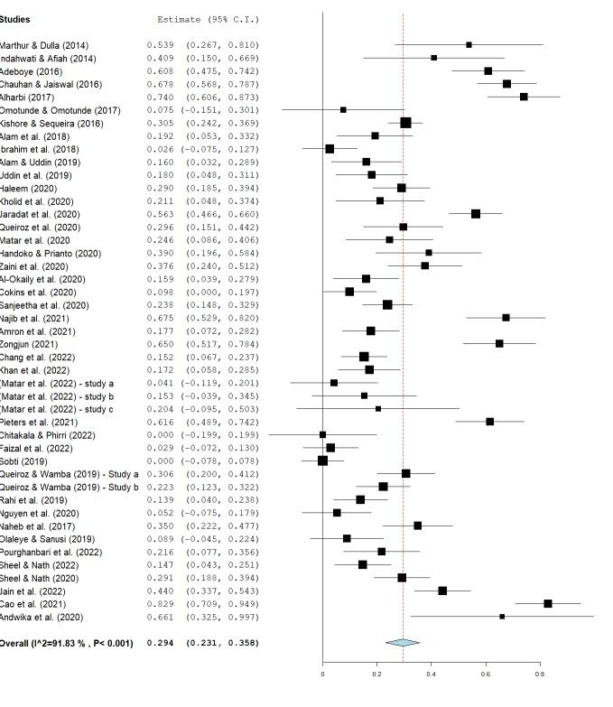
Source(s): Authors’ own work

Figure B2
Forest Plot of the Impact of EE on BIDAT
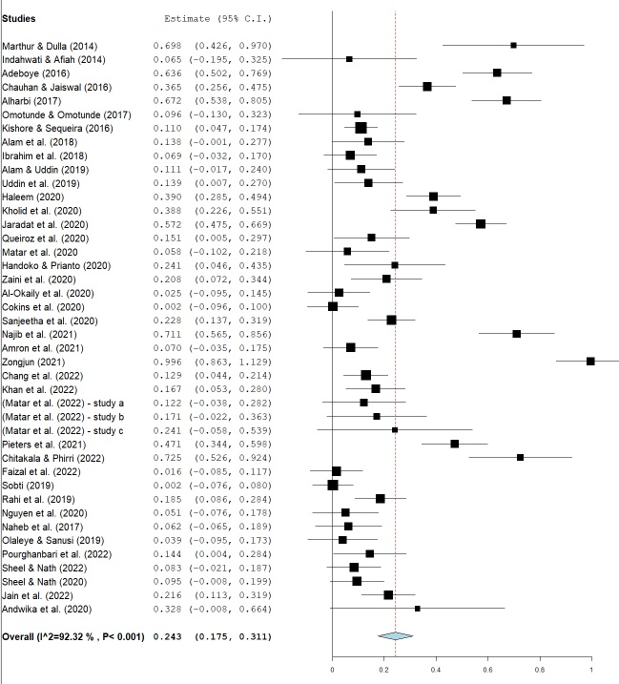
Source(s): Authors’ own work

Figure B3
Forest Plot of the Impact of SI on BIDAT
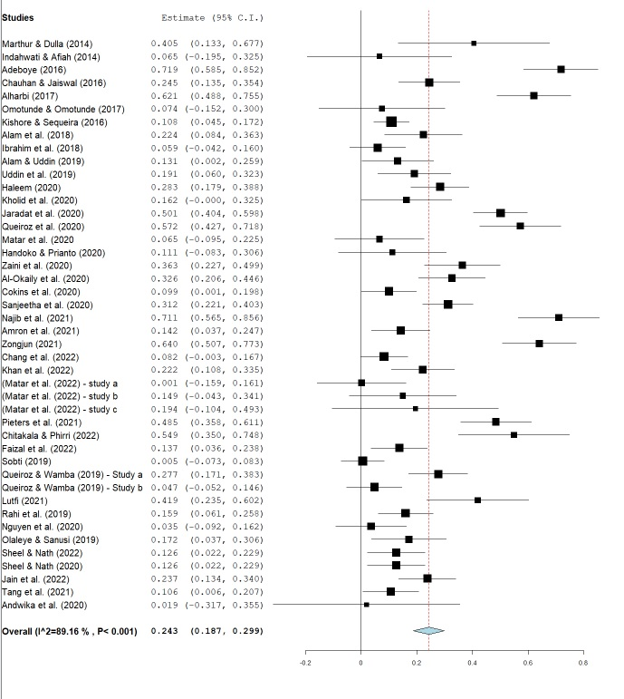
Source(s): Authors’ own work

Appendix C. Summary of Subgroups Analysis Results

Figure C1
Results of the Subgroups Analysis by Technology Type

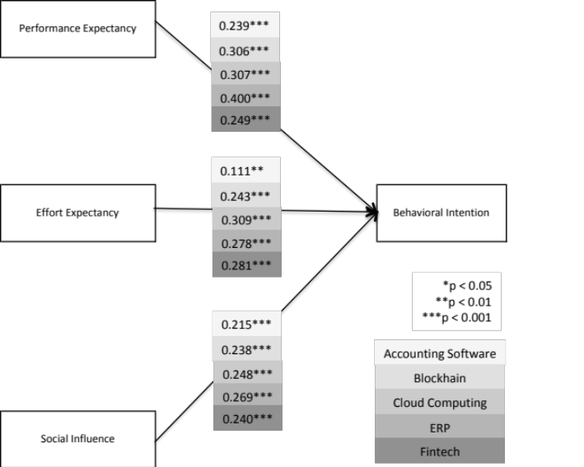

Source(s): Authors’ own work

Figure C2
Results of the Subgroups Analysis by the Economic Level

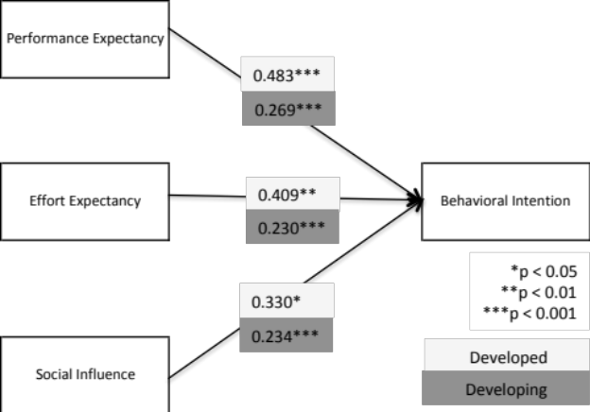

Source(s): Authors’ own work

