Appendix A
Figure A.1. Example of ESG in ASE
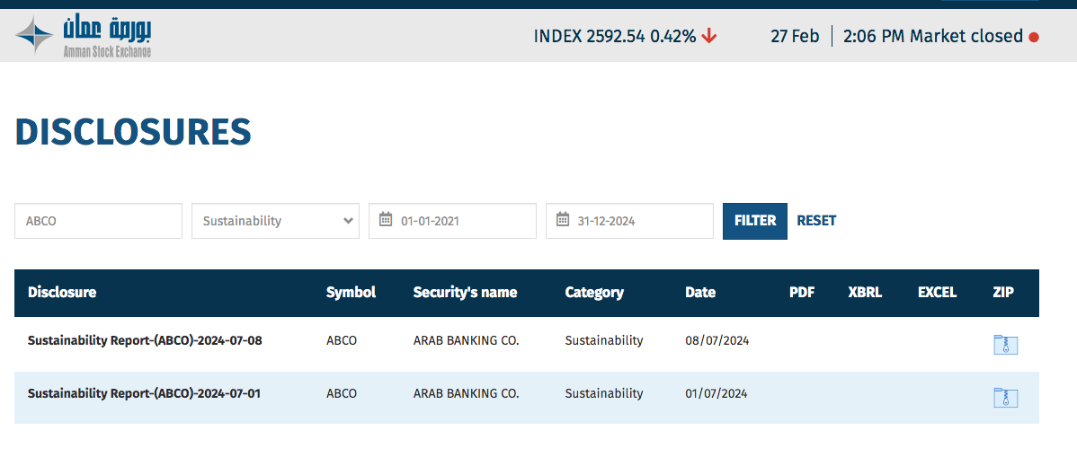

Source: ASE website - https://www.ase.com.jo/en/disclosures

Appendix B
Table B.1. Variables measurements
Variable | Measurement
SUS | An explanatory variable is the bank's ESG disclosure index (i) for the period (t). In this study, a qualitative scoring index assessed the bank's ESG procedures.
Period | A dummy variable with the code 1 represents the years that were changed by Covid-19 (2019–2020), and a code 0 represents the years before Covid-19 (2005–2018).
DA | Discretionary accruals using modified jones model.
SIZE | The fraction showing the natural logarithm of a business's total assets.
DEBIT | The sum of debt split by the sum of assets.
OPN | A dummy variable that has a value of 1 if the audit opinion is unqualified and 0 if none.
TEN | Auditors' terms of three years: 0 if the audit company did not change, 1 if it did.
BIG-4 | This setting is set to 1 if the audit firm is one of the "Big 4" It is set to 0 if it is not.
BLOCK_OWN | The amount (at least 5%) of ordinary stock that each individual block-holder owns.
FOR_OWN | The amount of a company's shares that are owned by individuals from foreigners.
Source: created by author

