Appendix A

Sample Size Determination with G*Power Analysis
To determine the appropriate sample size for the current study, a power analysis was conducted using G*Power (Version 3; Faul et al., 2007) based on the statistical tests corresponding to each hypothesis. The analysis aimed to ensure sufficient power to detect meaningful effects while minimizing Type I and Type II errors. The study involved two primary objectives and five hypotheses: the first three (H1-H3) examined regional differences in product purchase criteria (PPC) and perceived brand evaluation (PBE) across three Chinese cities (Beijing, Wuhan, and Harbin), while the latter two (H4-H5) tested whether these regional differences moderated the relationship between PPC and PBE for both Chinese and Western brands.
For Hypotheses 1 through 3, a one-way MANOVA was the planned analytical approach to test the variables PPC and PBE in general, and a one-way ANOVA was planned to test each attribute (i.e., quality, trust, reliability, image, and price). Firstly, the “MANOVA: Global effects” option was chosen in G*Power. Parameters for the power analysis were set as follows: number of groups = 3, number of response variables = 5, significance level (α) = .05, desired statistical power (1 − β) = .95, and a small-to-moderate multivariate effect size (f²(V) = 0.10). These parameters are commonly used in behavioral research to ensure adequate power for hypothesis testing. According to these specifications, the minimum required sample size was calculated to be 387 participants, or approximately 129 participants per group. Secondly, the “ANOVA: Fixed effects, omnibus, one-way” option was chosen in G*Power. The power analysis was conducted using the following parameters: a medium effect size (f = .25), significance level (α = .05), desired statistical power of .95, and three groups (corresponding to the three cities). The resulting estimated minimum total sample size was 252 participants, or approximately 84 participants per city. A more conservative estimate was chosen to ensure adequate power across all dependent variables.
For Hypotheses 4 and 5, which involved moderation analyses testing whether city-tier classification moderated the PPC-PBE relationship, the appropriate analysis was multiple linear regression including interaction terms. Sample size estimation was conducted using the “Linear multiple regression: Fixed model, R² increase” option in G*Power. Given that moderation effects are typically small, a conservative small effect size (f² = .02) was selected. The analysis included four predictors: two dummy-coded city-tier variables, the continuous PPC predictor, and the interaction term (PPC × city). Using α = .05 and power = .95, the minimum required total sample size was 776 participants.
Based on power analyses across all hypotheses, and to accommodate potential missing data and ensure sufficient statistical power, the final sample size for the study was set at 1,500 participants, well above the minimum thresholds required for all planned analyses. This sample was distributed across the three cities to ensure adequate representation of each regional group.

Appendix B

Surveys of Consumers’ Product Purchase Criteria (PPC) and Perceived Brand Evaluation (PBE) of Chinese and Western Brands
Product Purchase Criteria (PPC):
How important are the following aspects to you when you buy a branded product?
Please rate from 1 (highly unimportant) to 5 (highly important):
 | Highly Unimportant | Unimportant | Neutral | Important | Highly Important
Product Quality | 1 | 2 | 3 | 4 | 5
Brand Trust | 1 | 2 | 3 | 4 | 5
Brand Reliability | 1 | 2 | 3 | 4 | 5
Brand Image | 1 | 2 | 3 | 4 | 5
Product Price | 1 | 2 | 3 | 4 | 5

Perceived Brand Evaluation (PBE) of Chinese Brands:
How do you rate Chinese brands on the following aspects?
Please rate from 1 (very low) to 5 (very high):
 | Very Low | Low | Neutral | High | Very High
Product Quality | 1 | 2 | 3 | 4 | 5
Brand Trust | 1 | 2 | 3 | 4 | 5
Brand Reliability | 1 | 2 | 3 | 4 | 5
Brand Image | 1 | 2 | 3 | 4 | 5
Product Price | 1 | 2 | 3 | 4 | 5

Perceived Brand Evaluation (PBE) of Western Brands:
How do you rate Western brands on the following aspects?
Please rate from 1 (very low) to 5 (very high):
 | Very Low | Low | Neutral | High | Very High
Product Quality | 1 | 2 | 3 | 4 | 5
Brand Trust | 1 | 2 | 3 | 4 | 5
Brand Reliability | 1 | 2 | 3 | 4 | 5
Brand Image | 1 | 2 | 3 | 4 | 5
Product Price | 1 | 2 | 3 | 4 | 5

Appendix C

Mean, Standard Deviation, Pearson Correlations Between Chinese Consumers’ Product Purchase Criteria (PPC) and Perceived Brand Evaluation (PBE) of Chinese and Western Brands
 |  |  |  |  |  |  |  | - PPC |  |  |  |  |  | - PBE of Chinese Brands |  |  |  |  |  | - PBE of Western Brands
 | M | SD |  | Min |  | Max | 1.1 |  | 1.5 | 1.2 | 1.3 | 1.4 | 2.1 |  | 2.2 | 2.3 | 2.4 | 2.5 | 3.1 |  | 3.2 | 3.3 | 3.4 | 3.5
1.1 Quality | 4.23 | 4.68 |  | 1.00 |  | 5.00 | 1 |  | .74** | .72** | .67** | .62** | .59** |  | .55** | .52** | .53** | .52** | .57** |  | .49** | .46** | .49** | .35**
1.2 Trust | 3.87 | 3.48 |  | 1.00 |  | 5.00 |  |  | 1 | .65** | .66** | .47** | .62** |  | .56** | .53** | .55** | .57** | .55** |  | .48** | .45** | .48** | .34**
1.3 Reliability | 3.75 | 3.54 |  | 1.00 |  | 5.00 |  |  | . | 1 | .64** | .56** | .55** |  | .51** | .49** | .49** | .54** | .50** |  | .42** | .43** | .43** | .31**
1.4 Image | 3.79 | 3.64 |  | 1.00 |  | 5.00 |  |  |  |  | 1 | .58** | .55** |  | .54** | .51** | .54** | .52** | .46** |  | .42** | .38** | .47** | .30**
1.5 Price | 3.68 | 3.69 |  | 1.00 |  | 5.00 |  |  |  |  |  | 1 | .46** |  | .45** | .44** | .47** | .45** | .40** |  | .39** | .37** | .40** | .29**
2.1 Quality | 3.93 | 1.16 |  | 1.00 |  | 5.00 |  |  |  |  |  |  | 1 |  | .82** | .78** | .76** | .72** | .48** |  | .42** | .42** | .42** | .31**
2.2 Trust | 3.81 | 1.19 |  | 1.00 |  | 5.00 |  |  |  |  |  |  |  |  | 1 | .83** | .82** | .70** | .45** |  | .38** | .40** | .40** | .29**
2.3 Reliability | 3.75 | 1.20 |  | 1.00 |  | 5.00 |  |  |  |  |  |  |  |  |  | 1 | .83** | .69** | .44** |  | .38** | .40** | .41** | .31**
2.4 Image | 3.79 | 1.18 |  | 1.00 |  | 5.00 |  |  |  |  |  |  |  |  |  |  | 1 | .68** | .43** |  | .37** | .40** | .40** | .32**
2.5 Price | 3.87 | 1.22 |  | 1.00 |  | 5.00 |  |  |  |  |  |  |  |  |  |  |  | 1 | .46** |  | .42** | .41** | .43** | .27**
3.1 Quality | 3.71 | 1.14 |  | 1.00 |  | 5.00 |  |  |  |  |  |  |  |  |  |  |  |  | 1 |  | .69** | .70** | .70** | .55**
3.2 Trust | 3.58 | 1.32 |  | 1.00 |  | 5.00 |  |  |  |  |  |  |  |  |  |  |  |  |  |  | 1 | .77** | .79** | .60**
3.3 Reliability | 3.54 | 1.17 |  | 1.00 |  | 5.00 |  |  |  |  |  |  |  |  |  |  |  |  |  |  |  | 1 | .77** | .59**
3.4 Image | 3.64 | 1.18 |  | 1.00 |  | 5.00 |  |  |  |  |  |  |  |  |  |  |  |  |  |  |  |  | 1 | .55**
3.5 Price | 3.48 | 1.32 |  | 1.00 |  | 5.00 |  |  |  |  |  |  |  |  |  |  |  |  |  |  |  |  |  | 1
Note. N = 1585; Scale: 1-5; PPC = Product Purchase Criteria; PBE = Perceived Brand Evaluation; ** = Correlation is significant at the 0.01 level (2-tailed); M = Mean; SD = standard deviation.

Appendix D

Multiple Comparisons Between the Attributes of Chinese Consumers’ Product Purchase Criteria (PPC)
 |  | Mean | SD | Post Hoc Test | Profile Plots  (1. Beijing, 2. Wuhan, 3. Harbin)
Quality | Beijing | 4.68 | .78 | Beijing > Wuhan >** Harbin  Beijing >** Harbin | 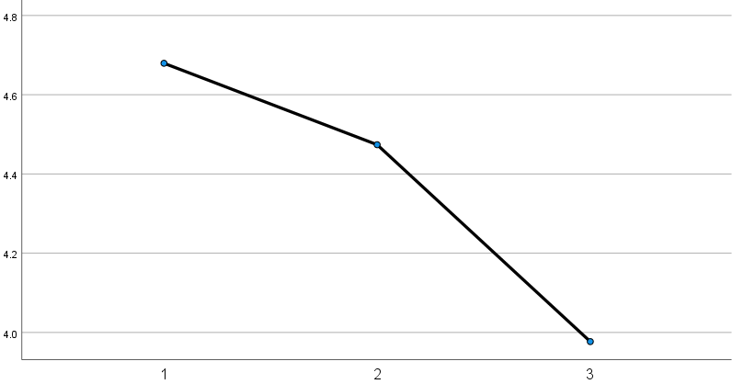
Quality | Wuhan | 4.47 | 1.11 | Beijing > Wuhan >** Harbin  Beijing >** Harbin
Quality | Harbin | 3.98 | 1.38 | Beijing > Wuhan >** Harbin  Beijing >** Harbin
Trust | Beijing | 4.19 | .99 | Harbin > Beijing > Wuhan | 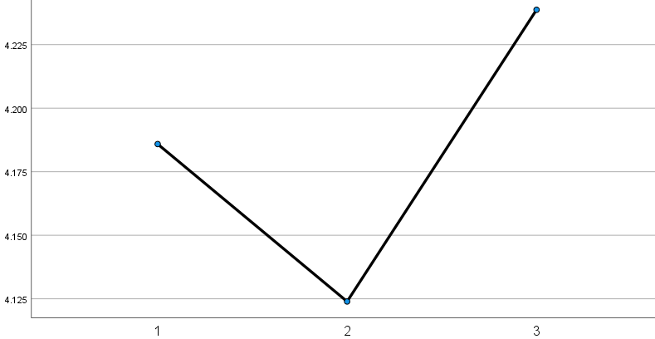
Trust | Wuhan | 4.12 | 1.16 | Harbin > Beijing > Wuhan
Trust | Harbin | 4.24 | 1.36 | Harbin > Beijing > Wuhan
Reliability | Beijing | 4.64 | .75 | Beijing > Wuhan >** Harbin  Beijing > ** Harbin | 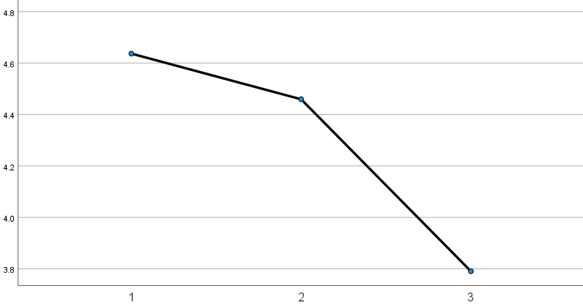
Reliability | Wuhan | 4.46 | 1.11 | Beijing > Wuhan >** Harbin  Beijing > ** Harbin
Reliability | Harbin | 3.79 | 1.35 | Beijing > Wuhan >** Harbin  Beijing > ** Harbin
Image | Beijing | 4.00 | 1.08 | Wuhan > Beijing >* Harbin  Wuhan >* Harbin | 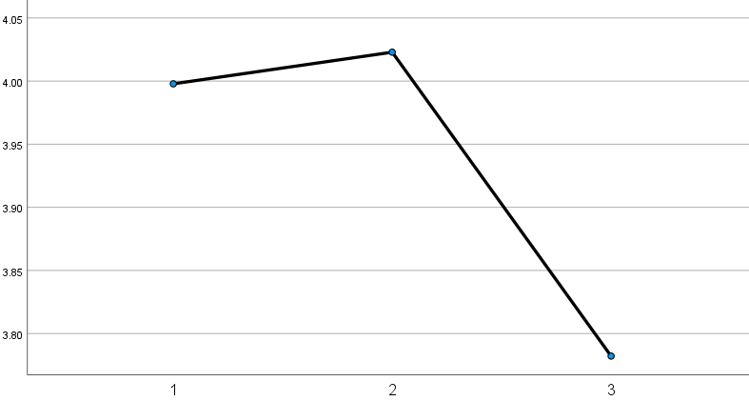
Image | Wuhan | 4.02 | 1.15 | Wuhan > Beijing >* Harbin  Wuhan >* Harbin
Image | Harbin | 3.78 | 1.36 | Wuhan > Beijing >* Harbin  Wuhan >* Harbin
Price | Beijing | 3.99 | .97 | Wuhan > Beijing >** Harbin  Wuhan >** Harbin | 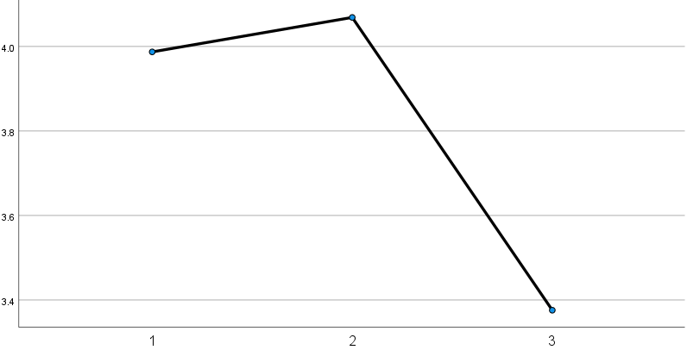
Price | Wuhan | 4.07 | 1.17 | Wuhan > Beijing >** Harbin  Wuhan >** Harbin
Price | Harbin | 3.38 | 1.38 | Wuhan > Beijing >** Harbin  Wuhan >** Harbin
Note. * = p < .05; ** = p < .001.

Appendix E

Multiple Comparisons Between the Attributes of Consumers’ Perceived Brand Evaluation (PBE) of Chinese Brands
 |  | Mean | SD | Post Hoc Test | Profile Plots  (1. Beijing, 2. Wuhan, 3. Harbin)
Quality | Beijing | 3.66 | .08 | Wuhan >* Harbin > Beijing  Wuhan >* Beijing | 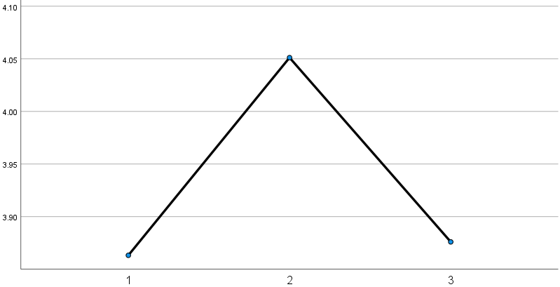
Quality | Wuhan | 4.05 | .05 | Wuhan >* Harbin > Beijing  Wuhan >* Beijing
Quality | Harbin | 3.88 | .04 | Wuhan >* Harbin > Beijing  Wuhan >* Beijing
Trust | Beijing | 3.66 | .08 | Wuhan > Harbin > Beijing  Wuhan >* Beijing | 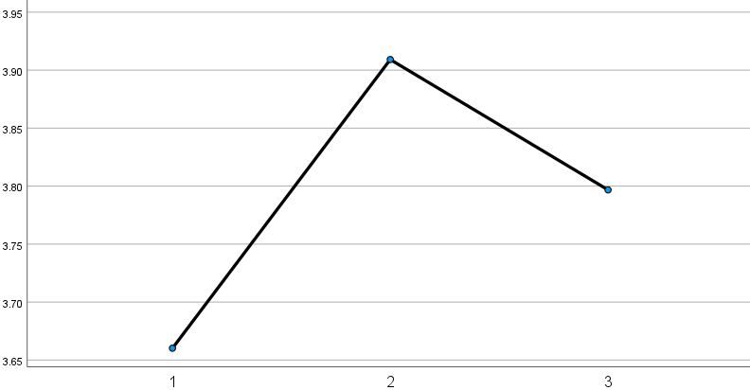
Trust | Wuhan | 3.91 | .05 | Wuhan > Harbin > Beijing  Wuhan >* Beijing
Trust | Harbin | 3.80 | .04 | Wuhan > Harbin > Beijing  Wuhan >* Beijing
Reliability | Beijing | 3.58 | .08 | Wuhan >* Harbin > Beijing  Wuhan >* Beijing | 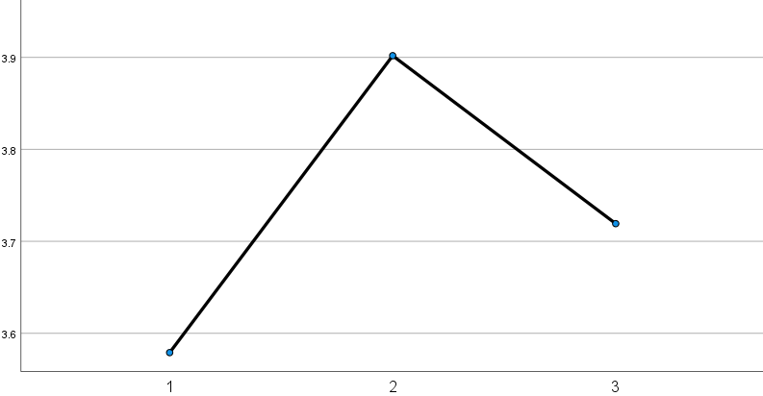
Reliability | Wuhan | 3.90 | .06 | Wuhan >* Harbin > Beijing  Wuhan >* Beijing
Reliability | Harbin | 3.72 | .04 | Wuhan >* Harbin > Beijing  Wuhan >* Beijing
Image | Beijing | 3.59 | .08 | Wuhan >* Harbin > Beijing  Wuhan >** Beijing | 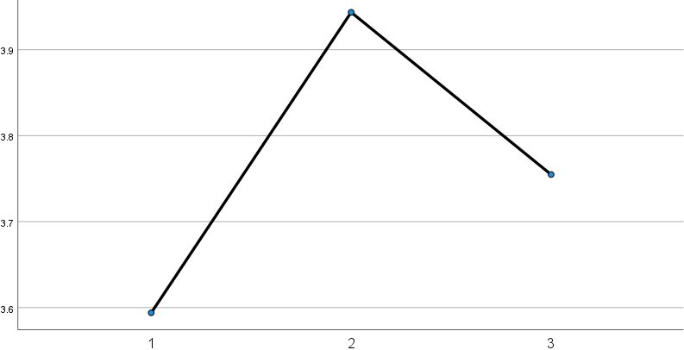
Image | Wuhan | 3.94 | .05 | Wuhan >* Harbin > Beijing  Wuhan >** Beijing
Image | Harbin | 3.75 | .04 | Wuhan >* Harbin > Beijing  Wuhan >** Beijing
Price | Beijing | 3.94 | .08 | Beijing > Wuhan > Harbin  Beijing > Harbin | 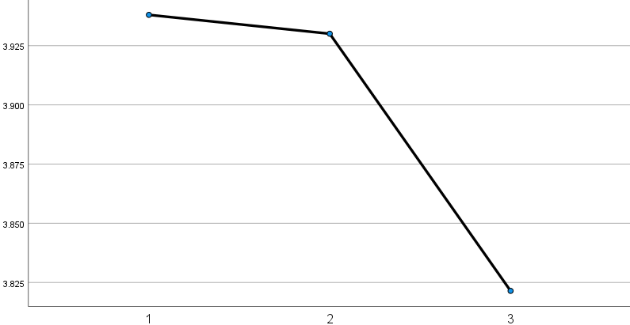
Price | Wuhan | 3.93 | .06 | Beijing > Wuhan > Harbin  Beijing > Harbin
Price | Harbin | 3.82 | .04 | Beijing > Wuhan > Harbin  Beijing > Harbin
Note. SD = standard deviation; * = p < .05; ** = p < .001.

Appendix F

Multiple Comparisons Between the Attributes of Consumers’ Perceived Brand Evaluation (PBE) of Western Brands
 |  | Mean | SD | Post Hoc Test | Profile Plots  (1. Beijing, 2. Wuhan, 3. Harbin)
Quality | Beijing | 3.98 | .07 | Beijing >* Wuhan > Harbin  Beijing >** Harbin | 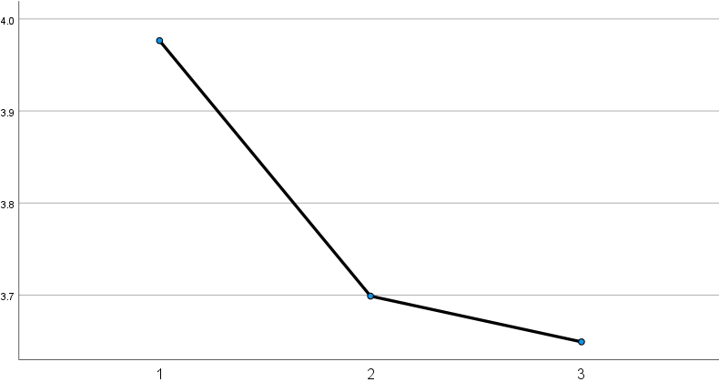
Quality | Wuhan | 3.70 | .05 | Beijing >* Wuhan > Harbin  Beijing >** Harbin
Quality | Harbin | 3.65 | .04 | Beijing >* Wuhan > Harbin  Beijing >** Harbin
Trust | Beijing | 3.78 | .08 | Beijing >* Wuhan > Harbin  Beijing >* Harbin | 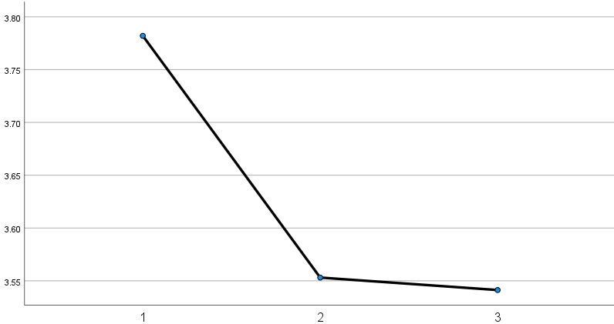
Trust | Wuhan | 3.55 | .05 | Beijing >* Wuhan > Harbin  Beijing >* Harbin
Trust | Harbin | 3.54 | .04 | Beijing >* Wuhan > Harbin  Beijing >* Harbin
Reliability | Beijing | 4.00 | .07 | Beijing >* Wuhan > Harbin  Beijing >** Harbin | 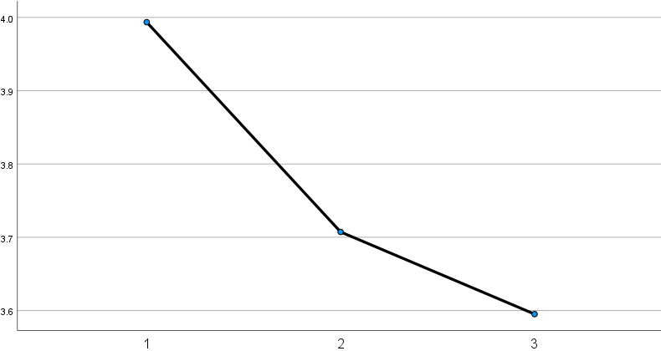
Reliability | Wuhan | 3.71 | .05 | Beijing >* Wuhan > Harbin  Beijing >** Harbin
Reliability | Harbin | 3.60 | .04 | Beijing >* Wuhan > Harbin  Beijing >** Harbin
Image | Beijing | 3.86 | .08 | Beijing >* Harbin > Wuhan  Beijing >* Wuhan | 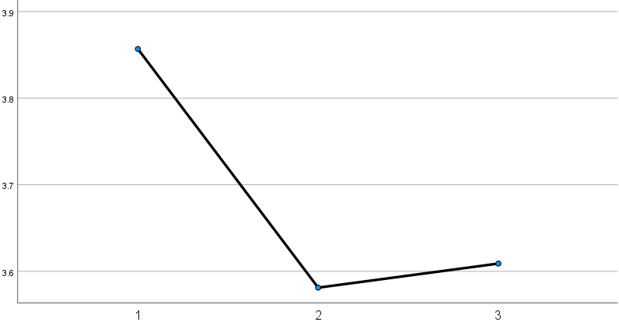
Image | Wuhan | 3.58 | .05 | Beijing >* Harbin > Wuhan  Beijing >* Wuhan
Image | Harbin | 3.61 | .04 | Beijing >* Harbin > Wuhan  Beijing >* Wuhan
Price | Beijing | 3.57 | .09 | Beijing > Wuhan > Harbin  Beijing > Harbin | 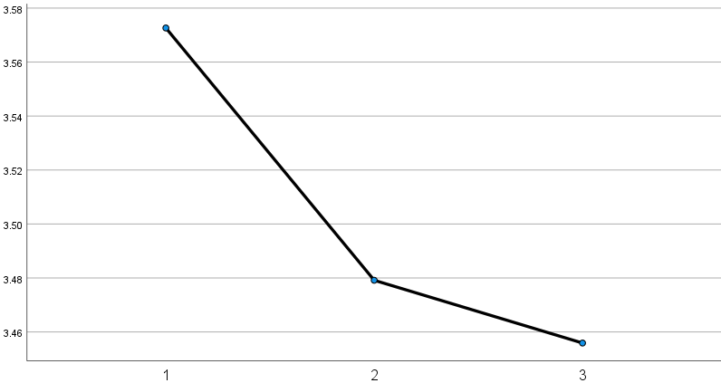
Price | Wuhan | 3.48 | .06 | Beijing > Wuhan > Harbin  Beijing > Harbin
Price | Harbin | 3.46 | .05 | Beijing > Wuhan > Harbin  Beijing > Harbin
Note. SD = standard deviation; * = p < .05; ** = p < .001.

Appendix G

Simple Slope Analysis of the Three Cities’ Moderating Effects on the Relationship Between Chinese Consumers’ Product Purchase Criteria (PPC) and Perceived Brand Evaluation (PBE) of Chinese Brands.
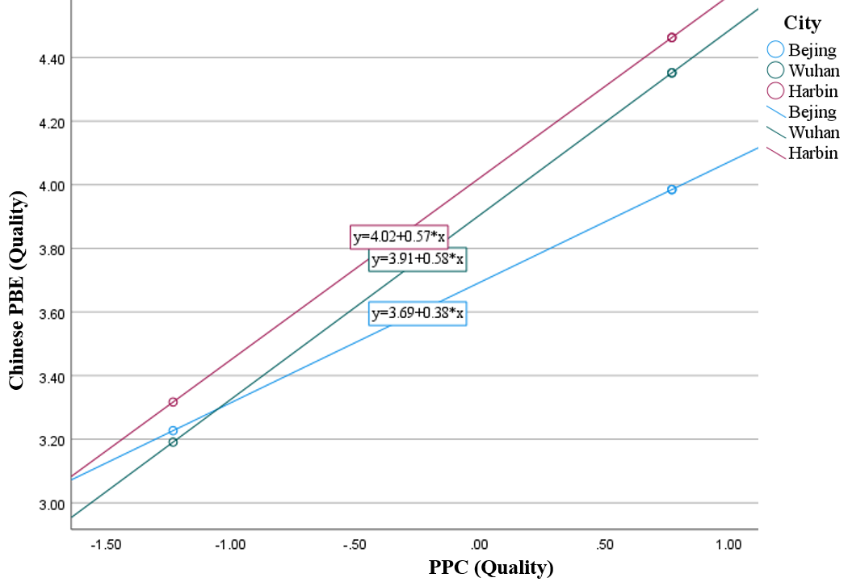
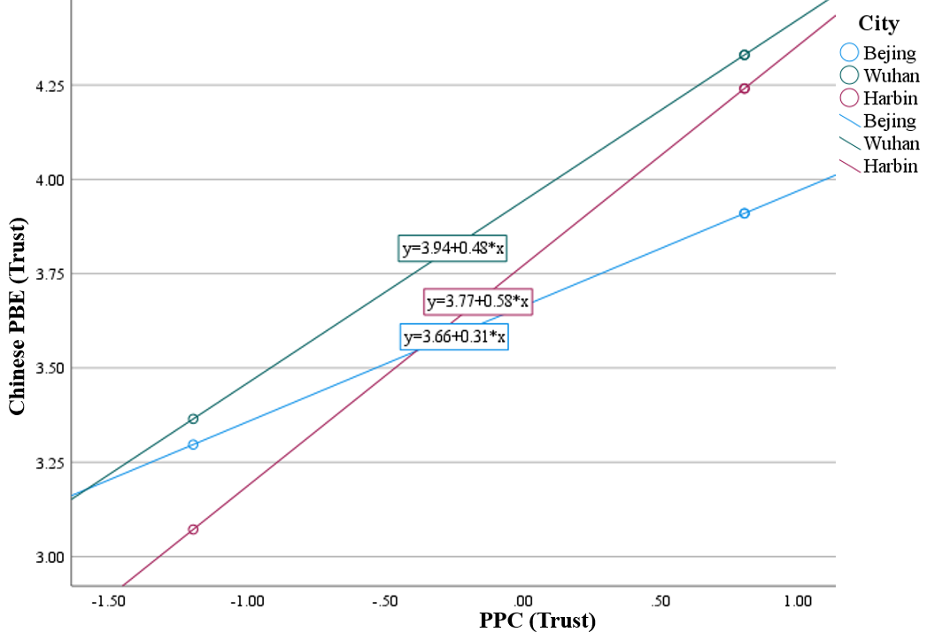
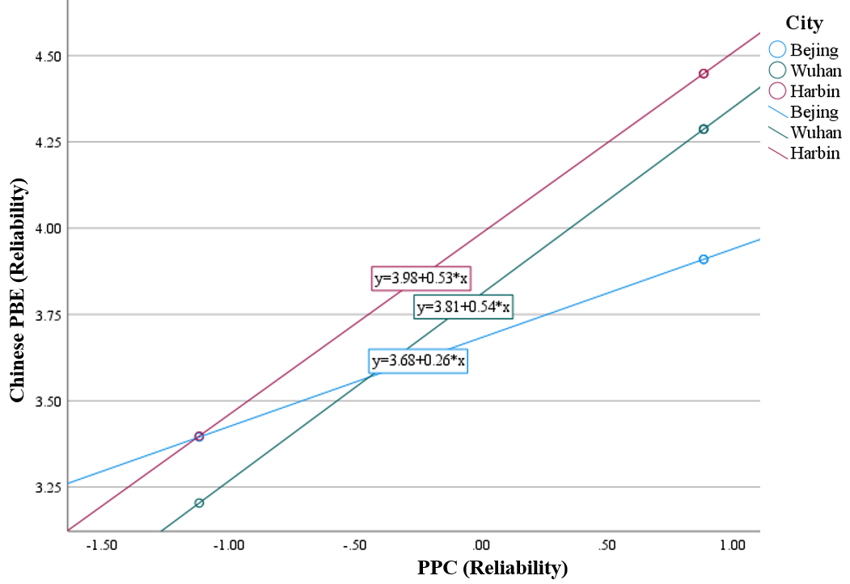
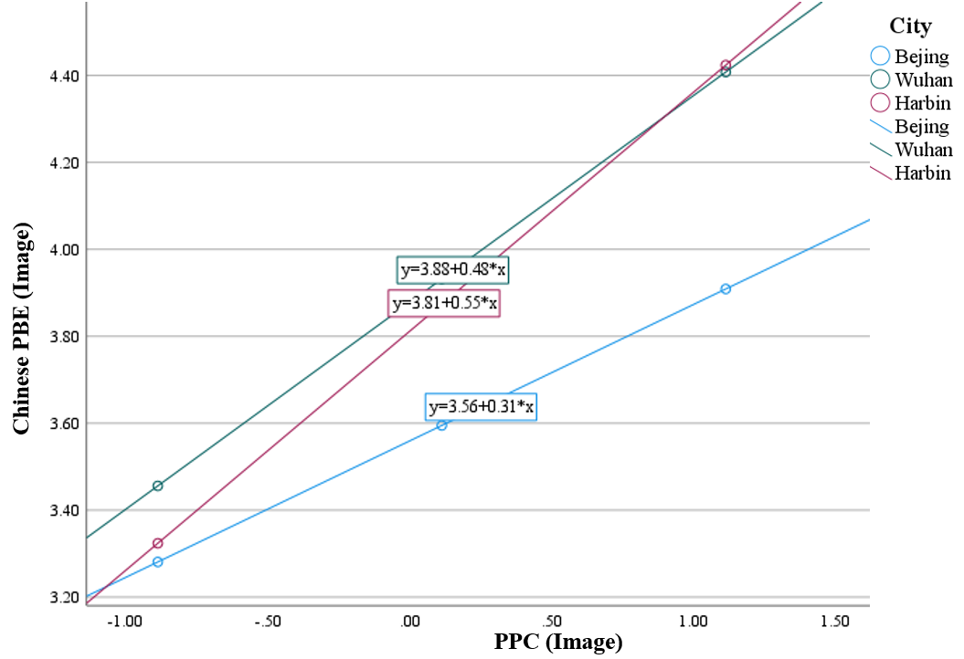
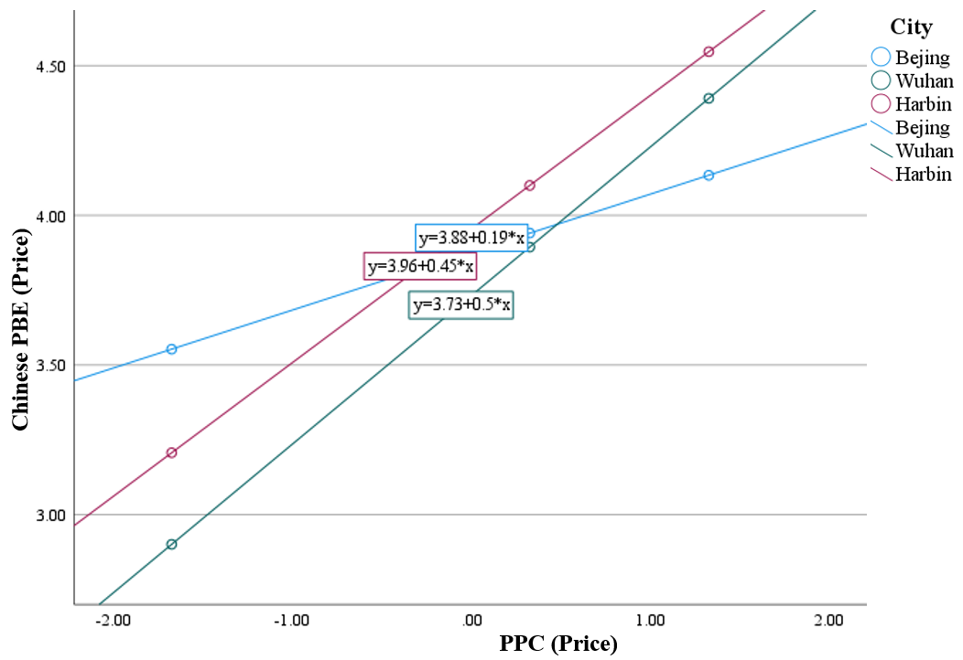

Appendix H

Simple Slope Analysis of the Three Cities’ Moderating Effects on the Relationship Between Chinese Consumers’ Product Purchase Criteria (PPC) and Perceived Brand Evaluation (PBE) of Western Brands.
