Supplementary materials

Appendix

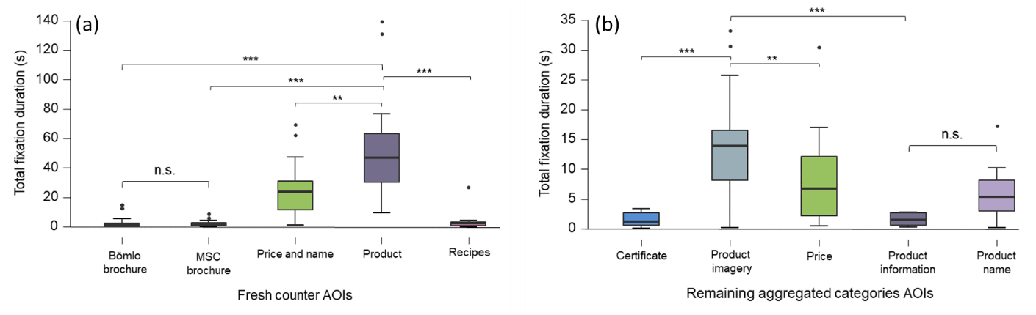
Figure S1: Box plots showing total fixation duration on AOIs at the fresh counter (a) and remaining aggregated categories (refrigerated, frozen, and canned) (b). Medians are marked with a line and outliers with a solid dot, significant differences are indicated with asterisks (*p<.05, **p<.01, ***p<.001). (Source: Authors work)

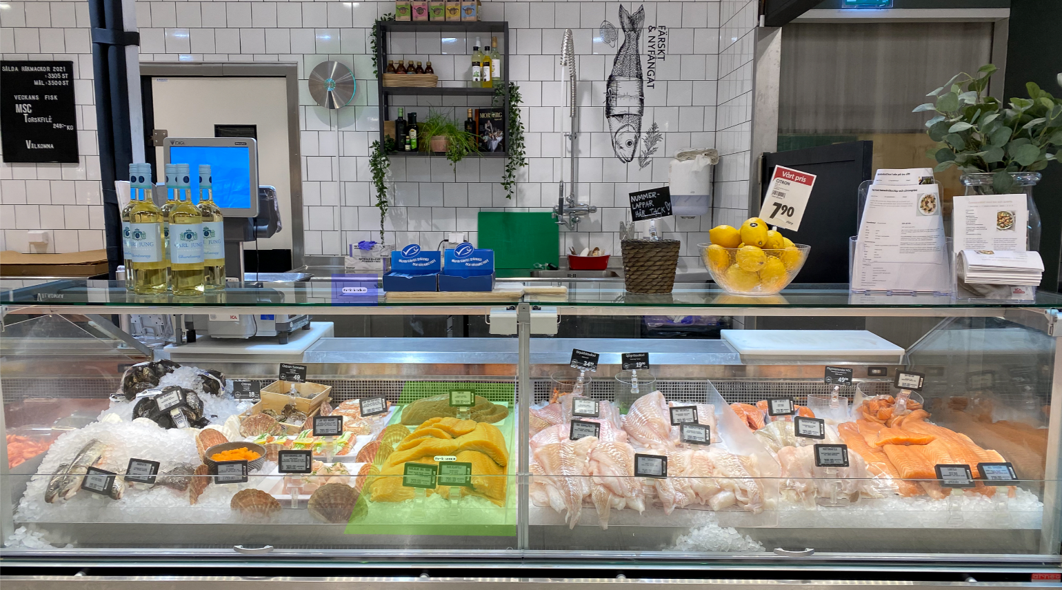
Figure S2. Section of the fresh seafood counter, displaying a variety of fish and shellfish. Highlighted in green is Bömlo salmon, and in purple the accompanying brochure. An alternative to this salmon is placed at some distance from Bömlo (to the right). (Source: Authors work)

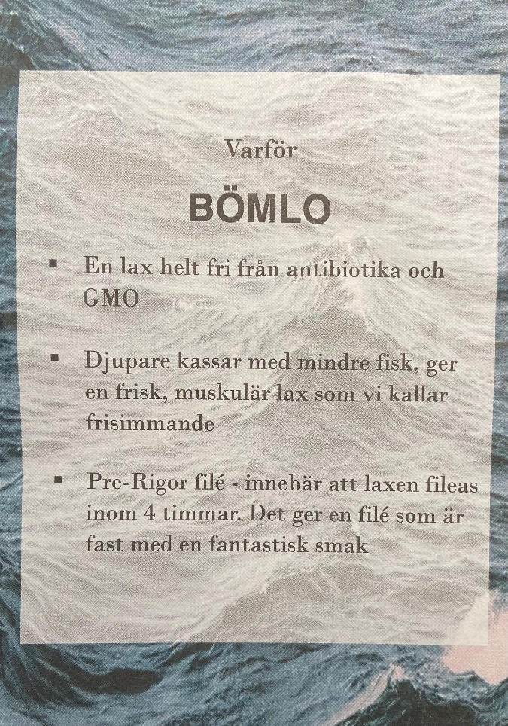
Figure S3. Brochure displayed at the fresh counter explaining the selling points of Bömlo salmon (Source: Authors work)

