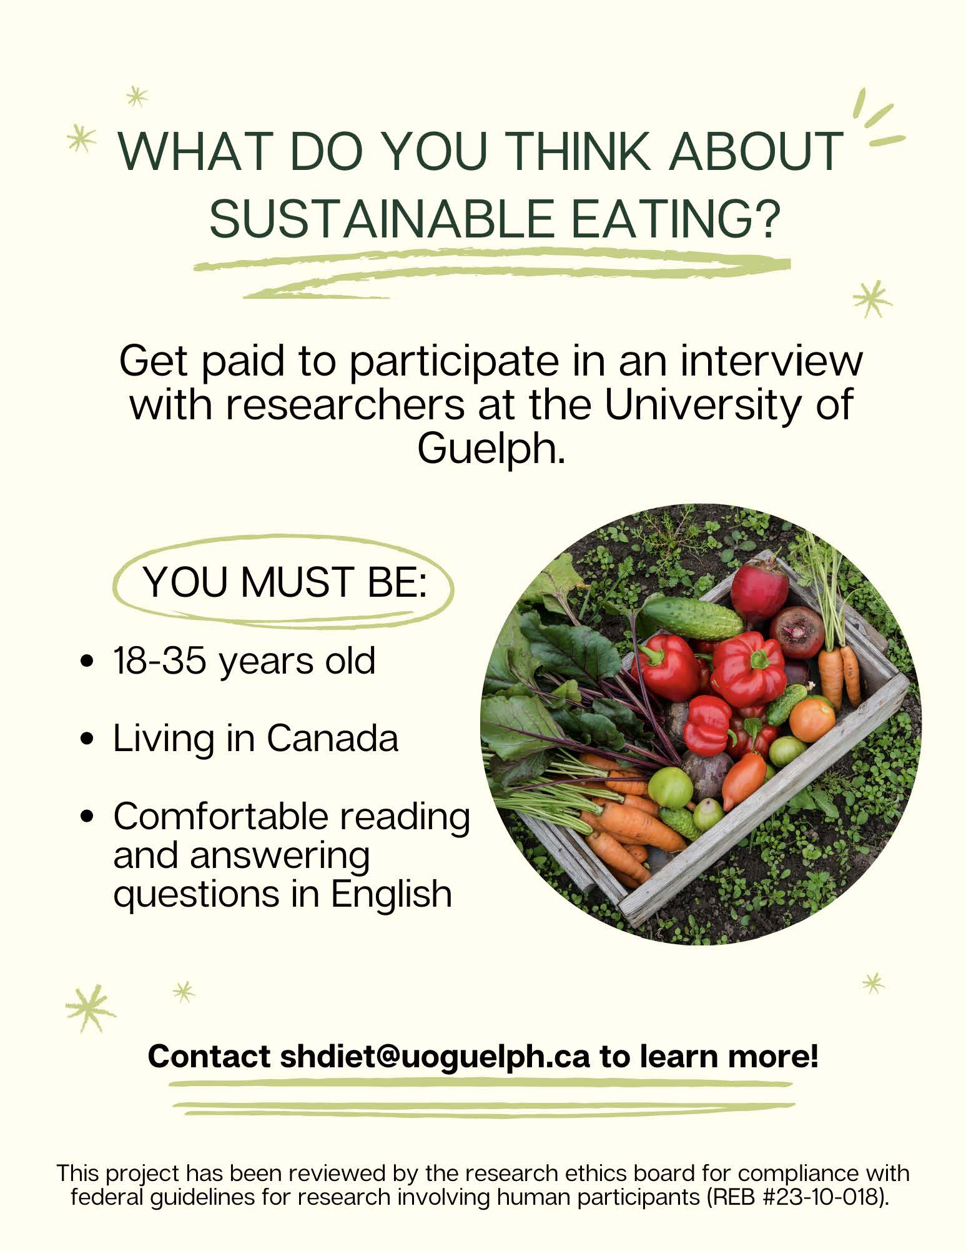

Supplementary File 1: Recruitment advertisement for this study exploring sustainable diet perceptions among Canadian young adults. Source: Authors own work

