Appendix A. Experimental stimuli (Study 1)
Note: Color should be used for all of the figures below in printing
Hedonic food product (Chocolate brownie)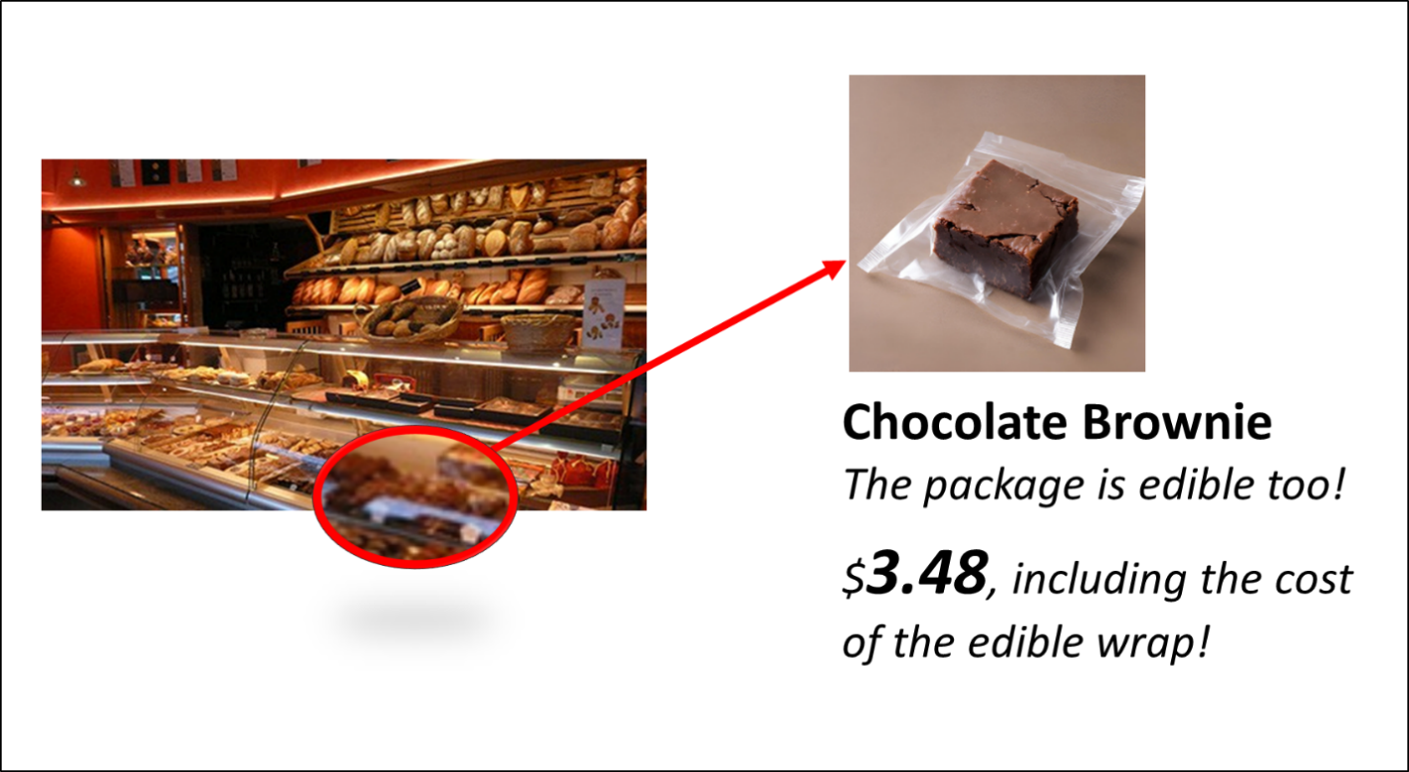

Utilitarian food product (Whole grain granola)
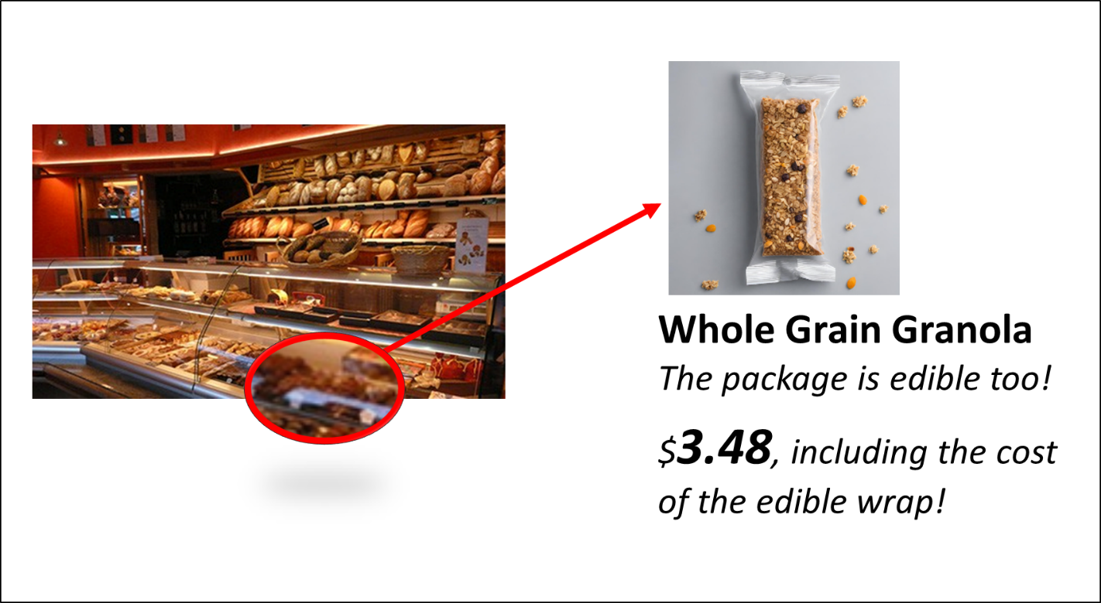
Source: Authors’ own work

Appendix B
Variable | Items | Reference
Manipulation Check (Hedonic) | Based on the message you just reviewed, please indicate your thoughts about the chocolate brownie/whole grain granola bar: | Weisstein et al., 2023; Choi et al., 2020.
Manipulation Check (Hedonic) | Not at all tasty (1)/Very tasty (7) | Weisstein et al., 2023; Choi et al., 2020.
Manipulation Check (Hedonic) | Not at all looking good in appearance (1)/Looking very good in appearance (7) | Weisstein et al., 2023; Choi et al., 2020.
Manipulation Check (Hedonic) | Not at all satisfying (1)/Very satisfying (7) | Weisstein et al., 2023; Choi et al., 2020.
Manipulation Check (Hedonic) | Not at all hedonic (1)/Very much hedonic (7) | Weisstein et al., 2023; Choi et al., 2020.
Manipulation Check (Utilitarian) | Based on the message you just reviewed, please indicate your thoughts about the chocolate brownie/whole grain granola bar: | Weisstein et al., 2023; Choi et al., 2020.
Manipulation Check (Utilitarian) | Not at all healthy (1)/Very healthy (7) | Weisstein et al., 2023; Choi et al., 2020.
Manipulation Check (Utilitarian) | Not at all giving energy (1)/Giving a lot of energy (7) | Weisstein et al., 2023; Choi et al., 2020.
Manipulation Check (Utilitarian) | Not at all improves performance (1)/Very much improves performance (7) | Weisstein et al., 2023; Choi et al., 2020.
Manipulation Check (Utilitarian) | Not at all utilitarian (1)/Very much utilitarian (7)
Realism Check | The advertisement message is realistic. | Zhang and Jeong (2023)
Realism Check | I can imagine myself in this scenario. | Zhang and Jeong (2023)
Perceived Green Value | Edible food packaging provides very good value for me. | Chen (2013)
Perceived Green Value | Edible food packages’ environmental performance meets my expectations. | Chen (2013)
Perceived Green Value | I would purchase this snack with edible food packaging because it has more environmental concern than other products. | Chen (2013)
Attractiveness of the Edible Food Package | To me, I think the edible food packaging shown in the message is: | Choi et al., 2019
Attractiveness of the Edible Food Package | Very unattractive (1)/Very attractive (7) | Choi et al., 2019
Attractiveness of the Edible Food Package | Very expensive (1)/Very inexpensive (7) | Choi et al., 2019
Attractiveness of the Edible Food Package | Not a good deal (1)/A great deal (7) | Choi et al., 2019
Purchase Intentions | I would buy the snack wrapped in the edible package. | Shen et al. (2022)
Purchase Intentions | I would desire to purchase the snack in the edible package. | Shen et al. (2022)
Purchase Intentions | I would plan to purchase the snack in the edible package. | Shen et al. (2022)
Source: Authors’ own work
Appendix C. Experimental stimuli (Study 2)
Hedonic food product (Chocolate brownie) + Combined price (control)

Utilitarian food product (Whole grain granola) + Combined price (control)

Hedonic food product (Chocolate brownie) + Partitioned price
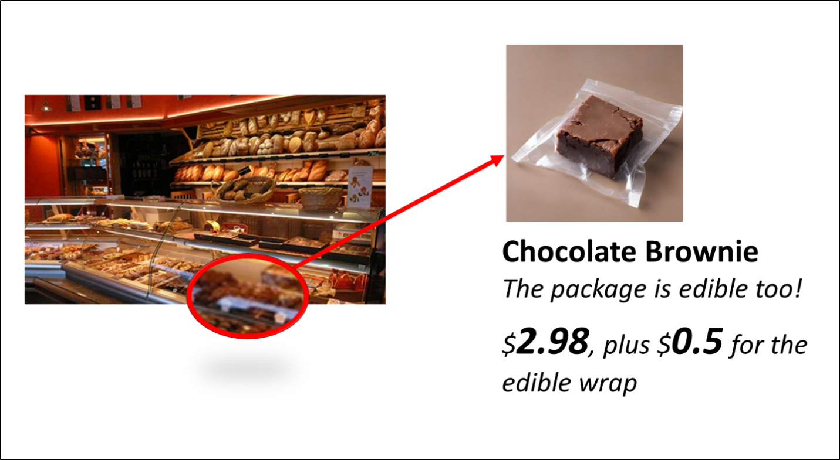

Utilitarian food product (Whole grain granola) + Partitioned price
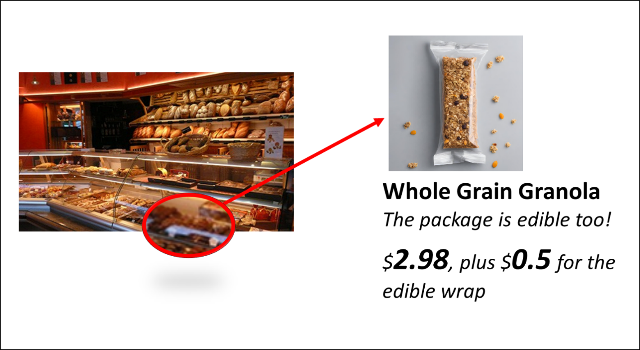
Source: Authors’ own work

