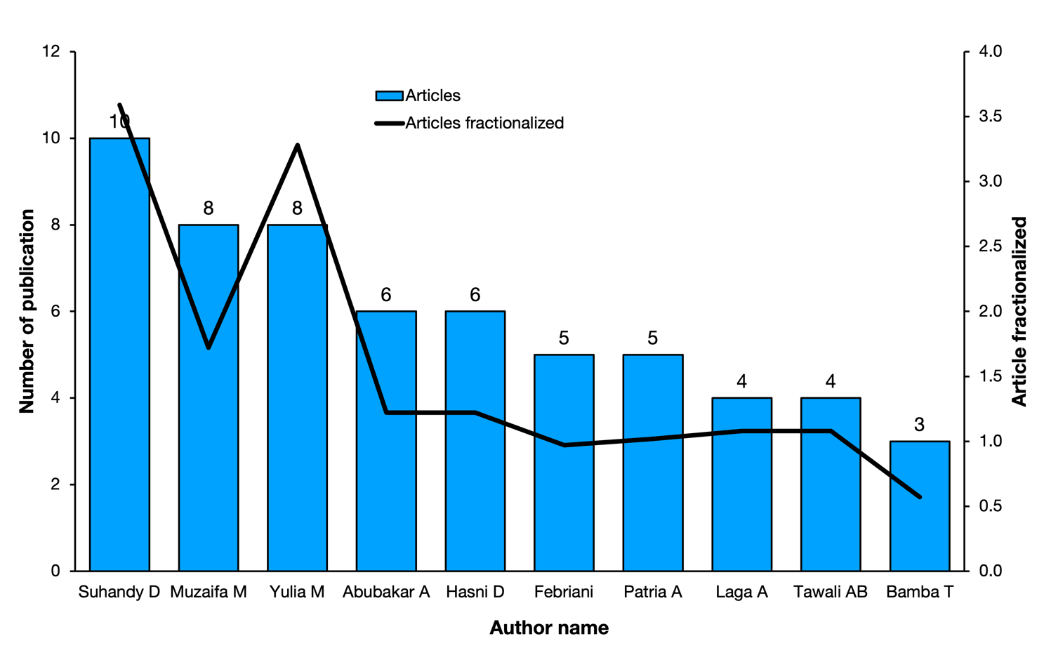
Figure S1. The top 10 authors in civet coffee studies based on their publication output from 2004 to 2025, as indexed in Scopus. The blue bars represent the number of publications, while the black line indicates article fractionalisation, a measure of collaborative activity. Analysis was conducted using the Bibliometrix software. This visualisation provides insights into the productivity and collaboration patterns of leading researchers in this field. (Source: Authors work)

