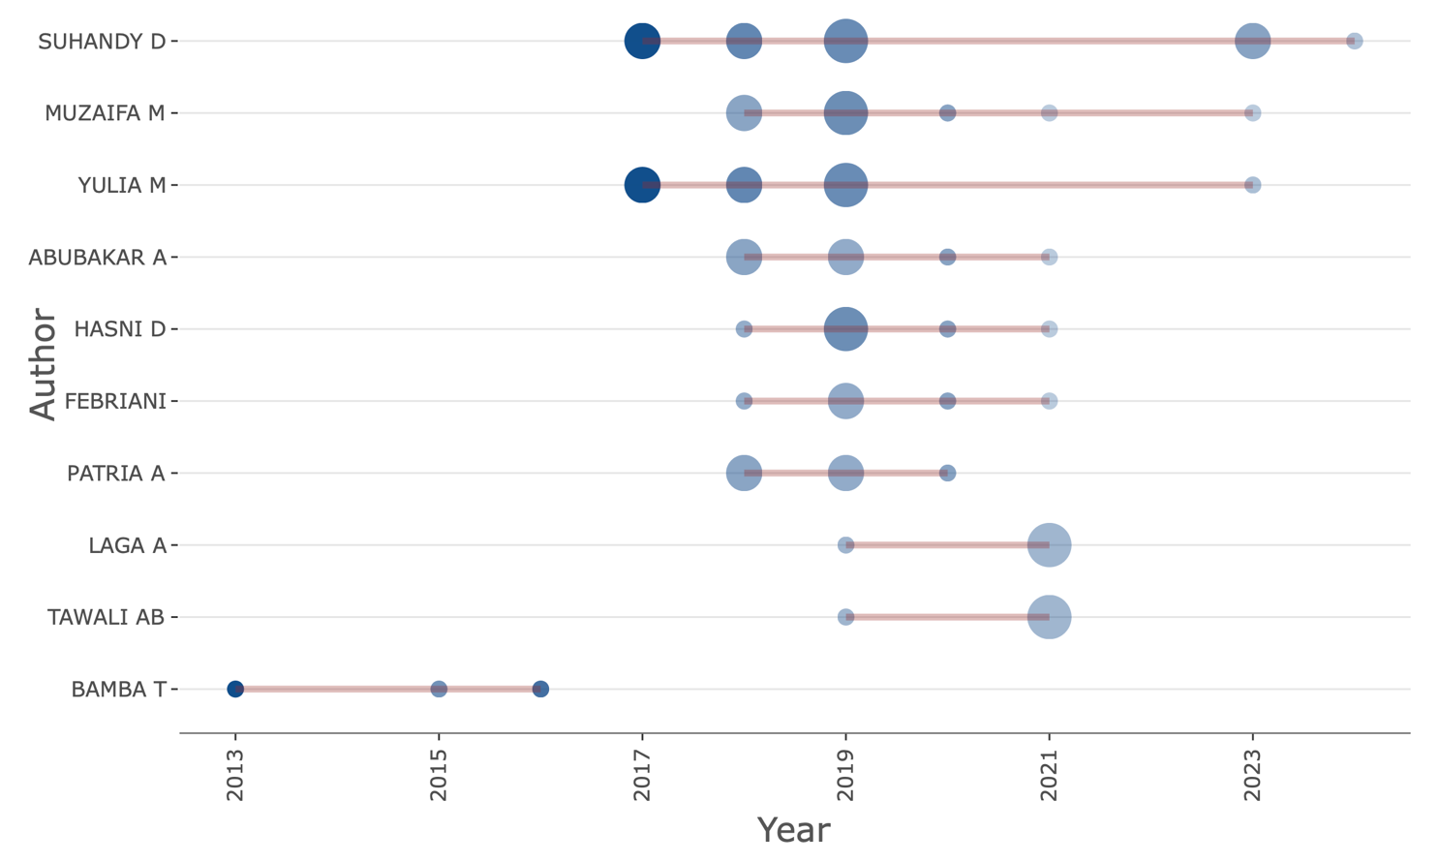
Figure S2. This figure analyses the publication output and citation impact of the top ten key authors over time, illustrating trends in research productivity and the dynamics of civet coffee studies, as visualised through bibliometrics. The total number of publications is represented by the size of the circles, with larger circles indicating higher publication volumes. The color intensity of the circles reflects citations per year, with deeper blue hues signifying a higher concentration of citations. (Source: Authors work)

