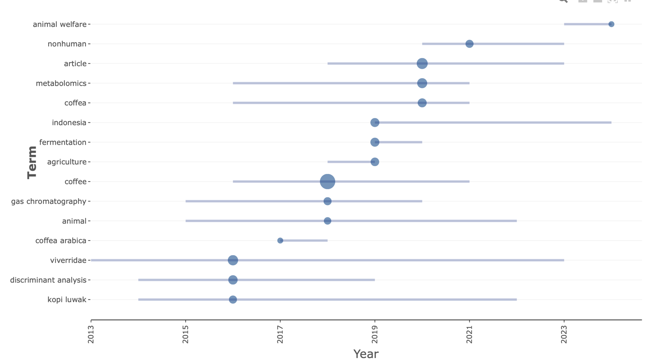
Figure S4. Trend topics in civet coffee studies (2004–2025) based on Keyword Plus analysis of Scopus database publications. (Source: Authors work)

