Supplementary Material
Appendix 1: Overview of the online questionnaire including distribution of nudge subsamples
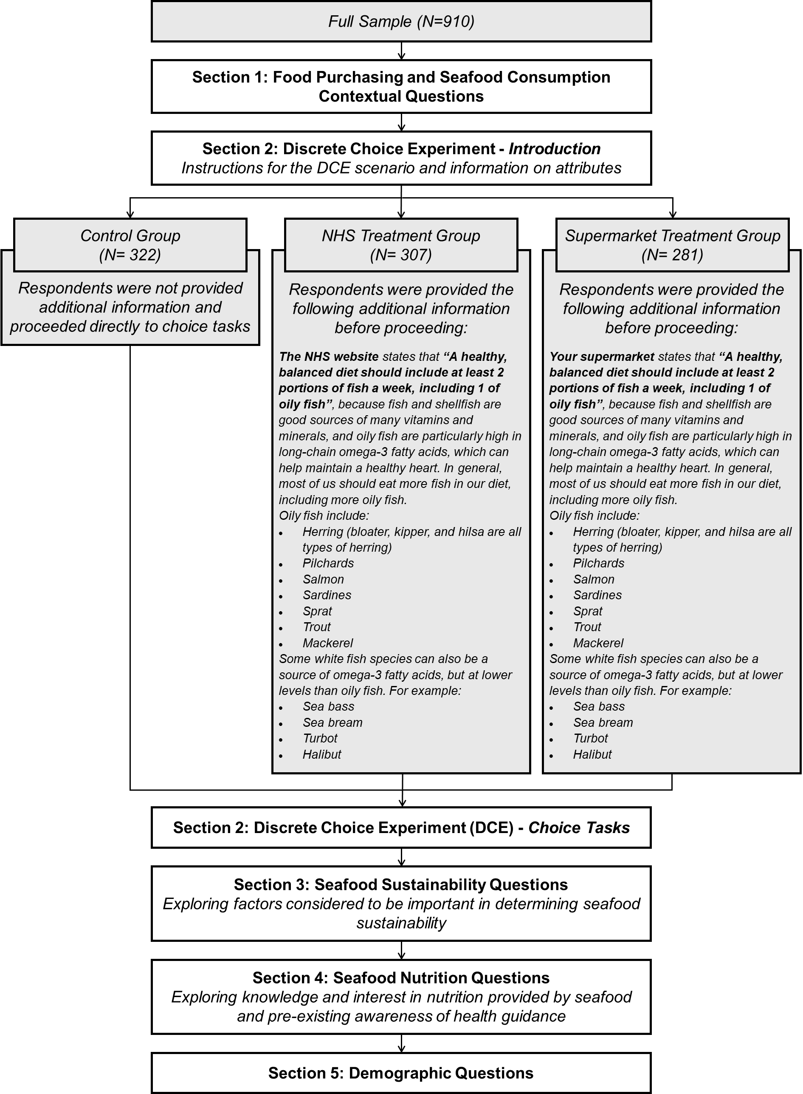
Appendix 2.1: Survey Sample Demographics
Demographic |  | Full sample | Control Group | NHS Treatment Group | Supermarket Treatment Group
Sample size (N) |  | 910 | 322 | 307 | 281
Gender | Male | 51% | 54% | 52% | 46%
Gender | Female | 49% | 45% | 48% | 54%
Gender | Other/Prefer not to say | 1% | 1% | 0% | 0%
Age | 18-24 | 12% | 11% | 11% | 14%
Age | 25-34 | 19% | 16% | 21% | 21%
Age | 35-44 | 18% | 17% | 19% | 18%
Age | 45-54 | 19% | 21% | 17% | 20%
Age | 55-64 | 15% | 16% | 17% | 14%
Age | 65+ | 16% | 20% | 15% | 13%
Household Income (Before Tax) | Less than £15,000 | 11% | 11% | 11% | 11%
Household Income (Before Tax) | £15,001-£20,000 | 10% | 10% | 11% | 8%
Household Income (Before Tax) | £20,001-£30,000 | 21% | 22% | 23% | 19%
Household Income (Before Tax) | £30,001-£40,000 | 16% | 15% | 13% | 19%
Household Income (Before Tax) | £40,001-£50,000 | 12% | 12% | 12% | 11%
Household Income (Before Tax) | £50,001-£60,000 | 10% | 10% | 9% | 9%
Household Income (Before Tax) | £60,001-£80,000 | 9% | 10% | 9% | 9%
Household Income (Before Tax) | £80,001-£100,000 | 2% | 1% | 3% | 4%
Household Income (Before Tax) | £100,001-£150,000 | 3% | 4% | 3% | 2%
Household Income (Before Tax) | More than £150,000 | 1% | 1% | 1% | 1%
Household Income (Before Tax) | Prefer not to say | 5% | 5% | 4% | 6%

Appendix 2.2: Chi-square tests of differences in demographic variables across nudge treatment subsamples, indicating that the distribution of demographic variables did not differ significantly across nudge groups
Variable | Χ² | df | N | p-value | Interpretation
Gender | 6.89 | 4 | 910 | 0.14 | Not significant
Age | 11.84 | 10 | 910 | 0.30 | Not significant
Household Income | 15.78 | 20 | 910 | 0,73 | Not significant

Appendix 3: Key fit indices for latent class models with between two and five classes
Model | LL | BIC | AIC | R^2 | Adj R^2
2-class | -7345.39 | 15275.94 | 14826.79 | 0.1641 | 0.1564
3-class | -7128.82 | 15032.12 | 14437.65 | 0.1888 | 0.1785
4-class | -7006.36 | 15045.35 | 14252.73 | 0.2027 | 0.1890
5-class | -6929.53 | 15149.84 | 14159.06 | 0.2114 | 0.1944

Appendix 4: Format-specific marginal indirect utilities by species and latent class (Model 4)
Species | Format | Class 1 | Class 2 | Class 3
Salmon | Fresh | 0.000 | 0.000 | 0.000
Salmon | Breaded | -1.200 | 0.049 | -1.271
Salmon | Easy-to-cook | -1.137 | 0.246 | -0.407
Mackerel | Fresh | -2.835 | -2.988 | -1.218
Mackerel | Breaded | -1.763 | -3.406 | -0.010
Mackerel | Easy-to-cook | -2.535 | -3.559 | -0.819
Herring | Fresh | -3.760 | -3.955 | -1.846
Herring | Breaded | -2.699 | -3.749 | -0.413
Herring | Easy-to-cook | -2.754 | -4.018 | -2.238
Cod | Fresh | -0.334 | 0.380 | -0.287
Cod | Breaded | 0.708 | 0.312 | 0.779
Cod | Easy-to-cook | 0.278 | 0.087 | -0.360
Haddock | Fresh | -1.634 | -0.151 | -0.942
Haddock | Breaded | -0.303 | -0.461 | 0.400
Haddock | Easy-to-cook | 0.144 | -1.006 | -0.542
Hake | Fresh | -1.829 | -2.552 | -1.308
Hake | Breaded | -1.684 | -2.230 | 0.065
Hake | Easy-to-cook | -2.748 | -2.344 | -0.712
Sea bass | Fresh | -0.461 | -1.039 | -0.646
Sea bass | Breaded | -2.571 | -0.895 | 0.171
Sea bass | Easy-to-cook | -0.261 | -1.313 | 0.053
Sole | Fresh | -2.646 | -2.026 | -1.000
Sole | Breaded | -0.687 | -1.681 | -0.412
Sole | Easy-to-cook | -1.436 | -2.534 | -0.954
Note: Marginal indirect utilities are calculated from the coefficients reported in Table 5, with the reference category (salmon, fresh fillet) set to zero. Marginal indirect utilities for processed salmon correspond to the format main effects. For non-reference species, marginal indirect utilities for fresh fillets equal the species coefficients, while marginal indirect utilities for processed formats equal the sum of the species coefficient and the species × format interaction coefficient. For example, using Table 5:
$marginal indirect utility for breaded mackerel \left(Class 1\right)= {β_{salmon1}+β}_{mackerel1}+β_{mackerel x breaded1} =0-2.835+1.072$
This approach reflects the coding of categorical variables and their interactions in the latent class model.
Variations in utility across species and format do not necessarily reflect statistically significant differences and should be interpreted with caution. Statistical significance for all underlying coefficients is reported in Table 5.

Appendix 5: Summary of existing DCE studies exploring UK seafood choices
Authors | Paper | Location(s) | Sample | Alternatives | Attributes and levels | Species Included | Modelling approach
Jaffry et al. (2004) | Consumer choices for quality and sustainability labelled seafood products in the UK | UK | n = 600 | Four product alternatives and none option | Product form:  - Fresh and chilled cod fillets  - Fresh and chilled salmon steaks  - Tinned tuna  - Frozen fish fingers  - Smoked haddock fillets  - Frozen Prawns  Certification:  - Certified for sustainability  - Certified for quality  - Uncertified  Certifier:  - Non-governmental  - Governmental  Origin:  - UK  - Foreign  Production method:  - Wild  - Farmed  Price:  - Low  - Medium  - High  - Very High  Brand  - Shop’s brand  - Manufacturer’s brand | Cod, Salmon, Tuna, Haddock, Prawns | Conditional logit
Banovic et al. (2019) | A cross-cultural perspective on impact of health and nutrition claims, country-of-origin and eco-label on consumer choice of new aquaculture products | Germany, France, Italy, Spain, UK | n = 1598 (including 316 UK consumers) | Three Greater Amberjack products | Country of Origin label:  - None  - Produced in the EU  - Produced in own country  ASC eco label:  - None  - Yes  Nutritional claims:  - None  - Rich in Omega 3  - High in protein  Price (per 300g):  - 0% (reference price)  - 15% premium  - 30% premium | Amberjack | Conditional logit
Van Osch et al.  (2019) | Estimating the Public’s Preferences for Sustainable Aquaculture: A Country Comparison | Ireland, UK, Italy, Israel, Norway | n = 2520  (including 510 UK respondents) | Two purchasing options and one opt-out option (no purchase) | Production Location:  - National waters  - Outside of national waters  Sustainability  - Level A: 30% increase  - Level B: 20% increase  - Level C: 10 % increase  - Level D: monoculture production  Price per kg:  - Low price in national market  - Average price in nation market  - High price in national market  - Status quo alternative price (£0) | Salmon, Seabream | Latent class
Menozzi et al.  (2020) | Consumers’ Preferences and Willingness to Pay for Fish Products with Health and Environmental Labels: Evidence from Five European Countries | France, Germany, Italy, Spain, UK | n = 2509 (including 473 UK respondents) | Trout, Herring, Salmon, Seabass, Seabream, Cod, Pangasius | Price:  - Average market price  - -30%  - +30%  Production Method:  - Wild-caught fish  - Farm-raised fish  Presentation:  - Whole fish/Round cut  - Fillet  - Ready to cook  Sustainability label:  - No  - Yes  Nutrition and Health Claim:  - No  - Yes | Trout, Herring, Salmon, Seabass, Seabream, Cod, Pangasius | Mixed Logit
Martino et al. (2023) | The importance of local fisheries as a cultural attribute: insight from a discrete choice experiment of seafood consumers | Scotland | n=120 | Seafood options A, B and C | Origin:  - Local  - Imported  Processing:  - Fresh  - Frozen  Harvesting:  - Small vessel  - Industrial vessel  Environmental Certification:  - Certified capture  - Non-certified capture  Consumption:  - Restaurant  - Takeaway  Heritage:  - Waterfront development visibility  - Fishing Heritage visibility  Cost (£) | Not specified | Mixed logit

