A cointegration analysis on the demand for combustible cigarettes and heated tobacco products - Appendix

A1. Preliminary analysis of FMC and HTP demands (Source: Authors work)
A.1.1 FMC
The original series on factory-made cigarettes (FMC) has been adjusted for seasonality by means of an ARIMA X-12 filtering. An autoregressive distributed lag (ADL) model, as in Equation (A.1) is estimated using available data from 2010m1 to 2020m12.

$Δq_{t}=c_{0}+\left({αq}_{t-1}-\tilde{θ}x_{t-1}\right)+\sum_{i=1}^{p-1}{ψ_{yi}Δq_{t-1}}+ω^{'}Δx_{t}+\sum_{i=1}^{q-1}{ψ_{xi}^{'}Δx_{t-i}}+ε_{t}$ A.1)

where $x_{t-1}≡{\left(p_{t-1}^{FMC}, gdp_{t-1}\right)}^{'}$. Coefficients attached to variables in level have a straightforward interpretation in terms of adjustment term $(α)$ with respect to the long-run equilibrium and, since all variables are in logarithms, elasticities $(θ=\tilde{θ}/α)$, other coefficients are interpretable as short-run components. The appropriate number of lags for each regressor has been assessed through the Schwartz Bayesian information criterion. Estimated coefficients are reported in Table 1. The coefficients estimated over the full sample are reported in column (1) and it can be observed that level coefficient for price is statistically significant while per capita GDP is not. The estimated model however may be unable to take into account exogenous shocks that may have affected the true process determining demand of FMC. As shown in Figure 1. CUSUM test for ADL - Column (1), from 2017 on, the cumulated sum of squared residuals is outside the 95% confidence intervals, suggesting some misspecification. It is worth to remark that, despite the drift in CUSUM starts from the beginning of the series, from the end of 2016 the drift accelerates, denoting some possibly additional source of misspecification. A Wald test for structural break at unknown date suggest that a break occurred at 2016m10 at a 5% confidence level (p-value 0.0243). A remarkable, as well as unplausible, implication of the model estimates in column (1) is that the price-elasticity implied is -12.2, an extremely high value that is likely associated to some failure in fully explaining the determinants of demand. The model in Equation (1) has been estimated over a subsample from 2010m1 to 2016m12, ruling out the portion of the sample that is more affected by the misspecification. Estimated results are reported in Column (2) of Table 1, and it can be observed that the coefficient attached to price is statistically significant and smaller than in specification (1), implying an elasticity of -4.4. The CUSUM is shown in Figure 4 in Appendix and substantially supports the previous result, with cumulate squared errors drifting but not lying outside the confidence interval. A potential explanation to the misspecification occurred because of some exogenous factor affecting price sensitivity from late 2016 on, having it increased accordingly with estimates in columns (1) and (2).
Figure 5 shows predicted residuals from model (2). It can be observed that in-sample predictions from 2017m1 underestimate the actual change in FMC demand almost systematically, thus suggesting that some factor made the decline in FMC demand accelerate.
Columns (3) and (4) in Table 1 provide estimates for the subsample after the detected break (3) and before it keeping constant the number of observations (4). Despite statistical non-significance of price in specification (4), an increase in elasticity can be observed, as model (4) yields a unitary elasticity, whereas according to model (3) price elasticity is -2.

Table 1. ADL estimated coefficients. (Source: Authors work)
Dep. Var. D.FMC(t) | (1) |  | (2) |  | (3) |  | (4)
 | 2010m1 - 2020m12 |  | 2010m1 - 2016m12 |  | 2017m1 - 2020m12 |  | 2013m1 - 2016m12
 | Coeff. | p-value | Coeff. | p-value | Coeff. | p-value | Coeff. | p-value
FMC(t-1) | -0.22 | 0.001 | -0.45 | 0.015 | -0.92 | 0.003 | -0.69 | 0.065
Price(t-1) | -2.72 | 0.000 | -1.96 | 0.002 | -1.86 | 0.000 | -0.67 | 0.417
GDP(t-1) | -0.20 | 0.666 | 1.70 | 0.002 | -0.08 | 0.679 | -0.63 | 0.665
D.FMC(t-1) | -0.90 | 0.000 | -0.71 | 0.000 | -0.45 | 0.056 | -0.52 | 0.066
D.FMC(t-2) | -0.74 | 0.000 | -0.64 | 0.002 | -0.50 | 0.001 | -0.50 | 0.004
D.FMC(t-3) | -0.28 | 0.025 | -0.22 | 0.299
D.FMC(t-4) | -0.40 | 0.001 | -0.26 | 0.218
D.FMC(t-5) | -0.22 | 0.069 | 0.06 | 0.771
D.FMC(t-6) | -0.13 | 0.290 | 0.14 | 0.476
D.FMC(t-7) | -0.15 | 0.203 | -0.01 | 0.970
D.FMC(t-8) | -0.32 | 0.000 | -0.29 | 0.013
D.Price(t) | -0.61 | 0.000 | -0.88 | 0.000 | -1.72 | 0.001 | -0.47 | 0.332
D.GDP(t) | 0.66 | 0.000 | -0.83 | 0.555 | 0.74 | 0.000 | -1.48 | 0.605
D.GDP(t-1) | 0.51 | 0.005 | 0.22 | 0.889 | 0.66 | 0.001 | 1.69 | 0.547
cons | 7.24 | 0.000 | 3.78 | 0.162 | 24.50 | 0.000 | 17.98 | 0.142

The analysis above shows FMC price losing explanatory power in the subsample 2017m1 – 2020m12, plausibly, because of the structural break and the subsequent evolution of preferences which is in fieri and not fully captured.

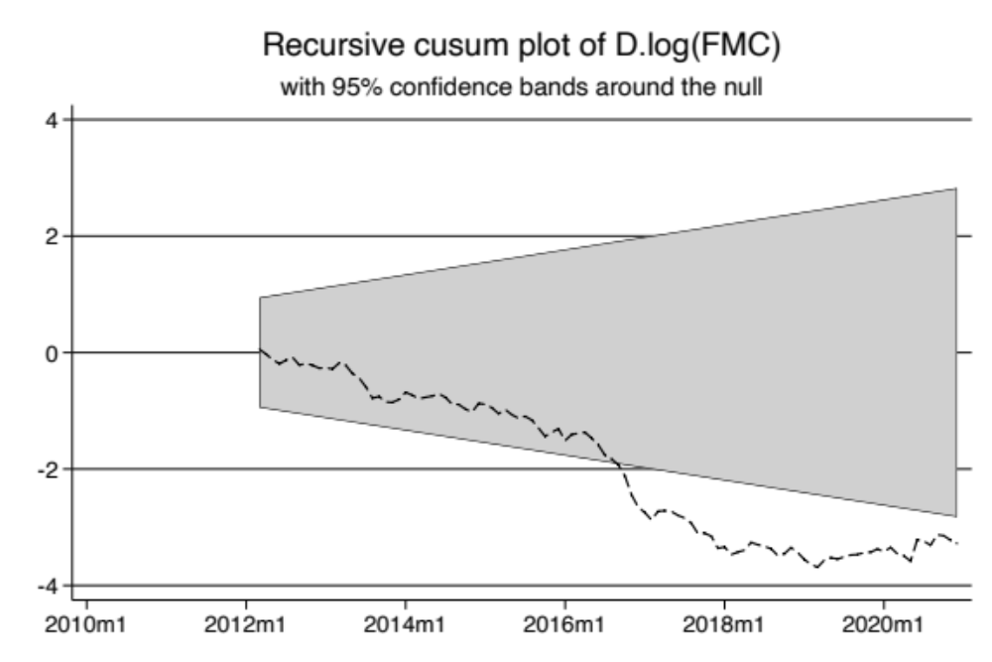
Figure 1. CUSUM test for ADL - Column (1) (Source: Authors work)
The weighted average price is essentially determined by tax changes. In order to support this assumption, variable D3 is built as a categorical variable increasing by one at each change in the excise structure. As it can be observed in Figure 2, major changes occur regularly only in presence of excise changes, and price and D3 essentially co-move.

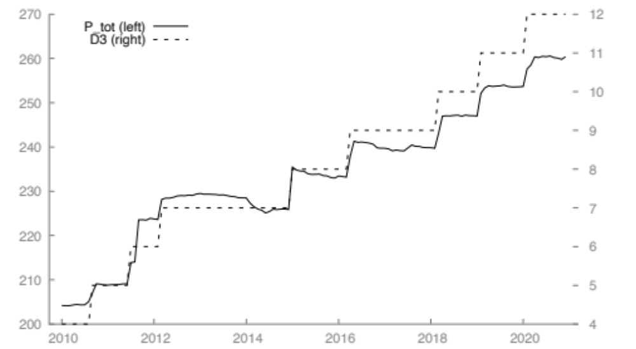
Figure 2. Weighted average price in nominal terms (P_tot) in eur/'000 sticks. Nominal increase in excise categorical variable (D3). (Source: Authors work)

In the estimation process of Equation (1), it has been assumed that FMC price is exogenous with respect to volume. We support this assumption both because of the co-movement with excise changes, and also on the basis of substantial stability of aggregate average manufacturers margins. As shown in Figure 3, manufacturers margin in real terms are essentially stable from 2015 on, i.e. after the implementation of a reform that introduced automatic increases in the excise. Larger oscillations of real manufacturers margin occurred before 2015 in a time of normative uncertainty about the minimum excise duty (declared illegitimate in late 2013) and successive increases of the specific excise more than proportionally with respect to the average price after years of relative stability. Such factors may have prompted gradual rather than fast price changes especially in the lower price category, thus slowing down the excise pass-on to prices, without ruling-out it as the main rationale of price changes. If margins are essentially stable, it follows that prices change essentially to keep margins constant following periodic increase of the excise, in a substantial pure pass-on logic.

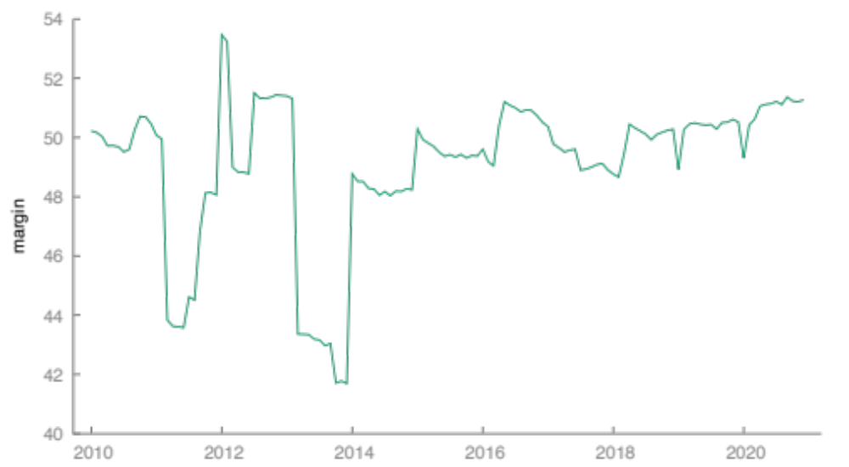
Figure 3. FMC average manufacturer margin in real terms. (Source: Authors work)
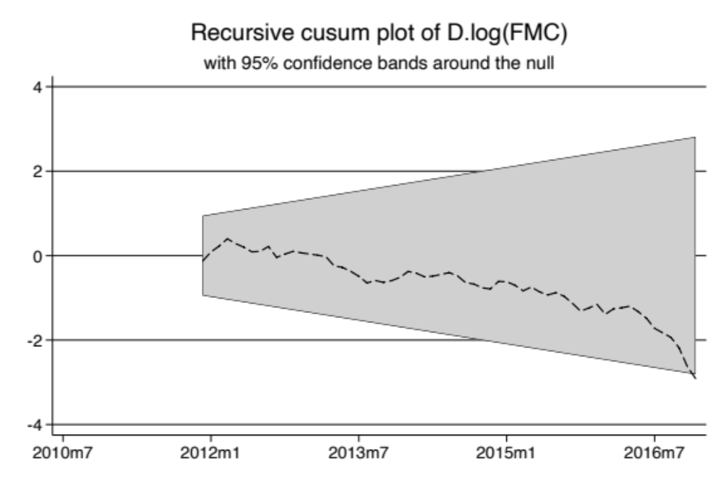
Figure 4. CUSUM ADL 2010m1 - 2016m12. (Source: Authors work)

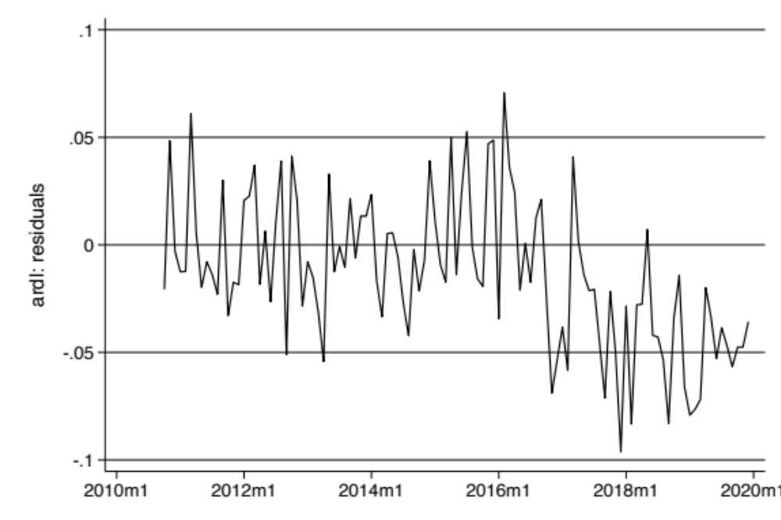
Figure 5. Residuals from model (2) - predictions from 2017m1. (Source: Authors work)

A.1.2 HTPs
Volumes of demand for HTPs are expanding almost exponentially. Figure 6 shows the evolution of average equivalent consumption. The equivalence is based on the puff-equivalence coefficients issued by the Italian Government to compute excise. It can be observed that monthly volume almost doubled between 2019 and 2020, and that by the end of 2020 is almost 300% its beginning of 2019 value. Moreover, the dynamics is still accelerating at mid 2021. Such growth led the HTP market to a share of 8.5% on the total (including combustible cigarettes as well as fine-cut), while the combustible cigarettes share of the market declined by 10 percentage points.

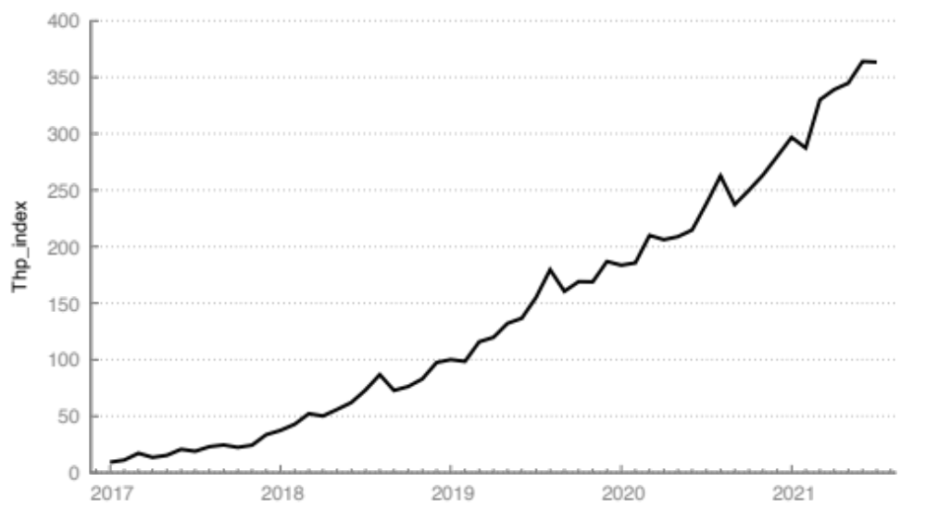
Figure 6. HTP volume (2019m1 = 100). (Source: Authors work)
A.1.2.1 An ADL model for FMC and HTP demand (Source: Authors work)
Based on data examined in the preliminary analyses above, we test the relationship between FMC and HTP in the following autoregressive distributed lags:
$$Δq_{t}=c_{0}+\left({αq}_{t-1}-\tilde{θ}x_{t-1}\right)+\sum_{i=1}^{p-1}{ψ_{yi}Δq_{t-1}}+ω^{'}Δx_{t}+\sum_{i=1}^{q-1}{ψ_{xi}^{'}Δx_{t-i}}+ε_{t}$$
Where $x_{t-1}≡{\left({q_{t-1}^{HTP}, p}_{t-1}^{FMC}, gdp_{t-1}\right)}^{'}$ and appropriate lag orders are determined through the Schwarz-Bayesian information criterion. Estimated coefficients are reported below in Table 2 and suggest a significant impact of the HTP demand on FMC demanded level. The two specifications differ for the maximum number of lags allowed, namely six maximum lags in specification (1) and two maximum lags in specification (2). It can be observed that in the more parsimonious specification coefficients are quite similar. Moreover, the last two rows of Table 2 refer to the Pesaran, Shin, and Smith (2001) bounds test and approximated p-values are from Kripfganz and Schneider (2020). In both specifications both the statistics strongly reject the null hypothesis of no level relationship between FMC and HTP.

Table 2 (Source: Authors work)
 | ADL Specification (1) |  | ADL Specification (2)
 | Coeff. | p-value | Coeff. | p-value
$$q_{t-1}^{FMC}$$ | -2.183*** | (0.000) | -2.093*** | (0.000)
Long-run equation
$$q_{t-1}^{HTP}$$ | -0.0289** | (0.001) | -0.0302*** | (0.000)
$$p_{t-1}^{FMC}$$ | -0.483 | (0.132) | -0.455 | (0.178)
$$gdp_{t-1}$$ | 0.286*** | (0.000) | 0.276** | (0.002)
Short-run equation
$$Δq_{t-1}^{FMC}$$ | 0.780** | (0.005) | 0.440** | (0.007)
$$Δq_{t-2}^{FMC}$$ | 0.426* | (0.035)
$$Δq_{t-3}^{FMC}$$ | 0.409** | (0.003)
$$Δq_{t-1}^{HTP}$$ | -0.0632** | (0.004) | -0.0632** | (0.002)
$$Δp_{t-1}^{FMC}$$ | -1.054 | (0.144) | -0.953 | (0.171)
$$Δgdp_{t-1}$$ | 0.624** | (0.001) | 0.817*** | (0.000)
$$Δgdp_{t-2}$$ |  |  | 0.484** | (0.010)
Constant | 33.87*** | (0.000) | 32.39*** | (0.000)
N | 42 |  | 46
F | 10.969 | (0.000) | 17.432 | (0.000)
t | -6.607 | (0.000) | -7.963 | (0.000)
p-values in parentheses
* p < 0.05, ** p < 0.01, *** p < 0.001

A.1.3 Vector error-correction model for FMC and HTP demand (Source: Authors work)
The model used to fit data is the following vector error-correction model with unmodelled variables as follows:

$\left[\begin{matrix}Δy_{t} \\ Δx_{t}\end{matrix}\right]=\left[\begin{matrix}α \\ α_{x}\end{matrix}\right]β\left[\begin{matrix}y_{t-1} \\ x_{t-1}\end{matrix}\right]+\left[\begin{matrix}Γ_{1} & Υ_{1} \\ 0 & Γ_{1}^{x}\end{matrix}\right]\left[\begin{matrix}Δy_{t-1} \\ Δx_{t-1}\end{matrix}\right]+…+\left[\begin{matrix}Γ_{p-1} & Υ_{p-1} \\ 0 & Γ_{p-1}^{x}\end{matrix}\right]\left[\begin{matrix}Δy_{t-p+1} \\ Δx_{t-p+1}\end{matrix}\right]+\left[\begin{matrix}u_{t} \\ v_{t}\end{matrix}\right]$ A.2)

where $y_{t}$ is a 2x1 vector of endogenous variables, namely natural logarithm of FMC volume (ARIMA X-12 adjusted) and natural logarithm of equivalent HTP volume at month t, and $x_{t}$ is a 2x1 vector of unmodelled (weakly exogenous) variables such as log of FMC average price and per capita SA real GDP.

A.1.3.1 Tests for order of integration

The order of integration has been tested by means of GSL based augmented Dickey-Fuller proposed in Elliot et al. (1996) (GLS-ADF) and KPSS (Kiatkowski et al. 1992) for stationarity. For all the variables, both endogenous and exogenous, both levels and differences have been tested. The GLS-ADF assumes the lags-order based on better (lowest) Akaike (AIC) or Schwartz (BIC) criteria as well as a trend in the estimated equation. The time range spans from 2010m1 to the latest data available. The lag for parameter truncation in the KPSS test has been set to three, in the original paper authors suggest setting a lag order equal to the integer part of $4{\left(T/{100}\right)}^{1/4}$, where T is the number of observations (54 in test sample). The KPSS as well assumes a trend in the test equation.

Table 3. GLS-ADF test for unit-root (p-values only reported for optimal lag accordingly with BIC and AIC, testing down from 12 lags) and KPSS (Kiatkowski et al. 1992)test for stationarity (Source: Authors work)
 |  | GLS-ADF |  | KPSS
 |  | AIC | BIC | statistics | p-value
FMC | Level | 0.529 | 0.529 | 0.216441 | <0.01
FMC | Difference | 0.000 | 0.000 | 0.0567187 | >0.10
HTP | Level | 0.393 | 0.751 | 0.36357 | <0.01
HTP | Difference | 0.000 | 0.000 | 0.0567187 | >0.10
FMC price | Level | 0.071 | 0.071 | 0.215028 | <0.01
FMC price | Difference | 0.014 | 0.014 | 0.0308376 | >0.10
GDP per capita | Level | 0.156 | 0.060 | 0.248019 | <0.01
GDP per capita | Difference | 0.000 | 0.000 | 0.0274618 | >0.10

A.1.3.2 Lag order selection
The proper lag order has been determined by comparing selection criteria at different lag orders of an unrestricted VAR, starting from a maximum number of lags equal to 8. The VAR order is tested assuming the presence of a deterministic linear trend. A good candidate for the proper lag order is 1, as pointed out by Schwartz (BIC) and Hannan-Quinn (HQC) criteria. Other lags arise as potential candidates depending on the maximum lag order allowed for the test. Nevertheless, the BIC is less susceptible to such changes constantly pointing to 1 order of lag. When the maximum lag is 12 BIC, as well as HQ and Akaike criteria point to 12. Removing the trend from the model does not change the general results, as all criteria point to one lag also with a maximum number of lags equal to 8.
Because of the convergence of the three criteria, the main model specification includes one lag in the VAR representation, which implies that the VEC representation has no lagged differenced equations and the processes on the left-hand side of in Equation 1) are determined by the cointegration equations and the stochastic component only. The model has also been estimated with a lag order equal to four. In fact, adding lagged differenced terms improves the significance of other terms as well, as the cointegration equation term in the HTP equation, thus leading to economically meaningful insights. Moreover, adding lags up to the fourth order is improves the selection criteria of the VEC model.

Table 4. VAR selection criteria (Source: Authors work)
lags | Log-likelihood | p(LR) | AIC | BIC | HQC
1 | 117.3799 |  | -5.3690 | -4.946775* | -5.216334*
2 | 121.68532 | 0.0716 | -5.38427 | -4.793158 | -5.17054
3 | 125.50783 | 0.10548 | -5.37539 | -4.615396 | -5.100601
4 | 131.40118 | 0.01901 | -5.47006 | -4.541175 | -5.134204
5 | 138.15814 | 0.00902 | -5.6079* | -4.510135 | -5.210988
6 | 142.03076 | 0.10137 | -5.6015 | -4.334879 | -5.143554
7 | 143.29916 | 0.63806 | -5.46496 | -4.029411 | -4.94591
8 | 146.244 | 0.20754 | -5.4122 | -3.807764 | -4.832087

A.1.3.3 Rank selection
In order to determine the number of cointegration relations, the rank of the cointegration matrix is tested through the maximum eigenvalue statistics (Johansen 1988, 1991). Results are shown in Table 4 for the unrestricted constant and restricted trend cases. The unrestricted constant case includes a drift for the differenced variables and accounts for the potential time trend in the level variables (in addition to the stochastic trend). The restricted trend case includes a time trend in the cointegration equation to deal with the same issue and test whether a deterministic linear trend may affect the long run relationship between variables. The results of the rank test using both specifications with 1 and 4 lags, suggest that one cointegration relation exists, as the eigenvalue tests fail to reject the null for unitary rank. As a robustness check, the same test was conducted adding lags up to 10, always resulting in unitary rank of the cointegration matrix, with a confidence level at 95%.

Table 5. Rank test for cointegration (Source: Authors work)
 | Rank test | Cointegration test conditional on two I(1) variables
 |  | Rank | Eigenvalue | Trace test | p-value | pval(T)
Untrstricted constant | Lags order: 1 | 0 | 0.666 | 58.124 | [0.0001] | [0.0001]
Untrstricted constant | Lags order: 1 | 1 | 0.131 | 6.608 | [0.7940] | [0.8175]
Untrstricted constant | Lags order: 4 | 0 | 0.590 | 47.688 | [0.0018] | [0.0049]
Untrstricted constant | Lags order: 4 | 1 | 0.176 | 8.4929 | [0.6116] | [0.6554]
Restricted trend | Lags order: 1 | 0 | 0.666 | 63.073 | [0.0000] | [0.0000]
Restricted trend | Lags order: 1 | 1 | 0.218 | 11.541 | [0.3318] | [0.3676]
Restricted trend | Lags order: 4 | 0 | 0.591 | 50.988 | [0.0006] | [0.0020]
Restricted trend | Lags order: 4 | 1 | 0.232 | 11.616 | [0.3259] | [0.3738]

A2. VEC Estimation results and robustness checks

Table 6. Additional estimation results. VEC(1) unrestricted constant. (Source: Authors work)
Equation 1 | Differenced FMC
 | coefficient | std. error | t-ratio | p-value
const | 16.8173 | 1.79635 | 9.362 | 4.90E-12 | ***
EC1 | −1.35253 | 0.144458 | −9.363 | 4.89E-12 | ***
Equation 2 | Differenced HTP
 | coefficient | std. error | t-ratio | p-value
const | 8.22246 | 6.08417 | 1.351 | 0.1835
EC1 | −0.655391 | 0.489276 | −1.340 | 0.1873

Table 7. Additional estimation results, VEC(4) unrestricted constant (Source: Authors work)
Equation 1 | Differenced FMC
 | coefficient | std. Error | t-ratio | p-value
const | 31.932 | 5.033 | 6.345 | 2.72E-07 | ***
d_log(FMC)_1 | 0.674 | 0.240 | 2.814 | 0.008 | ***
d_log(FMC)_2 | 0.382 | 0.171 | 2.232 | 0.0321 | **
d_log(FMC)_3 | 0.410 | 0.117 | 3.513 | 0.0012 | ***
d_log(HTP)_1 | −0.0469068 | 0.050 | −0.9383 | 0.3545
d_log(HTP)_2 | −0.0284655 | 0.046 | −0.6199 | 0.5393
d_log(HTP)_3 | 0.007 | 0.044 | 0.161 | 0.873
EC1 | −1.98159 | 0.312 | −6.345 | 2.72E-07 | ***
Equation 2 | Differenced HTP
 | coefficient | std. error | t-ratio | p-value
const | 33.935 | 15.2323 | 2.228 | 0.0324 | **
d_log(FMC)_1 | 1.50657 | 0.72529 | 2.077 | 0.0452 | **
d_log(FMC)_2 | 0.939518 | 0.517954 | 1.814 | 0.0783 | *
d_log(FMC)_3 | 0.245662 | 0.353052 | 0.6958 | 0.4911
d_log(HTP)_1 | −0.144058 | 0.151303 | −0.9521 | 0.3476
d_log(HTP)_2 | −0.190656 | 0.138972 | −1.372 | 0.1788
d_log(HTP)_3 | 0.185866 | 0.134324 | 1.384 | 0.1752
EC1 | −2.10095 | 0.945174 | −2.223 | 0.0328 | **

Table 8. Additional estimation results VEC(1) restricted trend. (Source: Authors work)
Equation 1 | Differenced FMC
 | coefficient | std. Error | t-ratio | p-value
const | 16.3869 | 1.77038 | 9.256 | 8.54E-12 | ***
EC1 | −1.35549 | 0.146429 | −9.257 | 8.52E-12 | ***
Equation 2 | Differenced HTP
 | coefficient | std. Error | t-ratio | p-value
const | 7.80328 | 6.00313 | 1.3 | 0.2006
EC1 | −0.639404 | 0.496521 | −1.288 | 0.2047

Allowing for a restricted trend reduces the statistical significance of HTP, that is nonetheless accepted at 10% confidence level in VEC(4).

Table 9. Additional estimation results VEC(4) restricted trend (Source: Authors work)
Equation 1 | Differenced FMC
 | coefficient | std. Error | t-ratio | p-value
const | 31.3703 | 4.91891 | 6.377 | 2.80E-07 | ***
d_log(FMC)_1 | 0.699651 | 0.242382 | 2.887 | 0.0067 | ***
d_log(FMC)_2 | 0.400213 | 0.173015 | 2.313 | 0.0269 | **
d_log(FMC)_3 | 0.42327 | 0.117662 | 3.597 | 0.001 | ***
d_log(HTP)_1 | −0.0533474 | 0.050099 | −1.065 | 0.2945
d_log(HTP)_2 | −0.0345910 | 0.0461882 | −0.7489 | 0.4591
d_log(HTP)_3 | 0.00257513 | 0.0446231 | 0.05771 | 0.9543
EC1 | −2.01460 | 0.315859 | −6.378 | 2.79E-07 | ***
Equation 2 | Differenced HTP
 | coefficient | std. Error | t-ratio | p-value
const | 31.4733 | 15.1444 | 2.078 | 0.0453 | **
d_log(FMC)_1 | 1.4523 | 0.746252 | 1.946 | 0.0599 | *
d_log(FMC)_2 | 0.916108 | 0.532683 | 1.72 | 0.0946 | *
d_log(FMC)_3 | 0.245882 | 0.36226 | 0.6787 | 0.5019
d_log(HTP)_1 | −0.152264 | 0.154246 | −0.9871 | 0.3305
d_log(HTP)_2 | −0.195231 | 0.142205 | −1.373 | 0.1788
d_log(HTP)_3 | 0.182865 | 0.137386 | 1.331 | 0.192
EC1 | −2.01609 | 0.972474 | −2.073 | 0.0458 | **

Table 10. Likelihood-ratio tests. (Source: Authors work)
 | unrestricted constant |  | restricted trend
 | lags order: 1 | lags order: 4 | lags order: 1 | lags order: 4
b[HTP] = 0 | P(Chi-square(1) > 8.5396) = 0.00347503 | P(Chi-square(1) > 12.4164) = 0.00042559 | P(Chi-square(1) > 1.99017) = 0.158323 | P(Chi-square(1) > 3.45109) = 0.0632099
b[Price FMC] = 0 | P(Chi-square(1) > 0.0401458) = 0.841196 | P(Chi-square(1) > 3.03527) = 0.0814732 | P(Chi-square(1) > 0.00147306) = 0.969384 | P(Chi-square(1) > 1.19633) = 0.274057
b[GDP] = 0 | P(Chi-square(1) > 9.19887) = 0.00242164 | P(Chi-square(1) > 11.8425) = 0.000578926 | P(Chi-square(1) > 9.04882) = 0.00262865 | P(Chi-square(1) > 11.5269) = 0.000685973
linear trend = 0 |  |  | P(Chi-square(1) > 0.0171603) = 0.895777 | P(Chi-square(1) > 0.177069) = 0.673904
b[Price FMC] = 0 & b[GDP] = 0 | P(Chi-square(2) > 12.9573) = 0.00153586 | P(Chi-square(2) > 22.7212) = 1.16454e-05 | P(Chi-square(2) > 9.76717) = 0.00756983 | P(Chi-square(2) > 15.0058) = 0.000551489
b[Price FMC] = 0 & b[GDP] = 0 & linear trend = 0 |  |  | P(Chi-square(3) > 12.9745) = 0.00469209 | P(Chi-square(3) > 22.8983) = 4.24036e-05
Equation 1 (FMC): a[CE] | P(Chi-square(1) > 44.9061) = 2.06717e-11 | P(Chi-square(1) > 26.7633) = 2.29968e-07 | P(Chi-square(1) > 39.9853) = 2.55875e-10 | P(Chi-square(1) > 24.8092) = 6.3296e-07
Equation 2 (HTP): a[CE] | P(Chi-square(1) > 1.73358) = 0.187955 | P(Chi-square(1) > 4.89958) = 0.0268632 | P(Chi-square(1) > 1.52615) = 0.216691 | P(Chi-square(1) > 4.09124) = 0.043106

Table 11. Doornik-Hansen (2008) Normality test of residuals (Source: Authors work)
Lags order | Unrestricted constant |  | Restricted trend
 | Chi-sq(4) | p-value | Chi-sq(4) | p-value
1 | 5.03256 | [0.2840] | 5.03943 | [0.2833]
4 | 1.94808 | [0.7453] | 1.7961 | [0.7732]

Table 12. Autocorrelation of residuals – unrestricted constant (Source: Authors work)
 | Unrestricted constant
Lags | Lags order = 1 |  |  | Lags order = 4
 | Rao F | Approximate distribution | p-value | Rao F | Approximate distribution | p-value
1 | 1.07 | F(4,86) | 0.38 | 0.90 | F(4,68) | 0.47
2 | 1.02 | F(8,82) | 0.43 | 0.79 | F(8,64) | 0.61
3 | 0.89 | F(12,78) | 0.56 | 0.83 | F(12,60) | 0.62
4 | 1.52 | F(16,74) | 0.12 | 0.62 | F(16,56) | 0.85
5 | 1.67 | F(20,70) | 0.06 | 0.62 | F(20,52) | 0.88
6 | 1.47 | F(24,66) | 0.11 | 0.70 | F(24,48) | 0.83
7 | 1.42 | F(28,62) | 0.13 | 0.85 | F(28,44) | 0.67
8 | 1.21 | F(32,58) | 0.26 | 0.84 | F(32,40) | 0.70
9 | 1.18 | F(36,54) | 0.29 | 0.73 | F(36,36) | 0.82
10 | 1.09 | F(40,50) | 0.38 | 0.63 | F(40,32) | 0.91
11 | 0.94 | F(44,46) | 0.59 | 0.59 | F(44,28) | 0.95
12 | 0.89 | F(48,42) | 0.66 | 0.68 | F(48,24) | 0.87

Table 13. Autocorrelation of residuals - Restricted trend (Source: Authors work)
 | Restricted trend
 | Lags order = 1 |  |  | Lags order = 4
Lags | Rao F | Approximate distribution | p-value | Rao F | Approximate distribution | p-value
1 | 1.08 | F(4,86) | 0.37 | 0.91 | F(4,68) | 0.47
2 | 1.02 | F(8,82) | 0.43 | 0.76 | F(8,64) | 0.64
3 | 0.89 | F(12,78) | 0.56 | 0.81 | F(12,60) | 0.64
4 | 1.52 | F(16,74) | 0.12 | 0.61 | F(16,56) | 0.86
5 | 1.66 | F(20,70) | 0.06 | 0.62 | F(20,52) | 0.88
6 | 1.46 | F(24,66) | 0.12 | 0.70 | F(24,48) | 0.83
7 | 1.42 | F(28,62) | 0.13 | 0.88 | F(28,44) | 0.64
8 | 1.21 | F(32,58) | 0.26 | 0.86 | F(32,40) | 0.67
9 | 1.18 | F(36,54) | 0.29 | 0.76 | F(36,36) | 0.80
10 | 1.10 | F(40,50) | 0.37 | 0.67 | F(40,32) | 0.89
11 | 0.94 | F(44,46) | 0.58 | 0.63 | F(44,28) | 0.92
12 | 0.89 | F(48,42) | 0.65 | 0.72 | F(48,24) | 0.84

Table 14. Conditional heteroscedasticity of residuals (Source: Authors work)
 | Unrestricted constant
 | VEC(1) |  |  | VEC(4)
Lags | LM | df | p-value | LM | df | p-value
1 | 6.7 | 9 | 0.67 | 11.4 | 9 | 0.25
2 | 9.4 | 18 | 0.95 | 20.0 | 18 | 0.33
3 | 17.3 | 27 | 0.92 | 29.0 | 27 | 0.36
4 | 21.1 | 36 | 0.98 | 37.3 | 36 | 0.41
5 | 31.3 | 45 | 0.94 | 40.9 | 45 | 0.65
6 | 45.4 | 54 | 0.79 | 56.4 | 54 | 0.38
7 | 53.7 | 63 | 0.79 | 70.5 | 63 | 0.24
8 | 62.1 | 72 | 0.79 | 79.7 | 72 | 0.25
9 | 71.9 | 81 | 0.75 | 92.7 | 81 | 0.18
10 | 79.4 | 90 | 0.78 | 96.3 | 90 | 0.31
11 | 87.8 | 99 | 0.78 | 104.6 | 99 | 0.33
12 | 98.4 | 108 | 0.74 | 114.3 | 108 | 0.32

Table 15. Heteroscedasticity of residuals (Source: Authors work)
 | Restricted trend
 | VEC(1) |  |  | VEC(4)
Lags | LM | df | p-value | LM | df | p-value
1 | 6.8 | 9 | 0.66 | 11.0 | 9 | 0.27
2 | 9.6 | 18 | 0.95 | 19.5 | 18 | 0.36
3 | 17.4 | 27 | 0.92 | 27.8 | 27 | 0.42
4 | 21.5 | 36 | 0.97 | 35.8 | 36 | 0.48
5 | 31.6 | 45 | 0.94 | 39.1 | 45 | 0.72
6 | 45.8 | 54 | 0.78 | 55.1 | 54 | 0.43
7 | 54.2 | 63 | 0.78 | 69.0 | 63 | 0.28
8 | 62.4 | 72 | 0.78 | 78.6 | 72 | 0.28
9 | 71.8 | 81 | 0.76 | 93.2 | 81 | 0.17
10 | 79.2 | 90 | 0.79 | 96.7 | 90 | 0.30
11 | 87.7 | 99 | 0.79 | 106.8 | 99 | 0.28
12 | 98.6 | 108 | 0.73 | 114.4 | 108 | 0.32

HTP => FMC
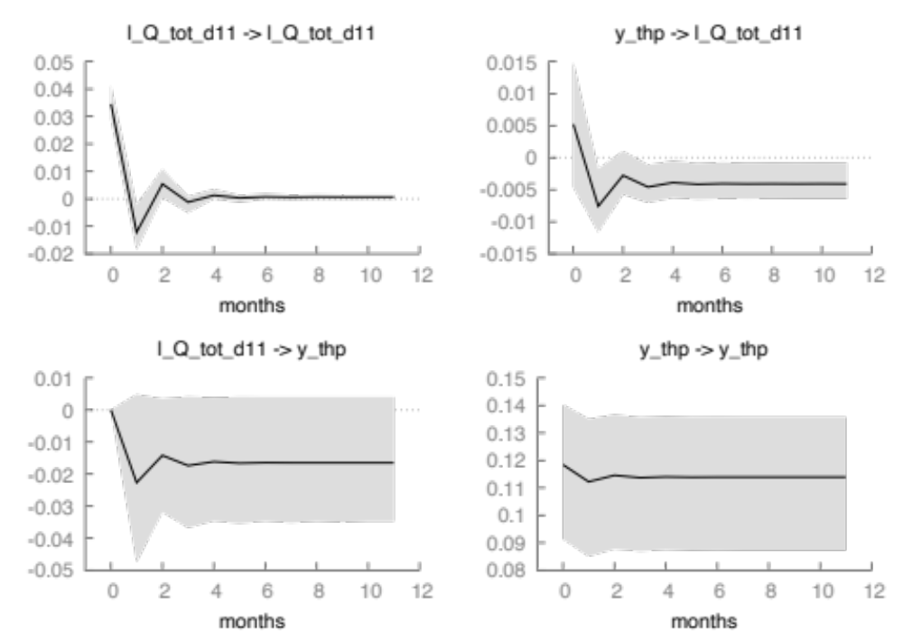
HTP => HTP
FMC => FMC
FMC => HTP
Figure 7. VEC(1) IRF unrestricted constant, recursive order: HTP-FMC (Source: Authors work)
HTP => FMC
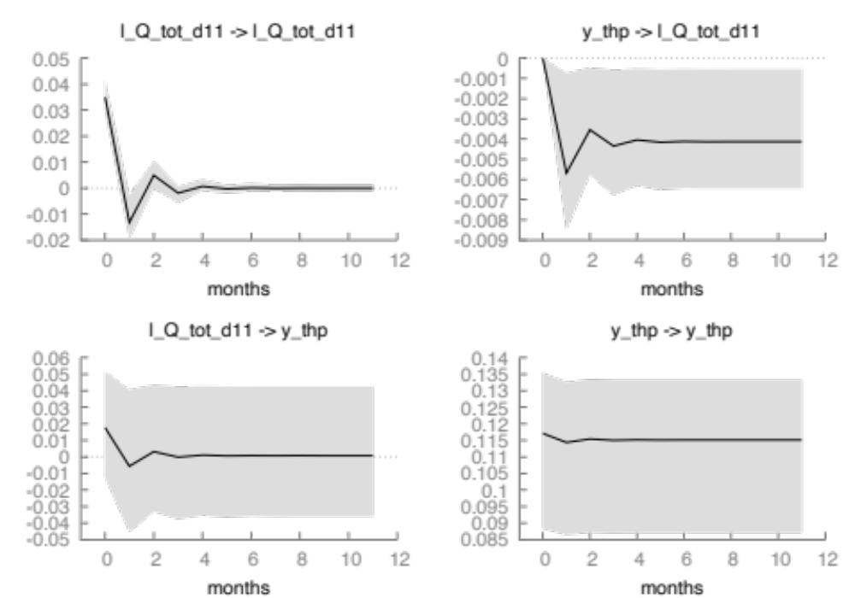
HTP => HTP
FMC => HTP
FMC => FMC
Figure 8. VEC(1) IRF unrestricted constant, recursive order: FMC-HTP (Source: Authors work)

