“Fruit Basket Upset”: spatially explicit crop mixture responses to climatic and economic pressures

Supplementary Information S1 - about the allocation philosophy

Ideally the algorithm should be able to reproduce three major (and contradictory) patterns observed in the global distribution of cropland. First, crops are grown in places where they are highly productive due to a combination of biophysical and socio-economic factors (in particular, market conditions). Second, crops are still produced in places where yields and market conditions are not optimal. Finally, while a particular crop may dominate a region, a variety of crops are typically grown in close proximity to one another in the majority of locations.

Balancing these considerations in the distribution of crops is difficult. An approach where crops are distributed based on pure profit maximization leads toward extreme concentration inconsistent with the spread and diversity of production observed in the real-world. The seemingly unprofitable distributions might derive from more complicated production systems, risk management, and subsistence motivations. To accommodate these different characteristics, we designed an algorithm that while prioritizing optimization, allows for mixing of crops and discourages complete domination by a single crop.

Supplementary Information S2 – additional figures

Figure S1. Diet composition. Change between 2010 and 2050 across selected regions. Baseline scenario without climate change effects
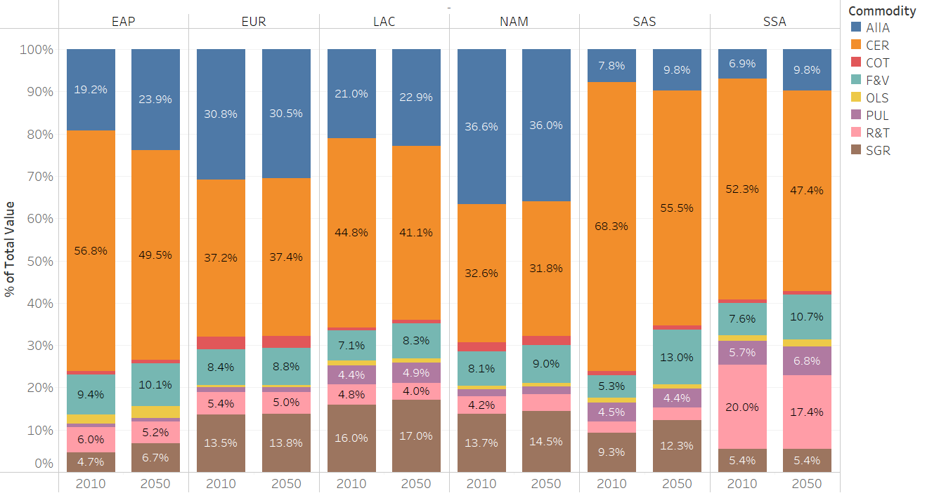
Source: Authors, IMPACT projections.
Notes: AllA= meats; CER=cereals, COT=other crops, F&V=fruits and vegetables, OLS=oil crops, PUL=pulses, R&T=roots and tubers, SGR=sugars EAP=east Asia pacific, EUR=Europe, LAC=Latin America and the Caribbeans, NAM=north America, SAS=south Asia, SSA=Africa south of the Sahara

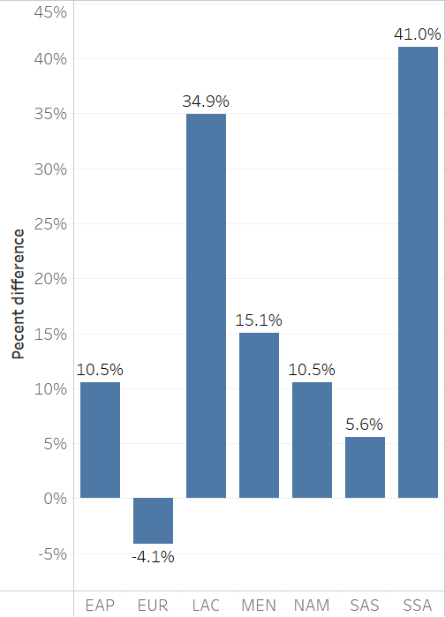
Figure S2. Percent change in harvested area for all crops between 2010 and 2050. Selected regions. Baseline scenario without climate change effects
Source: Authors, IMPACT projections.
Notes: EAP=east Asia pacific, EUR=Europe, LAC=Latin America and the Caribbeans, NAM=north America, SAS=south Asia, SSA=Africa south of the Sahara

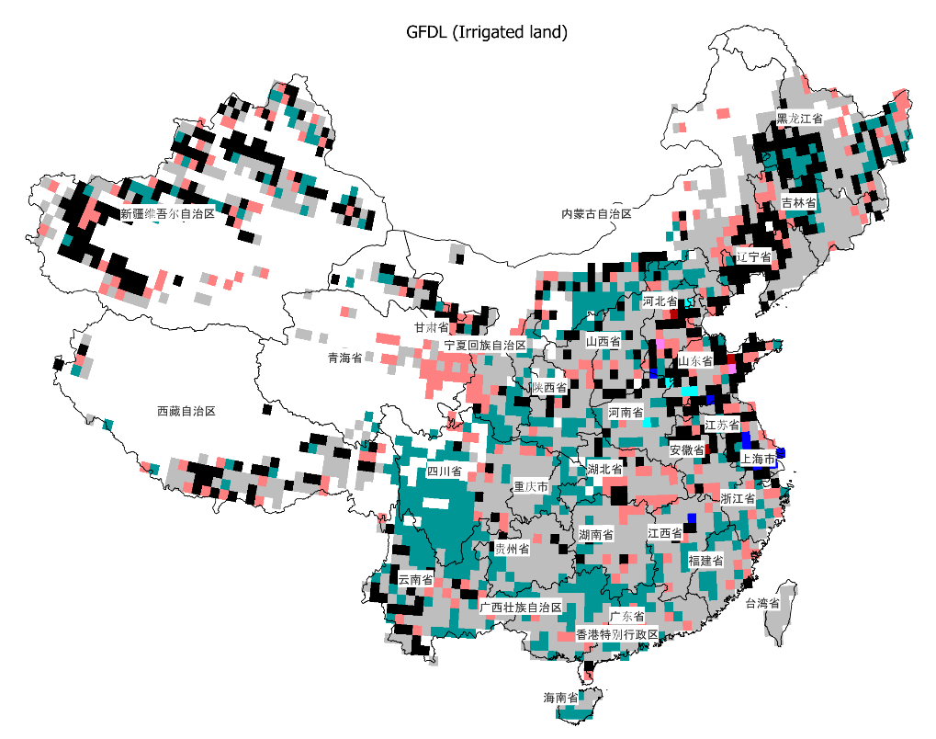
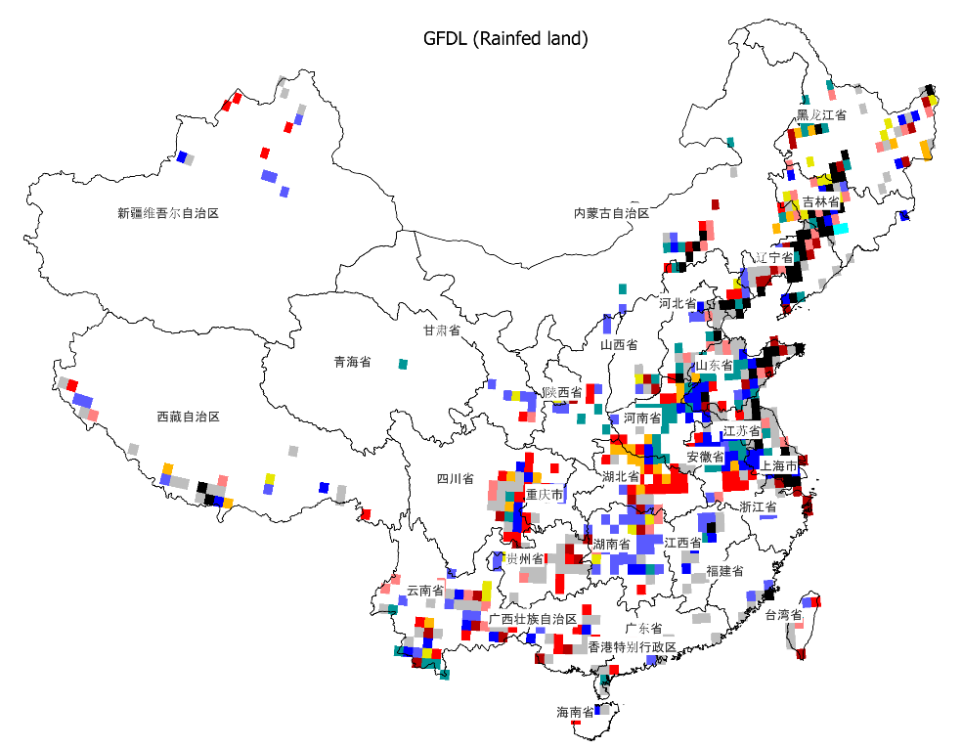
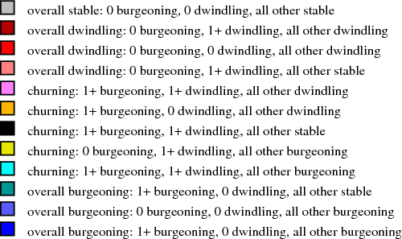
Figure S3. Upheaval types for cropland in China in 2050 compared to 2005 under GFDL/RCP 8.5 (Top: Irrigated cropland. Bottom: rainfed cropland)
Source: Authors

