Appendix A
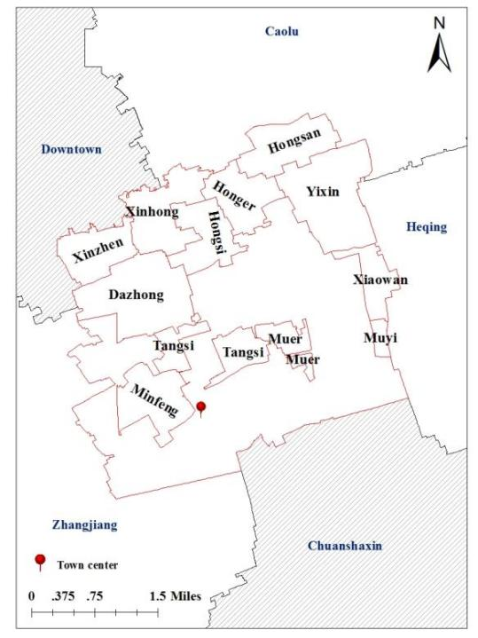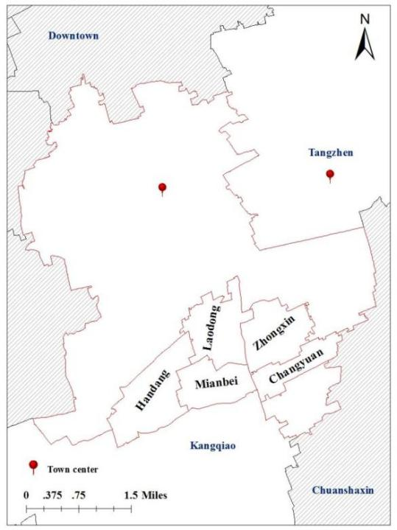
a: The distribution of villages in Tangzhen Town. b: The distribution of villages in Zhangjiang Town.
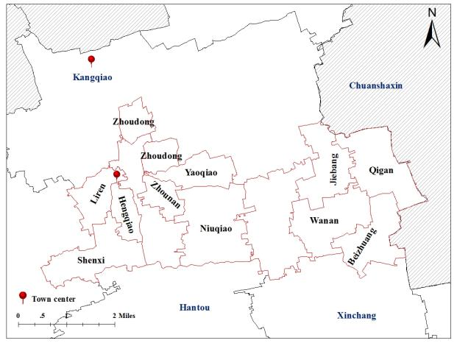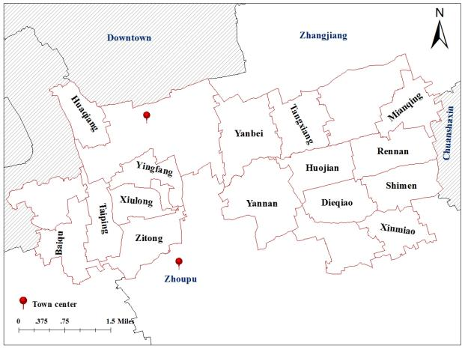
c: The distribution of villages in Zhoupu Town. d: The distribution of villages in Kangqiao Town.
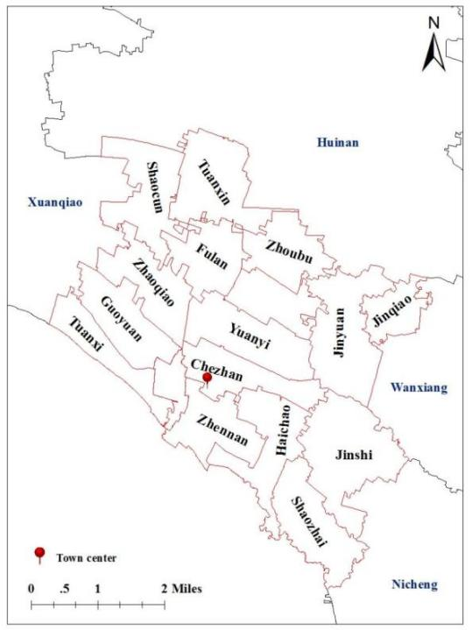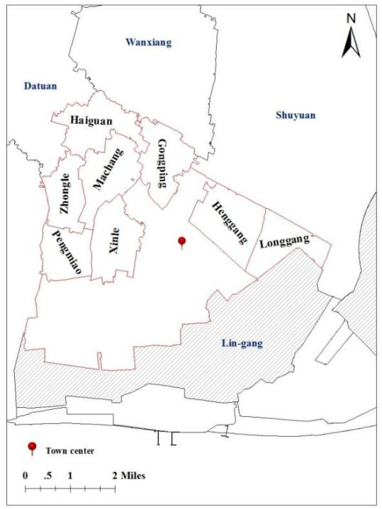
e: The distribution of villages in Datuan Town. f: The distribution of villages in Nicheng Town.
Figure A1. The distribution of villages in six towns.
Source(s): Authors’ own work
Table A1. Land area change of expanded houses based on area groups
Area Groups | Initial land area (m²/house) |  |  |  | Current land area(m²/house) |  |  |  | Area change (m²/house)
Area Groups | Main rooms | Auxiliary rooms | Sheds | Subtotal | Main rooms | Auxiliary rooms | Sheds | Subtotal | Main rooms | Auxiliary rooms | Sheds | Subtotal
<150m² | 55.89 | 5.07 | 0.17 | 61.14 | 73.12 | 46.22 | 7.94 | 127.29 | 17.23 | 41.15 | 7.77 | 66.15
150-250m² | 87.81 | 10.24 | 0.42 | 98.48 | 93.07 | 59.10 | 13.01 | 165.18 | 5.26 | 48.86 | 12.58 | 66.70
250-350m² | 102.28 | 22.11 | 1.14 | 125.53 | 105.23 | 69.81 | 18.25 | 193.29 | 2.95 | 47.70 | 17.11 | 67.76
≥350m² | 126.84 | 38.22 | 2.68 | 167.74 | 129.98 | 85.95 | 25.69 | 241.62 | 3.14 | 47.72 | 23.01 | 73.88
Overall | 86.79 | 13.57 | 0.67 | 101.03 | 93.93 | 60.48 | 13.91 | 168.31 | 7.14 | 46.90 | 13.24 | 67.28
Source(s): Authors’ own work
Table A2. Change in rural housing area before and after housing expansion according to the age of the household head in expanded houses
Group | Expanded houses | Total of houses | Proportion of expanded houses(%) | Frequency of expanded  (times) | Building area change (m²/house) |  |  |  | Land area change (m²/house)
 |  |  |  |  | Main room | Auxiliary room | Shed | Subtotal | Main room | Auxiliary room | Shed | Subtotal
<30 | 532 | 2475 | 21.49 | 680 | 10.39 | 50.11 | 16.19 | 76.69 | 4.30 | 42.08 | 16.19 | 62.57
30-40 | 2293 | 7530 | 30.45 | 3032 | 10.51 | 50.83 | 14.74 | 76.08 | 4.68 | 42.72 | 14.74 | 62.14
40-50 | 3536 | 9506 | 37.20 | 4881 | 16.87 | 60.07 | 13.20 | 90.14 | 6.97 | 49.48 | 13.19 | 69.65
50-60 | 1960 | 5431 | 36.09 | 2708 | 23.96 | 59.32 | 11.96 | 95.24 | 10.27 | 49.20 | 11.74 | 71.21
>60 | 651 | 2092 | 31.12 | 873 | 20.88 | 52.70 | 10.26 | 83.84 | 9.61 | 44.70 | 10.26 | 64.57
Overall | 8972 | 27034 | 33.19 | 12174 | 16.70 | 56.42 | 13.29 | 86.41 | 7.14 | 46.90 | 13.24 | 67.28
Source(s): Authors’ own work
Table A3. Change in rural housing area before and after housing expansion according to the gender of the household head in expanded houses
Group | Expanded houses | Total of houses | Proportion of expanded houses(%) | Frequency of expanded  (times) | Building area change (m²/house) |  |  |  | Land area change (m²/house)
 |  |  |  |  | Main room | Auxiliary room | Shed | Subtotal | Main room | Auxiliary room | Shed | Subtotal
Female | 2357 | 6986 | 33.74 | 3140 | 15.99 | 56.32 | 11.41 | 83.72 | 6.92 | 46.55 | 11.36 | 64.83
Male | 6615 | 20048 | 33.00 | 9034 | 16.95 | 56.45 | 13.96 | 87.36 | 7.22 | 47.03 | 13.91 | 68.16
Overall | 8972 | 27034 | 33.19 | 12174 | 16.70 | 56.42 | 13.29 | 86.41 | 7.14 | 46.90 | 13.24 | 67.28
Source(s): Authors’ own work
Table A4. Change in rural housing area before and after housing expansion according to the household size in expanded houses
Group | Expanded houses | Total of houses | Proportion of expanded houses(%) | Frequency of expanded  (times) | Building area change (m²/house) |  |  |  | Land area change (m²/house)
 |  |  |  |  | Main room | Auxiliary room | Shed | Subtotal | Main room | Auxiliary room | Shed | Subtotal
< =3 | 4445 | 15616 | 28.46 | 5811 | 10.59 | 49.87 | 13.31 | 73.77 | 4.63 | 42.21 | 13.24 | 60.08
= 4 | 2372 | 6159 | 38.51 | 3284 | 18.02 | 60.89 | 13.19 | 92.11 | 7.66 | 49.52 | 13.18 | 70.36
= 5 | 1268 | 3060 | 41.44 | 1775 | 26.90 | 62.67 | 13.47 | 103.04 | 11.43 | 52.32 | 13.47 | 77.23
> 5 | 887 | 2199 | 40.34 | 1304 | 29.20 | 68.31 | 13.20 | 110.72 | 12.22 | 55.70 | 13.02 | 80.94
Overall | 8972 | 27034 | 33.19 | 12174 | 16.70 | 56.42 | 13.29 | 86.41 | 7.14 | 46.90 | 13.24 | 67.28
Source(s): Authors’ own work
Table A5. Change in rural housing area before and after housing expansion according to the number of household laborers in expanded houses
Group | Expanded houses | Total of houses | Proportion of expanded houses(%) | Frequency of expanded  (times) | Building area change (m²/house) |  |  |  | Land area change (m²/house)
 |  |  |  |  | Main room | Auxiliary room | Shed | Subtotal | Main room | Auxiliary room | Shed | Subtotal
< =3 | 6553 | 21177 | 30.94 | 8708 | 13.43 | 52.96 | 13.50 | 79.88 | 5.86 | 44.39 | 13.45 | 63.71
= 4 | 1682 | 4114 | 40.88 | 2378 | 24.71 | 63.61 | 11.95 | 100.27 | 10.25 | 51.81 | 11.89 | 73.95
= 5 | 495 | 1162 | 42.60 | 733 | 25.20 | 72.65 | 14.51 | 112.36 | 10.31 | 59.40 | 14.51 | 84.22
> 5 | 242 | 581 | 41.65 | 355 | 32.32 | 66.87 | 14.47 | 113.65 | 13.67 | 55.31 | 14.20 | 83.17
Overall | 8972 | 27034 | 33.19 | 12174 | 16.70 | 56.42 | 13.29 | 86.41 | 7.14 | 46.90 | 13.24 | 67.28
Source(s): Authors’ own work
Table A6. Change in rural housing area before and after housing expansion according to number of urban Hukou in expanded houses
Group | Expanded houses | Total of houses | Proportion of expanded houses(%) | Frequency of expanded  (times) | Building area change (m²/house) |  |  |  | Land area change (m²/house)
 |  |  |  |  | Main room | Auxiliary room | Shed | Subtotal | Main room | Auxiliary room | Shed | Subtotal
0 | 2032 | 6798 | 29.89 | 2512 | 22.50 | 45.94 | 12.71 | 81.15 | 9.22 | 41.29 | 12.57 | 63.08
[1,3] | 4801 | 15059 | 31.88 | 6450 | 16.58 | 55.88 | 13.02 | 85.47 | 7.09 | 46.60 | 13.02 | 66.70
[4,6] | 1947 | 4739 | 41.08 | 2928 | 11.53 | 66.93 | 14.42 | 92.88 | 5.34 | 52.63 | 14.42 | 72.39
> 6 | 192 | 438 | 43.84 | 284 | 10.91 | 74.28 | 14.74 | 99.94 | 4.67 | 55.92 | 13.91 | 74.50
Overall | 8972 | 27034 | 33.19 | 12174 | 16.70 | 56.42 | 13.29 | 86.41 | 7.14 | 46.90 | 13.24 | 67.28
Source(s): Authors’ own work
Table A7. Change in rural housing area before and after housing expansion according to the number of household heads in expanded houses
Group | Expanded houses | Total of houses | Proportion of expanded houses(%) | Frequency of expanded  (times) | Building area change (m²/house) |  |  |  | Land area change (m²/house)
 |  |  |  |  | Main room | Auxiliary room | Shed | Subtotal | Main room | Auxiliary room | Shed | Subtotal
1 | 4067 | 14433 | 28.18 | 5395 | 7.84 | 51.22 | 12.75 | 71.81 | 3.45 | 42.78 | 12.73 | 58.95
2 | 4135 | 10476 | 39.47 | 5687 | 22.94 | 59.77 | 13.34 | 96.06 | 9.68 | 49.59 | 13.25 | 72.52
≥3 | 770 | 2125 | 36.24 | 1092 | 29.96 | 65.85 | 15.87 | 111.69 | 13.01 | 54.28 | 15.87 | 83.16
Overall | 8972 | 27034 | 33.19 | 12174 | 16.70 | 56.42 | 13.29 | 86.41 | 7.14 | 46.90 | 13.24 | 67.28
Source(s): Authors’ own work
Table A8. State of rural house expansion and related key villages
Index of houses expansion | Villages involved expansion
Percent of expanded houses ≥50% ª | Changyuan (61.36), Dazhong (67.05), Gongping (63.92), Handang (55.03), Henggang (55.42), Honger (64.76), Huojian (55.56), Jiebang (63.82), Laodong (54.39), Longgang (59.9), Muer (60.14), Muyi (50), Qigan (70.81), Wannan (54.88), Xiaowan (54.91), Xinzhen (70), Yaoqiao (79.17), Yixin (65.23), Zhongxin (60.39), Zhoudong (64.25), Zhounan (55.26)
Increment of building area for expanded houses≥100 m^{2 b} | Dazhong (132.62), Haichao (100.88), Haiguan (150.17), Honger (100.91), Hongsan (119.67), Hongsi (152.05), Huaqiang (106.81), Jinshi (104.34), Minfeng (110.29), Niuqiao (106.98), Shaozhai (106.83), Taiping (141.72), Tangsi (145.81), Xiaowan (135.09), Xinhong (118.6), Xinle (109.09), Xinzhen (135.22), Yanbei (101.32), Yaoqiao (107.75), Yixin (133.94), Zhennan (105.34), Zhoudong (111.08), Zhounan (96.03)
Increment of land area for expanded houses≥80 m^{2 c} | Dazhong (102.76), Haiguan (85.6), Hongsan (85.44), Hongsi (109.67), Taiping (133.27), Tangsi (92.46), Xiaowan (89.22), Xinhong (80.98), Xinle (102.39), Xinzhen (85.78), Yaoqiao (96.16), Yixin (97.95), Zhoudong (88.23), Zhounan (85.95)
ª Percentage of expanded houses is given in parentheses.
^{b} Increase in the building area of expanded houses is given in parentheses.
^{c} Increase in the area of land of expanded houses is given in parentheses.
Source(s): Authors’ own work
Table A9. Collinearity test and correlation analysis of the explanatory variables.
Variables | VIF | 1 | 2 | 3 | 4 | 5 | 6 | 7 | 8 | 9 | 10 | 11 | 12 | 13 | 14 | 15 | 16 | 17
1. Initial building area of main room ª | 2.40 | 1
2. Initial building area of auxiliar room ª | 1.82 | 0.08  ** | 1
3. Initial building area of shed ª | 1.39 | 0.05  ** | 0.14  ** | 1
4. Initial FAR of main room ª | 2.31 | 0.74  ** | 0.12  ** | 0.03  ** | 1
5. Initial FAR of auxiliar room ª | 1.78 | 0.05  ** | 0.65  ** | 0.07  ** | 0.16  ** | 1
6. Initial FAR of shed ª | 1.44 | 0.03  ** | 0.17  ** | 0.52  ** | 0.01 | 0.11  ** | 1
7. Age of household head ^{b} | 1.28 | -0.14  ** | 0.07  ** | -0.01 | -0.18  ** | 0.06  ** | 0.02  ** | 1
8. Gender of household head ^{b} | 1.07 | 0.07  ** | 0 | 0.02  * | 0.06  ** | -0.01 | 0.01 | -0.19  ** | 1
9. Household size ^{b} | 3.92 | 0.16  ** | 0.15  ** | 0.02  ** | 0.10  ** | 0.10  ** | 0.04  ** | 0.31  ** | 0.02  ** | 1
10. Number of household labors ^{b} | 2.75 | 0.17  ** | 0.12  ** | 0.01 | 0.11  ** | 0.08  ** | 0.02  ** | 0.17  ** | 0.08  ** | 0.79  ** | 1
11. Number of urban hukou ^{b} | 2.06 | -0.06  ** | 0.07  ** | -0.02  ** | -0.04  ** | 0.03  ** | -0.01 | 0.20  ** | -0.07  ** | 0.56  ** | 0.44  ** | 1
12. Number of Household heads ^{b} | 1.82 | 0.12  ** | 0.13  ** | 0.03  ** | 0.06  ** | 0.09  ** | 0.05  ** | 0.34  ** | -0.05  ** | 0.63  ** | 0.55  ** | 0.28  ** | 1
13. Road network density ^{c} | 1.46 | -0.06  ** | 0.07  ** | -0.05  ** | -0.04  ** | -0.07  ** | -0.09  ** | 0.01 | 0.01  * | 0 | -0.01 | 0.03  ** | -0.06  ** | 1
14. Convenience-of-living ^{c} | 2.46 | -0.14  ** | 0 | -0.04  ** | -0.09  ** | -0.03  ** | -0.07  ** | 0.01 | -0.04  ** | 0.03  ** | 0.03  ** | 0.40  ** | -0.07  ** | -0.01  * | 1
15. Ratio of cultivation land ^{c} | 1.82 | 0.05  ** | 0.02  ** | 0.07  ** | 0.03  ** | 0.04  ** | 0.13  ** | 0.01 | 0.06  ** | 0 | -0.01 | -0.33  ** | 0.09  ** | 0.12  ** | -0.61  ** | 1
16. Distance to downtown ^{c} | 2.41 | 0.23  ** | -0.02  ** | 0.01 | 0.14  ** | 0.03  ** | -0.01 | -0.04  ** | 0.03  ** | -0.06  ** | -0.04  ** | -0.36  ** | 0.05  ** | -0.42  ** | 0.50  ** | 0.19  ** | 1
17. Distance to town ^{c} | 1.41 | -0.04  ** | -0.05  ** | 0.03  ** | -0.01 | -0.01  * | 0.07  ** | 0.05  ** | 0.01 | 0.06  ** | 0.03  ** | -0.04  ** | 0.06  ** | 0 | -0.25  ** | 0.33  ** | -0.20  ** | 1
ª plot characteristics. ^{b} Household characteristic. ^{c} Village characteristic.
* p≤0.05. ** p≤0.01. *** p≤0.001.
Source(s): Authors’ own work
Table A10. Regression result of driving factors for increment of rural houses expansion
Variables | Housing expansion area | Housing expansion frequency
Initial building area of main room ª | -0.177***  (0.016) | -0.001  (0.001)
Initial building area of auxiliar room ª | -0.072*  (0.037) | -0.001*  (0.001)
Initial building area of shed ª | 0.161  (0.215) | -0.002  (0.002)
Initial FAR of main room ª | 19.503***  (2.439) | 0.116***  (0.019)
Initial FAR of auxiliar room ª | -5.768**  (1.974) | -0.039*  (0.016)
Initial FAR of shed ª | -9.204  (6.935) | 0.082  (0.054)
Age of household head ^{b} | 0.117  (0.106) | 0.002*  (0.001)
Gender of household head ^{b} | 4.254  (2.130) | 0.055  (0.017)
Household size ^{b} | 9.126***  (1.190) | 0.008  (0.009)
Number of household labors ^{b} | 3.130**  (1.159) | 0.032***  (0.009)
Number of urban hukou ^{b} | -6.537***  (0.716) | -0.005  (0.006)
Number of Household heads ^{b} | 13.122***  (1.825) | 0.028*  (0.014)
Road network density ^{c} | -4.497**  (1.487) | 0.006  (0.012)
Convenience-of-living ^{c} | 0.094**  (0.031) | 0.001***  (0.001)
Ratio of cultivation land ^{c} | -37.066  (7.432) | -0.493  (0.058)
Distance to downtown ^{c} | -0.686*  (0.365) | -0.026***  (0.003)
Distance to town ^{c} | -1.190  (0.864) | 0.012  (0.007)
Constant | 53.280***  (10.424) | 1.039***  (0.082)
ª Plot characteristics. ^{b} Household characteristics. ^{c} Village characteristics.
* p≤0.05. ** p≤0.01. *** p≤0.001.
Source(s): Authors’ own work
Table A11. Results of regression of factors driving the expansion in rural housing obtained by clustering the standard error.
Variables | Housing expansion area | Housing expansion frequency
Initial building area of main room ª | -0.177***  (0.018) | -0.0002  (0.0001)
Initial building area of auxiliar room ª | -0.072*  (0.042) | -0.001**  (0.0002)
Initial building area of shed ª | 0.161  (0.185) | -0.002  (0.001)
Initial FAR of main room ª | 19.503***  (2.430) | 0.116***  (0.019)
Initial FAR of auxiliar room ª | -5.768**  (2.189) | -0.039**  (0.015)
Initial FAR of shed ª | -9.204*  (5.509) | 0.082  (0.052)
Age of household head ^{b} | 0.117  (0.100) | 0.002**  (0.001)
Gender of household head ^{b} | 4.254  (2.119) | 0.055  (0.016)
Household size ^{b} | 9.126***  (1.310) | 0.008  (0.009)
Number of household labors ^{b} | 3.130**  (1.240) | 0.032***  (0.009)
Number of urban hukou ^{b} | -6.537***  (0.802) | -0.005  (0.005)
Number of Household heads ^{b} | 13.122***  (1.885) | 0.028*  (0.015)
Road network density ^{c} | -4.497***  (1.382) | 0.006  (0.011)
Convenience-of-living ^{c} | 0.094**  (0.033) | 0.001***  (0.0003)
Ratio of cultivation land ^{c} | -37.066  (7.416) | -0.493  (0.061)
Distance to downtown ^{c} | -0.686*  (0.399) | -0.026***  (0.003)
Distance to town ^{c} | -1.190  (0.923) | 0.012*  (0.007)
Constant | 53.280***  (11.013) | 1.039***  (0.086)
ª plot characteristics. ^{b} Household characteristic. ^{c} Village characteristic.
* p≤0.05. ** p≤0.01. *** p≤0.001.
Source(s): Authors’ own work

