Appendix A. Textual analysis of HCM disclosure
In this appendix, we report the word cloud figures of each HCM dimension in English and Chinese in Figures A1-A10 and the top 10 key phrases of each HCM dimension in Table A1.
The word cloud figures are generated from the datasets comprising the most salient phrases in each HCM dimension, with a maximum of 100 phrases represented. Each phrase’s size in the figure corresponds to its frequency, offering a visual hierarchy of linguistic prevalence. In cases where the dataset contains fewer than 100 phrases, the word cloud includes all available phrases, ensuring a complete representation of the linguistic data.

Figure A1. Word cloud for the dimension of compensation
(Figures by authors)
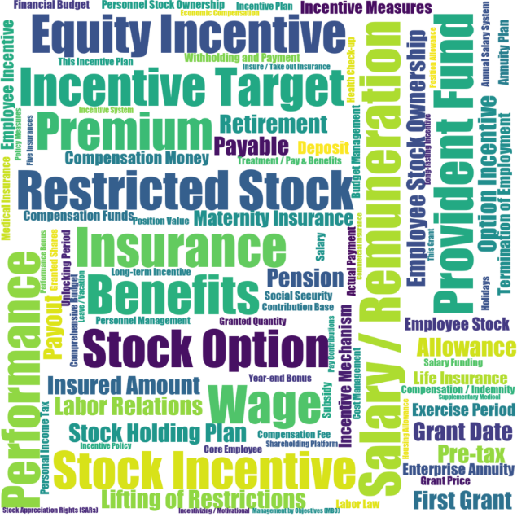
Figure A2. Word cloud for the dimension of culture
(Figures by authors)
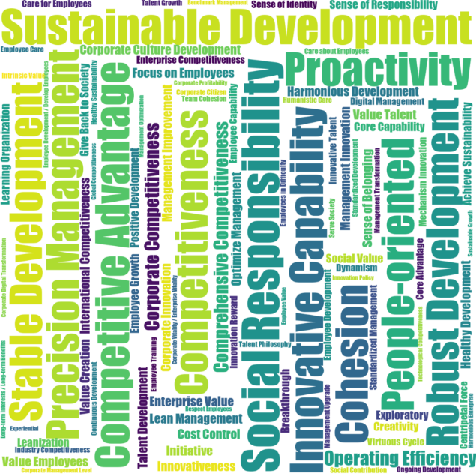
Figure A3. Word cloud for the dimension of diversity
(Figures by authors)
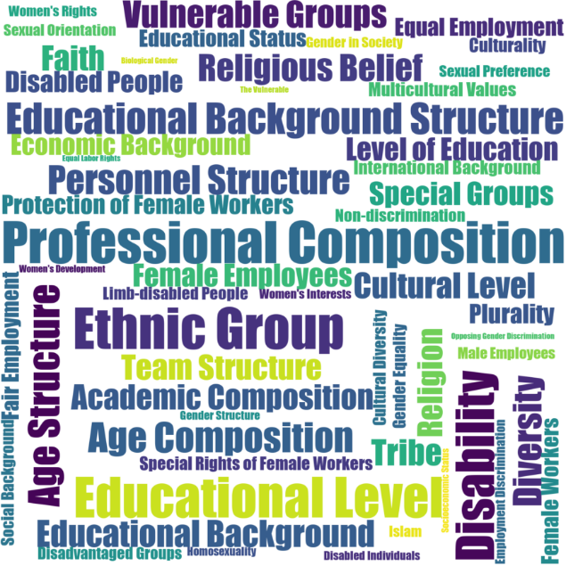
Figure A4. Word cloud for the dimension of employee development
(Figures by authors)
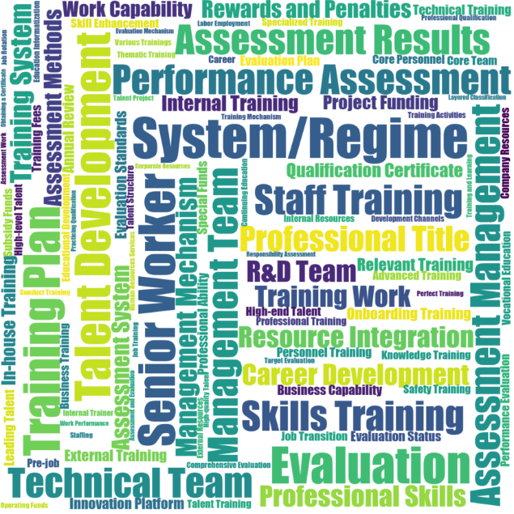Figure A5. Word cloud for the dimension of employee engagement
(Figures by authors)
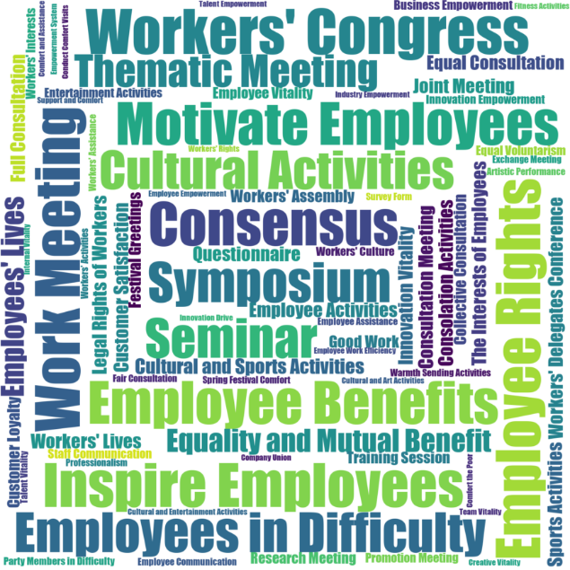Figure A6. Word cloud for the dimension of pay equity
(Figures by authors)
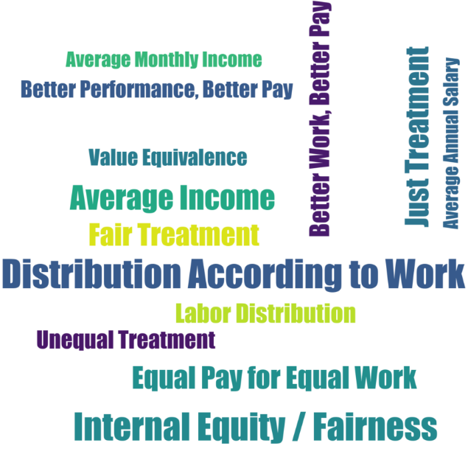
Figure A7. Word cloud for the dimension of recruiting
(Figures by authors)
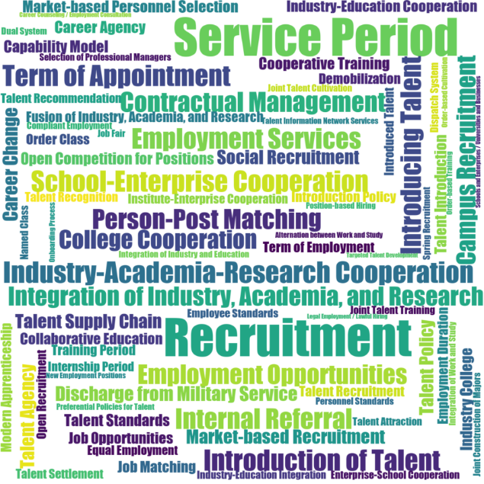
Figure A8. Word cloud for the dimension of safety and health
(Figures by authors)


Figure A9. Word cloud for the dimension of succession planning
(Figures by authors)
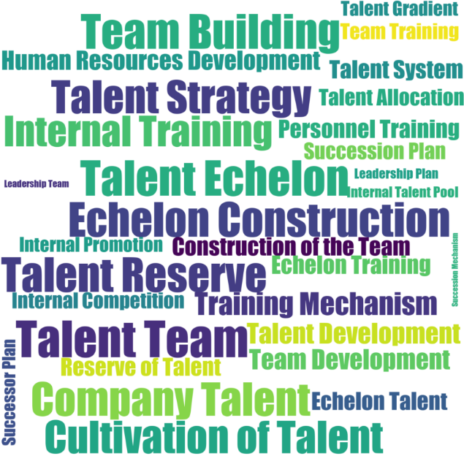
Figure A10. Word cloud for the dimension of turnover retention
(Figures by authors)
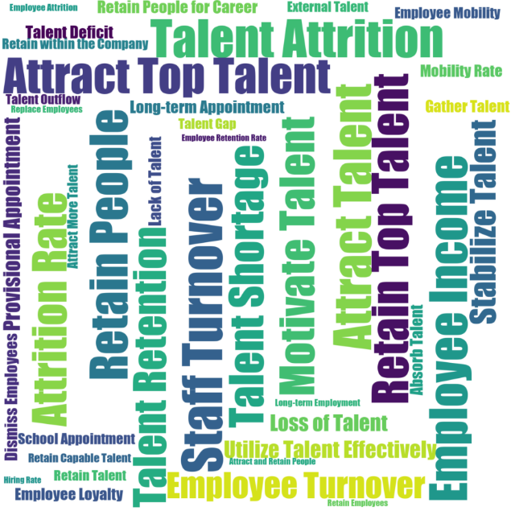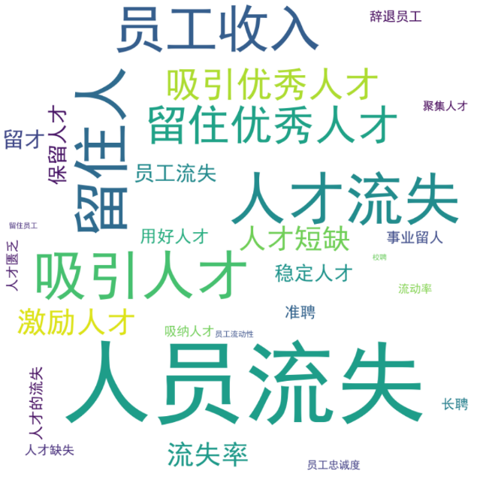

Table A1. List of HCM-related phrases
(Table by authors)
HCM dimension | Top 10 phrases (in order of occurrence frequency)
Compensation | Salary / Remuneration (薪酬), Insurance (保险), Benefits (福利), Restricted Stock (限制性股票), Provident Fund (公积金), Equity Incentive (股权激励), Performance (绩效), Wage (工资), Incentive Target (激励对象), Stock Option (股票期权)
Culture | Social Responsibility (社会责任), Sustainable Development (持续发展), Competitive Advantage (竞争优势), Healthy Development (健康发展), Proactivity (积极性), Innovative Capability (创新能力), People-oriented (人为本), Stable Development (稳定发展), Precision Management (精细化管理), Competitiveness (竞争能力)
Diversity | Professional Composition (专业构成), Ethnic Group (族), Educational Level (教育程度), Disability (残疾), Educational Background Structure (学历结构), Age Structure (年龄结构), Age Composition (年龄构成), Personnel Structure (人员结构), Diversity (多样性), Religious Belief (信教)
Employee Development | System/Regime (制度), Evaluation (考评), Senior Worker (高级工), Training Plan (培训计划), Talent Development (人才培养), Performance Assessment (业绩考核), Management Team (管理团队), Assessment Management (考核管理), Assessment Results (考核结果), Staff Training (员工培训)
Employee Engagement | Work Meeting (工作会议), Workers' Congress (职工代表大会), Employee Rights (员工权益), Motivate Employees (调动员工), Customer Satisfaction (客户满意度), Inspire Employees (激发员工), Consensus (协商一致), Motivate Employees (激励员工), Employee Benefits (员工利益), Employees in Difficulty (困难职工)
Pay Equity | Distribution According to Work (按劳分配), Fair Treatment (公平对待), Internal Equity / Fairness (内部公平性), Average Income (平均收入), Just Treatment (公正对待), Fair Treatment (公平的对待), Equal Pay for Equal Work (同岗同酬), Better Work, Better Pay (优劳优酬), Labor Distribution (劳动分配), Unequal Treatment (不平等对待)
Recruiting | Recruitment (招聘), Service Period (服务期), Talent Introduction (人才引进), Industry-Academia-Research Cooperation (产学研合作), Term of Appointment (聘期), Introduction of Talent (人才的引进), School-Enterprise Cooperation (校企), Introducing Talent (引进人才), Employment Services (就业服务), Internal Referral (内推)
Safety & Health | Safe Production (安全生产), Accident (事故), Safety Management (安全管理), Preventive Measures (防范措施), Health Management (健康管理), Occupational Health (职业健康), Enterprise Safety (企业安全), Hidden Danger Inspection (隐患排查), Emergency Drills (应急演练), Safety Protection (安全防护)
Succession Planning | Talent Team (人才队伍), Talent Echelon (人才梯队), Team Building (团队建设), Talent Reserve (人才储备), Echelon Construction (梯队建设), Company Talent (公司人才), Talent Strategy (人才战略), Cultivation of Talent (人才的培养), Internal Training (内部培养), Training Mechanism (培养机制)
Turnover Retention | Staff Turnover (人员流失), Talent Attrition (人才流失), Retain People (留住人), Attract Talent (吸引人才), Employee Income (员工收入), Retain Top Talent (留住优秀人才), Attract Top Talent (吸引优秀人才), Motivate Talent (激励人才), Talent Shortage (人才短缺), Attrition Rate (流失率)

Appendix B. Variable definitions
(Table by authors)
Variables | Definition | Source
HCM_Turnover Retention | The number of phrases related to turnover retention in the MD&A section in the annual report divided by the total number of phrases in the MD&A section. HCM_Safety & Health, HCM_Succession Planning, HCM_Recruiting, HCM_Pay Equity, HCM_Employment Engagement, HCM_Employee Development, HCM_Diversity, HCM_Culture, and HCM_Compensation are defined analogously | Juchao Information Network and own calculation
Tobin’s Q | The market value of equity plus total liability divided by total assets | CSMAR
MTB | The market value of equity divided by the book value of equity | CSMAR
ROA | Operating profit divided by total assets | CSMAR
Tangibility | Net fixed assets divided by total assets | CSMAR
Cash/assets | Cash and cash equivalent divided by total assets | CSMAR
Sales growth | The change in total revenue divided by the total revenue in the previous year | CSMAR
Leverage | Total liabilities divided by total assets | CSMAR
Log(assets) | The logarithm of total assets | CSMAR
Local SOE | A dummy variable that takes the value of one if the company’s ultimate controlling shareholder is the local (municipal or provincial) government and zero otherwise | CSMAR
Central SOE | A dummy variable that takes the value of one if the company’s ultimate controlling shareholder is the central government and zero otherwise | CSMAR
Foreign capital entity | A dummy variable that takes the value of one if the firm’s equity nature is “foreign capital (外资)”, and zero otherwise | CSMAR
Private entity | A dummy variable that takes the value of one if the firm’s equity nature is “private (民营)”, and zero otherwise | CSMAR
Industry competition | Herfindahl index of firm revenue for each industry-year | CSMAR
Provincial GDP per capita | GDP per capita of the province in which the firm is registered | CSMAR

