Appendix A

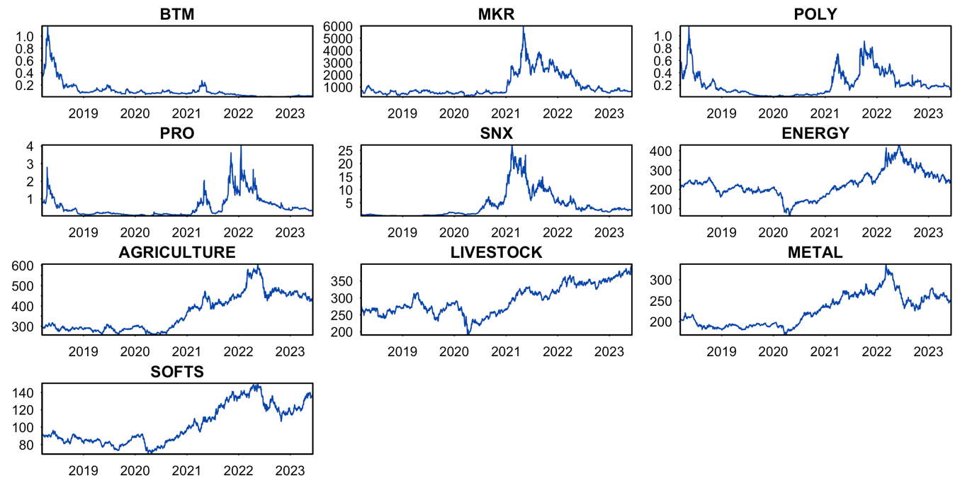
Source: Figure by authors.
Figure A.1: Historical closing price series.

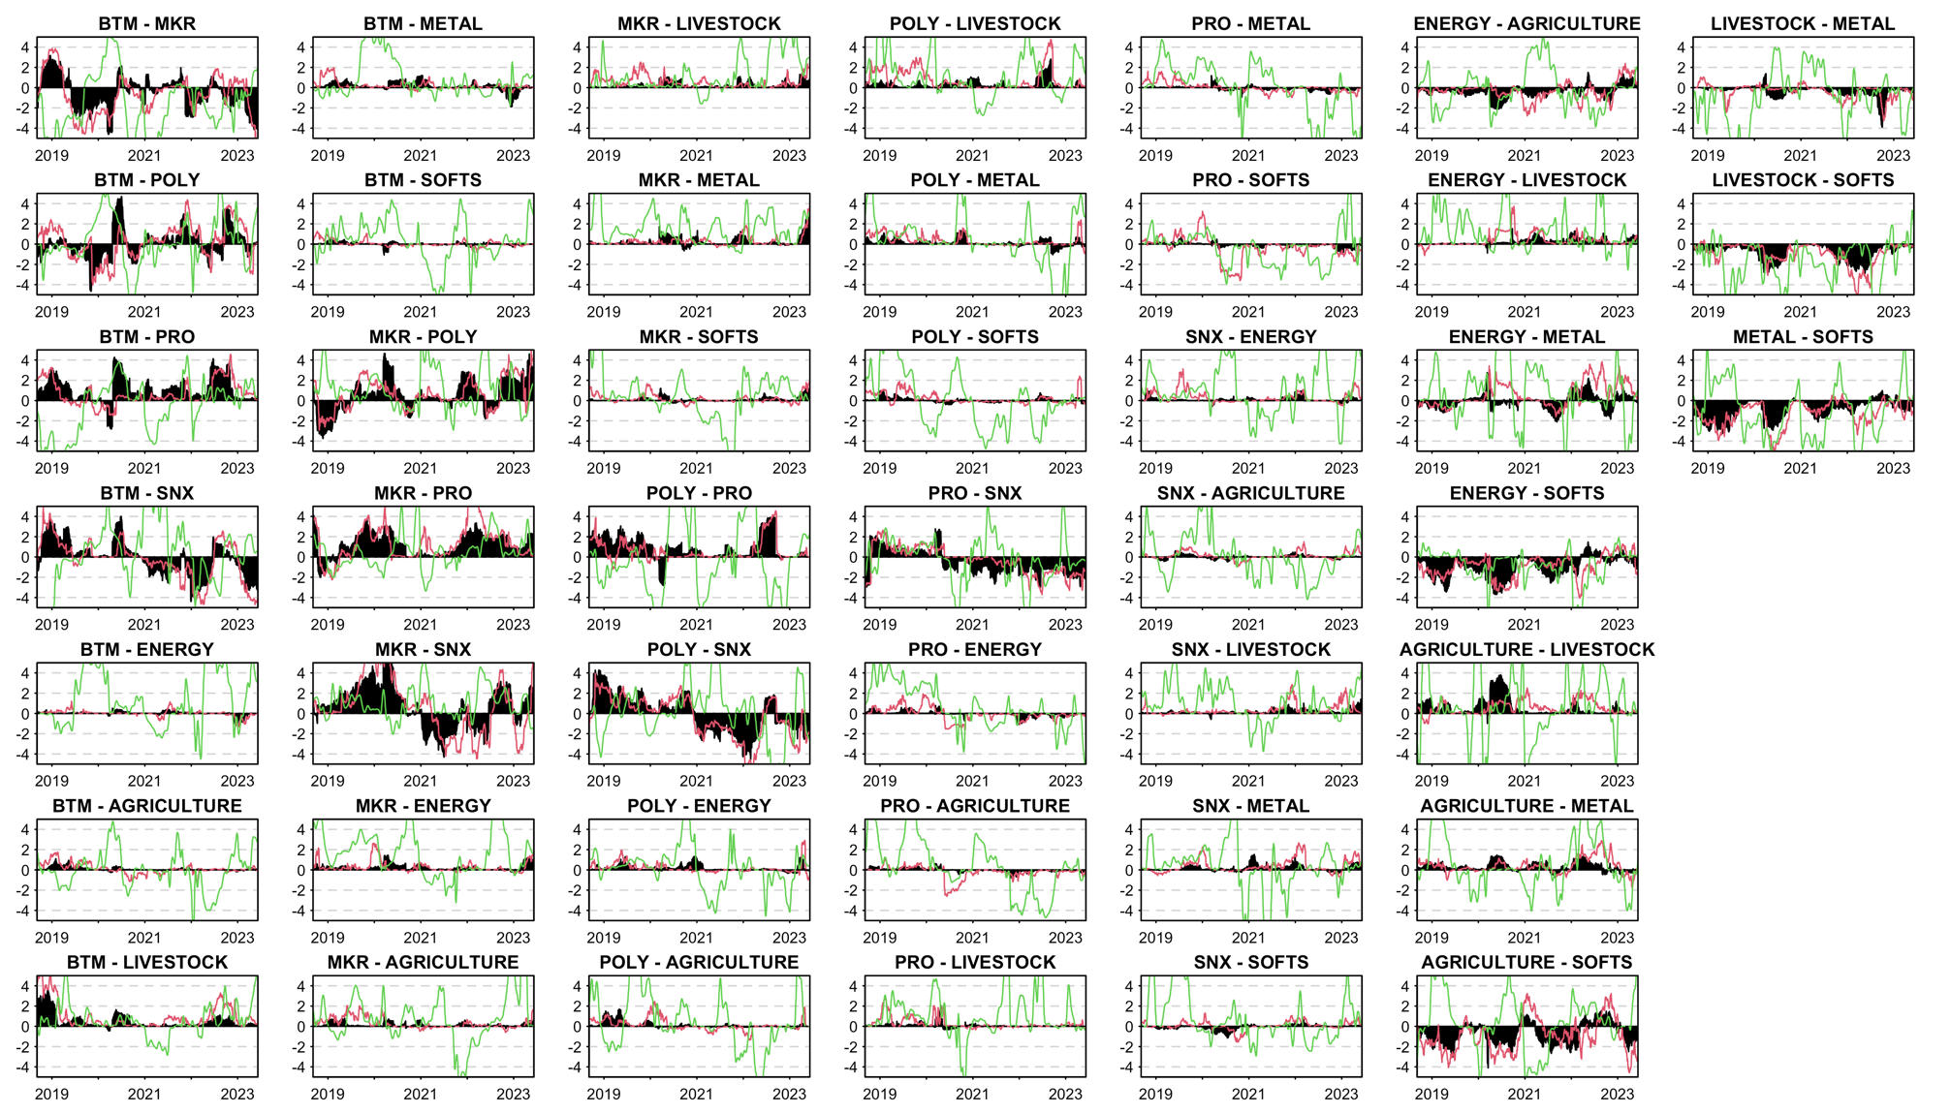
Notes: Results are based on a biannual (126 days) rolling window $R^{2}$ model. Source: Figure by authors.
Figure A.2: Dynamic Net pairwise directional connectedness.
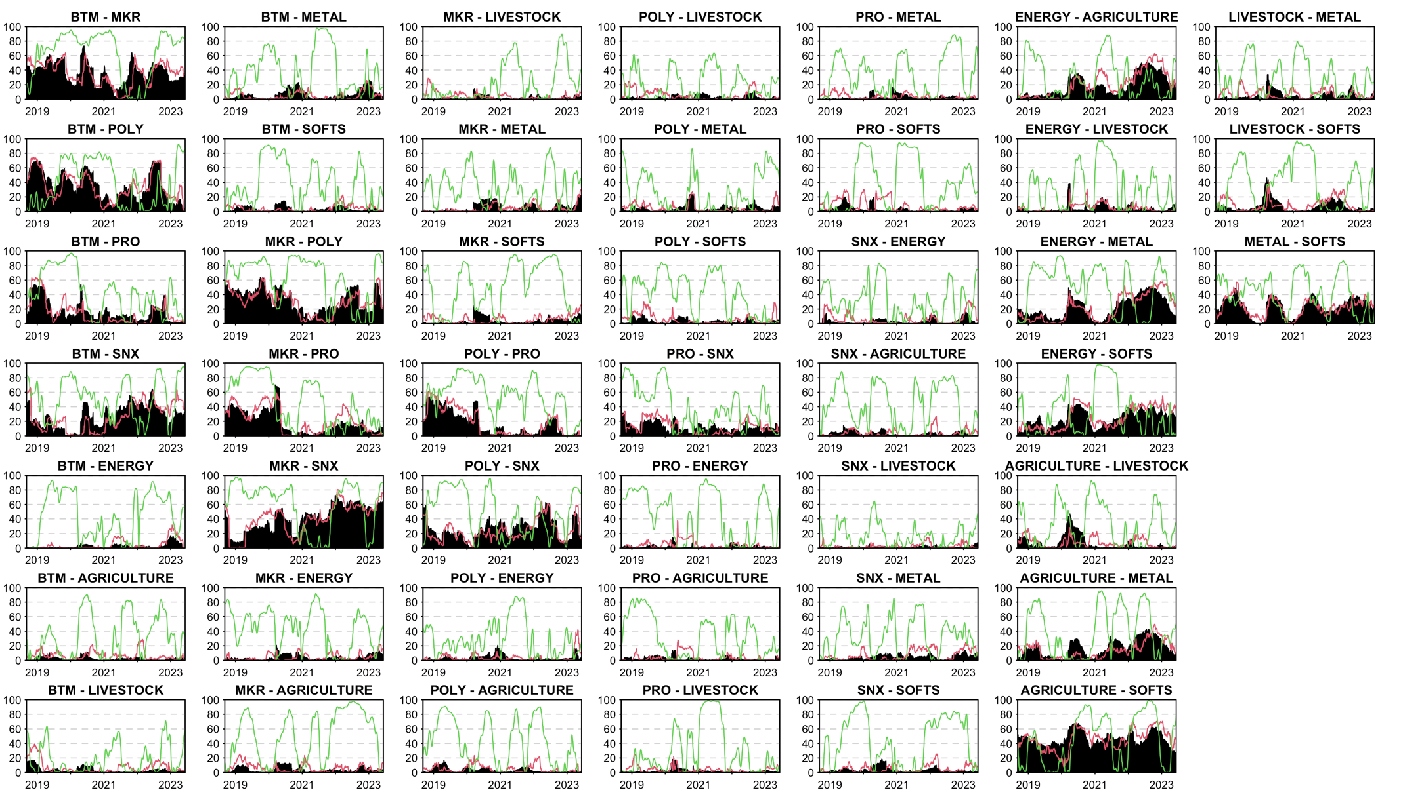
Notes: Results are based on a biannual (126 days) rolling window $R^{2}$ model. Source: Figure by authors.
Figure A.3: Dynamic pairwise connectedness index

