Appendix A
Table A1
Variable Definitions
ASC 606 Effect Variables
NI_606 | Reported net income under ASC 606 for the first quarter of adoption
Rev_606 | Reported total revenue under ASC 606 for the first quarter of adoption
NI_605 | Net income under ASC 605 for the first quarter of adoption of ASC 606 (as-if ASC 606 had not been adopted)
Rev_605 | Total revenue under ASC 605 for the first quarter of adoption of ASC 606 (as-if ASC 606 had not been adopted)
NI_606_Effect | NI_606 - NI_605 divided by Rev_605
ASC606ImpactMagnitude | Absolute value of NI_606_Effect
Negative606Impact | An indicator variable equal to 1 if NI_606_Effect is negative and 0 otherwise
Quintile606ImpactImpact | The quintile ranking of NI_606_Effect
SAB 74 Disclosure Timeliness Variables

DisclosureTimeliness | 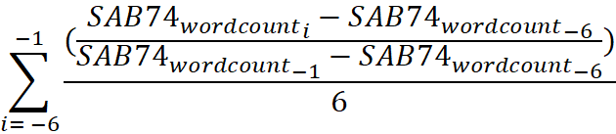
DisclosureTimeliness | where SAB74wordcount is the number of words in the SAB 74 disclosure for ASC 606, -6 is the quarter 6 quarters prior to implementation date (Q3 2016), and -1 is the quarter immediately prior to implementation date (Q4 2017). This measure is similar in construction to Intra-Period Timeliness of stock prices, see Butler et al. (2007) or Twedt (2016).  If the numerator is greater than one (for example, in quarter -4 there were more words than there were in quarter -1) and adjustment was made to calculate the distance from 1. For example, if the numerator is 1.3, I transformed the numerator to be equal to 0.7, which is the same distance away from 100% disclosure. The minimum for this measure is truncated to be zero.
DisclosureJumpQuarter | This variable identifies which quarter (-5 through -1) experiences the largest jump in disclosure length—serving as a simple indicator of whether a firm’s meaningful SAB 74 information is released earlier or later in the pre-adoption timeline. Taking values from 1 to 5, a higher value indicates that the largest disclosure jump occurred more distantly from quarter -1. For example, if the largest increase in the SAB 74 disclosure occurred from the quarter Q = -4 to the quarter Q= -3, then the value of DisclosureJumpQuarter = 3.

Analyst Forecast Characteristic Variables
AFE | Analyst forecast error, measured as the I/B/E/S analyst median analyst forecast made 90 days before earnings announcement date of the first period under implementation minus the I/B/E/S actual earnings, scaled by stock price at the close of the most recent quarter
AbsAFE | Absolute value of the median analyst forecast made 90 days before earnings announcement date of the first period under implementation, minus IBES actual (I/B/E/S), scaled by stock price at the close of the most recent quarter
AnalystDispersion | Standard deviation of unique analysts' forecasts of EPS for the Q of adoption (Q1 2018) released 90 days prior to fiscal period end (I/B/E/S), scaled by stock price at the close of the most recent quarter

Control Variables
ComparePoliciesDisclosure | Indicator equal to one if the firm compares old and new accounting policies in the SAB 74 ASC 606 disclosure in quarter before adoption (-1)
ImplementationStatusDisclosure | Indicator equal to one if the firm describes their status of the implementation in the SAB 74 ASC 606 disclosure in quarter before adoption (-1)
QualitativeImpactDisclosure | Indicator equal to one if the firm gives a qualitative directional income statement effect (i.e. revenues will be accelerated under the new standard) in the SAB 74 ASC 606 disclosure in quarter before adoption (-1)
SAB74FinalWordCount | Number of words in SAB 74 ASC 606 disclosure in quarter before adoption (-1)
PYDispersion | Standard deviation of unique analysts' forecasts of EPS for Q1 2017 (one year prior to the adoption of ASC 606) released 90 days prior to fiscal period end (I/B/E/S), scaled by stock price at the close of the most recent quarter
InstitutionalOwnership | Institutional ownership percentage (from Thompson Reuters)
10KLength | The number of words in the 10-K immediately prior to ASC 606 adoption (EDGAR)
GuidancePastYear | Equal to one if the firm provides guidance at all in the year prior to implementation of ASC 606
NumGuidancePastYear | Number of guidance provided in the year prior to ASC 606
GuidedEPSQ12018 | Indicator equal to one if the firm guided EPS for quarter of ASC 606 adoption (Q1 2018)
RestOrWeaknessPast3Years | Indicator equal to one if the firm has had a material restatement or material weakness in a period 3 years prior to the adoption period
Sales | Natural log of total revenue for implementation period (Q1 2018; Source: Compustat)
NumBusSegs | Numer of business segments (Compustat)
AnalystFollowing | Number of unique analysts forecasting earnings within 90 days of Q1 2018 fiscal period end
LogFirmAge | Natural log of 1 + firm age (Compustat)
LogMarketCap | Natural log of market value of equity (Compustat)
BookToMarket | Book value of equity / market value of equity
SalesVolatility | Standard deviation of total sales for the 8 quarters prior to the adoption period of ASC 606, scaled by total assets at the quarter of adoption
Warranty | Indicator equal to one if the 10-K prior to ASC 606 adoption period contains the word "warranty", zero otherwise
MultipleElementArrangement | Indicator equal to one if the 10-K prior to ASC 606 adoption period contains the phrase "multiple element arrangement", zero otherwise
Rebate | Indicator equal to one if the 10-K prior to ASC 606 adoption period contains the word "rebate", zero otherwise
ComplexityPCA | The fitted value from a Principle Component Analysis of SalesVolatility, Warranty, Imel, Rebate, NumBusSegs, and ASC606ImpactMagnitude
CEOChairDuality | Indicator equal to one if the CEO is the Chairman of the Board, zero otherwise
BoardSize | Number of directors on the board as of Q1 2018
Concentration | The Herfindahl–Hirschman Index (HHI) of annual sales within each three-digit SIC industry. It is computed by summing the squared sales shares of all firms in the industry, where each firm’s sales share is its total annual sales divided by the industry’s total annual sales. Higher values indicate greater market concentration.
Tangibility | Net Property, Plant, and Equipment, scaled by total assets as of Q1 2018
RD | Research and Development Expense, scaled by total assets as of Q1 2018
ROA | Net income divided by total assets as of Q1 2018
Big4Auditor | Indicator equal to one if the auditor is a Big 4 firm, zero otherwise
Note. All continuous variables are winsorized at the 1% and 99% levels.
Appendix B
Step 1 Hand-collection example (Q1 2018 ASC 606 effect)
Hilton Grand Vacations: Impact of New Revenue Guidance on Financial Statement Line Items
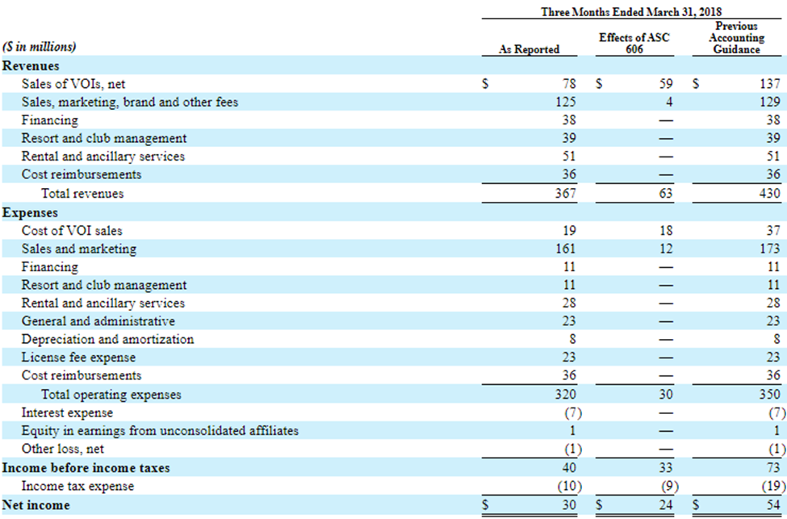
The above table is from a sample firm’s 10-Q for the first period under implementation of ASC 606, utilizing the modified retrospective adoption approach. The red boxes underscore the four items that were hand-collected to measure NI606Effect and Rev606Effect.
Appendix C
Step 2 Hand-collection example (SAB 74 disclosures and DisclosureTimeliness measurement)
Below is an example of the i = -6 and i = -5 (Q3 and Q4 2016) SAB 74 disclosures for Fiserv Inc. The company initially has a boilerplate disclosure, informing users that there is a change to their accounting upcoming, describing the new standard, and disclosing that the company is currently assessing the impact. The number of words in this disclosure is 233. In the following quarter, the company increased the disclosure to 479 words, including substantially the same paragraph from the previous quarter, while adding firm-specific information such as implementation status and expected directional impacts on certain income statement items. The next four quarters leading up to the implementation date, the company’s disclosure increased very little to the final quarter before implementation to include 571 words.
DisclosureTimeliness is calculated as:
$$\sum_{i= -6}^{-1}{\frac{(\frac{{SAB{74}_{wordcount}}_{i}-{SAB{74}_{wordcount}}_{-6}}{{SAB{74}_{wordcount}}_{-1}-{SAB{74}_{wordcount}}_{-6}})}{6}}$$
Fiserv’s word counts and percentage to full disclosure each quarter leading up to the final quarter is presented in the table below:
Quarter | Fiserv SAB74 disclosure length | Percent to Full disclosure
-6 | 233 | 0.0%
-5 | 479 | 72.8%
-4 | 503 | 79.9%
-3 | 568 | 99.1%
-2 | 569 | 99.4%
-1 | 571 | 100.0%

For Fiserv Inc., the calculation for DisclosureTimeliness is:
$\frac{(233-233)/(571-233)}{6}+\frac{(479-233)/(571-233)}{6}+\frac{(503-233)/(571-233)}{6}+\frac{(568-233)/(571-233)}{6}+\frac{(569-233)/(571-233)}{6}+\frac{(571-233)/(571-233)}{6}$ = 0.7519724
In the rightmost column, each entry represents the fraction of the gap to full disclosure 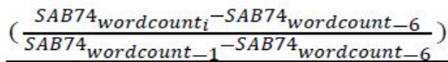 already covered by quarter i, where quarter -6 is the boilerplate baseline (233 words) and quarter -1 is the final disclosure (571 words). We then average these six numbers (0.0%, 72.8%, 79.9%, etc.) to obtain DisclosureTimeliness of 0.75. Graphically, consider plotting “Percent to Full Disclosure” over quarters -6 through -1—the measure essentially becomes the “area under this curve” divided by 6—see below. A high average value (e.g., 0.75) indicates the company reached a large portion of its final disclosure relatively early.

Note that if the numerators in the calculation above are above 1, an adjustment was made, $1- (\frac{{SAB74}_{wordcounti}-{SAB74}_{wordcount-6 }}{{SAB74}_{wordcount-1}-{SAB74}_{wordcount-6 }}-1)$ to calculate the distance from 100% full disclosure. Our results are robust to not making this distance adjustment and instead capping the intermediate quarter’s percentages at 100%.
An additional timeliness variable, DisclosureJumpQuarter, identifies which quarter (-5 through -1) experiences the largest jump in disclosure length—serving as a simple indicator of whether a firm’s meaningful SAB 74 information is released earlier or later in the pre-adoption timeline. Taking values from 1 to 5, a higher value indicates that the largest disclosure jump occurred more distantly from quarter -1. For Fiserv, the largest increase in the disclosures occurs from Q -6 to Q -5, so the value of DisclosureJumpQuarter is 5, indicating early disclosure of SAB 74.
Fiserv Inc. SAB 74 Disclosure for ASC 606- Q3 2016: Baseline “boilerplate” disclosure
In May 2014, the FASB issued ASU No. 2014-09, Revenue from Contracts with Customers (“ASU 2014-09”), to clarify the principles of recognizing revenue and to create common revenue recognition guidance between U.S. generally accepted accounting principles and International Financial Reporting Standards. ASU 2014-09 outlines a single comprehensive model for entities to use in accounting for revenue arising from contracts with customers and supersedes most current revenue recognition guidance. The core principle of the revenue model is that an entity recognizes revenue to depict the transfer of promised goods or services to customers in an amount that reflects the consideration to which the entity expects to be entitled in exchange for those goods or services. This model involves a five-step process for achieving that core principle, along with comprehensive disclosures about the nature, amount, timing and uncertainty of revenue and cash flows arising from contracts with customers. In July 2015, the FASB deferred the effective date of the new revenue standard for one year and will permit early adoption as of the original effective date in ASU 2014-09. For public entities, the standard is effective for annual and interim periods beginning after December 15, 2017. Entities have the option of using either a full retrospective or a modified approach to adopt this new guidance. The Company is currently assessing the impact that the adoption of ASU 2014-09 will have on its consolidated financial statements.

Appendix C, Continued
Fiserv Inc. SAB 74 Disclosure for ASC 606- Q4 2016: Increased disclosure
In May 2014, the FASB issued ASU No. 2014-09, Revenue from Contracts with Customers (“ASU 2014-09”), to clarify the principles of recognizing revenue and to create common revenue recognition guidance between U.S. generally accepted accounting principles and International Financial Reporting Standards. ASU 2014-09 outlines a single comprehensive model for entities to use in accounting for revenue arising from contracts with customers and supersedes most current revenue recognition guidance. The core principle of the revenue model is that an entity recognizes revenue to depict the transfer of promised goods or services to customers in an amount that reflects the consideration to which the entity expects to be entitled in exchange for those goods or services. This model involves a five-step process for achieving that core principle, along with comprehensive disclosures about the nature, amount, timing and uncertainty of revenue and cash flows arising from contracts with customers. In August 2015, the FASB issued ASU 2015-14, Revenue from Contracts with Customers (Topic 606): Deferral of the Effective Date, to defer the effective date of the new revenue standard for one year and permit early adoption as of the original effective date in ASU 2014-09. For public entities, the new revenue standard is effective for annual and interim periods beginning after December 15, 2017. The Company plans to adopt ASU 2014-09 on January 1, 2018.

The Company has performed a review of the requirements of the new revenue standard and related ASUs and is monitoring the activity of the FASB and the transition resource group as it relates to specific interpretive guidance. The Company is reviewing customer contracts and is in the process of applying the five-step model of the new revenue standard to each of its key identified revenue streams included within either processing and services revenue or product revenue and is comparing the results to its current accounting practices. While the Company continues to assess all potential impacts of adopting this new revenue standard on its consolidated financial statements, it currently believes the new revenue standard will not have a significant impact on the accounting for stand-ready account- and transaction-based processing fees, the Company’s most significant revenue stream. Areas that the Company currently expects will be impacted by the new revenue standard include the accounting for costs to obtain a contract, such as commissions for sales personnel, which are currently expensed as incurred, and the timing of revenue recognition of certain termination fees over the modified contract term, which will generally result in an acceleration of revenue as compared to our current accounting practice.

Entities have the option of adopting this new guidance using either a full retrospective or a modified approach with the cumulative effect of applying the guidance recognized at the date of initial application. The Company is currently evaluating the transition method to elect as well as necessary control and process changes due to implementing the new revenue standard.

