10, 11, 12 topic model evaluations

Table of Contents
Selecting optimal topic number 2
Ten topics 3
Keywords and texts 3
Topic correlations 13
Eleven topics 14
Keywords and texts 14
Topic correlations 24
Twelve topics 25
Keywords and texts 25
Topic correlations 28

Topic number selection:
Semantic coherence: measures the likelihood that the most probable words in a topic co-occur in the same documents.
Exclusivity: measures words that are more likely to appear in one topic rather than in others.

Keywords:
Prob: Highest probability
FREX: Most frequent and exclusive
Score: Log frequency of the word in the topic divided by the log frequency of the word in other topics.

Texts:
Title of the most representative texts whose abstract has the highest proportion of that topic. Unrelated to influence or quality.

Topic correlations:
Nodes are joined if they share a positive correlation coefficient.

Selecting optimal topic number
The plot below illustrates how we selected the number of topics. We first evaluated the semantic coherence and exclusivity of topic numbers between three and 30, in intervals of three, to narrow the window of suitable topic numbers. The results of our evaluation of 3 to 30 topics, shown in the plot on the left, suggested that between 6 and 12 topics may be optimal. Semantic coherence degraded for models of more than 12 topics, while adding little to their exclusivity. We then evaluated this finer range of 6 to 12 topic numbers, shown on the plot on the right of the plot. The results suggest that 10 or 11 topics would yield the best balance between semantic coherence and exclusivity.

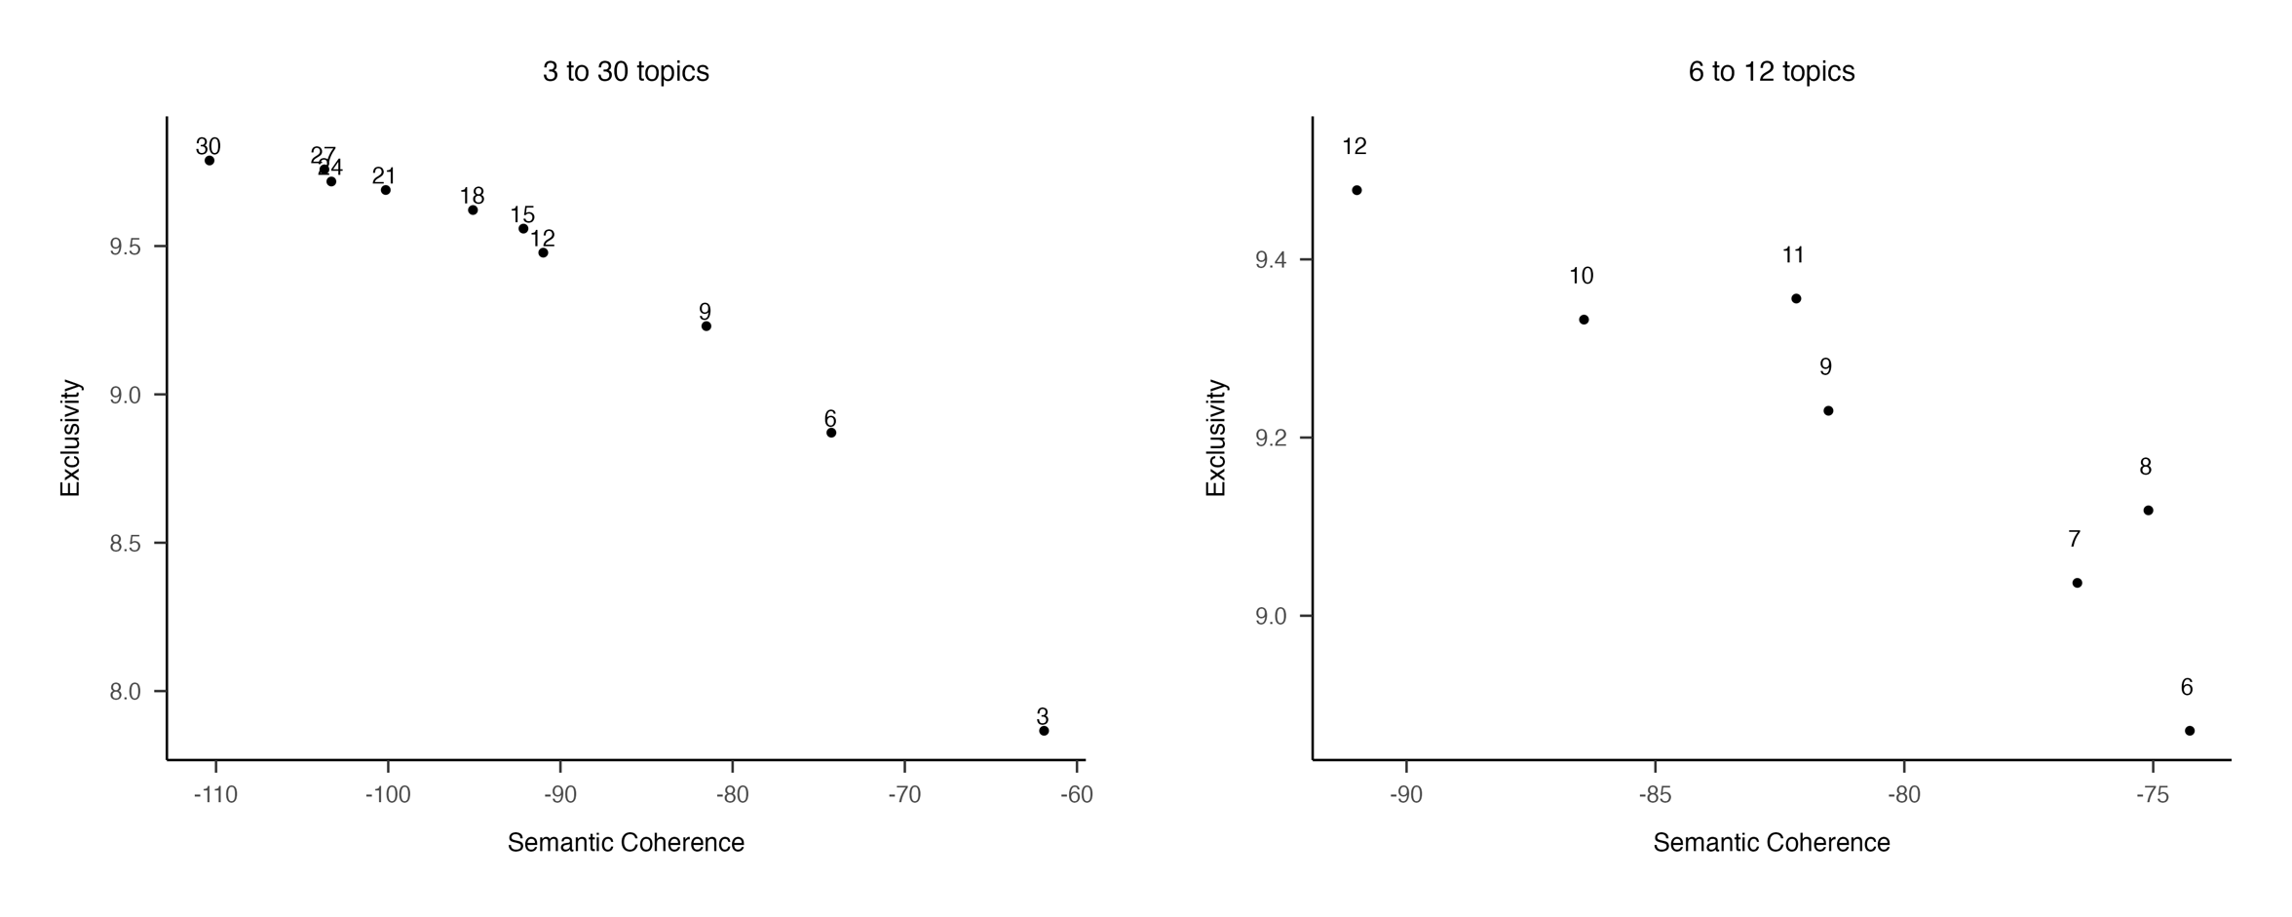

Figure 1: Exclusivity and semantic coherence of three to 30 topics (left) and six to 12 topics (right).

To decide between 10 and 11 topics, we ran and evaluated both models. For each model, we manually reviewed lists of the words most associated with each topic, the titles of the articles most closely associated with each topic, and the structure of correlations between topics (shown in remainder of this file). We found that the 11-topic model resulted in qualitatively meaningful, coherent and distinct topics and did not decline in quality when compared to the 10-topic model. To be certain of our choice, we also evaluated the 12-topic model to be sure that we could rule it out. Indeed, we found that the coherence of some topics started to break down, as the plot on the right suggested it would.

Ten topics

Keywords and texts

One | Highest Prob: skills, skill, education, training, engineering, industry, communication, technology, development, student, language, technical, soft, english, knowledge  FREX: tvet, english, proficiency, technical, engineering, digital, efl, teachers, soft, skill, literacy, engineer, language, ict, communication  Score: skills, engineering, skill, soft, technical, english, language, digital, tvet, student, communication, teacher, technology, education, curriculum | PRESENTATION AS EMPLOYABILITY SOFT SKILL TO ESP LEARNERS IN THE ENGLISH LANGUAGE INSTITUTE AT KING ABDULAZIZ UNIVERSITY  GREENING THE WAY FORWARD: A QUALITATIVE ASSESSMENT OF GREEN TECHNOLOGY INTEGRATION AND PROSPECTS IN A CHINESE TECHNICAL AND VOCATIONAL INSTITUTE  CONTEMPORARY EMPLOYABILITY SKILLS NEEDED FOR LEARNERS TO SUCCEED IN THE CIVIL TECHNOLOGY FIELD IN THE 4IR ERA  ENGLISH COMMUNICATION SKILLS AND EMPLOYABILITY IN THE ARABIAN GULF: THE CASE OF OMAN  INCORPORATION OF "HUMAN VALUES" IN ALL HIGHER EDUCATION CURRICULA (TECHNICAL & NON-TECHNICAL) - AN INEVITABLE ACTION TO ERADICATE DISCRIMINATIONS  A STUDY ON AMELIORATING INDIAN ENGINEERING STUDENTS’ COMMUNICATION SKILLS IN RELATION WITH CEFR  STAKEHOLDER’S PERSPECTIVES OF THE TWENTY-FIRST CENTURY SKILLS  IMPLEMENTATION OF TEACHING METHODS IN MECHANICAL ENGINEERING PROGRAM AT THE MALAYSIA’S VOCATIONAL COLLEGE  THE REFORMING OF VOCATIONAL TEACHER TRAINING COLLEGES IN TURKEY  ENGLISH FOR STUDENTS OF TECHNOLOGY
Two | Highest Prob: social, policy, education, labour, market, economic, employment, high, country, people, young, development, youth, focus, mobility  FREX: migrant, neoliberal, migration, discourse, union, political, activation, refugees, policy, neet, inequality, vet, almp, europe, labour  Score: labour, policy, discourse, migrant, youth, market, welfare, neoliberal, young, education, country, capital, economy, economic, people | SPATIAL MOBILITY, WORKERS AND JOBS: PERSPECTIVES FROM THE NORTHERN IRELAND EXPERIENCE  TALKING THE TALK OF SOCIAL MOBILITY: THE POLITICAL PERFORMANCE OF A MISGUIDED AGENDA  YOUNG EU MIGRANT CITIZENS’ ACCESS TO FINANCIAL INDEPENDENCE IN CONDITIONS OF PRECARIOUS WORK: A TRIPARTITE APPROACH TO WELFARE CONDITIONALITY  UNEVEN GEOGRAPHIES OF YOUTH VOLUNTEERING IN UGANDA: MULTI-SCALAR DISCOURSES AND PRACTICES  FROM SOCIAL SECURITY TO INDIVIDUAL RESPONSIBILITY (PART TWO): WRITING OFF POOR WOMEN'S WORK IN THE WELFARE REFORM ACT 2009  OBSCENITY AND FABRICATION IN EQUITY AND WIDENING PARTICIPATION METHODOLOGIES  BETWEEN INTEGRATION AND REPATRIATION–FRONTLINE EXPERIENCES OF HOW CONFLICTING IMMIGRANT INTEGRATION POLICIES HAMPER THE INTEGRATION OF YOUNG REFUGEES IN DENMARK  AGENDA-SETTING FOR VET POLICY IN THE WESTERN BALKANS: EMPLOYABILITY VERSUS SOCIAL INCLUSION  NEW LABOURERS? MAKING A NEW DEAL FOR THE 'WORKLESS CLASS'  NEO-LIBERAL SUBJECTIVITIES AND THE EMERGENCE OF SPIRITUAL ENTREPRENEURSHIP: AN ANALYSIS OF SPIRITUAL DEVELOPMENT PROGRAMS IN CONTEMPORARY ROMANIA
Three | Highest Prob: relationship, perceived, employees, implication, effect, organization, social, organizational, employee, model, management, role, human, design, resource  FREX: organizational, intention, hrm, equation, entrepreneurial, employee, organization, commitment, turnover, internal, sem, external, modeling, structural, indirect  Score: employees, employee, organizational, turnover, equation, entrepreneurial, intention, perceived, entrepreneurship, relationship, sem, mediate, mediating, moderating, organization | EMPLOYABILITY PARADOX: THE EFFECT OF DEVELOPMENT IDIOSYNCRATIC DEALS ON RECIPIENT EMPLOYEES’ TURNOVER INTENTION  RELATIONSHIP BETWEEN PERCEIVED EMPLOYABILITY AND SABOTAGE BEHAVIOR: MODERATING ROLES OF PERCEIVED ORGANIZATIONAL SUPPORT AND PROCEDURAL JUSTICE  CAN TRAINING PROMOTE EMPLOYEE ORGANIZATIONAL COMMITMENT? THE EFFECT OF EMPLOYABILITY AND EXPECTATION VALUE  VALENCE OF FORMAL LEARNING, EMPLOYABILITY AND THE MODERATING ROLES OF TRANSFORMATIONAL LEADERSHIP AND INFORMAL LEARNING IN THE PUBLIC SECTOR  ENHANCING PERCEIVED EMPLOYABILITY: AN INTERACTIONIST PERSPECTIVE ON RESPONSIBILITIES OF ORGANIZATIONS AND EMPLOYEES  THE EFFECTS OF LEADER-MEMBER EXCHANGE AND EMPLOYEE LEARNING ON PERCEIVED EMPLOYABILITY  AUTHORITARIAN AND BENEVOLENT LEADERSHIP: THE ROLE OF FOLLOWER HOMOPHILY, POWER DISTANCE ORIENTATION AND EMPLOYABILITY  HIGH-INVOLVEMENT HUMAN RESOURCE PRACTICES, EMPLOYEE LEARNING AND EMPLOYABILITY  DOES EMPLOYEE ENVY DRIVE SERVICE SABOTAGE? EVIDENCE FROM HOTEL ORGANIZATIONS  UNDERSTANDING HOW SATISFACTORY SERVICE RELATIONSHIPS CAN BE MUTUALLY BENEFICIAL IN THE HIGHER EDUCATION CONTEXT
Four | Highest Prob: student, learning, work, university, practice, experience, development, education, teaching, project, design, skills, develop, assessment, activity  FREX: authentic, wil, module, experiential, reflective, eportfolio, pedagogy, learning, pedagogical, project, integrated, capstone, translation, reflection, sport  Score: student, learning, wil, teaching, placement, curriculum, university, pedagogical, module, authentic, project, undergraduate, assessment, embed, reflective | PUTTING THE ACTION INTO POLITICS: EMBEDDING EMPLOYABILITY IN THE ACADEMIC CURRICULUM  COURSE PLANNING FROM FIRST PRINCIPLES AND EARLY INTERVENTION: THE CASE FOR STUDIO-BASED LEARNING - NO DRAWING BOARD REQUIRED  A NEW HUB-AND-SPOKE BIOLOGY CURRICULUM DESIGNED AROUND INTERDISCIPLINARY LABORATORY PRACTICAL SESSIONS TO ENHANCE STUDENT EMPLOYABILITY  INCLUSIVE WORK-INTEGRATED LEARNING IN HIGHER EDUCATION: A SCOPING REVIEW  AN EVALUATION OF LEARNER-GENERATED CONTENT AND PODCASTING  LEVERAGING THE COLLABORATIVE AND INTERACTIVE POTENTIAL OF 21ST CENTURY LEARNING SPACES: VICTORIA UNIVERSITY'S STUDENT BUSINESS INNOVATION AND INCUBATION SPACE  ENGAGING THE STUDENTS IN ACTIVITY BASED LEARNING FOR FUTURE EMPLOYABILITY  STUDENTS’ PERCEPTION OF WRITTEN, AUDIO, VIDEO AND FACE-TO-FACE REFLECTIVE APPROACHES FOR HOLISTIC COMPETENCY DEVELOPMENT  KICKSTARTING CREATIVE COLLABORATION: PLACING AUTHENTIC FEEDBACK AT THE HEART OF ONLINE DIGITAL MEDIA EDUCATION  EVALUATING ALTERNATIVE WORK-INTEGRATED LEARNING OPPORTUNITIES: STUDENT PERCEPTIONS OF INTERDISCIPLINARY INDUSTRY-BASED PROJECTS
Five | Highest Prob: graduate, university, employer, education, high, student, skills, employment, market, degree, business, institution, competencies, perception, industry  FREX: graduate, internships, internship, graduates, phd, tourism, accounting, veterinary, heis, alumni, master, marketing, degrees, lis, degree  Score: graduate, university, student, internship, employer, heis, graduates, curriculum, lis, competencies, internships, skills, curricula, education, accounting | EMPLOYABILITY OUTCOMES FOR UNIVERSITY JOINT HONOURS GRADUATES  CHARTERED PROFESSIONAL ACCOUNTANT'S COMPETENCIES: THE SYNERGY BETWEEN ACCOUNTING EDUCATION AND EMPLOYERS' NEEDS—EVIDENCE FROM ALBERTA  DO ACCREDITED UNDERGRADUATE ACCOUNTING PROGRAMMES IN AUSTRALIA MEET THE NEEDS AND EXPECTATIONS OF THE ACCOUNTING PROFESSION?  EDUCATIONAL ADVANTAGE AND EMPLOYABILITY OF UK UNIVERSITY GRADUATES  EXPLORING EDUCATIONAL ADVANTAGE IN THE UK VIA GRADUATE EMPLOYMENT OF JOINT HONOURS DEGREES BY EXAMINING PRE-UNIVERSITY TARIFF AND DEGREE CLASSIFICATION  CHALLENGES IN OBTAINING EMPLOYMENT IN CHINA: LIVED EXPERIENCES OF AUSTRALIAN CHINESE GRADUATES  ARE GRADUATES OF BACHELOR’S DEGREE PROGRAMS IN GERONTOLOGY EMPLOYED? A REPORT OF A NATIONAL SURVEY  EMPLOYABILITY CHALLENGES FACING VOCAL ART GRADUATES IN SOUTH AFRICA: A CASE STUDY OF TSHWANE UNIVERSITY OF TECHNOLOGY  GRADUATE READINESS FOR A PROFESSIONAL CAREER IN ACCOUNTING - AN INVESTIGATION OF EMPLOYERS' PERSPECTIVES IN FIJI  DO REAL ESTATE COURSES SUFFICIENTLY DEVELOP GRADUATES’ EMPLOYABILITY SKILLS? PERSPECTIVES FROM MULTIPLE STAKEHOLDERS
Six | Highest Prob: career, student, development, success, capital, efficacy, identity, work, individual, professional, personal, future, adaptability, relate, support  FREX: career, adaptability, protean, identity, resilience, efficacy, music, psychology, proactive, orientation, exploration, success, aspiration, emotional, personality  Score: career, identity, protean, capital, student, adaptability, efficacy, music, psychological, proactive, boundaryless, success, resilience, emotional, orientation | FREELANCERS AS PROTEAN CAREERISTS: WHY AND HOW CAREER META-COMPETENCIES LEAD TO CAREER SUCCESS  THE MULTIDIMENSIONAL NATURE OF CAREER SELF-MANAGEMENT BEHAVIOURS AND THEIR RELATION TO FACETS OF EMPLOYABILITY  HOW THEATRE ACTORS IN FLANDERS MAKE SENSE OF AND ENACT THEIR EMPLOYABILITY IN A CONTEXT IN MOTION: A MATTER OF FIT  HOW DOES PROACTIVE PERSONALITY PROMOTE AFFECTIVE WELL-BEING? A CHAINED MEDIATION MODEL  CAREER IDENTITY AND THE COMPLEX MEDIATING RELATIONSHIPS BETWEEN CAREER PREPARATORY ACTIONS AND CAREER PROGRESS MARKERS  EMOTIONAL INTELLIGENCE AS A PREDICTOR OF EMPLOYEES' CAREER ADAPTABILITY  THE INFLUENCE OF CAREER DECISION-MAKING SELF-EFFICACY ON EMPLOYABILITY OF HIGHER VOCATIONAL STUDENTS: MEDIATED BY EMOTIONAL INTELLIGENCE  PREDICTORS OF "NEW ECONOMY" CAREER ORIENTATION IN AN AUSTRALIAN SAMPLE OF LATE ADOLESCENTS  CROSS-SECTIONAL STUDY OF THE RELATIONSHIP BETWEEN TRAIT EMOTIONAL INTELLIGENCE AND CAREER ADAPTABILITY OF CHINESE YOUTHS  STUDENTS' CAREER EXPLORATION: A META-ANALYSIS
Seven | Highest Prob: job, work, worker, employment, age, effect, employees, insecurity, time, result, working, search, relate, individual, find  FREX: insecurity, temporary, craft, crafting, search, worker, older, job, exhaustion, security, permanent, retirement, age, probability, burnout  Score: insecurity, worker, job, temporary, age, employees, retirement, older, crafting, search, exhaustion, contract, loss, vitality, unemployed | THE EFFECTS OF TEMPORARY AGENCY WORK CONTRACT TRANSITIONS ON WELL-BEING  BURN-OUT AND EMPLOYABILITY RATES ARE IMPACTED BY THE LEVEL OF JOB AUTONOMY AND WORKLOAD AMONG DUTCH GASTROENTEROLOGISTS  IS JOB INSECURITY COMPENSATED FOR BY EMPLOYMENT AND INCOME SECURITY?  WORK CHARACTERISTICS IN LONG-TERM TEMPORARY WORKERS AND TEMPORARY-TO-PERMANENT WORKERS: A PROSPECTIVE STUDY AMONG FINNISH HEALTH CARE PERSONNEL  MOTIVES FOR ACCEPTING TEMPORARY EMPLOYMENT: A TYPOLOGY  A LONGITUDINAL PERSON-CENTRED VIEW ON PERCEIVED EMPLOYABILITY: THE ROLE OF JOB INSECURITY  SIGNALING, SELECTION AND TRANSITION: EMPIRICAL EVIDENCE ON STEPPING-STONES AND VICIOUS CYCLES IN TEMPORARY AGENCY WORK  THE RELATIONSHIP BETWEEN JOB INSECURITY AND EMPLOYABILITY AND WELL-BEING AMONG FINNISH TEMPORARY AND PERMANENT EMPLOYEES  THE PROMISE OF FLEXICURITY: CAN EMPLOYMENT AND INCOME SECURITY MITIGATE THE NEGATIVE EFFECTS OF JOB INSECURITY?  JOB INSECURITY IN THE YOUNGER SPANISH WORKFORCE: CAUSES AND CONSEQUENCES
Eight | Highest Prob: health, work, patient, year, care, mental, employment, result, intervention, medical, methods, return, occupational, women, relate  FREX: patient, cancer, epilepsy, pain, tbi, alcohol, survivor, military, pwe, radiology, medical, smoking, cardiac, asthma, injured  Score: patient, health, rehabilitation, injury, cancer, epilepsy, medical, mental, disorder, care, illness, chronic, pain, tbi, surgery | THE ANATOMICAL PATTERN AND DETERMINANTS OF PAIN IN THE NECK AND UPPER LIMBS: AN EPIDEMIOLOGIC STUDY  CORONARY OCCLUSION IN INDUSTRY. A STUDY OF EIGHTY-FOUR CASES WITH REFERENCE TO SUBSEQUENT EMPLOYABILITY  THE RELATIONSHIP BETWEEN NONORGANIC SIGNS AND CENTRALIZATION OF SYMPTOMS IN THE PREDICTION OF RETURN TO WORK FOR PATIENTS WITH LOW BACK PAIN  ANTERIOR CRUCIATE LIGAMENT RECONSTRUCTION IN THE MILITARY PATIENT  DISTURBED CORONARY HEMODYNAMICS IN VESSELS WITH INTERMEDIATE STENOSES EVALUATED WITH FRACTIONAL FLOW RESERVE A COMBINED ANALYSIS OF EPICARDIAL AND MICROCIRCULATORY INVOLVEMENT IN ISCHEMIC HEART DISEASE  FINANCIAL AND VOCATIONAL OUTCOMES 1 YEAR AFTER TRAUMATIC BRAIN INJURY  WHO SHOULD NOT GO HIGH: CHRONIC DISEASE AND WORK AT ALTITUDE DURING CONSTRUCTION OF THE QINGHAI-TIBET RAILROAD  UNEMPLOYMENT AMONG ADULT SURVIVORS OF CHILDHOOD CANCER: A REPORT FROM THE CHILDHOOD CANCER SURVIVOR STUDY  MOTIVATION FOR RETURN TO WORK AND ACTUAL RETURN TO WORK AMONG PEOPLE ON LONG-TERM SICK LEAVE DUE TO PAIN SYNDROME OR MENTAL HEALTH CONDITIONS  EARLY CHILDHOOD ABUSE IN CHRONIC SPINAL DISORDER PATIENTS: A MAJOR BARRIER TO TREATMENT SUCCESS
Nine | Highest Prob: employment, participant, people, job, employer, individual, program, disability, disabilities, training, work, barrier, result, group, candidate  FREX: disabilities, applicant, offender, autistic, autism, discrimination, candidate, disclosure, accommodation, prison, hire, criminal, asd, hiring, disabled  Score: disability, disabilities, applicant, rehabilitation, disabled, offender, discrimination, candidate, autistic, hire, people, disclosure, criminal, employment, psychiatric | BARRIERS TO EMPLOYMENT: RATERS' PERCEPTIONS OF MALE AUTISTIC AND NON-AUTISTIC CANDIDATES DURING A SIMULATED JOB INTERVIEW AND THE IMPACT OF DIAGNOSTIC DISCLOSURE  IMPACT OF LARGE ANGLE HORIZONTAL STRABISMUS ON ABILITY TO OBTAIN EMPLOYMENT  WORKPLACE DISCRIMINATION, DEAFNESS AND HEARING IMPAIRMENT: THE NATIONAL EEOC ADA RESEARCH PROJECT  INVISIBLE DISABILITY DISCLOSURE IN AN EMPLOYMENT INTERVIEW: IMPACT ON EMPLOYERS' HIRING DECISIONS AND VIEWS OF EMPLOYABILITY  WHEN ACCENT DOES NOT MATCH EXPECTATIONS: A DYNAMIC PERSPECTIVE OF L2 SPEAKER EVALUATIONS IN A FRENCH INTERVIEW CONTEXT  WORKPLACE DISCRIMINATION AND DISFIGUREMENT: THE NATIONAL EEOC ADA RESEARCH PROJECT  WORKPLACE DISCRIMINATION AND MISSING LIMBS: THE NATIONAL EEOC ADA RESEARCH PROJECT  SEXUAL OFFENDING AND BARRIERS TO EMPLOYABILITY: PUBLIC PERCEPTIONS OF WHO TO HIRE  STRABISMUS AND EMPLOYMENT: THE OPINION OF HEADHUNTERS  DISABILITY DISCLOSURE EFFECTS ON EMPLOYMENT INTERVIEW RATINGS OF APPLICANTS WITH NONVISIBLE DISABILITIES
Ten | Topic 10 Top Words:  Highest Prob: student, analysis, factor, performance, result, model, academic, university, datum, high, quality, test, scale, questionnaire, measure  FREX: validity, reliability, instrument, items, scale, item, mining, correlation, confirmatory, measure, statistical, machine, indicators, descriptive, version  Score: student, validity, items, academic, performance, reliability, university, confirmatory, test, scale, instrument, satisfaction, measure, factor, mining | DETERMINANTS OF EMPLOYABILITY OF GRADUATES: A CASE STUDY OF UNIVERSITY OF MUMBAI  AN ALTERNATIVE EVALUATION METHOD FOR LIKERT TYPE ATTITUDE SCALES: ROUGH SET DATA ANALYSIS  STUDY OF AN EVALUATION INDEX SYSTEM OF NURSING UNDERGRADUATE EMPLOYABILITY DEVELOPED USING THE DELPHI METHOD  A UNIFIED MODEL OF CLUSTERING AND CLASSIFICATION TO IMPROVE STUDENTS' EMPLOYABILITY PREDICTION  DECISION SUPPORT SYSTEM TO ENHANCE STUDENTS’ EMPLOYABILITY USING DATA MINING TECHNIQUES FOR HIGHER EDUCATION INSTITUTIONS  DEVELOPMENT AND VALIDATION OF CHINESE COLLEGE STUDENTS’ FUTURE EMPLOYABILITY SCALE  PREDICTION OF STUDENTS' EMPLOYABILITY USING CLUSTERING ALGORITHM: A HYBRID APPROACH  EXPLAINING AND PREDICTING GRADUATE EMPLOYABILITY USING DATA-MINING TECHNIQUES  STUDENTS’ EMPLOYABILITY PREDICTION MODEL THROUGH DATA MINING  STUDENT EMPLOYABILITY EXAMINED FROM ACADEMIC ACHIEVEMENT AND SELF-CONCEPT

Topic correlations
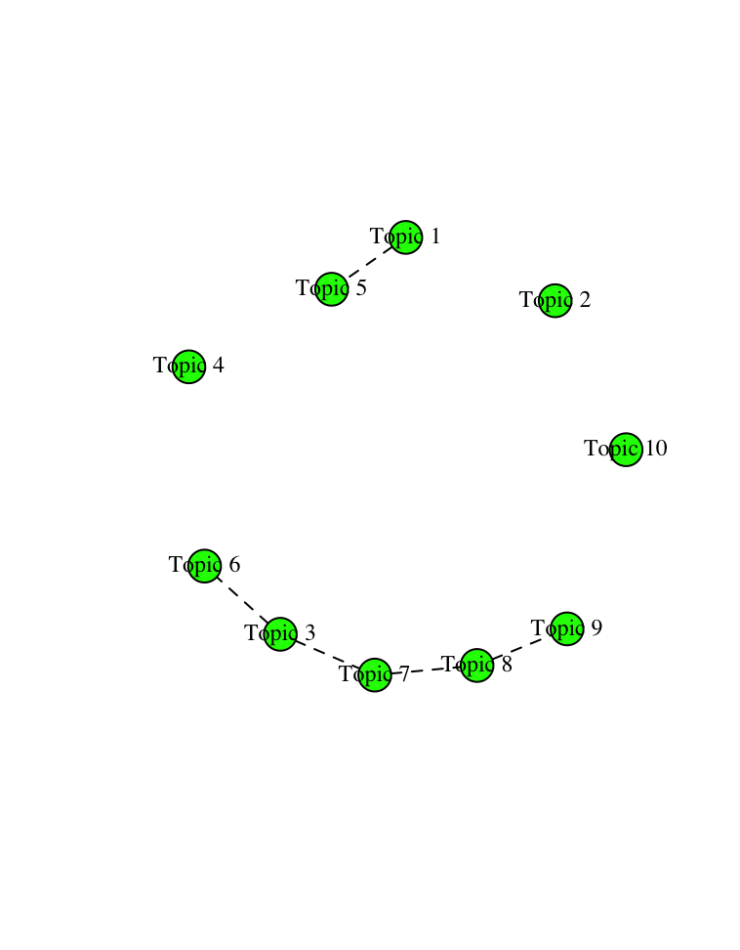

Eleven topics

Keywords and texts
Note: topic order and numbers here are different to those in the manuscript. This is the raw output.

One |  | Highest Prob: skills, skill, education, training, industry, engineering, development, technology, communication, knowledge, technical, soft, competence, digital, teacher  FREX: tvet, engineer, technical, engineering, digital, ict, skill, soft, technology, communication, solving, industrial, literacy, skills, technological  Score: skills, engineering, skill, soft, technical, digital, tvet, technology, industry, communication, curriculum, ict, teacher, solving, teaching | GREENING THE WAY FORWARD: A QUALITATIVE ASSESSMENT OF GREEN TECHNOLOGY INTEGRATION AND PROSPECTS IN A CHINESE TECHNICAL AND VOCATIONAL INSTITUTE  INNOVATION AND RESEARCH SKILL FOR KNOWLEDGE-BASED ECONOMY OF MYANMAR: CURRENT STATUS AND RECOMMENDATION  CONTEMPORARY EMPLOYABILITY SKILLS NEEDED FOR LEARNERS TO SUCCEED IN THE CIVIL TECHNOLOGY FIELD IN THE 4IR ERA  INCORPORATION OF "HUMAN VALUES" IN ALL HIGHER EDUCATION CURRICULA (TECHNICAL & NON-TECHNICAL) - AN INEVITABLE ACTION TO ERADICATE DISCRIMINATIONS  ENHANCING EMPLOYABILITY THROUGH TRAINING AND ASSESSMENT: (A STUDY OF MANAGERIAL TALENT POOL IN INDIA)  STAKEHOLDER’S PERSPECTIVES OF THE TWENTY-FIRST CENTURY SKILLS  AN OVERVIEW OF EMPIRICAL STUDY ON EMPLOYABILITY SKILLS AMONG COLLEGE YOUTH IN 21ST CENTURY  THE HYBRIDIZATION OF THE SPANISH COMMUNICATION FACULTIES: ECONOMIC CRISIS, DIGITALIZATION, AND NEW ACADEMIC APPROACH  IMPLEMENTATION OF TEACHING METHODS IN MECHANICAL ENGINEERING PROGRAM AT THE MALAYSIA’S VOCATIONAL COLLEGE  FRAMEWORK FOR TECHNICAL COMMUNICATION SKILLS CONTENT DEVELOPMENT FOR STUDENTS IN MALAYSIAN VOCATIONAL COLLEGES: A FUZZY DELPHI STUDY
Two |  | Highest Prob: policy, education, social, labour, market, economic, people, young, development, high, focus, government, youth, public, work  FREX: migrant, neoliberal, union, refugees, political, policy, activation, discourse, vet, neet, credential, almp, neoliberalism, roma, england  Score: labour, discourse, policy, migrant, youth, neoliberal, welfare, market, young, political, economy, activation, education, people, vet | A THEORETICAL BASIS FOR GREEN GROWTH  OBSCENITY AND FABRICATION IN EQUITY AND WIDENING PARTICIPATION METHODOLOGIES  IMPACT OF THE EUROPEANISATION OF EDUCATION: QUALIFICATIONS FRAMEWORKS IN EUROPE  BETWEEN INTEGRATION AND REPATRIATION–FRONTLINE EXPERIENCES OF HOW CONFLICTING IMMIGRANT INTEGRATION POLICIES HAMPER THE INTEGRATION OF YOUNG REFUGEES IN DENMARK  BOARDING SCHOOLS IN TRANSITION: A POST-SOCIALIST ANALYSIS OF “RELEVANCE” AS AN EDUCATION POLICY PROBLEM IN MONGOLIA  CO-PRODUCTION AND SOCIAL INNOVATION IN STREET-LEVEL EMPLOYABILITY SERVICES: LESSONS FROM SERVICES WITH LONE PARENTS IN SCOTLAND  (EDUCATION FOR) WORK SETS YOU FREE: ‘EMPLOYABILITY’ AND HIGHER EDUCATION IN FORMER YUGOSLAVIA AND ITS SUCCESSOR STATES  DELIVERING EMPLOYABILITY IN A VANGUARD 'ACTIVE' WELFARE STATE: THE CASE OF GREATER COPENHAGEN IN DENMARK  SPATIAL MOBILITY, WORKERS AND JOBS: PERSPECTIVES FROM THE NORTHERN IRELAND EXPERIENCE  MORAL CODES OF MOTHERING AND THE INTRODUCTION OF WELFARE-TO-WORK IN ONTARIO
Three |  | Highest Prob: student, social, education, international, high, language, english, university, entrepreneurship, entrepreneurial, country, global, mobility, cultural, media  FREX: abroad, intercultural, emi, entrepreneurial, language, english, volunteering, media, international, entrepreneurship, foreign, linguistic, internationalisation, overseas, bilingual  Score: english, language, student, entrepreneurship, international, entrepreneurial, abroad, media, emi, foreign, intercultural, mobility, capital, university, internationalisation | MAINLAND CHINESE STUDENTS AT AN ELITE HONG KONG UNIVERSITY: HABITUS-FIELD DISJUNCTURE IN A TRANSBORDER CONTEXT  THE ROLE OF ENGLISH AS AN AUXILIARY INTERNATIONAL LANGUAGE IN A GLOBALIZED WORLD  INTERNATIONAL EDUCATION 'HERE' AND 'THERE': GEOGRAPHIES, MATERIALITIES AND DIFFERENTIATED MOBILITIES WITHIN UK DEGREES  THE ROLE OF ACCENT AND ETHNICITY IN THE PROFESSIONAL AND ACADEMIC CONTEXT  TWO SIDES OF THE SAME COIN? INTERNATIONALISATION AND EMPLOYABILITY: STUDENTS' PERCEPTIONS OF EMPLOYABILITY AND CAREER OUTCOMES FROM INTERNATIONAL STUDIES  WHY DO STUDENTS CHOOSE ENGLISH AS A MEDIUM OF INSTRUCTION? A BOURDIEUSIAN PERSPECTIVE ON THE STUDY STRATEGIES OF NON-NATIVE ENGLISH SPEAKERS  -ED ALLOMORPHS AND LINGUISTIC KNOWLEDGE OF MALAY SPEAKERS OF ENGLISH: A DESCRIPTIVE AND CORRELATIONAL STUDY  INTERNATIONAL STUDENTS AND THEIR RACIOLINGUISTIC SENSEMAKING OF AURAL EMPLOYABILITY IN CANADIAN UNIVERSITIES  STUDENT MOBILITY IN PORTUGAL: GRAPPLING WITH ADVERSITY  INTERNATIONAL STUDENT MOBILITY: ONSET FOR A FUTURE CAREER OR AN EXPERIENTIAL OPPORTUNITY?
Four |  | Highest Prob: student, learning, work, university, practice, experience, teaching, development, education, design, project, assessment, develop, activity, skills  FREX: wil, authentic, module, eportfolio, reflective, experiential, learning, pedagogy, pedagogical, translation, integrated, teaching, capstone, project, reflection  Score: student, learning, wil, teaching, placement, curriculum, pedagogical, module, university, authentic, assessment, undergraduate, reflective, embed, pedagogy | PUTTING THE ACTION INTO POLITICS: EMBEDDING EMPLOYABILITY IN THE ACADEMIC CURRICULUM  COURSE PLANNING FROM FIRST PRINCIPLES AND EARLY INTERVENTION: THE CASE FOR STUDIO-BASED LEARNING - NO DRAWING BOARD REQUIRED  LEVERAGING THE COLLABORATIVE AND INTERACTIVE POTENTIAL OF 21ST CENTURY LEARNING SPACES: VICTORIA UNIVERSITY'S STUDENT BUSINESS INNOVATION AND INCUBATION SPACE  A NEW HUB-AND-SPOKE BIOLOGY CURRICULUM DESIGNED AROUND INTERDISCIPLINARY LABORATORY PRACTICAL SESSIONS TO ENHANCE STUDENT EMPLOYABILITY  BIOMEDICAL RESEARCH CONFERENCE  AN EVALUATION OF LEARNER-GENERATED CONTENT AND PODCASTING  ‘STUDENTS-AS-PARTNERS’ SCHEME ENHANCES POSTGRADUATE STUDENTS’ EMPLOYABILITY SKILLS WHILE ADDRESSING GAPS IN BIOINFORMATICS EDUCATION  ‘FILMMAKING IS A HARD THING TO DO’: REFLECTIONS ON STUDENT AND LECTURER EXPERIENCE OF FALMOUTH UNIVERSITY’S FILMMAKER IN RESIDENCE INITIATIVE  INCLUSIVE WORK-INTEGRATED LEARNING IN HIGHER EDUCATION: A SCOPING REVIEW  MAKING SHORT POLITICS PLACEMENTS WORK: THE PROFESSION
Five |  | Highest Prob: graduate, university, employer, education, high, skills, market, student, employment, degree, business, competencies, institution, perception, datum  FREX: graduate, internships, internship, tourism, graduates, phd, veterinary, accounting, heis, sport, marketing, competencies, master, degree, lis  Score: graduate, university, internship, employer, student, graduates, heis, curriculum, internships, competencies, lis, curricula, skills, hospitality, accounting | DO ACCREDITED UNDERGRADUATE ACCOUNTING PROGRAMMES IN AUSTRALIA MEET THE NEEDS AND EXPECTATIONS OF THE ACCOUNTING PROFESSION?  CHARTERED PROFESSIONAL ACCOUNTANT'S COMPETENCIES: THE SYNERGY BETWEEN ACCOUNTING EDUCATION AND EMPLOYERS' NEEDS—EVIDENCE FROM ALBERTA  EMPLOYABILITY OUTCOMES FOR UNIVERSITY JOINT HONOURS GRADUATES  EDUCATIONAL ADVANTAGE AND EMPLOYABILITY OF UK UNIVERSITY GRADUATES  DO REAL ESTATE COURSES SUFFICIENTLY DEVELOP GRADUATES’ EMPLOYABILITY SKILLS? PERSPECTIVES FROM MULTIPLE STAKEHOLDERS  GRADUATE READINESS FOR A PROFESSIONAL CAREER IN ACCOUNTING - AN INVESTIGATION OF EMPLOYERS' PERSPECTIVES IN FIJI  EXPLORING EDUCATIONAL ADVANTAGE IN THE UK VIA GRADUATE EMPLOYMENT OF JOINT HONOURS DEGREES BY EXAMINING PRE-UNIVERSITY TARIFF AND DEGREE CLASSIFICATION  SPORTS GRADUATE CAPABILITIES AND COMPETENCIES: A COMPARISON OF GRADUATE AND EMPLOYER PERCEPTIONS IN SIX EU COUNTRIES  ARE WE TEACHING WHAT EMPLOYERS WANT? IDENTIFYING AND REMEDYING GAPS BETWEEN EMPLOYER NEEDS, ACCREDITOR PRESCRIPTIONS, AND UNDERGRADUATE CURRICULAR PRIORITIES  ARE GRADUATES OF BACHELOR’S DEGREE PROGRAMS IN GERONTOLOGY EMPLOYED? A REPORT OF A NATIONAL SURVEY
Six |  | Highest Prob: career, development, success, work, identity, professional, efficacy, individual, personal, future, student, adaptability, capital, transition, life  FREX: career, adaptability, music, identity, resilience, psychology, protean, efficacy, exploration, success, musician, aspiration, orientation, counselling, emotional  Score: career, identity, protean, adaptability, music, efficacy, capital, student, boundaryless, resilience, psychology, counselling, transition, success, emotional | HOW THEATRE ACTORS IN FLANDERS MAKE SENSE OF AND ENACT THEIR EMPLOYABILITY IN A CONTEXT IN MOTION: A MATTER OF FIT  THE MULTIDIMENSIONAL NATURE OF CAREER SELF-MANAGEMENT BEHAVIOURS AND THEIR RELATION TO FACETS OF EMPLOYABILITY  FREELANCERS AS PROTEAN CAREERISTS: WHY AND HOW CAREER META-COMPETENCIES LEAD TO CAREER SUCCESS  PROTEAN AND BOUNDARYLESS CAREERS AS METAPHORS  PREDICTORS OF "NEW ECONOMY" CAREER ORIENTATION IN AN AUSTRALIAN SAMPLE OF LATE ADOLESCENTS  THE MEANING OF DIFFICULTIES IN CAREER NARRATIVES: THE CASE OF SPORTS GRADUATES  EMOTIONAL INTELLIGENCE AS A PREDICTOR OF EMPLOYEES' CAREER ADAPTABILITY  CARPER IDENTITIES AND MILLENNIALS' RESPONSE TO THE GRADUATE TRANSITION TO WORK: LESSONS LEARNED  THE CAREER DECISION-MAKING COMPETENCE: A NEW CONSTRUCT FOR THE CAREER REALM  CAREER MOBILITY AT THE INTERSECTION BETWEEN AGENT AND STRUCTURE: A CONCEPTUAL MODEL
Seven |  | Highest Prob: job, worker, employment, work, market, labor, age, unemployment, effect, time, insecurity, increase, result, low, find  FREX: temporary, insecurity, search, labor, worker, unemployment, probability, security, older, permanent, unemployed, wage, locked, retirement, seeker  Score: insecurity, worker, job, temporary, unemployment, unemployed, retirement, age, market, labour, labor, older, search, employment, women | TOO OLD TO WORK, TOO YOUNG TO RETIRE?  FEWER IN NUMBER BUT HARDER TO EMPLOY: INCIDENCE AND DURATION OF UNEMPLOYMENT IN AN ECONOMIC UPSWING  SOCIAL NETWORKS AND JOB ACCESS FOR THE UNEMPLOYED: WORK TIES FOR THE UPPER-MIDDLE CLASS, COMMUNAL TIES FOR THE WORKING CLASS  MOTIVES FOR ACCEPTING TEMPORARY EMPLOYMENT: A TYPOLOGY  RETAINING THROUGH TRAINING EVEN FOR OLDER WORKERS  TEMPORARY TALENT: WAGE PENALTIES AMONG HIGHLY EDUCATED TEMPORARY WORKERS IN CANADA  EMPLOYABILITY OF YOUNG ITALIAN MEN AFTER A JOBLESS PERIOD, 1989-98  THE EFFECTS OF TEMPORARY AGENCY WORK CONTRACT TRANSITIONS ON WELL-BEING  THE EFFECT OF THE POTENTIAL DURATION OF UNEMPLOYMENT BENEFITS ON UNEMPLOYMENT EXITS TO WORK AND MATCH QUALITY IN FRANCE  TEMPORARY EMPLOYMENT AND THE FUTURE LABOR MARKET STATUS
Eight |  | Highest Prob: health, work, patient, mental, care, year, intervention, result, methods, medical, relate, physical, occupational, return, ability  FREX: patient, cancer, epilepsy, pain, physicians, drug, tbi, substance, alcohol, survivor, physician, military, medical, pwe, radiology  Score: patient, health, rehabilitation, injury, cancer, mental, epilepsy, medical, illness, care, disorder, pain, surgery, diabetes, tbi | THE RELATIONSHIP BETWEEN NONORGANIC SIGNS AND CENTRALIZATION OF SYMPTOMS IN THE PREDICTION OF RETURN TO WORK FOR PATIENTS WITH LOW BACK PAIN  THE ANATOMICAL PATTERN AND DETERMINANTS OF PAIN IN THE NECK AND UPPER LIMBS: AN EPIDEMIOLOGIC STUDY  ANTERIOR CRUCIATE LIGAMENT RECONSTRUCTION IN THE MILITARY PATIENT  WHO SHOULD NOT GO HIGH: CHRONIC DISEASE AND WORK AT ALTITUDE DURING CONSTRUCTION OF THE QINGHAI-TIBET RAILROAD  DISTURBED CORONARY HEMODYNAMICS IN VESSELS WITH INTERMEDIATE STENOSES EVALUATED WITH FRACTIONAL FLOW RESERVE A COMBINED ANALYSIS OF EPICARDIAL AND MICROCIRCULATORY INVOLVEMENT IN ISCHEMIC HEART DISEASE  HEALTH RELATED QUALITY OF LIFE IN CYSTIC FIBROSIS: TO WORK OR NOT TO WORK?  EARLY CHILDHOOD ABUSE IN CHRONIC SPINAL DISORDER PATIENTS: A MAJOR BARRIER TO TREATMENT SUCCESS  HEALTH-RELATED WORK PRODUCTIVITY LOSS IS LOW FOR PATIENTS IN A METHADONE MAINTENANCE PROGRAM IN VIETNAM  CORONARY OCCLUSION IN INDUSTRY. A STUDY OF EIGHTY-FOUR CASES WITH REFERENCE TO SUBSEQUENT EMPLOYABILITY  FINANCIAL AND VOCATIONAL OUTCOMES 1 YEAR AFTER TRAUMATIC BRAIN INJURY
Nine |  | Highest Prob: employment, participant, people, employer, job, program, individual, disability, disabilities, work, barrier, training, person, result, group  FREX: disabilities, applicant, offender, accommodation, autistic, hearing, prison, disclosure, autism, discrimination, accommodations, assistive, candidate, hire, hiring  Score: disability, disabilities, rehabilitation, applicant, disabled, offender, discrimination, candidate, autistic, hire, disclosure, people, criminal, psychiatric, autism | BARRIERS TO EMPLOYMENT: RATERS' PERCEPTIONS OF MALE AUTISTIC AND NON-AUTISTIC CANDIDATES DURING A SIMULATED JOB INTERVIEW AND THE IMPACT OF DIAGNOSTIC DISCLOSURE  IMPACT OF LARGE ANGLE HORIZONTAL STRABISMUS ON ABILITY TO OBTAIN EMPLOYMENT  WORKPLACE DISCRIMINATION, DEAFNESS AND HEARING IMPAIRMENT: THE NATIONAL EEOC ADA RESEARCH PROJECT  INVISIBLE DISABILITY DISCLOSURE IN AN EMPLOYMENT INTERVIEW: IMPACT ON EMPLOYERS' HIRING DECISIONS AND VIEWS OF EMPLOYABILITY  SEXUAL OFFENDING AND BARRIERS TO EMPLOYABILITY: PUBLIC PERCEPTIONS OF WHO TO HIRE  WORKPLACE DISCRIMINATION AND DISFIGUREMENT: THE NATIONAL EEOC ADA RESEARCH PROJECT  WORKPLACE DISCRIMINATION AND MISSING LIMBS: THE NATIONAL EEOC ADA RESEARCH PROJECT  DISABILITY DISCLOSURE EFFECTS ON EMPLOYMENT INTERVIEW RATINGS OF APPLICANTS WITH NONVISIBLE DISABILITIES  WORKPLACE DISCRIMINATION AND CUMULATIVE TRAUMA DISORDERS: THE NATIONAL EEOC ADA RESEARCH PROJECT  STRABISMUS AND EMPLOYMENT: THE OPINION OF HEADHUNTERS
Ten |  | Highest Prob: student, analysis, factor, performance, model, result, academic, university, datum, high, test, scale, questionnaire, quality, measure  FREX: reliability, mining, validity, item, instrument, items, scale, correlation, measure, statistical, psychometric, version, confirmatory, indicators, descriptive  Score: student, validity, items, performance, reliability, confirmatory, academic, test, university, scale, mining, satisfaction, spe, regression, item | AN ALTERNATIVE EVALUATION METHOD FOR LIKERT TYPE ATTITUDE SCALES: ROUGH SET DATA ANALYSIS  CUTTLE FISH CRACKERS PRODUCT QUALITY CONTROL TO REDUCE TOTAL OF PRODUCT DEFECTS IN TRADING COMPANY ARDIAL, BANYUWANGI REGENCY  DETERMINANTS OF EMPLOYABILITY OF GRADUATES: A CASE STUDY OF UNIVERSITY OF MUMBAI  A UNIFIED MODEL OF CLUSTERING AND CLASSIFICATION TO IMPROVE STUDENTS' EMPLOYABILITY PREDICTION  DECISION SUPPORT SYSTEM TO ENHANCE STUDENTS’ EMPLOYABILITY USING DATA MINING TECHNIQUES FOR HIGHER EDUCATION INSTITUTIONS  DEVELOPMENT AND VALIDATION OF CHINESE COLLEGE STUDENTS’ FUTURE EMPLOYABILITY SCALE  POTENTIAL OF LIVESTOCK PRODUCTION SYSTEMS: EXPLAINING EMPLOYABILITY AND MILK PRODUCTIVITY THROUGH MULTIVARIATE TYPOLOGY  EXPLAINING AND PREDICTING GRADUATE EMPLOYABILITY USING DATA-MINING TECHNIQUES  PREDICTION OF STUDENTS' EMPLOYABILITY USING CLUSTERING ALGORITHM: A HYBRID APPROACH  MULDASA: MULTIFACTOR LEXICAL SENTIMENT ANALYSIS OF SOCIAL-MEDIA CONTENT IN NONSTANDARD ARABIC SOCIAL MEDIA
Eleven |  | Highest Prob: relationship, perceived, employees, effect, organization, employee, job, work, organizational, implication, result, role, resource, positive, model  FREX: turnover, organizational, employee, modeling, equation, organization, mediation, employees, hrm, mediate, mediating, positively, perceived, moderating, relationship  Score: employees, employee, organizational, turnover, equation, mediate, psychological, perceived, mediating, mediation, moderating, relationship, sem, intention, structural | DOES EMPLOYEE ENVY DRIVE SERVICE SABOTAGE? EVIDENCE FROM HOTEL ORGANIZATIONS  INVESTIGATING THE ROLE OF EMPLOYEE PSYCHOLOGICAL WELL-BEING AND PSYCHOLOGICAL EMPOWERMENT WITH RELATION TO WORK ENGAGEMENT AND SUSTAINABLE EMPLOYABILITY  EMPLOYABILITY AND PERFORMANCE: THE ROLE OF PERCEIVED CONTROL AND AFFECTIVE ORGANIZATIONAL COMMITMENT  EMPLOYEE SELF-CONCEPTS, VOLUNTARY LEARNING BEHAVIOR, AND PERCEIVED EMPLOYABILITY  UNDERSTANDING HOW SATISFACTORY SERVICE RELATIONSHIPS CAN BE MUTUALLY BENEFICIAL IN THE HIGHER EDUCATION CONTEXT  DOES COWORKERS’ UPWARD MOBILITY AFFECT EMPLOYEES’ TURNOVER INTENTION? THE ROLES OF PERCEIVED EMPLOYABILITY AND PRIOR JOB SIMILARITY  GOAL COMMITMENT BUFFERS THE NEGATIVE EFFECTS OF PERCEIVED ABUSIVE SUPERVISION  TRANSFORMATIONAL LEADERSHIP AND FRONTLINE MANAGERS WORK ENGAGEMENT, INNOVATIVE WORK BEHAVIOR, ORGANIZATIONAL CITIZENSHIP BEHAVIOR, AND EMPLOYEE SUSTAINABILITY IN THE HOTEL INDUSTRY IN PAKISTAN  DETERMINANTS AND CONSEQUENCES OF JOB CRAFTING UNDER THE BOUNDARY CONDITIONS OF WORK UNCERTAINTY  THE MEDIATING ROLE OF PSYCHOLOGICAL DISTRESS BETWEEN OSTRACISM, WORK ENGAGEMENT, AND TURNOVER INTENTIONS: AN ANALYSIS IN THE CYPRIOT HOSPITALITY CONTEXT

Topic correlations
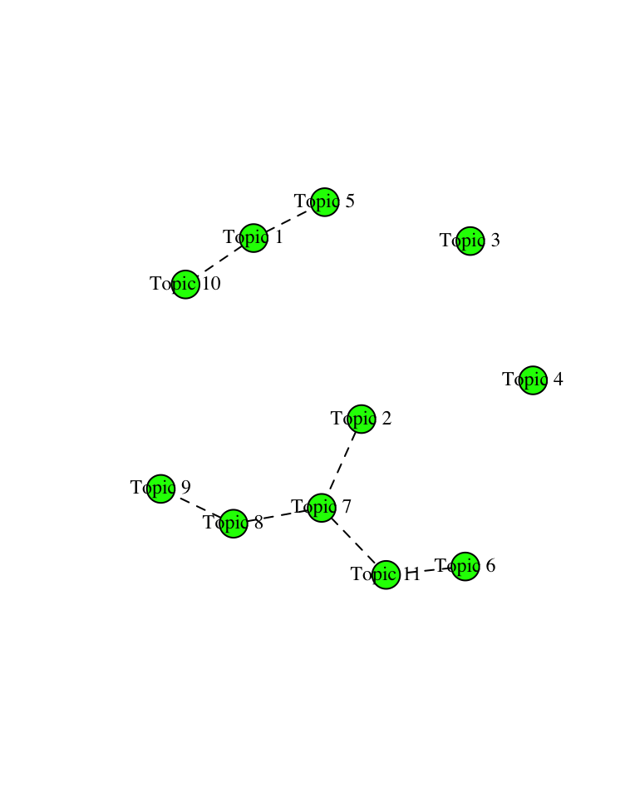

Twelve topics

Keywords and texts

Going from eleven to twelve topics results in a group of three topic which seem to share the same general focus on training/skills/labour market and industry priorities. The topics are less distinct from each other. Describing qualitative differences between them may be possible, but I believe that they would be too nuanced and weaken rather than strengthen the interpretability of the topic model.

One |  | Highest Prob: skills, skill, education, training, engineering, communication, development, student, competence, soft, technical, teacher, digital, knowledge, technology  FREX: tvet, engineering, soft, digital, skill, technical, solving, literacy, entrepreneurship, communication, teacher, skills, competence, transversal, teamwork  Score: skills, engineering, skill, soft, technical, digital, tvet, entrepreneurship, teacher, student, communication, teaching, solving, teamwork, education | THE REFORMING OF VOCATIONAL TEACHER TRAINING COLLEGES IN TURKEY  UNDERSTANDING AND ACQUISITION OF ENTREPRENEURIAL SKILLS: A PEDAGOGICAL RE-ORIENTATION FOR CLASSROOM TEACHER IN SCIENCE EDUCATION  FRAMEWORK FOR TECHNICAL COMMUNICATION SKILLS CONTENT DEVELOPMENT FOR STUDENTS IN MALAYSIAN VOCATIONAL COLLEGES: A FUZZY DELPHI STUDY  EDUCATIONAL INSTITUTIONS TEACHERS’ SKILLS HOPE IN BABIL  A CASE STUDY ON THE DEVELOPMENT OF SOFT SKILLS AMONG TESL GRADUATES IN A UNIVERSITY  STAKEHOLDER’S PERSPECTIVES OF THE TWENTY-FIRST CENTURY SKILLS  STUDENTS AND ACADEMICIANS VIEWS ON THE ENGINEERING CURRICULUM AND INDUSTRIAL SKILLS REQUIREMENT FOR A SUCCESSFUL JOB CAREER  IMPLEMENTATION OF TEACHING METHODS IN MECHANICAL ENGINEERING PROGRAM AT THE MALAYSIA’S VOCATIONAL COLLEGE  HISTORICAL DEVELOPMENT OF ISLAMIC INTEGRATED EDUCATION IN MALAYSIA SINCE 15TH CENTURY: CURRENT NEEDS FOR THE GLOBALIZED WORLD  HOW TVET TEACHERS FOSTER EMPLOYABILITY SKILLS: INSIGHTS FROM DEVELOPING COUNTRIES
Five |  | Highest Prob: graduate, university, employer, education, high, degree, market, employment, skills, institution, competencies, perception, professional, curriculum, survey  FREX: graduate, graduates, sport, accounting, phd, heis, veterinary, master, lis, degree, graduation, attribute, competencies, bachelor, curricula  Score: graduate, university, employer, curriculum, graduates, heis, lis, curricula, competencies, accounting, market, generic, sport, skills, phd | DO ACCREDITED UNDERGRADUATE ACCOUNTING PROGRAMMES IN AUSTRALIA MEET THE NEEDS AND EXPECTATIONS OF THE ACCOUNTING PROFESSION?  EMPLOYABILITY OUTCOMES FOR UNIVERSITY JOINT HONOURS GRADUATES  EDUCATIONAL ADVANTAGE AND EMPLOYABILITY OF UK UNIVERSITY GRADUATES  HOW TO DEVELOP HIGHER EDUCATION CURRICULA TOWARDS EMPLOYABILITY? A MULTI-STAKEHOLDER APPROACH  EXPLORING EDUCATIONAL ADVANTAGE IN THE UK VIA GRADUATE EMPLOYMENT OF JOINT HONOURS DEGREES BY EXAMINING PRE-UNIVERSITY TARIFF AND DEGREE CLASSIFICATION  ARE GRADUATES OF BACHELOR’S DEGREE PROGRAMS IN GERONTOLOGY EMPLOYED? A REPORT OF A NATIONAL SURVEY  CHARTERED PROFESSIONAL ACCOUNTANT'S COMPETENCIES: THE SYNERGY BETWEEN ACCOUNTING EDUCATION AND EMPLOYERS' NEEDS—EVIDENCE FROM ALBERTA  SPORTS GRADUATE CAPABILITIES AND COMPETENCIES: A COMPARISON OF GRADUATE AND EMPLOYER PERCEPTIONS IN SIX EU COUNTRIES  MAPPING EMPLOYERS' PERSPECTIVES ON STUDENT EMPLOYABILITY TO ADDRESS SKILLS-GAPS IN THE UNITED ARAB EMIRATES  TRAINING AND EMPLOYABILITY IN THE TRANSLATION AND INTERPRETING DEGREE AT THE UNIVERSITY OF GRANADA
Twelve |  | Highest Prob: industry, management, business, sector, development, company, internship, manager, knowledge, technology, sustainable, sustainability, improve, design, identify  FREX: tourism, hospitality, internship, interns, sustainability, marketing, talent, industry, internships, company, sector, india, intern, industries, manufacturing  Score: industry, internship, hospitality, tourism, company, business, marketing, internships, sector, management, india, manager, interns, innovation, sustainability | THE CURRENT AND FUTURE STATE OF THE MARKETING MANAGEMENT PROFESSION  IMPACT OF THE DIGITAL ECONOMY AND INNOVATION ON THE BUSINESSES OF SMALL AND MEDIUM ENTERPRISES  CUTTLE FISH CRACKERS PRODUCT QUALITY CONTROL TO REDUCE TOTAL OF PRODUCT DEFECTS IN TRADING COMPANY ARDIAL, BANYUWANGI REGENCY  MAPPING THE NEEDS FOR TRAINED LIGHTING ENGINEERS IN CONSTRUCTION INDUSTRY: THE FIRST OUTCOMES FROM ECOSLIGHT SKILLS ALLIANCES EUROPEAN PROJECT  SUSTAINABLE SUPPLIER SELECTION FOR THE COLD SUPPLY CHAIN (CSC) IN THE CONTEXT OF A DEVELOPING COUNTRY  SIMULATION DEVELOPMENT CONTENT FOR STUDENTS EMPLOYABILITY IN LOGISTICS AND TRANSPORTATION FIELD IN MALAYSIA  EMPLOYABILITY MANAGEMENT PRACTICES IN THE POLISH ICT SECTOR  MAKE-IN-INDIA AND INDUSTRY 4.0: TECHNOLOGY READINESS OF SELECT FIRMS, BARRIERS AND SOCIO-TECHNICAL IMPLICATIONS  DOES STRATEGIC AGILITY AND ORGANIZATIONAL AMBIDEXTERITY AFFECT THE RELATIONSHIP BETWEEN TALENTS MANAGEMENT AND HUMAN CAPITAL SUSTAINABILITY?  DIGITISING EDUCATION IN NIGERIA: LESSONS FROM COVID-19

Topic correlations
Topics 1, 5, and 12 are closely related and difficult to interpret as qualitatively distinct.
