Supplementary Material
Method
Measures
Coping
Instructions: “These sentences deal with ways you've been coping with the worries or concerns that you’ve had in the past month about your career. There are many strategies to try to deal with these worries or concerns. These sentences ask what you've been doing to cope with your worries or concern about your career. Obviously, different people deal with things in different ways, but I'm interested in how you've tried to deal with it. Each sentence says something about a particular way of coping. I want to know to what extent you've been doing what the sentence says. How much or how frequently. Don't answer on the basis of whether it seems to be working or not—just whether or not you're doing it. Use the response choices. Try to rate each item separately in your mind from the others. Make your answers as true FOR YOU as you can. To cope with my worries and concerns about my career…”

Results
Preference for and Aversion to Ambiguity
In relation to Hypothesis 1b (i.e., aversion to ambiguity is expected to weaken the positive relationship between career insecurity and approach coping), simple slopes analyses were run considering the interaction of aversion to ambiguity with career insecurity on approach coping was approaching significance (β = -.091, p = .062). In line with our expectations, when aversion to ambiguity was high (1SD above the mean), the relationship between career insecurity and approach coping was less positive (B = -.066, p = .177) than when aversion to ambiguity was low (1SD below the mean; B = .037, p = .405; see Figure 4).

Figure 4
Aversion to ambiguity as a moderator in the relationship between career insecurity and approach coping
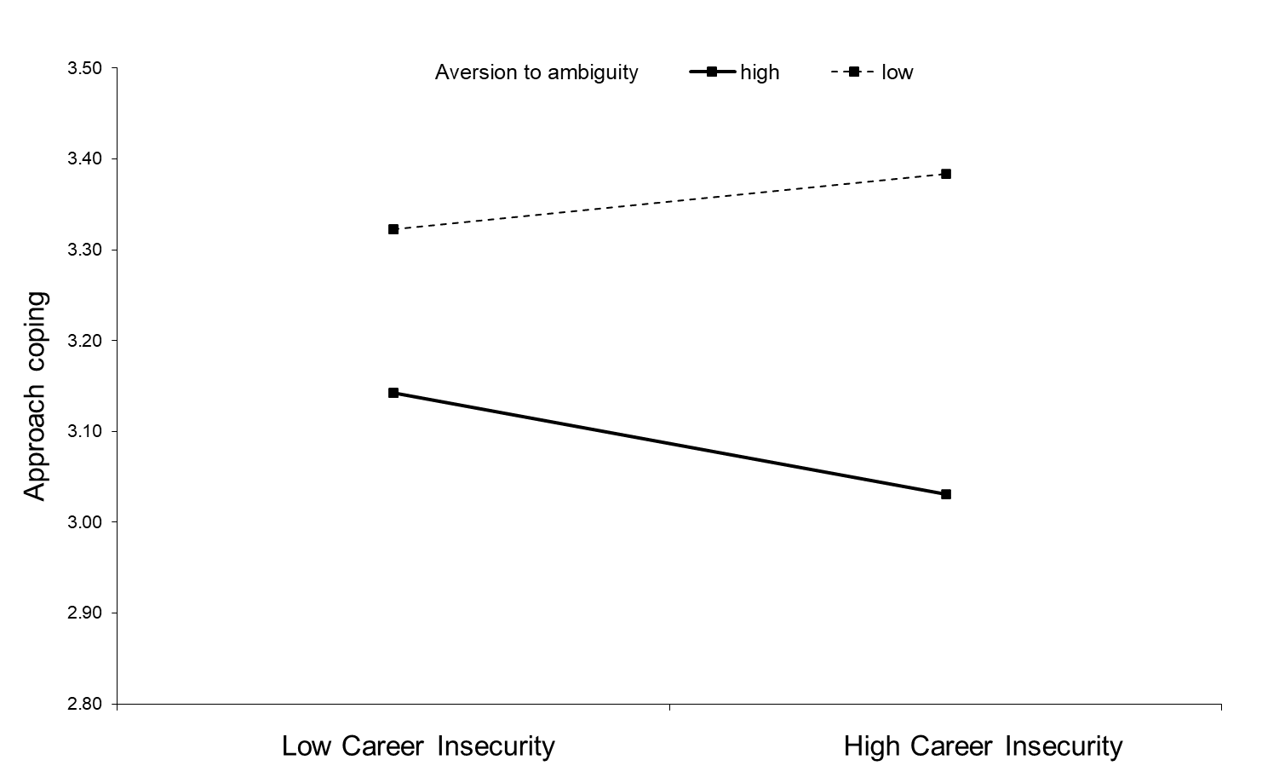
Source: Authors’ own work

Table VI
Path analysis results predicting approach and avoidance coping
 | Approach coping |  |  |  | Avoidance coping
 | B | SE | β | p | B | SE | β | p
Gender | .133 | .060 | .114 | .023 | .013 | .057 | .011 | .815
Neuroticism | -.100 | .031 | -.183 | .001 | .149 | .032 | .266 | < .01
Career Insecurity | -.084 | .040 | -.129 | .036 | .190 | .033 | .285 | < .01
R² |  |  | .063 | .033 |  |  | .200 | < .01
Source: Authors’ own work

Table VII
Path analysis results predicting approach and avoidance coping without control variables
 | Approach coping |  |  |  | Avoidance coping
 | B | SE | β | p | B | SE | β | p
Career Insecurity | -.109 | .040 | -.163 | .007 | .249 | .031 | .370 | < .01
R² |  |  | .026 | .188 |  |  | .137 | < .01
Source: Authors’ own work

Table VIII
Path analysis results predicting psychological well-being and subjective career success
 | Psychological well-being |  |  |  | Subjective career success
 | B | SE | β | p | B | SE | β | p
Gender | .009 | .094 | .008 | .920 | .023 | .161 | .012 | .884
Neuroticism | .035 | .050 | .062 | .487 | -.031 | .087 | -.034 | .722
Career Insecurity | -.205 | .065 | -.306 | .001 | -.221 | .101 | -.208 | .028
Approach coping | .184 | .086 | .178 | .033 | .343 | .146 | .210 | .019
Avoidance coping | -.100 | .098 | -.099 | .309 | -.023 | .176 | -.015 | .894
R² |  |  | .162 | .008 |  |  | .113 | .033
Source: Authors’ own work

Table IX
Path analysis results predicting psychological well-being and subjective career success without control variables
 | Psychological well-being |  |  |  | Subjective career success
 | B | SE | β | p | B | SE | β | p
Career Insecurity | -.181 | .064 | -.266 | .005 | -.227 | .097 | -.210 | .018
Approach coping | .200 | .079 | .197 | .012 | .302 | .137 | .186 | .028
Avoidance coping | -.094 | .096 | -.093 | .327 | -.058 | .168 | -.036 | .728
Source: Authors’ own work

Table X
Estimates and confidence intervals of total, direct, and indirect effects for psychological well-being and subjective career success without control variables
Path | Lower 2.5% | Lower 5% | Point estimate | Upper 5% | Upper 2.5%
Total effects from career insecurity to psychological well-being | -.335 | -.319 | -.226 | -.125 | -.104
Total indirect effects | -.097 | -.088 | -.045 | -.003 | .005
Specific indirect effects
Career insecurity → Approach coping → Psychological well-being | -.055 | -.049 | -.022 | -.006 | -.003
Career insecurity → Avoidance coping → Psychological well-being | -.072 | -.063 | -.023 | .016 | .024
Direct effect of career insecurity to psychological well-being | -.302 | -.282 | -.181 | -.073 | -.050
Total effects from career insecurity to subjective career success | -.435 | -.412 | -.274 | -.121 | -.094
Total indirect effects | -.138 | -.122 | -.047 | .026 | .038
Specific indirect effects
Career insecurity → Approach coping → Subjective career success | -.090 | -.079 | -.033 | -.008 | -.004
Career insecurity → Avoidance coping → Subjective career success | -.103 | -.085 | -.015 | .053 | .065
Direct effect of career insecurity to subjective career success | -.401 | -.376 | -.227 | -.055 | -.023
Source: Authors’ own work

Table XI
Moderation analyses results without control variables
 | Approach coping |  |  |  | Avoidance coping
 | B | SE | β | p | B | SE | β | p
Preference moderation model
Career Insecurity | -.073 | .031 | -.109 | .017 | .249 | .031 | .370 | < .001
Preference | .344 | .043 | .368 | < .001 | -.138 | .043 | -.146 | .001
Preference x Career insecurity | -.087 | .048 | -.083 | .072 | -.093 | .049 | -.088 | .058
Aversion moderation model
Career Insecurity | -.018 | .037 | -.027 | .627 | .158 | .035 | .235 | < .001
Aversion | -.217 | .041 | -.289 | < .001 | .195 | .039 | .258 | < .001
Aversion x Career insecurity | -.054 | .037 | -.071 | .138 | -.053 | .035 | -.068 | .133
Source: Authors’ own work

