Appendix
Figures A1–A40: ΔCoVaR [black], Refinitiv-based E-ΔCoVaR [mauve] and Bloomberg-based E-ΔCoVaR [violet] for individual banks listed in Table A1. Source: own elaboration.

ΔCoVaR | DSRI
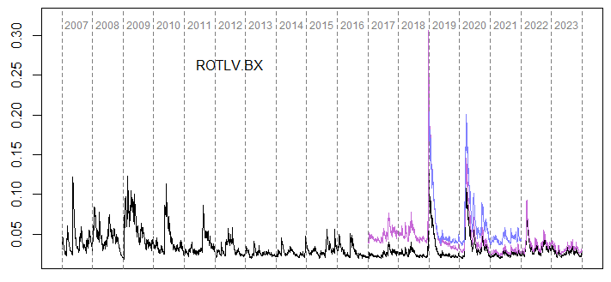 | 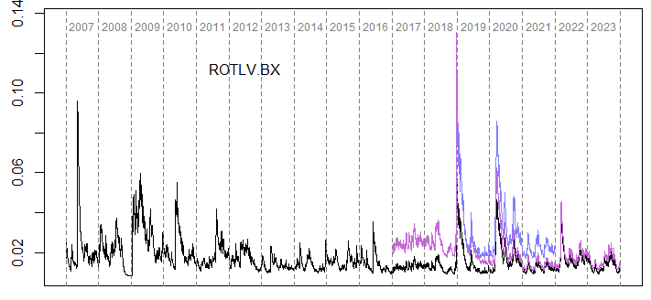
ΔCoVaR | DSRI
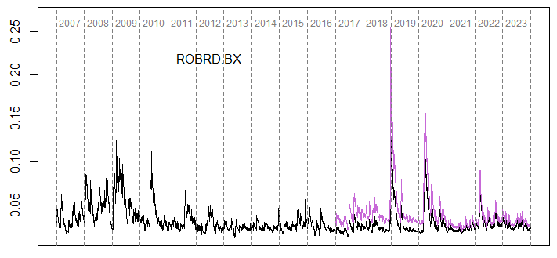 | 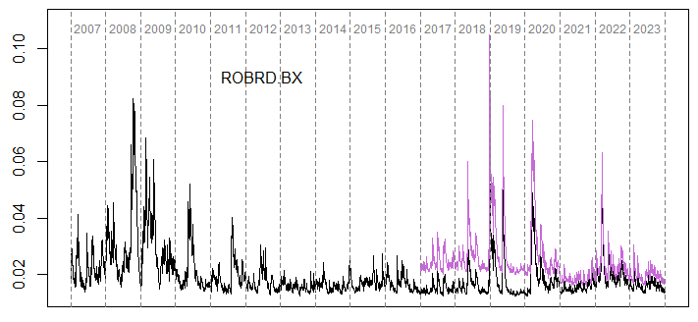
ΔCoVaR | DSRI
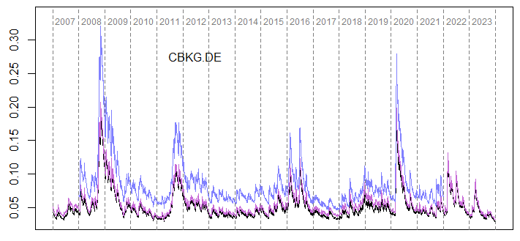 | 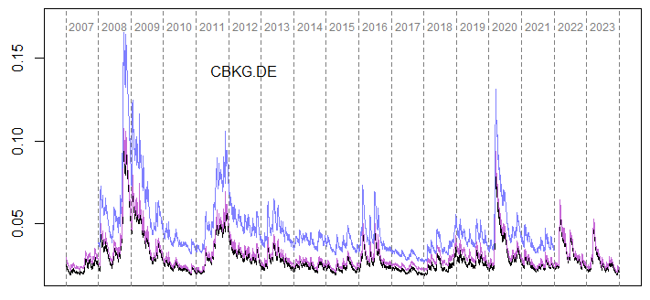
ΔCoVaR | DSRI
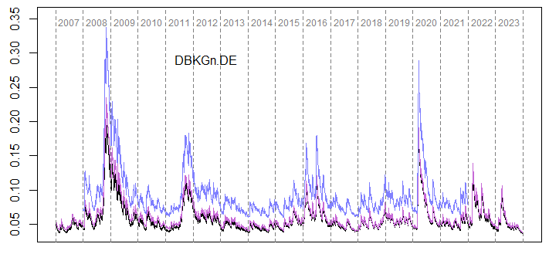 | 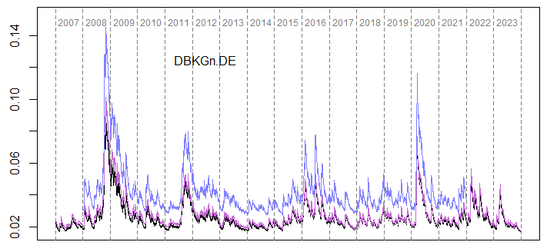
ΔCoVaR | DSRI
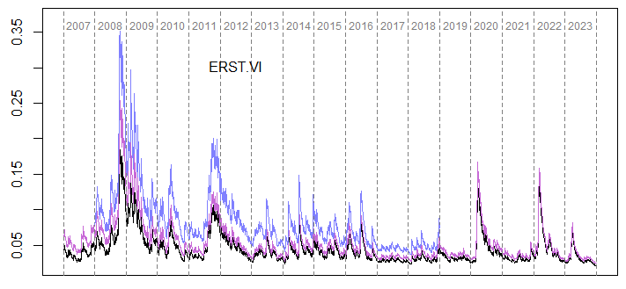 | 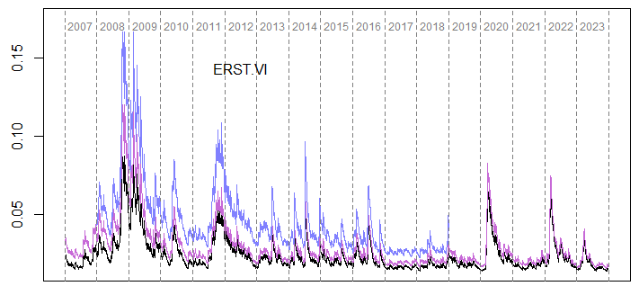
ΔCoVaR | DSRI
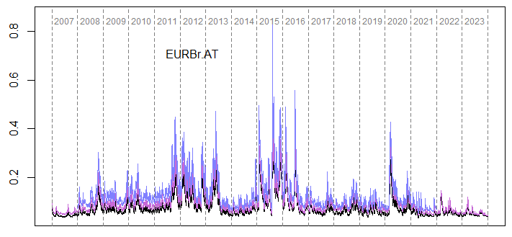 | 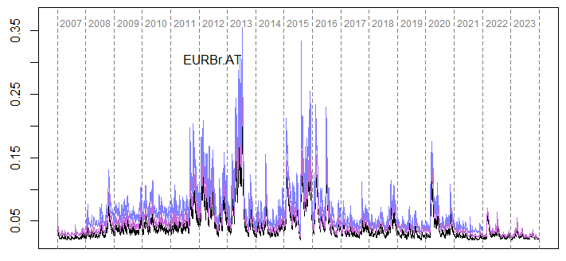
ΔCoVaR | DSRI
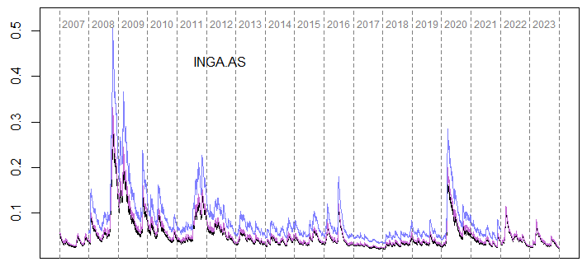 | 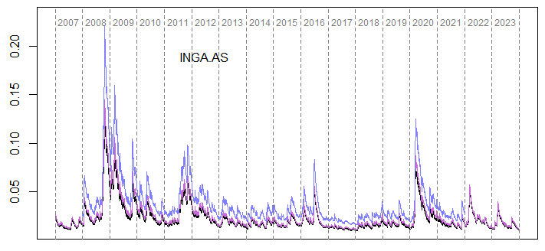
ΔCoVaR | DSRI
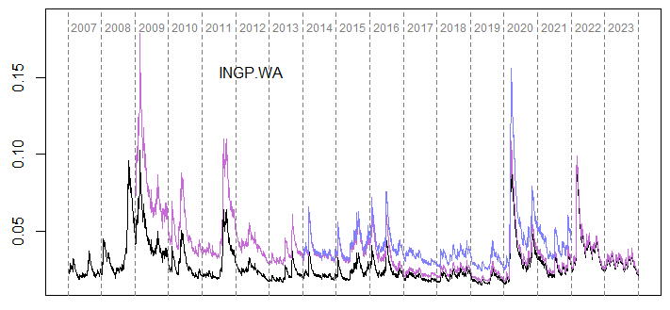 | 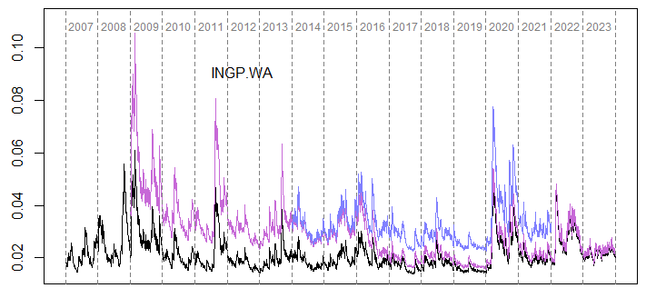
ΔCoVaR | DSRI
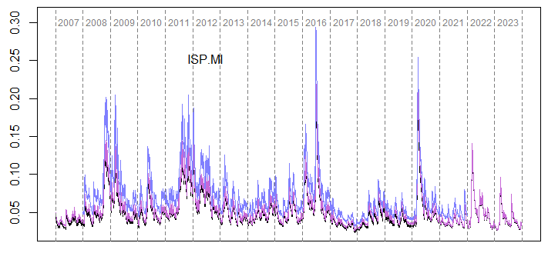 | 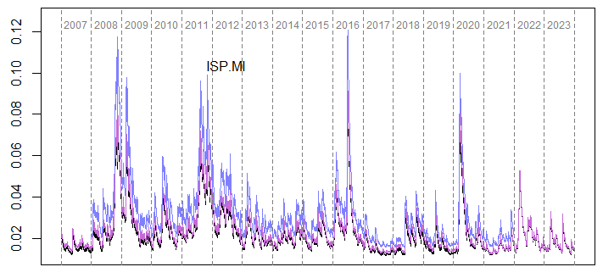
ΔCoVaR | DSRI
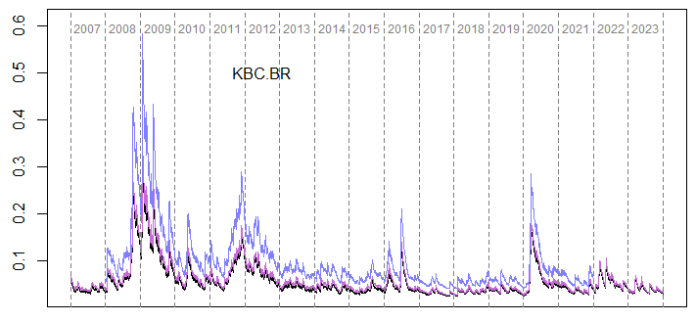 | 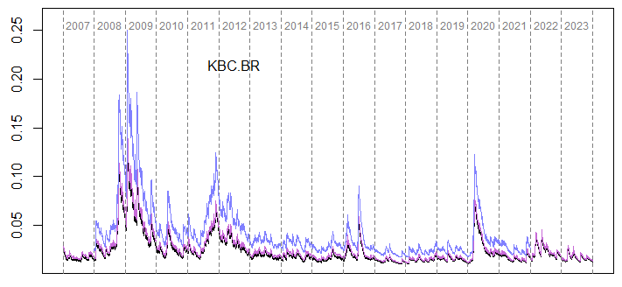
ΔCoVaR | DSRI
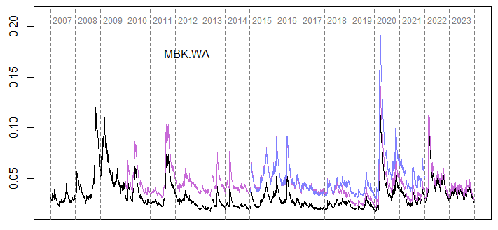 | 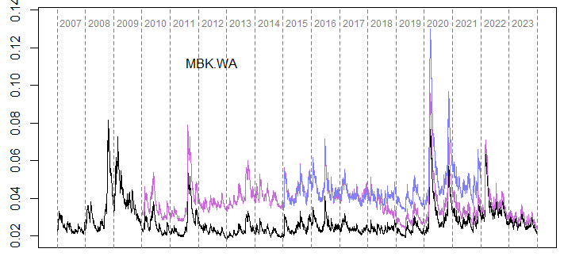
ΔCoVaR | DSRI
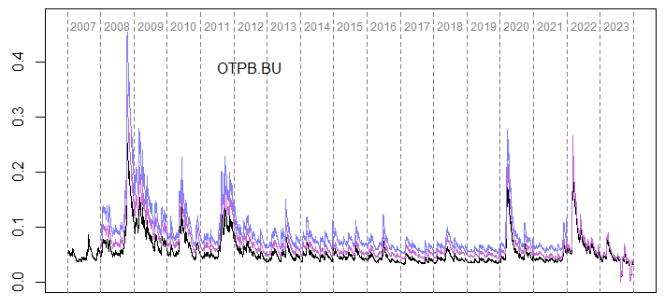 | 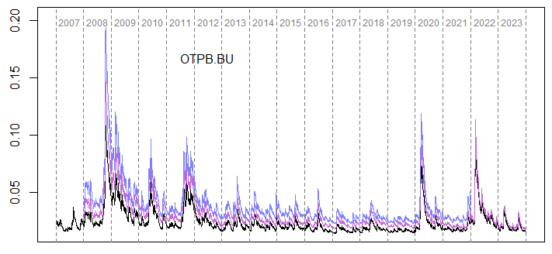
ΔCoVaR | DSRI
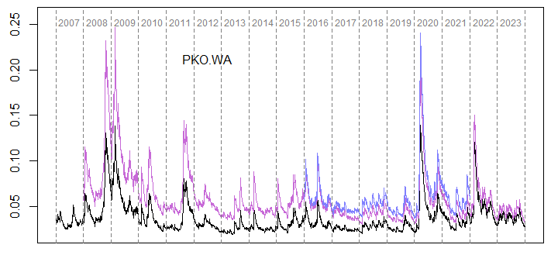 | 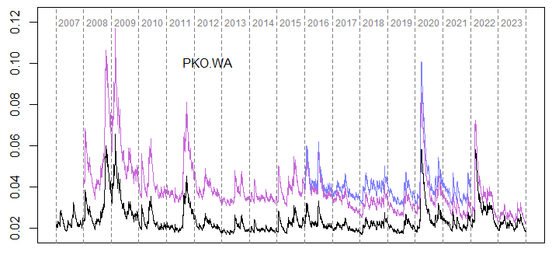
ΔCoVaR | DSRI
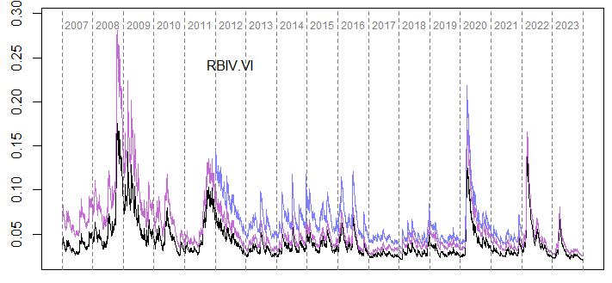 | 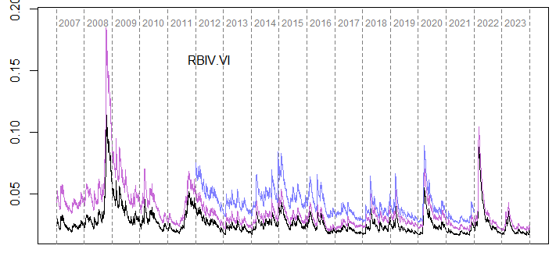
ΔCoVaR | DSRI
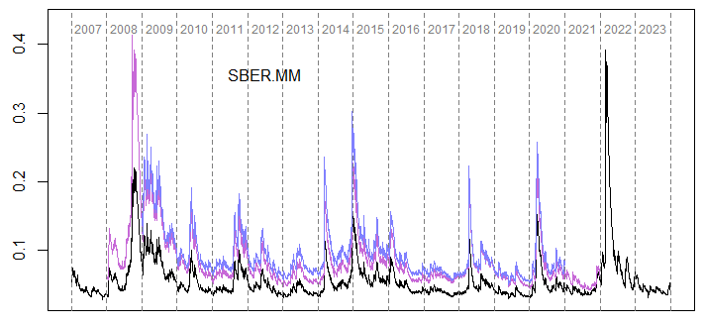 | 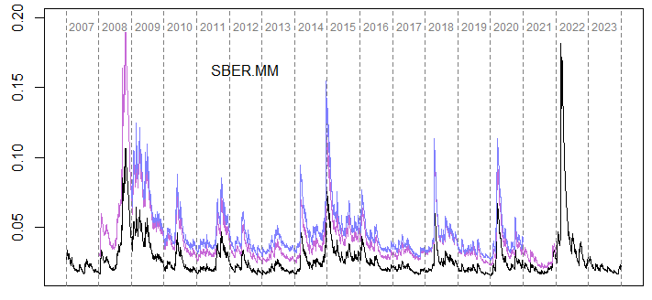
ΔCoVaR | DSRI
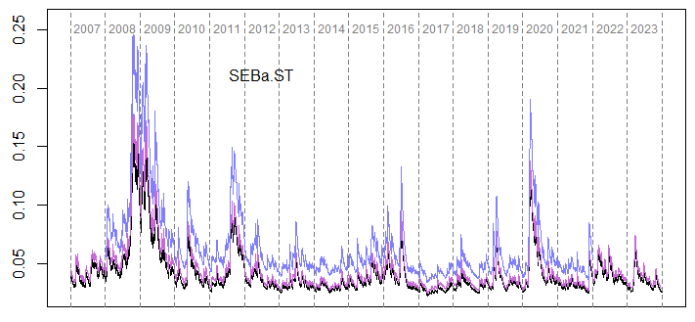 | 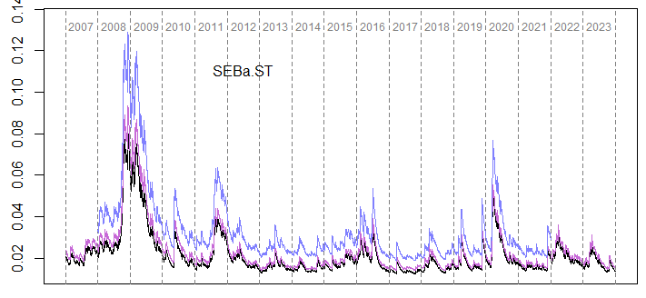
ΔCoVaR | DSRI
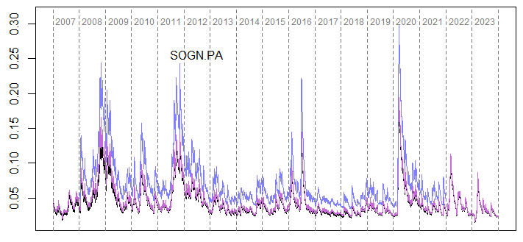 | 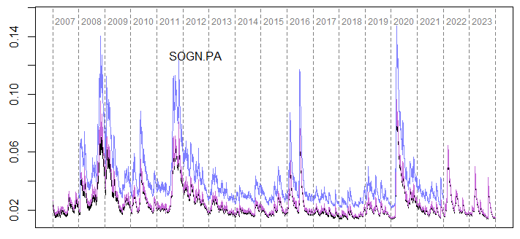
ΔCoVaR | DSRI
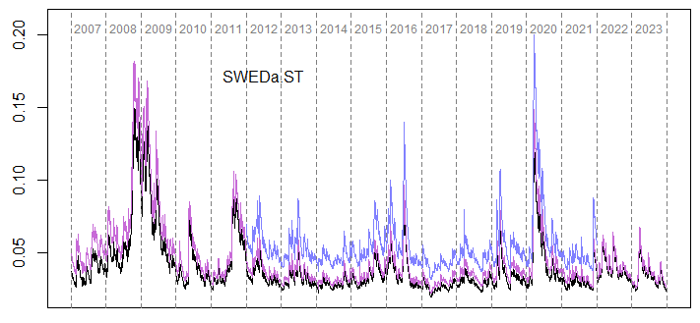 | 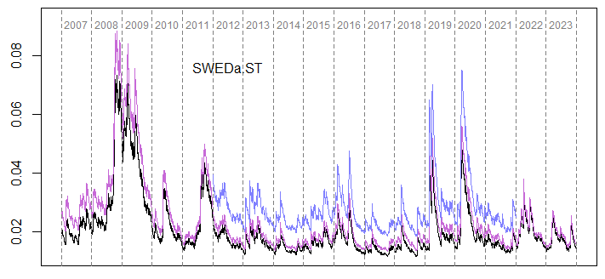
ΔCoVaR | DSRI
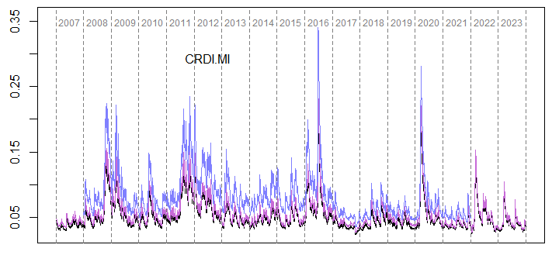 | 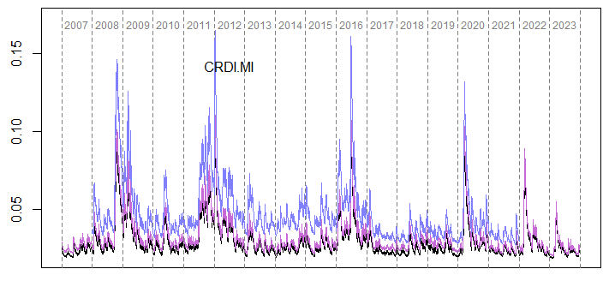
ΔCoVaR | DSRI
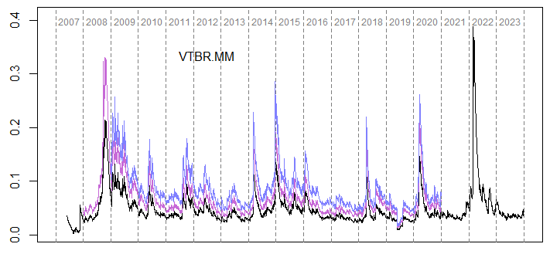 | 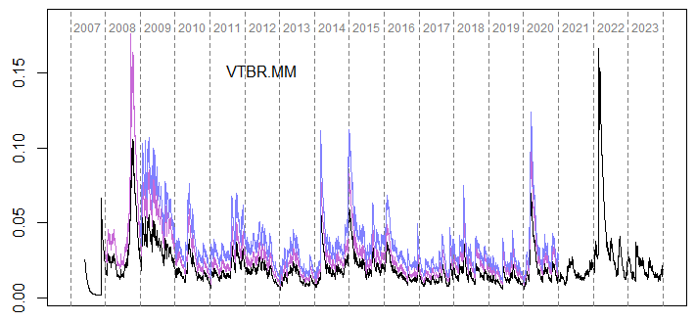

Figures A41–A80: SRISK [black], Refinitiv-based E-SRISK [mauve] and Bloomberg-based E-ΔCoVaR [violet] for individual banks listed in Table A1. Source: own elaboration.

SRISK | QLaR
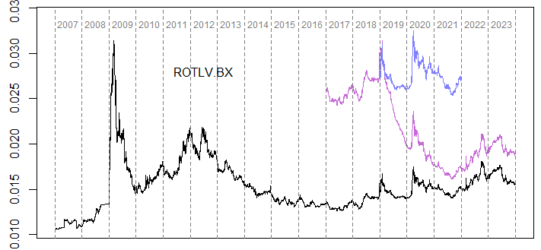 | 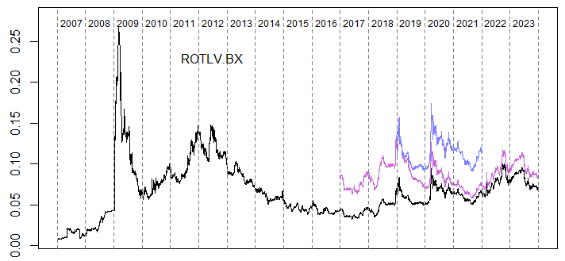
SRISK | QLaR
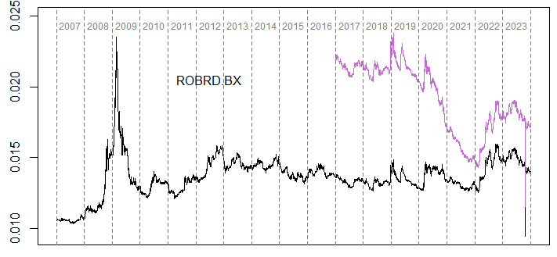 | 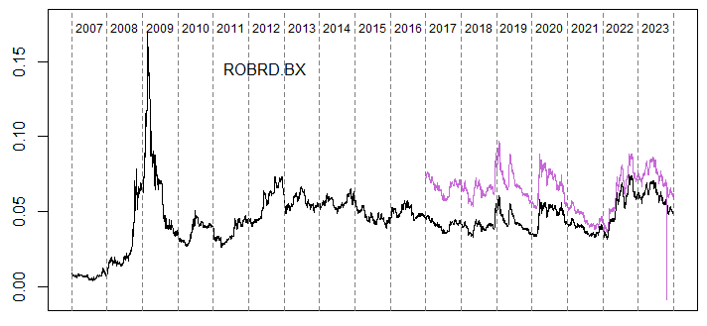
SRISK | QLaR
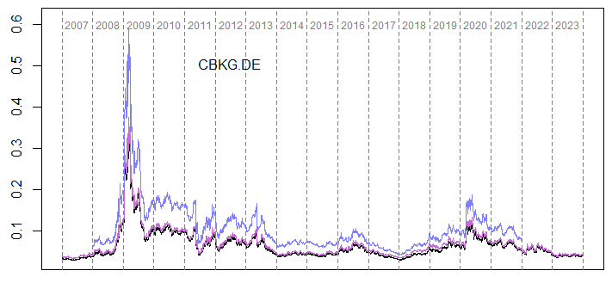 | 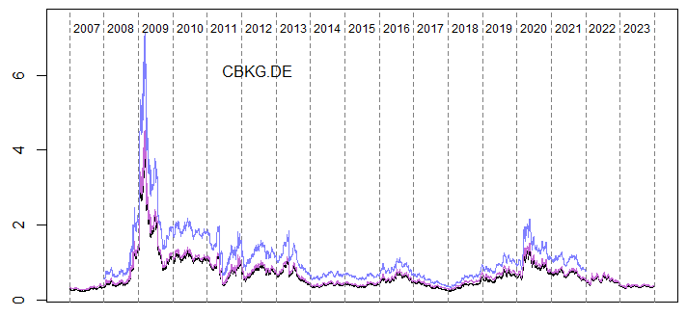
SRISK | QLaR
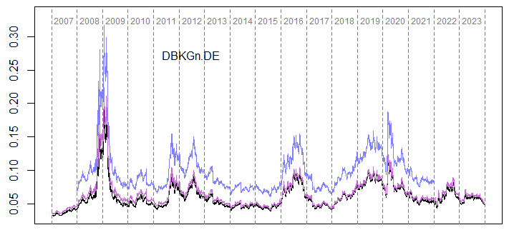 | 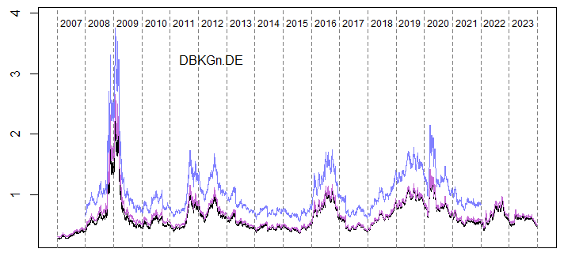
SRISK | QLaR
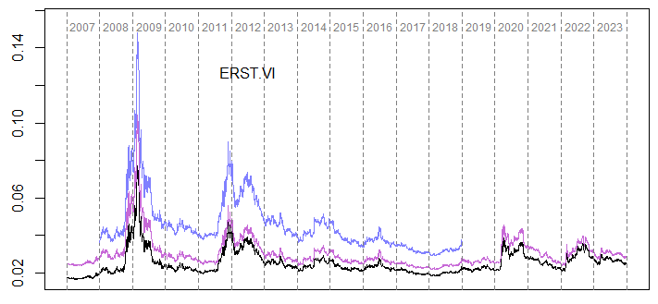 | 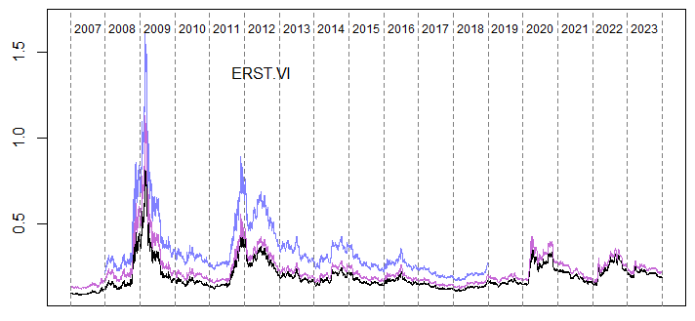
SRISK | QLaR
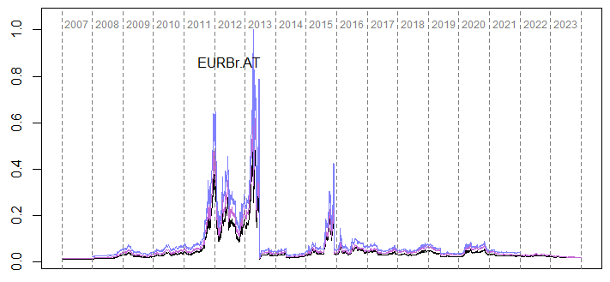 | 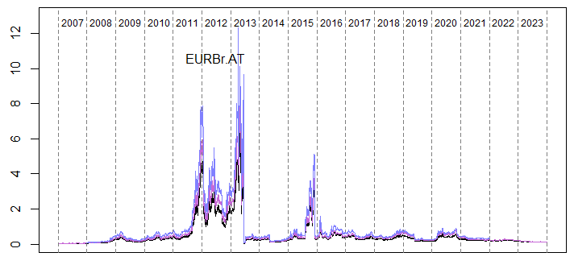
SRISK | QLaR
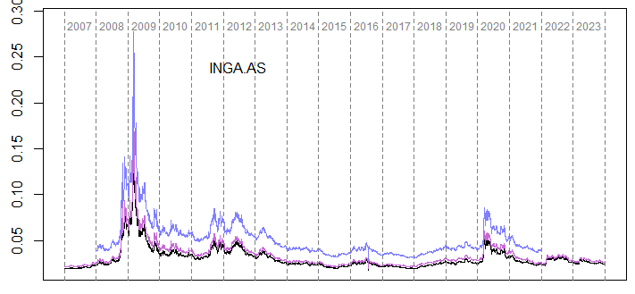 | 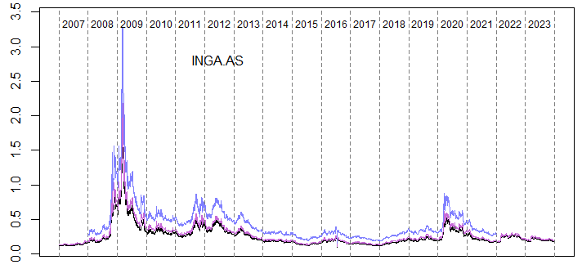
SRISK | QLaR
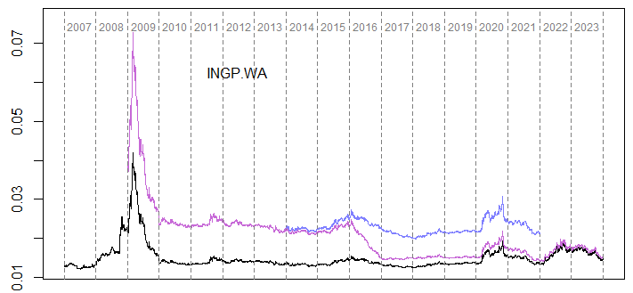 | 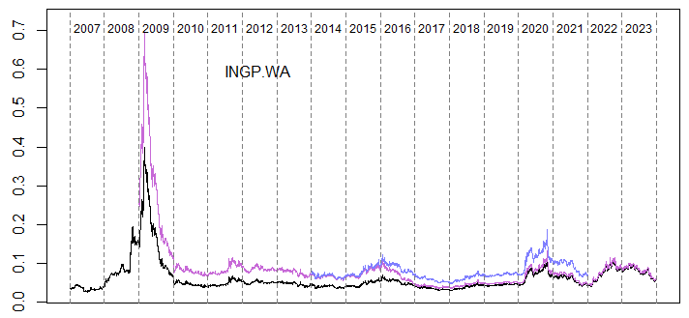
SRISK | QLaR
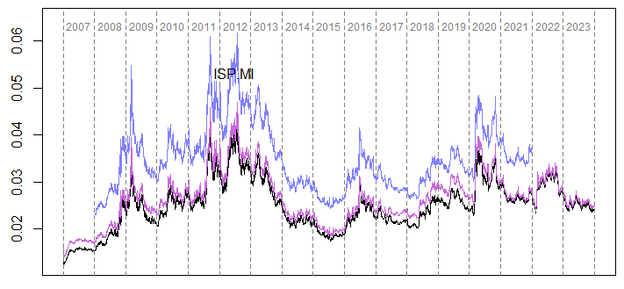 | 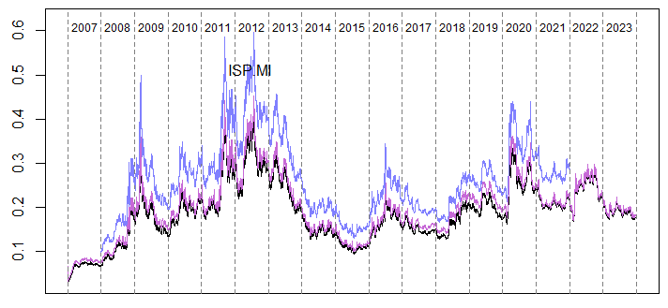
SRISK | QLaR
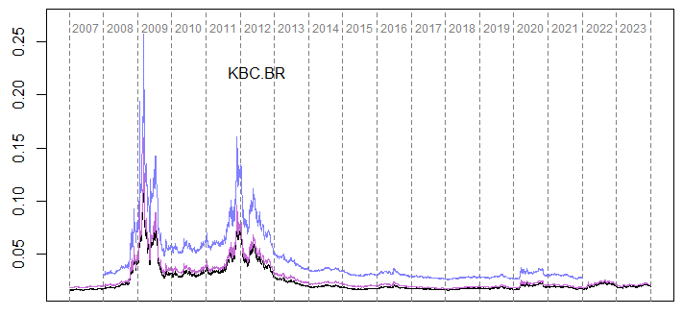 | 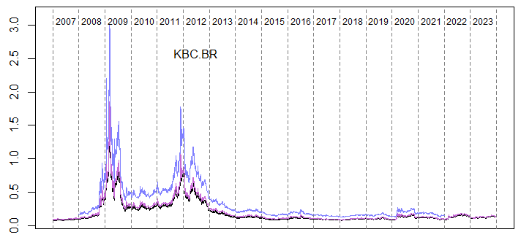
SRISK | QLaR
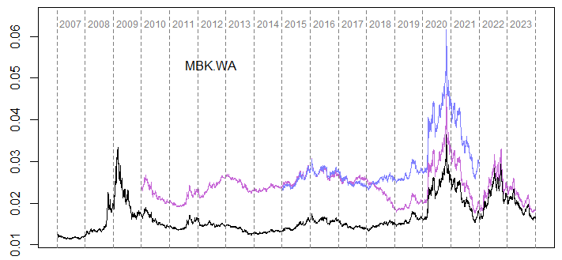 | 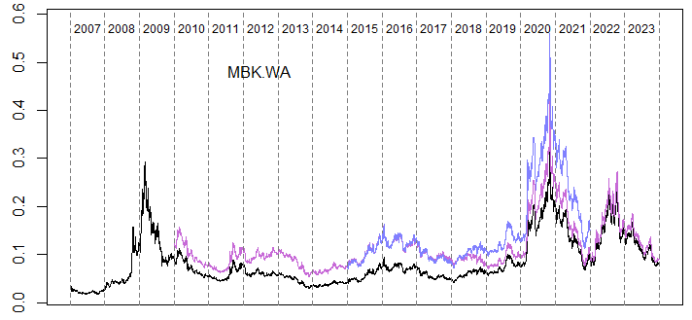
SRISK | QLaR
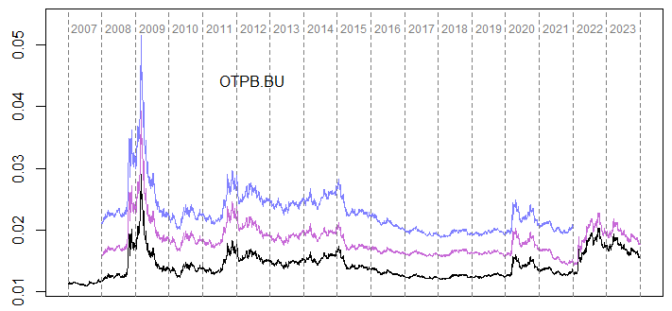 | 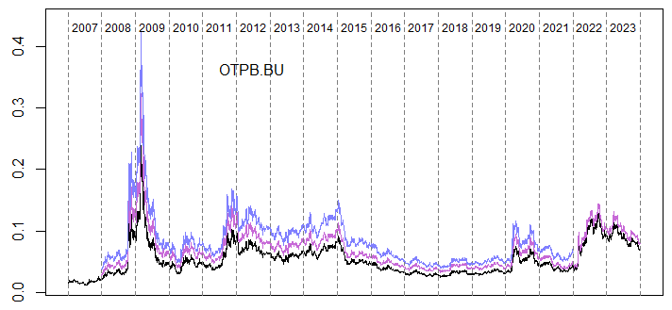
SRISK | QLaR
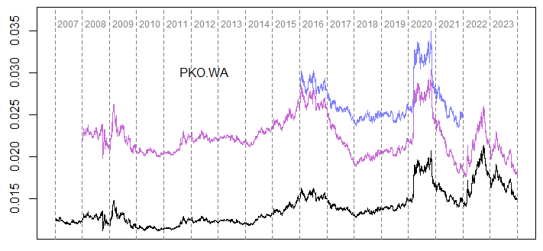 | 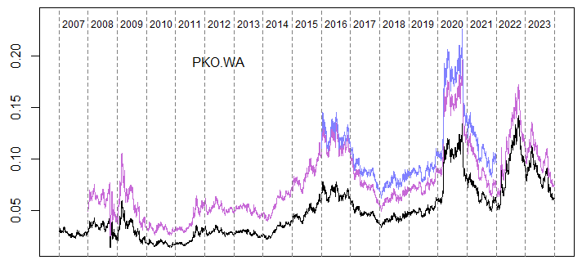
SRISK | QLaR
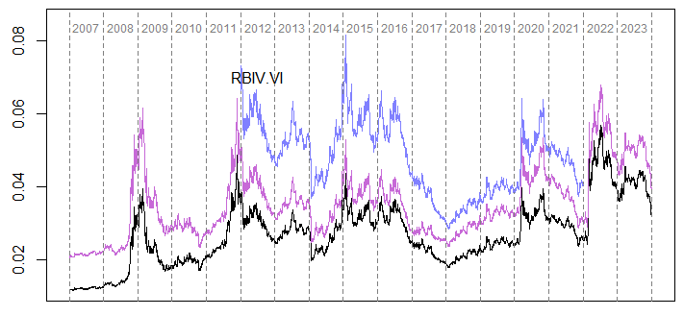 | 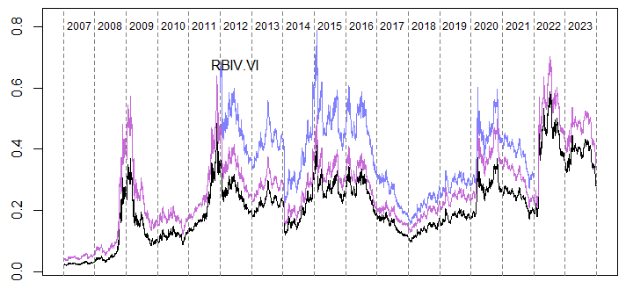
SRISK | QLaR
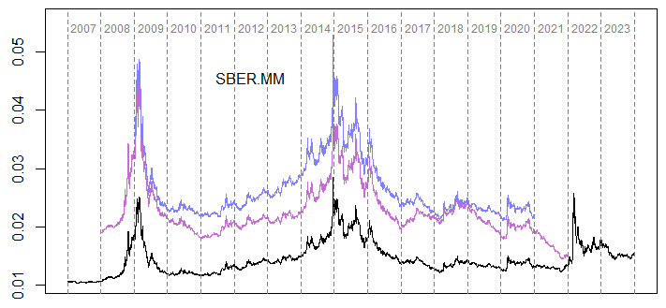 | 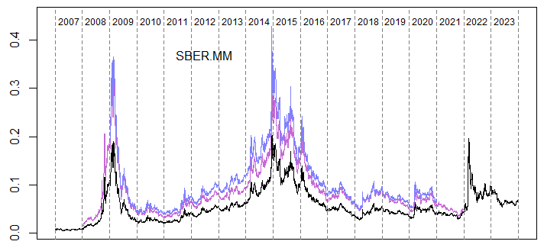
SRISK | QLaR
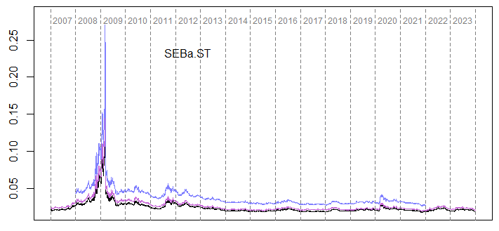 | 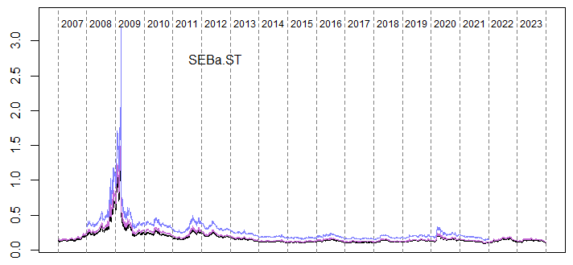
SRISK | QLaR
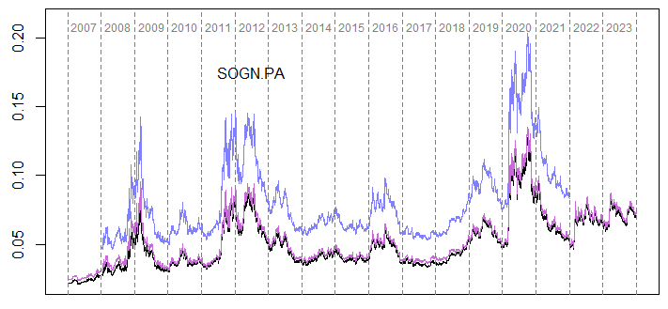 | 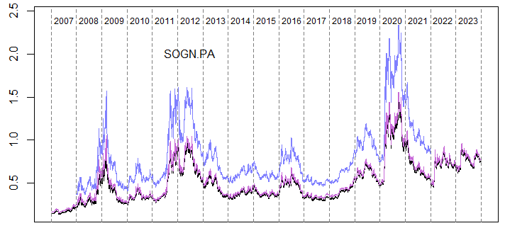
SRISK | QLaR
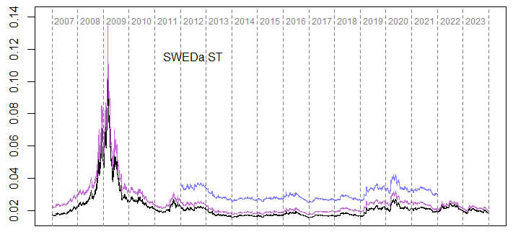 | 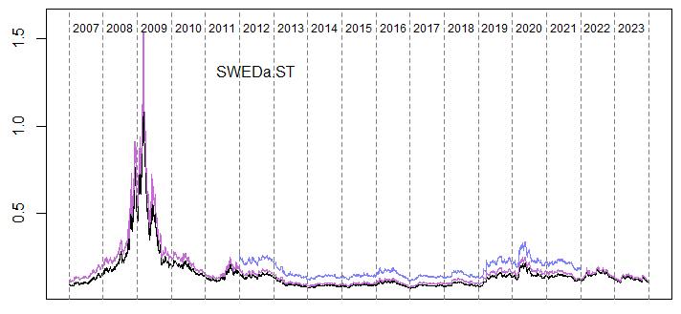
SRISK | QLaR
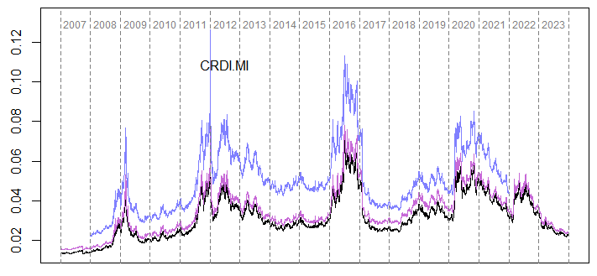 | 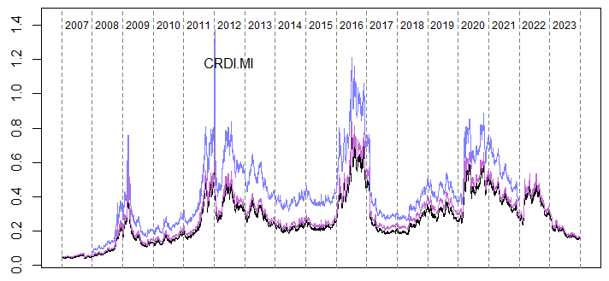
SRISK | QLaR
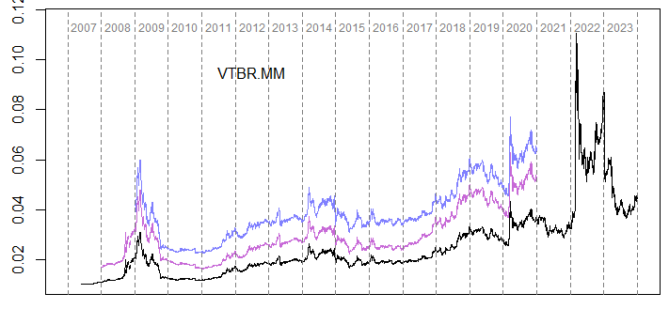 | 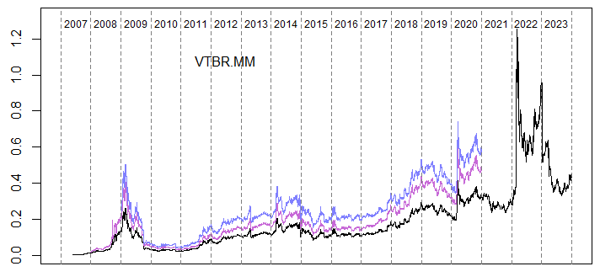

Table A1. List of analyzed banks and information about their systemic importance
Country | Systemically Important Financial Institution (O-SII) | RIC identifier | Globally systemic bank (G-SIB) | European systemic bank | Systemic in other European countries* | Under the SSM
Austria | Erste Group Bank A.G. | ERST.VI |  | YES | 5 | YES
Austria | Raiffeisen Bank I.A.G. | RBIV.VI |  | YES | 7 | YES
Belgium | KBC Group N.V. | KBC.BR |  | YES | 4 | YES
France | Société Générale S.A. | SOGN.PA | YES | YES | 7 | YES
Greece | Eurobank E.S.&H. S.A. | EURBr.AT |  | YES | 3 | YES
Germany | Commerzbank A.G. | CBKG.DE |  | YES | 1 | YES
Germany | Deutsche Bank A.G. | DBKGn.DE | YES | YES | 2 | YES
Hungary | OTP Bank Nyrt | OTPB.BU |  | YES | 4
Italy | UniCredit S.p.A. | CRDI.MI | YES | YES | 7 | YES
Italy | Intesa San Paolo S.p.A. | ISP.MI |  | YES | 3 | YES
The Netherlands | ING Bank N.V. | INGA.AS | YES | YES | 3 | YES
Poland | ING Bank Śląski S.A. | INGP.WA |  | YES | 0
Poland | mBank S.A. | MBK.WA |  | YES | 0
Poland | Powszechna Kasa Oszczędności Bank Polski S.A. | PKO.WA |  | YES | 0
Romania | BRD – Groupe Société Générale S.A. | ROBRD.BX |  | YES | 0
Romania | Banca Transilvania S.A. | ROTLV.BX |  | YES | 0
Russia | Sberbank PAO** | SBER.MM |  | YES | 2
Russia | VTB PAO | VTBR.MM |  | YES | 2
Sweden | Skandinaviska Enskilda Banken A.B. | SEBa.ST |  | YES | 3
Sweden | Swedbank A.B. | SWEDa.ST |  | YES | 3
Note: *Other European countries where the bank is systemic either directly or indirectly via branch or daughter-parent association in the study period. ** On 24.02.2022, as a result of the Russian invasion of Ukraine, US announced sanctions and new restrictions on Sberbank’s operations, Sberbank’s stock lost more than half of its value and on 28.02.2022, Sberbank Europe was facing bankruptcy and 2 days later, Sberbank Europe declared that it was leaving the European market (Reuters, 2022). Source: own elaboration.

Table A2. Descriptive statistics of the log-returns’ series (minimum, first quartile, median, mean, third quartile, maximum, standard deviation, skewness, excess kurtosis)
Bank | Min | Q1 | Median | Mean | Q3 | Max | SD | Skew. | Kurt.
ROTLV.BX | -0.24909 | -0.00293 | 0.00000 | 0.00031 | 0.00417 | 0.25326 | 0.01700 | -0.37103 | 29.16049
ROBRD.BX | -0.18474 | -0.00354 | 0.00000 | -0.00007 | 0.00439 | 0.14767 | 0.01720 | -0.76664 | 15.42053
CBKG.DE | -0.27458 | -0.00765 | 0.00000 | -0.00045 | 0.00708 | 0.20482 | 0.02576 | -0.34539 | 11.45826
DBKGn.DE | -0.20378 | -0.00715 | 0.00000 | -0.00030 | 0.00646 | 0.21245 | 0.02251 | -0.03284 | 11.40465
ERST.VI | -0.20002 | -0.00585 | 0.00000 | -0.00007 | 0.00666 | 0.17025 | 0.02307 | -0.33366 | 10.98933
EURBr.AT | -0.35667 | -0.01070 | 0.00000 | -0.00153 | 0.00803 | 0.26189 | 0.04381 | -0.78922 | 14.47813
INGA.AS | -0.32136 | -0.00542 | 0.00000 | -0.00010 | 0.00589 | 0.25653 | 0.02443 | -0.16337 | 22.42458
INGP.WA | -0.13174 | -0.00478 | 0.00000 | 0.00017 | 0.00522 | 0.12986 | 0.01826 | -0.14656 | 6.90760
ISP.MI | -0.26059 | -0.00570 | 0.00000 | -0.00012 | 0.00619 | 0.17962 | 0.02115 | -0.68511 | 14.02217
KBC.BR | -0.28664 | -0.00587 | 0.00000 | -0.00007 | 0.00634 | 0.40484 | 0.02626 | -0.20885 | 27.70440
MBK.WA | -0.19106 | -0.00655 | 0.00000 | 0.00007 | 0.00701 | 0.21940 | 0.02314 | 0.05075 | 8.93634
OTPB.BU | -0.25612 | -0.00568 | 0.00000 | 0.00003 | 0.00672 | 0.22359 | 0.02274 | -0.65366 | 15.32233
PKO.WA | -0.19273 | -0.00593 | 0.00000 | 0.00000 | 0.00612 | 0.13428 | 0.01941 | -0.24711 | 8.04478
RBIV.VI | -0.28313 | -0.00673 | 0.00000 | -0.00029 | 0.00689 | 0.17143 | 0.02447 | -0.52313 | 13.28674
SBER.MM | -0.64102 | -0.00645 | 0.00000 | 0.00001 | 0.00726 | 0.29731 | 0.02716 | -2.70255 | 72.40497
SEBa.ST | -0.22912 | -0.00449 | 0.00000 | 0.00000 | 0.00559 | 0.26473 | 0.02073 | -0.12433 | 20.77347
SOGN.PA | -0.23034 | -0.00688 | 0.00000 | -0.00025 | 0.00645 | 0.21425 | 0.02374 | -0.35307 | 12.14691
SWEDa.ST | -0.21489 | -0.00426 | 0.00000 | -0.00004 | 0.00591 | 0.20597 | 0.02062 | -0.54974 | 15.29376
CRDI.MI | -0.27166 | -0.00777 | 0.00000 | -0.00033 | 0.00705 | 0.19007 | 0.02498 | -0.31927 | 10.20451
VTBR.MM | -0.56741 | -0.00619 | 0.00000 | -0.00055 | 0.00498 | 0.16824 | 0.02521 | -3.47515 | 68.51019
Source: own elaboration.

Table A3. Descriptive statistics of the Refinitiv Environmental Pillar Score (minimum, first quartile, median, mean, third quartile, maximum, standard deviation)
Bank | Min | Q1 | Median | Mean | Q3 | Max | SD
INGA.AS | 81.04 | 86.95 | 88.82 | 88.74 | 90.63 | 93.36 | 3.30
EURBr.AT | 61.97 | 69.60 | 70.58 | 73.69 | 81.71 | 95.04 | 9.45
KBC.BR | 82.95 | 84.37 | 90.17 | 88.73 | 91.76 | 94.03 | 3.85
OTPB.BU | 62.74 | 66.23 | 70.37 | 72.31 | 75.29 | 88.01 | 8.30
ROBRD.BX | 35.71 | 37.13 | 70.98 | 60.16 | 77.04 | 86.11 | 22.44
ROTLV.BX | 2.42 | 30.34 | 77.45 | 55.68 | 82.22 | 84.80 | 37.32
CBKG.DE | 79.28 | 88.60 | 91.06 | 89.65 | 91.73 | 94.16 | 4.02
DBKGn.DE | 82.04 | 90.49 | 91.88 | 92.22 | 95.21 | 97.53 | 4.13
CRDI.MI | 83.05 | 86.44 | 88.87 | 88.50 | 91.15 | 93.84 | 3.43
ISP.MI | 87.62 | 89.28 | 93.73 | 93.17 | 95.84 | 98.28 | 3.54
SBER.MM | 16.54 | 30.77 | 45.36 | 43.26 | 50.89 | 88.16 | 17.97
VTBR.MM | 40.02 | 49.04 | 56.08 | 54.81 | 61.22 | 68.16 | 8.70
SOGN.PA | 83.92 | 93.45 | 94.36 | 93.59 | 96.24 | 96.67 | 3.57
SEBa.ST | 82.70 | 85.19 | 89.21 | 88.23 | 90.50 | 92.57 | 3.13
SWEDa.ST | 67.00 | 81.47 | 86.57 | 84.47 | 88.40 | 92.99 | 6.36
ERST.VI | 54.81 | 78.26 | 81.33 | 78.78 | 84.03 | 88.38 | 8.94
RBIV.VI | 18.32 | 63.93 | 66.77 | 65.33 | 77.74 | 86.48 | 17.65
INGP.WA | 22.18 | 32.05 | 80.00 | 61.06 | 88.30 | 95.63 | 31.64
MBK.WA | 8.27 | 16.78 | 56.60 | 50.14 | 75.03 | 88.69 | 31.40
PKO.WA | 15.30 | 17.07 | 22.33 | 36.89 | 50.29 | 78.34 | 24.09
Source: own elaboration.

Table A4. Descriptive statistics of the Bloomberg Environmental Pillar Score (minimum, first quartile, median, mean, third quartile, maximum, standard deviation)
Bank | Min | Q1 | Median | Mean | Q3 | Max | SD
INGA.AS | 28.33 | 29.99 | 34.12 | 32.55 | 34.22 | 35.64 | 2.80
EURBr.AT | 19.48 | 30.76 | 39.93 | 35.17 | 39.93 | 42.77 | 8.43
KBC.BR | 15.95 | 16.13 | 19.97 | 25.38 | 37.28 | 38.15 | 10.14
OTPB.BU | 15.77 | 33.83 | 34.07 | 35.62 | 40.59 | 43.76 | 7.06
ROTLV.BX | 9.73 | 10.52 | 11.30 | 12.76 | 14.28 | 17.25 | 3.97
CBKG.DE | 28.00 | 30.74 | 35.75 | 37.92 | 41.56 | 54.76 | 8.97
DBKGn.DE | 30.72 | 36.30 | 38.96 | 38.12 | 40.54 | 42.40 | 3.44
CRDI.MI | 22.29 | 31.06 | 41.29 | 41.22 | 52.59 | 61.07 | 12.32
ISP.MI | 48.50 | 57.08 | 59.51 | 60.18 | 66.23 | 67.32 | 5.99
SBER.MM | 1.72 | 9.77 | 18.05 | 16.63 | 23.26 | 32.50 | 9.65
VTBR.MM | 0.76 | 6.40 | 10.23 | 9.63 | 11.51 | 18.36 | 5.44
SOGN.PA | 27.09 | 30.70 | 37.61 | 34.65 | 37.84 | 37.84 | 4.12
SEBa.ST | 28.51 | 38.96 | 42.77 | 42.10 | 46.69 | 48.32 | 5.89
SWEDa.ST | 32.44 | 35.58 | 37.24 | 37.19 | 38.95 | 41.53 | 3.01
ERST.VI | 1.24 | 5.92 | 19.06 | 19.58 | 36.85 | 38.90 | 15.62
RBIV.VI | 7.85 | 10.62 | 28.39 | 24.69 | 35.43 | 39.66 | 13.42
INGP.WA | 20.39 | 27.26 | 36.64 | 32.87 | 37.07 | 39.78 | 6.97
MBK.WA | 21.59 | 22.29 | 25.34 | 24.87 | 26.85 | 28.90 | 2.85
PKO.WA | 8.85 | 10.00 | 17.75 | 18.29 | 26.72 | 28.27 | 9.11
Source: own elaboration.

Table A5. Refinitiv Environmental Pillar Score-based ranking based on average scores calculated for the whole study periods and sub-periods
RIC | Full name of the bank | 2007–2009 | 2010–2013 | 2014–2019 | 2020–2021 | 2022–2023 | 2007–2023
SOGN.PA | Société Générale S.A. | 88.40 | 94.47 | 94.21 | 94.88 | 96.46 | 93.59
ISP.MI | Intesa San Paolo S.p.A. | 89.93 | 93.81 | 91.47 | 97.64 | 97.38 | 93.17
DBKGn.DE | Deutsche Bank A.G. | 86.04 | 90.60 | 95.58 | 93.19 | 93.73 | 92.22
CBKG.DE | Commerzbank A.G. | 89.68 | 91.24 | 86.77 | 92.61 | 92.11 | 89.65
INGA.AS | ING Bank N.V. | 86.22 | 88.56 | 89.26 | 88.33 | 91.72 | 88.74
KBC.BR | KBC Group N.V. | 86.95 | 87.00 | 88.74 | 90.82 | 92.72 | 88.73
CRDI.MI | UniCredit S.p.A. | 87.18 | 89.06 | 86.23 | 92.50 | 92.14 | 88.50
SEBa.ST | Skandinaviska Enskilda Banken A.B. | 83.78 | 88.46 | 89.64 | 90.36 | 88.09 | 88.23
SWEDa.ST | Swedbank A.B. | 74.74 | 86.19 | 85.23 | 86.50 | 91.32 | 84.47
ERST.VI | Erste Group Bank A.G. | 63.50 | 80.60 | 81.33 | 82.37 | 86.81 | 78.78
EURBr.AT | Eurobank E.S.&H. S.A. | 70.46 | 70.54 | 73.23 | 72.21 | 87.66 | 73.69
OTPB.BU | OTP Bank Nyrt | 62.91 | 67.53 | 71.11 | 81.03 | 86.18 | 72.31
RBIV.VI | Raiffeisen Bank I.A.G. | 32.39 | 69.38 | 72.89 | 71.54 | 77.74 | 65.33
INGP.WA | ING Bank Śląski S.A. | 22.32 | 28.00 | 68.50 | 89.66 | 95.59 | 61.06
ROBRD.BX | BRD – Groupe Société Générale S.A. |  |  | 36.66 | 78.55 | 77.04 | 60.16
ROTLV.BX | Banca Transilvania S.A. |  |  | 21.03 | 83.94 | 79.41 | 55.68
VTBR.MM | VTB P.A.O. | 41.26 | 58.70 | 57.31 | 51.43 |  | 54.81
MBK.WA | mBank S.A. |  | 35.97 | 37.01 | 79.63 | 88.42 | 50.14
SBER.MM | Sberbank P.A.O. | 17.43 | 44.32 | 42.21 | 70.11 |  | 43.26
PKO.WA | Powszechna Kasa Oszczędności B.P. S.A. | 17.43 | 16.14 | 34.98 | 62.21 | 78.26 | 36.89
Source: own elaboration.

Table A6. The rankings based on the surplus area of the E-DSRI over DSRI – the whole study periods and sub-periods
RIC | Full name of the bank | 2007–2009 | 2010–2013 | 2014–2019 | 2020–2021 | 2022–2023 | 2007–2023
SOGN.PA | Société Générale S.A. | 12.59% | 5.14% | 5.59% | 4.92% | 3.40% | 6.62%
ISP.MI | Intesa San Paolo S.p.A. | 8.82% | 6.48% | 7.37% | 5.28% | 2.17% | 6.63%
DBKGn.DE | Deutsche Bank A.G. | 13.63% | 9.54% | 4.55% | 5.09% | 7.35% | 7.94%
CBKG.DE | Commerzbank A.G. | 9.72% | 8.10% | 12.52% | 8.84% | 6.81% | 9.73%
KBC.BR | KBC Group N.V. | 11.08% | 11.65% | 11.59% | 8.95% | 7.50% | 10.77%
CRDI.MI | UniCredit S.p.A. | 11.89% | 10.44% | 12.35% | 9.33% | 8.00% | 10.95%
INGA.AS | ING Bank N.V. | 12.05% | 11.96% | 9.86% | 13.28% | 7.08% | 11.12%
SEBa.ST | Skandinaviska Enskilda Banken A.B. | 15.28% | 11.98% | 9.87% | 8.69% | 10.85% | 11.81%
SWEDa.ST | Swedbank A.B. | 23.66% | 14.68% | 13.74% | 15.74% | 7.63% | 16.33%
ERST.VI | Erste Group Bank A.G. | 36.74% | 19.20% | 17.52% | 18.16% | 12.20% | 22.14%
EURBr.AT | Eurobank E.S.&H. S.A. | 27.87% | 27.89% | 22.70% | 31.84% | 15.06% | 25.35%
OTPB.BU | OTP Bank Nyrt | 35.14% | 32.03% | 27.50% | 22.54% | 12.36% | 27.54%
RBIV.VI | Raiffeisen Bank I.A.G. | 64.60% | 34.09% | 24.81% | 31.19% | 20.06% | 36.26%
INGP.WA | ING Bank Śląski S.A. | 73.80% | 69.76% | 35.86% | 11.26% | 4.73% | 39.73%
ROBRD.BX | BRD – Groupe Société Générale S.A. |  |  | 60.49% | 33.53% | 19.00% | 40.29%
VTBR.MM | VTB P.A.O. | 55.19% | 40.99% | 39.66% | 45.47% |  | 44.51%
MBK.WA | mBank S.A. |  | 54.68% | 64.71% | 22.76% | 11.41% | 45.91%
ROTLV.BX | Banca Transilvania S.A. |  |  | 84.96% | 23.40% | 17.63% | 47.33%
SBER.MM | Sberbank P.A.O. | 77.96% | 57.03% | 55.22% | 37.56% |  | 58.23%
PKO.WA | Powszechna Kasa Oszczędności B.P. S.A. | 77.98% | 79.47% | 64.71% | 42.16% | 22.06% | 61.71%
Source: own elaboration.

Table A7. The rankings based on the surplus area of the E-QLaR over QLaR – the whole study periods and sub-periods
RIC | Full name of the bank | 2007–2009 | 2010–2013 | 2014–2019 | 2020–2021 | 2022–2023 | 2007–2023
SOGN.PA | Société Générale S.A. | 12.40% | 5.30% | 5.41% | 5.09% | 3.40% | 5.72%
ISP.MI | Intesa San Paolo S.p.A. | 8.89% | 6.50% | 7.94% | 4.68% | 2.19% | 6.35%
DBKGn.DE | Deutsche Bank A.G. | 13.99% | 9.47% | 4.41% | 5.00% | 7.20% | 7.68%
CBKG.DE | Commerzbank A.G. | 8.31% | 7.94% | 12.45% | 8.74% | 6.78% | 9.14%
CRDI.MI | UniCredit S.p.A. | 11.34% | 10.23% | 12.42% | 8.76% | 8.11% | 10.62%
KBC.BR | KBC Group N.V. | 10.84% | 11.40% | 11.52% | 8.97% | 7.42% | 10.78%
INGA.AS | ING Bank N.V. | 12.39% | 11.83% | 10.09% | 13.34% | 7.16% | 11.29%
SEBa.ST | Skandinaviska Enskilda Banken A.B. | 15.33% | 12.10% | 9.88% | 8.77% | 10.94% | 12.12%
SWEDa.ST | Swedbank A.B. | 22.63% | 14.96% | 13.88% | 15.49% | 7.64% | 16.57%
ERST.VI | Erste Group Bank A.G. | 35.93% | 18.46% | 17.54% | 18.31% | 12.17% | 20.60%
OTPB.BU | OTP Bank Nyrt | 35.15% | 31.44% | 26.85% | 22.46% | 12.59% | 26.00%
EURBr.AT | Eurobank E.S.&H. S.A. | 28.33% | 27.58% | 22.44% | 32.00% | 15.67% | 26.07%
RBIV.VI | Raiffeisen Bank I.A.G. | 60.50% | 31.67% | 23.69% | 31.14% | 20.28% | 28.70%
MBK.WA | mBank S.A. |  | 53.60% | 61.55% | 23.44% | 11.38% | 38.57%
ROBRD.BX | BRD – Groupe Société Générale S.A. |  |  | 60.50% | 32.91% | 19.70% | 38.90%
ROTLV.BX | Banca Transilvania S.A. |  |  | 82.68% | 21.99% | 17.88% | 40.88%
INGP.WA | ING Bank Śląski S.A. | 73.80% | 69.63% | 35.50% | 11.36% | 4.60% | 41.23%
VTBR.MM | VTB P.A.O. | 55.22% | 40.05% | 42.23% | 45.57% |  | 43.70%
PKO.WA | Powszechna Kasa Oszczędności B.P. S.A. | 77.97% | 79.61% | 64.59% | 42.81% | 21.71% | 53.43%
SBER.MM | Sberbank P.A.O. | 77.98% | 54.90% | 53.66% | 37.66% |  | 55.56%
Source: own elaboration.

