Supplementary_material_appendix_1

Exploratory factor analysis

Prior to hypothesis testing, we conducted both exploratory factor analysis (EFA) and confirmatory factor analysis (CFA) to assess the construct validity of the study measures. This two-stage approach aimed to examine the dimensional structure and stability of the latent constructs, particularly given the cross-cultural context of the research.
EFA is commonly employed to identify the underlying structure of latent variables, and it is especially recommended when adapting measurement instruments across languages and cultures. Cultural differences and translation processes may alter item meanings or factor structures. As noted by Bandalos and Finney (2010), EFA is a suitable tool for detecting such structural changes, including item elimination, which are often expected during scale adaptation. Given that the survey instrument used in this study was translated into national languages and administered across four countries, the application of EFA was deemed both appropriate and necessary.
To investigate the interrelationships among questionnaire items, principal component analysis (PCA) was conducted within the EFA framework, employing varimax rotation in line with Hair et al. (2009), using SPSS version 26.0. Factor extraction was guided by two commonly accepted criteria: eigenvalues greater than 1.0 and minimum factor loadings of 0.30 for individual items.
The data’s suitability for factor analysis was confirmed through the Kaiser-Meyer-Olkin (KMO) measure of sampling adequacy and Bartlett’s test of sphericity. The KMO value was 0.926, which exceeds the threshold of 0.50 and is considered excellent according to Kaiser’s guidelines. Bartlett’s test yielded statistically significant results (p < 0.05), indicating that the correlation matrix is not an identity matrix and that sufficient inter-item correlations exist to proceed with factor analysis (Hair et al., 2009) (Table 1).

Table 1. KMO and Bartlett's Test
Kaiser-Meyer-Olkin Measure of Sampling Adequacy. |  | 0.926
Bartlett's Test of Sphericity | Approx. Chi-Square | 46969.242
Bartlett's Test of Sphericity | df | 1225
Bartlett's Test of Sphericity | Sig. | 0.000
Source: authors’ elaboration

The findings from the exploratory factor analysis show that the solution follows the predicted 9-factor structure, with all items loading correctly on the corresponding factors, except for two items (one from the EOE factor and one from the innovativeness factor) that show loading on different factors. As a result, these items were removed in subsequent analyses from the scale prior to the confirmation study. This nine-factor model accounts for 60.363% of the total variance, indicating a solid level of validity for chosen factors.

Confirmatory factor analysis

To assess how well the data fit a hypothesised structure, confirmatory factor analysis was used to test the stability of the nine factors derived from EFA.
To confirm the scales' reliability and establish both convergent and discriminant validity, all independent and dependent latent variables were incorporated into a single multifactorial confirmatory factor analysis model. This model was computed using a robust maximum likelihood estimator (MLR). As suggested by Wang and Wang (2019), the ML robust estimator is simple to implement and functions effectively regardless of whether the data distribution is normal or not, eliminating the need to check for non-normality before its application. Given that the assumption of data normality is rarely met in social science research, employing robust estimators for model estimation is always a safer approach. Additionally, the MLR robust estimator offers flexibility in dealing with cases of missing data.
IEO was defined as second-order factors in the CFA model and comprised of three first-order factors.
Several metrics were used to assess the goodness of fit of the confirmatory factor analysis model. Good model fit is indicated by the Tucker-Lewis index (TLI) and the comparative fit index (CFI), with values above 0.90 and the root mean square error of approximation (RMSEA) and standardised root mean square residual (SRMR) values below 0.08 (Kline, 2023).
The model showed a satisfactory fit, with all metrics above or below acceptable values. This indicates that the model is adequate to represent the data. All results of examining model fit are presented in the Table 2, along with the reference values.

Table 2. Fitness Index and result obtained from CFA model for all the constructs
Name of Index | Level of acceptance | CFA model results
CFI | >0.90 | 0.953
TLI | >0.90 | 0.948
RMSEA | <0.08 | 0.037
SRMR | <0.08 | 0.036
Source: authors’ elaboration

The next step was to assess the validity and feasibility of the constructs. This was done according to the diagram shown in Figure 1.

Figure 1. Criteria of validity and feasibility. Source: authors’ elaboration

Construct validity refers to the extent to which a measurement accurately reflects the theoretical latent construct it is intended to assess (Furr, 2021; Hair et al., 2009). In this study, construct validity was evaluated using confirmatory factor analysis (CFA), focusing on convergent and discriminant validity (Fornell & Larcker, 1981).
Convergent validity was confirmed as all standardized factor loadings exceeded the 0.50 threshold and were statistically significant (Kline, 2023). Average Variance Extracted (AVE) values ranged from 0.501 to 0.671, surpassing the recommended minimum of 0.50 (Hair et al., 2009).
Discriminant validity was established by verifying that inter-construct correlations remained below 0.85 and that the square roots of AVE values exceeded the corresponding inter-factor correlations, indicating conceptual distinctiveness among constructs (Hair et al., 2009; Kline, 2023).
Reliability was assessed through construct reliability (CR) and composite reliability. CR values, calculated after CFA, exceeded the recommended threshold of 0.70 (Fornell & Larcker, 1981; Geldhof et al., 2014), indicating consistent measurement of latent constructs. Composite reliability, assessed via Cronbach’s alpha, also yielded values above 0.70 (Cho & Kim, 2015), supporting the internal consistency of the scales.
To improve model fit, modification indices were analyzed. Two item pairs—within the entrepreneurial intention and entrepreneurial self-efficacy constructs—were allowed to covary based on conceptual overlap. This adjustment was theoretically justified and improved model fit.
The initial model included 48 items across 9 constructs. During CFA, 14 items were removed due to insufficient AVE or reliability values: 1 from innovativeness, 4 from proactiveness, 2 from risk-taking, 1 from perceived support, 1 from ESE, and 5 from EOE. Each modification was followed by model re-evaluation. The final validated model comprised 34 items (see Table 3 and Table 4 for IEO).

Table3. Reliability and validity scores of the model
Construct | Alpha | CR | AVE | 1 | 2 | 3 | 4 | 5 | 6 | 7
1. EI | 0.909 | 0.904 | 0.655 | 0.809 | 0.606*** | 0.343*** | 0.678*** | 0.285*** | 0.268*** | 0.106***
2. ESE | 0.906 | 0.906 | 0.518 |  | 0.720 | 0.270*** | 0.698*** | 0.271*** | 0.209*** | 0.123***
3.EOE | 0.776 | 0.778 | 0.540 |  |  | 0.735 | 0.436*** | 0.064* | 0.326*** | -0.030
4.IEO | − | − | − |  |  |  | − | 0.266*** | 0.304*** | 0.102**
5.PES | 0.847 | 0.854 | 0.663 |  |  |  |  | 0.815 | 0.222*** | 0.332***
6.PRS | 0.795 | 0.797 | 0.662 |  |  |  |  |  | 0.814 | 0.070*
7.PSS | 0.797 | 0.802 | 0.576 |  |  |  |  |  |  | 0.759
Note: The square root of the average variance extracted values appears in bold. Cronbach's alpha, CR, and AVE for IEO were calculated for each individual dimension and presented below in Table 4. MLRχ2(501) = 1934.314, CFI = 0.953, TLI = 0.948, and RMSEA = 0.037 (90% CI [0.035–0.038]), SRMR = 0.036); ***p < 0.001, **p < 0.01, *p < 0.10; n = 2136. Source: authors’ elaboration

Table 4. Reliability and validity measures for the IEO construct
Construct | Alpha | CR | AVE
Innovativnes | 0.714 | 0.72 | 0.516
Proactivness | 0.738 | 0.749 | 0.501
Risk taking | 0.772 | 0.780 | 0.544
Note: MLRχ2(501) = 1934.314, CFI = 0.953, TLI = 0.948, and RMSEA = 0.037 (90% CI [0.035–0.038]), SRMR = 0.036.
Source: authors’ elaboration

Structural equation modelling

After assessing the validity and reliability of the measurement model, the focus is on evaluating the structural model. This involves integrating the constructs identified in the measurement phase into a structural model, which is then analysed using SEM techniques. The utility of SEM in this study is based on its ability to simultaneously estimate multiple and interrelated relationships between latent variables, while accounting for measurement error (Hari et al., 2009). The confirmatory nature of the study also further justified the use of SEM (Anderson & Gerbing, 1988).
Structural equation modelling was used to test the direct and indirect relationships. Work experience, business exposure, field of study and university (coded as dummy variables) were defined as control variables and regressed on entrepreneurial intention. EI was defined as the dependent variable and regressed on ESE, EOE, person and background input factors. The model was calculated as a single structural model including all dependent, independent and mediating factors. Estimates of both direct and indirect effects were calculated. The robustness of the results was enhanced by using 5000 bootstrap samples. The results indicate that the fit model is good, with an RMSEA of 0.051, and SRMR of 0.059 below the recommended threshold of 0.08, and a CFI of 0.914, and TLI of 0.906 exceeding the desired level of 0.9. As a result, the structural model met the required fit criteria. Having established the fit of the model, the estimated coefficients were analysed to evaluate the hypotheses.
Table 5 provides a summary of the structural coefficients. While the business exposure variable was found to be non-significant (p = 0.708), the results indicated that the work experience has a small but statistically significant positive effect on EI (β=0.039, p=0.029). The positive β coefficient (0.052) with a statistically significant p-value (0.004) for Business and Economics students (coded as 1) compared to STEM students (coded as 0) indicates that Business and Economics students are more likely to exhibit entrepreneurial intentions than their peers in STEM fields.

Table 5. A summary of the calculations
Hypothesis | β | t-value | p-value
H1a. IEO →EI | 0.431 | 9.798 | 0.000
H1b. PES→EI | 0.040 | 1.614 | 0.130
H1c. PRS→EI | 0.056 | 2.124 | 0.034
H1d. PSS→EI | 0.024 | 1.054 | 0.292
H1e. ESE → EI | 0.224 | 6.020 | 0.000
H1f. EOE → EI | 0.071 | 2.744 | 0.006
Direct effects
a_{path}1. IEO → ESE | 0.677 | 30.105 | 0.000
a_{path}2. PES → ESE | 0.085 | 3.334 | 0.001
a_{path}3. PRS → ESE | -0.016 | -0.667 | 0.505
a_{path}4. PSS → ESE | 0.026 | 1.059 | 0.290
b_{path}1. IEO → EOE | 0.428 | 8.628 | 0.000
b_{path}2. PES → EOE | -0.065 | -2.402 | 0.016
b_{path}3. PRS → EOE | 0.226 | 6.527 | 0.000
b_{path}4. PSS → EOE | -0.030 | -1.077 | 0.291
b_{path}5. ESE → EOE | -0.050 | -1.183 | 0.237
Control variables
WE → EI | 0.040 | 2.197 | 0.028
BE → EI | 0.007 | 0.430 | 0.667
Field → EI | 0.052 | 2.914 | 0.004
Univ2 → EI | 0.161 | 7.537 | 0.000
Univ3 → EI | 0.087 | 4.259 | 0.000
Univ4- → EI | -0.009 | -0.467 | 0.641
Mediation analysis | Specific indirect β | t-value | p-value
H2a: IEO→ESE→EI | 0.151 | 6.090 | 0.000
H2b: PES→ESE→EI | 0.019 | 2.852 | 0.004
H2c: PRS→ESE→EI | -0.004 | -0.662 | 0.508
H2d: PSS→ESE→EI | 0.006 | 1.045 | 0.296
H3a: IEO→EOE→EI | 0.030 | 2.755 | 0.006
H3b: PES→EOE→EI | -0.005 | -1.781 | 0.075
H3c: PRS→EOE→EI | 0.016 | 2.530 | 0.011
H3d: PSS→EOE→EI | -0.004 | -1.574 | 0.116
H4a: IEO->ESE->EOE->EI | -0.002 | -1.086 | 0.277
H4b: PES->ESE->EOE->EI | 0.000 | -1.345 | 0.179
H4c: PRS->ESE->EOE->EI | 0.000 | 0.535 | 0.592
H4d: PSS->ESE->EOE->EI | 0.000 | -0.761 | 0.447
Total effects (Total indirect+ Direct)
IEO → EI | 0.610 | 24.525 | 0.000
PES → EI | 0.054 | 1.992 | 0.043
PRS → EI | 0.068 | 2.554 | 0.011
PSS → EI | 0.025 | 1.056 | 0.291
ESE → EI | 0.219 | 5.902 | 0.000
MLχ2(699) = 3851.574, CFI = 0.914, TLI = 0.906, and RMSEA = 0.046 (90% CI [0.045–0.047]); SRMR = 0.059; n = 2130; number of bootstrap draws = 5000; a_{path} =direct structural path from independent variable to ESE mediator, b_{path =} direct structural path from independents variable to EOE mediator. Source: authors’ elaboration

In regard to university control variable Ukrainian and Latvian students have a significantly higher likelihood of having entrepreneurial intentions than Polish (β = 0.168, p < 0.001, and β = 0.090, p < 0.001) but in case of Bulgaria difference is not statistically significant (p=0.732).
The full SEM model, showing only direct and statistically significant pathways, is shown in the Figure 2.
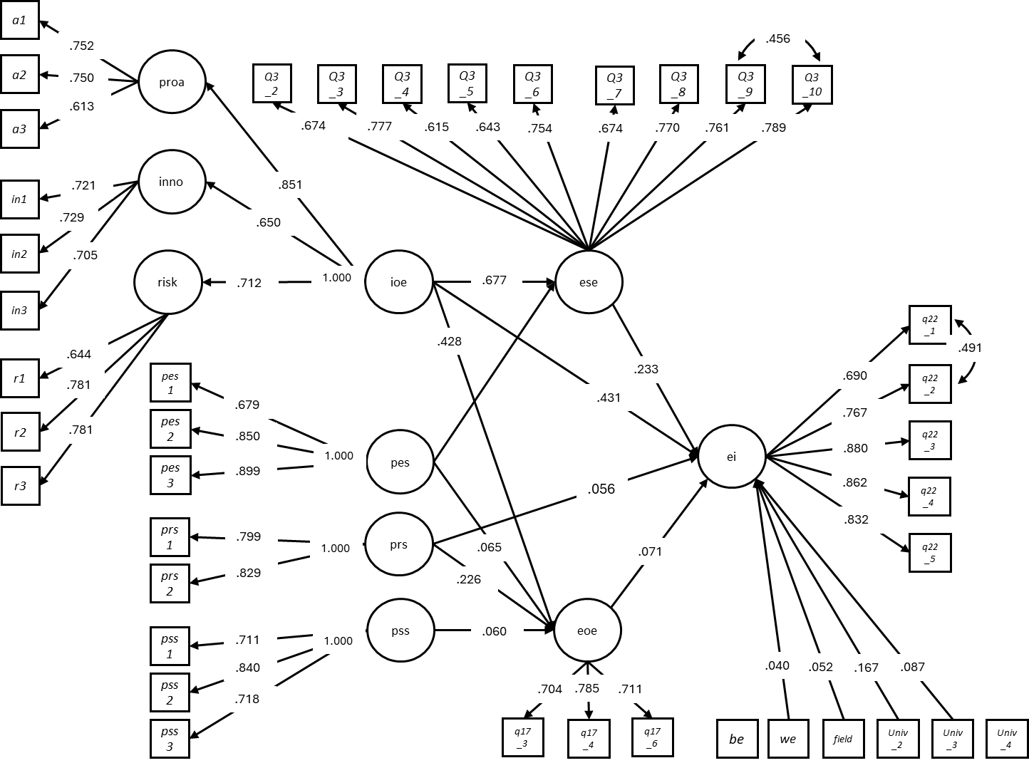

Figure 2. SEM results (only direct effects).
Source: authors’ elaboration

All shown paths are statistically significant with standardized path coefficients. The circles refer to latent variables; the rectangular refers to an observed variable. ei = entrepreneurial intentions; ieo= individual entrepreneurial orientation; proa = proactiveness, inno = innvativeness, risk = risk-taking, pes = perceived educational support; prs= perceived relational support; pss = perceived structural support; ese= entrepreneurial self-efficacy; eoe = entrepreneurial outcome expectations; be = business exposure; we = work experience; field = field of study; univ_2 = LPNU (Ukraine); Univ_3 = RTU (Latvia); Univ_4 = TUS (Bulgaria).

Bibliography
Anderson, J. C., & Gerbing, D. W. (1988). Structural Equation Modelling in Practice: A Review and Recommended Two-Step Approach. Psychological Bulletin, 103(3), 411–423. https://doi.org/10.1037/0033-2909.103.3.411
Bandalos, D. L., & Finney, S. J. (2019). Factor analysis: Exploratory and confirmatory. In G. R. Hancock, L. M. Stapleton, & R. O. Mueller (Eds.), The reviewer’s guide to quantitative methods in the social sciences (2nd ed., 98–122). Routledge/Taylor & Francis Group. https://doi.org/10.4324/9781315755649-8

Cho, E., & Kim, S. (2015). Cronbach’s coefficient alpha: Well known but poorly understood. Organizational research methods, 18(2), 207-230. https://doi.org/10.1177/1094428114555994
Fornell, C., & Larcker, D. F. (1981). Evaluating structural equation models with unobservable variables and measurement error. Journal of Marketing Research, 18(1), 39–50. https://doi.org/10.2307/3151312
Furr, R. M. (2021). Psychometrics: An Introduction. SAGE Publications.
Hair, J. F., Black, W. C., Babin, B. J., & Anderson, R. E. (2009). Multivariate data analysis (7th ed.).
Geldhof, G. J., Preacher, K. J., & Zyphur, M. J. (2014). Reliability estimation in a multilevel confirmatory factor analysis framework. Psychological Methods, 19(1), 72–91. https://doi.org/10.1037/a0032138
Kline, R. B. (2023). Principles and practice of structural equation modelling. Guilford Publications.
Tabachnick, B. G., Fidell, L. S., & Ullman, J. B. (2013). Using multivariate statistics 6, 497–516. Boston, MA: Pearson.
Wang, J., & Wang, X. (2019). Structural equation modelling: Applications using Mplus. John Wiley & Sons.

