Supplementary Material Appendix 1
- Diagram of Solution Architecture
Admin User Interface
Client User Interface
Constructor User Interface
Supplier User Interface
Backend
Tezos API
Tezos Blockchain
Firebase Database

- Screenshots of other stakeholders’ dashboards
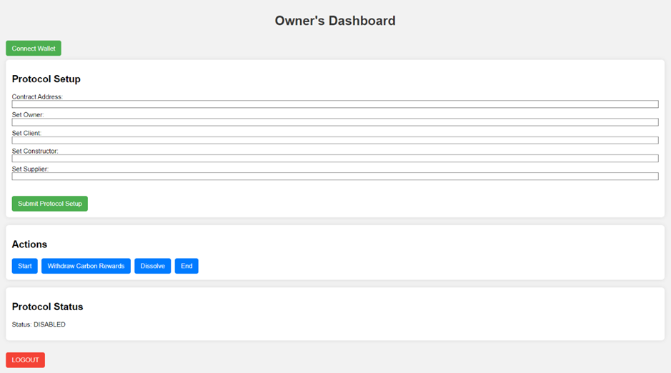
- Protocol Owner’s Dashboard

- Contractor’s Dashboard
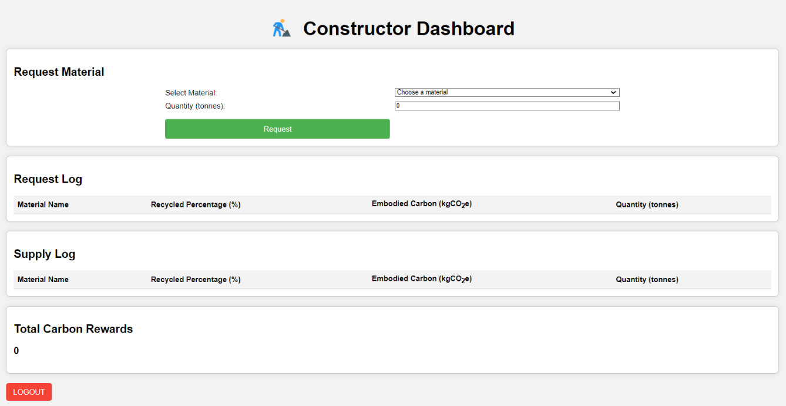
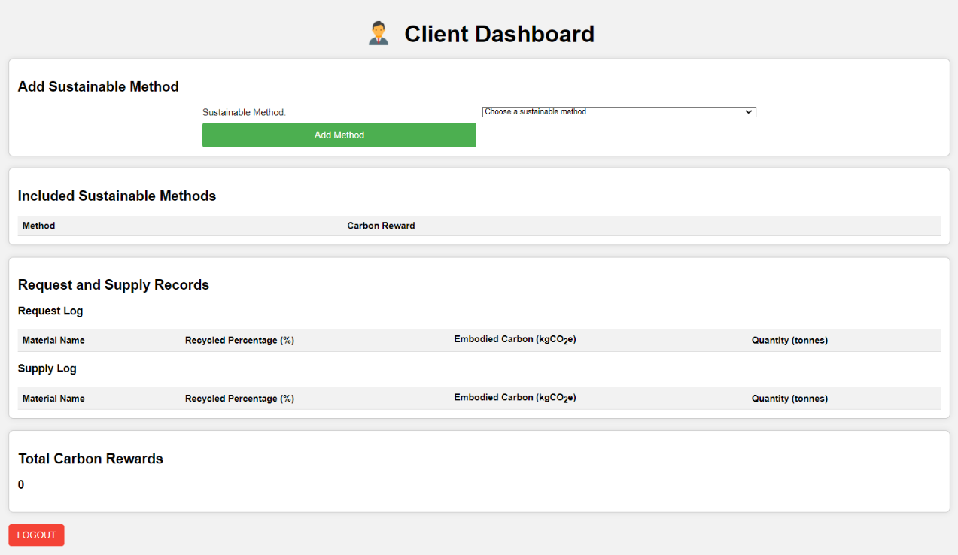
- Client’s Dashboard

