Supplementary Material Appendix 2
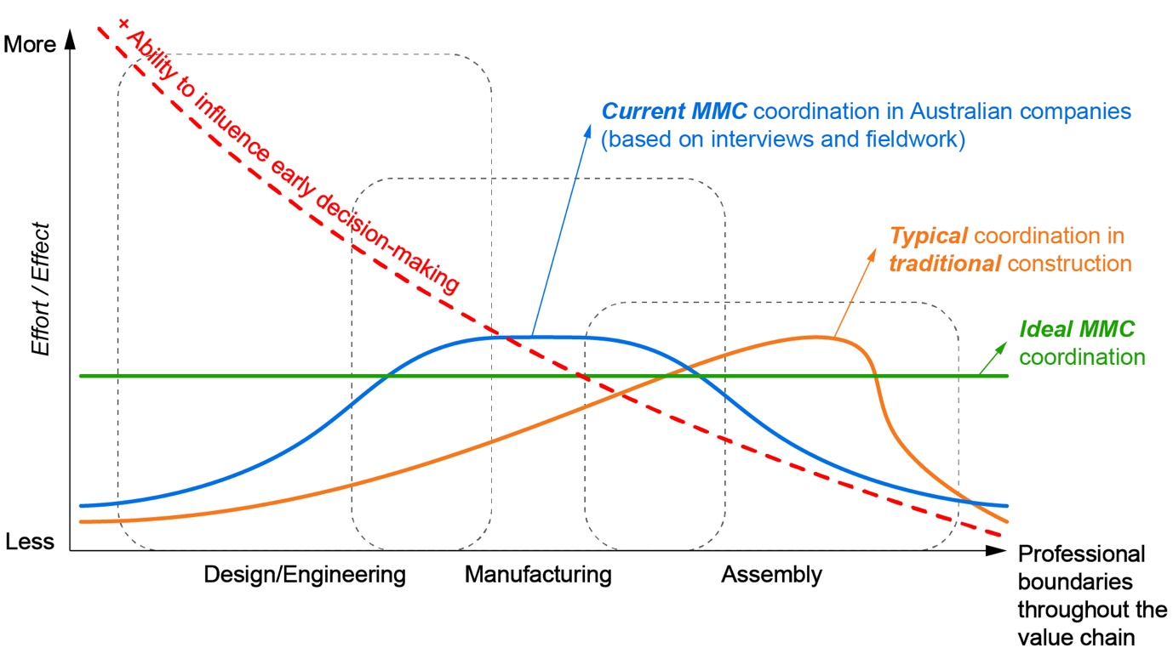
Figure 1. Comparison of decision-making and coordination workflows: MMC vs. traditional construction. Source: Authors’ own elaboration.
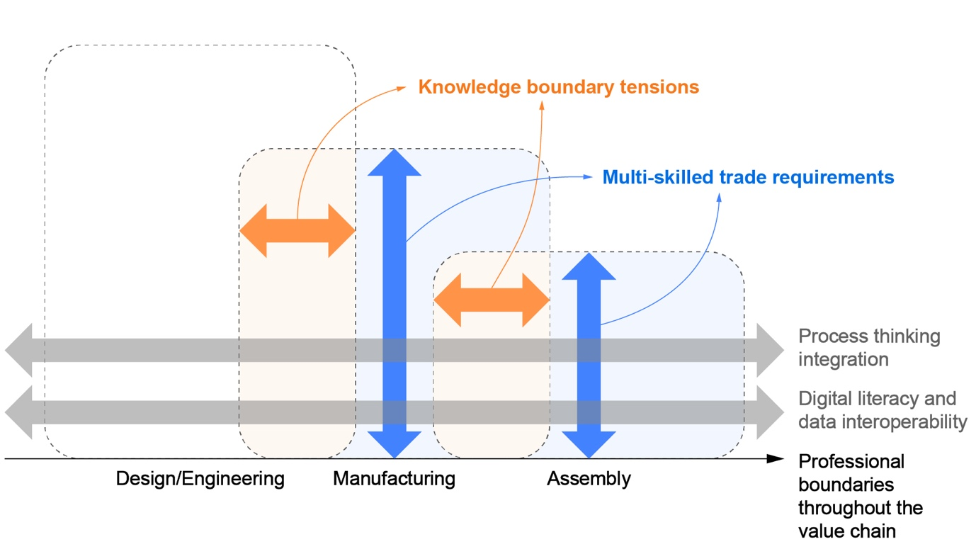
Figure 2. The evolution of the MMC workforce: Skills dynamics and knowledge boundaries. Source: Authors’ own elaboration.

