 | Stone  (corresponding disaster) | Type | Year built | Water level  mark(s) | Location/  Religious facility precinct | Other notable features | Visibility  Maintenance
1 | Meiji 29 Flood Stone  明治29年洪水石標  (Lake Biwa flood  Sept. 1896) | kinen-hi | 1899 | Yes  (high water levels of previous floods in 1860, 1868, 1885) | Otsu, Shiga  (Sakai shrine)  Shrine precinct | - stand-alone (1)  - Designated Cultural Asset  - information panel describing the flood | High
2 | Meiji 29 Flood Stone  明治29年洪水石標  (Lake Biwa flood  Sept. 1896) | kinen-hi | 1971 | Yes | Otsu, Shiga  (Zennen temple)  Temple precinct | Integrated (1) | High
3 | Meiji 29 Flood Stone  明治29年洪水石標  (Lake Biwa flood  Sept. 1896) | kinen-hi | 1979 | yes | Otsu, Shiga (Saikou temple)  Temple precinct | stand-alone | High
4 | Debris flow recovery stone  山津波復興記念碑(Debris flow, June 29, 1935) | kinen-hi | 1936 |  | Otsu, Shiga | stand-alone | High
5 | Stone (commemorating the) damage from 2nd typhoon Muroto  第二室戸台風被害の碑  (2nd typhoon Muroto (Typhoon Nancy) Sept. 16, 1961) | kinen-hi | ? |  | Otsu, Shiga  (Togakushi shrine)  Shrine precinct | integrated | Low
6 | Water disaster memory tower  水害想出の塔  (Mudflow  Sept. 25, 1953) | kinen-hi | ? |  | Otsu, Shiga | stand-alone | High
7 | Mudflow remembrance tower  山崩供養塔  (Mudflow  June 5, 1848) | kuyō-hi | ? |  | Otsu, Shiga |  | High
- “stand-alone” refers to a self-standing monument, whereas “integrated” refers to one part of a larger structure.

1
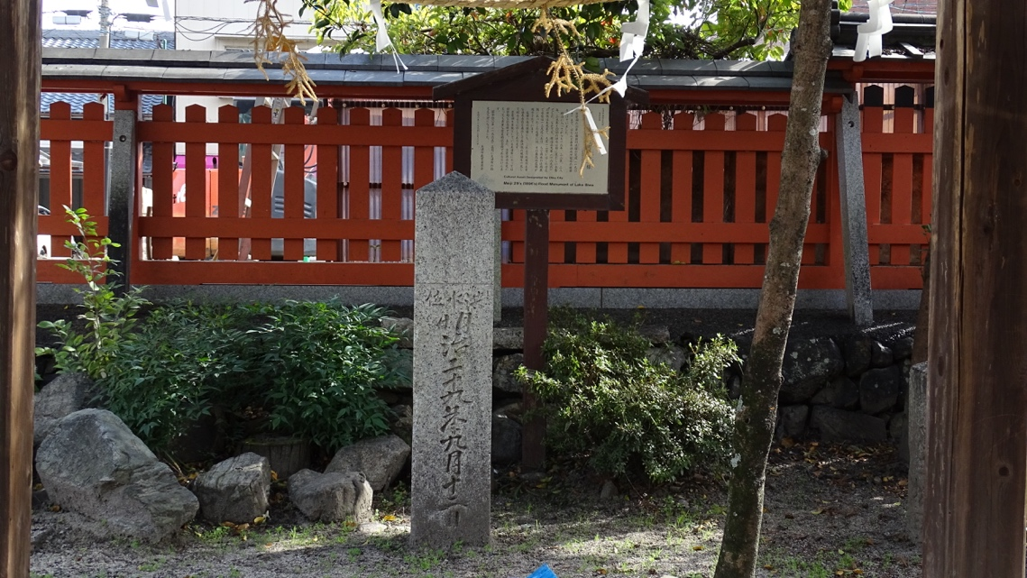

2
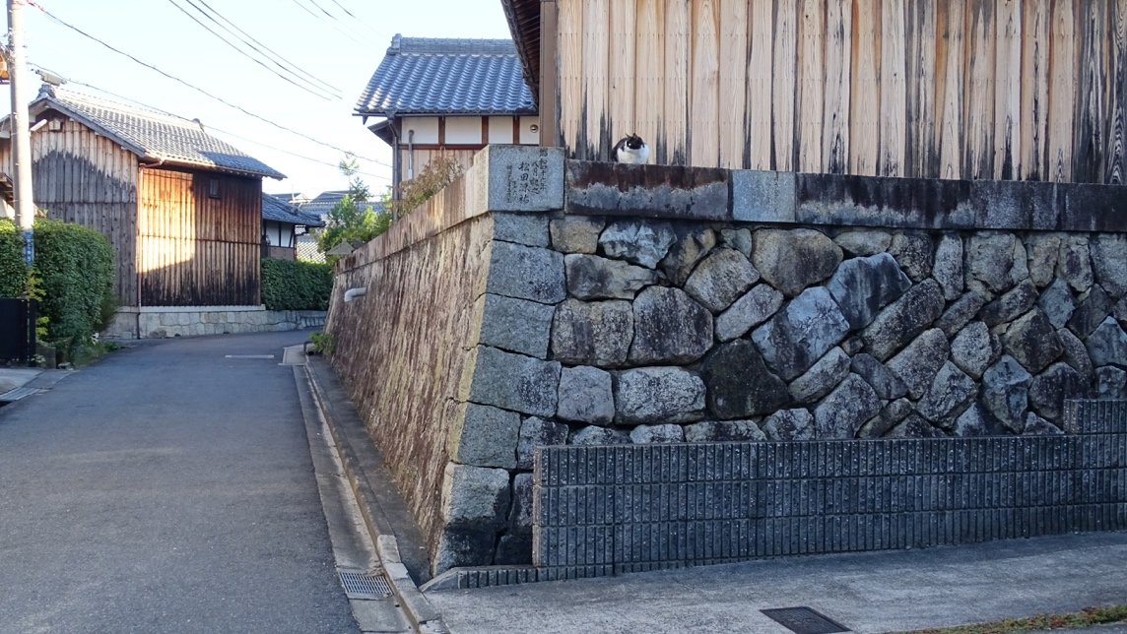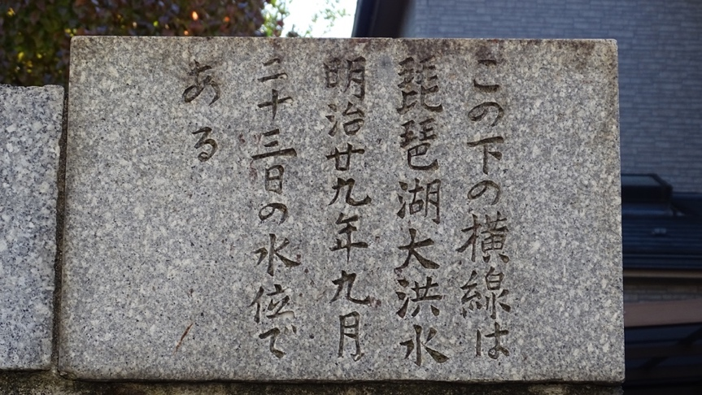

3

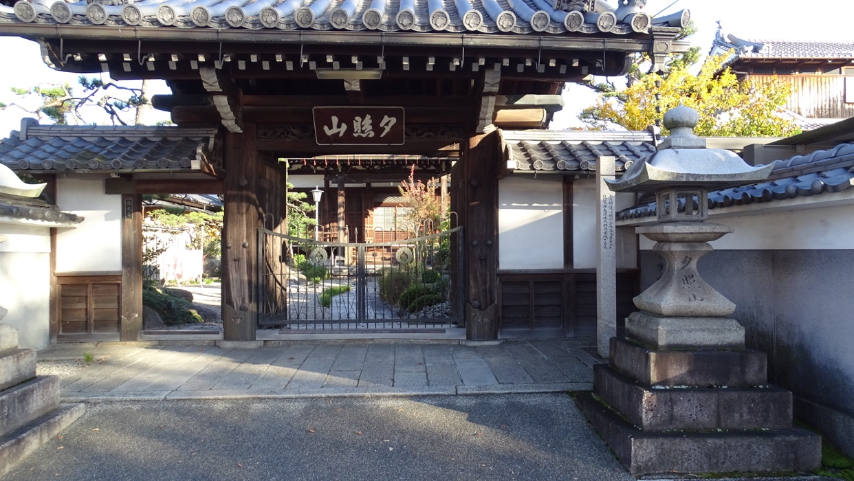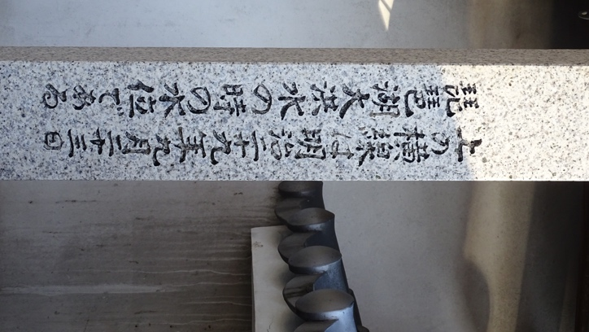

4
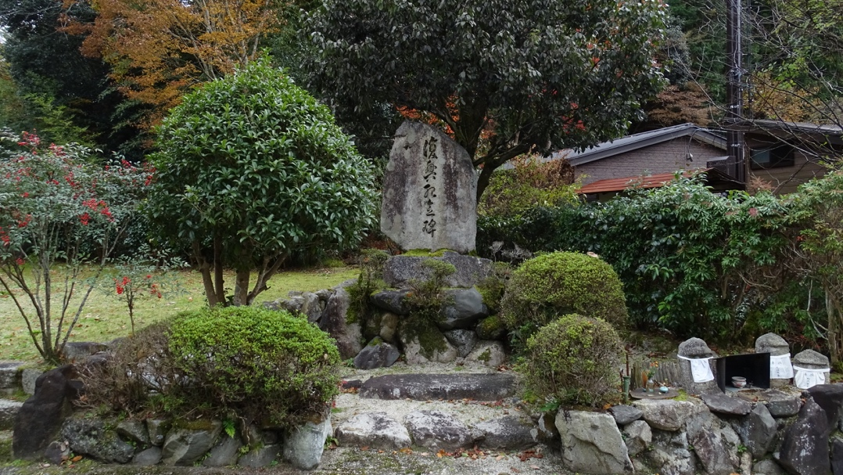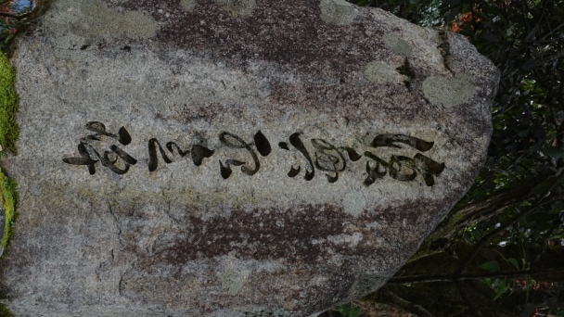

5
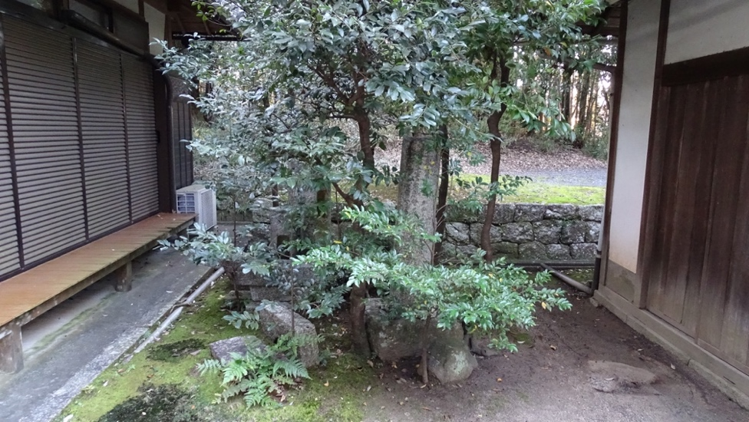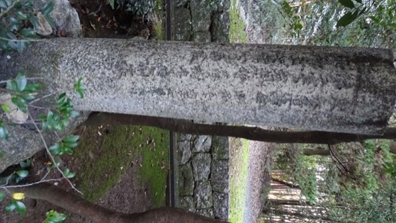

6
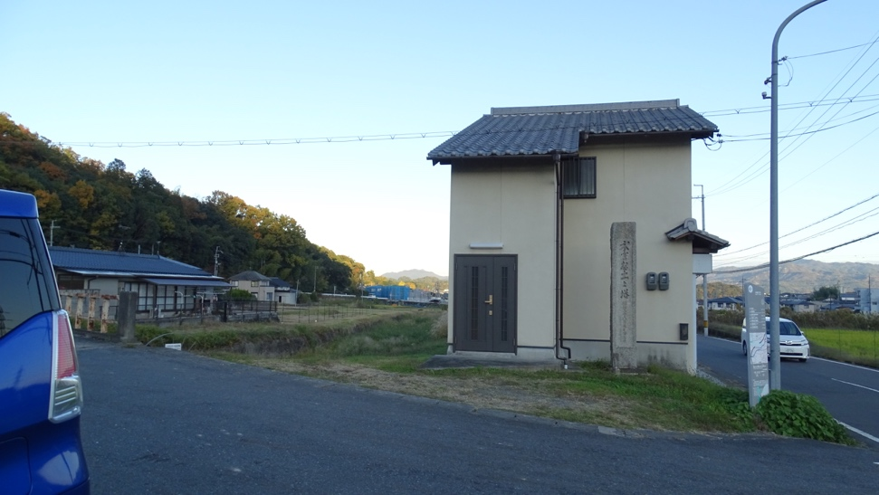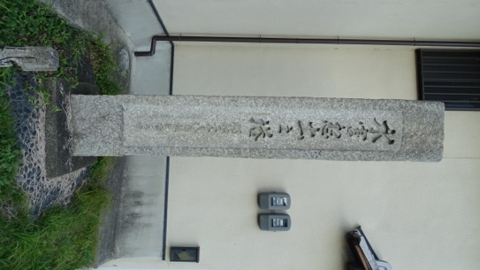

7
