Appendices

Appendix A: Interview Guide
- Do you know what ChatGPT is? (This is a qualifying question for the interview. If the respondent replies " No, " the interview will not be conducted with that participant).
- According to you, what is ChatGPT? Moreover, how does it work?
- Do you use ChatGPT? If yes, then for what purposes?
- Do you think that ChatGPT will be useful in the government sector? If yes, then how?
- In your opinion, what are some potential applications of ChatGPT in the government sector?
- How can ChatGPT be used to improve customer service in the government sector?
- Can ChatGPT be used to automate certain government processes? If so, which processes and how?
- What challenges may arise from using ChatGPT in the government sector, and how can they be addressed?
- How can ChatGPT be used to improve data analysis in the government sector?
- What are some potential ethical considerations that should be taken into account when using ChatGPT in the government sector?
- What are some limitations of ChatGPT that may prevent it from being useful in the government sector?
- Can you provide examples of government agencies or organisations successfully implementing ChatGPT?
- What do you think the future of ChatGPT looks like in the government sector?

(Source: Developed by Author)

Appendix B: Participant Information
Participant Code | Designation | Knowledge about and usage of ChatGPT | Years of working experience in government | Sector | I have been using ChatGPT at work
P1. | IT Director | Yes-Registered User | More than 10 years | Government Only | Yes
P2. | Senior Officer | Yes-Registered User | More than 10 years | Government and Private Sector | Yes
P3. | Data Analyst Consultant | Yes-Registered User | More than 10 years | Government and Private Sector | Yes
P4. | Legal Advisor | Yes-Registered User | More than 10 years | Government and Private Sector | Yes
P5. | Office Manager | Yes-Registered User | More than 10 years | Government Only | Yes
P6. | Projects Manager – Digital Transformation | Yes-Registered User | More than 10 years | Government and Private Sector | Yes
P7. | IT Consultant | Yes-Registered User | More than 10 years | Government Only | Yes
P8. | Government Communication Director | Yes-Registered User | 7 - 10 years | Government Only | Yes
P9. | HR Director | Yes-Registered User | More than 10 years | Government Only | Yes
P10. | Customer Relationship Director | Yes-Registered User | More than 10 years | Government Only | Yes
P11. | AI Expert | Yes-Registered User | More than 8 years | Government Only | Yes
P12. | IT Governance Executive | Yes-Registered User | More than 12 years | Government Only | Yes
P13. | Data governance and privacy specialist | Yes-Registered User | More than 15 years | Government Only | Yes
P14 | IT executive | Yes-Registered User | More than 12 years | Government Only | Yes
P15 | Data manager | Yes-Registered User | More than 10 years | Government Only | Yes
P16 | Data analyst | Yes-Registered User | 13 years | Government Only | Yes
P17 | Data analyst | Yes-Registered User | More than 7 years | Government Only | Yes
P18 | Digital transformation manager | Yes-Registered User | More than 9 years | Government Only | Yes
P19 | Digital executive | Yes-Registered User | 15 years | Government Only | Yes
P20 | Data analyst | Yes-Registered User | 11 years | Government Only | Yes
Note: Specific entities of these participants have not been mentioned due to their mentioned job positions, which can create confidentiality and anonymity concerns.
(Source: Developed by Author)

Appendix C: Thematic Analysis Process
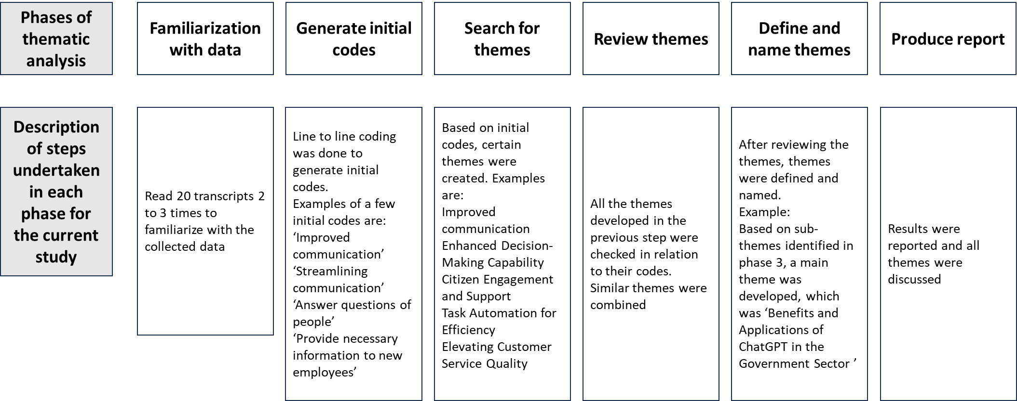
(Source: Developed by Author, steps taken from Braun, V., & Clarke, V. (2012))

