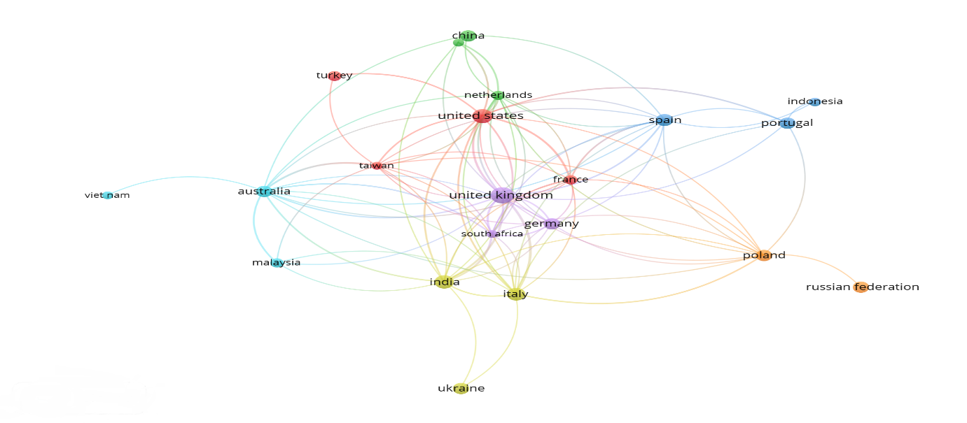
Figure A1: Cross-country collaboration analysis.
Source(s): Figure by authors
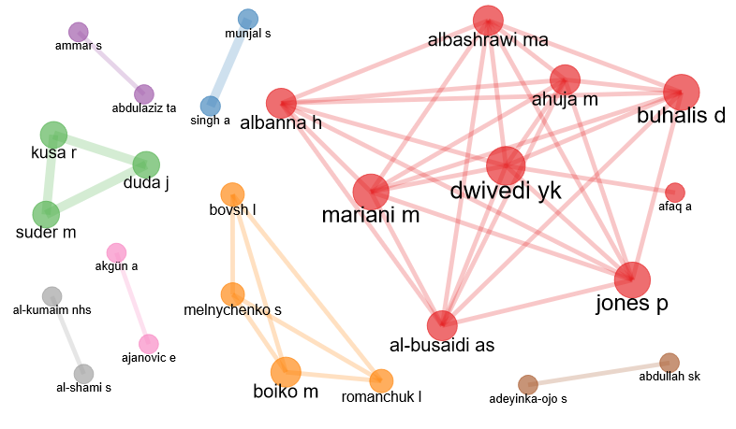
Figure A2 Collaboration of author network
Source(s): Figure by authors

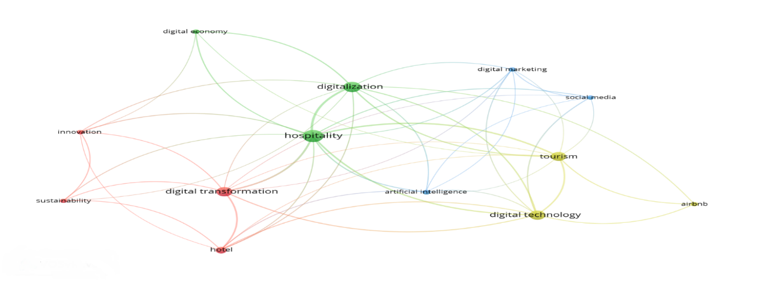
Figure A3: Author keyword co-occurrence and network analysis
Source(s): Figure by authors
Table A1: Most influential authors, institutions, and countries of digital transformation
Author | TP | TC | Countries | TP | TC | Institution | TP | TC
Buhalis D | 3 | 1534 | United kingdom | 28 | 2397 | University of warsaw, Poland | 2 | 130
Dwivedi YK | 2 | 1532 | Italy | 15 | 2014 | Swinburne university of technology, Australia | 2 | 80
Alrawadieh Z | 2 | 136 | Spain | 19 | 1877 | Bolyai university, Romania | 2 | 23
Gyódi K | 3 | 135 | Australia | 15 | 1735 | University of houston, United states | 2 | 19
Busulwa R | 2 | 80 | United states | 21 | 1708 | kazakh university kazakhstan | 2 | 16
Duda J | 2 | 38 | India | 20 | 1672 | Vedatya institute, gurgaon,India | 2 | 9
Boiko M | 3 | 20 | Poland | 14 | 1621 | Helwan university, Egypt | 2 | 7
Borysova O | 2 | 6 | China | 19 | 396 | Zhejiang university,  China | 2 | 5
Zhou D | 4 | 4 | Turkey | 12 | 275 | Beijing international studies university, China | 2 | 4
Note: TC-Total Citations TP-Total Publications Source(s): Table by authors

Table A2: Most influential journals for digital transformation research
Sources | TP | Quartile | SJR | Publisher | SJR h index
Sustainability (Switzerland) | 18 | Q1 | 0.66 | Multidisciplinary Digital Publishing Institute (MDPI) | 136
International journal of hospitality management | 7 | Q1 | 2.93 | Elsevier Ltd. | 151
International journal of contemporary hospitality management | 7 | Q1 | 2.5 | Emerald Group Publishing Ltd. | 113
Worldwide hospitality and tourism themes | 8 | Q2 | 0.42 | Emerald Group Publishing Ltd. | 28
Information technology and tourism | 2 | Q1 | 1.9 | Springer Science | 39
International journal of information management | 2 | Q1 | 5.78 | Elsevier Ltd | 177
Journal of business research | 2 | Q1 | 3.13 | Elsevier Inc. | 265
Journal of hospitality, leisure, sport and tourism education | 2 | Q1 | 1.05 | Elsevier B.V. | 40
Technology in society | 2 | Q1 | 2.25 | Elsevier Ltd | 88
Tourism and hospitality research | 2 | Q1 | 0.83 | SAGE Publications Inc. | 52
Note: SJR-Scimago journal ranking TP-Total publication Source(s): Table by authors

Table A3: Prominent scholarly articles based on citation metrics.
 | Authors | TC | TC Per year | Title
1 | Dwivedi et al,2023 | 1403 | 1403.00 | “So what if ChatGPT wrote it?” Multidisciplinary perspectives on opportunities, challenges and implications of generative conversational AI for research, practice and policy”
2 | Pencarelli, 2019 | 363 | 90.75 | “The digital revolution in the travel and tourism industry”
3 | Ferreri & Sanyal, 2018 | 175 | 29.16 | “Platform economies and urban planning: Airbnb and regulated deregulation in London”
4 | Gaur et al., 2021 | 129 | 43.00 | “Role of artificial intelligence and robotics to foster the touchless travel during a pandemic: a review and research agenda”
5 | Filimonau & Naumova, 2020 | 128 | 32.00 | “The blockchain technology and the scope of its application in hospitality operations”
6 | Lau, 2020 | 110 | 27.50 | “New technologies used in COVID-19 for business survival: Insights from the Hotel Sector in China”
7 | Buhalis & Deimezi, 2004 | 107 | 6.29 | “E-Tourism Developments in Greece: Information Communication Technologies Adoption for the Strategic Management of the Greek Tourism Industry”
8 | Jimenez-Marquez et al., 2019 | 102 | 20.40 | “Towards a big data framework for analyzing social media content”
9 | Mariani, 2019 | 100 | 25.00 | “Big Data and analytics in tourism and hospitality: a perspective article”
10 | Shen et al,2022 | 99 | 49.5 | “Exploring the factors influencing the adoption and usage of Augmented Reality and Virtual Reality applications in tourism education within the context of COVID-19 pandemic”
TC-Total citations. Source(s): Table by authors
Table A4: Thematic clusters of digital transformation
Theme | Author(s) | Title | TC
Virtual avatars | Shen et al., 2022 | Exploring the factors influencing the adoption and usage of Augmented Reality and Virtual Reality applications in tourism education within the context of COVID-19 pandemic | 99
Virtual avatars | Choi et al., 2020 | “Role of virtual avatars in digitalized hotel service | 44
Digital platforms and the sharing economy | Ferreri & Sanyal, 2018 | Platform economies and urban planning: Airbnb and regulated deregulation in London | 175
Digital platforms and the sharing economy | Gyódi, 2019 | Airbnb in European cities: Business as usual or true sharing economy? | 135
Digital travelers and hospitality | Alrawadieh et al., 2020 | Digital transformation and revenue management: Evidence from the hotel industry | 136
Digital travelers and hospitality | Yallop et al., 2021 | The digital traveler: implications for data ethics and data governance in tourism and hospitality | 19
Artificial Intelligence and data | Dwivedi et al., 2023 | So, what if ChatGPT wrote it?” Multidisciplinary perspectives on opportunities, challenges, and implications of generative conversational AI for research, practice, and policy | 1403
Artificial Intelligence and data | Jimenez-Marquez et al., 2019 | Towards a big data framework for analyzing social media content | 102
IoT in travel | Pencarelli, 2019 | The digital revolution in the travel and tourism industry | 363
IoT in travel | Pappas et al.,2021 | The complexity of decision-making processes and IoT adoption in accommodation SMEs | 70
Hospitality and Tourism Education | Adeyinka-Ojo et al., 2020 | Hospitality and tourism education in an emerging digital economy | 40
Hospitality and Tourism Education | Fauzi, 2022 | A bibliometric review on knowledge management in tourism and hospitality: past, present and future trends | 26
Source(s): Table by authors

