Supplementary file

Table A1 Most Prominent Authors (Source: Created by Authors)
Author | Publications | Total Citations | H  Index | G  Index | M  Index | Sample Article
MCCARTNEY S | 5 | 177 | 4 | 5 | 0.67 | (McCartney et al., 2021)
FU N | 4 | 124 | 3 | 4 | 0.6 | (McCartney and Fu, 2024)
ARORA M | 3 | 19 | 2 | 3 | 0.67 | (Arora, Prakash, Dixit, et al., 2023)
CAVANAGH J | 3 | 25 | 3 | 3 | 1 | (Pariona‐Cabrera et al., 2023)
DI PRIMA C | 3 | 10 | 2 | 3 | 1 | (Di Prima, Kotaskova, et al., 2024)
FERRARIS A | 3 | 10 | 2 | 3 | 1 | (Di Prima, Cepel, et al., 2024)
HALVORSEN B | 3 | 25 | 3 | 3 | 1 | (Cavanagh et al., 2024)
MITTAL A | 3 | 19 | 2 | 3 | 0.67 | (Arora, Prakash, Mittal, et al., 2023)
PARIONA-CABRERA P | 3 | 25 | 3 | 3 | 1 | (Pariona‐Cabrera et al., 2023)
SINGH S | 3 | 20 | 2 | 3 | 0.67 | (Singh and Muduli, 2023)
WANG L | 3 | 51 | 2 | 3 | 0.67 | (Wang and Katsamakas, 2019)

Table A2 Most Prominent Articles (Source: Created by Authors)
Article | Title | Total Citations | Journal
(Marler and Boudreau, 2017) | “An evidence-based review of HR Analytics” | 381 | The International Journal of Human Resource Management
(Angrave et al., 2016) | “HR and analytics: why HR is set to fail the big data challenge” | 352 | Human Resource Management Journal
(Newman et al., 2020) | “When eliminating bias isn’t fair: Algorithmic reductionism and procedural justice in human resource decisions” | 251 | Organizational Behavior and Human Decision Processes
(Gal et al., 2020) | “Breaking the vicious cycle of algorithmic management: A virtue ethics approach to people analytics” | 185 | Information and Organization
(Pessach et al., 2020) | “Employees recruitment: A prescriptive analytics approach via machine learning and mathematical programming” | 153 | Decision Support Systems
(van den Heuvel and Bondarouk, 2017) | “Building credible human capital analytics for organizational competitive advantage” | 146 | Human Resource Management
(Hamilton and Sodeman, 2020) | “The questions we ask: Opportunities and challenges for using big data analytics to strategically manage human capital resources” | 138 | Business Horizons
(Margherita, 2022) | “Human resources analytics: A systematization of research topics and directions for future research” | 136 | Human Resource Management Review
(van den Heuvel and Bondarouk, 2017) | “The rise (and fall?) of HR analytics: A study into the future application, value, structure, and system support” | 133 | Journal of Organizational Effectiveness
(Fernandez and Gallardo-Gallardo, 2021) | “Tackling the HR digitalization challenge: key factors and barriers to HR analytics adoption” | 120 | Competitiveness Review
(McIver et al., 2018) | “A strategic approach to workforce analytics: Integrating science and agility” | 100 | Business Horizons

Figure A1 (Countries' Total Citations and Average Article Citations (Source: Created by Authors)

Figure A2: Co-citation Analysis (Source: Created by Authors)
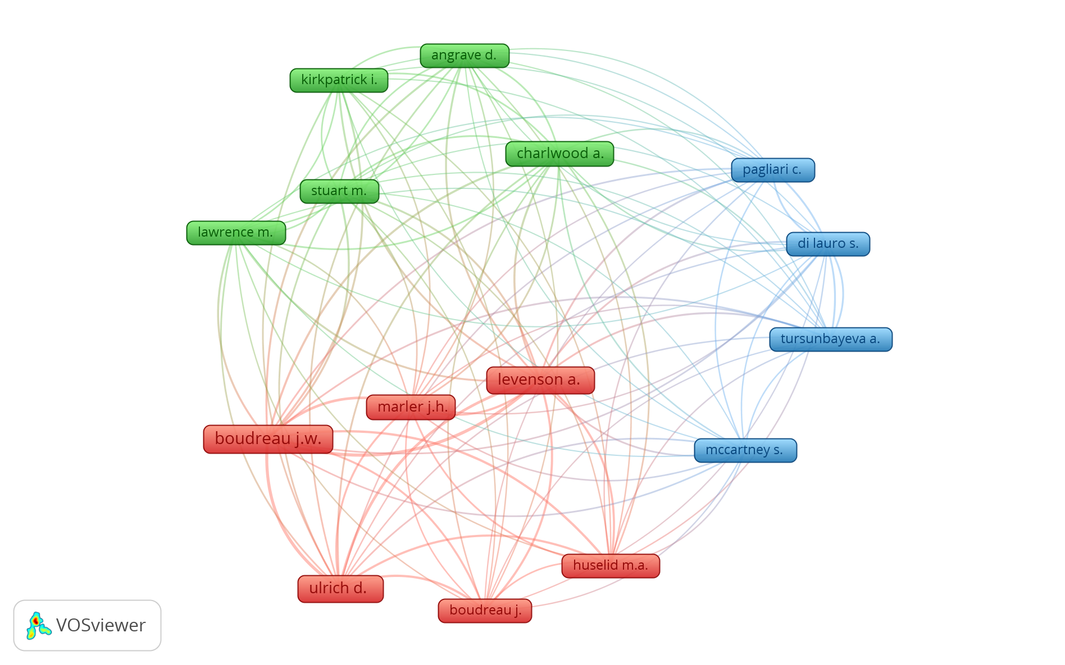

Figure A3: Co-authorship Analysis (Source: Created by Authors)

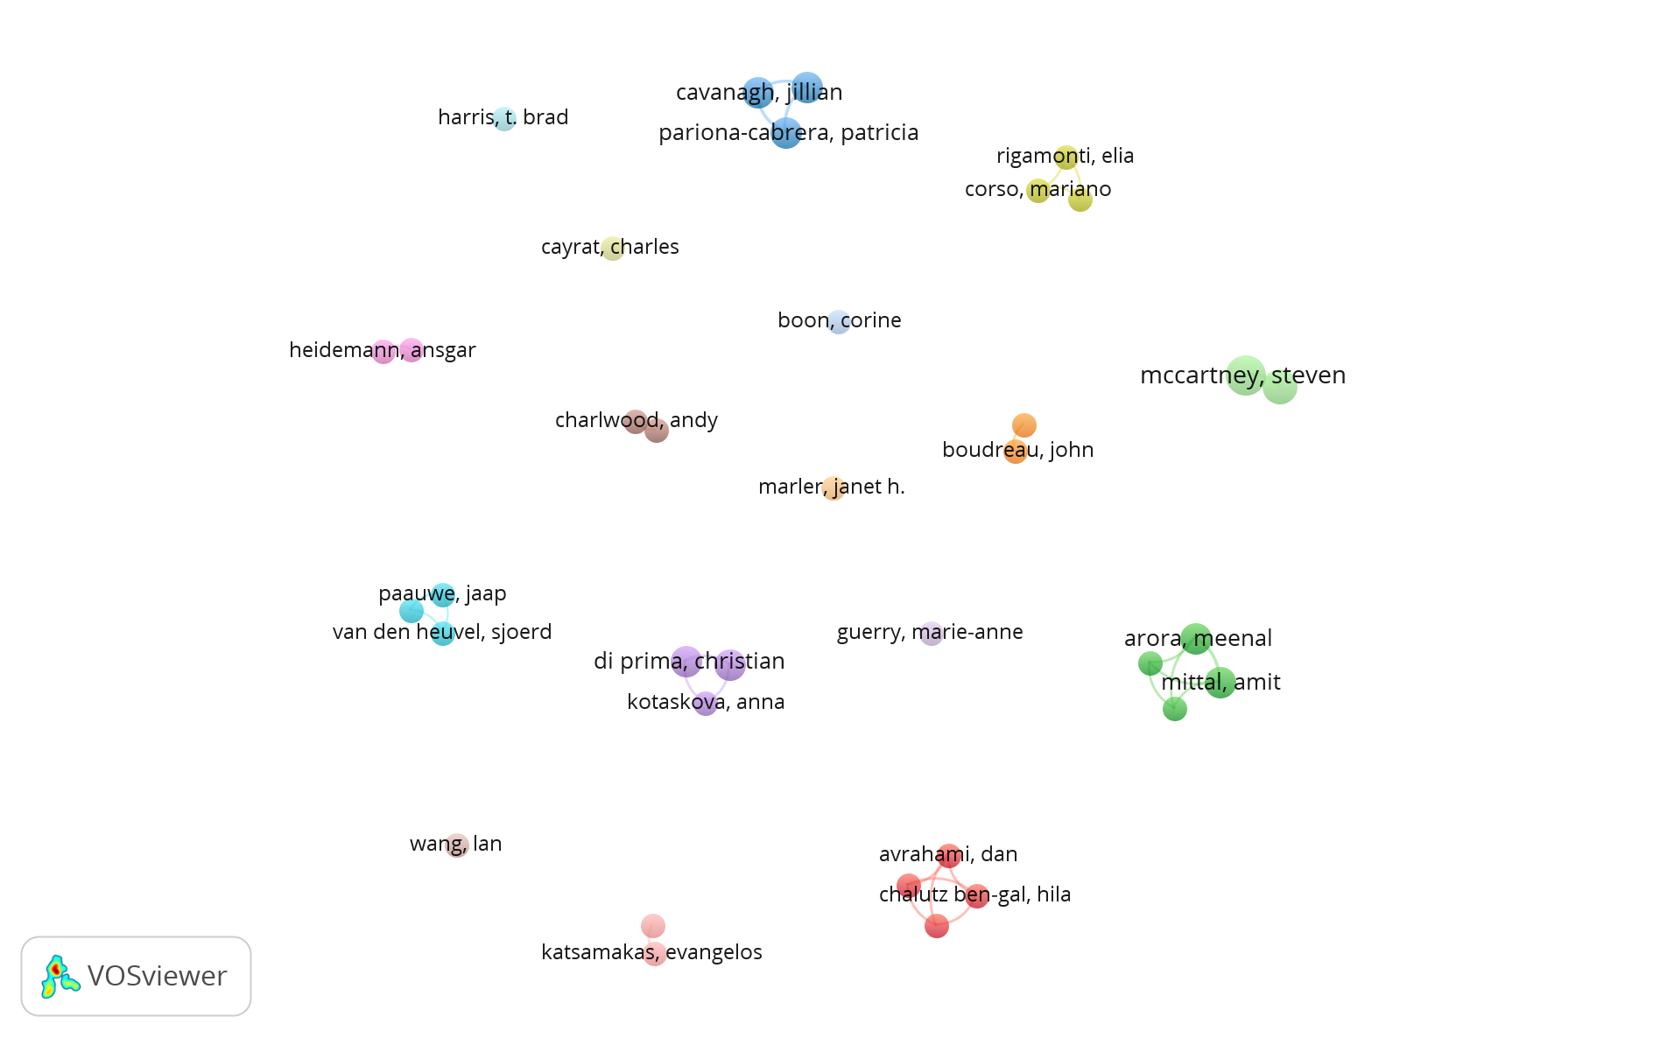

References
Angrave, D., Charlwood, A., Kirkpatrick, I., Lawrence, M. and Stuart, M. (2016), “HR and analytics: why HR is set to fail the big data challenge”, Human Resource Management Journal, Vol. 26 No. 1, pp. 1–11, doi: 10.1111/1748-8583.12090.
Arora, M., Prakash, A., Dixit, S., Mittal, A. and Singh, S. (2023), “A critical review of HR analytics: visualization and bibliometric analysis approach”, Information Discovery and Delivery, Vol. 51 No. 3, pp. 267–282, doi: 10.1108/IDD-05-2022-0038.
Arora, M., Prakash, A., Mittal, A. and Singh, S. (2023), “Moderating role of resistance to change in the actual adoption of HR analytics in the Indian banking and financial services industry”, Evidence-Based HRM, Emerald Publishing, Vol. 11 No. 3, pp. 253–270, doi: 10.1108/EBHRM-12-2021-0249.
Cavanagh, J., Bartram, T., Walker, M., Pariona-Cabrera, P. and Halvorsen, B. (2024), “Health services in Australia and the impact of antiquated rostering practices on medical scientists: a case for HR analytics and evidenced-based human resource management”, Personnel Review, Vol. 53 No. 1, pp. 18–33, doi: 10.1108/PR-09-2021-0690.
Fernandez, V. and Gallardo-Gallardo, E. (2021), “Tackling the HR digitalization challenge: key factors and barriers to HR analytics adoption”, Competitiveness Review: An International Business Journal, Vol. 31 No. 1, pp. 162–187, doi: 10.1108/CR-12-2019-0163.
Gal, U., Jensen, T.B. and Stein, M.-K. (2020), “Breaking the vicious cycle of algorithmic management: A virtue ethics approach to people analytics”, Information and Organization, Vol. 30 No. 2, p. 100301, doi: 10.1016/j.infoandorg.2020.100301.
Hamilton, R.H. and Sodeman, W.A. (2020), “The questions we ask: Opportunities and challenges for using big data analytics to strategically manage human capital resources”, Business Horizons, Vol. 63 No. 1, pp. 85–95, doi: 10.1016/j.bushor.2019.10.001.
Margherita, A. (2022), “Human resources analytics: A systematization of research topics and directions for future research”, Human Resource Management Review, Vol. 32 No. 2, p. 100795, doi: 10.1016/j.hrmr.2020.100795.
Marler, J.H. and Boudreau, J.W. (2017), “An evidence-based review of HR Analytics”, The International Journal of Human Resource Management, Vol. 28 No. 1, pp. 3–26, doi: 10.1080/09585192.2016.1244699.
McCartney, S. and Fu, N. (2024), “Enacting people analytics: Exploring the direct and complementary effects of analytical and storytelling skills”, Human Resource Management, Vol. 63 No. 2, pp. 187–205, doi: 10.1002/hrm.22194.
McCartney, S., Murphy, C. and Mccarthy, J. (2021), “21st century HR: a competency model for the emerging role of HR Analysts”, Personnel Review, Vol. 50 No. 6, pp. 1495–1513, doi: 10.1108/PR-12-2019-0670.
McIver, D., Lengnick-Hall, M.L. and Lengnick-Hall, C.A. (2018), “A strategic approach to workforce analytics: Integrating science and agility”, Business Horizons, Vol. 61 No. 3, pp. 397–407, doi: 10.1016/j.bushor.2018.01.005.
Newman, D.T., Fast, N.J. and Harmon, D.J. (2020), “When eliminating bias isn’t fair: Algorithmic reductionism and procedural justice in human resource decisions”, Organizational Behavior and Human Decision Processes, Vol. 160, pp. 149–167, doi: 10.1016/j.obhdp.2020.03.008.
Pariona‐Cabrera, P., Cavanagh, J. and Halvorsen, B. (2023), “Examining the need for HR analytics to better manage and mitigate incidents of violence against nurses and personal care assistants in aged care”, Asia Pacific Journal of Human Resources, Vol. 61 No. 4, pp. 888–906, doi: 10.1111/1744-7941.12361.
Pessach, D., Singer, G., Avrahami, D., Chalutz Ben-Gal, H., Shmueli, E. and Ben-Gal, I. (2020), “Employees recruitment: A prescriptive analytics approach via machine learning and mathematical programming”, Decision Support Systems, Vol. 134, p. 113290, doi: 10.1016/j.dss.2020.113290.
Di Prima, C., Cepel, M., Kotaskova, A. and Ferraris, A. (2024), “Help me help you: How HR analytics forecasts foster organizational creativity”, Technological Forecasting and Social Change, Elsevier Inc., Vol. 206, doi: 10.1016/j.techfore.2024.123540.
Di Prima, C., Kotaskova, A., Yildiz, H. and Ferraris, A. (2024), “How to survive social crises? An HR analytics data-driven approach to improve social sustainable operations’ effectiveness”, Management Decision, Vol. 62 No. 7, pp. 2064–2084, doi: 10.1108/MD-06-2023-0973.
Singh, S. and Muduli, A. (2023), “Examining the role of organisational trust on information sharing intention and human resource analytics outcomes: an empirical study”, International Journal of Knowledge Management Studies, Vol. 14 No. 4, pp. 435–456, doi: 10.1504/IJKMS.2023.133866.
Wang, N. and Katsamakas, E. (2019), “A Network Data Science Approach to People Analytics”, Information Resources Management Journal, Vol. 32 No. 2, pp. 28–51, doi: 10.4018/IRMJ.2019040102.
Van den Heuvel, S. and Bondarouk, T. (2017), “The rise (and fall?) of HR analytics”, Journal of Organizational Effectiveness: People and Performance, Vol. 4 No. 2, pp. 157–178, doi: 10.1108/JOEPP-03-2017-0022.

