Appendix A - Main GUEST iterations with improvement points

Table 3 - Main GUEST iterations with improvements
Year | Reference | Domain / Application | Methodological contribution / Improvement point
2016 | Perboli, 2016 | Origin of the methodology | Original GUEST framework introduced as a structured approach linking lean business and Operations Research; first formulation of the GO – UNIFORM – EVALUATE – SOLVE – TEST cycle.
2017 | Perboli et al., 2017 | Freight transportation (synchro-modality, slow steaming) | First extension of GUEST to multi-actor freight contexts; integration of business model design with strategic transport choices, validating GUEST beyond purely operational use cases.
2018 | Perboli & Rosano, 2018 | Last-mile logistics | Embedding of a Decision Support System within the EVALUATE phase to mix traditional and green logistics; first systematic data-driven trade-off analysis inside GUEST.
2018 | Fadda et al., 2018 | Urban waste collection | Real-world deployment validating the iterative build–evaluate cycle; introduction of pilot-based TEST routines and KPI-based monitoring as standard GUEST artifacts.
2018 | Perboli et al., 2018 | Car-sharing services | Use of GUEST for business-model and tariff simulation; reinforcement of the SOLVE phase with scenario-based economic modelling and sensitivity analysis.
2018 | Rosano et al., 2018 | Collaborative urban freight | Extension of stakeholder mapping in GO and UNIFORM phases through a multi-actor mobile platform; first explicit treatment of digital platforms as enablers of ecosystem value.
2019 | Brotcorne et al., 2019 | Urban parcel delivery (managerial analysis) | Consolidation of the lean–business orientation; refinement of the value-proposition canvas and decision-rule articulation, strengthening replicability across managerial cases.
2019 | Perboli & Rosano, 2019 | Urban parcel delivery (mixed business models) | Integration of opportunities/threats assessment within EVALUATE; explicit handling of green vs. traditional trade-offs, anticipating later sustainability-aligned extensions.
2023 | Apruzzese et al., 2023 | 5G-enabled logistics and supply chain | Coupling of GUEST with companion digital technologies (5G, IoT); explicit consideration of technology readiness and digital-maturity assessment in UNIFORM.
2025 | Bruni et al., 2025 | Electric-vehicle diffusion / EU policy | Robust, data-driven decision support inside EVALUATE through a Bass-diffusion-based explanatory model; first application of GUEST to large-scale Pan-European policy analysis under uncertainty.
2025 | Perboli et al., 2025 | Web 3.0 and the Metaverse | Adaptation of GUEST to decentralized value-creation contexts; revision of stakeholder mapping and governance design to accommodate token-based and ecosystem-driven business models.
2026 | Catana et al. 2026 | Digital governance of ports (5G-LOGINNOV) | Use of GUEST for policy learning and governance design in port digital transformation; integration of regulatory uncertainty and multi-level governance into the SOLVE and TEST phases – setting the basis for GUEST 2.0.

Table 3 traces the evolution of the GUEST methodology from its original formulation (Perboli, 2016) to the present GUEST 2.0 framework. Each row reports a published application and the corresponding methodological refinement it introduced, illustrating how the framework has progressively matured through iterative build–evaluate cycles in line with Design Science Research principles.
The early iterations (2016–2019) consolidated the core GO–UNIFORM–EVALUATE–SOLVE–TEST cycle through applications in freight transportation (Perboli et al., 2017), last-mile and urban logistics (Perboli and Rosano, 2018, 2019; Brotcorne et al., 2019), waste collection (Fadda et al., 2018), car-sharing (Perboli et al., 2018), and collaborative urban freight platforms (Rosano et al., 2018). These contributions progressively embedded data-driven decision support, stakeholder mapping, and pilot-based validation into the methodology.
More recent iterations (2023–2026) extended GUEST toward digitally interconnected and policy-oriented contexts: 5G-enabled logistics and supply chain (Apruzzese et al., 2023), Pan-European policy analysis for electric-vehicle diffusion (Bruni et al., 2025), decentralized value creation in Web 3.0 and the Metaverse (Perboli et al., 2025), and digital governance of ports (Catana et al., 2026). These applications introduced explicit treatment of technology readiness, regulatory uncertainty, ecosystem-level value, and multi-level governance, laying the foundation for the consolidated GUEST 2.0 framework presented in this paper.

Appendix B - GUEST workflow and checkpoints

Figure 4
GUEST 2.0 workflow: the five interconnected phases with key data inputs, outputs, and the iterative learning loop

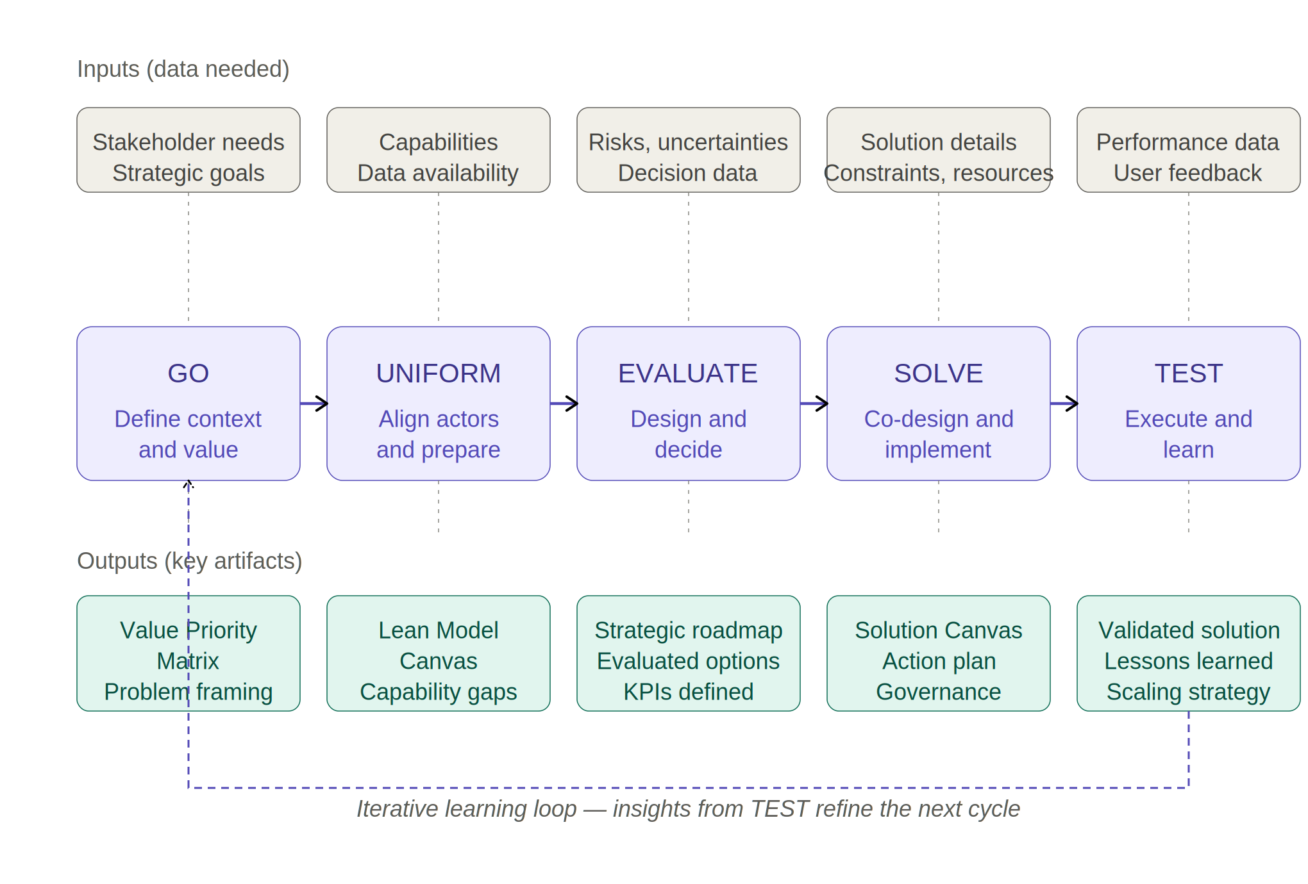

Table 4
GUEST 2.0 practitioner checklist: phase-by-phase items and gates for advancing through the methodology
# | Phase | ✓ | Checklist item
1 | GO  Define context and value | ☐ | All four Quadruple Helix groups (industry, academia, government, civil society) have been identified and contacted
1 | GO  Define context and value | ☐ | Each stakeholder group’s jobs, pains, and gains have been documented
1 | GO  Define context and value | ☐ | A Value Priority Matrix has been produced and reviewed across stakeholders
1 | GO  Define context and value | ☐ | A shared, written definition of “value” exists for the project
1 | GO  Define context and value | ☐ | The problem to be addressed has been framed in one paragraph and signed off
▸ Gate to UNIFORM — if any stakeholder group disputes the value definition, return to stakeholder mapping before proceeding.
2 | UNIFORM  Align actors and prepare | ☐ | A common terminology and documentation standard has been agreed
2 | UNIFORM  Align actors and prepare | ☐ | A digital readiness assessment has been completed (technological, organizational, cultural)
2 | UNIFORM  Align actors and prepare | ☐ | Capability gaps have been listed and ranked by impact
2 | UNIFORM  Align actors and prepare | ☐ | Governance roles and decision rights have been mapped
2 | UNIFORM  Align actors and prepare | ☐ | A Lean Model Canvas (or equivalent) has been completed for the initiative
▸ Gate to EVALUATE — if more than two critical capability gaps remain unaddressed, schedule remediation before proceeding.
3 | EVALUATE  Design and decide | ☐ | At least two alternative solutions have been articulated
3 | EVALUATE  Design and decide | ☐ | Each alternative has been assessed against KPIs and the Value Priority Matrix
3 | EVALUATE  Design and decide | ☐ | Risks, uncertainties, and opportunities have been logged (ICE diagram or equivalent)
3 | EVALUATE  Design and decide | ☐ | Short-term/long-term and explore/exploit trade-offs have been made explicit
3 | EVALUATE  Design and decide | ☐ | A strategic roadmap with performance predictors has been approved
▸ Gate to SOLVE — the chosen solution must be defensible against at least one rejected alternative.
4 | SOLVE  Co-design and implement | ☐ | A Solution Canvas has been co-produced with users and stakeholders
4 | SOLVE  Co-design and implement | ☐ | Decisions, timelines, and responsibilities are documented per work-package
4 | SOLVE  Co-design and implement | ☐ | Costs and trade-offs have been modelled (sensitivity to at least two key parameters)
4 | SOLVE  Co-design and implement | ☐ | Governance and escalation paths are operational
4 | SOLVE  Co-design and implement | ☐ | Stop/continue criteria for the pilot are written down before launch
▸ Gate to TEST — no pilot starts until stop/continue criteria are signed.
5 | TEST  Execute and learn | ☐ | Real-world performance data are being collected against the defined KPIs
5 | TEST  Execute and learn | ☐ | A user feedback channel is open and reviewed at fixed intervals
5 | TEST  Execute and learn | ☐ | Gaps between expected and observed performance are documented
5 | TEST  Execute and learn | ☐ | Lessons learned are captured and dated, not only at the end
5 | TEST  Execute and learn | ☐ | A scaling, redesign, or stop decision has been made and recorded
▸ Loop back to GO — if scaling or redesign, the Value Priority Matrix and stakeholder map are revisited, not reused as is.

This appendix complements the methodology described in Section 4 with two operational artifacts: a workflow diagram (Figure 4) and a practitioner checklist (Table 4). Together they translate GUEST 2.0 from a conceptual framework into a tool that organizations can directly apply when strategizing digital transformation.
Figure 4 visualizes the five phases of GUEST 2.0 (GO, UNIFORM, EVALUATE, SOLVE, TEST) as a sequential, iterative cycle. Each phase is presented with its key data inputs (above) and its key output artifacts (below), making explicit what feeds the phase and what the phase produces. The dashed return arrow from TEST to GO represents the iterative learning loop central to the Design Science Research foundation of the methodology: insights generated during testing do not close the project but feed back into the next cycle, refining the value definition, the stakeholder map, and the chosen solutions. The diagram is intended as a one-page reference that practitioners and project teams can use to locate themselves within the process and to verify, at any moment, which inputs they should be working with and which outputs they are accountable for.
Table 4 operationalizes the workflow into a phase-by-phase checklist. For each of the five phases, the checklist specifies five concrete items that should be verified before the phase can be considered complete, and a final gate condition that defines the entry criterion for the next phase. The checklist makes three deliberate methodological choices. First, it is artifact-oriented: each item points to a tangible output (a Value Priority Matrix, a Lean Model Canvas, a Solution Canvas, a set of stop/continue criteria) rather than to a generic activity, so that progress can be observed rather than self-reported. Second, it embeds governance gates between phases: the transition from one phase to the next is not automatic but conditional on a specific check (for instance, no pilot starts in TEST until stop/continue criteria have been signed in SOLVE). This reduces the risk of premature commitment and makes the iterative nature of GUEST 2.0 enforceable in practice. Third, the closing gate of TEST does not point forward to a new phase but loops back to GO, reinforcing the message that scaling or redesign decisions require revisiting the original value framing rather than reusing it implicitly.
Taken together, the workflow and the checklist provide a practitioner-ready operationalization of GUEST 2.0. They can be adopted as-is in small and medium-sized projects or adapted by extending the checklist with sector-specific items in larger or more regulated contexts. In both cases, they support the core ambition of GUEST 2.0: bridging strategic intent and execution under uncertainty, while keeping ecosystem value and sustainability considerations explicit at every step.

Appendix C – Glossary

Acronym/Term | Meaning | Brief description
DT | Digital Transformation | Organizational transformation enabled by digital technologies
IM | Innovation Management | Processes for creating, developing and implementing innovations
DSR | Design Science Research | Research paradigm based on iterative artifact development and evaluation
QH | Quadruple Helix | Innovation model involving industry, academia, government and civil society
ONA | Organizational Network Analysis | Analysis of relationships and information flows among actors
CCAM | Cooperative, Connected and Automated Mobility | Future mobility ecosystem integrating connectivity and automation
MaaS | Mobility-as-a-Service | Integrated digital mobility platform
KPI | Key Performance Indicator | Measure used to monitor progress and outcomes
Stochastic Optimisation | Optimization approach with mathematical models generating and using random variables
Opportunity | The possibility of a positive outcome of the uncertainty
Risk | The possibility of a negative outcome of the uncertainty
Proactive planning | A planning process that considers new information and future decisions that might unfold

