Supplementary Material
This file contains the complete supplementary material for manuscript DTS-01-2026-0039.R4. It comprises four sections: A, task–variable mapping protocol; B, frozen evaluation prompt and scoring scales; C, supporting tables and figures; and D, illustrative US approval-workflow and contract-clause mapping. These materials support transparency and interpretation. They do not change the accepted results.

Supplementary Material A. Task–Variable Mapping Protocol

A.1 Protocol Summary
The mapping protocol involved reading every O*NET task and identifying candidate GAII variables based on keywords and formal definitions. TA variables were assigned where task wording indicated structured data or routine computation (e.g., “compute,” “CAD”), while IR variables were assigned where text implied licensure, approvals, or legal liability (e.g., “ensure compliance,” “sign off”). Double-coding was performed on a subset of tasks to ensure consistency.

A.2 Files
All mapping files are provided in the replication materials, one spreadsheet per occupation. Total: 28 files, 674 tasks.

Supplementary Material B. Master Evaluation Prompt (Frozen Version)
For Rubric-Based Multi-Run Language-Model Scoring Using Frozen Task–Variable Mapping
MASTER PROMPT — DO NOT MODIFY
You are a professional civil and environmental engineer. Your task is to evaluate how suitable each occupational task is for generative AI assistance based on a frozen mapping.

B.1 Non-Negotiable Rules
Variables are fixed; you must not add or remove them. Scoring must follow defined scales for forward and reverse variables.

B.2 Variable Definitions
The definitions provided in Supplementary Table B1 and Supplementary Table B2 are the only basis for scoring.
Supplementary Table B1. Forward Variable Definitions
Variable | Definition
Cognitive/Data Analysis | Data interpretation, analytical reasoning
Domain Expertise | Specialised engineering knowledge, professional judgement
Technological Integration | Digital workflows, system coordination
AI Readiness | Structured, rule-based tasks
Collaboration | Teamwork, stakeholder alignment
Innovation/Synergy | Pattern discovery, novel solution generation
Automation Potential | suitability for semi-autonomous execution

Supplementary Table B2. Reverse Variable Definitions (Higher = Stronger Institutional Barrier)
Variable | Definition
Algorithm Limitation (rev) | Emotional intelligence, contextual judgement
Compliance/Responsibility (rev) | Legal accountability, liability
Data Security/Privacy (rev) | Sensitive data protection
Sociotechnical Challenges (rev) | Organisational politics, public trust
Industry Barriers (rev) | Professional gatekeeping, institutional inertia

B.3 Scoring Scale
See Supplementary Table B3 and Supplementary Table B4 for the 0–10 scales.
Supplementary Table B3. Forward Scoring Scale (0–10)
Score | Meaning
0–2 | Minimal suitability for AI assistance
3–4 | Low suitability for AI assistance
5–6 | Moderate suitability for AI assistance
7–8 | High suitability for AI assistance
9–10 | Very high suitability for AI assistance

Supplementary Table B4. Reverse Scoring Scale (rev)
Score | Meaning
0–2 | Minimal barrier
3–4 | Weak barrier
5–6 | Moderate barrier
7–8 | Strong barrier
9–10 | Very strong barrier

Supplementary Material C. Supporting Tables and Figures
This section reproduces the established supporting task, reliability, diagnostic-group, model-bias, and SOC crosswalk tables, together with the established exploratory diagnostic figures. These materials support transparency and interpretation; they do not add validation evidence or change the reported results (Tables C1-C5, Figure C1-C6).

C.1 Tables
Supplementary Table C1. Task Inventory Sample (Architecture & Engineering Management)
ID | Task Description | Primary Variable | Cons. | Imp.
1 | Manage coordination and integration of technical activities in architecture/engineering projects | Tech. Integration | 4.0 | 82.0
2 | Direct, review, or approve project design changes | Algorithm Limitation | 5.0 | 75.0
3 | Consult or negotiate with clients to prepare project specifications | Sociotech. Challenges | 4.78 | 71.0
4 | Prepare budgets, bids, or contracts | Cogn./Data Analysis | 8.0 | 62.0
5 | Present and explain proposals, reports, or findings to clients | Cogn./Data Analysis | 5.5 | 62.0
6 | Confer with management, production, or marketing staff | Tech. Integration | 3.11 | 60.0
7 | Assess project feasibility by analyzing technology, resource needs | Cogn./Data Analysis | 6.56 | 60.0
8 | Review, recommend, or approve contracts or cost estimates | Cogn./Data Analysis | 7.0 | 58.0
9 | Develop or implement policies, standards, or procedures | Industry Barriers | 5.5 | 54.0
10 | Establish scientific or technical goals within broad outlines | Domain Expertise | 4.5 | 54.0
11 | Direct recruitment, placement, and evaluation of project staff | Sociotech. Challenges | 5.11 | 54.0
12 | Perform administrative functions (reports, expenditures) | Cogn./Data Analysis | 7.67 | 53.0
13 | Develop or implement programs to improve sustainability | Sociotech. Challenges | 6.33 | 51.0
14 | Evaluate environmental impacts of engineering activities | Cogn./Data Analysis | 5.78 | 57.0
15 | Plan or direct installation, testing, operation of facilities | Tech. Integration | 5.33 | 57.0
16 | Identify environmental threats/opportunities with new tech | AI Readiness | 6.5 | 54.0
17 | Plan, direct, or coordinate survey work with other projects | Tech. Integration | 5.33 | 48.0
18 | Evaluate environmental regulations or social pressures | Sociotech. Challenges | 6.5 | 47.0
19 | Solicit project support by conferring with officials/public | Sociotech. Challenges | 5.33 | 45.0
Supplementary Table C2. Inter-Rater Reliability Metrics (Example: Architecture & Engineering Management)
SOC | Scope | Items | Cronbach α | ICC(2,1) | Kendall W
11-9041.00 | Task-level | 19 | 0.999 | 0.999 | 0.992
Supplementary Table C3. Exploratory Diagnostic Group Distribution
Diagnostic group | N
Diagnostic group A | 4
Diagnostic group B | 11
Diagnostic group C | 8
Diagnostic group D | 4
Singleton diagnostic | 1
Supplementary Table C4. Model Bias Profiles Across GAII Variables
Variable | Construct | ChatGPT-5 Bias | DeepSeek-R1 Bias | Qwen-3 Bias | Interpretation
Cognitive/Data Analysis | TA | −0.09 | +0.28** | +0.11 | DeepSeek emphasizes reasoning capabilities
Technological Integration | TA | −0.06 | +0.22* | +0.14 | DeepSeek optimistic about technical integration
AI Readiness | TA | +0.03 | +0.15 | +0.09 | Minimal divergence across models
Automation Potential | TA | −0.12 | +0.18 | +0.06 | DeepSeek views more tasks as automatable
Collaboration | TA | −0.08 | +0.11 | −0.05 | Minor variance; human-AI interaction complex
Innovation/Synergy | TA | +0.05 | +0.14 | −0.11 | Models diverge on creative augmentation
Domain Expertise | TA | −0.04 | −0.09 | +0.13 | Qwen rates domain suitability higher
Compliance/Responsibility | IR | +0.34** | −0.12 | −0.18 | ChatGPT-5 assigns stronger regulatory constraints
Algorithm Limitation | IR | +0.21 | +0.09 | −0.31** | Qwen underweights AI system constraints
Data Security/Privacy | IR | +0.29* | −0.08 | −0.15 | ChatGPT-5 emphasizes privacy risks
Industry Barriers | IR | +0.16 | −0.07 | −0.11 | ChatGPT-5 more sensitive to sector-specific resistance
Sociotechnical Challenges | IR | +0.11 | −0.04 | −0.27* | Qwen downplays organizational friction
Note: * p < 0.05; ** p < 0.01. Biases reflect divergent epistemic perspectives.
Supplementary Table C5. Crosswalk Between US O*NET SOC Codes and UK SOC 2020 for Civil and Environmental Engineering Occupations
US O*NET | US Occupation | ISEF | UK SOC | UK Occupation Title
17-3023.00 | Electrical/Electronic Eng. Technologists | 63.0 | 3113 | Engineering technicians
17-3022.00 | Civil Eng. Technologists/Technicians | 62.3 | 3114/02 | Civil engineering technicians
11-9161.00 | Emergency Management Director | 61.0 | 1139/02 | Emergency planning officers
17-2151.00 | Mining/Geological Engineers | 60.5 | 2121/03 | Mining engineers
17-3025.00 | Environmental Eng. Technologists | 59.8 | 3114/99 | Building/civil eng. technicians n.e.c.
17-3026.00 | Industrial Eng. Technologists | 59.7 | 3116 | Planning/process/production technicians
17-3027.00 | Mechanical Engineering Technologists | 59.6 | 3113 | Engineering technicians
17-2171.00 | Petroleum Engineers | 59.3 | 2125/01 | Chemical engineers
19-3011.01 | Environmental Economist | 59.0 | 2425 | Economists
17-2121.00 | Marine Engineers/Naval Architects | 58.5 | 2122/02 | Marine engineers/naval architects
17-2141.00 | Mechanical Engineer | 58.4 | 2122 | Mechanical engineers
47-4011.00 | Construction Building Inspectors | 57.6 | 3114/01 | Building surveyors/inspectors
17-1022.00 | Surveyors | 57.3 | 2454/03 | Land surveyors
17-2051.01 | Transportation Engineers | 56.4 | 2121/05 | Transportation engineers
19-2042.00 | Geoscientists | 55.0 | 2114/01 | Geologists
11-9021.00 | Construction Managers | 54.9 | 2455/01 | Construction project/contract managers
17-2112.00 | Industrial Engineers | 51.1 | 2125/03 | Industrial/production engineers
17-3029.01 | Non-Destructive Testing Specialists | 51.0 | 3113 | Engineering technicians
19-2041.00 | Environmental Scientists/Specialists | 50.5 | 2152/04 | Environmental scientists
17-2051.00 | Civil Engineers | 50.2 | 2121 | Civil engineers
17-2051.02 | Water/Wastewater Engineers | 49.1 | 2121/06 | Water engineers (professional)
25-1053.00 | Environmental Science Teachers | 47.1 | 2311 | Higher education teaching professionals
11-9199.09 | Wind Energy Operations Managers | 46.5 | 1123/02 | Managers in production of energy
13-1041.01 | Environmental Compliance Inspectors | 44.4 | 3581/04 | Health and safety inspectors
17-2081.00 | Environmental Engineers | 41.3 | 2152/02 | Environmental/geo-environmental eng.
19-3051.00 | Urban and Regional Planners | 38.6 | 2452/02 | Town planning officers
11-9041.00 | Architecture and Eng. Management | 37.9 | 2127 | Eng. project managers/project engineers
25-1032.00 | Engineering Teachers, Postsecondary | 35.2 | 2311 | Higher education teaching professionals
Notes: UK SOC 2020 codes follow the ONS Extended Standard Occupational Classification structure. ISEF scores range from 0–100; higher values indicate greater AI exposure. Lawyers and Special Effects Artists were excluded from the final engineering sample.

C.2 Figures
The following established diagnostics support the exploratory clustering and exposure visualisations.
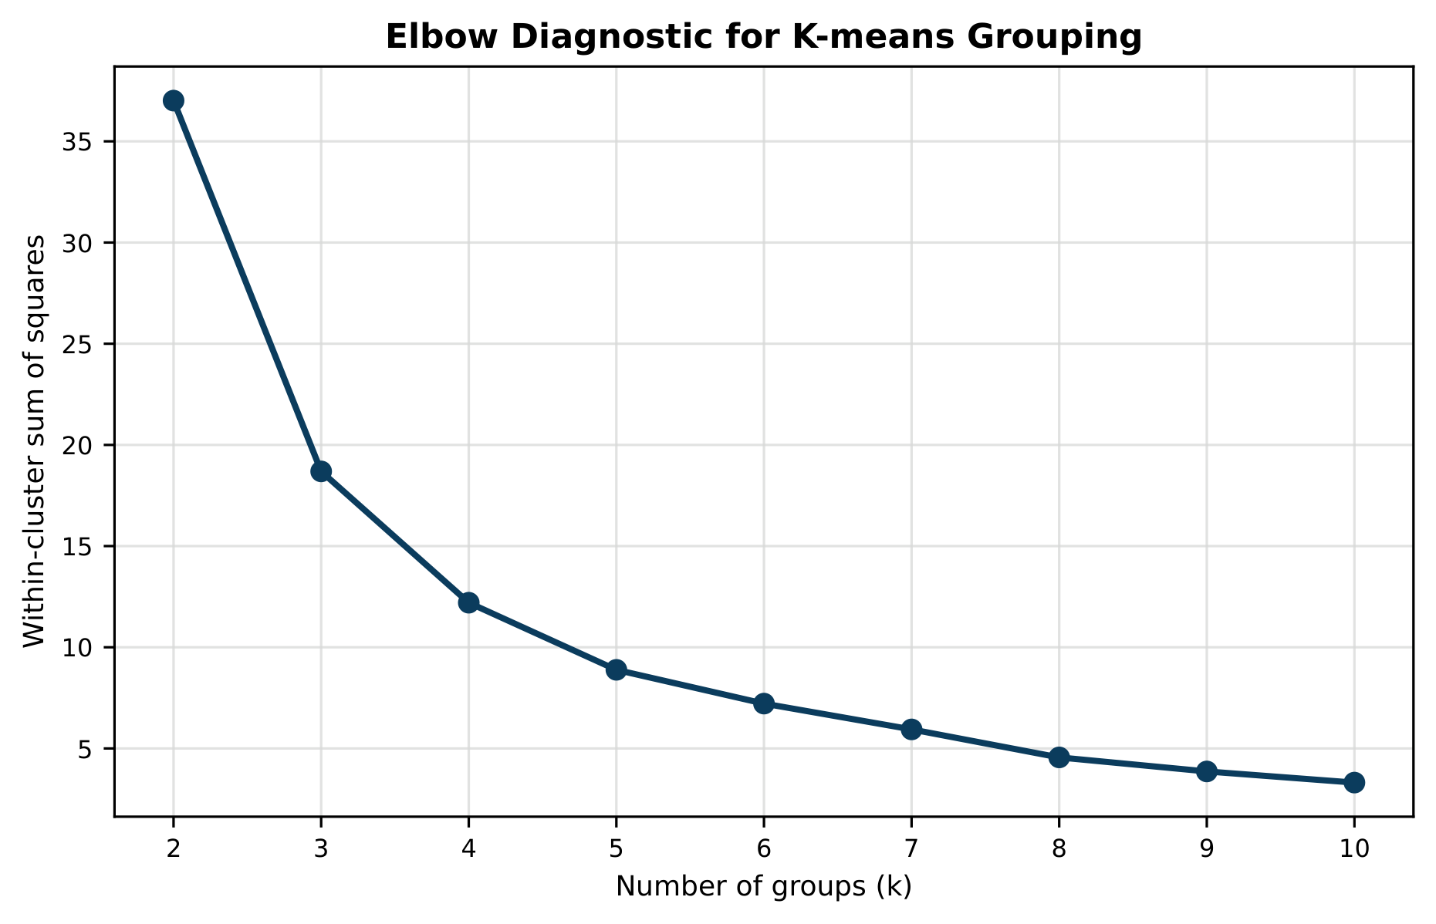
Supplementary Figure C1. Elbow diagnostic for exploratory K-means groupings (k=2–10).
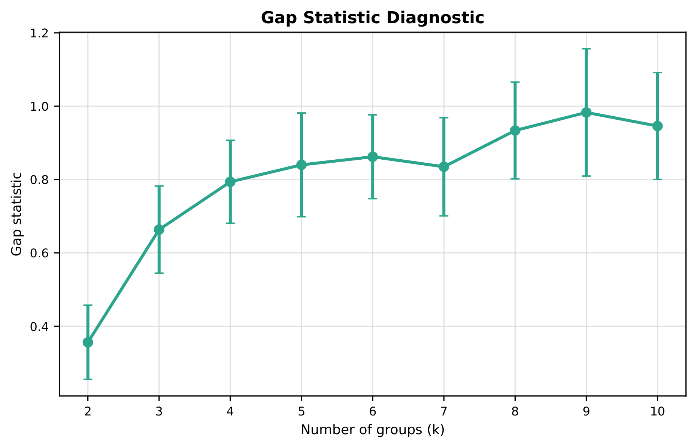
Supplementary Figure C2. Gap statistic diagnostic across candidate grouping counts.
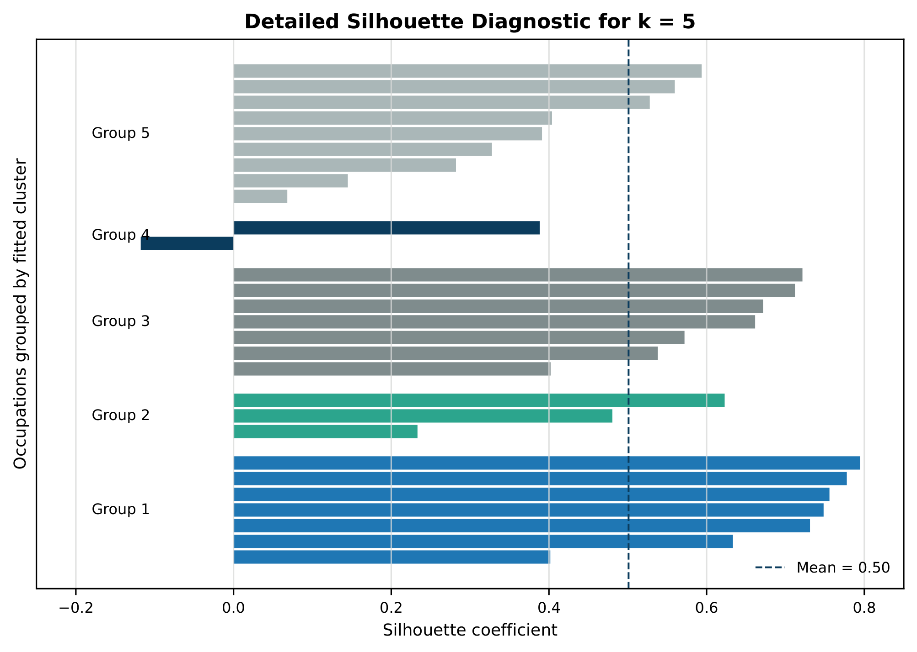
Supplementary Figure C3. Detailed silhouette diagnostic for the exploratory k=5 grouping.
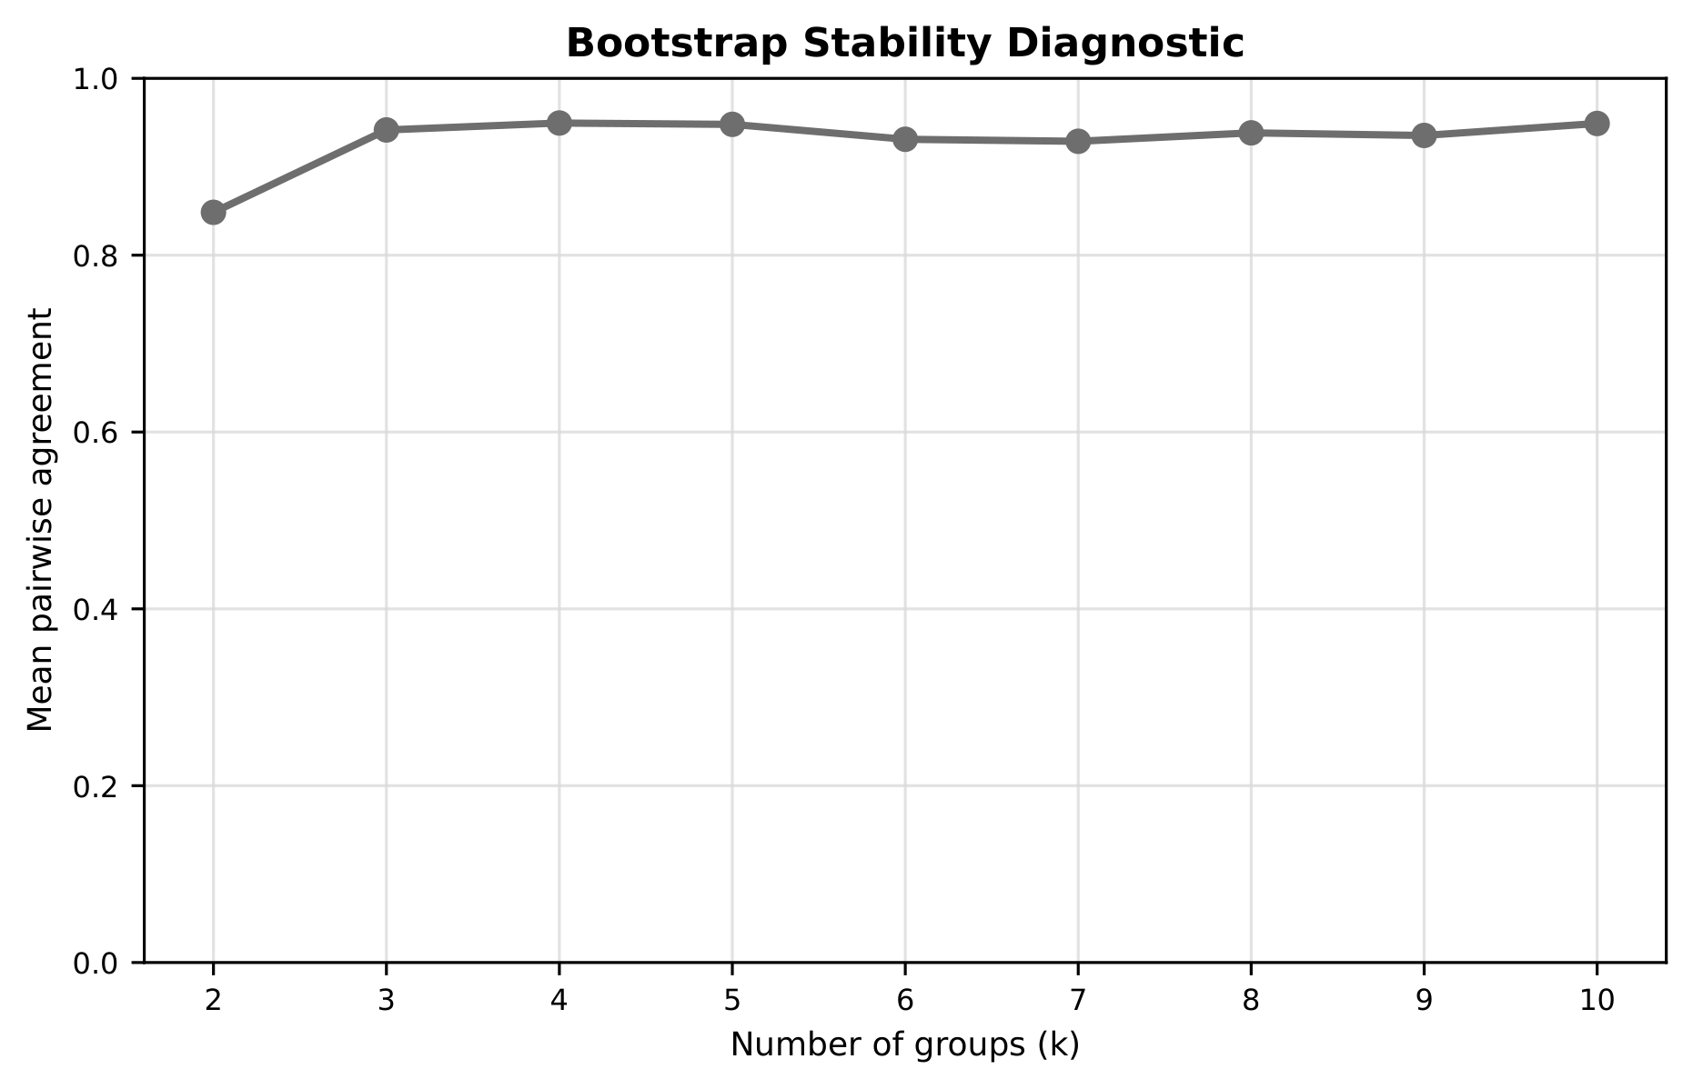
Supplementary Figure C4. Bootstrap stability diagnostic for candidate grouping counts.
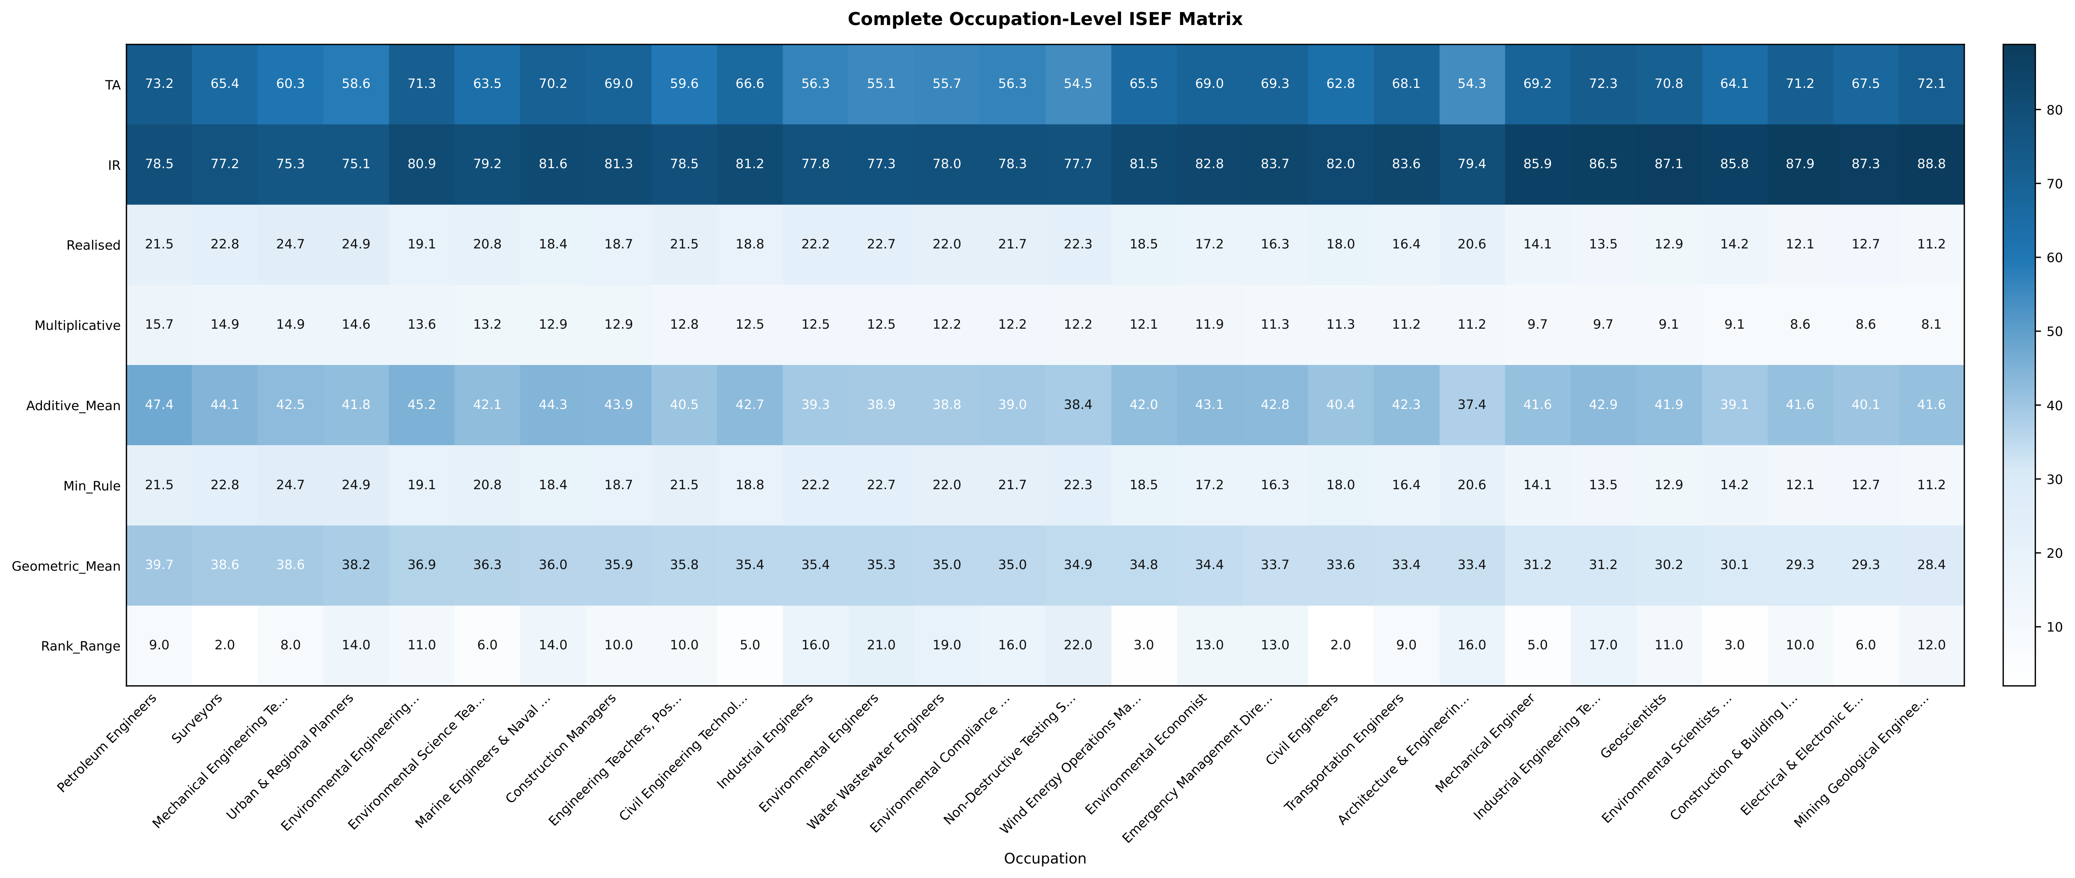
Supplementary Figure C5. Complete occupation-level heatmap of TA, IR, realised permission, exposure specifications, and rank dispersion.
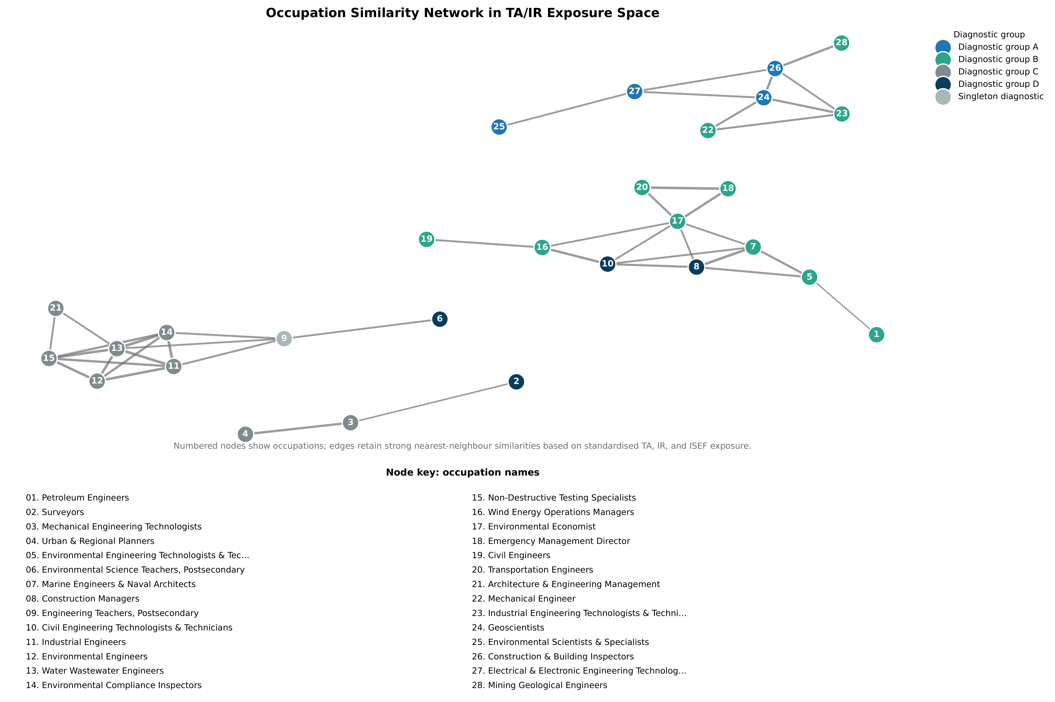
Supplementary Figure C6. Occupation similarity network in TA/IR exposure space; numbered nodes correspond to the occupation key.

Supplementary Material D. Illustrative External Anchoring (US)—Approval Workflows and Contract Clauses
Scope and caveat. This section reproduces the accepted illustrative mapping used to explain the relevance of institutional resistance (IR) to regulated engineering work. The three representative workflows and three sampled federal contracts illustrate how approval, inspection, audit, records, acceptance, liability, and review requirements enter the construct. They do not validate the ISEF index, estimate adoption, or establish generalisability beyond these examples (Tables D1-D4).

D.1 Three representative approval workflows (illustrative case studies)
Supplementary Table D1. Approval-workflow case study (US): Civil Engineer (17-2051.00)—where IR enters in practice
Stage | Typical approval / evidence artefact | Why this matters for IR (governance frictions)
Problem framing | Scope memo; client requirements; constraints register | Liability and public-safety duties constrain “acceptable” solution space; requirements are often contractual and auditable.
Design development | Calculations; model outputs; drawings/specifications; design narrative | Even when AI assists drafting/calculation, responsibility typically remains with licensed professionals; documentation must be reviewable.
Independent/peer review | Internal QA/QC checklist; independent check report; review comments log | Formal review introduces sign-off gates; revisions and traceability can be mandatory, slowing or bounding automation.
Regulatory/permitting interface | Permit submissions; code compliance documentation; responses to regulator queries | External approvals create institutional checkpoints; not all artefacts are substitutable by automated outputs.
Construction administration | Submittal review; RFIs; change orders; site observation reports | Workflow is socio-legal: decisions are recorded, defensible, and often litigable; AI assistance must fit evidentiary standards.
Close-out / as-builts | As-built drawings; O&M manuals; completion certificates | Audit trails persist beyond delivery; archival obligations shape tooling choices.
Source: accepted verified source table_us_case_study_workflow_civil_engineer.tex. This is an illustrative workflow mapping, not validation evidence.
Supplementary Table D2. Approval-workflow case study (US): Construction and Building Inspector (47-4011.00)—documentation and enforcement as core constraints
Stage | Typical approval / evidence artefact | Why this matters for IR (governance frictions)
Pre-inspection planning | Inspection schedule; permit file; applicable code references | The “object” is a regulated compliance record, not only a technical judgement; auditability is built in.
On-site inspection | Inspection notes/photos; measurements; checklist against code items | Evidence collection and standardised documentation limit black-box automation; outputs must be defensible.
Non-compliance handling | Notice of violation; corrective action requirements; re-inspection requests | Enforcement authority creates procedural rigidity; discretion is bounded by codes and recordkeeping.
Approval / sign-off | Pass/fail record; inspection report; sign-off log | Decisions create legal consequences; chain-of-custody and record integrity matter.
Escalation | Appeals / supervisor review; third-party reports | Institutional layers (appeals, re-checks) structure how technology can be introduced.
Source: accepted verified source table_us_case_study_workflow_building_inspector.tex. This is an illustrative workflow mapping, not validation evidence.
Supplementary Table D3. Approval-workflow case study (US): Petroleum Engineer (17-2171.00)—standards, safety, and documented decision rights
Stage | Typical approval / evidence artefact | Why this matters for IR (governance frictions)
Design basis | Design basis memo; risk register; assumptions log | Safety- and risk-critical assumptions must be explicit and reviewable; “why” matters, not only outputs.
Engineering analysis | Calculations; simulation outputs; model validation notes | High-TA tasks exist, but acceptance depends on documented validation and review norms.
Operational readiness | Procedures; hazard analysis; training / competency records | Adoption is conditioned on operations and safety governance; systems must fit established controls.
Change management | Management-of-change (MOC) records; approvals; version control | Formal change control is often mandatory; it constrains rapid deployment of new AI tooling.
Incident / audit learning | Audit findings; corrective actions; compliance documentation | Post-incident accountability sustains institutional resistance: audit trails and traceability are non-negotiable.
Source: accepted verified source table_us_case_study_workflow_petroleum_engineer.tex. This is an illustrative workflow mapping, not validation evidence.

D.2 Contract clause verification
Supplementary Table D4. Contract clause verification (US): sampled federal contracts and auditable clause sources
PIID | FPDS evidence | Clause source | Adoption-relevant clause categories covered
FA865019C6036 | FPDS search + view page + CSV export (cached) | Acquisition.gov (cached HTML/TXT) | Audit/records access (FAR 52.215-2); inspection/acceptance (FAR 52.246-4); baseline commercial terms (FAR 52.212-4)
HDTRA120C0041 | FPDS search + view page + CSV export (cached) | Acquisition.gov (cached HTML/TXT) | Same clause set; FPDS confirms award type, dates, agency/office context
HR001112C0014 | FPDS search + view page + CSV export (cached) | Acquisition.gov (cached HTML/TXT) | Same clause set; FPDS confirms award type, dates, agency/office context
Source: accepted verified source table_us_contract_clause_validation.tex, which records FPDS search/view/CSV evidence and cached Acquisition.gov clause material. The accepted reduced archive does not retain the complete underlying mapping spreadsheets; these three contracts illustrate construct relevance and do not validate the index.

