Appendix A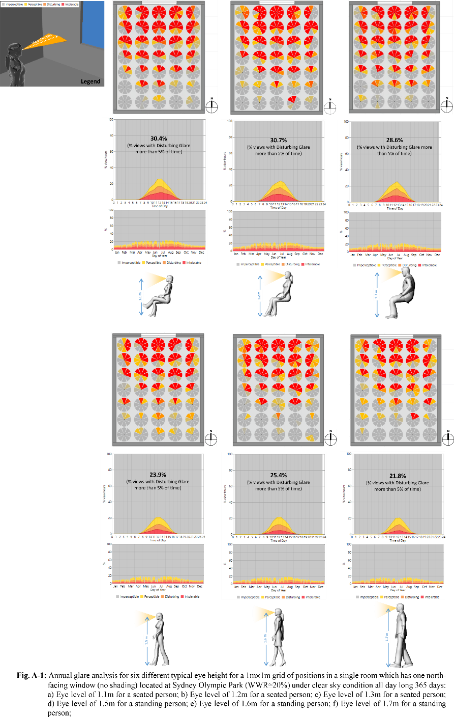

Appendix B: In-detail Comparison Between before and After Adding Shade
Case N-01:
Daylight Glare Probability:
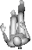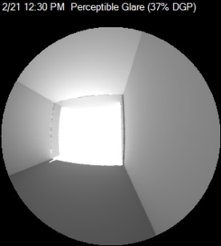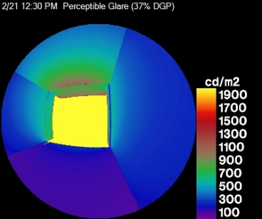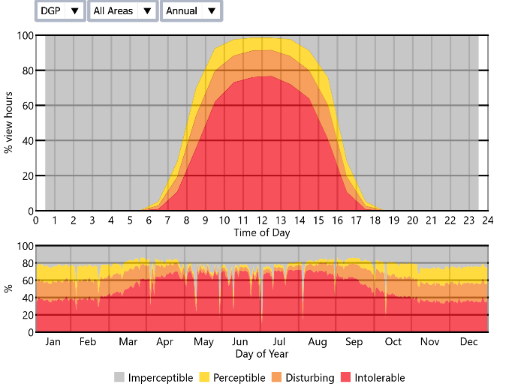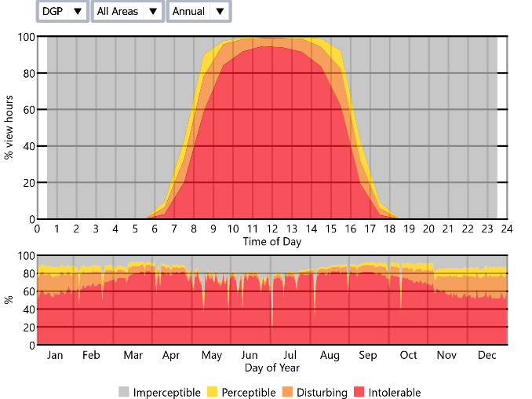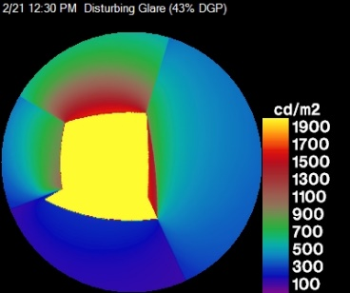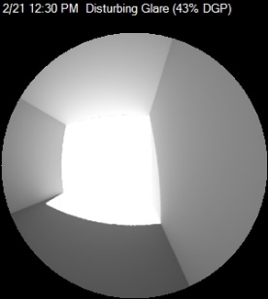
2/21 12:30 pm Perceptible Glare (37% DGP)
2/21 12:30 pm Disturbing Glare (43% DGP)
After shade
Before shade
N
N

Useful Daylight Illuminance:

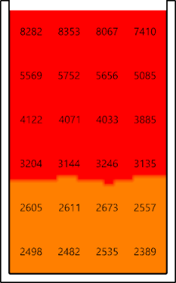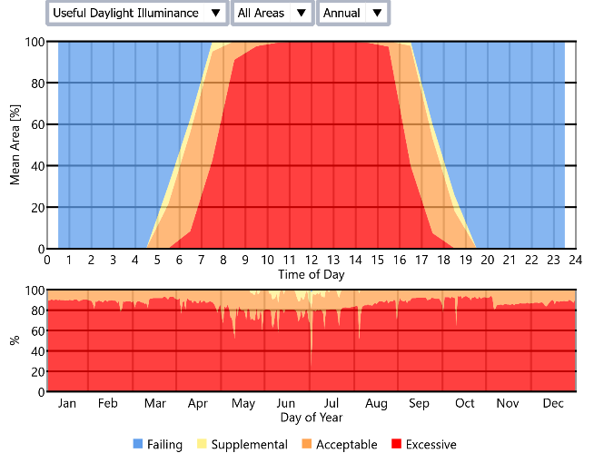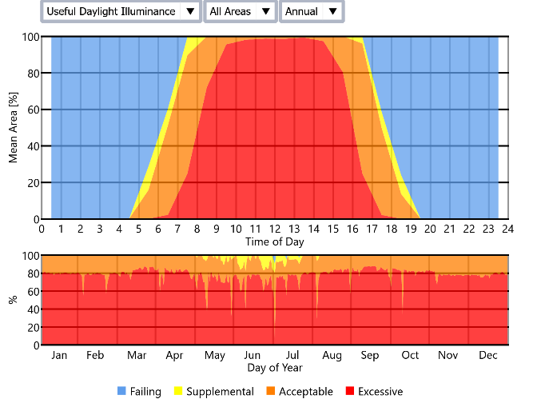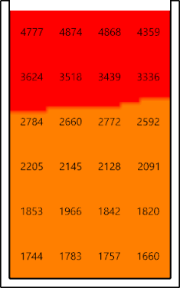
Before shade
2/21 12:30 pm Excessive Daylight Illuminance (3885 [lux])
After shade
2/21 12:30 pm Acceptable Daylight Illuminance (2592 [lux])
N
N

Case N-02:
Daylight Glare Probability:
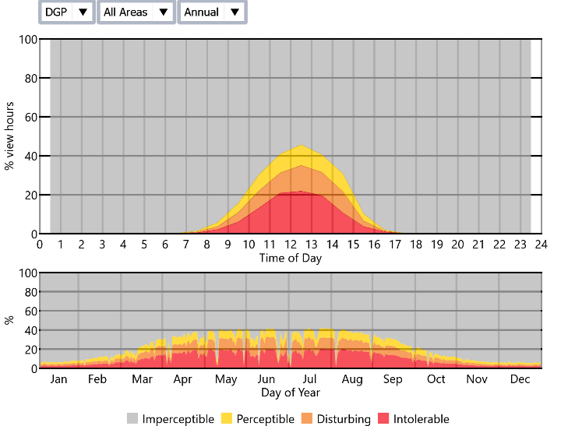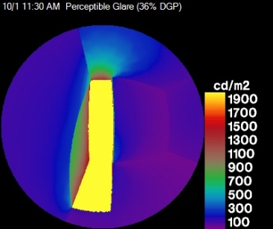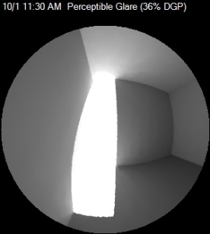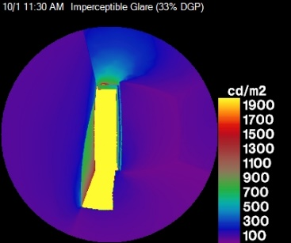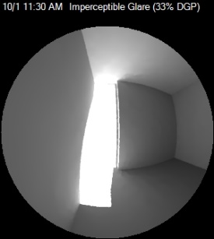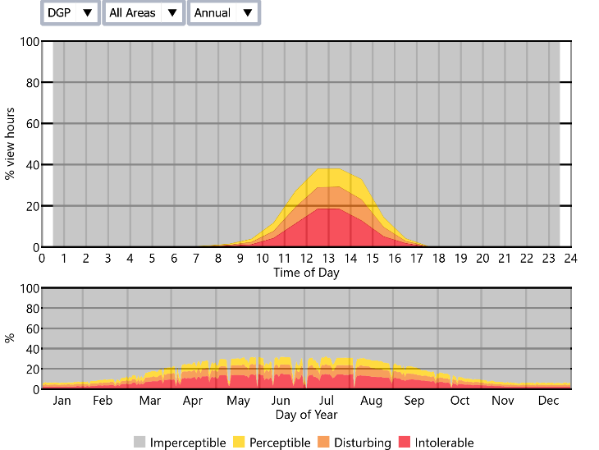
Before shade
10/1 11:30 am Perceptible Glare (36% DGP)
10/1 11:30 am Imperceptible Glare (33% DGP)
After shade
N
N

Useful Daylight Illuminance:

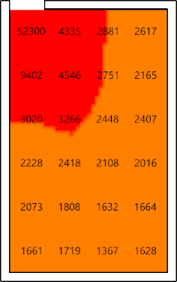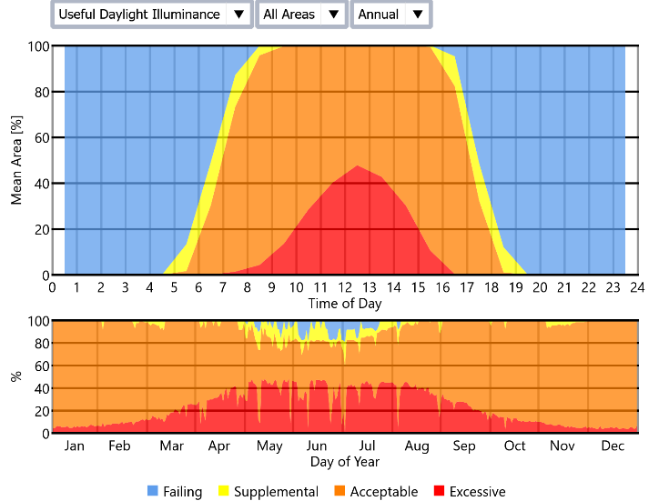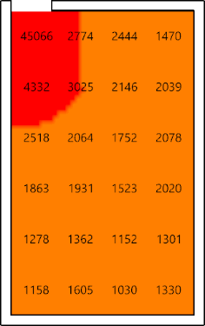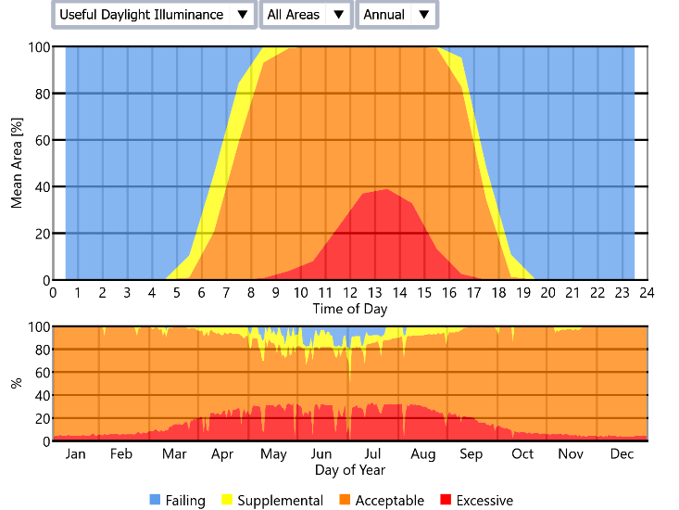
10/1 11:30 am Excessive Daylight Illuminance (3020 [lux])
N
Before shade
10/1 11:30 am Acceptable Daylight Illuminance (2518 [lux])
N
After shade

Case N-03:
Daylight Glare Probability:
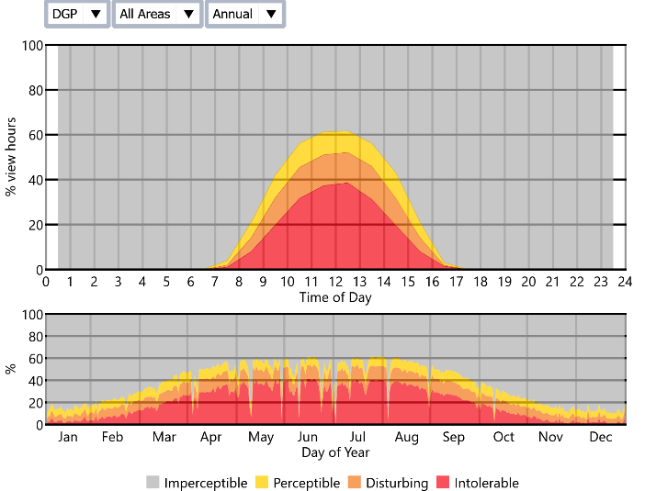
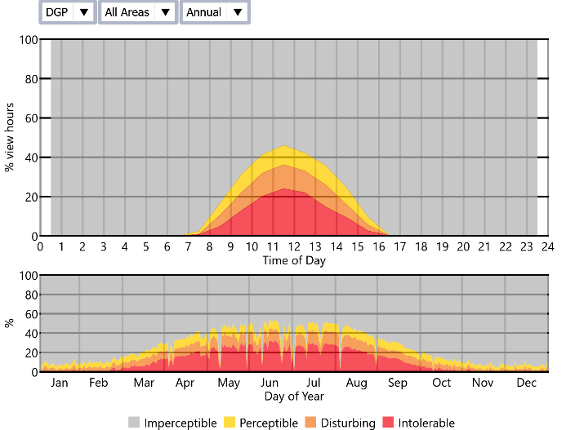
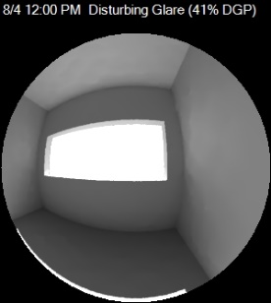
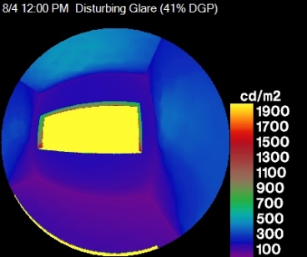
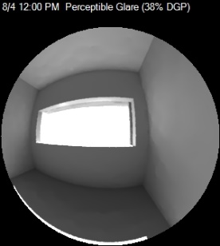
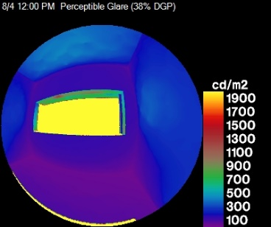

Before shade
After shade
8/4 12:00 pm Disturbing Glare (41% DGP)
8/4 12:00 pm Perceptible Glare (38% DGP)
N
N

Useful Daylight Illuminance:
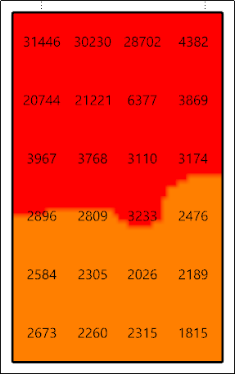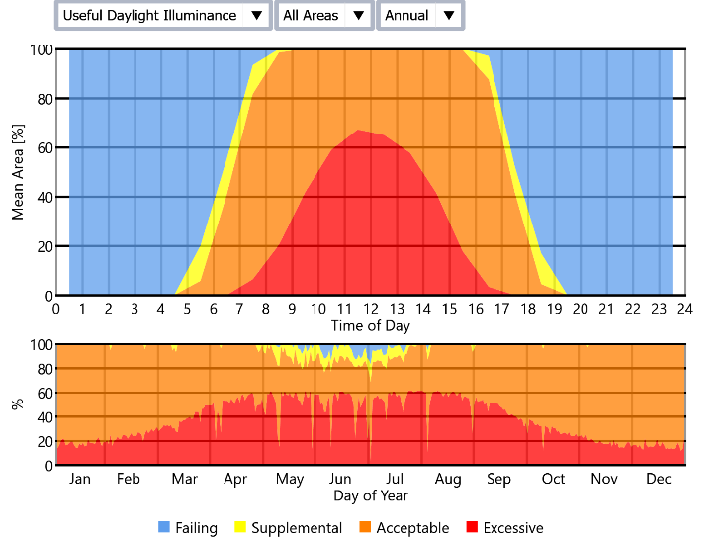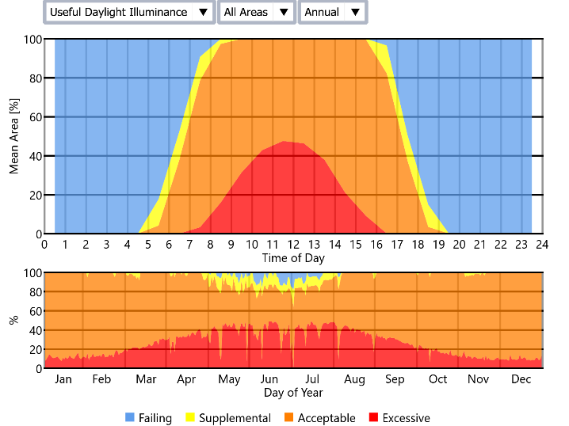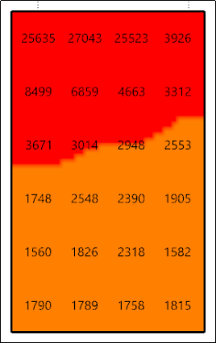
Before shade
8/4 12:00 pm Excessive Daylight Illuminance (3174 [lux])
N
8/4 12:00 pm Acceptable Daylight Illuminance (2553 [lux])
N
After shade

Case N-04:
Daylight Glare Probability:
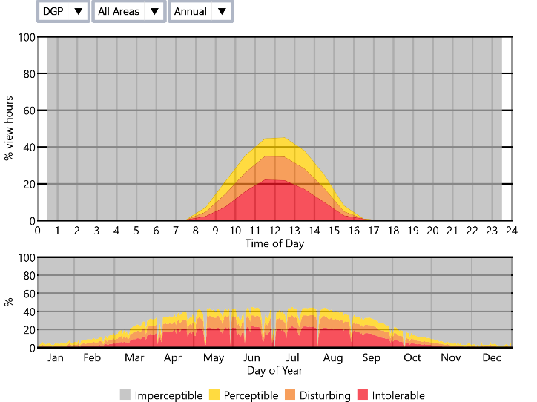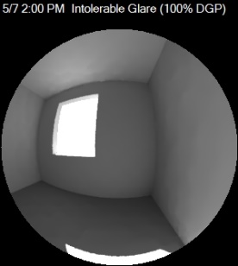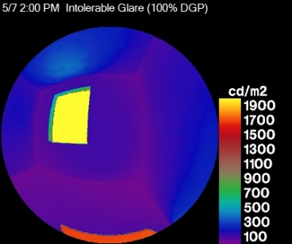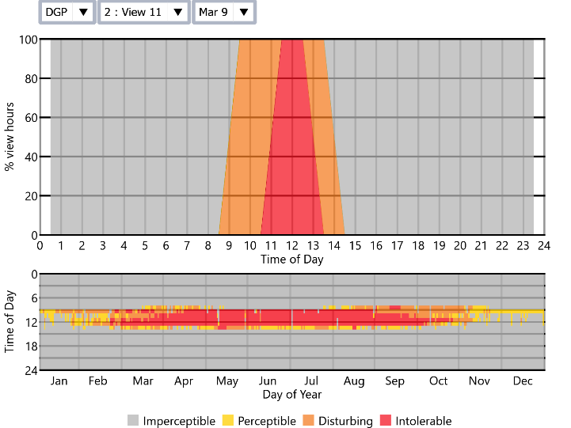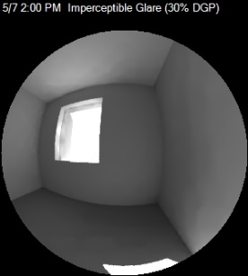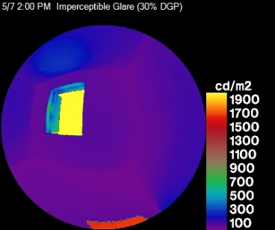
5/7 2:00 pm Intolerable Glare (100% DGP)
N
Before shade
5/7 2:00 pm Imperceptible Glare (30% DGP)
N
After shade

Useful Daylight Illuminance:

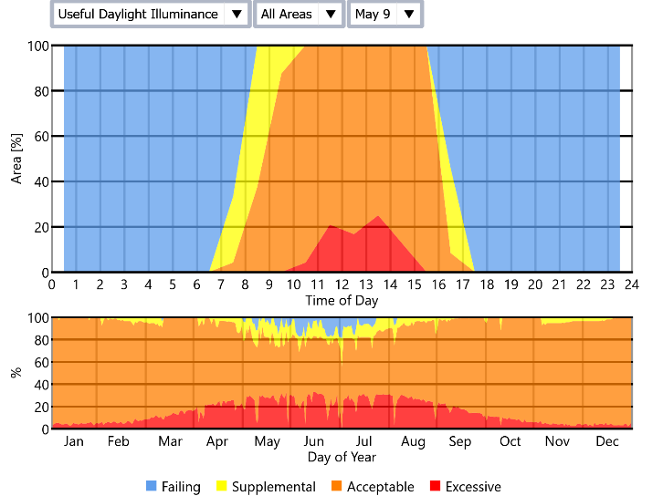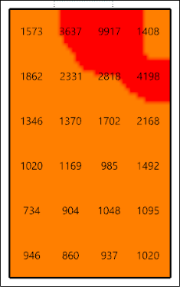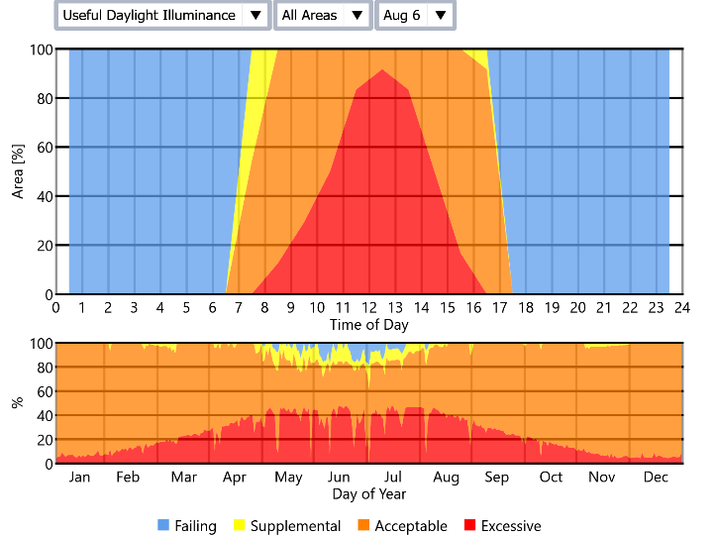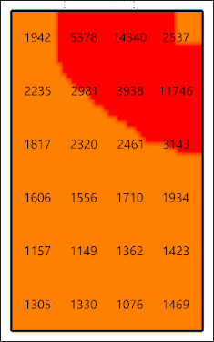
After shade
N
5/7 2:00 pm Excessive Daylight Illuminance (2168 [lux])
Before shade
N
5/7 2:00 pm Acceptable Daylight Illuminance (3143 [lux])

Case N-05:
Daylight Glare Probability:
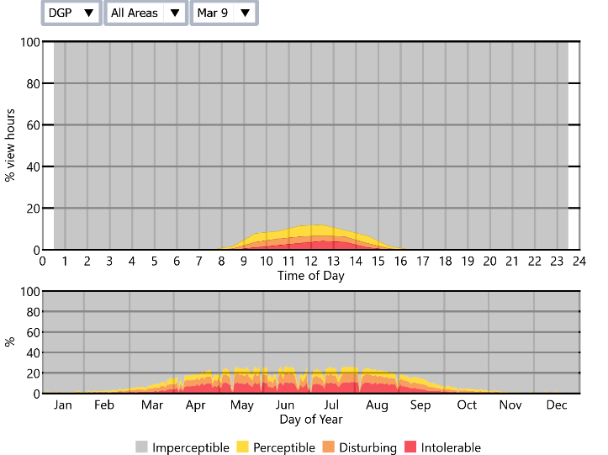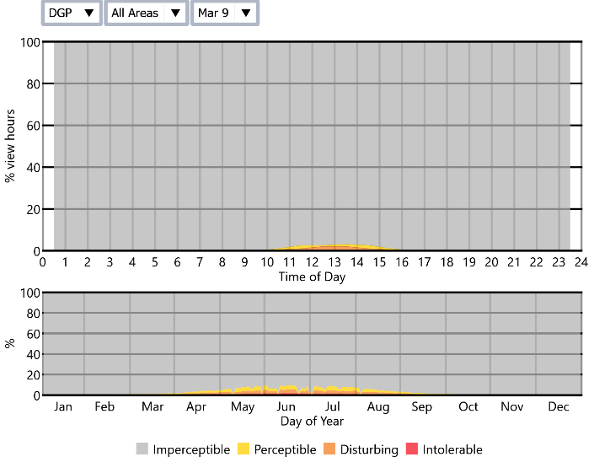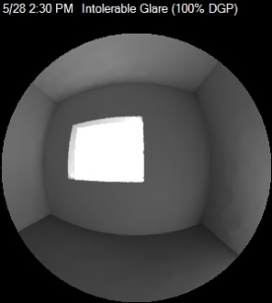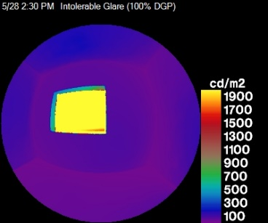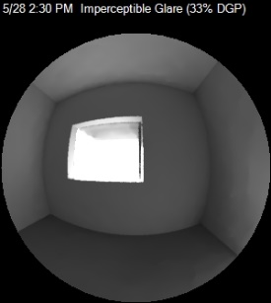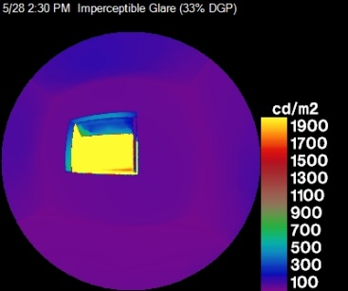
Before shade
After shade
5/28 2:30 pm Intolerable Glare (100% DGP)
5/28 2:30 pm Imperceptible Glare (33% DGP)
N
N

Useful Daylight Illuminance:

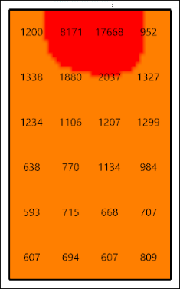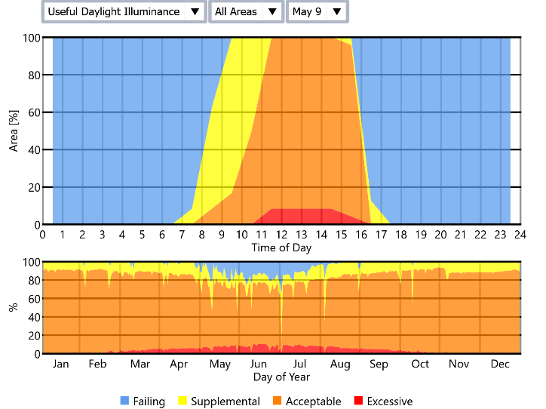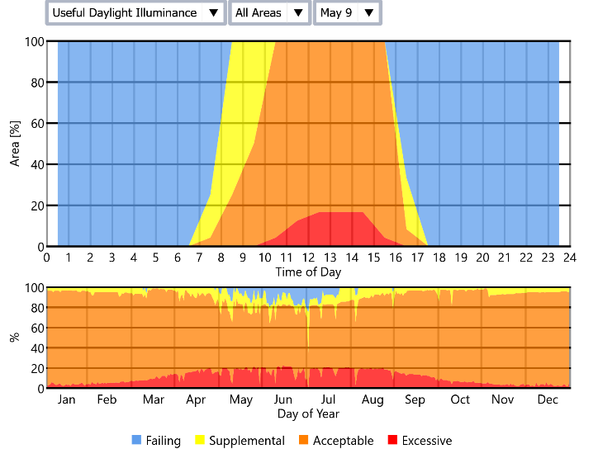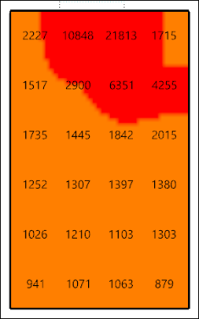
After shade
5/28 2:30 pm Acceptable Daylight Illuminance (2037 [lux])
N
Before shade
5/28 2:30 pm Excessive Daylight Illuminance (6351 [lux])
N

Case N-06:
Daylight Glare Probability:
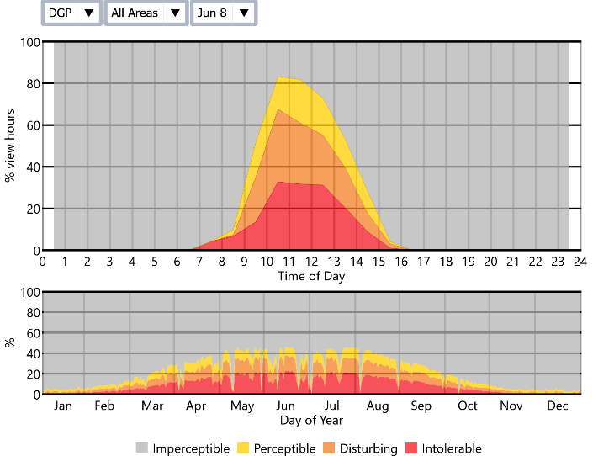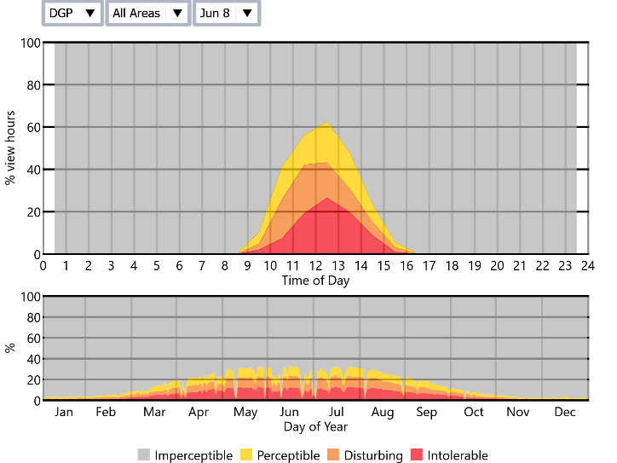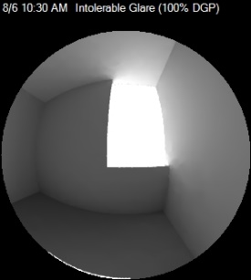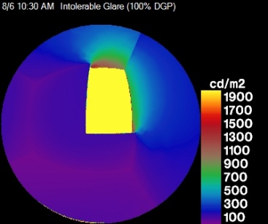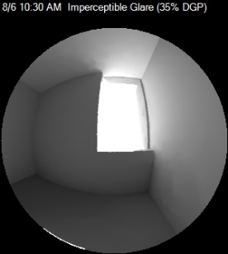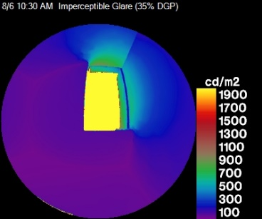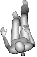
Before shade
After shade
8/6 10:00 am Intolerable Glare (100% DGP)
8/6 10:00 am Imperceptible Glare (35% DGP)
N
N

Useful Daylight Illuminance:

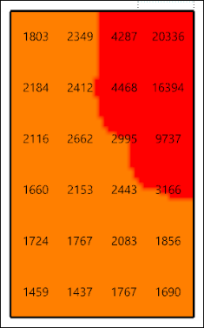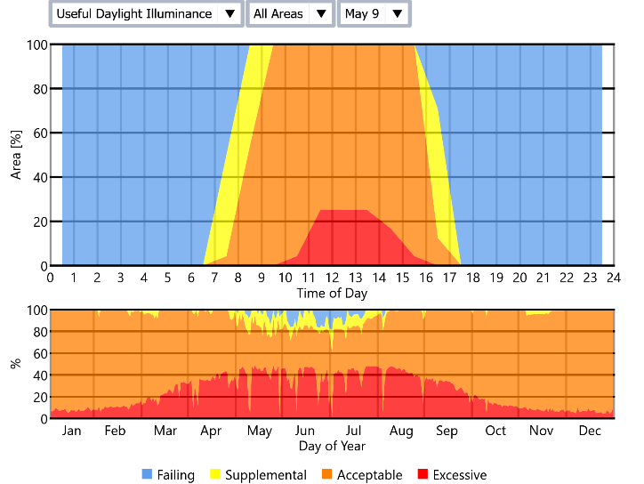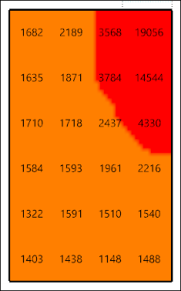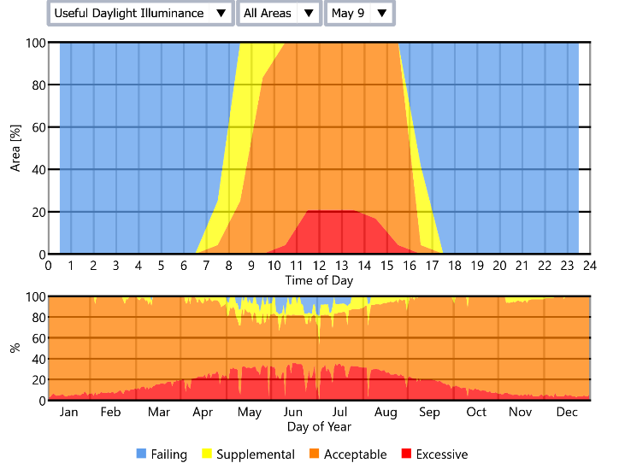
8/6 10:00 am at the border of Acceptable and Excessive Daylight Illuminance (2995 [lux])
N
8/6 10:00 am Acceptable Daylight Illuminance (2437 [lux])
N
Before shade
After shade

Case N-07:
Daylight Glare Probability:
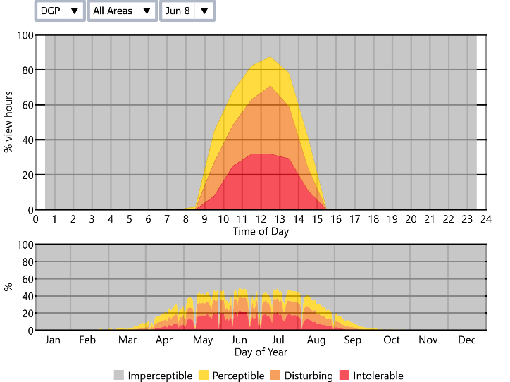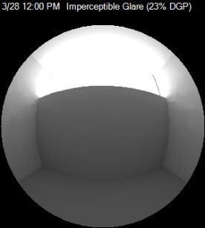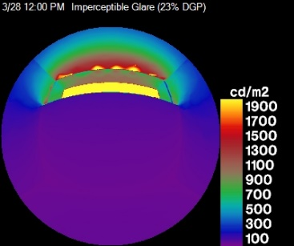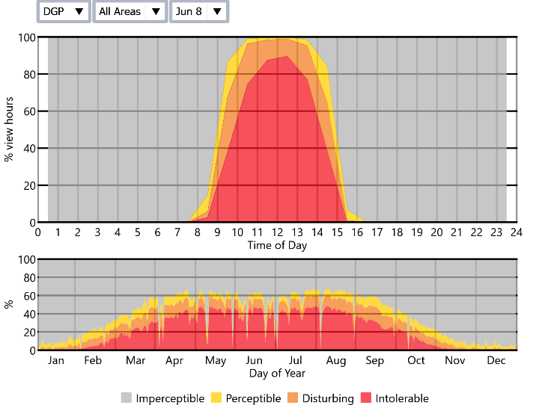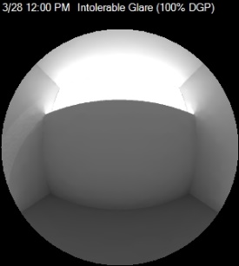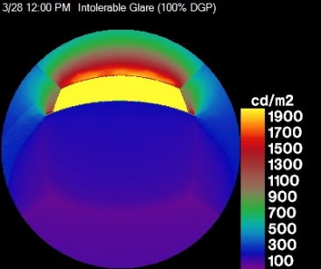
N
After shade
3/28 12:00 pm Imperceptible Glare (23% DGP)
N
Before shade
3/28 12:00 pm Intolerable Glare (100% DGP)

Useful Daylight Illuminance:

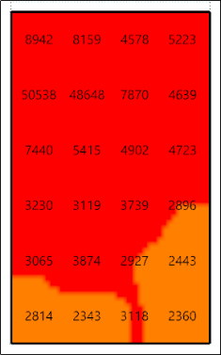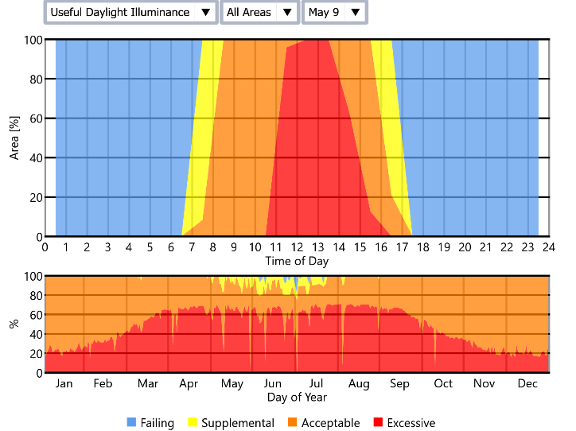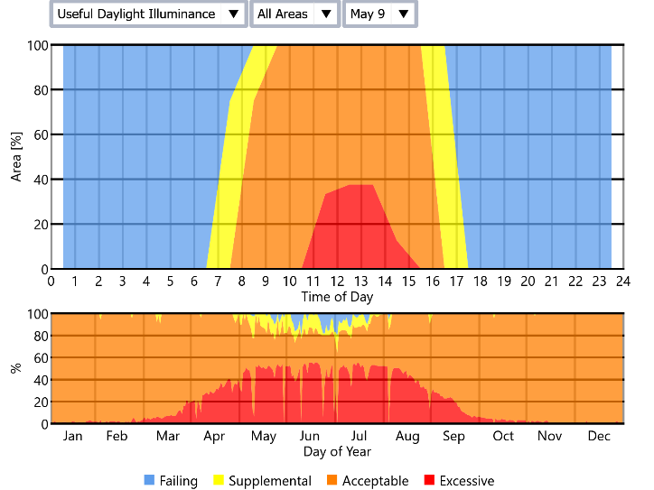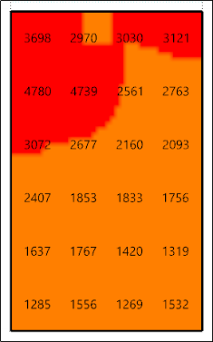
N
Before shade
3/28 12:00 pm Excessive Daylight Illuminance (7870 [lux])
After shade
N
3/28 12:00 pm Acceptable Daylight Illuminance (2561 [lux])

