Appendixes
Appendix 1. TFP decomposition technique
The assessment of productivity and its components at the national (Van et al., 2023) and sub-national levels (Thanh et al., 2019) follows the methodology outlined by O’Donnell (2018). Accordingly, the TFP of firm/province/nation $i$ in period t can be defined as
${TFP}_{it}$ = $\frac{Q(q_{it})}{X(x_{it})}$ (a)
where Q(.) and X(.) represent scalar aggregator functions that are non-decreasing, non-negative, linear, and homogeneous. $q_{it}$ refers to the vector of $L$ outputs, while $x_{it}$ represents the vector of $M$ inputs. We define the output distance function specific to a given period and environment, as well as the input distance function.
$D_{O}^{t}(x, q, z) ≡ inf [p>0: (x, q/p) ∈$ T^{t}$(z)]$ and (b)
$D_{I}^{t}(x, q, z) ≡ sup [θ>0: (x/θ, q) ∈$T^{t}$(z)]$
where T^{t}(z), = [$(x,y)$: input $x$ can produce output $y$ in period $t,$ and environment $z$] represents the production possibilities set specific to a particular period and environment. In other words, this set encompasses the combinations of outputs and inputs achievable using the meta-technology for that specific period, within a production environment defined by parameter $z$. $D_{O}^{\overline{t}}$($\overline{x}$,q,$\overline{z}$) (resp. X(x) = $D_{I}^{\overline{t}}$(x,$\overline{q}$,$\overline{z}$), where $\overline{x}$,$\overline{q}$, and $\overline{z}$ are vectors of representative inputs, outputs, and environmental variables in the representative time period $\overline{t}$. Through its design, the output/input distance specific to a given period and environment exhibits two fundamental properties: it is both non-negative and linearly homogeneous concerning outputs (or inputs). The resulting index for comparing the total factor productivity (TFP) of province $i$ in year $t$ with that of province $k$ in year $s$ can be calculated as the ratio of $TFP_{it}$ to $TFP_{ks}$, expressed as:
${TFPI}_{ksit}$ = $\frac{D_{O}^{\overline{t}}(\overline{x},q_{it}, \overline{z}) }{D_{O}^{\overline{t}}(\overline{x},q_{ks}, \overline{z}) }\frac{D_{I}^{\overline{t}}(x_{ks},\overline{q},\overline{z})}{D_{I}^{\overline{t}}(x_{it},\overline{q},\overline{z})}$ (c)
In theoretical terms, as mentioned by O’Donnell (2018), the selection of a suitable distance function can be guided by opting for the Cobb-Douglas log-distance function. This mathematical model has also found application in recent empirical studies such as (Njuki et al., 2018; Van et al., 2023):
${LnD}_{O}^{t}$($x_{it},q_{it},z_{it}$) = $\sum_{l=1}^{L}{γ_{l}{lnq}_{ilt}}$ $- φ_{i}- λt$ $-\sum_{j=1}^{J}{δ_{j}{lnz}_{ijt}}-$ $\sum_{m=1}^{M}{β_{m}{lnx}_{imt}}$ (d)
where $φ_{i}$ represents a fixed effect that accounts for unobservable invariant factors, such as topography, $\sum_{l=1}^{L}{γ_{l}}$ = 1, and $\sum_{m=1}^{M}{β_{m}}$ = r. In empirical studies where the production process has one goal, such as profit or total output, when substituting Equation (d) into (c), we have the total factor productivity index (TFPI), taking the form employed by O’Donnell (2016):
${TFPI}_{ksit}= \frac{q_{lit}}{q_{lks}}\prod_{m=1}^{M}{(\frac{x_{mks}}{x_{mit}}})^{\frac{β_{m}}{r}}$ (e)
The estimation of the parameters $β_{1},..., β_{M}$ in Equation (d) can be achieved through the utilization of stochastic frontier analysis (SFA) methods, as per the estimator suggested by Greene’s “true fixed effect” computation (Greene, 2005a, 2005b). Following this method, the distance function is defined as follows:
${lnq}_{it}$ = $φ_{i}+ λt$ $+\sum_{j=1}^{J^{*}}{δ_{j}{lnz}_{ijt}}+$ $\sum_{m=1}^{M}{β_{m}{lnx}_{imt}+}u_{it}+$ $v_{it}$ (f)
where $u_{it},$ = $-{LnD}_{O}^{t}$($x_{it},q_{it},z_{it}$) is commonly known as a non-negative technical efficiency (Farrell, 1957). Economically, it reflects the learning-by-doing ability of provinces/cities in sharing their achievements with each other. The error component denoted as $v_{it}$ accommodates functional error (which may arise from the distance function deviating from the Cobb-Douglas form) and unobservable variables. $\sum_{m=1}^{M}{{lnx}_{imt}}$ and $\sum_{j=1}^{J^{*}}{{lnz}_{ijt}}$ denote conventional input variables and environmental factors, respectively, while $λ$ represents a binary variable that facilitates the assessment of the pace of technological advancement. Consequently Equation (f), offers a means of decomposing total factor productivity changes into components attributable to (i) technological advancement, (ii) environmental shifts, (iii) and change in efficiency (see Table [1]), or
${TFPI}_{ksit}= \underset{OTI}{\underbrace{\frac{exp⁡(λt)}{exp⁡(λs)}}}\underset{OEI}{\underbrace{\frac{{exp⁡(∅}_{i})}{{exp⁡(∅}_{k})}\prod_{j=1}^{J^{*}}{(\frac{z_{jit}}{z_{jks}}})^{δ_{j}}}}\underset{OSEI}{\underbrace{\prod_{m=1}^{M}{(\frac{x_{mit}}{x_{mks}}})^{β_{m}(\frac{r-1}{r})}}}\underset{OTE}{\underbrace{\frac{exp⁡(-u_{it})}{exp⁡(-u_{ks})}}}\underset{SNI}{\underbrace{\frac{exp⁡(v_{it})}{{exp⁡(v}_{ks})}}}$ (g)

Appendix 2. Descriptive statistic: Variables, Units, and References
 |  |  | 2012 |  | 2016 |  | 2019
 | Units | References | MEAN | SD | MEAN | SD | MEAN | SD
The first step: Data for calculating TFPI and its components
Gross Regional Domestic Product (GRDP) | Thousand bill VND | Njuki et al. (2018); Thanh et al. (2019) | 47.45 | 85.01 | 64.58 | 114.27 | 81.50 | 142.29
Capital stock | Thousand bill VND | Njuki et al. (2018); Thanh et al. (2019) | 136.85 | 220.81 | 210.86 | 331.51 | 289.31 | 454.93
Labor | Thousand people | Njuki et al. (2018); Thanh et al. (2019) | 812.48 | 648.34 | 849.36 | 682.07 | 874.21 | 719.93
Total land | Thousand hectares | Njuki et al. (2018); Thanh et al. (2019) | 525.34 | 368.32 | 525.98 | 367.77 | 525.33 | 367.44
Temperature | Degrees Celsius | Njuki et al. (2018); Thanh et al. (2019) | 25.23 | 2.19 | 25.50 | 2.06 | 25.92 | 1.89
Rain | mm | Njuki et al. (2018); Thanh et al. (2019) | 1767 | 408 | 1978 | 569 | 1684 | 575
Dependent variables: TFPI and its components
TFPI | % | Author’s calculations, see Appendix [1] | 156.80 | 29.41 | 178.10 | 39.51 | 197.7 | 45.66
OSEI | % | Author’s calculations, see Appendix [1] | 84.49 | 4.05 | 79.93 | 5.21 | 76.89 | 5.74
OTEI | % | Author’s calculations, see Appendix [1] | 111.20 | 20.90 | 108.70 | 23.73 | 107.8 | 24.52
OTI | % | Author’s calculations, see Appendix [1] | 167.10 | 0.00 | 205.20 | 0.00 | 239.4 | 0.00
OEI | % | Author’s calculations, see Appendix [1] | 99.96 | 0.19 | 99.99 | 0.02 | 99.83 | 0.19
SNI | % | Author’s calculations, see Appendix [1] | 100.00 | 0.00 | 100.00 | 0.00 | 100.00 | 0.00
TECH | % | Author’s calculations, see Appendix [1] | 141.20 | 6.76 | 164.00 | 10.69 | 184.1 | 13.73
The second step: Retention rate on TFPI and its components
Retention rate | [0,100] % | Suggested by the authors | 92.46 | 17.91 | 92.46 | 17.91 | 91.73 | 18.51
Covariates 1: List of control variables
Implemented FDI on log | Mill USD | Liu et al. (2016) | 2.93 | 2.30 | 3.35 | 2.47 | 3.41 | 2.55
Industry index | GSO calculation | Kim (2002) | 110.64 | 12.63 | 110.97 | 22.60 | 110.34 | 10.66
Multidimensional poverty | [0,100] % | Ivanic and Martin (2018) | 19.77 | 15.43 | 12.93 | 12.00 | 8.52 | 9.07
High-quality labor rate | [0,100] % | Griliches (2000) | 14.79 | 6.29 | 18.12 | 7.19 | 19.64 | 7.79
literacy | [0,1] | Griliches (2000) | 0.93 | 0.07 | 0.93 | 0.07 | 0.94 | 0.07
Urbanization rate | [0,1] | Andersson, Burgess, and Lane (2007) | 0.27 | 0.17 | 0.29 | 0.18 | 0.30 | 0.18
Provincial competitiveness index (PCI) | [0,100] | Hiep and Trung (2022) | 57.02 | 4.15 | 58.89 | 2.93 | 65.66 | 2.60
Private sector development | [0,1] | Andersson et al. (2007) | 0.87 | 0.10 | 0.91 | 0.08 | 0.94 | 0.07
Number of teachers | Thousand people | Griliches (2000) | 13453 | 8490 | 13631 | 8988 | 12888 | 8733
Covariates 2: List of control variables
Labor rate | [0,1] | Andersson et al. (2007) | 0.58 | 0.04 | 0.62 | 0.28 | 0.62 | 0.28
Government spending for socio-economic development activities on log | Bill. VND | Fan et al. (2000) | 5.58 | 0.72 | 6.02 | 0.80 | 6.18 | 0.84
GRDP per capita on log | Mill VND | Van Biesebroeck (2005) | 3.17 | 0.50 | 3.47 | 0.51 | 3.68 | 0.50
Agriculture land | Thousand hectares | Ruttan (2002) | 4.93 | 0.78 | 4.93 | 0.78 | 4.93 | 0.78
Instrumental variable
Regional retention rate | [0,100] % | Suggested by the authors | 92.46 | 9.36 | 92.46 | 9.36 | 91.73 | 9.76
Mechanism test
GRDP/capital stock | 1 million times | Suggested by the authors | 12.67 | 0.38 | 12.57 | 0.38 | 12.53 | 0.38
Budget spending | Million VND | Suggested by the authors | 15.36 | 0.58 | 15.71 | 0.61 | . | .
Source: Authors. Note: “.” represents unavailable data.

Appendix 3. Evolution of TFPI and its components
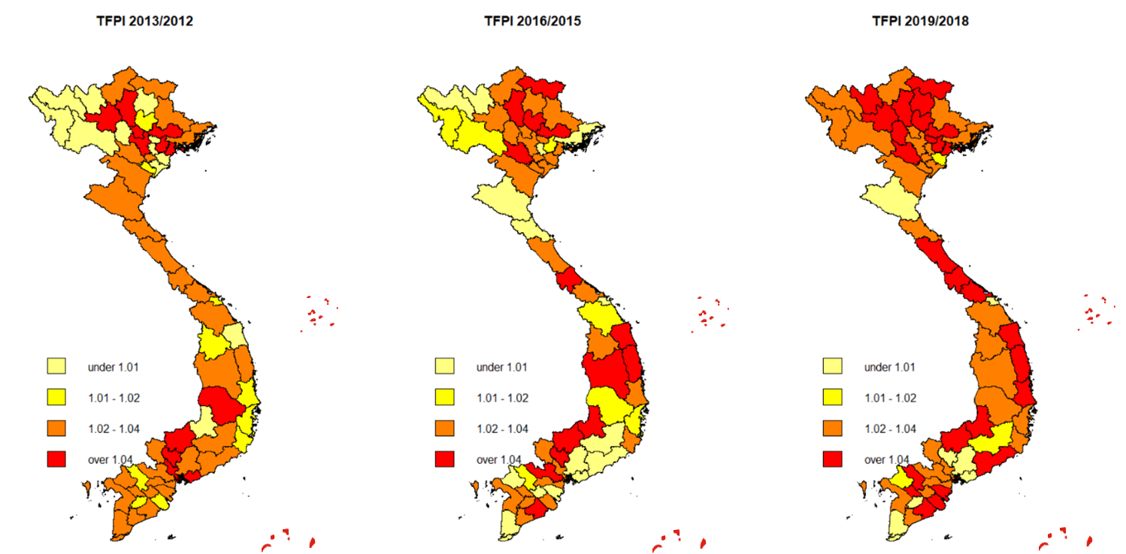
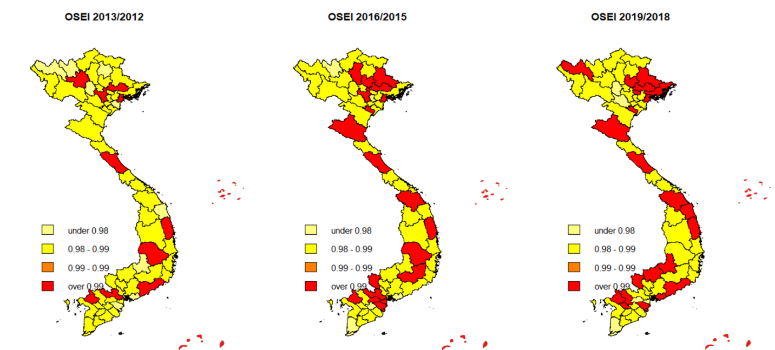
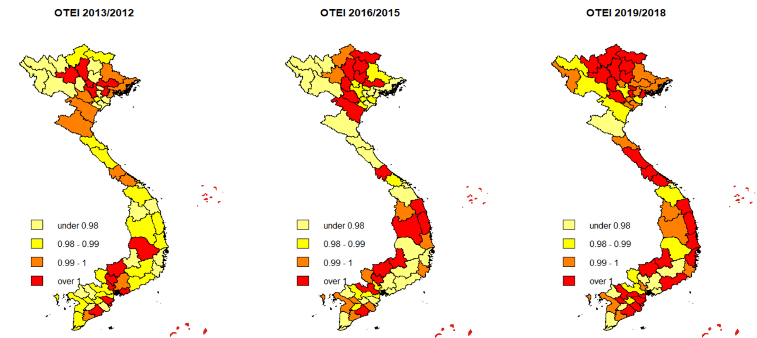
Source: Authors.
Appendix 4. Correlation between $∆RER$ and TFPI/its components
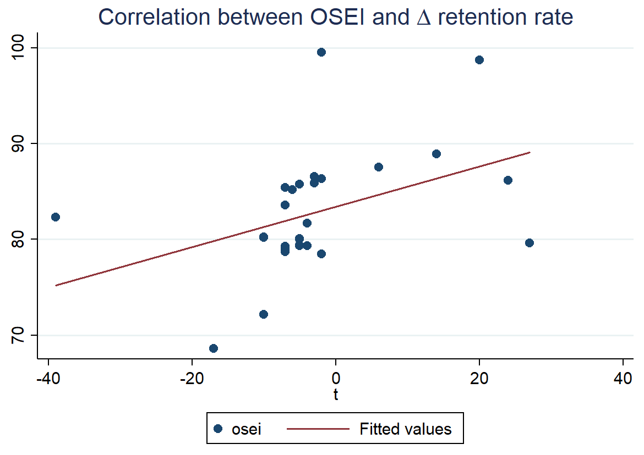 | 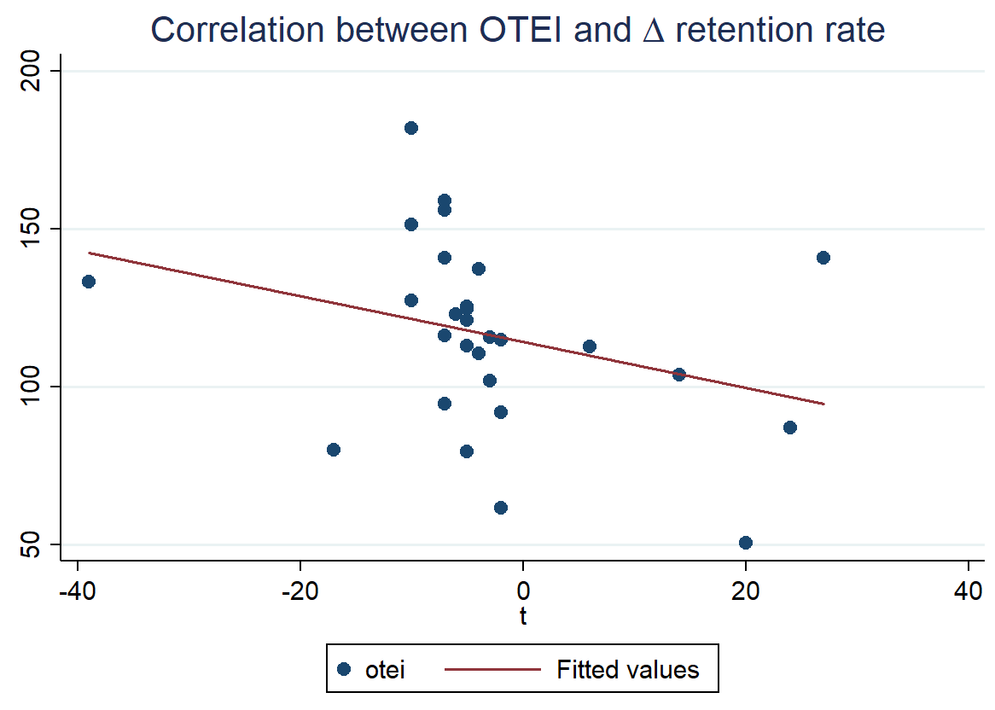
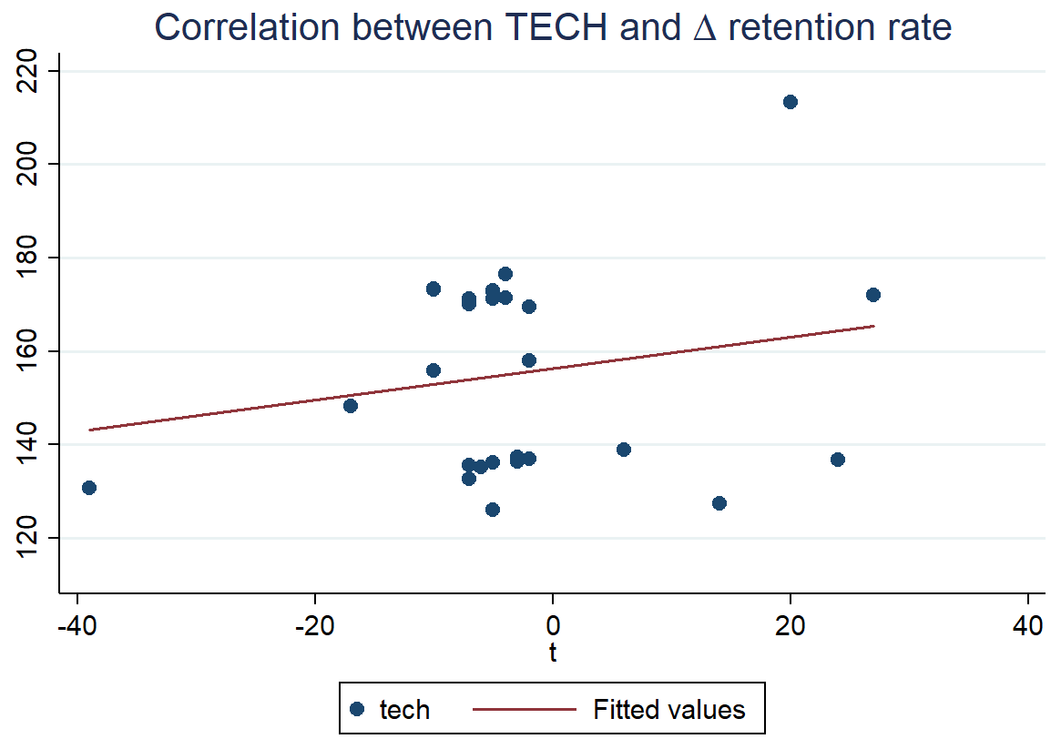 | 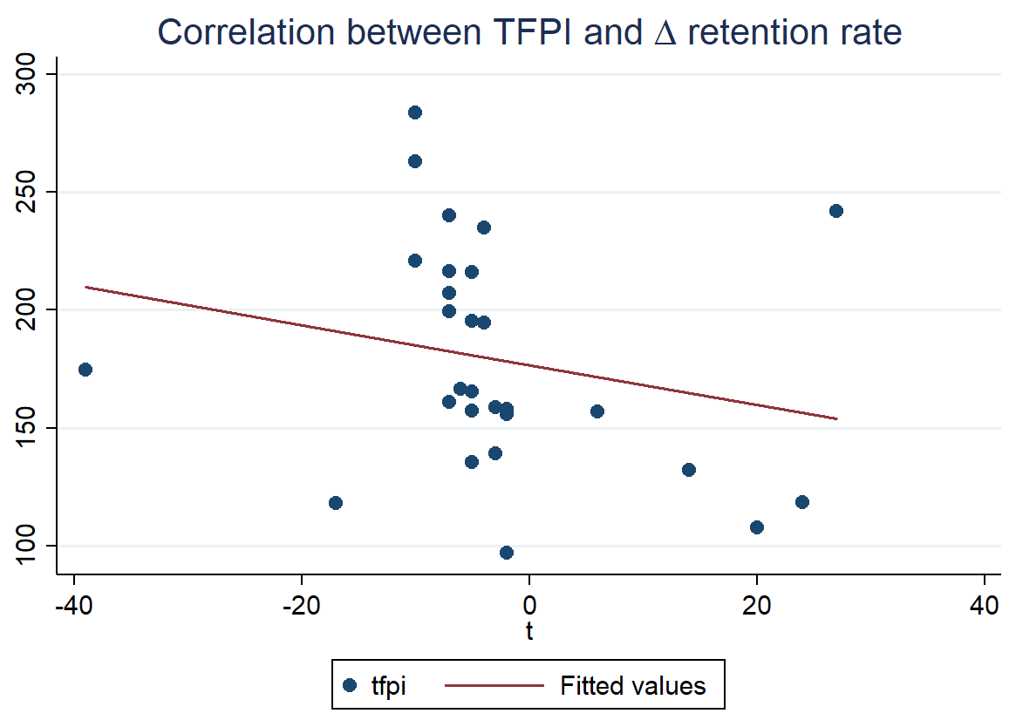

Source: Authors. Note: we have eliminated all provinces/cities that showed no change in retention rate during the period from 2012 to 2019. These provinces/cities are mainly located in the northern mountainous areas and the Central Highlands (see figure [2]).
Appendix 5. $∆$Retention rate on TFPI and its components
Dependent variables: | TFPI |  | OSEI |  | OTEI |  | $$TECH=OSEI×OTEI$$
Meaning: | Total factor productivity |  | Allocative efficiency and scale efficiency in the use of inputs (i.e., labor, capital, land) |  | Technical efficiency, known as learning-by-doing, denotes the effective dissemination of achievements between provinces/cities |  | Effective after ruling out all environmental shocks and other stochastic factors
Estimators: | OLS | FEM | OLS | FEM | OLS | FEM | OLS | FEM
 | (1) | (2) | (3) | (4) | (5) | (6) | (7) | (8)
$∆$Retention Rate (RER) | -0.786 | -0.093 | 0.292 | 0.076** | -0.697 | -0.100 | 0.630 | 0.185**
 | (1.610) | (0.300) | (0.189) | (0.030) | (1.040) | (0.161) | (0.411) | (0.080)
Implemented FDI | 4.564*** | -0.356 | -0.077 | -0.069 | 3.078*** | -0.055 | -0.151 | -0.204
 | (1.136) | (0.609) | (0.141) | (0.061) | (0.694) | (0.326) | (0.296) | (0.161)
Industry index on log | -19.786 | -1.895 | -10.666*** | 0.102 | 2.171 | 1.741 | -22.104*** | -0.068
 | (18.023) | (5.354) | (2.953) | (0.540) | (10.965) | (2.870) | (6.266) | (1.420)
Multidimensional poverty | -0.133 | 0.371 | -0.045 | 0.023 | -0.081 | 0.080 | -0.073 | 0.194***
 | (0.273) | (0.266) | (0.037) | (0.027) | (0.170) | (0.143) | (0.076) | (0.071)
High-quality labor rate | -0.620* | 0.382 | -0.080* | -0.060 | -0.313 | 0.249 | -0.170* | -0.154
 | (0.375) | (0.371) | (0.042) | (0.037) | (0.217) | (0.199) | (0.089) | (0.098)
Literacy | -73.148* | 132.824** | 10.323* | 16.657** | -65.943*** | 42.926 | 23.220* | 35.637**
 | (41.633) | (66.480) | (6.098) | (6.700) | (24.164) | (35.643) | (12.702) | (17.628)
Urbanization rate | 1.636 | 25.902 | 0.769 | 2.116 | 2.178 | -0.049 | 1.618 | 3.466
 | (13.981) | (17.943) | (1.714) | (1.808) | (8.662) | (9.620) | (3.616) | (4.758)
PCI on log | 69.889** | 28.483 | -1.206 | 4.140** | 40.921** | 10.630 | -1.463 | 11.563**
 | (32.279) | (19.343) | (3.742) | (1.949) | (20.284) | (10.370) | (7.365) | (5.129)
Private sector development | -20.260 | 10.275 | 2.565 | 3.519 | -17.712* | -4.867 | 5.512 | 13.005**
 | (17.423) | (23.011) | (1.944) | (2.319) | (10.568) | (12.337) | (4.060) | (6.102)
Number of teachers | -0.001*** | -0.001 | 0.000 | -0.000 | -0.000*** | -0.001* | 0.000 | -0.000
 | (0.000) | (0.001) | (0.000) | (0.000) | (0.000) | (0.000) | (0.000) | (0.000)
Year dummies | Yes | Yes | Yes | Yes | Yes | Yes | Yes | Yes
Constant | 57.747 | -84.322 | 129.475*** | 49.544*** | 13.891 | 30.567 | 227.960*** | 51.382*
 | (170.410) | (103.170) | (23.415) | (10.397) | (105.983) | (55.314) | (47.892) | (27.357)
Observations | 504 | 504 | 504 | 504 | 504 | 504 | 504 | 504
R-squared | 0.173 | 0.589 | 0.305 | 0.830 | 0.097 | 0.059 | 0.691 | 0.957
Number of years | 8 | 8 | 8 | 8 | 8 | 8 | 8 | 8
Number of provinces/cities |  | 63 |  | 63 |  | 63 |  | 63
Source: Authors. Notes: Multidimensional poverty assesses various facets of individuals’ well-being, such as income, access to clean water, healthcare, electricity, and other relevant considerations. Private sector development is computed as the total number of workers in both domestic and foreign-owned private enterprises relative to the total labor force. Data for this analysis was collected across 63 provinces/cities from 2012 to 2019. Robust standard errors are reported in parentheses, with significance levels denoted as *** p<0.01, ** p<0.05, * p<0.1.
Appendix 6. Lagged effects of $∆$Retention rate on TFPI and its components
Dependent variables: | TFPI |  | OSEI |  | OTEI |  | $$TECH=OSEI×OTEI$$
Meaning: | Total factor productivity |  | Allocative efficiency and scale efficiency in the use of inputs (i.e., labor, capital, land) |  | Technical efficiency, known as learning-by-doing, denotes the effective dissemination of achievements between provinces/cities |  | Effective after ruling out all environmental shocks and other stochastic factors
Estimators: | OLS | FEM | OLS | FEM | OLS | FEM | OLS | FEM
 | (1) | (2) | (3) | (4) | (5) | (6) | (7) | (8)
One-year lagged $∆$RER | 0.230 |  | 0.047** |  | 0.066 |  | 0.118**
 | (0.200) |  | (0.020) |  | (0.107) |  | (0.053)
Two-year lagged $∆$RER |  | -0.006 |  | 0.060*** |  | -0.103 |  | 0.177***
 |  | (0.198) |  | (0.020) |  | (0.106) |  | (0.052)
Implemented FDI | -0.377 | -0.350 | -0.079 | -0.082 | -0.057 | -0.035 | -0.227 | -0.238
 | (0.608) | (0.609) | (0.061) | (0.061) | (0.327) | (0.326) | (0.162) | (0.160)
Industry index on log | -1.955 | -1.895 | 0.087 | 0.122 | 1.726 | 1.707 | -0.105 | -0.009
 | (5.346) | (5.355) | (0.540) | (0.538) | (2.870) | (2.869) | (1.421) | (1.410)
Multidimensional poverty | 0.387 | 0.373 | 0.023 | 0.025 | 0.087 | 0.075 | 0.195*** | 0.203***
 | (0.266) | (0.267) | (0.027) | (0.027) | (0.143) | (0.143) | (0.071) | (0.070)
High-quality labor rate | 0.381 | 0.380 | -0.058 | -0.055 | 0.247 | 0.242 | -0.149 | -0.141
 | (0.370) | (0.371) | (0.037) | (0.037) | (0.199) | (0.199) | (0.098) | (0.098)
Literacy | 115.390* | 131.048** | 15.057** | 16.975** | 36.417 | 43.016 | 31.483* | 35.775**
 | (67.466) | (66.329) | (6.816) | (6.662) | (36.224) | (35.534) | (17.926) | (17.463)
Urbanization rate | 26.336 | 25.818 | 2.266 | 2.393 | 0.028 | -0.507 | 3.838 | 4.259
 | (17.921) | (17.959) | (1.811) | (1.804) | (9.622) | (9.621) | (4.762) | (4.728)
PCI on log | 28.219 | 28.550 | 3.940** | 4.737** | 10.667 | 9.552 | 11.068** | 13.388***
 | (19.313) | (19.483) | (1.951) | (1.957) | (10.369) | (10.438) | (5.132) | (5.130)
Private sector development | 9.415 | 10.416 | 3.265 | 2.866 | -5.054 | -3.767 | 12.371** | 11.109*
 | (22.991) | (23.095) | (2.323) | (2.320) | (12.344) | (12.373) | (6.109) | (6.080)
Number of teachers | -0.001 | -0.001 | -0.000 | -0.000 | -0.001* | -0.001* | -0.000 | -0.000
 | (0.001) | (0.001) | (0.000) | (0.000) | (0.000) | (0.000) | (0.000) | (0.000)
Year dummies | Yes | Yes | Yes | Yes | Yes | Yes | Yes | Yes
Constant | -65.732 | -83.323 | 52.478*** | 47.314*** | 36.561 | 34.136 | 58.828** | 45.139*
 | (104.140) | (103.274) | (10.522) | (10.373) | (55.915) | (55.327) | (27.671) | (27.190)
Observations | 504 | 504 | 504 | 504 | 504 | 504 | 504 | 504
R-squared | 0.590 | 0.589 | 0.829 | 0.831 | 0.059 | 0.060 | 0.957 | 0.957
Number of provinces/cities | 63 | 63 | 63 | 63 | 63 | 63 | 63 | 63
Source: Authors. Notes: Multidimensional poverty assesses various facets of individuals’ well-being, such as income, access to clean water, healthcare, electricity, and other relevant considerations. Private sector development is computed as the total number of workers in both domestic and foreign-owned private enterprises relative to the total labor force. Data for this analysis was collected across 63 provinces/cities from 2012 to 2019. Robust standard errors are reported in parentheses, with significance levels denoted as *** p<0.01, ** p<0.05, * p<0.1.

Appendix 7. Robustness check: Mechanism tests
 | GRDP/capital stock |  |  | Budget spending |  |  | Literacy
 | FEM |  |  | FEM |  |  | FEM
 | (1) | (2) | (3) | (4) | (5) | (6) | (7) | (8) | (9)
$∆$Retention rate (RER) | 0.004* |  |  | 0.008*** |  |  | 0.000*
 | (0.003) |  |  | (0.002) |  |  | (0.000)
One-year lagged $∆$RER |  | 0.004** |  |  | -0.001 |  |  | 0.001***
 |  | (0.002) |  |  | (0.001) |  |  | (0.000)
Two-year lagged $∆$RER |  |  | 0.004** |  |  | 0.003 |  |  | 0.000
 |  |  | (0.002) |  |  | (0.002) |  |  | (0.000)
Implemented FDI | -0.014** | -0.014*** | -0.014*** | -0.002 | -0.002 | -0.002 | 0.001** | 0.001** | 0.001**
 | (0.005) | (0.005) | (0.005) | (0.004) | (0.005) | (0.004) | (0.000) | (0.000) | (0.000)
Industry index on log | -0.012 | -0.013 | -0.011 | -0.002 | -0.004 | 0.001 | -0.007* | -0.007* | -0.007*
 | (0.048) | (0.048) | (0.048) | (0.039) | (0.040) | (0.040) | (0.004) | (0.004) | (0.004)
Multidimensional poverty | -0.006*** | -0.006** | -0.006** | 0.003 | 0.002 | 0.002 | -0.000 | -0.000 | -0.000
 | (0.002) | (0.002) | (0.002) | (0.002) | (0.002) | (0.002) | (0.000) | (0.000) | (0.000)
High-quality labor rate | 0.001 | 0.001 | 0.001 | 0.001 | 0.001 | 0.001 | 0.000 | 0.000 | 0.000
 | (0.003) | (0.003) | (0.003) | (0.003) | (0.003) | (0.003) | (0.000) | (0.000) | (0.000)
Literacy | 0.745 | 0.577 | 0.762
 | (0.597) | (0.605) | (0.595)
Urbanization rate | 0.135 | 0.146 | 0.152 | -0.174 | -0.171 | -0.165 | 0.005 | 0.007 | 0.006
 | (0.161) | (0.161) | (0.161) | (0.132) | (0.135) | (0.135) | (0.013) | (0.013) | (0.013)
PCI on log | 0.550*** | 0.536*** | 0.586*** | -0.164 | -0.179 | -0.156 | 0.013 | 0.011 | 0.015
 | (0.174) | (0.173) | (0.175) | (0.138) | (0.141) | (0.142) | (0.014) | (0.014) | (0.014)
Private sector development | 0.044 | 0.024 | 0.004 | 0.057 | 0.074 | 0.048 | 0.032* | 0.028* | 0.030*
 | (0.207) | (0.206) | (0.207) | (0.185) | (0.189) | (0.189) | (0.017) | (0.016) | (0.017)
Number of teachers | -0.000 | -0.000 | -0.000 | -0.000 | -0.000 | -0.000 | -0.000 | -0.000 | -0.000
 | (0.000) | (0.000) | (0.000) | (0.000) | (0.000) | (0.000) | (0.000) | (0.000) | (0.000)
Year dummies | Yes | Yes | Yes | Yes | Yes | Yes | Yes | Yes | Yes
Constant | 9.922*** | 10.180*** | 9.788*** | 0.856 | 0.949 | 0.858 | 0.877*** | 0.892*** | 0.873***
 | (0.926) | (0.935) | (0.926) | (0.610) | (0.624) | (0.625) | (0.062) | (0.061) | (0.063)
Observations | 504 | 504 | 504 | 441 | 441 | 441 | 504 | 504 | 504
R-squared | 0.235 | 0.239 | 0.238 | 0.510 | 0.488 | 0.491 | 0.169 | 0.195 | 0.165
Number of provinces/cities | 63 | 63 | 63 | 63 | 63 | 63 | 63 | 63 | 63
Source: Authors. Notes: Multidimensional poverty assesses various facets of individuals’ well-being, such as income, access to clean water, healthcare, electricity, and other relevant considerations. Private sector development is computed as the total number of workers in both domestic and foreign-owned private enterprises relative to the total labor force. Data for this analysis was collected across 63 provinces/cities from 2012 to 2019. Robust standard errors are reported in parentheses, with significance levels denoted as *** p<0.01, ** p<0.05, * p<0.1.

Appendix 8. Non-linear relationship between $∆RER$ and TFPI/its components
 | (1) | (2) | (3) | (4)
VARIABLES | TFPI | OSEI | OTEI | TECH
D.retention_rate | 0.036 | 0.113*** | -0.054 | 0.263***
 | (0.351) | (0.035) | (0.188) | (0.093)
cD.retention_rate#cD.retention_rate | -0.013 | -0.004** | -0.004 | -0.008
 | (0.018) | (0.002) | (0.010) | (0.005)
Implemented FDI | -0.385 | -0.078 | -0.065 | -0.221
 | (0.611) | (0.061) | (0.327) | (0.162)
Industry index on log | -2.040 | 0.061 | 1.690 | -0.156
 | (5.361) | (0.538) | (2.875) | (1.418)
Multidimensional poverty | 0.383 | 0.026 | 0.084 | 0.201***
 | (0.267) | (0.027) | (0.143) | (0.071)
High-quality labor rate | 0.385 | -0.059 | 0.250 | -0.152
 | (0.371) | (0.037) | (0.199) | (0.098)
Literacy | 135.416** | 17.393*** | 43.847 | 37.207**
 | (66.619) | (6.686) | (35.729) | (17.621)
Urbanization rate | 25.519 | 2.008 | -0.185 | 3.234
 | (17.961) | (1.803) | (9.633) | (4.751)
PCI on log | 28.802 | 4.231** | 10.743 | 11.756**
 | (19.359) | (1.943) | (10.383) | (5.121)
Private sector development | 10.935 | 3.706 | -4.633 | 13.404**
 | (23.044) | (2.313) | (12.359) | (6.095)
Number of teachers | -0.001 | -0.000 | -0.001* | -0.000
 | (0.001) | (0.000) | (0.000) | (0.000)
Year dummies | Yes | Yes | Yes | Yes
Constant | -88.615 | 48.324*** | 29.042 | 48.780*
 | (103.408) | (10.378) | (55.460) | (27.352)
Observations | 504 | 504 | 504 | 504
R-squared | 0.590 | 0.831 | 0.060 | 0.957
Number of provinces/cities | 63 | 63 | 63 | 63
Source: Authors. Notes: Multidimensional poverty assesses various facets of individuals’ well-being, such as income, access to clean water, healthcare, electricity, and other relevant considerations. Private sector development is computed as the total number of workers in both domestic and foreign-owned private enterprises relative to the total labor force. Data for this analysis was collected across 63 provinces/cities from 2012 to 2019. Robust standard errors are reported in parentheses, with significance levels denoted as *** p<0.01, ** p<0.05, * p<0.1.

Appendix 9. Heterogeneous effects among regions
Dependent variables: | OSEI |  |  | TECH
Meanings: | Allocative efficiency and scale efficiency in the use of inputs (i.e., labor, capital, land) |  |  | Effective after ruling out all environmental shocks and other stochastic factors
Estimator | FEM | FEM | FEM | FEM | FEM | FEM
Region | North | Center | South | North | Center | South
 | (1) | (2) | (3) | (4) | (5) | (6)
One-year lagged $∆$RER | -0.019 | 0.023 | 0.067** | -0.022 | 0.058 | 0.255***
 | (0.074) | (0.028) | (0.028) | (0.181) | (0.073) | (0.086)
Implemented FDI | -0.144 | -0.149 | -0.074 | -0.291 | -0.564 | -0.242
 | (0.104) | (0.148) | (0.065) | (0.255) | (0.385) | (0.198)
Industry index on log | 0.477 | -2.274 | 1.145 | 1.193 | -9.622** | 4.040
 | (0.626) | (1.766) | (0.810) | (1.536) | (4.602) | (2.480)
Multidimensional poverty | 0.030 | -0.484*** | -0.016 | 0.129 | -0.820*** | 0.085
 | (0.036) | (0.094) | (0.047) | (0.089) | (0.245) | (0.143)
High-quality labor rate | -0.134** | -0.043 | 0.052 | -0.294** | -0.208 | 0.127
 | (0.060) | (0.087) | (0.037) | (0.146) | (0.227) | (0.112)
Literacy | 13.370 | 26.144* | 36.724*** | 30.390 | 53.016 | 94.572***
 | (10.070) | (15.539) | (9.407) | (24.727) | (40.494) | (28.813)
Urbanization rate | 0.471 | 33.055** | 1.928 | -2.070 | 113.959*** | 7.776
 | (2.195) | (13.192) | (3.331) | (5.391) | (34.379) | (10.202)
PCI on log | 2.590 | -5.443 | 2.507 | 11.015 | -11.608 | 1.612
 | (3.062) | (5.691) | (1.917) | (7.520) | (14.830) | (5.872)
Private sector development | 8.688** | -5.424 | 2.060 | 25.888*** | -6.681 | 10.712
 | (3.941) | (5.058) | (2.493) | (9.678) | (13.182) | (7.637)
Number of teachers | -0.000 | -0.000 | -0.000 | -0.000 | -0.001 | -0.000
 | (0.000) | (0.000) | (0.000) | (0.000) | (0.001) | (0.000)
Year dummies | Yes | Yes | Yes | Yes | Yes | Yes
Observations | 200 | 128 | 264 | 200 | 128 | 264
R-squared | 0.843 | 0.850 | 0.917 | 0.962 | 0.949 | 0.978
Number of provinces/cities | 25 | 16 | 33 | 25 | 16 | 33
Source: Authors. Notes: Multidimensional poverty assesses various facets of individuals’ well-being, such as income, access to clean water, healthcare, electricity, and other relevant considerations. Private sector development is computed as the total number of workers in both domestic and foreign-owned private enterprises relative to the total labor force. Data for this analysis was collected across 63 provinces/cities from 2012 to 2019. Robust standard errors are reported in parentheses, with significance levels denoted as *** p<0.01, ** p<0.05, * p<0.1.

