TABLES
Table A1 - Industry 4.0 Development Stages
Industry 4.0 | 6. Adaptability | “Self-optimization”: how can autonomous response be achieved?
Industry 4.0 | 5. Predictive capability | “Being prepared”: what will happen?
Industry 4.0 | 4. Transparency | “Understanding”: why is it happening?
Industry 4.0 | 3. Visibility | “Visualizing”: what is happening?
Digitalisation | 2. Connectivity
Digitalisation | 1. Computerisation
Source: adapted from Schuh et al. (2020).

Table A2 - Descriptive statistics for binary variables
Technology | Response | Unweighted TI
Technology | Response | N | %
Fiber Optics | 0 | 187 | 8,03
Fiber Optics | 1 | 2131 | 91,54
Fiber Optics | 97 | 10 | 0,43
ERP | 0 | 977 | 41,97
ERP | 1 | 1291 | 55,46
ERP | 97-99 | 60 | 2,57
Cloud Processing | 0 | 1262 | 54,21
Cloud Processing | 1 | 1005 | 43,17
Cloud Processing | 97-99 | 61 | 2,62
Big Data | 0 | 1925 | 82,69
Big Data | 1 | 403 | 17,31
Big Data | 97-99 | 0 | 0,00
Industrial Robots | 0 | 2159 | 92,74
Industrial Robots | 1 | 136 | 5,84
Industrial Robots | 97-99 | 33 | 1,41
Service Robots | 0 | 2235 | 96,01
Service Robots | 1 | 79 | 3,39
Service Robots | 97-99 | 14 | 0,6
3D Printing | 0 | 2198 | 94,42
3D Printing | 1 | 130 | 5,58
3D Printing | 97-99 | 0 | 0,00
Internet of Things | 0 | 1503 | 64,56
Internet of Things | 1 | 796 | 34,19
Internet of Things | 97-99 | 29 | 1,25
Artificial Intelligence | 0 | 1551 | 66,62
Artificial Intelligence | 1 | 777 | 33,38
Artificial Intelligence | 97-99 | 0 | 0,00
Digital Security Policy | 0 | 474 | 20,36
Digital Security Policy | 1 | 1794 | 77,06
Digital Security Policy | 97-99 | 60 | 2,58
Source: Authors' elaboration with TIC Enterprises 2021 data.

Table A3 - Descriptive statistics for demographic variables of companies
Variable | Response | Unweighted TI
Variable | Response | N | %
Region | North | 294 | 12,6%
Region | Northeast | 333 | 14,3%
Region | Southeast | 993 | 42,7%
Region | South | 412 | 17,7%
Region | Central-West | 296 | 12,7%
CNAE | Industry | 393 | 16,9%
CNAE | Construction | 196 | 8,4%
CNAE | Trade | 603 | 25,9%
CNAE | Transport | 249 | 10,7%
CNAE | Accommodation and Food | 180 | 7,7%
CNAE | Information and Communication | 301 | 12,9%
CNAE | Real Estate, Scientific and Admin. | 234 | 10,1%
CNAE | Arts, Culture, Sports | 172 | 7,4%
Size | 10 – 49 | 1127 | 48,4%
Size | 50 – 249 | 728 | 31,3%
Size | 250 or more | 473 | 20,3%
Source: Authors' elaboration with TIC Enterprises 2021 data.

Table A4 – Specification test for the logit model
 | Coefficient | Std. Err. | z | P > |z|
_hat | 0,95 | 0,08 | 0,00 | 0,80
_hatsq | -0,04 | 0,06 | 0,45 | -0,15
_cons | 0,02 | 0,06 | 0,78 | -0,11
Source: Authors' elaboration using the linktest function in Stata

FIGURES
Figure A1 - Scientific publications in AI vs per capita GDP, by country and region
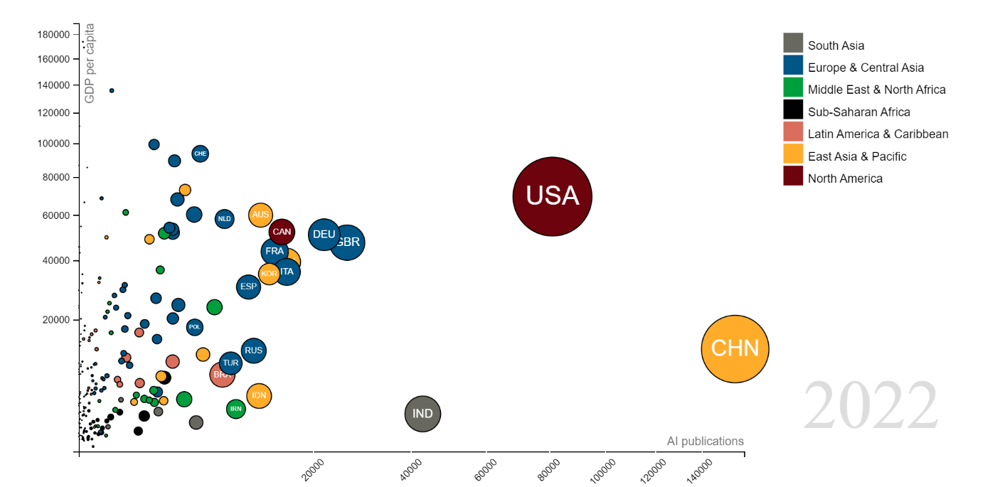
Data Source: OpenAIex. Query conducted by the authors on 26/07/2023.

Figure A2 - Collaboration between Brazil and other countries in scientific publications on AI
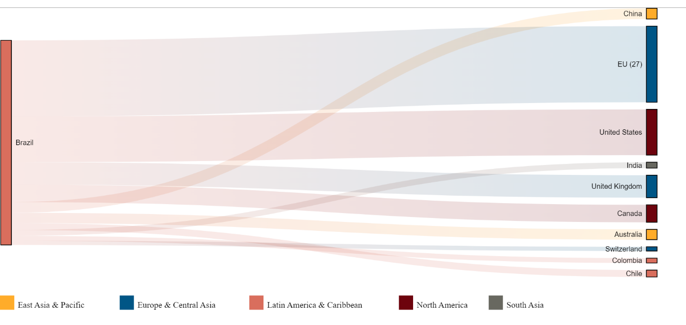
Data Source: OpenAIex. Query conducted by the authors on 26/07/2023.

Figure A3 - Main research areas in scientific publications on AI in Brazil until 2022
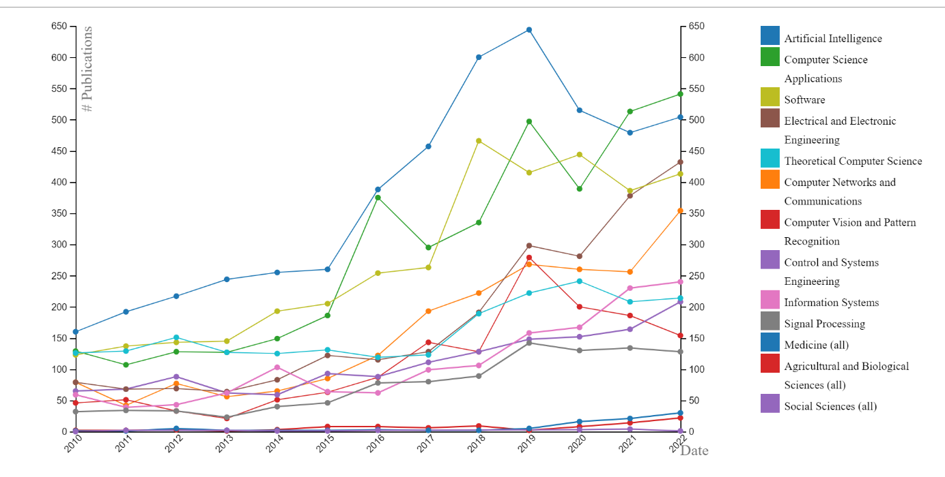
Data Source: OpenAIex. Query conducted by the authors on 26/07/2023.

