Supplementary materials

Appendix A:

Since our focus is on investigating possible crowding-in or crowding-out effects, we have relegated the “main result” column in Table 1A to this finding. Other results, however, have also been reported in the “additional results” column, but they are not the focus of this article.

Table 1A: Summary of the empirical literature on the relationship between public and private investment in Brazil
Study | Period | Methodology | Main Result | Additional Results
Melo and Rodrigues Junior (1998) | 1970-1995 | Error correction model | Crowding-out effect: Public investment displaces around a third of private investment in the short term. | -The main factor affecting private investment (positively) is demand.  -Interest rates and inflation rates have a negative impact on private investment.
Jacinto and Ribeiro (1998) | 1973-1989 | First difference regression (short term) | Crowding-out effect: private investment responds negatively to public investment. | -The degree of capacity utilization has a positive effect on private investment.  -Credit (BNDES) has no statistically significant impact.
Cruz and Teixeira (1999) | 1948-1990 | ADL (Autoregressive Distributed Lag) | Crowding-in effect in the long term: public investment positively impacts private investment in the regression that considers the long-term effect.  Crowding-out effect in the short term: public investment in the current period affects private investment negatively.. | -Expected demand is the main factor in determining private investment (accelerator effect)  -Interest rates have no significant impact.
Alves and Luporini (2008) | 1996-2005 | Panel regression for industrial sectors | Crowding-in effect:  -Positive effect of public investment on the variable "acquisitions of fixed assets in industrial sectors". | -The level of activity in the sector, the level of capacity utilization, and the availability of BNDES credit positively affect investment.  -The real exchange rate and external indebtedness have a negative impact, while the interest rate has an impact close to zero.
Sonaglio et al. (2010) | 1995-2006 | VECM (Vector Error Correction Model) – long term | Crowding-out effect:  -A 1% increase in public investment reduces private investment by 0.429%. | - Private investment responds positively to demand, and negatively to the tax burden, the capital price, and the interest rate.
Sanches and Rocha (2010) | 1991-2004 | Panel regression for Brazilian states. | Crowding-in effect:  - A 1% increase in public investment raises private investment by between 0.74% and 1.135%. | -Positive effect of demand on private investment.  - Interest rates have a negative impact on private investment.
Tadeu and Silva (2013) | 1996-2011 | Regression analysis | Crowding-in effect:  -A 1% increase in public investment in infrastructure raises private investment by 0.113%. | -Positive effect of demand on private investment.  -A 1% increase in public investment not related to infrastructure has a negative impact of 0.0741% on private investment.  -Interest rates have no significant effect, while the exchange rate has a negative impact on private investment.  - BNDES credit to the private sector has a positive impact.
Dos Santos et al. (2015) | 1996-2013 | VAR (Vector Autoregressive Model) | Crowding-in effect:  -Private investment responds positively to public investment. | -There was a positive relationship between commodity prices and private investment and a negative between the exchange rate and private investment.
Reis et al. (2019) | 1982-2013 | VECM (Vector Error Correction Model) – long term | Crowding-in effect:  -Private investment responds positively to public investment | -Private investment responds positively to demand, the degree of capacity utilization, the share of profits in income, and the real exchange rate.  -Industrial production responds positively to public investment.
Bredow et al. (2022) | 1996-2018 | VAR (Vector Autoregressive Model) | Crowding-in effect:  -A 10% increase in public investment generates a 1.64% increase in private investment in the first period.  -The cumulative effect over time is 2.04% after four quarters and 1.89% after twenty quarters. | -No response from the economy's prices to expansions in public investment (exchange rate, Selic interest rate, and machine prices do not respond significantly).
Fraga and Ferreira-Filho (2023) | 1960-2013 | Bayesian Model Averaging e Weighted-Average Least-  Squares | Crowding-in effect:  -Private investment responds positively to public investment, especially in infrastructure. | -Private investment responds positively to demand, to the real exchange rate and the availability of credit, and negatively to the real interest rate.
Iasco-Pereira and Duregger (2023) | 1947-2017 | ARDL (Distributed Lag Autoregressive Model) | Crowding-in effect:  -A 1% increase in public investment generates an increase of approximately 0.6% in private investment (in the short term and long term).  - A 1% increase in infrastructure investment generates an increase of between 0.6 and 0,7% in private investment in the long term and 0.5% in the short term. | -Aggregate demand and the terms of trade have a positive effect on private investment.  -No robust evidence of the impact of inflation, exchange rates, BNDES credit, and labor costs.
Source: authors’ elaboration based on the literature.

Appendix B: Residual tests for the Linear VAR estimations presented in Section 5

Based on the information criteria, we selected 4 lags. The residual test for autocorrelation (Box-Jung test) showed a p-value of 0.78 (lag 1), 0.95 (lag 2), 0.85 (lag 3), 0.92 (lag 4), 0.86 (lag 5), 0.92 (lag 6), 0.83 (lag 7), 0.58 (lag 8), indicating that they do not have autocorrelation. The ARCH test for heteroscedasticity showed a p-value of 0.1674, indicating that the model is free of this problem. Furthermore, the model is stable since all the eigenvalues of the coefficient matrix are smaller than one. Finally, the normality test Jarque Bera rejects the null hypothesis that residuals are normally distributed.

Appendix C
This Appendix shows the results for the impact of private investment on public investment. While the TVAR estimations show statistically significant results - see Table 1 in Section 5 (Figure 1C), the linear VAR approach (Figure 2C) does not show a statistically significant impact.

Figure 1C: Accumulated response of public investment to a standard deviation shock in private investment in the relatively low- and high-inequality regimes - Results from TVAR
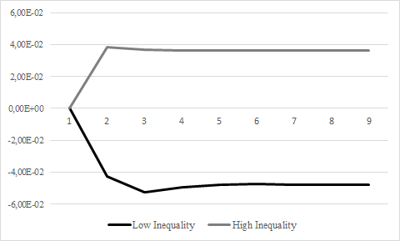
Source: authors’ elaboration

Figure 2C: Accumulated response of public investment to a standard deviation shock in private investment for Brazil - Results from linear VAR
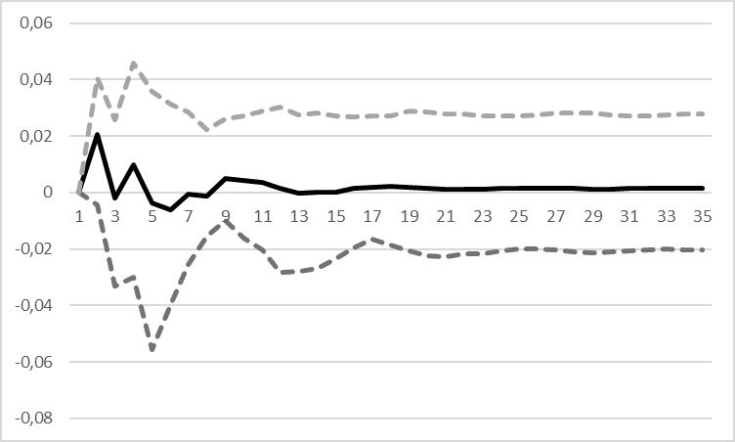
Source: authors’ elaboration. The dashed lines correspond to confidence intervals of 90%.

Appendix D: Control variables

Firstly, we consider the possibility of private investment being influenced by aggregate demand, known as the accelerator effect. To account for this, we incorporate a control variable representing the degree of capacity utilization, serving as a proxy for aggregate demand (Fraga and Ferreira-Filho, 2023; Reis et al., 2019; Bredow et al., 2022; Alves and Luporini, 2008; Jacinto and Ribeiro, 1998). Our analysis indicates that this variable is positive and statistically significant at the 0.1% level, implying a positive impact on private investment. Figure 1D shows that the crowding-in effect still appears when we control for aggregate demand: a 10% increase in public investment leads to an increase in private investment of 1.24% in the first period, and of 2.21% after four quarters.

Figure 1D: Accumulated response of private investment to a standard deviation shock in public investment in the linear VAR using the capacity utilization variable as exogenous
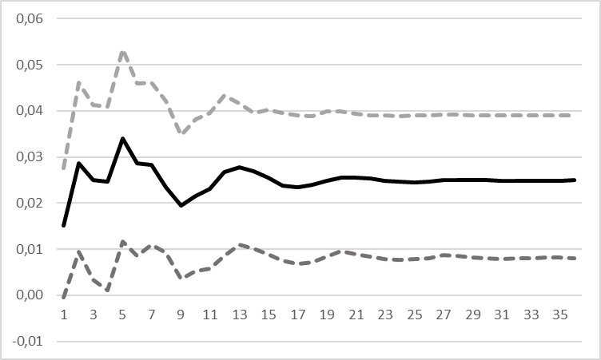
Source: authors’ elaboration. The dashed lines correspond to confidence intervals of 90%.

This finding aligns with previous studies by Jacinto and Ribeiro (1998), Alves and Luporini (2008), Sonaglio et al. (2010), and Reis et al. (2019), which have similarly observed a positive relationship between capacity utilization and private investment. The rationale behind this relationship is that companies tend to increase their investments as the utilization of installed capacity rises. Moreover, in the presence of demand stimuli, private investment tends to rise until it achieves the desired capital stock (Conte Filho, 2013).
Furthermore, we have included the exogenous real exchange rate variable (Ribeiro and Teixeira, 2001; Tadeu and Silva, 2013; Reis et al., 2019; Bredow et al., 2022). We found a negative and significant effect at the 5% level (Tadeu and Silva, 2013; Dos Santos et al., 2016). According to Figure 2D, with the inclusion of the exchange rate variable, a 10% increase in public investment implies an increase in private investment of 1.25% and 2.44% in the first and after four quarters, respectively.
The negative sign of the exchange rate may indicate that higher accurate (devaluated) exchange rates may not encourage imports of capital goods and, therefore, reduce private investment. This result is in line with Ribeiro and Teixeira (2001) and Tadeu and Silva, 2013), who found that the exchange rate significantly and negatively affects private investment in Brazil.

Figure 2D: Accumulated response of private investment to a standard deviation shock in public investment in the linear VAR using the exchange rate variable as exogenous
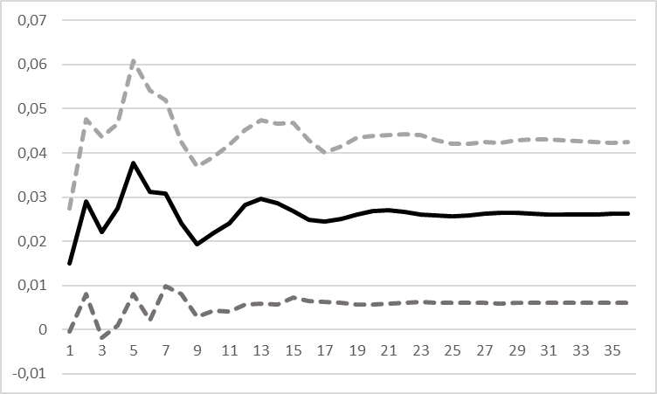
Source: authors’ elaboration. The dashed lines correspond to confidence intervals of 90%.

We have also included the commodity price index as a control variable. As in Dos Santos et al. (2016), the exogenous variable commodities had a positive effect and was significant at the 1% level. This effect may be associated with increased agricultural and extractive investment participation. Another explanation would be indirect channels, for example, the reduction of external restrictions on economic growth and the expansion of the domestic consumer market (Dos Santos et al., 2016). Figure 3D shows that our crowding-in result is robust to the inclusion of the commodity price index as a control variable: a 10% increase in public investment leads to an increase in private investment of 1.23% and 2.97% after one and four quarters.

Figure 3D: Accumulated response of private investment to a standard deviation shock in public investment in the linear VAR using the commodities variable as exogenous
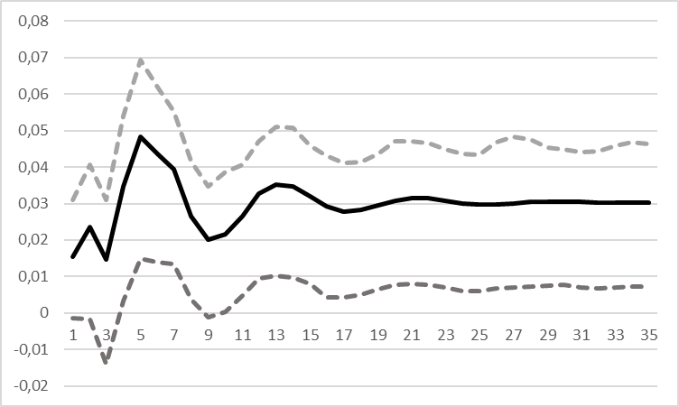
Source: authors’ elaboration. The dashed lines correspond to confidence intervals of 90%.

Finally, we have included the interest rate control variable (Bredow et al., 2022; Alves and Luporini, 2008; Cruz and Teixeira, 1999). This control variable did not show statistical significance. Notably, in addition to not being significant, the interest rate has a negative value, in line with Bredow et al. (2022). It is worth remembering one of the arguments why public investment would generate a crowding-out effect on private investment. If there were an increase in the interest rate to finance public investment through the sale of public bonds, the availability of private-sector credit would be reduced. Moreover, private investment would consequently be discouraged. Our result suggests the opposite since public spending did not exert pressure on prices and costs in the economy. Furthermore, it had a potential negative impact on private investments.

Therefore, public investment would not compete with private investment for resources by raising the interest rate or increasing production costs (putting pressure on inflation). On the contrary, public investment would generate a crowding-in effect on private investment due to its multiplier effect and the physical expansion and expansion of the domestic market. In addition to acting as a facilitator of services and reducing production costs of private investment, increasing the productivity of the economy, mainly when aimed at meeting infrastructure demands (Aschauer, 1989a and 1989b; Greene and Villanueva, 1991; Calderón and Servén, 2004 and Perrotti and Sánchez, 2011; Reis et al., 2019).

Tests for the Linear VARs presented in Section 7

Tests on the residuals of the models with control variables are available in the following and indicate the estimations are stable and do not exhibit heteroscedasticity or residual correlations.

-Linear VAR using the degree of capacity utilization as a control variable
Based on the information criteria, we selected 4 lags. The residual autocorrelation test (Box-Jung test) presented p-values of 0.69 (lag 1), 0.92 (lag 2), 0.87 (lag 3), 0.94 (lag 4), 0, 87 (lag 5), 0.93 (lag 6), 0.85 (lag 7), 0.59 (lag 8), indicating that they do not have autocorrelation. The ARCH test for heteroscedasticity presented a p-value of 0.80, indicating that the model is free from this problem. The model is stable, as all eigenvalues in the coefficient matrix are less than one. Finally, the Jarque Bera normality test rejects the null hypothesis that the residuals are normally distributed.
-Linear VAR using exchange rate as a control variable
Based on the information criteria, we selected 4 lags. The residual autocorrelation test (Box-Jung test) presented p-values of 0.71 (lag 1), 0.89 (lag 2), 0.87 (lag 3), 0.95 (lag 4), 0, 90 (lag 5), 0.94 (lag 6), 0.87 (lag 7), 0.62 (lag 8), indicating that they do not have autocorrelation. The ARCH test for heteroscedasticity presented a p-value of 0.77, indicating that the model is free from this problem. The model is stable, as all eigenvalues in the coefficient matrix are less than one. Finally, the Jarque Bera normality test rejects the null hypothesis that the residuals are normally distributed.
-Linear VAR using commodity price index as a control variable
Based on the information criteria, we selected 4 lags. The residual autocorrelation test (Box-Jung test) presented p-values of 0.74 (lag 1), 0.93 (lag 2), 0.90 (lag 3), 0.95 (lag 4), 0, 85 (lag 5), 0.92 (lag 6), 0.72 (lag 7), 0.39 (lag 8), indicating that they do not have autocorrelation. The ARCH test for heteroscedasticity presented a p-value of 0.055, indicating that the model is free from this problem. The model is stable, as all eigenvalues in the coefficient matrix are less than one. Finally, the Jarque Bera normality test rejects the null hypothesis that the residuals are normally distributed.

Normality is hard to achieve in the short run time series. As pointed out by Brenck (2021, p.378), “The Law of Large Number states that when sample size tends to infinity, the sample mean converges to the population mean, and the error term becomes normally distributed so that the lack of normality can be due to shorter term data”.
This exercise is performed for the period 2003-2022. Data for the commodity price index are available by the IMF from 2003 onwards.

