Appendix
Table A1. Summary Statistics
Variables | Mean | St. Dev. | Min | Max | N
Municipal Characteristics
Number of Seats | 9.94 | 1.64 | 7.00 | 17.00 | 10479
Population (in thousand) | 17.06 | 17.73 | 0.78 | 99.99 | 10512
Total Candidates | 69.94 | 49.74 | 9.00 | 396.00 | 10510
Candidates per Seat | 6.73 | 3.85 | 1.00 | 30.89 | 10479
Gender
Women Candidates | 24.03 | 16.66 | 3.00 | 129.00 | 10510
Men Candidates | 45.90 | 33.22 | 6.00 | 266.00 | 10510
Women Elected | 1.52 | 1.16 | 0.00 | 8.00 | 10316
Share of Women Candidates (%) | 34.68 | 2.71 | 25.93 | 50.00 | 10510
Share of Women Elected (%) | 15.45 | 11.68 | 0.00 | 77.78 | 10286
Race
Non-White Candidates | 36.33 | 35.93 | 1.00 | 333.00 | 10192
Non-White Elected | 4.86 | 3.31 | 0.00 | 17.00 | 9466
Share of Non-White Candidates (%) | 49.47 | 28.76 | 1.25 | 100.00 | 10192
Share of Non-White Elected (%) | 48.07 | 30.92 | 0.00 | 100.00 | 9436
Age
Candidates Under 30 | 7.14 | 5.25 | 1.00 | 49.00 | 10262
Candidates Over 60 | 6.77 | 6.12 | 1.00 | 62.00 | 10068
Share of Candidates Under 30 (%) | 10.64 | 5.07 | 0.93 | 38.46 | 10262
Share of Candidates Over 60 (%) | 9.44 | 4.85 | 0.83 | 53.33 | 10068
Elected Under 30 | 0.77 | 0.84 | 0.00 | 6.00 | 9682
Elected Over 60 | 0.83 | 0.87 | 0.00 | 5.00 | 8456
Share of Elected Under 30 (%) | 7.90 | 8.71 | 0.00 | 66.67 | 9653
Share of Elected Over 60 (%) | 8.35 | 8.63 | 0.00 | 55.56 | 8433
Education
High School Graduates Candidates | 42.13 | 34.14 | 2.00 | 290.00 | 10510
College Graduates Candidates | 12.78 | 12.11 | 1.00 | 112.00 | 10424
Share of High School Graduates Candidates (%) | 58.66 | 12.30 | 9.52 | 100.00 | 10510
Share of College Graduates Candidates (%) | 17.54 | 8.10 | 1.25 | 58.82 | 10424
High School Graduates Elected | 6.73 | 2.42 | 0.00 | 17.00 | 10510
College Graduates Elected | 2.64 | 1.90 | 0.00 | 13.00 | 10358
Share of High School Graduates Elected (%) | 67.14 | 18.60 | 0.00 | 100.00 | 10479
Share of College Graduates Elected (%) | 25.88 | 16.91 | 0.00 | 100.00 | 10328
Source(s): Table by authors
Notes: The table presents descriptive statistics on the characteristics of candidates and councilors who were elected. The data cover the 2017-2020 and 2021-2024 electoral cycles for municipalities with a population of up to 100,000, using population Figures from IBGE and details on candidates and council members from TSE.

Table A2. Municipal Thresholds according to Constitutional Amendment nº 58/2009
Municipal Population | Number of Seats (Maximum Limit) | Municipal Count | Municipalities Adopting Maximum
Up to 15,000 | 9 (nine) | 3262 | 3224
From 15,001 to 30,000 | 11 (eleven) | 1139 | 845
From 30,001 to 50,000 | 13 (thirteen) | 496 | 326
From 50,001 to 80,000 | 15 (fifteen) | 267 | 149
From 80,001 to 120,000 | 17 (seventeen) | 140 | 48
From 120,001 to 160,000 | 19 (nineteen) | 81 | 17
From 160,001 to 300,000 | 21 (twenty-one) | 94 | 33
From 300,001 to 450,000 | 23 (twenty-three) | 39 | 8
From 450,001 to 600,000 | 25 (twenty-five) | 17 | 3
From 600,001 to 750,000 | 27 (twenty-seven) | 11 | 2
From 750,001 to 900,000 | 29 (twenty-nine) | 6 | 2
From 900,001 to 1,050,000 | 31 (thirty-one) | 2 | 0
From 1,050,001 to 1,200,000 | 33 (thirty-three) | 2 | 0
From 1,200,001 to 1,350,000 | 35 (thirty-five) | 1 | 0
From 1,350,001 to 1,500,000 | 37 (thirty-seven) | 3 | 0
From 1,500,001 to 1,800,000 | 39 (thirty-nine) | 2 | 1
From 1,800,001 to 2,400,000 | 41 (forty-one) | 2 | 1
From 2,400,001 to 3,000,000 | 43 (forty-three) | 3 | 2
From 3,000,001 to 4,000,000 | 45 (forty-five) | 1 | 1
From 4,000,001 to 5,000,000 | 47 (forty-seven) | 0 | 0
From 5,000,001 to 6,000,000 | 49 (forty-nine) | 0 | 0
From 6,000,001 to 7,000,000 | 51 (fifty-one) | 1 | 1
From 7,000,001 to 8,000,000 | 53 (fifty-three) | 0 | 0
More than 8,000,000 | 55 (fifty-five) | 1 | 1
Source(s): Table by authors
Notes: Data refer to the maximum number of seats allowed for Brazilian municipal councils according to Constitutional Amendment No. 58/2009. Data refer to the 2021-2024 electoral cycle.

Table A3. Robustness check: Estimates with triangular kernel
 | Electoral Outcomes
 | (1) | (2) | (3)
 | Seats | Total Candidates | Candidates per Seat
𝛽 bias-correcteds.e. | 0.470** | 10.602* | 0,726
 | (0.151) | (4.791) | (0.424)
Bandwidth | 2227,902745 | 2395 | 2133
Observations | 1945 | 2163 | 1820
 | Racial Representation
 | (4) | (5) | (6) | (7) | (8)
 | Non-White Candidates | Non-White Elected | At Least 1 Non-White | Share of Non-White Candidates | Share of Non-White Elected
𝛽 bias-correcteds.e. | 7.622* | 0.935** | 0.051* | 3.554 | 5,442
 | (3.411) | (0.339) | (0.023) | (2.819) | (3.294)
Bandwidth | 2586 | 2534 | 2486 | 2280 | 2328
Observations | 2364 | 2103 | 2037 | 1946 | 1837
 | Gender Representation
 | (9) | (10) | 11) | (12) | (13)
 | Women Candidates | Women Elected | At Least 1 Woman | Share of Women Candidates | Share of Women Elected
𝛽 bias-correcteds.e. | 3.572* | 0.011 | 0.007 | -0.280 | -0.884
 | (1.640) | (0.097) | (0.035) | (0.212) | (0.856)
Bandwidth | 2384 | 3547 | 3556 | 2568 | 4378
Observations | 2159 | 3963 | 3982 | 2441 | 5364
 | Age Representation
 | (14) | (15) | (16) | (17) | (18) | (19) | (20) | (21)
 | Candidates Under 30 | Share of Candidates Under 30 | Elected Under 30 | Share of Elected Under 30 | Candidates Over 60 | Share of Candidates Over 60 | Elected Over 60 | Share of Elected Over 60
𝛽 bias-correcteds.e. | 1.557** | 0.522 | 0.020 | -0.160 | 0.712 | -0.411 | -0.050 | -1,416
 | (0.492) | (0.366) | (0.067) | (0.667) | (0.630) | (0.390) | (0.071) | (0.842)
Bandwidth | 2444 | 3839 | 3906 | 4079 | 2691 | 3302 | 4468 | 3418
Observations | 2186 | 4455 | 4334 | 4630 | 2555 | 3478 | 4514 | 3036
 | Educational Attainment Representation
 | (22) | (23) | (24) | (25) | (26) | (27) | (28) | (29)
 | High School Graduates Candidates | Share of High School Graduates Candidates | High School Graduates Elected | Share of High School Graduates Elected | College Graduates Candidates | Share of College Graduates Candidates | College Graduates Elected | Share of College Graduates Elected
𝛽 bias-correcteds.e. | 6.783* | 1.354 | 0.694** | 3,022 | 2,219 | 1,385 | 0.405* | 3,141
 | (3.250) | (1.062) | (0.212) | (1.736) | (1.142) | (0.739) | (0.199) | (1.856)
Bandwidth | 2412 | 2506 | 2517 | 2436 | 2502 | 2530 | 2295 | 2185
Observations | 2191 | 2337 | 2355 | 2222 | 2301 | 2345 | 2009 | 1854
Source(s): Table by authors
Notes: This table reports the reduced-form effects of council size on the pool of candidates and elected councilors in local elections. The estimates are derived from regression discontinuity (RD) designs, utilizing a local polynomial estimator with a triangular kernel. The optimal bandwidth for each regression, minimizing mean squared error (MSE), was chosen following the method outlined in Calonico et al. (2014, 2018). Significance levels are denoted by: *** p < 0.01, ** p < 0.05, * p < 0.1.

Table A4. Effects of Municipal Council Size on Placebo Outcomes
 | (1) | (2) | (3) | (4)
 | Share of Non-White | Share of High School Graduates | Share of Women | Share of People Aged 18-29
𝛽 bias-correcteds.e. | 3.288 | -0.321 | 0.229 | 0.310
 | (2.460) | (0.501) | (0.133) | (0.208)
Bandwidth | 1961 | 2743 | 2852 | 1695
Observations | 1601 | 2732 | 2912 | 1332
Source(s): Table by authors
Notes: This table reports the reduced-form effects of council size on placebo outcomes. The estimates are derived from regression discontinuity (RD) designs, utilizing a local polynomial estimator with a uniform kernel. The optimal bandwidth for each regression, minimizing mean squared error (MSE), was chosen following the method outlined in Calonico et al. (2014, 2018). Significance levels are denoted by: *** p < 0.01, ** p < 0.05, * p < 0.1. Data source: IBGE Censo 2010.

Table A5. RD estimates using bandwidth of 5,000
 | Electoral Outcomes
 | (1) | (2) | (3)
 | Seats | Total Candidates | Candidates per Seat
𝛽 bias-correcteds.e. | 0.759*** | 14.224*** | 1.007***
 | (0.087) | (2.784) | (0.229)
Bandwidth | 5000 | 5000 | 5000
Observations | 6481 | 6496 | 6481
 | Racial Representation
 | (4) | (5) | (6) | (7) | (8)
 | Non-White Candidates | Non-White Elected | At Least 1 Non-White | Share of Non-White Candidates | Share of Non-White Elected
𝛽 bias-correcteds.e. | 9.199*** | 0.916*** | 0.025 | 2.271 | 4.410*
 | (2.086) | (0.206) | (0.016) | (1.702) | (1.940)
Bandwidth | 5000 | 5000 | 5000 | 5000 | 5000
Observations | 6261 | 5774 | 5774 | 6261 | 5760
 | Gender Representation
 | (9) | (10) | 11) | (12) | (13)
 | Women Candidates | Women Elected | At Least 1 Woman | Share of Women Candidates | Share of Women Elected
𝛽 bias-correcteds.e. | 4.727*** | -0.052 | -0.010 | -0.177 | -1.514*
 | (0.941) | (0.071) | (0.025) | (0.150) | (0.712)
Bandwidth | 5000 | 5000 | 5000 | 5000 | 5000
Observations | 6496 | 6369 | 6369 | 6496 | 6355
 | Age Representation
 | (14) | (15) | (16) | (17) | (18) | (19) | (20) | (21)
 | Candidates Under 30 | Share of Candidates Under 30 | Elected Under 30 | Share of Elected Under 30 | Candidates Over 60 | Share of Candidates Over 60 | Elected Over 60 | Share of Elected Over 60
𝛽 bias-correcteds.e. | 1.966*** | 0.686* | 0.034 | -0.074 | 0.874* | -0.327 | -0.023 | -1,043
 | (0.305) | (0.289) | (0.051) | (0.530) | (0.378) | (0.292) | (0.059) | (0.597)
Bandwidth | 5000 | 5000 | 5000 | 5000 | 5000 | 5000 | 5000 | 5000
Observations | 6350 | 6350 | 6019 | 6006 | 6203 | 6203 | 5179 | 5167
 | Educational Attainment Representation
 | (22) | (23) | (24) | (25) | (26) | (27) | (28) | (29)
 | High School Graduates Candidates | Share of High School Graduates Candidates | High School Graduates Elected | Share of High School Graduates Elected | College Graduates Candidates | Share of College Graduates Candidates | College Graduates Elected | Share of College Graduates Elected
𝛽 bias-correcteds.e. | 8.581*** | -0.181 | 0.613*** | 0.797 | 2.749*** | 0.689 | 0.230* | 0.580
 | (1.892) | (0.694) | (0.133) | (1.078) | (0.664) | (0.466) | (0.111) | (1.017)
Bandwidth | 5000 | 5000 | 5000 | 5000 | 5000 | 5000 | 5000 | 5000
Observations | 6496 | 6496 | 6496 | 6481 | 6425 | 6425 | 6400 | 6386
Source(s): Table by authors
Notes: This table reports the reduced-form effects of council size on the pool of candidates and elected councilors in local elections. The estimates are derived from regression discontinuity (RD) designs, utilizing a local polynomial estimator with a uniform kernel. Significance levels are denoted by: *** p < 0.01, ** p < 0.05, * p < 0.1.

Table A6. RD estimates using bandwidth of 7,500
 | Electoral Outcomes
 | (1) | (2) | (3)
 | Seats | Total Candidates | Candidates per Seat
𝛽 bias-correcteds.e. | 0.740*** | 4.472* | -0.067
 | (0.067) | (2.127) | (0.173)
Bandwidth | 7500 | 7500 | 7500
Observations | 9914 | 9940 | 9914
 | Racial Representation
 | (4) | (5) | (6) | (7) | (8)
 | Non-White Candidates | Non-White Elected | At Least 1 Non-White | Share of Non-White Candidates | Share of Non-White Elected
𝛽 bias-correcteds.e. | 3.851* | 0.326* | 0.002 | -3.160* | -2.357
 | (1.599) | (0.160) | (0.013) | (1.336) | (1.517)
Bandwidth | 7500 | 7500 | 7500 | 7500 | 7500
Observations | 9622 | 8917 | 8917 | 9622 | 8892
 | Gender Representation
 | (9) | (10) | 11) | (12) | (13)
 | Women Candidates | Women Elected | At Least 1 Woman | Share of Women Candidates | Share of Women Elected
𝛽 bias-correcteds.e. | 1,391 | 0.045 | 0.020 | 0.117 | -0.420
 | (0.717) | (0.054) | (0.019) | (0.120) | (0.551)
Bandwidth | 7500 | 7500 | 7500 | 7500 | 7500
Observations | 9940 | 9754 | 9754 | 9940 | 9729
 | Age Representation
 | (14) | (15) | (16) | (17) | (18) | (19) | (20) | (21)
 | Candidates Under 30 | Share of Candidates Under 30 | Elected Under 30 | Share of Elected Under 30 | Candidates Over 60 | Share of Candidates Over 60 | Elected Over 60 | Share of Elected Over 60
𝛽 bias-correcteds.e. | 1.031*** | 0.741** | 0.057 | 0.168 | 0.180 | 0.115 | -0.015 | -0,885
 | (0.236) | (0.229) | (0.040) | (0.413) | (0.287) | (0.229) | (0.045) | (0.462)
Bandwidth | 7500 | 7500 | 7500 | 7500 | 7500 | 7500 | 7500 | 7500
Observations | 9693 | 9693 | 9180 | 9156 | 9499 | 9499 | 7941 | 7922
 | Educational Attainment Representation
 | (22) | (23) | (24) | (25) | (26) | (27) | (28) | (29)
 | High School Graduates Candidates | Share of High School Graduates Candidates | High School Graduates Elected | Share of High School Graduates Elected | College Graduates Candidates | Share of College Graduates Candidates | College Graduates Elected | Share of College Graduates Elected
𝛽 bias-correcteds.e. | 3.220* | -0.653 | 0.461*** | -0.714 | 1.174* | 0.244 | -0.001 | -1.892*
 | (1.455) | (0.549) | (0.105) | (0.849) | (0.512) | (0.365) | (0.085) | (0.786)
Bandwidth | 7500 | 7500 | 7500 | 7500 | 7500 | 7500 | 7500 | 7500
Observations | 9940 | 9940 | 9940 | 9914 | 9854 | 9854 | 9788 | 9763
Source(s): Table by authors
Notes: This table reports the reduced-form effects of council size on the pool of candidates and elected councilors in local elections. The estimates are derived from regression discontinuity (RD) designs, utilizing a local polynomial estimator with a uniform kernel. Significance levels are denoted by: *** p < 0.01, ** p < 0.05, * p < 0.1.

Table A7. RD estimates for the 2017-2020 Electoral Cycle
 | Electoral Outcomes
 | (1) | (2) | (3)
 | Seats | Total Candidates | Candidates per Seat
𝛽 bias-correcteds.e. | 0.791*** | 11,758 | 0.949
 | (0.192) | (6.768) | (0.587)
Bandwidth | 2110 | 1719 | 1725
Observations | 877 | 677 | 679
 | Racial Representation
 | (4) | (5) | (6) | (7) | (8)
 | Non-White Candidates | Non-White Elected | At Least 1 Non-White | Share of Non-White Candidates | Share of Non-White Elected
𝛽 bias-correcteds.e. | 11.394* | 1.617*** | 0.043 | 8.789* | 13.342**
 | (4.792) | (0.472) | (0.034) | (3.820) | (4.276)
Bandwidth | 2011 | 2123 | 3045 | 2151 | 2364
Observations | 787 | 792 | 1426 | 869 | 921
 | Gender Representation
 | (9) | (10) | 11) | (12) | (13)
 | Women Candidates | Women Elected | At Least 1 Woman | Share of Women Candidates | Share of Women Elected
𝛽 bias-correcteds.e. | 3,861 | -0.056 | -0.012 | -0.142 | -1.631
 | (2.218) | (0.133) | (0.051) | (0.229) | (1.223)
Bandwidth | 1719 | 2745 | 2888 | 2873 | 3386
Observations | 677 | 1340 | 1460 | 1463 | 1844
 | Age Representation
 | (14) | (15) | (16) | (17) | (18) | (19) | (20) | (21)
 | Candidates Under 30 | Share of Candidates Under 30 | Elected Under 30 | Share of Elected Under 30 | Candidates Over 60 | Share of Candidates Over 60 | Elected Over 60 | Share of Elected Over 60
𝛽 bias-correcteds.e. | 1.818* | 0.893 | 0.038 | -0.401 | 1.595* | 0.132 | -0.011 | -1.127
 | (0.788) | (0.546) | (0.085) | (0.993) | (0.760) | (0.560) | (0.104) | (1.152)
Bandwidth | 1797 | 3265 | 3961 | 3233 | 2229 | 2822 | 3165 | 2673
Observations | 702 | 1735 | 2203 | 1625 | 932 | 1374 | 1370 | 1039
 | Educational Attainment Representation
 | (22) | (23) | (24) | (25) | (26) | (27) | (28) | (29)
 | High School Graduates Candidates | Share of High School Graduates Candidates | High School Graduates Elected | Share of High School Graduates Elected | College Graduates Candidates | Share of College Graduates Candidates | College Graduates Elected | Share of College Graduates Elected
𝛽 bias-correcteds.e. | 9.210* | 0.083 | 0.662* | 0.821 | 1.975 | -1.263 | 0.241 | 0.552
 | (4.228) | (1.372) | (0.291) | (2.262) | (1.352) | (0.801) | (0.237) | (2.181)
Bandwidth | 1957 | 2491 | 2330 | 2510 | 2111 | 3209 | 2331 | 2324
Observations | 791 | 1134 | 1021 | 1152 | 862 | 1709 | 1005 | 998
Source(s): Table by authors
Notes: This table reports the reduced-form effects of council size on the pool of candidates and elected councilors in local elections. The estimates are derived from regression discontinuity (RD) designs, utilizing a local polynomial estimator with a uniform kernel. The optimal bandwidth for each regression, minimizing mean squared error (MSE), was chosen following the method outlined in Calonico et al. (2014, 2018). Significance levels are denoted by: *** p < 0.01, ** p < 0.05, * p < 0.1.}
Table A8. RD estimates for the 2021-2024 Electoral Cycle
 | Electoral Outcomes
 | (1) | (2) | (3)
 | Seats | Total Candidates | Candidates per Seat
𝛽 bias-correcteds.e. | 0.675** | 12,479 | 0.979
 | (0.206) | (7.479) | (0.609)
Bandwidth | 2215 | 1806 | 1709
Observations | 980 | 735 | 677
 | Racial Representation
 | (4) | (5) | (6) | (7) | (8)
 | Non-White Candidates | Non-White Elected | At Least 1 Non-White | Share of Non-White Candidates | Share of Non-White Elected
𝛽 bias-correcteds.e. | 10.156* | 0.504 | 0.009 | -4,921 | -2.891
 | (4.992) | (0.424) | (0.022) | (2.521) | (3.076)
Bandwidth | 2090 | 2447 | 2841 | 4291 | 3729
Observations | 865 | 1009 | 1278 | 2576 | 1909
 | Gender Representation
 | (9) | (10) | 11) | (12) | (13)
 | Women Candidates | Women Elected | At Least 1 Woman | Share of Women Candidates | Share of Women Elected
𝛽 bias-correcteds.e. | 4,551 | 0.055 | 0.011 | -0,698 | -0.777
 | (2.570) | (0.132) | (0.044) | (0.371) | (1.174)
Bandwidth | 1838 | 2990 | 3104 | 1670 | 3551
Observations | 753 | 1556 | 1635 | 659 | 1985
 | Age Representation
 | (14) | (15) | (16) | (17) | (18) | (19) | (20) | (21)
 | Candidates Under 30 | Share of Candidates Under 30 | Elected Under 30 | Share of Elected Under 30 | Candidates Over 60 | Share of Candidates Over 60 | Elected Over 60 | Share of Elected Over 60
𝛽 bias-correcteds.e. | 1.886** | 0.642 | -0.004 | 0.957 | 0.611 | -0.391 | -0.069 | -0.933
 | (0.713) | (0.475) | (0.109) | (0.872) | (0.986) | (0.494) | (0.109) | (1.041)
Bandwidth | 1827 | 3516 | 2593 | 3948 | 2228 | 3795 | 3235 | 3645
Observations | 730 | 1947 | 1171 | 2202 | 962 | 2129 | 1423 | 1677
 | Educational Attainment Representation
 | (22) | (23) | (24) | (25) | (26) | (27) | (28) | (29)
 | High School Graduates Candidates | Share of High School Graduates Candidates | High School Graduates Elected | Share of High School Graduates Elected | College Graduates Candidates | Share of College Graduates Candidates | College Graduates Elected | Share of College Graduates Elected
𝛽 bias-correcteds.e. | 7.950 | 0.883 | 1.130*** | 3,945 | 3,51 | 3.114** | 0.729* | 5,022
 | (5.007) | (1.341) | (0.307) | (2.103) | (1.912) | (1.113) | (0.295) | (2.581)
Bandwidth | 1875 | 2642 | 1879 | 2394 | 1796 | 1937 | 1797 | 1849
Observations | 772 | 1300 | 772 | 1099 | 725 | 793 | 718 | 746
Source(s): Table by authors
Notes: This table reports the reduced-form effects of council size on the pool of candidates and elected councilors in local elections. The estimates are derived from regression discontinuity (RD) designs, utilizing a local polynomial estimator with a uniform kernel. The optimal bandwidth for each regression, minimizing mean squared error (MSE), was chosen following the method outlined in Calonico et al. (2014, 2018). Significance levels are denoted by: *** p < 0.01, ** p < 0.05, * p < 0.1.}
Figure A1. Population density distribution 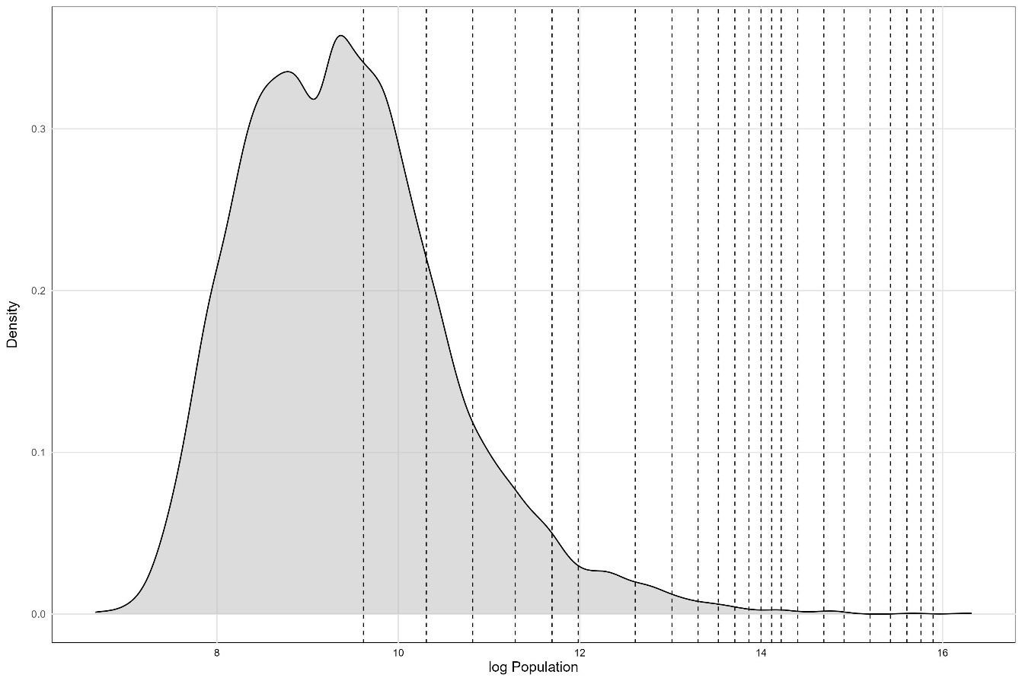
Source(s): Figure by authors

Figure A2. Effects of Municipal Council Size on Electoral Outcomes: RD Plots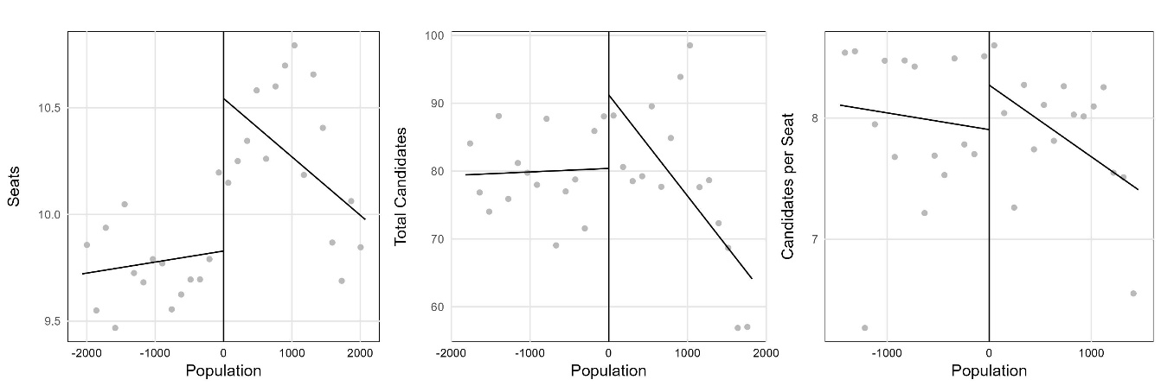
Source(s): Figure by authors
Note: The regression discontinuity plots visually represent the results of the regression discontinuity analysis for the normalized population threshold. Each plot corresponds to specific variables and illustrates changes around the cutoff point of the population threshold.

Figure A3. Effects of Municipal Council Size on Racial Representation in Local Elections: RD Plots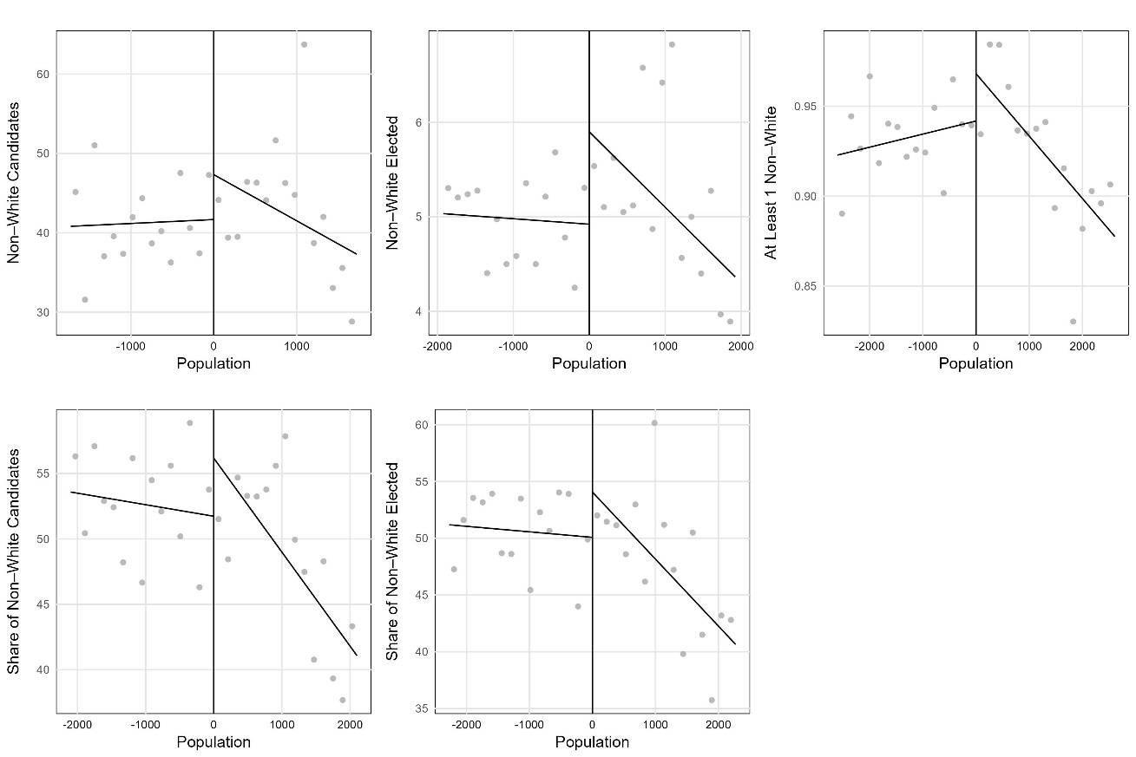
Source(s): Figure by authors
Note: The regression discontinuity plots visually represent the results of the regression discontinuity analysis for the normalized population threshold. Each plot corresponds to specific variables and illustrates changes around the cutoff point of the population threshold.

Figure A4. Effects of Municipal Council Size on Gender Representation in Local Elections: RD Plots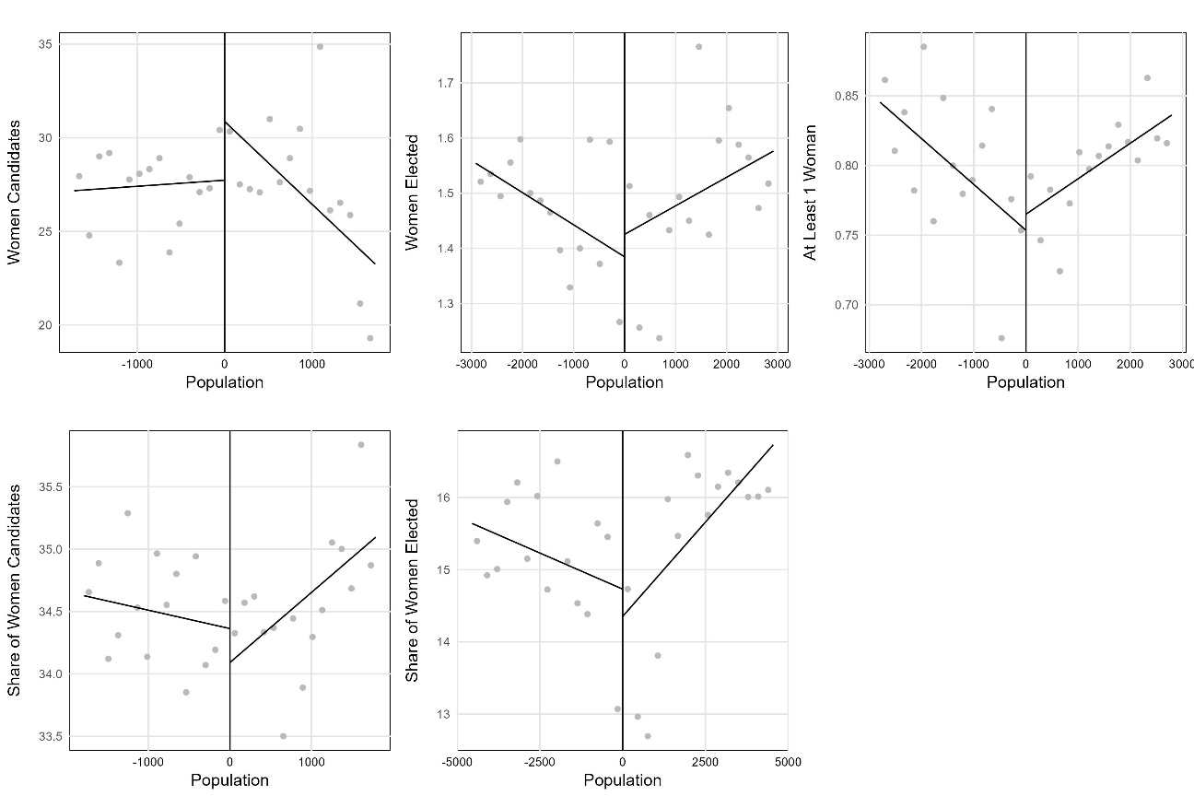
Source(s): Figure by authors
Note: The regression discontinuity plots visually represent the results of the regression discontinuity analysis for the normalized population threshold. Each plot corresponds to specific variables and illustrates changes around the cutoff point of the population threshold.

Figure A5. Effects of Municipal Council Size on Age Representation in Local Elections: RD Plots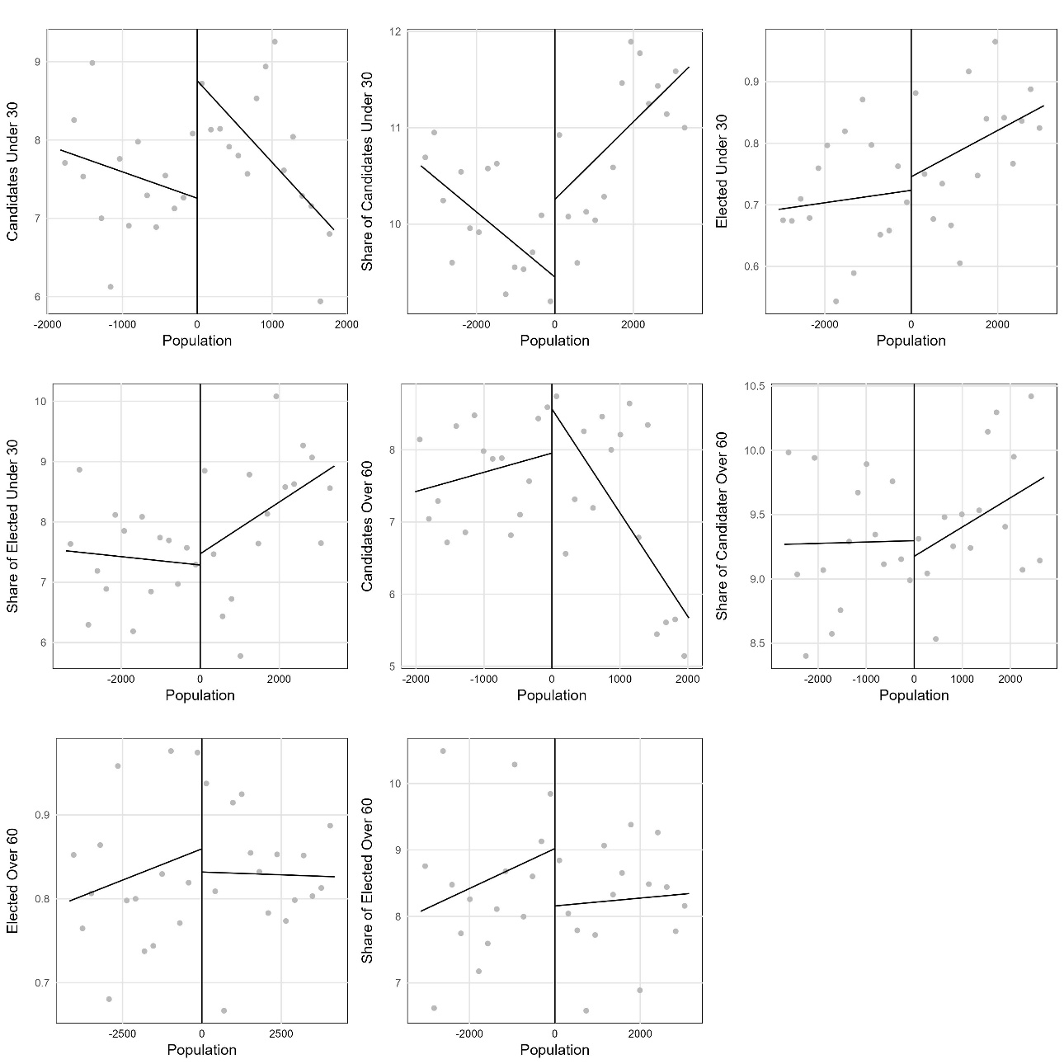
Source(s): Figure by authors
Note: The regression discontinuity plots visually represent the results of the regression discontinuity analysis for the normalized population threshold. Each plot corresponds to specific variables and illustrates changes around the cutoff point of the population threshold.

Figure A6. Effects of Municipal Council Size on Educational Attainment Representation in Local Elections: RD Plots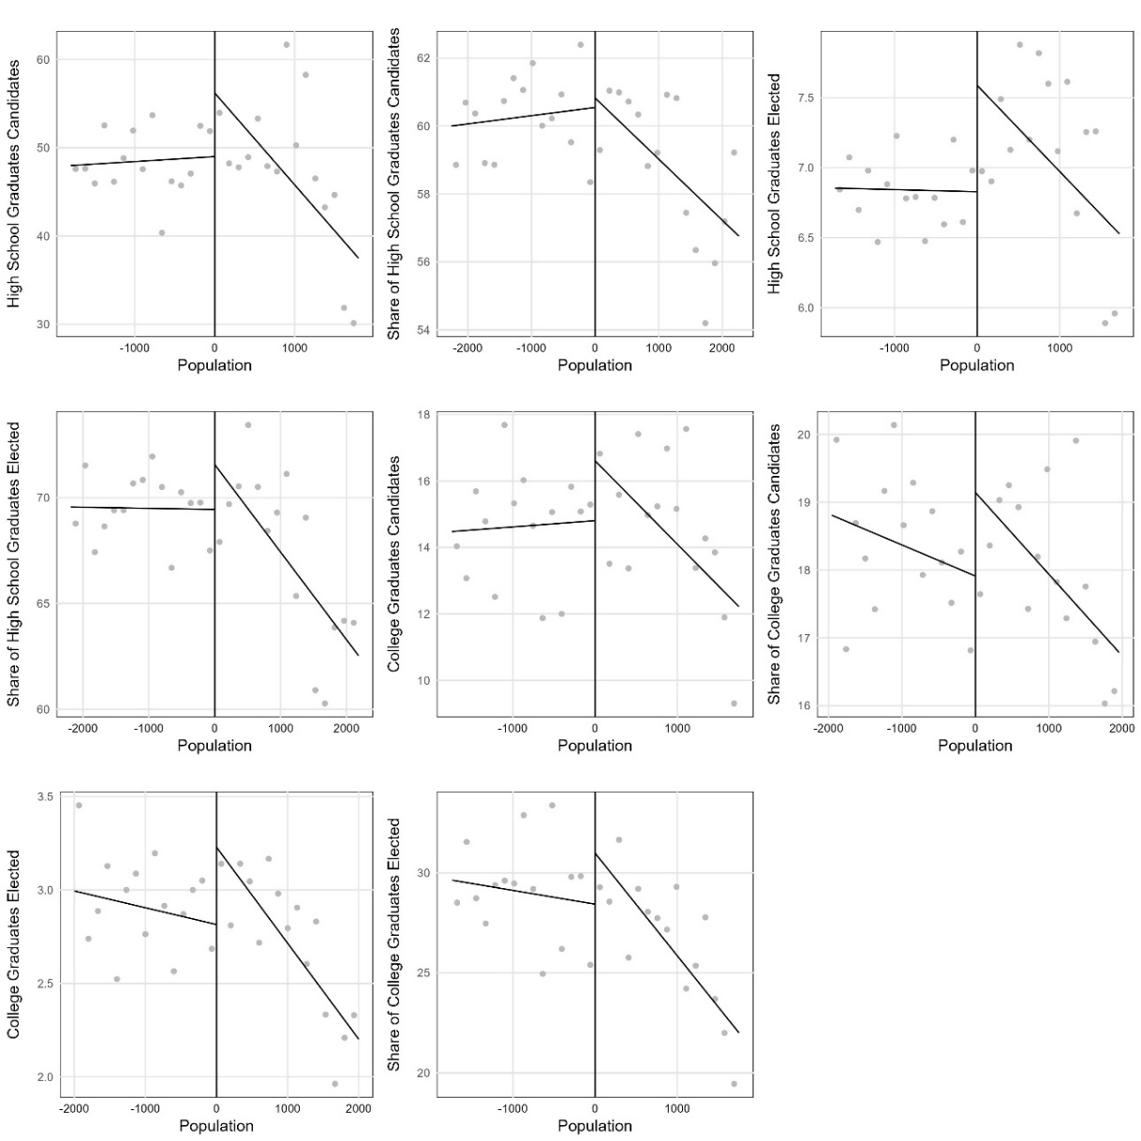
Source(s): Figure by authors
Note: The regression discontinuity plots visually represent the results of the regression discontinuity analysis for the normalized population threshold. Each plot corresponds to specific variables and illustrates changes around the cutoff point of the population threshold.

Figure A7. Histogram and Estimated Density of the Score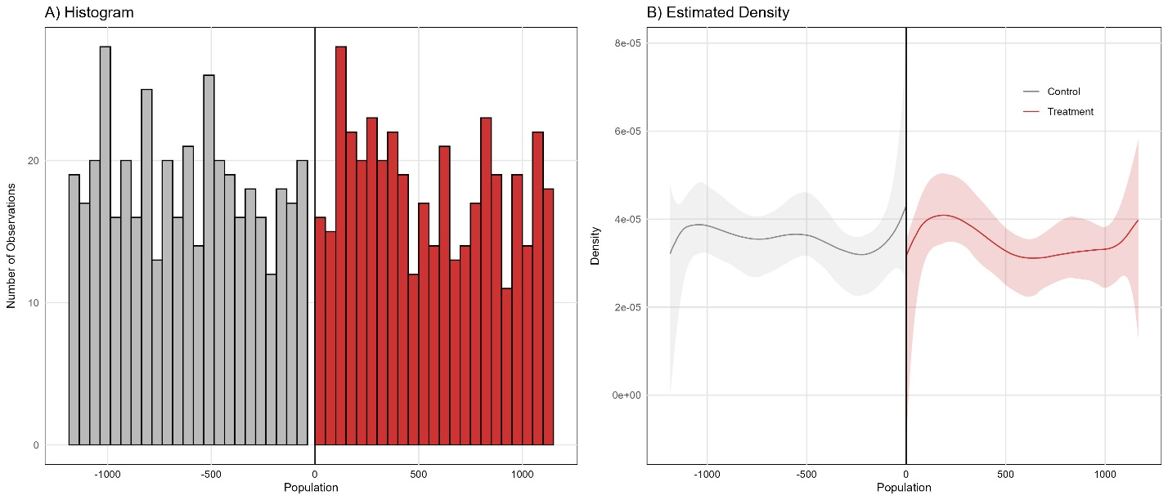
Source(s): Figure by authors

