Appendix

Table A1 – Summary Statistics per Municipality
Variable | Mean | SD | Min | Max
Population | 57,652 | 283,857 | 815 | 12,176,866
Log of Population | 9.92 | 1.21 | 6.70 | 16.31
GDP Municipality (R$) | 1,368,064 | 11,327,410 | 41,999 | 714,663,604
Log of GDP Municipality | 12.43 | 1.53 | 8.34 | 20.39
Construction Employees | 682.20 | 6,209 | 0 | 344,009
Ready-mix concrete plants | 2.57 | 6.36 | 0 | 214
Ready-mix concrete employees Municipality | 36.30 | 136.61 | 0 | 6,210
Source: table by authors. Note: The data is a fully balanced panel of 2801 markets over 17 years.
Figure A1 - Ready-Mix Concrete Plants Dispersion
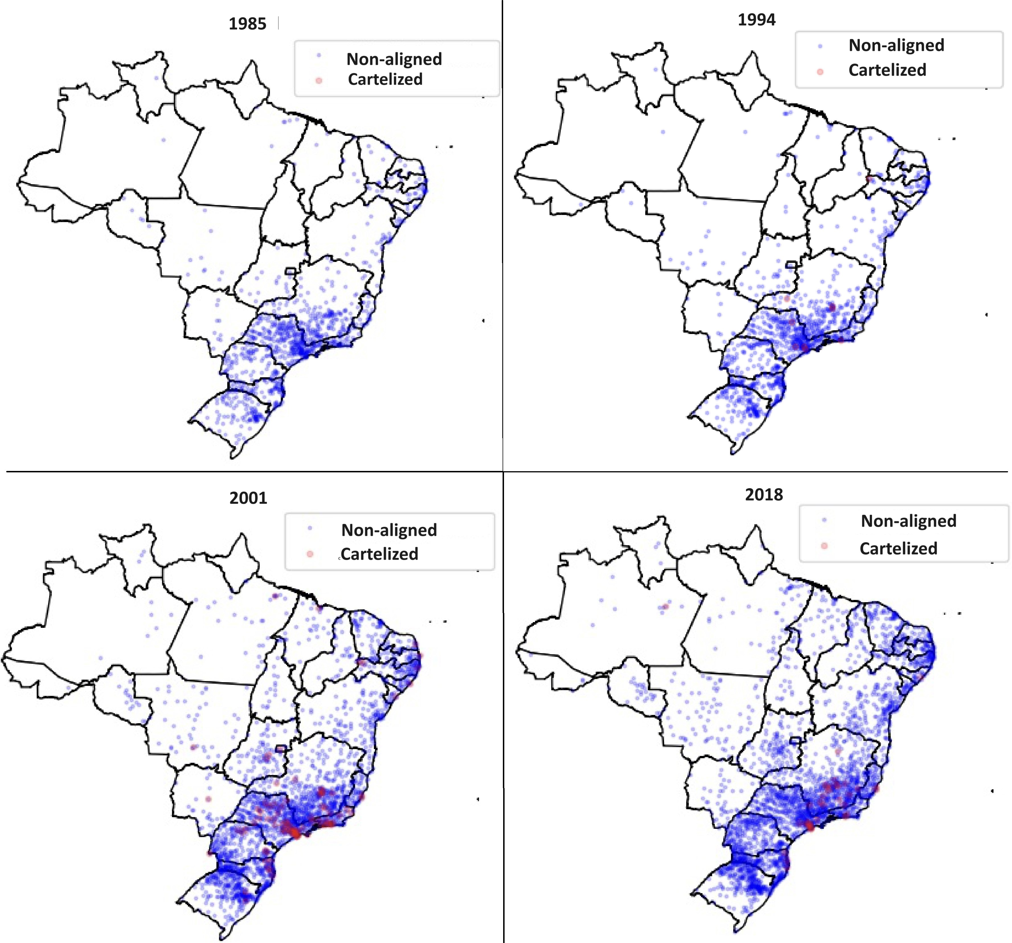
Source: figure by authors.
Table A2 – Acquisitions by Cartel members of Non-aligned Ready-mix concrete firms
Year | Number of Acquistions | Number of Plants Acquired
2004 | 5 | 11
2005 | 13 | 119
2006 | 4 | 23
2007 | 4 | 26
Total | 26 | 179
Source: table by authors.
Table A3 – Summary Statistics of Acquired Firms
Variable | Mean | SD | Min | Max
Population | 1,353,885 | 2,896,233 | 1,582 | 12,176,866
GDP Municipality (R$) | 52,076,591 | 127,122,962 | 30,606 | 714,663,604
Construction Employees | 29,556 | 67,850 | 0 | 344,009
Ready-mix concrete plants | 31.9 | 45.9 | 1 | 214
Ready-mix concrete employees per plant | 30.18 | 60.4 | 2 | 1,071
Source: table by authors.
Table A4 – Summary Statistics of Acquirer Firms Closed After Acquisition (Reverse Killer Acquisition)
Variable | Mean | SD | Min | Max
Population | 1,607,161 | 3,086,760 | 12,900 | 11,016,703
GDP Municipality (R$) | 28,717,642 | 61,069,511 | 75,888 | 283,840,192
Construction Employees | 19,444 | 40,012 | 14 | 158,797
Ready-mix concrete plants | 36.63 | 55.37 | 1 | 214
Ready-mix concrete employees per plant | 21.39 | 31.97 | 2 | 281
Source: table by authors.
Table A5 – Determinants of acquisition by Cartel (2004-2007) - Logit
Acquired = 1 | (1) | (2) | (3) | (4)
Size | 1.203*** | 1.210*** | 1.059*** | 1.063***
 | (0.074) | (0.219) | (0.206) | (0.199)
Pop | 0.067*** | 0.068*** | 0.000 | 0.001
 | (0.011) | (0.020) | (0.002) | (0.001)
GDP | 0.028*** | 0.026*** | 0.007*** | 0.004***
 | (0.005) | (0.007) | (0.002) | (0.001)
Compet | 1.591** | 2.133 | -0.649*** | -0.310***
 | (0.657) | (1.383) | (0.231) | (0.068)
Fixed Effects  Year |  | X |  | X
Municipality |  |  | X | X
Obs. | 17,704 | 17,704 | 17,704 | 17,704
t | 4 | 4 | 4 | 4
i | 6,270 | 6,270 | 6,270 | 6,270
Source: table by authors. Note: * * *p < 0.01; * * p < 0.05; *p < 0.1. Note: * * *p < 0.01; * * p < 0.05; *p < 0.1. Values in parentheses are heteroskedasticity‐robust standard errors, two‐way clustered by municipality and year

Figure A2 – Event Study - Acquired Firms
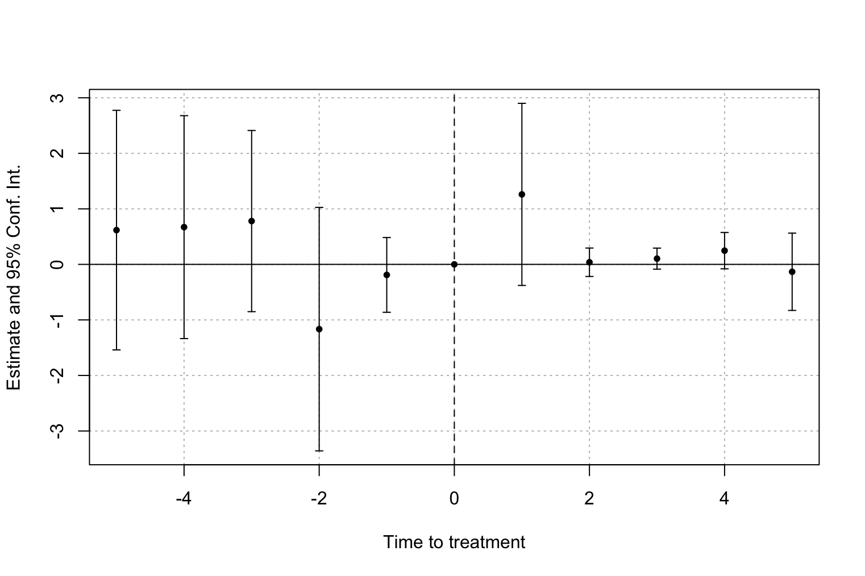
Source: figure by authors.

Figure A3 – Event Study - Acquirer Firms
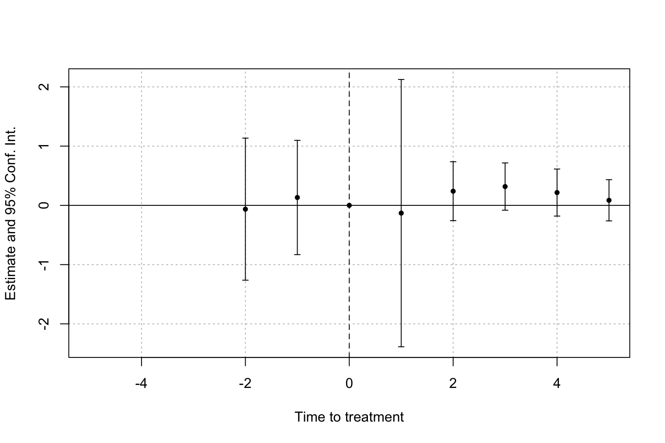
Source: figure by authors.

Table A6 – Average Treatment Effect on Treated - Callaway and Sant’Anna
ATT | Std. Error | Conf. Int. (95%)
-0.2133 | 0.021 | -0.2545 -0.1722*
Source: table by authors. Note: * confidence band does not cover 0

