Supplementary materials

Table S12 - Proportion of the sample by work status
Year | Occupied | Occupied - Self-employed driver | Unemployed | Discouraged | Inactive
2012 | 40.05 | 48.26 | 0.85 | 0.91 | 9.93
2013 | 38.19 | 48.57 | 3.02 | - | 10.22
2014 | 32.52 | 51.65 | 3.05 | - | 12.77
2015 | 38.59 | 47.53 | 4.40 | 0.07 | 9.41
2016 | 36.95 | 46.58 | 7.25 | 0.04 | 9.18
2017 | 34.66 | 48.75 | 10.12 | 0.20 | 6.26
2018 | 33.09 | 46.74 | 8.72 | 0.86 | 10.59
2019 | 26.54 | 59.42 | 5.12 | 1.22 | 7.70
2020 | 17.90 | 62.13 | 10.58 | 1.15 | 8.24
2021 | 39.55 | 42.75 | 7.68 | 0.57 | 9.46
Source: Authors own elaboration with data from PNAD-C/IBGE.

Table S23 - Proportion of the sample by occupational position
Year | Formal | Informal | Self employed | SE (private driver) | Employer
2012 | 15.96 | 9.41 | 16.31 | 54.65 | 3.68
2013 | 16.79 | 8.04 | 17.08 | 55.98 | 2.11
2014 | 13.70 | 8.81 | 14.89 | 61.36 | 1.24
2015 | 19.45 | 9.6 | 13.89 | 55.19 | 1.87
2016 | 21.42 | 9.97 | 11.47 | 55.76 | 1.38
2017 | 15.78 | 8.99 | 15.95 | 58.45 | 0.83
2018 | 15.87 | 10.07 | 14.03 | 58.55 | 1.48
2019 | 11.94 | 6.71 | 12.04 | 69.13 | 0.18
2020 | 7.40 | 5.26 | 9.70 | 77.64 | -
2021 | 13.19 | 5.03 | 26.61 | 51.95 | 3.22
Source: Authors own elaboration with data from PNAD-C/IBGE.

 | Formal -> Ridesharing |  |  | Informal -> Ridesharing |  |  | Self employed -> Ridesharing |  |  | Stayer
 | Start | End | ∆ (%) | Start | End | ∆ (%) | Start | End | ∆ (%) | Start | End | ∆ (%)
2012 > 2013 | R$ 16.3 | R$ 18.5 | 14% | R$ 24.4 | R$ 13.4 | -45% | R$ 20.6 | R$ 21.7 | 6% | R$ 19.3 | R$ 20.7 | 7%
2013 > 2014 | R$ 21.1 | R$ 17.9 | -15% | R$ 14.2 | R$ 13.7 | -4% | R$ 15.8 | R$ 15.7 | -1% | R$ 19.7 | R$ 20.2 | 3%
2014 > 2015 | R$ 16.2 | R$ 14.9 | -8% | R$ 16.7 | R$ 16.2 | -3% | R$ 16.2 | R$ 17.7 | 9% | R$ 21.1 | R$ 22.2 | 5%
2015 > 2016 | R$ 15.4 | R$ 15.8 | 3% | R$ 23.5 | R$ 21.6 | -8% | R$ 17.1 | R$ 15.2 | -11% | R$ 21.5 | R$ 20.4 | -5%
2016 > 2017 | R$ 18.1 | R$ 17.3 | -4% | R$ 11.3 | R$ 12.4 | 10% | R$ 22.8 | R$ 16.7 | -27% | R$ 18.0 | R$ 18.6 | 3%
2017 > 2018 | R$ 16.7 | R$ 19.0 | 14% | R$ 14.0 | R$ 16.7 | 19% | R$ 15,8 | R$ 14.1 | -11% | R$ 15.0 | R$ 15.2 | 1%
2018 > 2019 | R$ 22.4 | R$ 14.5 | -35% | R$ 14.5 | R$ 13.8 | -5% | R$ 19.3 | R$ 14.9 | -23% | R$ 15,9 | R$ 16.5 | 4%
2019 > 2020 | R$ 15.1 | R$ 12.7 | -16% | R$ 12.6 | R$ 10.0 | -21% | R$ 18.7 | R$ 14.5 | -23% | R$ 15.2 | R$ 14.0 | -8%
2020 > 2021 | R$ 12.0 | R$ 12.0 | 0% | R$ 12.9 | R$ 11.8 | -9% | R$ 12.9 | R$ 11.7 | -9% | R$ 13.3 | R$ 13.0 | -2%
2021 > 2022 | R$ 15.4 | R$ 13.2 | -14% | R$ 10.9 | R$ 10.5 | -4% | R$ 13.4 | R$ 14.1 | 6% | R$ 14.4 | R$ 12.6 | -12%
Source: Authors own elaboration with data from PNAD-C/IBGE
Table S3 - Annual hourly income and differential by type of transition (self-employed driver in the final interview)

Table S45 – Summary of ATT (simple aggregation) for unemployment rate
Source: Authors own elaboration with data from PNAD-C/IBGE.
 | (1)
ATT | 0.0003  0.0052  [(-0.01) - (0.0105)]
Std. Error | 0.0003  0.0052  [(-0.01) - (0.0105)]
95% Conf. Int | 0.0003  0.0052  [(-0.01) - (0.0105)]

Figure S1 - Economic activity and labor market indicators in Brazil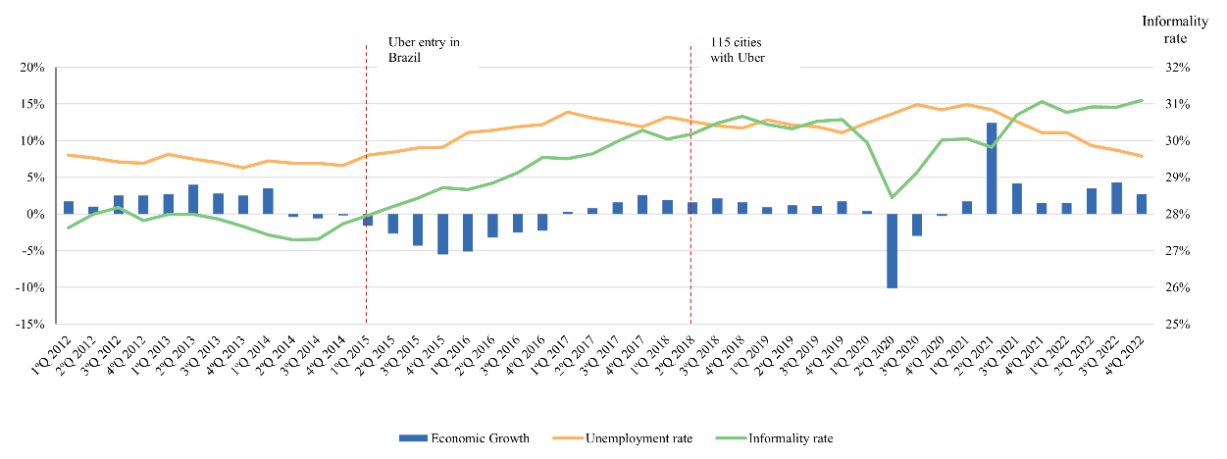
Source: Authors own elaboration with PNAD-C/IBGE data.

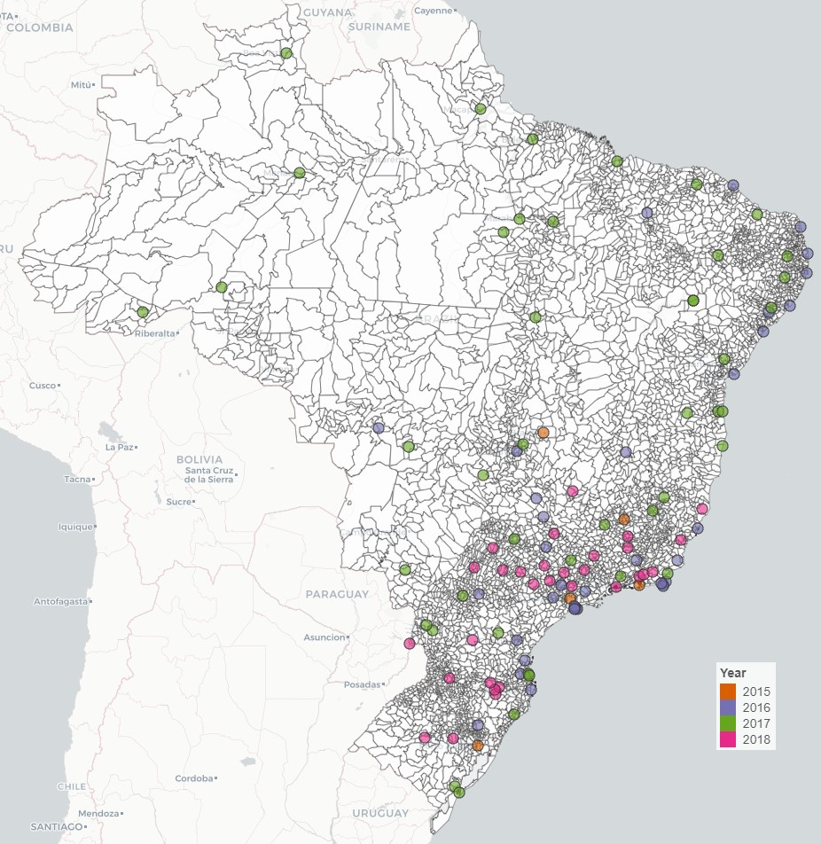
Figure S2 - Map of Brazilian cities with UberX (2015-2018) and chart with 99 Taxi entry
Source: Authors own elaboration with data manually colected.

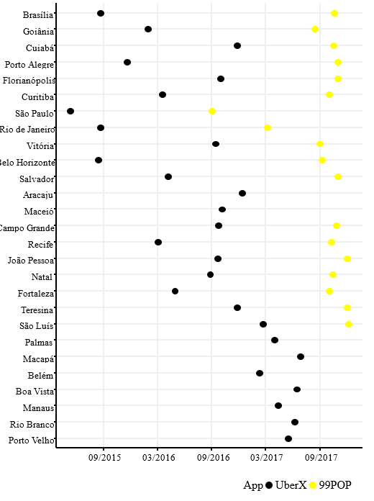
Figure S3 – Entry of the 99POP service into Brazilian capitals

Source: Authors own elaboration with data manually colected.

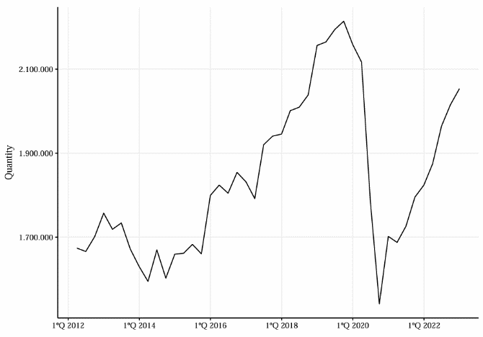
Figure S4 - Employed population in the transport sector
Source: Authors own elaboration with data from PNAD-C/IBGE.
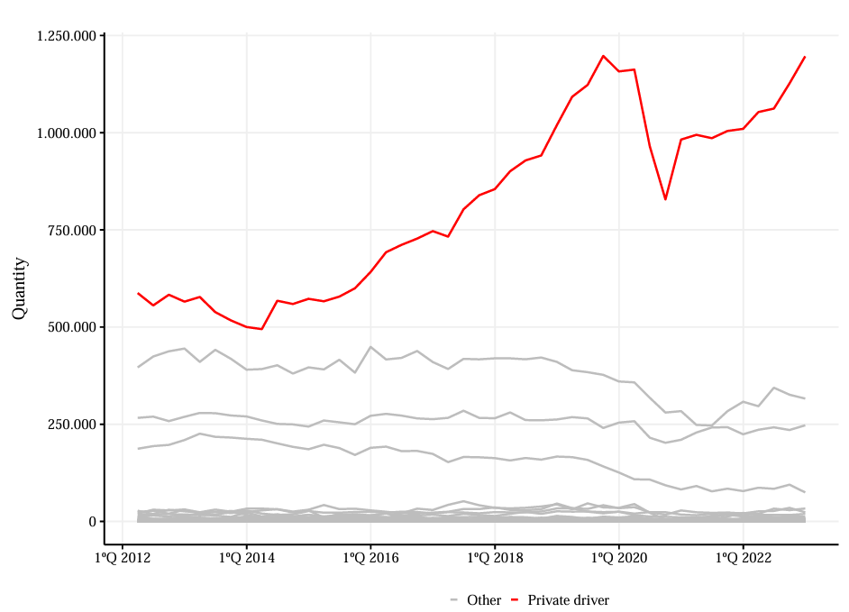
Figure S5 - Employed population in the transport sector disaggregated by occupation
Source: Authors own elaboration with data from PNAD-C/IBGE.
Source: Authors own elaboration with data from PNAD-C/IBGE.

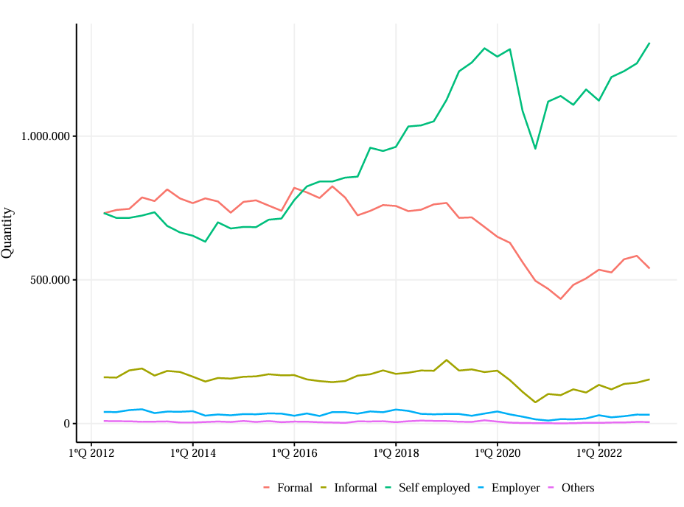
Figure S6 - Transport sector by occupational status
Source: Authors own elaboration with data from PNAD-C/IBGE.

Figure S7 – Average income of the transport sector by occupational status

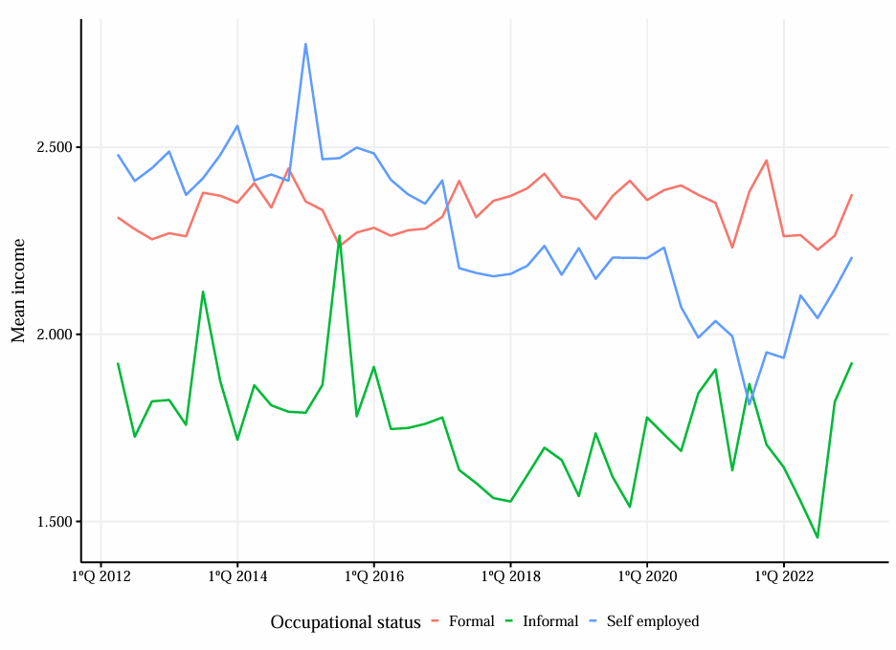
Source: Authors own elaboration with data from PNAD-C/IBGE.

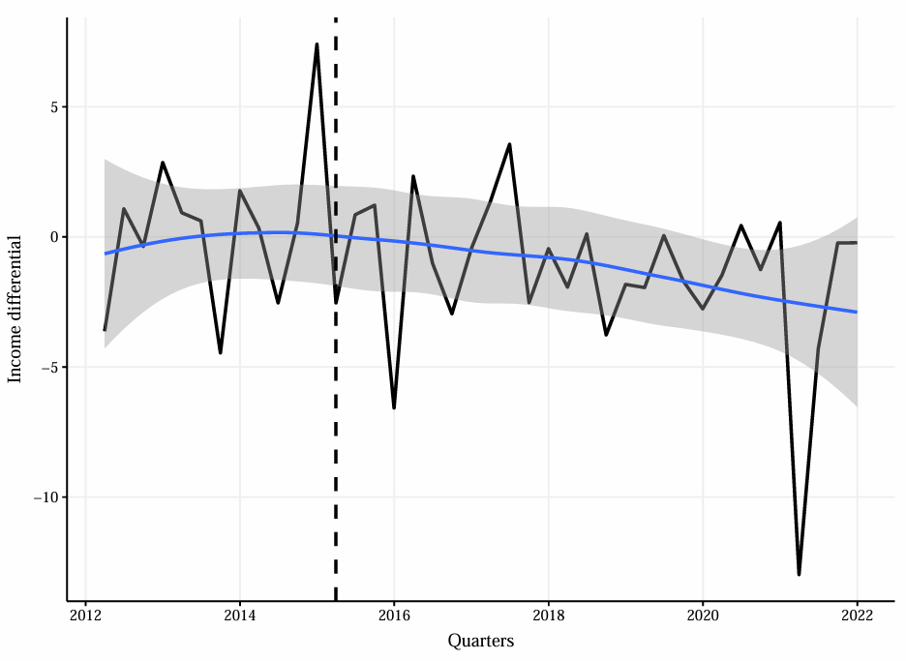
Figure S8 - Income differential when individual is self-employed driver on the fifth visit
Source: Authors own elaboration with data from PNAD-C/IBGE.

Figure S9 - Average effect of apps’ entry on the unemployment rate (27 capitals)
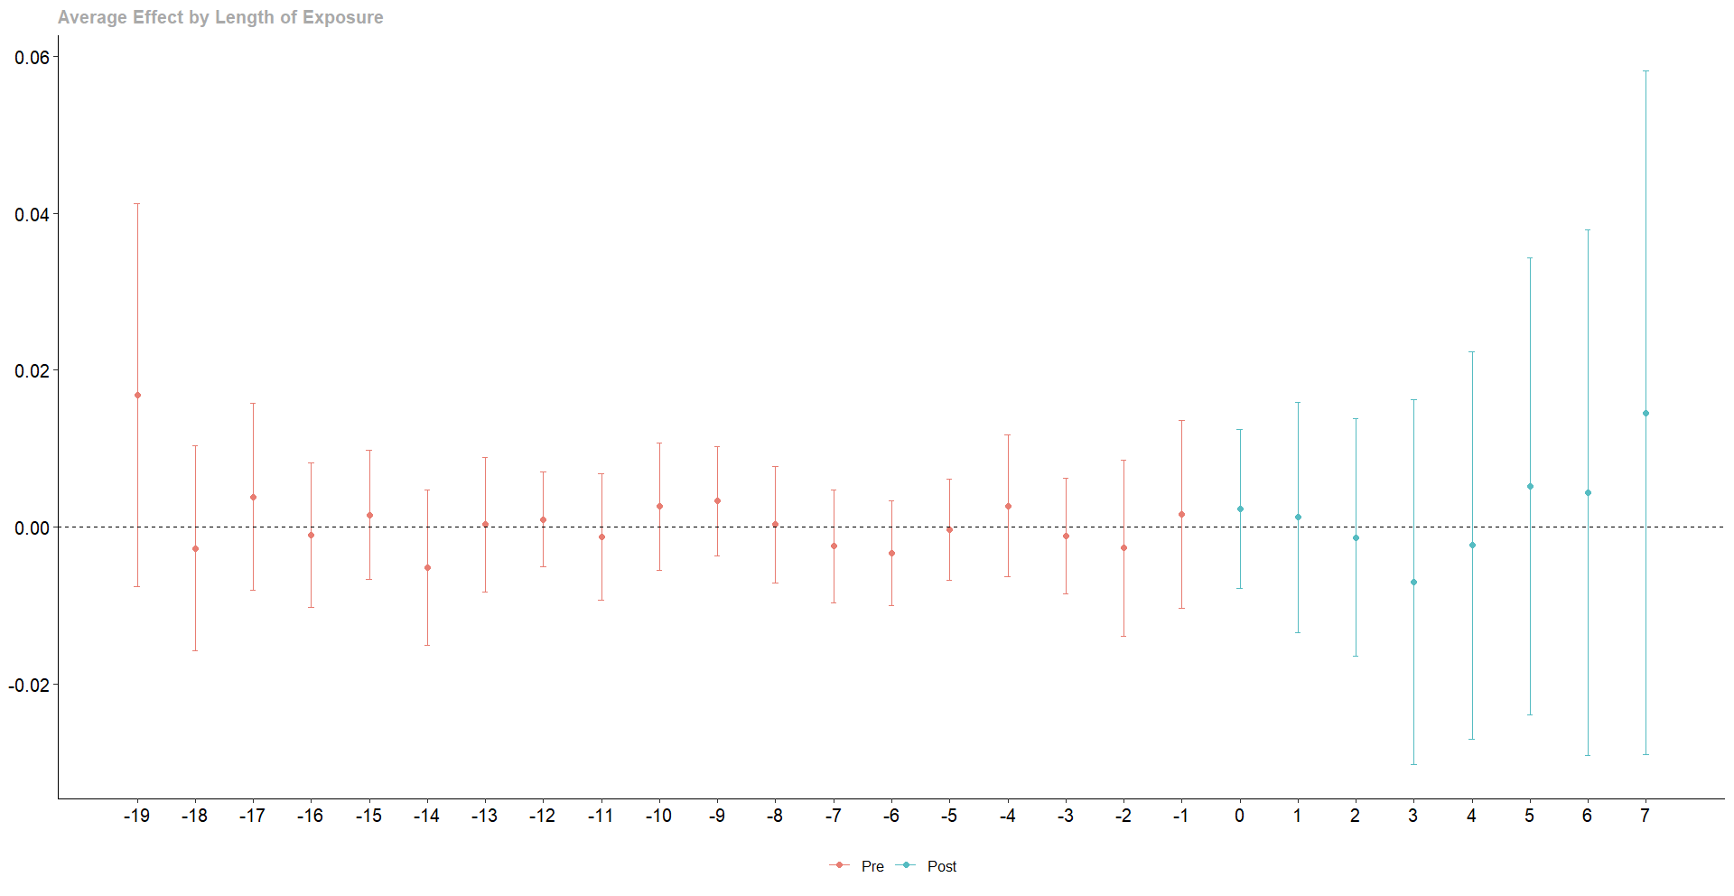
Source: Authors own elaboration with data from PNAD-C/IBGE.

Figure S10 - Average effect of ride-sharing apps’ entry on worked hours (self-employed driver)
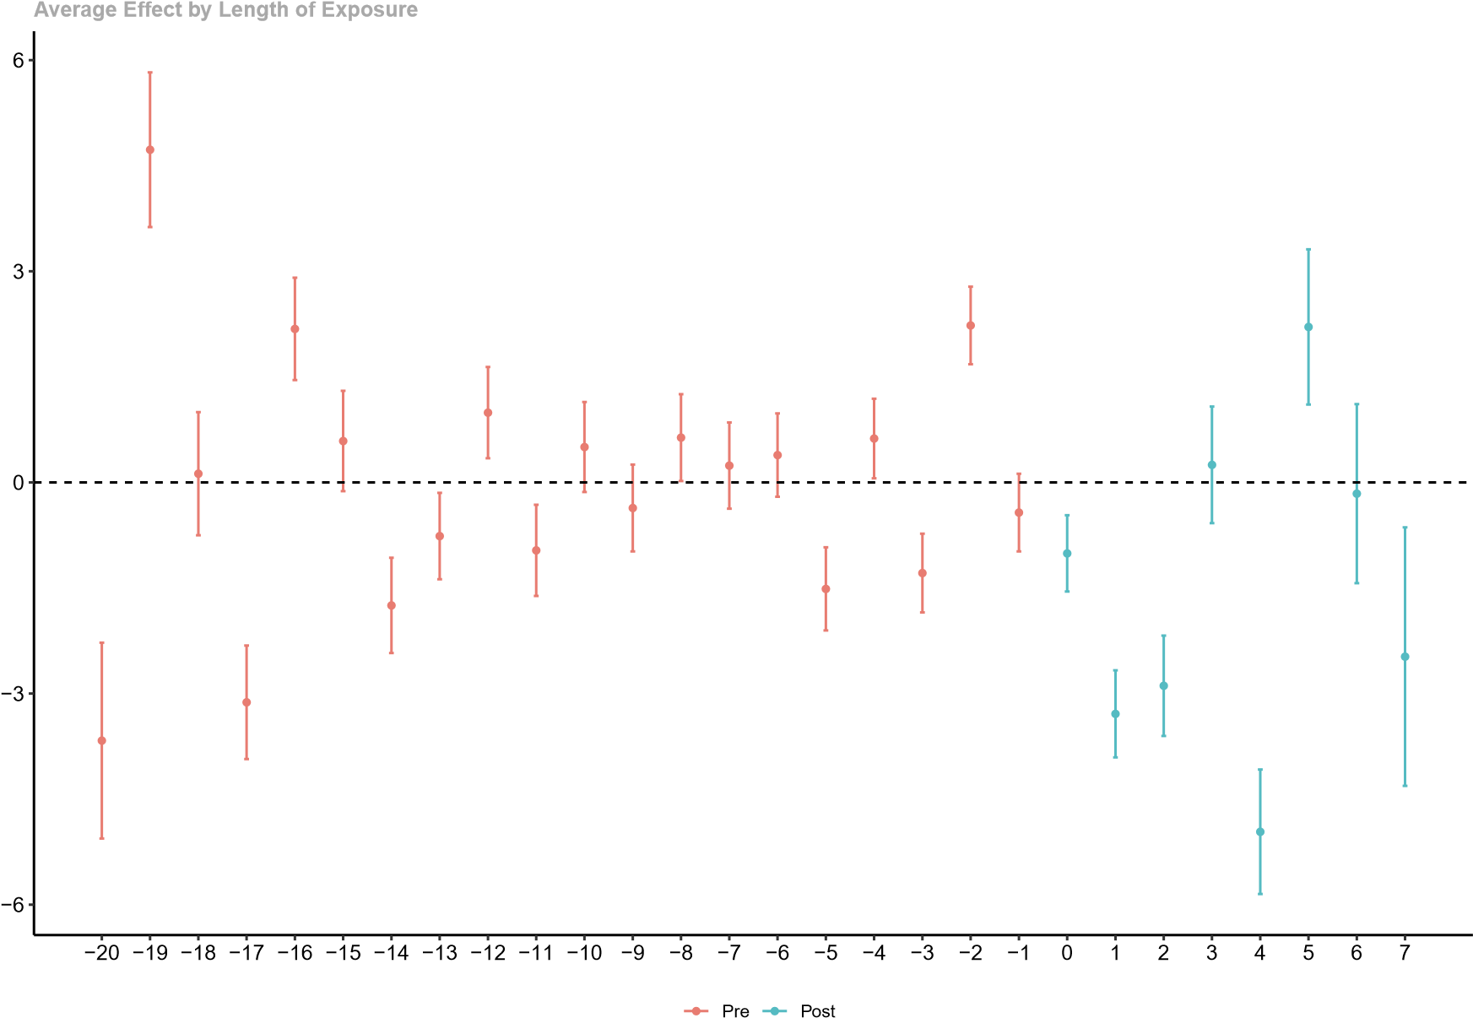
Source: Authors own elaboration with data from PNAD-C/IBGE.

Figure S11 - Average effect of ride-sharing apps’ entry on worked hours by group (SE driver)
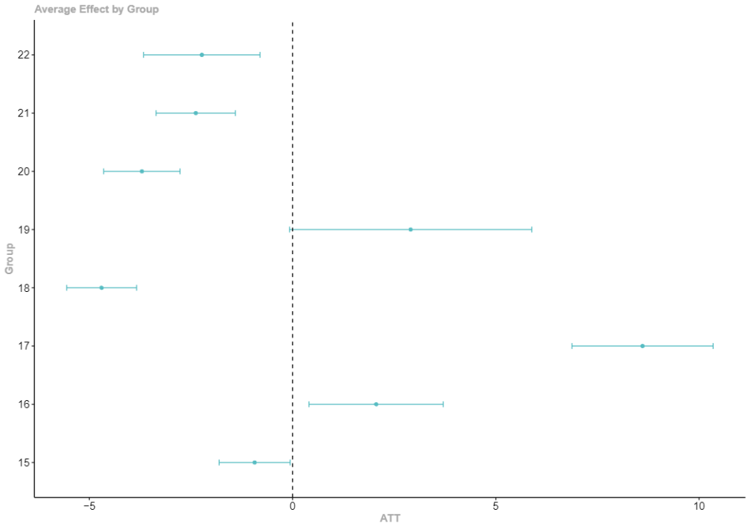
Source: Authors own elaboration with data from PNAD-C/IBGE.

Figure S12 - Average effect of ride-sharing apps’ entry on log income per hour (SE drivers)
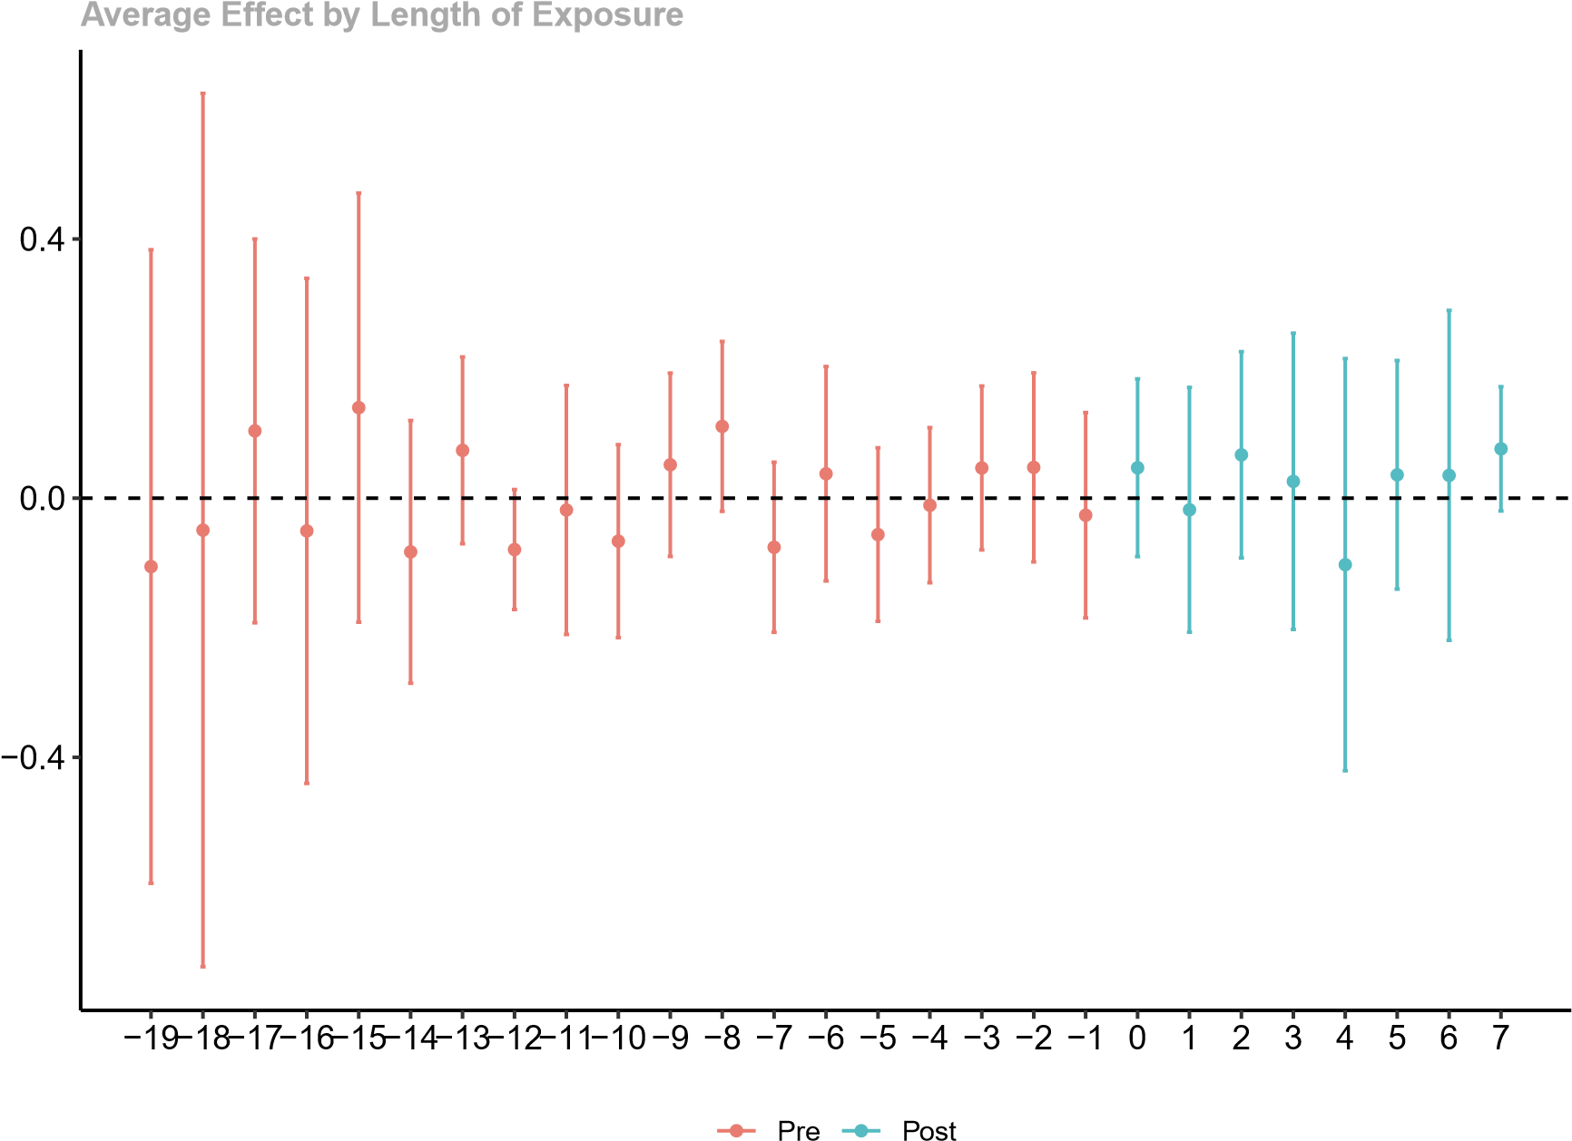
Source: Authors own elaboration with data from PNAD-C/IBGE.

