Supplementary Materials

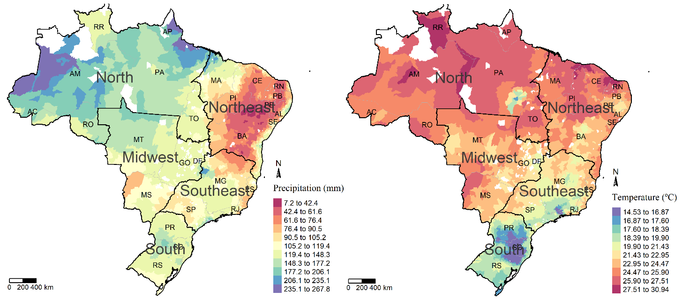
Figure A1: Historical Precipitation and Temperature Data (1971-2005) (mm) (ºC)
Source: Prepared by the authors based on Matsuura and Willmott (2012)

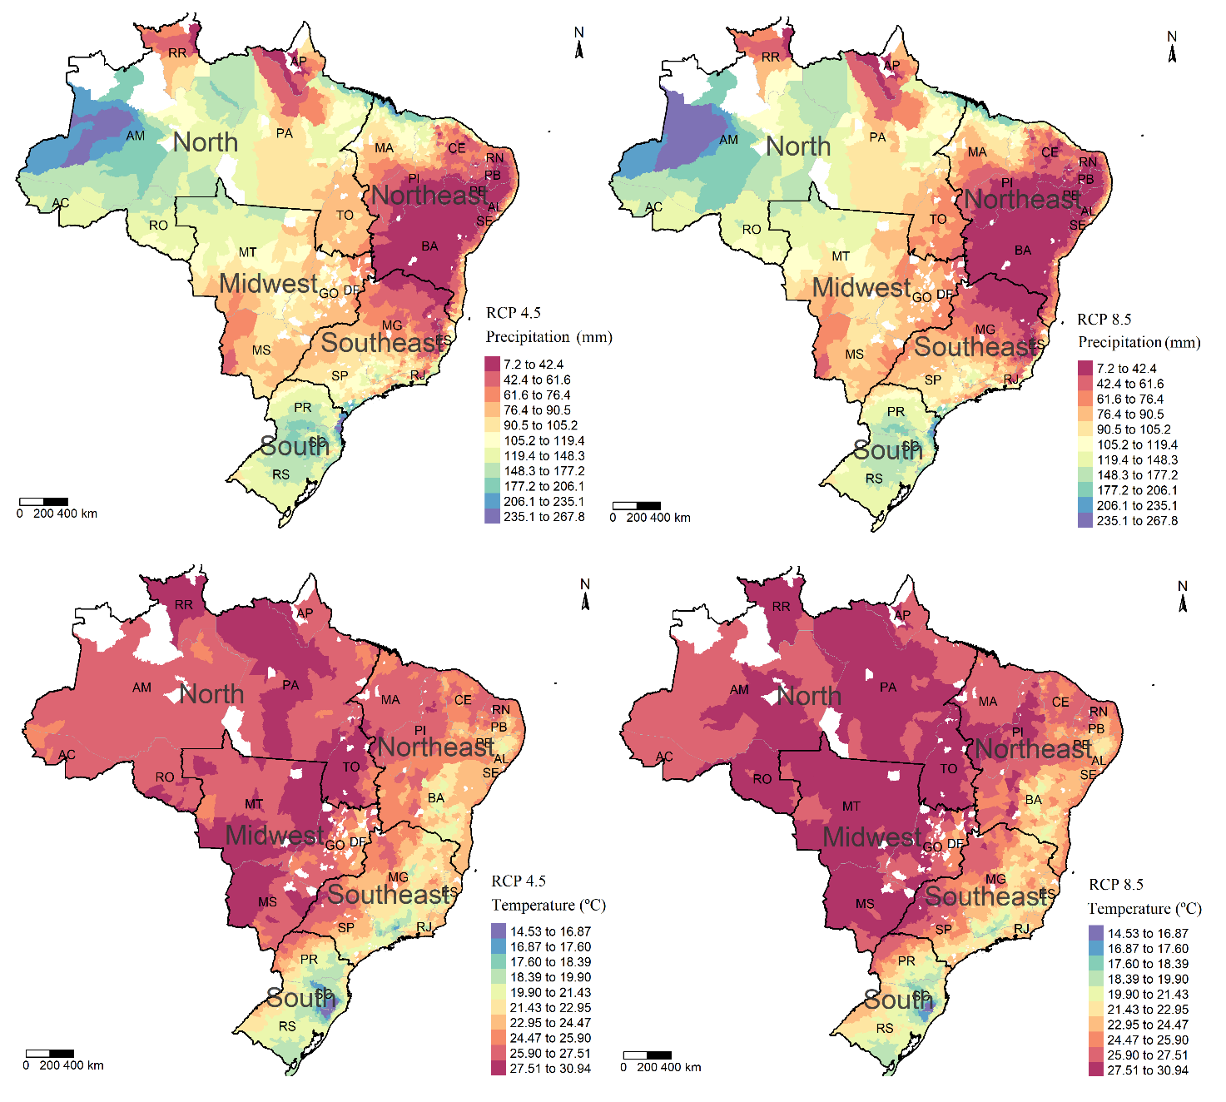
Figure A2: Precipitation and Average Temperature Projected by RCP 4.5 and RCP 8.5 Scenarios (mm) (ºC)
Source: Prepared by the authors based on Chou et al. (2014)

Table A1 – Baseline Model Estimation
Control Variables | Dependent Variable: log (Total Agricultural Productivity)
Control Variables | .25 (bottom quartile) | .50 (median) | .75 (top quartile)
Temperature Spring | 0.182 | -0.158 | -0.632*
Temperature Spring | (0.194) | (0.255) | (0.371)
Temperature Summer | -1.599*** | -1.453*** | -1.225**
Temperature Summer | (0.233) | (0.371) | (0.507)
Temperature Autumn | 1.211*** | 0.815*** | 0.672**
Temperature Autumn | (0.144) | (0.191) | (0.266)
Temperature Winter | -0.623*** | -0.211 | -0.0127
Temperature Winter | (0.103) | (0.148) | (0.212)
Temp. Spring^2 | -0.0106*** | -0.0032 | 0.0061
Temp. Spring^2 | (0.004) | (0.005) | (0.007)
Summer Season^2 | 0.0361*** | 0.0337*** | 0.0304***
Summer Season^2 | (0.004) | (0.007) | (0.010)
Autumn Season^2 | -0.0261*** | -0.0174*** | -0.0127**
Autumn Season^2 | (0.003) | (0.004) | (0.006)
Winter Temp^2 | 0.0163*** | 0.0067** | 0.0008
Winter Temp^2 | (0.002) | (0.003) | (0.004)
Spring Precipitation | 0.0124*** | 0.0126*** | 0.0105***
Spring Precipitation | (0.000) | (0.000) | (0.001)
Precipitation Summer | 0.0043*** | 0.0053*** | 0.0069***
Precipitation Summer | (0.000) | (0.000841) | (0.001)
Autumn Precipitation | -0.0072*** | -0.0106*** | -0.0131***
Autumn Precipitation | (0.000) | (0.001) | (0.001)
Winter Precipitation | 0.0072*** | 0.0141*** | 0.0183***
Winter Precipitation | (0.001) | (0.001) | (0.001)
Prec. Spring^2 | -0.0000*** | -0.0000*** | -0.0000***
Prec. Spring^2 | (0.000) | (0.000) | (0.000)
Prec. Summer^2 | -0.0000*** | -0.0000*** | -0.0000***
Prec. Summer^2 | (0.000) | (0.000) | (0.000)
Prec. Autumn^2 | 0.0000*** | 0.0000*** | 0.0000***
Prec. Autumn^2 | (0.000) | (0.000) | (0.000)
Prec. Winter^2 | -0.0000*** | -0.0000*** | -0.0000***
Prec. Winter^2 | (0.000) | (0.000) | (0.000)
Altitude | -0.0003*** | -0.0004*** | -0.0002***
Altitude | (0.000) | (0.000) | (0.000)
Latitude | 0.0059 | 0.0122** | 0.0184**
Latitude | (0.006) | (0.005) | (0.007)
Longitude | -0.0104*** | -0.0133*** | -0.0202***
Longitude | (0.003) | (0.002) | (0.003)
Capital | 0.0536*** | 0.0140 | 0.0054
Capital | (0.008) | (0.008) | (0.010)
Labor | 0.165*** | 0.197*** | 0.179***
Labor | (0.015) | (0.015) | (0.019)
Improvements | 0.0000*** | 0.0000*** | 0.0000**
Improvements | (0.000) | (0.000) | (0.000)
Irrigation | 0.0000*** | 0.0000*** | 0.0000
Irrigation | (0.000) | (0.000) | (0.000)
pH soil correction | 0.583*** | 0.803*** | 0.837***
pH soil correction | (0.064) | (0.074) | (0.090)
Soil Type | -0.0190*** | -0.0154*** | -0.00571*
Soil Type | (0.002) | (0.002) | (0.003)
Constant | 17.65*** | 19.78*** | 21.51***
Constant | (1.346) | (2.024) | (2.725)
Pseudo R-Square | 0.4241 | 0.3334 | 0.2844
Source: Prepared by the authors based on the results of the econometric model. Note: Robust standard error to heteroscedasticity in parentheses. p-value <0.01, ** p-value <0.05, * p-value <0.1.

Results by aggregate regions
This section presents the projections of climate change impacts on family farming land productivity at the regional level and for Brazil as a whole. Similar to the projections for federal units, the results for macro-regions and Brazil are based on productivity averages weighted by the production areas of each municipality. Thus, the aggregated results are not a simple average of the federal unit results, but rather an aggregation of municipal-level outcomes within each region, ensuring that larger production areas have a greater influence on the overall productivity impact.
Table A2 - Projected impacts of climate change on land productivity per hectare (cumulative variation, 2021-2050)
Productivity Quantile | Region | RCP 4.5 |  |  |  | RCP 8.5
Productivity Quantile | Region | Average change | Standard deviation | Confidence Interval (95%) |  | Average change | Standard deviation | Confidence Interval (95%)
0.25 | North | -37.4% | 0.37 | -41.2% | -33.5% | -46.6% | 0.36 | -50.4% | -42.9%
0.25 | Northeast | -19.3% | 0.29 | -20.8% | -17.9% | -19.6% | 0.43 | -21.9% | -17.4%
0.25 | Southeast | -32.3% | 0.19 | -33.3% | -31.3% | -43.6% | 0.16 | -44.5% | -42.8%
0.25 | South | 6.3% | 0.26 | 4.7% | 7.8% | 13.8% | 0.36 | 11.7% | 16.0%
0.25 | Midwest | -8.1% | 0.23 | -10.4% | -5.8% | -16.9% | 0.26 | -19.4% | -14.3%
0.25 | Brazil | -9.4% | 0.31 | -10.3% | -8.5% | -8.8% | 0.42 | -10.0% | -7.6%
0.50 | North | -30.4% | 0.43 | -34.9% | -25.9% | -35.6% | 0.44 | -40.2% | -31.0%
0.50 | Northeast | -21.6% | 0.25 | -22.9% | -20.4% | -24.1% | 0.33 | -25.8% | -22.4%
0.50 | Southeast | -17.0% | 0.33 | -18.7% | -15.2% | -27.1% | 0.31 | -28.8% | -25.5%
0.50 | South | 4.6% | 0.41 | 2.2% | 7.0% | 20.5% | 0.53 | 17.4% | 23.6%
0.50 | Midwest | 23.6% | 0.38 | 19.9% | 27.3% | 23.6% | 0.48 | 18.8% | 28.3%
0.50 | Brazil | -5.6% | 0.39 | -6.7% | -4.5% | -0.5% | 0.51 | -1.9% | 1.0%
0.75 | North | -29.2% | 0.45 | -33.9% | -24.4% | -26.0% | 0.52 | -31.4% | -20.5%
0.75 | Northeast | -23.6% | 0.22 | -24.8% | -22.5% | -22.5% | 0.33 | -24.1% | -20.8%
0.75 | Southeast | -6.4% | 0.48 | -9.0% | -3.9% | -5.8% | 0.58 | -8.9% | -2.7%
0.75 | South | 10.8% | 0.69 | 6.8% | 14.9% | 43.7% | 1.03 | 37.6% | 49.7%
0.75 | Midwest | 57.8% | 0.75 | 50.4% | 65.2% | 86.8% | 1.10 | 75.9% | 97.7%
0.75 | Brazil | 1.1% | 0.61 | -0.6% | 2.9% | 19.5% | 0.90 | 16.9% | 22.1%
Source: Prepared by the authors
The projected results for the lower productivity quantile (0.25) indicate that climate change would negatively impact the North, Northeast, Southeast, and Midwest regions. The North and Southeast regions are expected to experience the most severe impacts, with average productivity reductions of 37% and 32% under the RCP 4.5 scenario. Only the South region is projected to benefit from increased productivity. Under the RCP 8.5 scenario, the magnitude of the impacts would be amplified, albeit with variations across regions. The aggregated results for Brazil suggest an average productivity reduction of 9.4% under the RCP 4.5 scenario and 8.5% under the RCP 8.5 scenario.
For the median productivity quantile (0.50), compared to the lower quantile (0.25), the results indicate continued negative impacts in the North, Northeast, and Southeast regions, as well as positive impacts in the South. The Midwest region transitions to productivity gains of approximately 23% under both scenarios. Although the North and Southeast continue to experience negative impacts, these effects are less severe. Conversely, the negative impacts intensify in the Northeast, with productivity reductions of 21.6% under the RCP 4.5 scenario and 24% under the RCP 8.5 scenario. For Brazil as a whole, the median productivity quantile projects an average decline of 5.6% under the RCP 4.5 scenario and 0.5% under the RCP 8.5 scenario.
When comparing the results for the median productivity quantile (0.50), which represents the median productivity of family farmers, with the findings of Assunção and Chein (2016), who analyzed aggregated agricultural production using a different methodology, the direction and magnitude of effects appear similar for the North, Northeast, and Southeast regions. Assunção and Chein (2016) estimate productivity reductions of 35% in the North, 27% in the Northeast, and 16.8% in the Southeast, as well as declines of 28% in the Midwest and 4% in the South. These effects correspond to an 18% reduction in national production by 2050.
For the upper productivity quantile (0.75), projections indicate negative impacts on aggregate productivity in the North, Northeast, and Southeast regions, while positive impacts are observed in the South and Midwest regions. Under the RCP 8.5 scenario, the direction of impacts remains consistent; however, the magnitude of negative effects diminishes, while positive effects on productivity intensify. The Midwest region stands out, with projected cumulative productivity increases of 57% by 2050 under the RCP 4.5 scenario and 86% under the RCP 8.5 scenario. At the national level, aggregated average productivity is projected to increase by 1% under the RCP 4.5 scenario and 19% under the RCP 8.5 scenario, primarily driven by productivity gains in the South and Midwest regions.

Table A3 – Steps on the Baseline Model Estimation
Control Variables | Dependent Variable: log (Total Agricultural Land Productivity)
Control Variables | 0.25 Quantile |  |  | 0.50 Quantile |  |  | 0.75 Quantile
Control Variables | Step (1) | Step (2) | Step (3) | Step (1) | Step (2) | Step (3) | Step (1) | Step (2) | Step (3)
Temperature Spring | -0.0540 | 0.0419 | 0.182 | -0.972*** | -0.812*** | -0.158 | -0.876*** | -1.099*** | -0.632*
Temperature Spring | (0.231) | (0.227) | (0.194) | (0.239) | (0.260) | (0.255) | (0.273) | (0.251) | (0.371)
Temperature Summer | -1.458*** | -1.725*** | -1.599*** | -0.919*** | -1.169*** | -1.453*** | -1.600*** | -1.424*** | -1.225**
Temperature Summer | (0.331) | (0.321) | (0.233) | (0.321) | (0.382) | (0.371) | (0.407) | (0.370) | (0.507)
Temperature Autumn | 1.543*** | 1.453*** | 1.211*** | 1.136*** | 1.061*** | 0.815*** | 1.039*** | 0.926*** | 0.672**
Temperature Autumn | (0.174) | (0.172) | (0.144) | (0.175) | (0.196) | (0.191) | (0.215) | (0.203) | (0.266)
Temperature Winter | -0.733*** | -0.620*** | -0.623*** | -0.173 | -0.117 | -0.211 | 0.00344 | 0.153 | -0.0127
Temperature Winter | (0.132) | (0.130) | (0.103) | (0.142) | (0.154) | (0.148) | (0.165) | (0.148) | (0.212)
Temp. Spring^2 | -0.00688 | -0.00742 | -0.0106*** | 0.0123** | 0.00963* | -0.00323 | 0.00932* | 0.0133*** | 0.00611
Temp. Spring^2 | (0.00481) | (0.00461) | (0.00400) | (0.00485) | (0.00523) | (0.00519) | (0.00557) | (0.00513) | (0.00764)
Summer Season^2 | 0.0351*** | 0.0380*** | 0.0361*** | 0.0240*** | 0.0282*** | 0.0337*** | 0.0389*** | 0.0362*** | 0.0304***
Summer Season^2 | (0.00683) | (0.00658) | (0.00485) | (0.00652) | (0.00772) | (0.00753) | (0.00835) | (0.00759) | (0.0104)
Autumn Season^2 | -0.0345*** | -0.0312*** | -0.0261*** | -0.0232*** | -0.0219*** | -0.0174*** | -0.0217*** | -0.0196*** | -0.0127**
Autumn Season^2 | (0.00403) | (0.00408) | (0.00356) | (0.00398) | (0.00450) | (0.00434) | (0.00497) | (0.00484) | (0.00631)
Winter Temp^2 | 0.0196*** | 0.0163*** | 0.0163*** | 0.00534* | 0.00427 | 0.00676** | 0.00218 | -0.00141 | 0.000859
Winter Temp^2 | (0.00299) | (0.00298) | (0.00251) | (0.00309) | (0.00342) | (0.00323) | (0.00368) | (0.00344) | (0.00492)
Spring Precipitation | 0.0140*** | 0.0127*** | 0.0124*** | 0.0143*** | 0.0139*** | 0.0126*** | 0.0110*** | 0.0109*** | 0.0105***
Spring Precipitation | (0.000819) | (0.000854) | (0.000840) | (0.000749) | (0.000891) | (0.000792) | (0.000936) | (0.000986) | (0.00114)
Precipitation Summer | 0.00711*** | 0.00633*** | 0.00437*** | 0.00888*** | 0.00863*** | 0.00538*** | 0.0103*** | 0.0102*** | 0.00695***
Precipitation Summer | (0.000828) | (0.000819) | (0.000996) | (0.000775) | (0.00107) | (0.000841) | (0.00108) | (0.00116) | (0.00114)
Autumn Precipitation | -0.00533*** | -0.00544*** | -0.00724*** | -0.00885*** | -0.00944*** | -0.0106*** | -0.0112*** | -0.0115*** | -0.0131***
Autumn Precipitation | (0.00102) | (0.000986) | (0.000966) | (0.000946) | (0.00106) | (0.00106) | (0.00116) | (0.00116) | (0.00122)
Winter Precipitation | 0.0125*** | 0.0124*** | 0.00725*** | 0.0198*** | 0.0198*** | 0.0141*** | 0.0240*** | 0.0228*** | 0.0183***
Winter Precipitation | (0.00138) | (0.00141) | (0.00137) | (0.00129) | (0.00154) | (0.00151) | (0.00146) | (0.00156) | (0.00168)
Prec. Spring^2 | -0.0000384*** | -0.0000340*** | -0.0000331*** | -0.0000412*** | -0.0000396*** | -0.0000360*** | -0.0000335*** | -0.0000344*** | -0.0000315***
Prec. Spring^2 | (0.00000267) | (0.00000263) | (0.00000263) | (0.00000247) | (0.00000270) | (0.00000197) | (0.00000297) | (0.00000316) | (0.00000377)
Prec. Summer^2 | -0.0000143*** | -0.0000134*** | -0.00000854*** | -0.0000180*** | -0.0000180*** | -0.00000972*** | -0.0000202*** | -0.0000202*** | -0.0000128***
Prec. Summer^2 | (0.00000177) | (0.00000171) | (0.00000240) | (0.00000177) | (0.00000252) | (0.00000186) | (0.00000245) | (0.00000271) | (0.00000236)
Prec. Autumn^2 | 0.0000250*** | 0.0000264*** | 0.0000275*** | 0.0000308*** | 0.0000323*** | 0.0000303*** | 0.0000365*** | 0.0000363*** | 0.0000354***
Prec. Autumn^2 | (0.00000266) | (0.00000261) | (0.00000243) | (0.00000213) | (0.00000253) | (0.00000257) | (0.00000314) | (0.00000293) | (0.00000265)
Prec. Winter^2 | -0.0000493*** | -0.0000503*** | -0.0000270*** | -0.0000794*** | -0.0000795*** | -0.0000506*** | -0.000102*** | -0.0000981*** | -0.0000721***
Prec. Winter^2 | (0.00000527) | (0.00000543) | (0.00000533) | (0.00000469) | (0.00000588) | (0.00000563) | (0.00000556) | (0.00000599) | (0.00000546)
Geographical Characteristics | No | Yes | Yes | No | Yes | Yes | No | Yes | Yes
Primary Factors and other control variables | No | No | Yes | No | No | Yes | No | No | Yes
Observations | 4993 | 4993 | 4693 | 4993 | 4993 | 4693 | 4993 | 4993 | 4693
Pseudo R-Square | 0.4112 | 0.4140 | 0.4241 | 0.3138 | 0.3150 | 0.3334 | 0.2621 | 0.2638 | 0.2844
Source: Prepared by the authors based on the results of the econometric model. Note: Robust standard error to heteroscedasticity in parentheses. *** p-value <0.01, ** p-value <0.05, * p-value <0.1.

Table A4 - Data statistics by quantile
 | Quantile | Land Productivity | Capital | Labor | Infrastructure | Irrigation | Soil Type | Soil pH correction | Spring Precipitation | Summer Precipitation | Autumn Precipitation | Winter Precipitation | Spring Temperature | Summer Temperature | Autumn Temperature | Winter Temperature
mean | 0.25 | 7.09 | -0.17 | -1.87 | 1011.75 | 133.31 | 6.96 | 0.05 | 72.47 | 143.07 | 91.31 | 33.75 | 25.55 | 25.35 | 23.82 | 23.47
min | 0.25 | 5.42 | -4.39 | -4.11 | 5.00 | 0.00 | 1.00 | 0.00 | 6.43 | 39.53 | 13.18 | 3.11 | 16.97 | 18.35 | 12.94 | 11.59
max | 0.25 | 7.79 | 4.53 | 0.38 | 16292.00 | 15660.00 | 15.00 | 0.81 | 298.26 | 373.42 | 334.68 | 200.98 | 29.78 | 29.37 | 28.43 | 28.60
sd | 0.25 | 0.50 | 1.72 | 0.78 | 1334.84 | 612.41 | 3.44 | 0.09 | 66.71 | 63.69 | 44.14 | 31.41 | 1.98 | 1.43 | 2.35 | 2.90
obs | 0.25 | 1174 | 1174 | 1174 | 1174 | 1174 | 1174 | 1174 | 1174 | 1174 | 1174 | 1174 | 1174 | 1174 | 1174 | 1174
mean | 0.50 | 8.20 | 2.15 | -2.10 | 797.87 | 213.40 | 5.77 | 0.20 | 150.83 | 177.28 | 102.38 | 72.24 | 22.74 | 23.64 | 20.02 | 19.31
min | 0.50 | 7.79 | -4.24 | -4.16 | 5.00 | 0.00 | 1.00 | 0.00 | 8.19 | 36.14 | 14.01 | 2.99 | 16.12 | 17.81 | 12.62 | 11.23
max | 0.50 | 8.64 | 5.93 | 1.10 | 17919.00 | 76963.00 | 15.00 | 0.83 | 378.43 | 532.92 | 373.19 | 214.45 | 29.33 | 28.82 | 27.97 | 28.61
sd | 0.50 | 0.23 | 1.86 | 0.71 | 1303.69 | 1789.67 | 3.16 | 0.15 | 53.81 | 60.68 | 58.24 | 49.54 | 2.54 | 1.79 | 3.57 | 4.01
obs | 0.50 | 2346 | 2346 | 2346 | 2346 | 2346 | 2346 | 2346 | 2346 | 2346 | 2346 | 2346 | 2346 | 2346 | 2346 | 2346
mean | 0.75 | 9.05 | 2.15 | -1.84 | 923.52 | 513.87 | 5.19 | 0.26 | 149.01 | 191.42 | 106.37 | 71.11 | 22.90 | 23.86 | 20.54 | 19.75
min | 0.75 | 8.64 | -5.51 | -4.62 | 1.00 | 0.00 | 1.00 | 0.00 | 7.52 | 29.00 | 14.71 | 2.97 | 15.24 | 17.76 | 11.99 | 10.33
max | 0.75 | 10.76 | 5.40 | 4.08 | 26723.00 | 59029.00 | 15.00 | 0.89 | 275.20 | 439.01 | 466.22 | 221.34 | 29.00 | 28.91 | 27.93 | 28.49
sd | 0.75 | 0.33 | 2.01 | 0.79 | 1728.94 | 2352.67 | 3.21 | 0.19 | 48.49 | 68.04 | 72.45 | 41.64 | 2.74 | 1.89 | 3.51 | 4.07
obs | 0.75 | 1173 | 1173 | 1173 | 1173 | 1173 | 1173 | 1173 | 1173 | 1173 | 1173 | 1173 | 1173 | 1173 | 1173 | 1173

