Supplementary Material - Experimental
Instructions
General Instructions

Part 1

Welcome
Thanks for participating. Let me remind you that this experiment has two sessions. Today’s session of this experiment should be complete within an hour. You signed up to a second session which will take place here in one week’s time. I will say more about it at the end of today’s session.

Important Note
Please do not communicate in any way with other participants during this experiment. Please remember to switch off your mobile. Also, please do not write on these instructions. If you have a question or problem at any point in today’s session, please raise your hand and I will come to you.

The Experiment
This is a study of individual decision-making. Although there are many people participating in today’s session of this experiment, your earnings will not depend on what others do. The money you receive for participating will depend partly on choices you make yourself and partly on chance.
In this experiment, you will be asked to complete risk tasks and multiplechoice tasks. We will give you instructions for the risk tasks now. Please, take a few minutes to read them through with me.
Risk Tasks

Part 2

Instructions
You will be required to complete several risk tasks. In each risk task you will face a set of choice problems, in which you have to choose between option A, which involves receiving a sure amount of money, or option B, which involves receiving an amount of money where the amount is determined by chance.
Please click on the “Demonstration” button on your screen to see what each risk task will look like. Please follow my directions now. Do not click on anything until told to do so.

INTERACTIVE DEMONSTRATION
Figure 1: Screenshot of what a risk task looked like
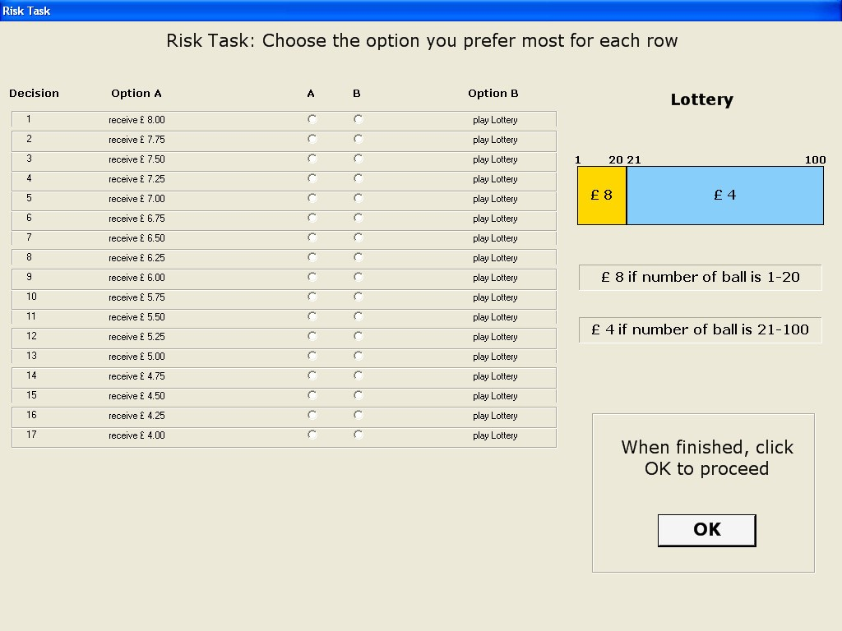
Parts in Italic below were not on subjects’ instructions; They were read out to them during on-screen demonstration
The table you see on the screen is an illustration of what each risk task
will look like.
Observe that this table presents a set of 21 choice problems, each posed in a given row; each row is a choice between Option A, a sure amount of money, and Option B, a lottery. You must make a choice between the options in every decision row. Observe that Option B, the lottery, is the same in each row, whereas option A varies, offering progressively smaller sums as you move down the table:
Let me explain now what a lottery is. As an example, look at two-colour bar on the right-side of your screen. This is a graphical representation of the lottery. The lottery has two possible prizes, in this example £7 and £2. We select the prize by drawing a numbered chip from a bag that contains 100 chips consecutively numbered from 1 to 100. £7 is paid if the chip drawn is numbered 1 to 35, whereas £2 is paid if the chip is numbered 36 to 100.
Let me explain now the following interactive feature.
Please click on the button corresponding to the Option A, offering £7.00 for sure, at the first decision row. This would mean that you prefer to receive £7.00 for sure to playing the lottery.
Now click on the the button corresponding to the Option A, offering £5.50 for sure, at the seventh decision row. This would mean that you prefer to receive £5.50 for sure to playing the lottery. Note that the computer automatically filled-in the buttons corresponding to the Option A up to £7.00. Why has it done so? When you chose option A at a certain row, the computer will then assume that you prefer option A whenever it is offering a sum larger than that at the row you clicked first. So, when you chose to receive £5.50 for sure to playing the lottery, the computer assumed that you also prefer £5.75, £6.00, and so on, up to £7.00, to playing the lottery.
Click now please on the the button corresponding to the Option B, at the bottom decision row of the table. This would mean that you prefer playing the lottery to receiving £2.00 for sure.
Now click on the the button corresponding to the Option B at the decision row 15th. This would mean that you prefer playing the lottery to receiving £3.50 for sure. Note that the computer automatically filled-in the buttons corresponding to the Option B down to £2.00. The logic here is similar to before. When you choose option B at a certain row, the computer will then assume that you prefer option B whenever the amount of money offered by Option A is smaller than that at the row where you selected option B. So, when you chose to play the lottery over receiving £3.50 for sure, the computer assumed that you also prefer to play the lottery to receiving £3.25, £3.00 for sure, and so on, down to £2.00.
Note that you must give a choice for every decision row of the table. As it stands, in our example, if you have exactly followed my instructions, a choice is still to be made at decision rows 8 to 14. The risk task is not complete until an option is chosen at every decision row. So, choose any option you like at decision row number 11. If you chose option A, the computer will fill-in the option A at all decision rows up, whereas if you chose option B, the computer will fill-in the option B at all decision rows down. Choose any option you like for the decision rows at which an option was not chosen yet. Doing so, you have completed a risk task. Before confirming your choices, you can, of course, change your mind and switch the option chosen at any row. The computer will adjust the choices accordingly.
It is important to observe that the computer fills in the button according to your choices. You can make any choices you like, subject to the constraint that you cannot switch between options A and B more than once in the same risk task.
Now, I will give you a few minutes to practice yourself. To do so, close the window by clicking on the “Finish Demonstration” button. Then, click on the “Practice” button again to see a new instance of this risk task. If you have a question, please raise your hand and I will come to you.
PRACTICE
Please, click on the ”Finish Demonstration” button now and turn to the instructions now please

How your earnings are determined
We will determine your earnings at the end of the experiment as follows. After you have finished all risk tasks in this experiment, the computer will then randomly pick one decision row on each risk task you performed. The following figure illustrates how the screen would look like at this point of the experiment if there had only been two risk tasks.
For each risk task you perform in this experiment, there will be a row like one of those on the figure above. Notice that there is a spin button for each task. You will be asked to hit all the spin buttons. As you do this, for a given task, the computer will randomly select one of the decision rows from that task. The computer will use a special randomization device that makes all decisions rows from the task equally likely to be chosen.
So, note that for every risk task you perform, one decision row will be selected; and all are equally likely.
Figure 2: Determining your earnings: selection of decision row per risk task
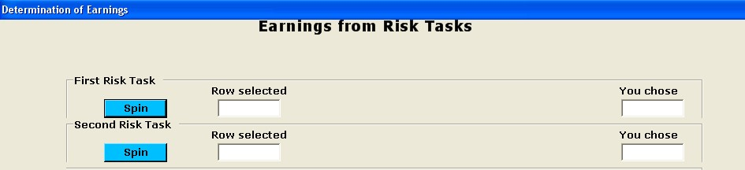
The set of selected decision rows will be displayed on the computer screen. The computer will then retrieve which option you chose at that row. We then select the option you chose from one of the selected rows. To do so, I will ask you to draw a ball from a bag, which contains balls individually numbered from 1 up to the number of risk tasks you performed. The number you draw will determine which risk task and its corresponding selected decision row will be used to determine your earnings. Once you select the ball, and so the risk task to be used for real, the computer screen will display the two options from the relevant row and the choice you made between them. If you chose Option A, you will receive the amount of money it specifies. If you chose Option B, you will play the lottery by drawing a chip form the bag and receive the prize accordingly.

Things to remember
(1) Though you make several decisions in this experiment, only one of them will be used to determine your earnings. (2) You will not know which decision will determine your earnings from the risk task until the end of the experiment. (3) Think carefully about your decisions in each risk task: every decision row of every risk task could turn out to be the choice that is for real for you.
Thanks for participating. Please, click on the “Start” button and enter the password I am going to tell you now.
Multiple-choice tasks

Part 3

Instructions
We now ask you to complete a test consisting of 12 questions. You will have 1 minute to work on each question of this test. There will be a countdown timer on the top right-side of the screen.
Answers to the questions in this test have no effect on your earnings from the experiment. Nevertheless, please think carefully about the questions and answer them as well as you can in the time available.
Important Note: If you finish before time is called please wait for instructions for the rest of the experiment. Please DO NOT do anything with your computer until you are specifically instructed to do so.
Please, click on the “Start” button and enter the password I am going to tell you now.
Money reward!

Part 4
Handed out to subjects in the non-zero increment treatment
only.

£7.00 is already guaranteed for you!
For completing the cognitive test, you will be given £7.00. This money will be paid in cash today at the end of this experiment.
Be assured that £7.00 is already guaranteed for you. You cannot lose this money or any part of it, provided you complete the experiment. This does not affect your earnings from the risk tasks. Therefore, £7.00 will be added to whatever you earn from the risk tasks.

Remaining part of the experiment
We are now going to give you instructions for the remaining part of this experiment.
More Risk Tasks

Part 5
[ → Non-zero increment treatment
( → Zero increment treatment

[(

Instructions
This is the last step of this experiment. Now, we ask you to complete some more risk tasks. They work just like the risk tasks you completed
before.
In each risk task you will face a set of choice problems, in which you have to choose between Option A, to receive an amount of money, and Option B, to play a lottery. All you need to do is to indicate the option you prefer most, option A or option B, for each decision problem.

On Your Earnings
After you complete these risk tasks, we will determine your earnings for all risk tasks you have performed and you will be paid at the end of this session. Therefore, the money you earn in the risk tasks) as well as the £7.00 reward for completing the cognitive test (will be paid to you directly in cash at the end of this session.
Please, click on the “Start” button and enter the password I am going to tell you now. ])

