SUPPLEMENTARY MATERIAL
Measures
Subjective Disadvantage Scale (used to measure subjective group status). Participants were introduced to the concepts of advantage and disadvantage with the following text: “In our society and in our workplaces, some groups are advantaged and hold more power, while others are disadvantaged and have less access to power. In general, the latter groups suffer from discrimination, exclusion, and less access to resources and opportunities. In this section, we would like to know whether you feel part of an advantaged or disadvantaged group in society and in your organization.” As shown in Table I, participants completed items assessing their perceived status both in society and in the workplace. These items were subsequently recoded and averaged to produce a single Subjective Disadvantage score. Our intent was to capture a general sense of perceived disadvantage, rather than a context-specific perception that might be too closely tied to DEI practices in the workplace.
Drawing from Tauber’s (2022) Intersectionality Scale, participants who scored 4 or higher on the disadvantaged items were then asked to identify the source(s) of their perceived disadvantage. They were prompted with: Based on your own perceptions and experiences, which attributes make you feel different from those who are advantaged at your workplace? (If you feel you do not differ in any way, please tick the last box).” Response options included: My race or ethnicity; My country of origin; My legal sex; My gender identity; My sexual orientation; My age (relative to my peers); My disability status; My social class; My religious affiliation (or lack thereof); None of these attributes make me feel different; and Other (open-ended response).
Table I. Subjective Disadvantage Subscale Items.
Subjective Disadvantage  (α = .88) | Items
In Society  (α = .83) | - In society, in general, I feel favored or advantaged.  - In society, in general, I feel disadvantaged or stigmatized.  - My life is negatively affected (by my group memberships).  - My life is positively affected (by my group memberships).
In the Workplace  (α = .81) | - In my workplace, I feel favored or advantaged.  - In my workplace, I feel disadvantaged or stigmatized.  - My career is negatively affected (by my group memberships).  - My career is positively affected (by my group memberships).

Perceived Total Number of DEI Practices.
Study 1. Participants were presented with a list of 11 DEI practices and asked to indicate which ones they believed were currently implemented in their organization. The full list included: (1) implicit bias training, (2) diversity and inclusion metrics tracking, (3) diversity recruiting initiatives, (4) employee resource groups (ERGs), (5) inclusive language guidelines, (6) mentorship and sponsorship programs, (7) communications about anti-harassment policies, (8) internal diversity statements across the organization, (9) external diversity statements communicated to the public, (10) workplace accommodations for disabilities, and (11) work-life benefits. The practices were intentionally framed in broad terms, without reference to specific target groups. This was done to maintain generalizability, as the groups prioritized by these practices may differ across organizations depending on their context, strategic priorities, or workforce composition. In Study 1, this measure reflected employees’ perceptions of which DEI practices were present in their workplace, which may not fully align with organizational reality. However, for our purposes, it was the perceived presence of these practices that mattered most, as employee perceptions are key drivers of psychological experiences and attitudes in the workplace.
Study 2. In Study 2, participants were randomly assigned to one of two experimental conditions that manipulated the number of DEI practices implemented by a fictitious company (“JTCompany”). The purpose was to assess how exposure to few versus many DEI practices affected participants’ projections of their work experiences. The manipulation was based on the same broad categories of commonly implemented practices used in Study 1, but applied in a controlled, hypothetical context. In the few DEI practices condition, participants read that JTCompany had adopted three core DEI initiatives: (1) diversity training (e.g., anti-discrimination, inclusion workshops), (2) employee resource groups (ERGs), and (3) mentorship and sponsorship programs. These were selected as widely recognized and commonly implemented practices across organizational settings. In the many DEI practices condition, participants read that JTCompany had implemented a comprehensive set of 13 DEI practices, which included the same three core practices plus ten additional initiatives: (4) diversity recruiting initiatives, (5) work-life benefits (e.g., flexible work or family services), (6) workplace accommodations for disabilities, (7) communications about anti-harassment policies, (8) formal grievance procedures for harassment and discrimination, (9) inclusive language guidelines, (10) internal diversity statements across the organization, (11) external diversity statements to the public, (12) dedicated diversity staff and resources, and (13) tracking of diversity and inclusion metrics (e.g., demographic reporting). Compared to Study 1, grievance procedures and dedicated diversity staff were added in Study 2 to create a more comprehensive list of the most common DEI practices and to reflect practices mentioned by participants in open-ended comments from Study 1.

Study 2: Additional Analyses
Exploratory Analyses Using Both Objective Status Operationalizations: Gender and Race.
Analysis Plan. We conducted two sets of moderated regression analyses using PROCESS (Model 3; Hayes, 2022) to examine the effect of the manipulated number of DEI Practices (-1 = Few DEI Practices, 1 = Many DEI Practices) on anticipated Sense of Inclusion and Job Satisfaction. In these models, we simultaneously included both operationalizations of objective status, namely Race and Gender, as moderators. Each model incorporated the main effects and all interaction terms among DEI Practices, Objective Status (Race), and Objective Status (Gender).
 | Inclusion 95% CI |  |  |  |  |  |  | Job Satisfaction |  |  |  | 95% CI
 |  | Estimate |  | SE | LL | UL | p |  | Estimate | SE |  | LL | UL | p
DEI Practices |  |  | .009 | .051 | -.092 | .109 | .867 |  | .011 | .042 |  | -.071 | .094 | .789
Gender |  |  | -.018 | .051 | -.118 | .083 | .728 |  | -.076 | .042 |  | -.159 | -.006 | .069
Race |  |  | -.440 | .051 | -.540 | -.339 | .000 |  | -.200 | .042 |  | -.283 | -.118 | .000
Gender*Race |  |  | -.155 | .051 | -.255 | -.055 | .003 |  | -.107 | .042 |  | -.190 | -.025 | .011
DEI Practices*Gender |  |  | .009 | .051 | -.092 | .109 | .866 |  | -.042 | .042 |  | -.124 | .041 | 322
DEI Practices*Race |  |  | -.117 | .051 | -.217 | -.016 | .023 |  | -.081 | .042 |  | -.163 | .002 | .056
DEI Practices*Gender*  Race |  |  | .135 | .051 | .035 | .235 | .009 |  | .061 | .042 |  | -.022 | .143 | .148
Table II. The effect of DEI Practices by Gender and Race on Inclusion and Job Satisfaction.
Note. CI = confidence interval; LL = lower limit; UL = upper limit. Table II displays all main and interaction effects from these exploratory analyses. In the following section, we focus on the highest-order significant interactions to illustrate the most complex patterns in the data.
A significant three-way interaction (DEI Practices × Gender × Race) was significant for anticipated Sense of Inclusion (B = 0.14, SE = 0.05, 95% CI [0.04, 0.24], t = 2.64, p = .009) but was not significant for anticipated Job Satisfaction (B = 0.06, SE = 0.04, 95% CI [-0.02, 0.14], t = 1.45, p = .148). We conducted simple slopes analyses to examine the effect of DEI Practices on anticipated Sense of Inclusion across Gender (coded -1 = Women, 1 = Men) and Race (-1 = Non-White, 1 = White) subgroups (see Figure 1).
- Non-White Women. Imagining many DEI Practices was associated with higher anticipations of Sense of Inclusion (B = 0.25, SE = 0.11, 95% CI [0.04, 0.47], t = 2.28, p = .023).
- White Women. In contrast, White women anticipated less Sense of Inclusion when imagining many DEI Practices (B = -0.25, SE = 0.09, 95% CI [-0.43, -0.07], t = -2.72, p = .007).
- Non-White Men. DEI Practices did not significantly influence their anticipations of Sense of Inclusion (B = -0.001, SE = 0.11, 95% CI [-0.21, 0.21], t = -0.01, p = .992).
- White Men. DEI Practices also did not significantly influence their anticipations of Sense of Inclusion (B = 0.04, SE = 0.10, 95% CI [-0.16, 0.23], t = 0.36, p = .716).
Figure 1. Simple slopes of DEI Practices × Gender × Race on Inclusion.
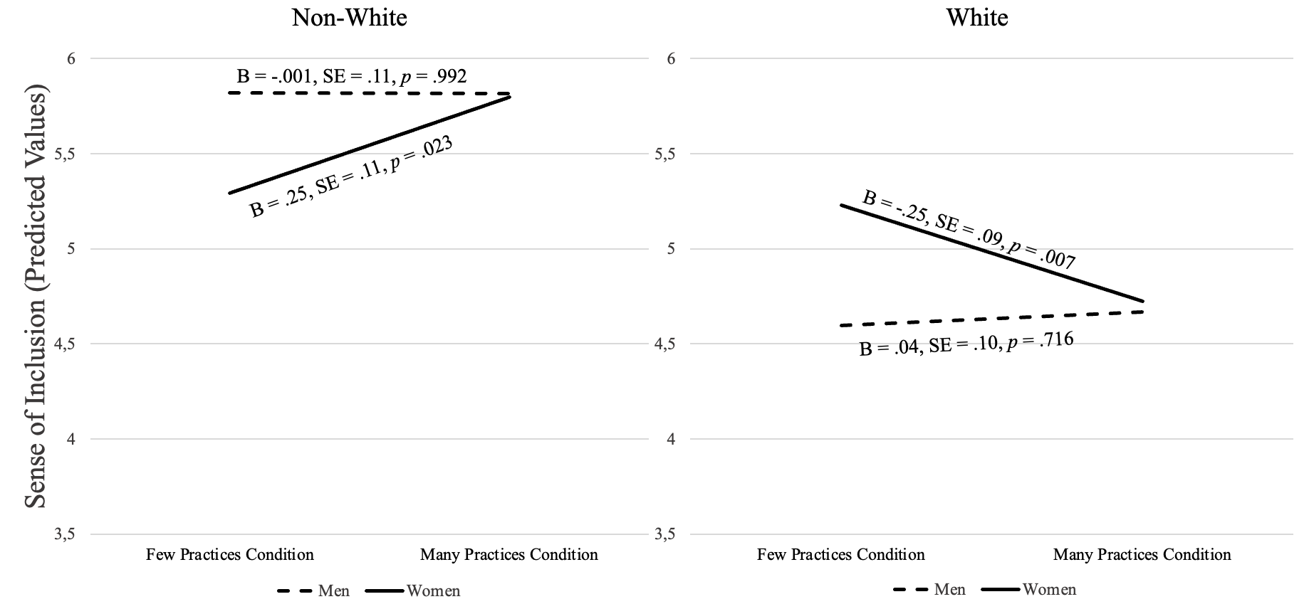
Taken together, for men, regardless of their race, the manipulated number of DEI practices did not meaningfully alter their anticipated sense of inclusion. This pattern indicates that men’s reactions appear less sensitive to how many DEI practices are present and instead may hinge more on the general presence or absence of DEI initiatives. Among women, however, a divergent pattern emerged: non-White women anticipated greater inclusion when imagining an organization with many DEI practices, whereas White women anticipated lower inclusion. Thus, when considering intersectional identities, increases in DEI practices were interpreted as inclusion-enhancing for non-White women but inclusion-reducing for White women.
Exploratory Analyses with Perceived Intergroup Threat.
Measure. Perceived Intergroup Threat was measured using Iyer’s (2022) framework. Iyer identifies three types of threats that advantaged groups may experience in response to DEI initiatives: resource threat, the fear of losing access to opportunities and power; symbolic threat, the perception that DEI challenges cultural norms like meritocracy that have historically benefited them; and in-group morality threat, the discomfort arising from being made aware of their group’s role in social inequalities. Based on this framework, we designed three subscales, each consisting of three items, to assess a) resource threats, b) symbolic threats, and c) in-group morality threats. Our intent was to capture general perceptions of threat, and we specifically chose not to reference any particular group or identity in the items. This allowed participants to respond based on whatever social group(s) came to mind as personally relevant, ensuring that the measure reflected their subjective interpretation of group membership. Example items (for all items, see Table III) include: “I am concerned that those DEI initiatives would limit the resources available to my group”, “I worry that those DEI practices would undermine the traditions of our organization”, and “I feel that those DEI initiatives would unfairly blame people like me for the existing bias and inequalities.” All items were rated using a 7-point Likert scale ranging from 1 (strongly disagree) to 7 (strongly agree). Since the subscales were strongly and positively correlated (r_{a,b}(739) = .77, p <.001; r_{a,c}(739) = .77, p <.001; r_{b,c}(739) = .75, p <.001), we created a composite of intergroup threat (α = .92), where higher scores indicated stronger perceptions of threat overall. Descriptive statistics indicated moderate average levels of perceived intergroup threat (M = 2.96, SD =
1.43), with similar means across the three subscales: resource threat (M = 3.01, SD = 1.52),
symbolic threat (M = 2.83, SD = 1.56), and in-group morality threat (M = 3.03, SD = 1.59).

Table III. Perceived Intergroup Threat Subscale Items.
Perceived Intergroup Threat | Items
Resource Threat  (α = .78) | - I feel that those DEI initiatives would increase the opportunities available to people like me in this organization. (R)  - I am concerned that those DEI initiatives would limit the resources available to my group.  - I worry that those DEI initiatives would divert resources away from my team or department.
Symbolic Threat  (α = .82) | - I am concerned that those DEI practices would change the fundamental values of my organization in a way I do not support.  - I feel that those DEI practices would strengthen the cultural norms that I value in our workplace. (R)  - I worry that those DEI practices would undermine the traditions of our organization.
Ingroup Morality Threat  (α = .81) | - I feel that those DEI initiatives would unfairly blame people like me for the existing bias and inequalities.  - I think that those DEI initiatives would help others to see my group positively. (R)  - I worry that those DEI initiatives would make my group look morally wrong.
Results.
Analysis Plan. To explore whether the manipulated number of DEI practices (-1 = Few DEI Practices, 1 = Many DEI Practices) influences Perceived Intergroup Threat, and whether this effect varied as a function of objective and subjective status, we investigated three sets of moderated regression models using PROCESS (Model 3; Hayes, 2022). In the first set, race (-1, 1) was used as the indicator of objective (dis)advantage; in the second, gender (-1, 1) served as the objective indicator. In both sets, Subjective Disadvantage (continuous scores) was entered as a moderator alongside Objective Status. The third set examined intersectional objective (dis)advantage by combining race and gender. All predictors involved were centered. Across all full models, we focused on the highest-order significant interactions to determine whether and how the effects of DEI practices on Perceived Intergroup Threat varied across objective and subjective status profiles.
DEI Practices × Race × Subjective Disadvantage on Perceived Intergroup Threat. When operationalizing Objective Status as Race (i.e., Non-White = objectively disadvantaged; White = objectively advantaged), none of the interactions involving DEI Practices reached significance (see Table IV). Race did not moderate the relationship between DEI Practices and Perceived Intergroup Threat (B = 0.06, SE = 0.05, 95% CI [-0.04, 0.16], t = 1.19, p = .236) and the three-way interaction including Subjective Disadvantage was not significant (B = 0.03, SE = 0.04, 95% CI [-0.06, 0.11], t = 0.65, p = .517). However, the two-way interaction between Race and Subjective Disadvantage was significant on Perceived Intergroup Threat (B = 0.14, SE = 0.04, 95% CI [0.06, 0.22], t = 3.27, p = .001).
Table IV. The effect of DEI Practices by Race and Subjective Disadvantage on Intergroup Threat.

 | Intergroup Threat 95% CI
 |  | Estimate |  | SE | LL | UL | p
DEI Practices |  |  | .038 | .050 | -.061 | .136 | .450
Race |  |  | .432 | .050 | .333 | .530 | .000
Subjective Disadvantage |  |  | .210 | .042 | .127 | .294 | .000
Race*Subjective Disadv. |  |  | .138 | .042 | .055 | .220 | .001
DEI Practices*Race |  |  | .060 | .050 | -.039 | .158 | .236
DEI Practices*Subjective Disadv. |  |  | .026 | .042 | -.056 | .109 | .533
DEI Practices*Race*  Subjective Disadv. |  |  | .027 | .042 | -.055 | .110 | .517

Note. CI = confidence interval; LL = lower limit; UL = upper limit.
To further probe this two-way interaction, we conducted simple slopes analyses to examine the effect of Race at low and high levels of Subjective Disadvantage (±1 SD) (see Figure 2). At low levels of Subjective Disadvantage, the effect of Race on Perceived Intergroup Threat was significant (B = 0.27, SE = 0.07, 95% CI [0.13, 0.40], p < .001), this effect was even stronger at high levels of Subjective Disadvantage (B = 0.60, SE = 0.07, 95% CI [0.46, 0.74], p < .001). When examining the reverse conditional effects, Subjective Disadvantage did not significantly predict perceived threat among non-White participants (B = 0.07, SE = 0.06, 95% CI [-0.04, 0.18], p = .185) but was significant among White participants (B = 0.35, SE = 0.06, 95% CI [0.23, 0.48], p < .001).
Figure 2. Simple slopes of Race × Subjective Disadvantage on Perceived Intergroup Threat.
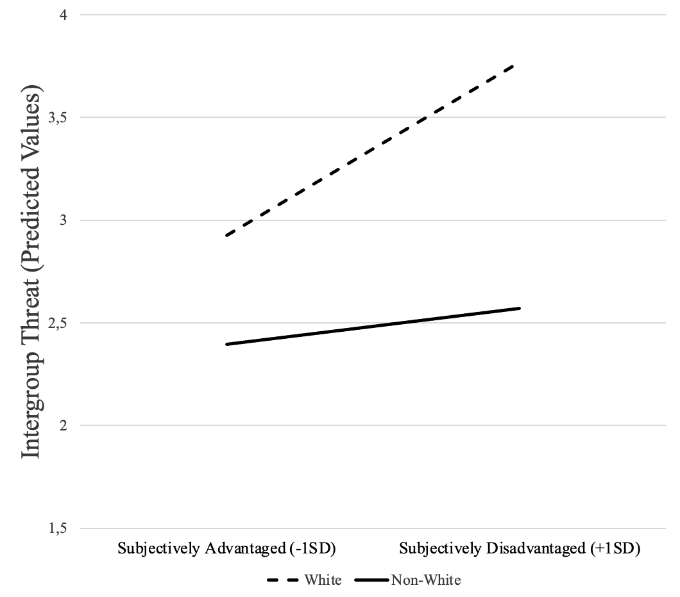
DEI Practices × Gender × Subjective Disadvantage on Perceived Intergroup Threat. A similar pattern emerged when operationalizing Objective Status as Gender (i.e., Women = objectively disadvantaged; Men = objectively advantaged) where no significant interactions involved DEI Practices (see Table V). Gender did not moderate the relationship between DEI Practices and Perceived Intergroup Threat (B = 0.02, SE = 0.05, 95% CI [-0.08, 0.12], t = 0.44, p = .661) and the three-way interaction including Subjective Disadvantage was not significant either (B = 0.04, SE = 0.04, 95% CI [-0.05, 0.13], t = 0.91, p = .362). However, the two-way interaction between Gender and Subjective Disadvantage on Perceived Intergroup Threat was significant (B = 0.12, SE = 0.04, 95% CI [0.04, 0.21], t = 2.79, p = .005).
Table V. The effect of DEI Practices by Gender and Subjective Disadvantage on Intergroup Threat.
 | Intergroup Threat 95% CI
 |  | Estimate |  | SE | LL | UL | p
DEI Practices |  |  | .087 | .052 | -.014 | .189 | .091
Gender |  |  | .181 | .052 | .080 | .282 | .001
Subjective Disadvantage |  |  | .191 | .044 | .106 | .277 | .000
Gender*Subjective Disadv. |  |  | .121 | .044 | .036 | .207 | .005
DEI Practices*Gender |  |  | .023 | .052 | -.079 | .124 | .661
DEI Practices*Subjective Disadv. |  |  | .058 | .044 | -.028 | .143 | .184
DEI Practices*Gender*  Subjective Disadv. |  |  | .040 | .044 | -.046 | .125 | .362

Note. CI = confidence interval; LL = lower limit; UL = upper limit.
We conducted simple slopes analyses to examine the effect of Gender at low and high levels of Subjective Disadvantage (±1 SD) on Perceived Intergroup Threat (see Figure 3). At low levels of Subjective Disadvantage, the effect of Gender on perceived threat was not significant (B = 0.04, SE = 0.07, 95% CI [-0.10, 0.19], p = .555), whereas the effect was significant at high levels of Subjective Disadvantage (B = 0.32, SE = 0.07, 95% CI [0.17, 0.46], p < .001). When examining the reverse conditional effects, Subjective Disadvantage did not significantly predict perceived threat among women (B = 0.07, SE = 0.06, 95% CI [-0.05, 0.19], p = .243) but was significant among men (B = 0.30, SE = 0.06, 95% CI [0.18, 0.42], p < .001).
Figure 3. Simple slopes of Gender × Subjective Disadvantage on Perceived Intergroup Threat.
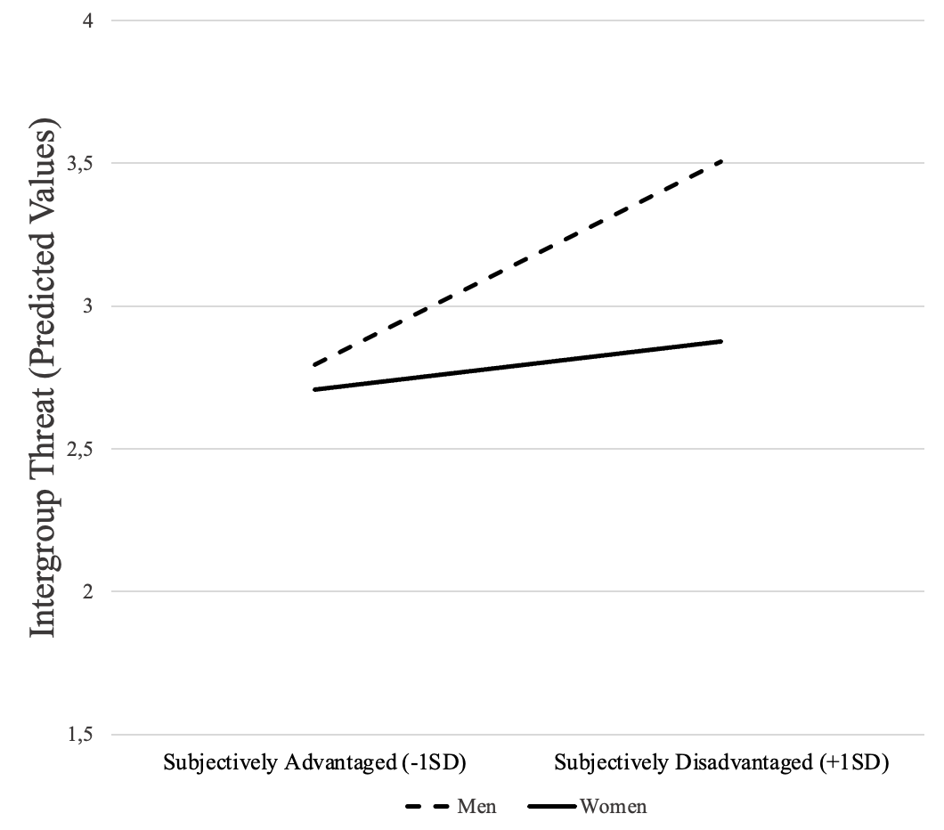
DEI Practices × Gender × Race on Perceived Intergroup Threat. Finally, when testing a model that simultaneously incorporated both operationalizations of Objective Status (gender and race) to examine intersectional identity profiles, the analyses again yielded no significant interactions with DEI Practices (see Table VI). Specifically, the three-way interaction was not significant (B = -0.03, SE = 0.05, 95% CI [-0.13, 0.07], t = -0.56, p = .572). However, interestingly, Gender and Race significantly interacted to predict Perceived Intergroup Threat (B = 0.13, SE = 0.05, 95% CI [0.03, 0.23], t = 2.59, p = .010).
Table VI. The effect of DEI Practices by Gender and Race on Intergroup Threat.
 | Intergroup Threat 95% CI
 |  | Estimate |  | SE | LL | UL | p
DEI Practices |  |  | .031 | .051 | -.068 | .130 | .538
Gender |  |  | .164 | .051 | .065 | .263 | .001
Race |  |  | .428 | .051 | .328 | .527 | .000
Gender*Race |  |  | .131 | .051 | .032 | .230 | .010
DEI Practices*Gender |  |  | -.005 | .051 | -.104 | .094 | .925
DEI Practices*Race |  |  | .058 | .051 | -.041 | .157 | .253
DEI Practices*Gender*  Race |  |  | -.029 | .051 | -.128 | .071 | .572

Note. CI = confidence interval; LL = lower limit; UL = upper limit.
We conducted simple slopes analyses examining Perceived Intergroup Threat across subgroups defined by Gender (coded -1 = Women, 1 = Men) and Race (-1 = Non-White, 1 = White) (see Figure 4). Among non-White participants, the effect of Gender on perceived threat was not significant (B = 0.03, SE = 0.08, 95% CI [-0.12, 0.18], p = .688), whereas it was significant among White participants (B = 0.30, SE = 0.07, 95% CI [0.17, 0.43], p < .001). Looking at the reverse conditional effects, Race significantly predicted perceived threat among both women (B = 0.29, SE = 0.07, 95% CI [0.15, 0.43], p < .001) and men (B = 0.56, SE = 0.07, 95% CI [0.42, 0.70], p < .001), with the effect being stronger among men.
Figure 4. Simple slopes of Gender × Race on Perceived Intergroup Threat.
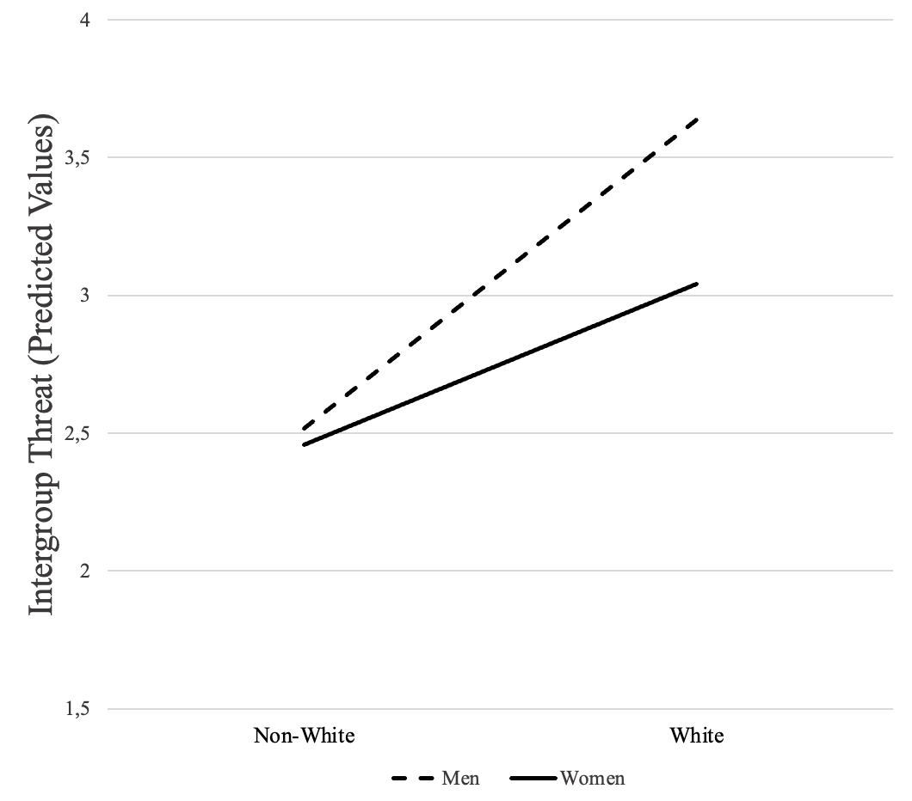
Across the exploratory analyses, all two-way interactions indicated that both Objective (Race, Gender) and Subjective status shaped perceptions of intergroup threat. The Race × Subjective Disadvantage and Gender × Subjective Disadvantage interactions showed that feelings of disadvantage were associated with higher perceived threat, with the effect being stronger for White participants and for men, respectively. The Race × Gender interaction indicated that men, particularly White men, reported the highest levels of perceived threat, whereas women and non-White participants reported lower levels. Overall, these results suggest that perceived intergroup threat is highest among objectively advantaged groups (White participants, men) whose objective advantage does not match with their subjective status—that is, when their subjective status indicates relative disadvantage.

Täuber, S. (2022). “Women academics’ intersectional experiences of policy ineffectiveness in the European context”, Frontiers in Psychology, Vol. 13 p. 2275. doi:10.3389/fpsyg.2022.810569

