WEB APPENDIX A

Study 1

Independent variable manipulation

Imagine that you are interested in buying a second-hand sofa. As you are searching on a Facebook selling page, you come across this post:

[Anthropomorphized couch]

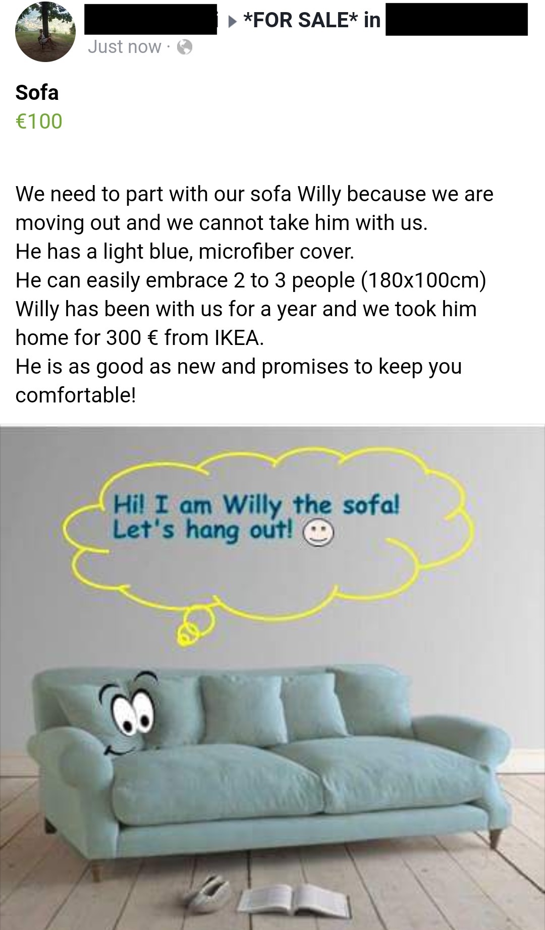
[Objectified couch]

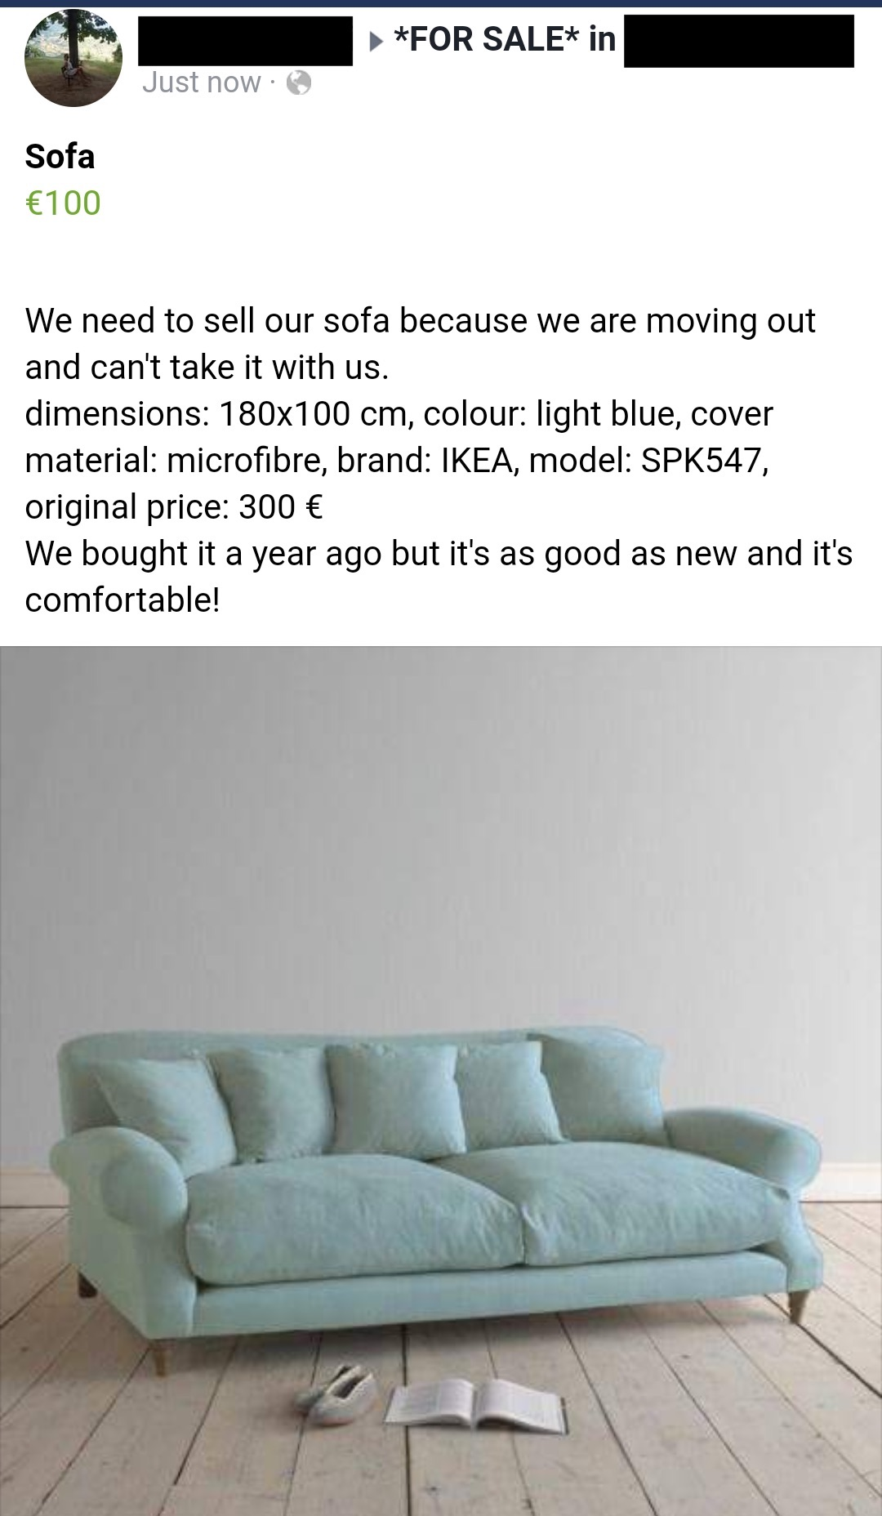

Dependent variable measure

- How likely are you to pay the asking price for this sofa?
Extremely unlikely – Moderately unlikely – Slightly unlikely – Neither likely nor unlikely – Slightly likely – Moderately likely – Extremely likely

- How likely are you to negotiate for the price of the sofa? (i.e. give a lower offer than the asking price)
Extremely unlikely – Moderately unlikely – Slightly unlikely – Neither likely nor unlikely – Slightly likely – Moderately likely – Extremely likely

- How much money would you offer for the sofa? Please write your answer in the space below.
(Indicate in €) _____

Exclusion criteria

One hundred and fifty-seven participants agreed to participate in the study. Because almost all participants were non-native English speakers and they were approached on the street or in a shopping center, there may have been some misunderstanding in the instructions among some participants. Participants were supposed to offer asking or lower than asking price for the sofa, as-is typical of Facebook Marketplace contexts. Seven participants offered prices significantly higher than the asking price of the sofa (100 Euros). These over-bids ranged from 120 to 200 Euros. The sofa was a typical IKEA couch, not a product that typically maintains its value when it is sold second-hand.

These seven participants were excluded from the analyses reported in-text. Including them does not change the effect of anthropomorphism on willingness to negotiate (F(1, 155) = 18.89, p < .001) or accept asking price (F(1, 155) = 9.05, p = .003). Including them does nullify the effect of anthropomorphism on the WTP amount (M_{object} = 80.90 Euros, SD = 31.48; M_{anthropomorphized} = 82.25 Euros, SD = 21.19; F(1, 155) = 9.05, p = .758).

WEB APPENDIX B

Study 2

Independent variable manipulation

Imagine that you’ve been wearing the same wrist watch over the last year. Please take a moment to picture in your mind a wrist watch in the style that you prefer, either analog or digital (but not a smartwatch or fitness band).

[Anthropomorphized watch] Over time, you begin thinking of your wrist watch as if it were a living being, not just an object to wear on your wrist. Now, please take a moment and imagine that your watch has actually come to life. Try to vividly imagine in your mind the kind of person that your watch would be like.
Think about the sort of person your watch would be in terms of his/her personality traits, physical appearance, attitudes, interests, and any other characteristics that you can think of. What would you name your watch?

[Objectified watch] Over time, you begin thinking of your wrist watch as a physical "thing", a mechanical object, and like a material item that is manufactured. Now, think about your watch as the physical object that it is. Try to vividly imagine this object in your mind.
Think about the sort of object that your watch is in terms of its features, physical appearance, material it is made of, its specifications and dimensions, and any other characteristics you can think of.

Dependent variable measure

Now, please consider the following situation:
Imagine that your wrist watch develops a mechanical issue. The warranty on your watch is still valid. You email the manufacturer and describe your issue. They email you back and inform you that the specific model of your watch is currently out of stock at all stores and they do not know when that model will be restocked.

They offer you two options:
Option A. You can visit a local brick-and-mortar watch shop in your city that carries this brand of watches. You can give them your wrist watch in exchange for a new watch. The model of the new watch will be different, but the style and function will be very similar to your original watch. This is option is offered to you at no additional cost.

Option B. You can visit a local brick-and-mortar watch shop in your city that carries this brand of watches. You can drop off your watch to be fixed by their experts. There will be no charge for the labor of the repair. One of the new mechanical parts will need to be special ordered and you will be charged $5.99. Once the repair is complete, your watch will function exactly the same as before.

Which option would you prefer?
Option A 1 2 3 4 5 6 7 Option B

Mediator

To what extent do you agree with the following statements?

- I care about the treatment of my current watch
- It doesn’t really matter to me what happens to my current watch

Strongly disagree – Disagree – Somewhat disagree – Neither agree nor disagree – Somewhat agree – Agree – Strongly agree

Anthropomorphism manipulation check

To what extent do you think the watch you wrote about earlier...

- …seemed as if it had free will
- …seemed as if it had intentions
- …seemed like it had feelings
- …seemed like a real person

Strongly disagree – Disagree – Somewhat disagree – Neither agree nor disagree – Somewhat agree – Agree – Strongly agree

Exclusion criteria

Five hundred and one participants were recruited in total. Twenty-nine participants were excluded: four were removed for writing nonsensical responses for one or more open-ended question, fourteen were removed for not following the instructions of the open-ended questions (e.g., refusing to anthropomorphize the product, writing unrelated descriptions about the product), and eleven were removed for low self-reported attention (more than 3 SD below the mean response of self-reported attention of 97.38 out of 100, SD = 7.339).

WEB APPENDIX C

Study 3

Independent variable manipulation

[Anthropomorphized car] This is a 2004 Lexus ES 330.
Imagine that this is your car. You named her Lexi and you’ve been together for almost 14 years. You’ve traveled more than 210,000 miles together.

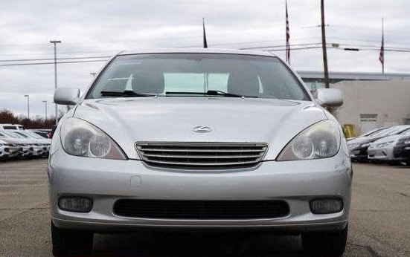

What kind of personality traits do you think Lexi has? Please take a moment and write about what kind of person you think Lexi is.

How would you rate Lexi on these traits?
Inattentive 1 2 3 4 5 6 7 Thoughtful
Aloof 1 2 3 4 5 6 7 Friendly
Irresponsible 1 2 3 4 5 6 7 Dependable
Uncreative 1 2 3 4 5 6 7 Creative
Disagreeable 1 2 3 4 5 6 7 Cooperative

[Objectified car] This is a 2004 Lexus ES 330.
Imagine that this is your car. You have owned it for almost 14 years. You’ve driven more than 210,000 miles in it.
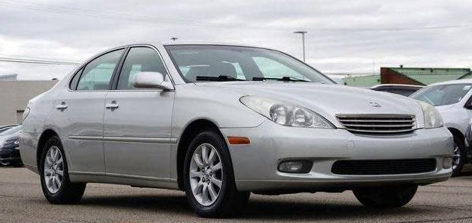

What kind of features do you think this Lexus has? Please take a moment and write about what kind of functions and features you think this Lexus has.

How would you rate the Lexus on these attributes?
Noisy 1 2 3 4 5 6 7 Quiet
Unresponsive 1 2 3 4 5 6 7 Responsive
Unreliable 1 2 3 4 5 6 7 Reliable
Difficult to use 1 2 3 4 5 6 7 Easy to use
Impractical 1 2 3 4 5 6 7 Functional

[Anthropomorphized car] Your car is still running smoothly after 14 years, but you think that perhaps it may be time to upgrade. You decide to sell Lexi, your Lexus, and you post the following ad online.
Find Lexi a new home! - $2500, or best offer
I need to part with my Lexi, a 2004 Lexus ES 330. Despite her age, she’s in great condition. She has a reliable V6 engine and she’ll keep you comfortable with her smooth leather seats.
She has traveled 211,583 miles, but you can be sure that she still has plenty of life left in her!
Please contact me at [email address] for more details and photos of Lexi.

[Objectified car] Your car is still running smoothly after 14 years, but you think that perhaps it may be time to upgrade. You decide to sell your Lexus, and you post the following ad online.
Used Lexus for sale! - $2500, or best offer
I need to sell my 2004 Lexus ES 330. Despite its age, it’s in great condition. It has a reliable V6 engine and smooth, comfortable leather seats.
Even though it has clocked 211,583 miles, you can be sure that it can run many more miles!
Please contact me at [email address] for more details and photos of the car.

Dependent variable measure

After you post your ad, you get two serious offers.

One offer is from a student from a nearby college who is looking to buy a used car to drive to-and-from school. The student offers you $2435.

Another offer is from the owner of a local auto salvage yard who is looking to buy a Lexus vehicle to break down for parts. The owner of the salvage yard offers you $2445.

Both are able to pick up your car from your driveway within the week and both offer to pay by cash.

Which buyer would you prefer to sell to?
College student 1 2 3 4 5 6 7 Salvage yard owner

Mediator

To what extent do you agree with the following statements?

- It doesn't really matter to me what happens to my Lexus after I sell it
- I would care about how my Lexus was treated by the buyer

Strongly disagree – Disagree – Somewhat disagree – Neither agree nor disagree – Somewhat agree – Agree – Strongly agree

Exclusion criteria

One hundred and fifty-five participants were recruited in total. Fourteen participants were excluded: ten were removed for not following instructions (e.g., explicitly refusing to anthropomorphize the car), and four were removed for low self-reported attention (more than 3 SD below the mean response of self-reported attention of 97.66 out of 100, SD = 5.713).

WEB APPENDIX D

Study 4

Independent variable manipulation

[Anthropomorphized dresser] This is the Mila solid wood dresser, in white.

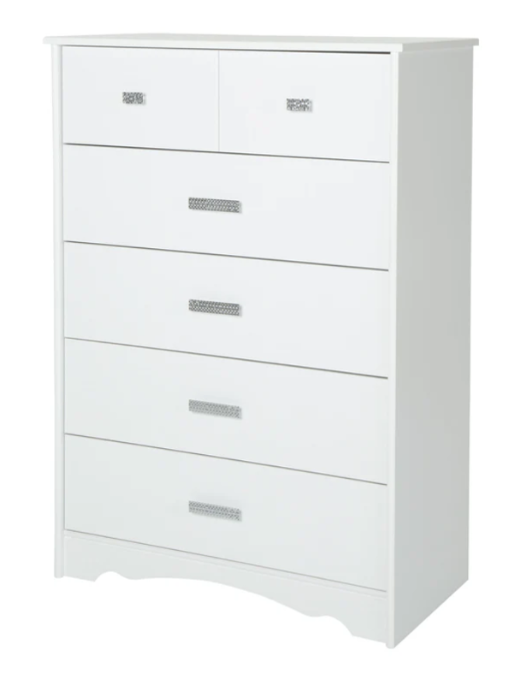
Imagine that you brought Mila home.

Now, please take a moment and imagine that Mila has actually come to life.

Try to vividly imagine in your mind the kind of person that Mila would be like. Think about the sort of person Mila would be in terms of personality traits, physical appearance, attitudes, interests, and any other characteristics that you can think of.

[Objectified dresser] This is the MLN solid wood dresser, in white.
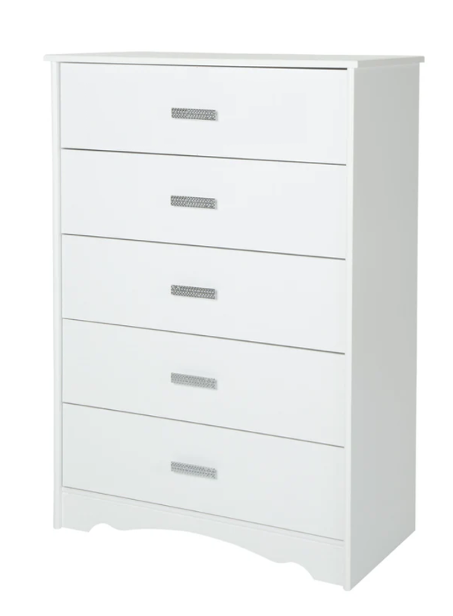
Imagine that you bought the MLN dresser.

Now, please take a moment and picture the MLN dresser as a physical object.

Try to vividly imagine this object in your mind. Think about the sort of object that your dresser is in terms of its features, physical appearance, material it is made of, its specifications and dimensions, and any other characteristics you can think of.

[Anthropomorphized dresser] You've had the dresser for a couple of years and it is a bit worn out now. You recently redecorated, and you decide to let Mila go. Since Mila is made of solid wood, two local secondhand furniture shops express interest.

[Objectified dresser] You've had the dresser for a couple of years and it is a bit worn out now. You recently redecorated, and you decide to sell the dresser. Since the MLN dresser is made of solid wood, two local secondhand furniture shops express interest.

Dependent variable measure

One offer comes from Alex, the owner of a shop that refurbishes old furniture. He takes old furniture, fixes and polishes them up. Alex offers you $175 for your dresser.

Another offer comes from Sam, the owner of shop that repurposes wood from old furniture and other wood products. He breaks down and takes apart old products, and reuses the wood for new products. Sam offers you $185 for your dresser.

Which buyer would you prefer to sell to?
Alex 1 2 3 4 5 6 7 Sam

Mediator

[Concern] To what extent do you agree with the following statements about the dresser?

- It matters to me what happens to my dresser after I sell it
- It's more important to me that I sell my dresser to the right person rather than earning more money
- It feels wrong for my dresser to be used/sold for parts
- I'd prefer my dresser to remain whole, rather than be taken apart, even after I sell it
- I would rather make sure that my dresser 'lives on' even if means I make less money

Strongly disagree – Disagree – Somewhat disagree – Neither agree nor disagree – Somewhat agree – Agree – Strongly agree

[Identity] To what extent do you agree with the following statements about the dresser?

- The dresser reflects who I am
- I can identify with the dresser
- I feel a personal connection with the dresser
- I consider the dresser to be “me”
- The dresser suits me well
- I would use this dresser to communicate who I am to other people
- I think this dresser helps me become the person I want to be

Strongly disagree – Disagree – Somewhat disagree – Neither agree nor disagree – Somewhat agree – Agree – Strongly agree

Anthropomorphism manipulation check

To what extent do you agree with the following statements about the dresser?

- It seems to have feelings
- It seems to have personality
- It seems to have free will
- It seems to have intentions
- It seems like a person
- It seems to be alive

Strongly disagree – Disagree – Somewhat disagree – Neither agree nor disagree – Somewhat agree – Agree – Strongly agree

Exclusion criteria

Two hundred participants were recruited in total. Four participants were removed for low self-reported attention (more than 3 SD below the mean response of self-reported attention of 96.12 out of 100, SD = 8.119).

WEB APPENDIX E

Study 5

Independent variable manipulation

[Anthropomorphized computer] A while back, you were shopping around for desktop computers. You came across this Lenovo desktop:

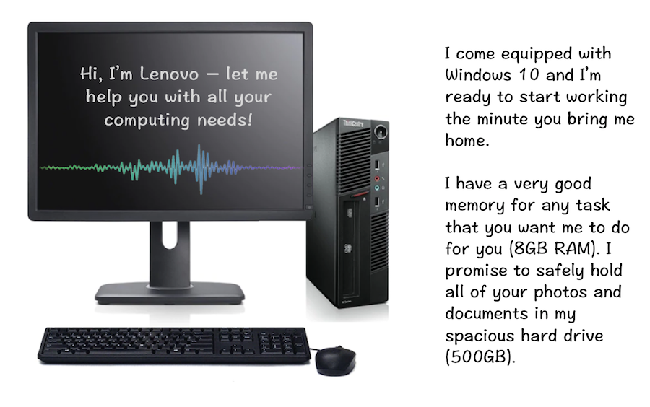

You decided to purchase this desktop. You took it home and set it up. Upon starting up, a pop up asked what you wanted to call your computer:
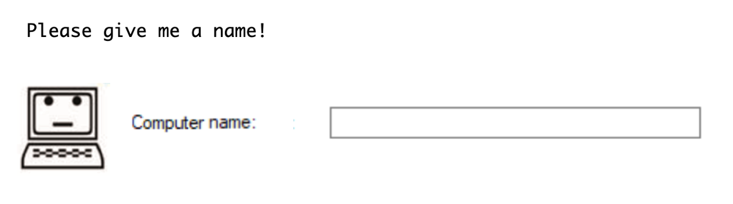

You thought for a moment, and typed in “Lenny”.
Please imagine that Lenny has come to life as a person. In the space below, briefly describe the sort of person Lenny would be in terms of personality, physical appearance, opinions, conversational style, and so forth.

[Objectified computer] A while back, you were shopping around for desktop computers. You came across this Lenovo desktop:



You decided to purchase this desktop. You took it home and set it up. Upon starting up, a pop up asked what you wanted to call your computer:
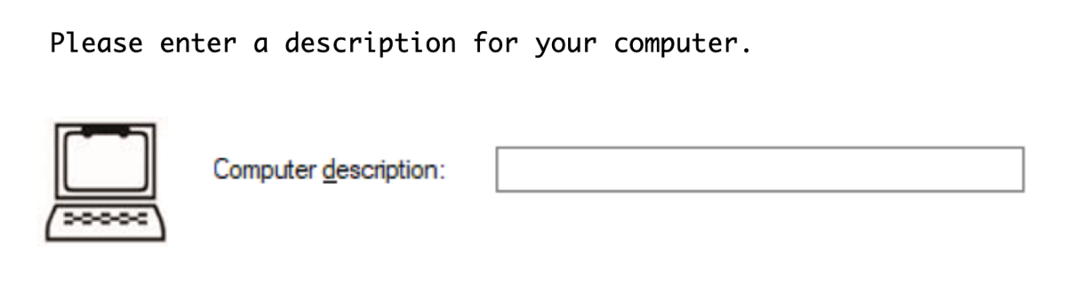

You thought for a moment, and typed in “LM91P”.
Consider the Lenovo desktop computer. In the space below, please briefly describe the features, benefits, characteristics, and different aspects of this product.

[Anthropomorphized computer] Now, after some time, you no longer use the computer. You decide to sell it online. You post an ad that says, “Lenny needs a new home! $290 or best offer."

[Objectified computer] Now, after some time, you no longer use the computer. You decide to sell it online. You post an ad that says, "Lenovo computer for sale! $290 or best offer."

Dependent variable measures

After you post your ad, you get two serious offers:

One of the offers is from Alex, an owner of a local shop who is looking to purchase an extra computer for his office. Alex offers to buy your computer for $255.

The other offer is Sam, an owner of a local shop that sells refurbished computers. He wants to buy your desktop in order to extract its component parts to fix up other refurbished computers. Sam offers to buy your computer for $265.

Both of the buyers offer to pick up your desktop this week and both offer to pay by cash.

Which of these two buyers would you prefer to sell to?
I'd prefer to sell to Alex 1 2 3 4 5 6 7 I'd prefer to sell to Sam

If you had to pick only one of the sellers to sell your computer to, which one would you choose?
-Alex
-Sam

Mediator

To what extent do you agree with the following statements?

- It matters to me what happens to my computer after I sell it
- It's more important to me that I sell my computer to the right person rather than earning more money
- It feels wrong for my computer to be used/sold for parts
- I'd prefer my computer to remain whole, rather than be taken apart, even after I sell it
- I would rather make sure that my computer 'lives on' even if means I make less money

Strongly disagree – Disagree – Somewhat disagree – Neither agree nor disagree – Somewhat agree – Agree – Strongly agree

Filler items

To what extent do you agree with the following statements?

- I am inclined to keep in the background on social occasions.
- I like to mix socially with people.
- I am sometimes bubbling over with energy and sometimes very sluggish.
- I like to have many social engagements.

Strongly disagree – Disagree – Somewhat disagree – Neither agree nor disagree – Somewhat agree – Agree – Strongly agree

Moderator

[Empathic concern]

Please read each statement and decide how much you agree or disagree with the statement.

- Sometimes I don't feel sorry for other people when they are having problems.
- When I see someone being treated unfairly, I sometimes don't feel very much pity for them.
- Other people's misfortunes do not usually disturb me a great deal.
- When I see someone being taken advantage of, I feel kind of protective toward them.
- I often have tender, concerned feelings for people less fortunate than me.
- I am often quite touched by things that I see happen.
- I would describe myself as a pretty soft-hearted person.

Strongly disagree – Somewhat disagree – Neither agree nor disagree – Somewhat agree – Strongly agree

Anthropomorphism manipulation check

Think back again to the computer you saw and wrote about earlier. To what extent do you agree with the following statements about your computer?

- It seems to have feelings
- It seems to have personality
- It seems to have free will
- It seems to have intentions
- It seems like a person
- It seems to be alive

Strongly disagree – Disagree – Somewhat disagree – Neither agree nor disagree – Somewhat agree – Agree – Strongly agree

Exclusion criteria

Three hundred and ninety-nine participants were recruited in total. Fourteen participants were excluded: three were removed for writing nonsensical responses for one or more open-ended question, one was removed for refusing to anthropomorphize the product, and ten were removed for low self-reported attention (more than 3 SD below the mean response of self-reported attention of 97.87 out of 100, SD = 6.875).

Additional analyses

After asking the participants to express their preference for which buyer they would sell to, we also asked them to choose between the two buyers. We probed the relationship between anthropomorphism, trait empathy, and choice of buyer using PROCESS Model 1. We also conducted a moderated mediation analysis using PROCESS Model 8, with empathy as the moderator (mean-centered), concern toward the product as the mediator, and choice of buyer as the outcome.

Anthropomorphism x empathy on buyer choice. Similar to the results of anthropomorphism on buyer preference, anthropomorphizing the product increased the likelihood that participants would choose the buyer who offered the lower offer price (but would keep the product intact). Again, there was no main effect of empathy on choice of buyer. Although directionally similar to the buyer preference results, the interaction effect between anthropomorphism and empathy was not significant. See the PROCESS output below. It is worth noting that the main analysis of interest, the moderated mediation effect, was replicated for buyer choice (refer to the next page).

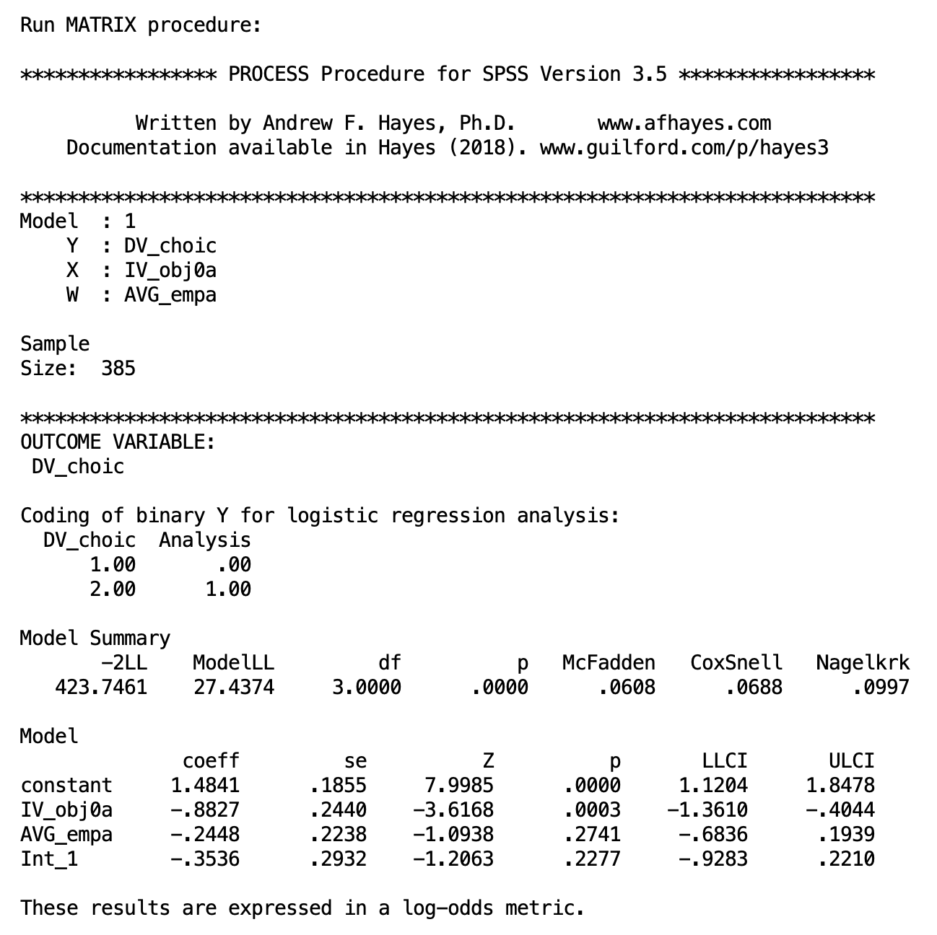
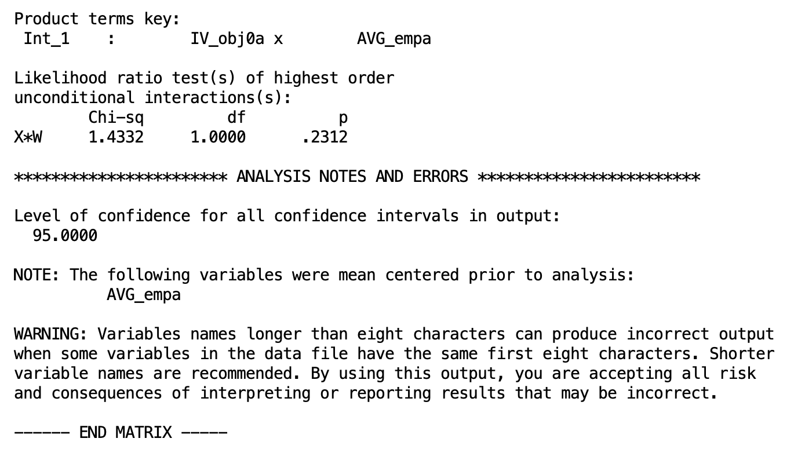

Effect of anthropomorphism x empathy on buyer choice, mediated by concern for the product. Similar to the results on buyer preference, analyses revealed a main effect of anthropomorphism on concern for the product, as well as an interaction effect of anthropomorphism and trait empathy. The effect of these factors on buyer choice was mediated by concern for the product. Specifically, among high empathy participants, concern mediated the relationship between anthropomorphism and choice; among low empathy participants, no such mediation occurred. See the PROCESS output below.

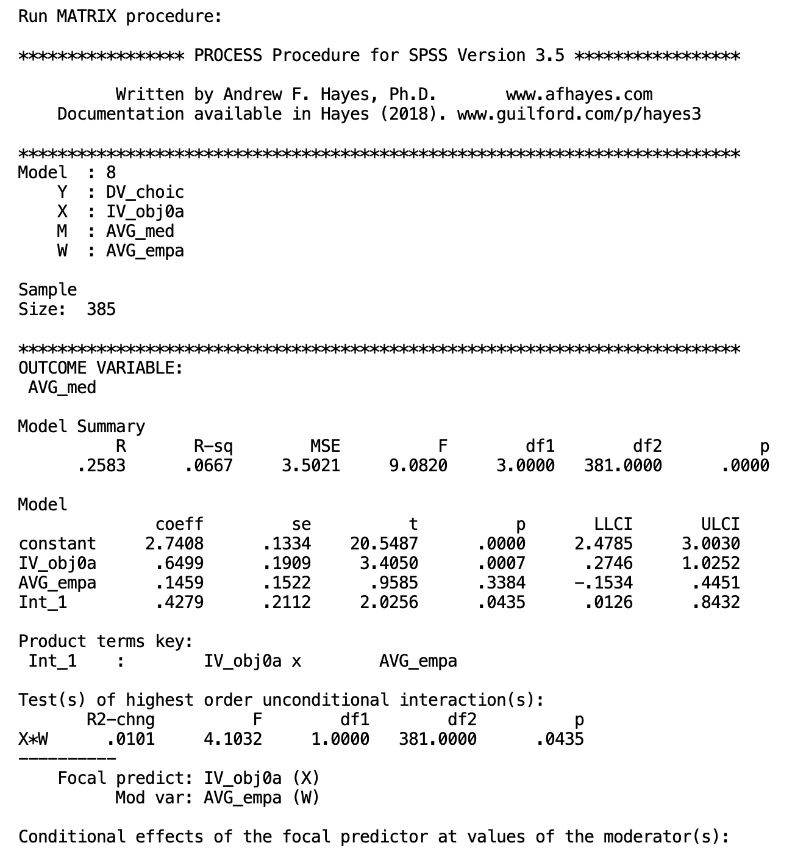

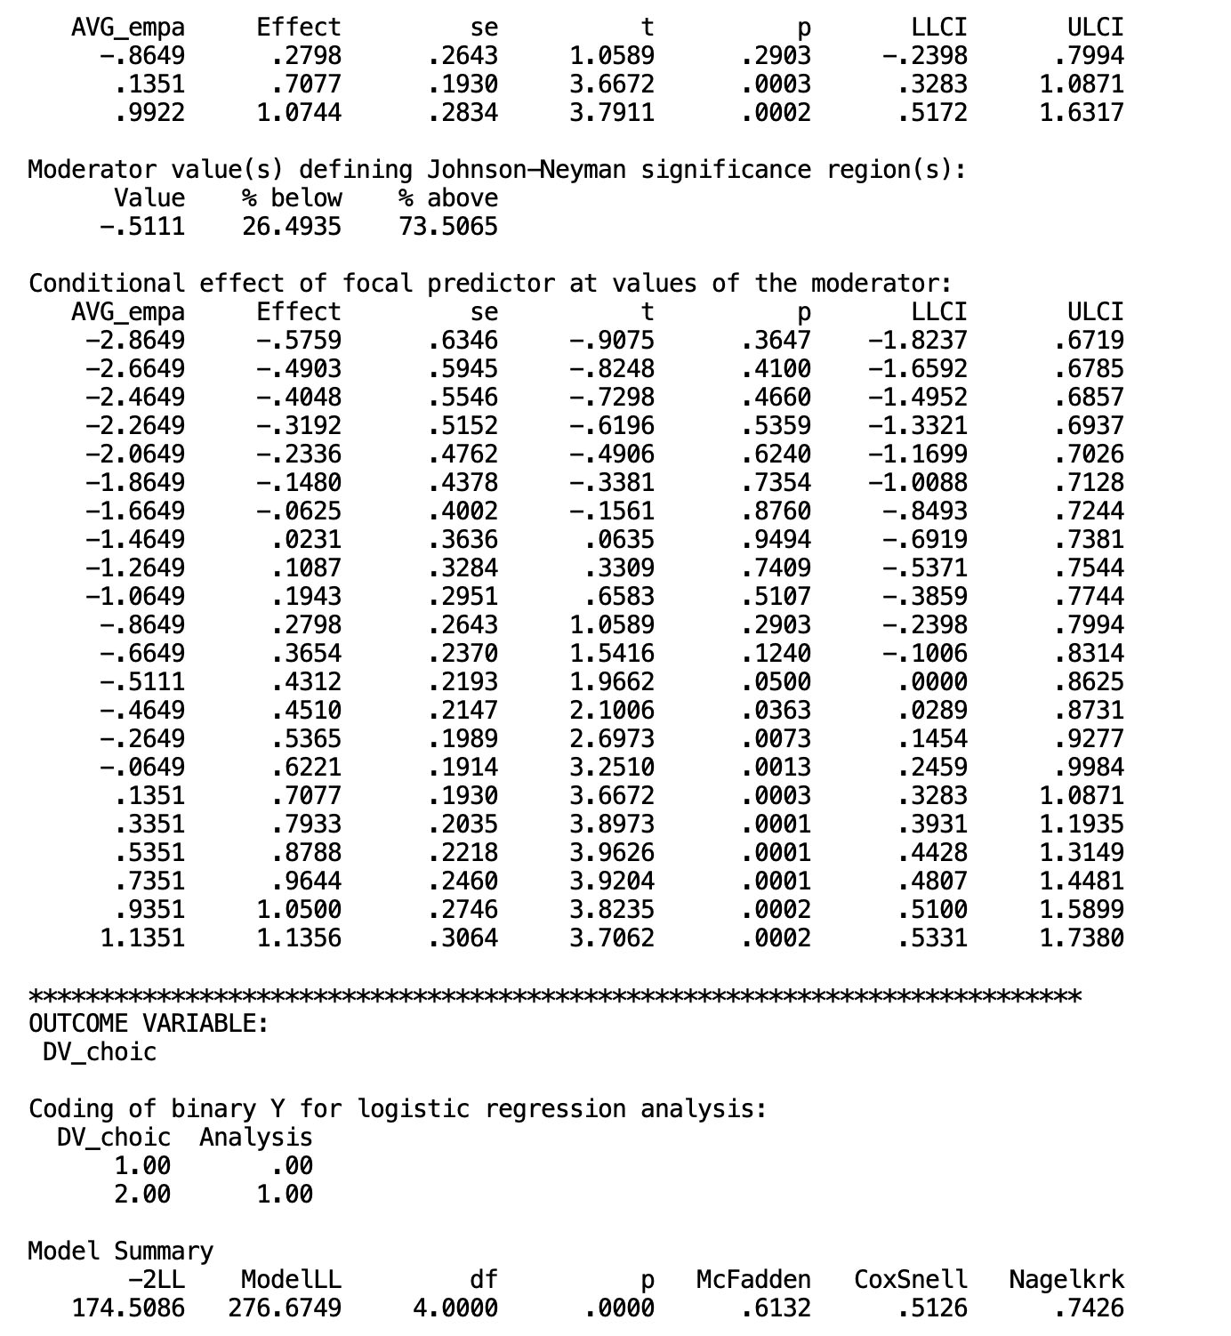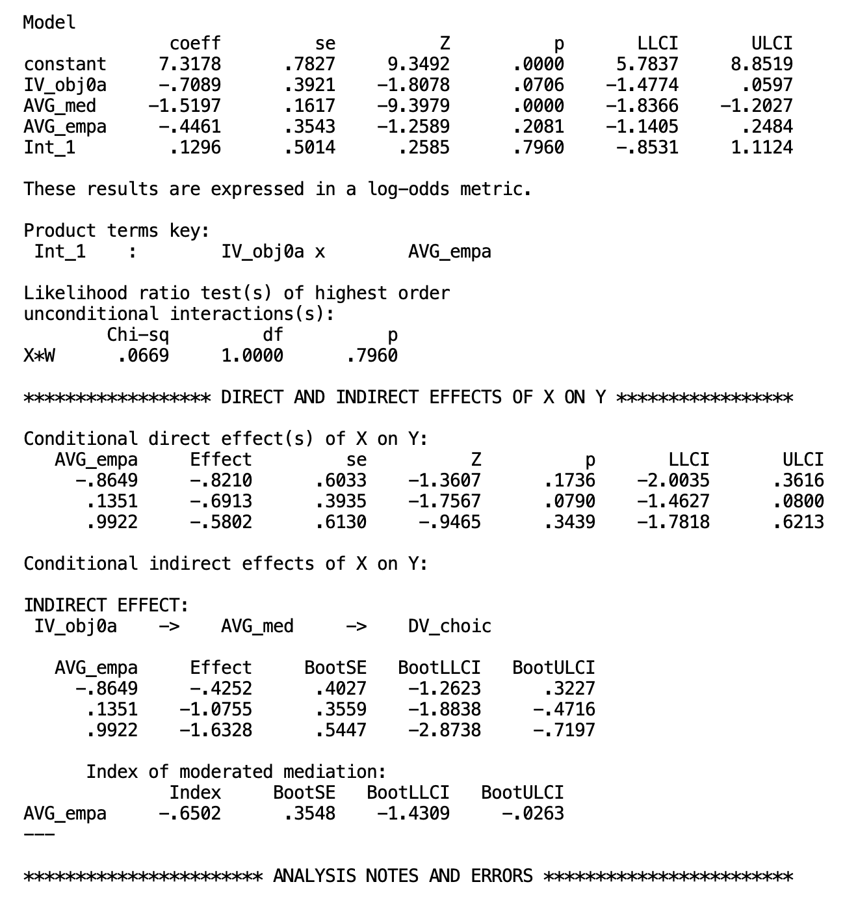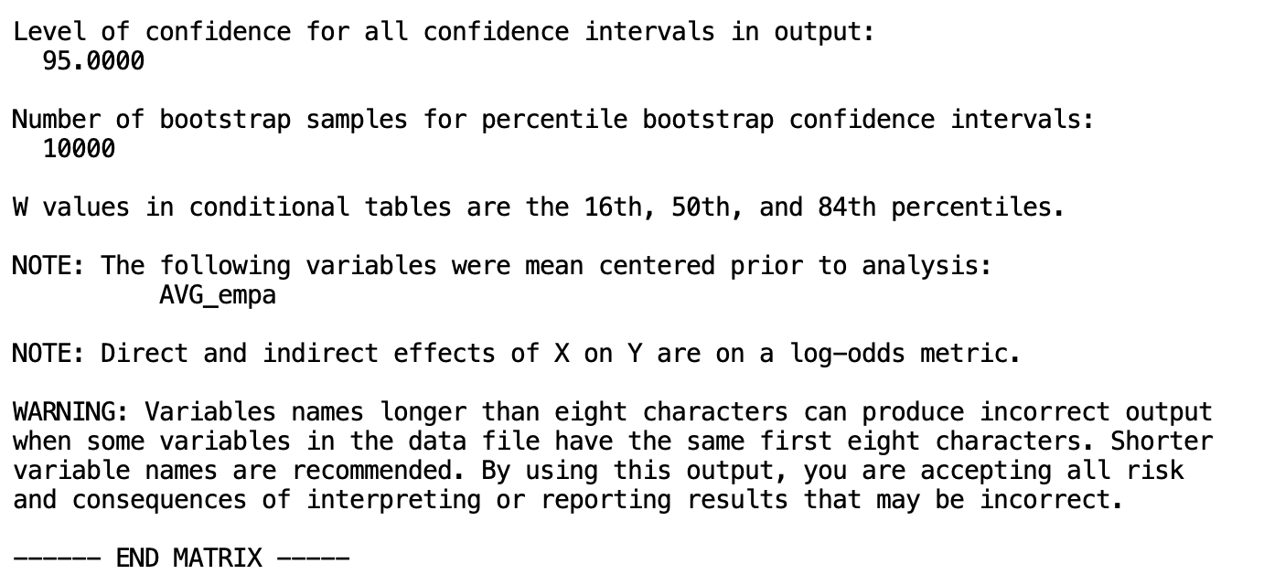

WEB APPENDIX F

Exclusion Criteria

Across all studies conducted on online panels (Amazon Mechanical Turk, Prolific), the following exclusion criteria were used:
- Self-reported attention: All participants are asked, at the end of the study, to self-report on how attentive they were during the study: “Based on your best judgment, how attentive were you when completing this study?” (slider scale: 1 = not at all attentive, 100 = very attentive). Their compensation was not tied to their answer. Most participants score themselves toward the higher end of the scale. Anyone who scores lower than three standard deviations below the mean is excluded.

- Open-ended responses: All opened-ended responses are read through by the first author prior to any statistical analyses. Although all MTurk studies were run through CloudResearch which has mechanisms in place to block bots and “farmed” responses, in our experience, there are still such participants who slip through. Such participants tend to answer open-ended questions with nonsensical replies that have little to do with the question. These participants are identified before the data is analyzed and are excluded.

Furthermore, there are occasionally participants who exhibit reactance when encountered with open-ended questions and do not follow the instructions in the open-ended questions. For example, if they are asked to describe a product’s personality, they respond that it is “ridiculous” to think of the product as a human. Or, when asked to describe a product’s features, participants may respond with an unrelated or non-descriptive answer. Such participants are identified before the data is analyzed and are excluded.

The specific number of excluded participants are described for each study in the previous appendices. Some participants may have been excluded based on more than one of the above criteria (e.g., low self-reported attention and writing a nonsensical response), but for clarity, excluded participants will not be double-counted—that is, if a participant is already excluded based on nonsensical responses, they will not be counted again for their low self-reported attention.

