Web Appendix
Construct and Scale Items | Source
Realism  - The situation described in this scenario seems realistic.  - It is easy to imagine being in such a situation.  - Something like this can happen to me. | Sharma et al. (2020)
Attitude towards Koala  - I love koalas.  - I have sympathy for koalas.  - I am concerned about koalas. | Pittinskly et al. (2011)
PWYW prices paid  - How much will you pay for the PWYW restaurant lunch ……... (amount in dollars) | Kim et al. (2009)
Satisfaction  - I think I will be satisfied with my dining experience at this restaurant. | Baker et al. (1994)
Fairness  - I think my price paid was fair toward the seller. | Bolton et al. (2003)
Price Consciousness  - I usually purchase items on sale only.  - I usually purchase the cheapest item.  - Price is the most important factor when I choose a brand.  - Before I buy a product, I often check the prices of different retailers to obtain the best benefits.  - I am willing to go to extra effort to find lower prices.  Construct and Scale Items | Donthu and Gililand (1996)
Social Desirability  - I am always courteous even to people who are disagreeable.  - There have been occasions when I took advantage of someone.  - I sometimes feel resentful when I don’t get my way.  - I sometimes try to get even rather than forgive and forget.  - No matter who I’m talking to, I’m a good listener. | Hays et al. (1989)
Altruism  - I love to help others.  - I have a good word for everyone.  - I am concerned about others.  - I make people feel welcome.  - I anticipate the needs of others. | Kim et al. (2009)
Intrinsic Motivation  - It was interesting to engage in this gamified app.  - It was enjoyable to engage in this gamified app  - It was fun to engage in this gamified app | Elliot & Church (1997)
Internal Reference Price  - How much do you think a similar lunch would normally cost without the PWYW pricing offer? | Roy et al. (2016)
Source: Authors own work

Experiment 1 Stimuli:
Tangible Reward
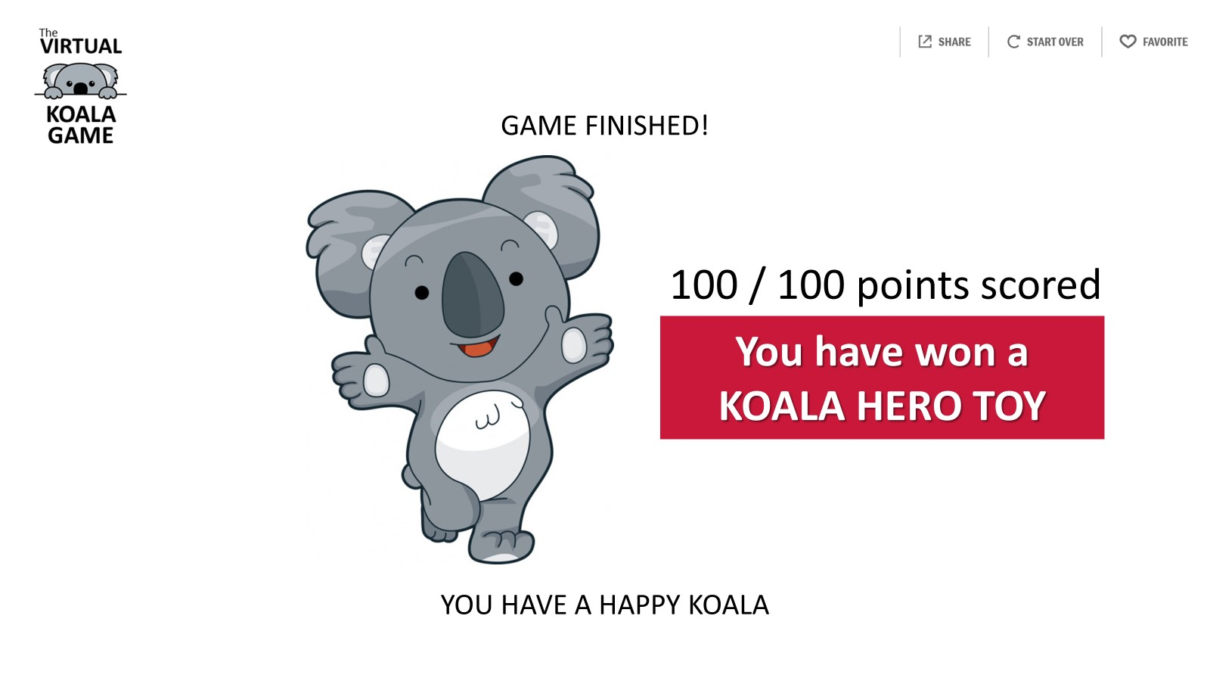
Source: Authors own work
Verbal Reward
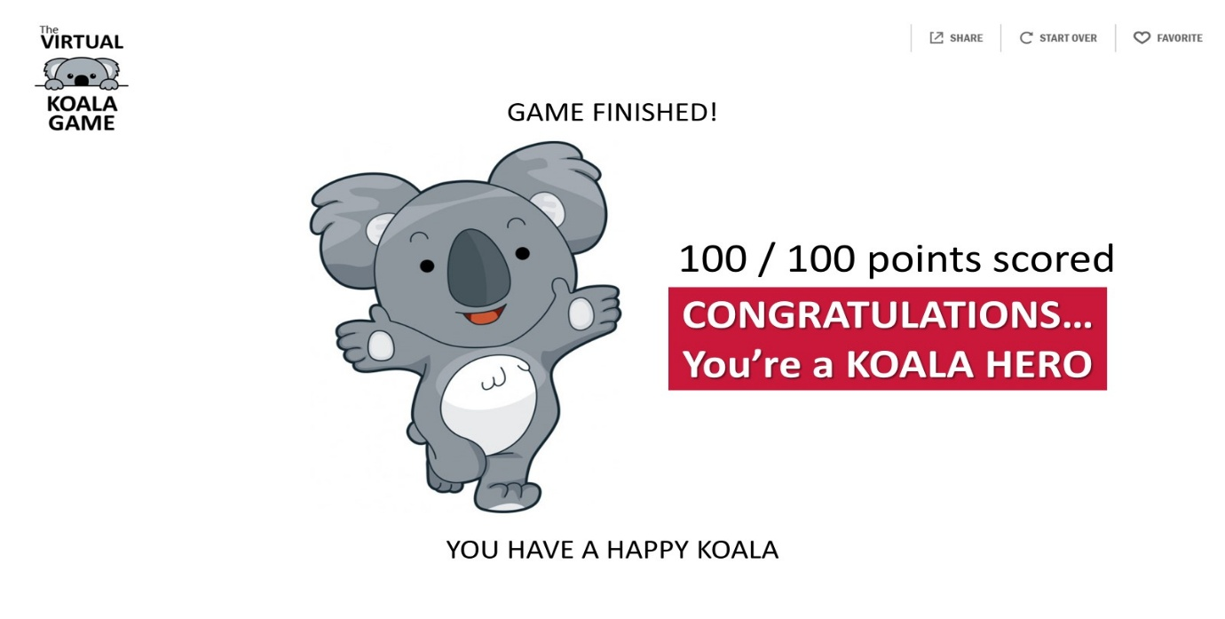
Source: Authors own work
Symbolic Reward
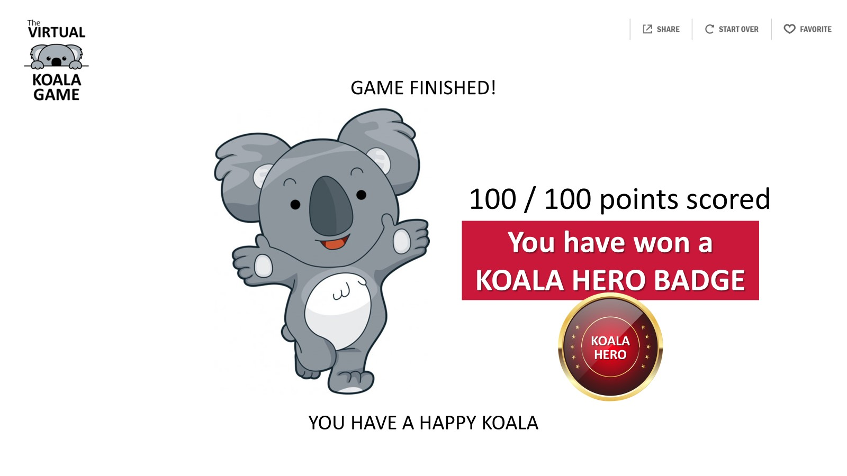
Source: Authors own work
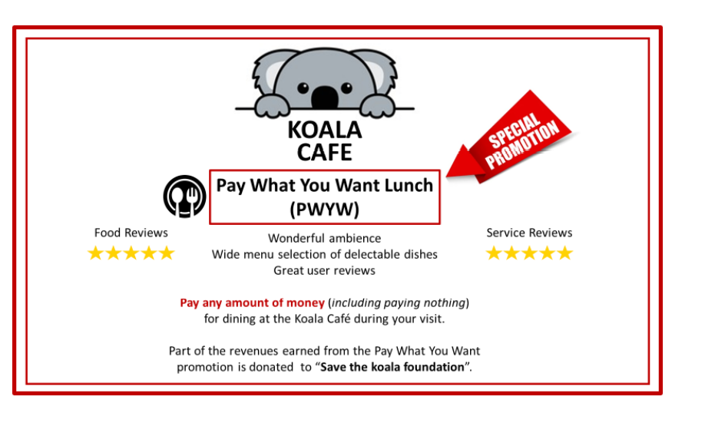
PWYW Offer- Experiments 1 and 3

Source: Authors own work

Experimental 2 Stimuli

Tangible Reward
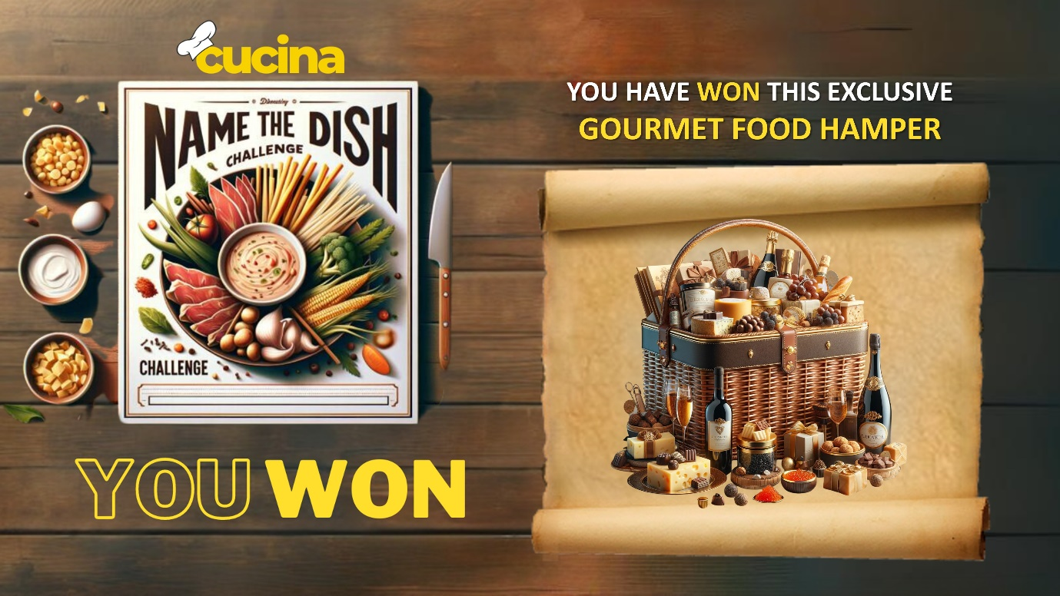
Source: Authors own work
Verbal Reward

Source: Authors own work

Symbolic Reward

Source: Authors own work
PWYW Offer – Experiment 2
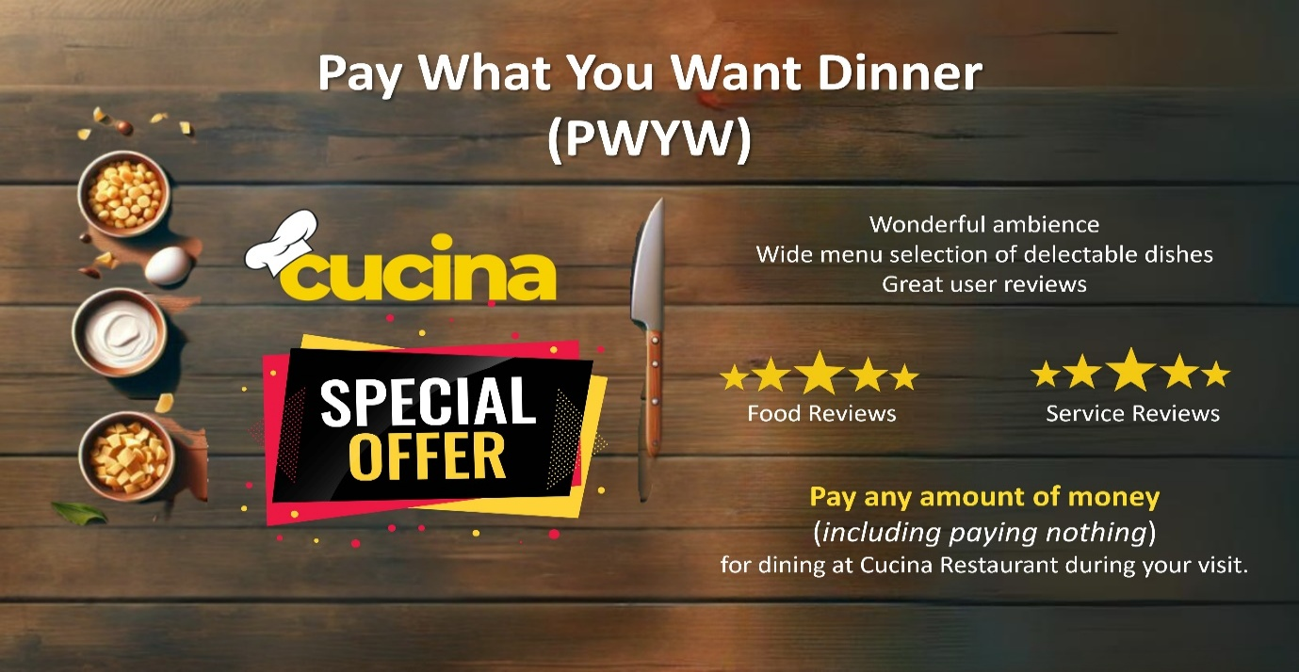
Source: Authors own work

