Web Appendix A1. Stimuli -Study 1a and 3: Washing machine (AI and Standard)

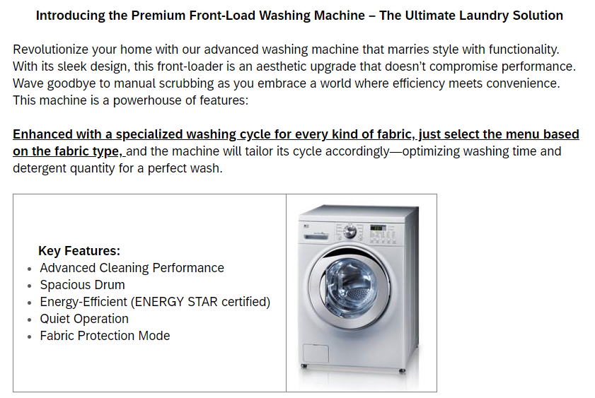
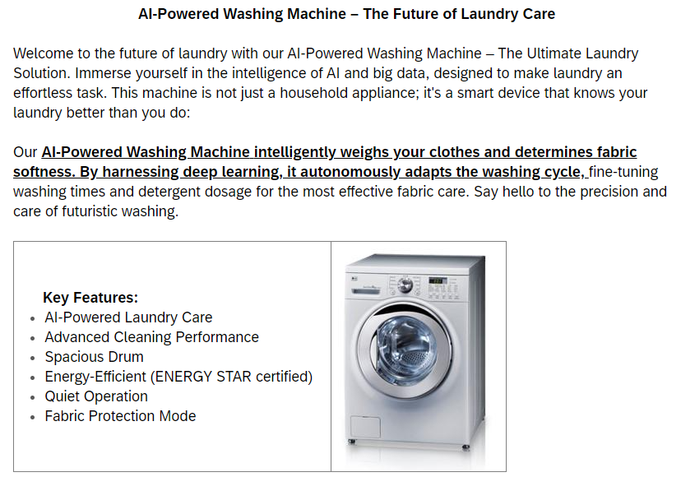

Web Appendix A2. Stimuli - Study 1a and 2: Refrigerator (AI and Standard)

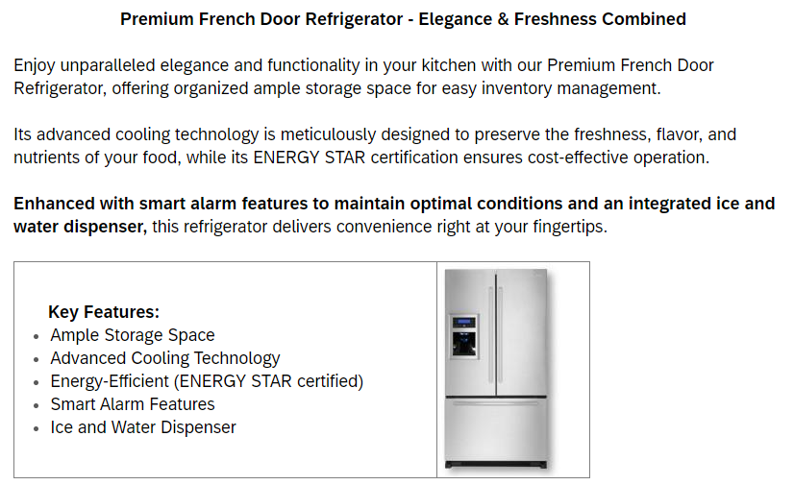
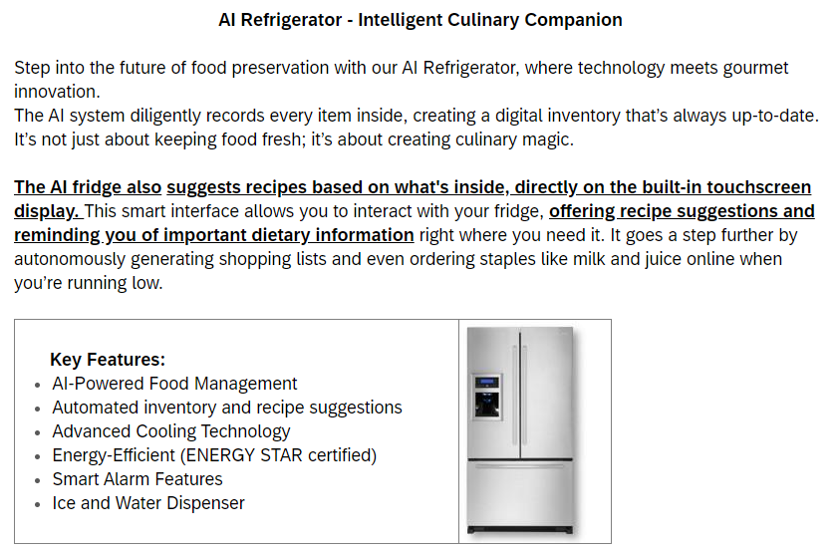

Web Appendix B1. Stimuli - Study 1b: Robot Vacuum Cleaner (AI and Standard)

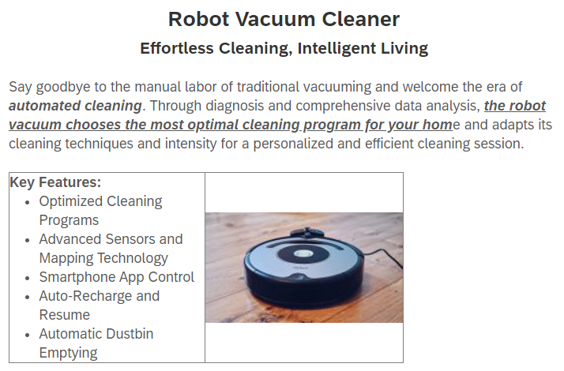
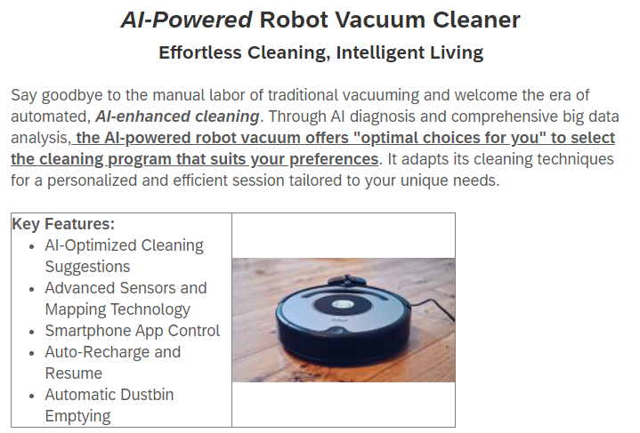

Web Appendix B2. Stimuli - Study 1b: Smart Bulb (AI and Standard)

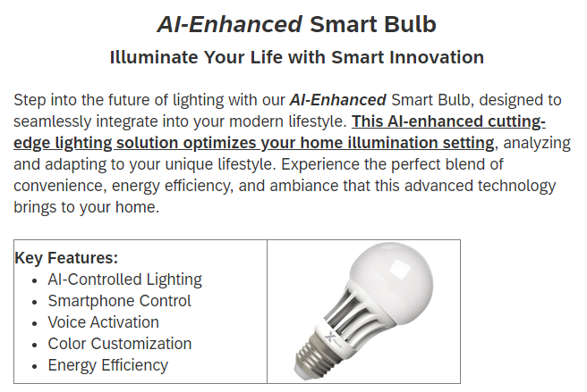
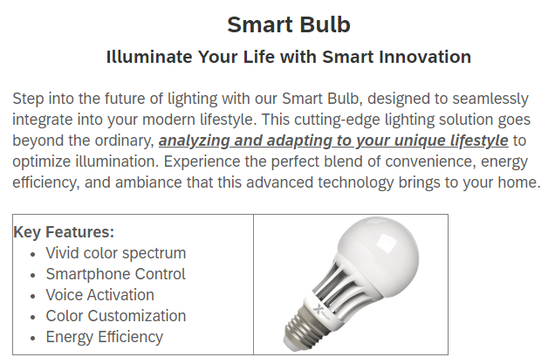

Web Appendix C. Participants number and Country individualism scores
 | Western Group |  |  | Eastern Group
Participants  Number | Hofstede  Individualism | Nationality | N | Hofstede  Individualism | Nationality | N
Study1a (N =275) | 60 | US | 275
Study 1b (N =156) | 76 | UK | 156
Study 2 (N=288) | 76 | UK | 155 | 43  50  5  62  58  27  37  30  5  17  43  40  19  30 | China  Hongkong  Indonesia  Japan  Korea (South)  Malaysia  Mongolia  Nepal  Pakistan  Philippines  Singapore  Taiwan  Thailand  Vietnam | 34  3  7  11  18  12  1  4  13  12  3  1  1  13
Study 2 (N=288) |  |  | 155 |  |  | 133
Study 3 (N=602) | 76  50  62  74  79  58  70  55  100  47  46 | UK  Bulgaria  Estonia  France  German  Ireland  Latvia  Lithuania  Netherlands  Poland  Russia | 283  2  1  1  1  3  1  1  1  4  2 | 43  50  24  5  25  62  58  20  27  30  5  17  43  35  40  30 | China  Hong Kong  India  Indonesia  Iraq  Japan  Korea (South)  Kazakhstan  Malaysia  Nepal  Pakistan  Philippines  Singapore  Sri Lanka  Taiwan  Vietnam | 95  6  112  10  1  13  6  1  4  8  19  14  3  2  3  5
Study 3 (N=602) |  |  | 300 |  |  | 302
Study 4 (N=604) | 76  73 | UK  Australia | 301  1 | 43  50  24  5  62  58  27  5  17  43  40  19  30 | China  Hong Kong  India  Indonesia  Japan  Korea (South)  Malaysia  Pakistan  Philippines  Singapore  Taiwan  Thailand  Vietnam | 39  10  142  18  19  15  5  11  21  3  3  2  3
Study 4 (N=604) |  |  | 302 |  |  | 302
Study 5  (N =202)  (N =77,674) | 91* | US | 101  videos,  55,564  comments | 58 | Korea | 101  videos,  22,110  comments
* The U.S. individualism score reported in Study 5 reflects the pre-2023 Hofstede index, as the videos were collected before the 2023 Hofstede index revision. Data from studies other than Study 5 reflect the updated (post-2023 revision) Hofstede individualism scores.

Web Appendix D1. Autonomy Dictionary - Study 5
Development of Autonomy dictionary. Development of Autonomy dictionary. This process involved iterative refinement, carefully selecting terms for inclusion or exclusion to maintain the dictionary’s thematic consistency. For the autonomy dictionary, we identified ten core concepts central to seminal research on the subject (such as able, achieve, choice, decide, goal, motivate, power, purpose, self, and will). Starting from these concepts, we compiled an initial list, incorporating synonyms and related terms, ultimately resulting in a comprehensive list of 86 autonomy-related terms (details in Appendix). To test the internal consistency of the autonomy dictionary, we calculated Kuder–Richardson Formula 20 (KR-20), a variant of Cronbach’s alpha suitable for binary-scored data, representing the presence or absence of words, thus capturing language’s non-repetitive essence (Adapted from Boyd et al., 2022).
Internal consistency of the autonomy dictionary. Internal consistency of the autonomy dictionary was calculated using a separate dataset (COCA, 2008). Kuder–Richardson Formula 20 of the autonomy dictionary were in an acceptable range, in various corpora: Magazine corpus (N = 106,080; KR 20 α = .82, M = .51, SD =.74), Blog corpus (N = 98,788; KR 20 α = .80, M = .63, SD =.58), and Academic journal corpus (N = 26,148; KR 20 α = .77, M = .77, SD =.55). The result implies high reliability of the dictionary. In Study 4 using YouTube video subtitles, the autonomy dictionary shows internal consistency (N = 202; KR20 α = .80, M = .76, SD =.62). Due to the highly unstructured and diverse nature of YouTube viewer-generated comments, we relied on the subtitles—a more controlled and structured textual source—for assessing dictionary reliability rather than directly evaluating comments.
Boyd, R. L., Ashokkumar, A., Seraj, S. & Pennebaker, J. W. 2022. The development and psychometric properties of LIWC-22. Austin, TX: University of Texas at Austin.
COCA: Corpus of Contemporary American English (2008-2023), Available online at https://www.english-corpora.org/coca/

Autonomy dictionary
abilities | compet* | incentive* | rebel*
ability | confiden* | indomitable | reward*
able | conquer* | ingenuity | self
accomplish* | consciousness | inherent | self-*
achiev* | core | initiativ* | selfish
acquir* | decid* | insight | selfishness
actualiz* | decisi* | insist* | sovereignty
aim | determin* | intrinsic* | spontane*
ambition* | drive | invent* | steadfast*
ambitious* | empower* | lead* | stubborn*
apt* | enable* | motivat* | sure
aspir* | enact* | negotiat* | target
assert* | establish* | objection | think
attain | excel | objectiv* | thought
autonom* | execute* | pioneer* | triumph*
basic | expert* | power | unaided
capab* | express* | powerful | willing*
capacity | focus* | principle | willpower
choice | fundamental | proactive* | won’t
choos* | goal* | protest*
chose | heroic* | purpose*
clever* | ideal* | pursu*

Web Appendix D2. LIWC2022 Anxiety Dictionary - Study 5

Anxiety dictionary
afraid | fearing | nervous* | stressful*
alarmed | fears | neurotic | stressing
alarming* | fearsome* | neuroticism | terrified
angst* | fidget* | ominous* | terrifies
antsy | fluster* | on edge | terrify
anxiet* | fomo | overwhelm* | terrifying
anxious | forboding* | overwhelming | terrifying*
anxious* | frantic | panic attack* | terrifyingly
apprehens* | frantic* | panic disorder* | terror
creep* | fret | panic* | terroriz*
creeped | fretful | paranoi* | terrors
creepier | frets | paranoid | trembl*
creepiest | fretted | phobi*
creepiness | fretting* | ptsd
creeping | fright* | restless
creeps | hesitan* | restless*
creepy | horrif* | scare
daunt* | horror* | scared
disquiet* | impatien* | scares
distraught* | Impatient | scarier
distress* | insecur* | scariest
dread | insecure | scarily
dreaded | jitters | scaring*
dreading | jittery | scary
dreads | looming | skittish*
eeri* | nerve wracking | spook*
fear | nerve-wracking | stress
feared | nervous | stress* out
fearful | nervous breakdown | stressed
fearful* | nervous disorder | Stresses

Web Appendix D3. LIWC2022 Positive tone Dictionary - Study 5

Positive tone dictionary
(-: | adoring* | beautif* | bright
(-; | affabl* | beautiful | brilliant
(: | affection* | beautifully | broad mind*
(; | altruism | beneficent | broad-mind*
(- | altruist* | beneficial* | calm
:) | amaze* | beneficience | calm*
:-) | amazed | benefit* | calmed
:) | amazing | benevolenc* | calmer
:-) | amiabl* | benevolent | calmest
=) | amicabl* | better | camarad*
a-ok | amus* | big heart* | candy
a-okay | amusement* | big-hearted | captivat*
accept* | appealing | birthday* | care
accomplish* | applaud* | bless you | care free
achiev* | applause* | bless* | care-free
admirabl* | appreciat* | blessed | cared
admiration* | approachable | bliss* | carefree
admire* | ardor* | bold | cares
admirer | aspiration* | bolder | caring
admirers | aspire* | boldest | celebrat*
admiring* | aspiring | bonus* | celebrate
adorabl* | attractive | bountiful | celebrated
adoration* | attractively | brave | celebrating
adore | award* | braved | celebration*
adored | awe* | bravely | charm
adorabl* | awesome | braver | charmed
adoration* | bae | bravest | charming
adore | bae* | breath taking* | cheer
adored | baes | breath-taking* | cheered
adores | bday | breathtaking* | cheerful …etc.

Web Appendix E. Summary of Studies
Study | Participants | IV:  Label  (Stimuli) | IV:  Culture Proxy | DV | Mediator | Mode-  rator | Findings
Study 1a | US  (N=275) | AI-labelled vs. Standard (washing machine, refrigerator) | - | Likelihood to use, Attitude, Willingness to purchase | Perceived autonomy | - | AI-labelled appliances less favoured; reduced autonomy mediates negative attitudes toward AI-labelled products
Study 1b | UK  (N=156) | AI-labelled vs. Standard  (robot vacuum cleaner, smart bulb) | - | Likelihood to use, Attitude, Willingness to purchase | Perceived autonomy | - | Replicated Study 1a findings; AI-labelled products less favoured due to autonomy concerns
Study  2 | Western (UK), Eastern (Asia), (N=288) | AI-labelled vs. Standard (refrigerator) | Western vs. Eastern (Individualism index) | Likelihood to use, Attitude, Willingness to purchase | - | Culture | Cultural moderation confirmed: Western consumers less favourable toward AI-labelled appliances; Eastern consumers unaffected
Study  3 | Western (UK), Eastern (Asia), (N=602) | AI-labelled vs. Standard (washing machine) | Western vs. Eastern (Individualism index) | Likelihood to use, Attitude, Willingness to purchase | Perceived autonomy | Culture | Cultural moderation confirmed in moderated mediation model: autonomy significantly mediates attitudes, stronger effect for Western consumers
Study  4 | Western (UK), Eastern (Asia), (N=604) | Automatic AI-labelled vs. Autonomy-enhanced AI-labelled vs. Standard  (oven) | Western vs. Eastern (Individualism index) | Likelihood to use, Perceived autonomy | Perceived autonomy | Culture | Autonomy-oriented framing effectively mitigates Western consumers' aversion to AI-labelled appliances, though standard appliances still preferred overall; Eastern consumers slightly prefer autonomy-oriented AI-labelled appliances
Study 5 | YouTube data  (202 videos,  US & Korea, ~77,674 comments) | Autonomy-related messaging frequency in videos | US (Western) vs. Korea (Eastern) | Anxiety (negative sentiment), Positive tone | Autonomy  dictionary | Culture | Real-world validation: Autonomy-related messages correlated with higher anxiety and lower positive sentiment among Western consumers; Eastern consumers less affected by autonomy mentions

Web Appendix F. Scale Items and Reliability Analysis
Study | Key construct and measurement items
Study 1a  Stimuli:  Washing machine,  Refrigerator | <IV> Label type  0 = Standard, 1 = AI  <DV>  Likelihood to use:  how likely are you to use this washing machine/refrigerator?  (M = 5.02, SD = 1.51; 1 = not at all, 7 = very much)  Attitudes towards appliances (Study 1a: α = .92, Study 1b: α = .95)  please evaluate this washing machine/refrigerator, using the scale below  (M = 5.66, SD = 1.25; 1 = bad/negative/dislike, 7 = good/positive/like)  Willingness to purchase  if you had the financial means to do so, how likely would you be to purchase this washing machine/refrigerator?  (M = 4.97, SD = 1.58; 1 = very unlikely, 7 = very likely)  <Mediator>  Perceived autonomy (Study 1a: α = .96, Study 1b: α = .96)  when using this washing machine/refrigerator, I would feel free to do things my own way,  …I would feel that I am in control of what I do,  ... I would feel that I make my own decisions,  …I would feel free to express my true self,  …I would feel that my decisions are based on my true interests and values  (M = 4.50, SD = 1.49; 1 = strongly disagree, 7 = strongly agree)  <Pre-test>  AI-ness perception:  How much do you agree with the following statements?  This product is equipped with Artificial Intelligence (AI).  This product operates using AI technology.  This product appears to use AI.  (M = 5.41, SD = 1.69; 1 = not at all, 7 = very much)  Premium-ness perception:  This product seems luxurious.  This product seems high-end.  This product seems like a premium product.  (M = 6.12, SD = 0.88; 1 = not at all, 7 = very much)
Study 1b  Stimuli:  Robot vacuum cleaner,  Smart bulb | <IV> Label type  0 = Standard, 1 = AI  <DV>  Likelihood to use:  how likely are you to use this washing machine/refrigerator?  (M = 4.58, SD = 1.55; 1 = not at all, 7 = very much)  Attitudes towards appliances (Study 1a: α = .92, Study 1b: α = .95)  please evaluate this washing machine/refrigerator, using the scale below  (M = 5.42, SD = 1.38; 1 = bad/negative/dislike, 7 = good/positive/like)  Willingness to purchase  if you had the financial means to do so, how likely would you be to purchase this washing machine/refrigerator?  (M = 4.83, SD = 1.62; 1 = very unlikely, 7 = very likely)  <Mediator>  Perceived autonomy (Study 1a: α = .96, Study 1b: α = .96)  when using this washing machine/refrigerator, I would feel free to do things my own way,  …I would feel that I am in control of what I do,  ... I would feel that I make my own decisions,  …I would feel free to express my true self,  …I would feel that my decisions are based on my true interests and values  (M = 4.75, SD = 1.49; 1 = strongly disagree, 7 = strongly agree)  <Pre-test>  AI-ness perception:  How much do you agree with the following statements? This product is equipped with Artificial Intelligence (AI).  This product operates using AI technology.  This product appears to use AI.  (M = 5.71, SD = 1.13; 1 = not at all, 7 = very much)  Premium-ness perception:  This product seems luxurious.  This product seems high-end.  This product seems like a premium product.  (M = 5.19, SD = 1.39; 1 = not at all, 7 = very much)
Study 2  Stimuli:  Refrigerator | <IV> Label type  0 = Standard, 1 = AI  <IV> Culture  0 = Western, 1 = Eastern  <DV>  Likelihood to use (M = 5.08, SD = 1.68)  Attitudes towards appliances (α = .95, M = 5.66, SD = 1.30)  Willingness to purchase (M = 4.94, SD = 1.78)  <Manipulation check>  AI-ness perception (M = 5.45, SD = 1.80)  Premium-ness perception (M = 6.11, SD = 0.96)
Study 3  Stimuli:  Washing machine | <IV> Label type  0 = Standard, 1 = AI  <IV> Culture  0 = Western, 1 = Eastern  <DV>  Likelihood to use (M = 5.08, SD = 1.59)  Attitudes towards appliances (α = .96; M = 5.53, SD = 1.38)  Willingness to purchase (M = 5.09, SD = 1.67)  <Mediator>  Perceived autonomy (α = .94; M = 4.78, SD = 1.50)  <Manipulation check>  AI-ness perception (M = 5.22, SD = 1.85)  Premium-ness perception (M = 5.86, SD = 1.09)
Study 4  Stimuli:  Oven,  Washing machine | <IV> Culture  0 = Western, 1 = Eastern  <DV>  Likelihood to use: How likely would you be to use this oven/washing machine?  1 = very unlikely, 7 = very likely  [Oven]  -Automatic AI: (M = 4.29, SD = 2.06)  “AI Takes Charge”– Fully automatic cooking with perfect results.  -Autonomy-enhanced AI: (M = 5.49, SD = 1.55)  “Your Choice, Your Control”– AI suggests cooking methods, you choose.  -Standard. (M = 5.39, SD = 1.48)  “Classic Cooking”– Traditional, reliable oven.  [Washing machine]  -Automatic AI: (M = 4.76, SD = 1.95)  “Let AI Do It All”– Fully automated washing, just press start.  -Autonomy-enhanced AI: (M= 5.44, SD = 1.54)  “Your Laundry, Your Control”– AI suggests, you decide.  -Standard: (M= 5.24, SD = 1.53)  “Classic Laundry”, Familiar Ease– Standard washing cycles.  <Manipulation check>  Perceived Autonomy Emphasis:  This oven/washing machine emphasises that users have freedom of choice and are in control of decision-making.  Cooking enjoyment:  How much do you agree with the following statements?  - I enjoy cooking in general (Oven)  - I enjoy laundry in general (Washing machine)
Study 5 | <IV>  Autonomy dictionary  <IV> Culture  0 = US video subtitles/comments, 1 = Korean video subtitles/comments  <DV>  Anxiety dictionary  Positive tone dictionary

Web Appendix G. Discriminant validity of the dependent measures (Studies 1a-1b)
Purpose. In Studies 1a and 1b, we interpret the three outcome measures (likelihood to use, attitude, and willingness to purchase) as conceptually distinct dependent variables. We assessed discriminant validity using (a) the Fornell–Larcker (1981) criterion and (b) Anderson and Gerbing’s (1988) chi-square difference tests.
CFA specification. For each study, we estimated a three-factor CFA model in which each latent construct was measured using product-specific indicators because participants evaluated two appliances (within-subject). Specifically, likelihood to use and willingness to purchase were each measured with two single-item indicators (one per appliance), while attitude/evaluation was measured with three semantic-differential items per appliance (six indicators in total). Given the repeated-measures nature of the design, a limited number of correlated residuals were allowed among indicators when supported by large modification indices to capture stimulus-specific shared variance.

G1. Fornell–Larcker criterion (1981)
Composite reliability (CR) and average variance extracted (AVE) were computed from standardized factor loadings. Discriminant validity is supported when the square root of AVE (√AVE) for each construct exceeds its correlations with other constructs (equivalently, when AVE exceeds the squared inter-construct correlation, r²).

Study 1a
A. CR and AVE (Study1a)
Construct | CR | AVE | √AVE
Likelihood to use | 0.703 | 0.573 | 0.757
Attitude | 0.895 | 0.603 | 0.777
Willingness to purchase | 0.712 | 0.579 | 0.761
B. Fornell–Larcker matrix (Study 1a)
(diagonal = √AVE; off-diagonal = latent correlations)
 | Like | Attitude | WTP
Likelihood to use | 0.757 | 0.839 | 0.910
Attitude | 0.839 | 0.777 | 0.810
Willingness to purchase | 0.910 | 0.810 | 0.761

Study 1b
A. CR and AVE (Study 1b)
Construct | CR | AVE | √AVE
Likelihood to use | 0.616 | 0.482 | 0.695
Attitude | 0.909 | 0.635 | 0.797
Willingness to purchase | 0.672 | 0.554 | 0.744
B. Fornell–Larcker matrix (Study 1b)
(diagonal = √AVE; off-diagonal = latent correlations)
 | Like | Attitude | WTP
Likelihood to use | 0.695 | 0.818 | 0.982
Attitude | 0.818 | 0.797 | 0.763
Willingness to purchase | 0.982 | 0.763 | 0.744
Interpretation. The Fornell–Larcker criterion suggests substantial overlap among the three outcomes, particularly between likelihood to use and willingness to purchase (Study 1a: r = .910; Study 1b: r = .982). We therefore also applied Anderson and Gerbing’s (1988) chi-square difference tests, which explicitly evaluate whether constructs are empirically indistinguishable (i.e., correlation fixed at 1).

G2. Anderson & Gerbing (1988) chi-square difference tests
Following Anderson and Gerbing (1988), we compared the freely estimated three-factor CFA model to restricted models in which each pairwise latent correlation was constrained to 1 (tested separately for each pair). A significant chi-square increase (Δχ² with Δdf = 1) indicates that the restricted model fits significantly worse, supporting discriminant validity.

Study 1a. Anderson & Gerbing chi-square difference tests
Free (three-factor) model: χ² (22) = 79.178
Pair constrained (r = 1) | χ²_free (df) | χ²_restricted (df) | Δχ²(Δdf=1) | p
Like–Attitude | 79.178 (22) | 103.273 (23) | 24.095 | < .001
Attitude–WTP | 79.178 (22) | 104.868 (23) | 25.690 | < .001
LIKE–WTP | 79.178 (22) | 177.909 (23) | 98.731 | < .001

Study 1b. Anderson & Gerbing chi-square difference tests
Free (three-factor) model: χ²(28) = 570.611
Pair constrained (r = 1) | χ²_free (df) | χ²_restricted (df) | Δχ²(Δdf=1) | p
Like–Attitude | 570.611 (28) | 589.987 (29) | 19.376 | < .001
Attitude–WTP | 570.611 (28) | 591.110 (29) | 20.499 | < .001
LIKE–WTP | 570.611 (28) | 668.352 (29) | 97.741 | < .001
Interpretation. Across Studies 1a and 1b, constraining any pairwise latent correlation to 1 significantly worsened model fit (all ps < .001). These chi-square difference tests indicate that the three outcome measures are not empirically identical, supporting discriminant validity in the Anderson and Gerbing (1988) sense, while also showing that the constructs are highly correlated.

Web Appendix H. Effect Sizes and Power Analyses (Cohen’s f and power)
Study | Observed effects | Sample  size | Cohen's f | Power
Study 1a | Likelihood to Use (Label type) | 275 | 0.23 | 1.00
Study 1a | Attitude (Label type) | 275 | 0.23 | 1.00
Study 1a | Willingness to Purchase (Label type) | 275 | 0.14 | 1.00
Study 1a | Willingness to Purchase (Product type) | 275 | 0.12 | 0.98
Study 1a | Perceived Autonomy (Label type) | 275 | 0.26 | 1.00
Study 1b | Likelihood to Use (Label type) | 156 | 0.25 | 0.99
Study 1b | Attitude (Label type) | 156 | 0.23 | 1.00
Study 1b | Willingness to Purchase (Label type) | 156 | 0.27 | 1.00
Study 1b | Perceived Autonomy (Label type) | 156 | 0.27 | 1.00
Study 1b | Perceived Autonomy (Product type) | 156 | 0.34 | 1.00
Study 2 | Likelihood to Use (Label type) | 288 | 0.18 | 0.86
Study 2 | Likelihood to Use (Culture) | 288 | 0.16 | 0.77
Study 2 | Likelihood to Use (Label × Culture) | 288 | 0.15 | 0.72
Study 2 | Attitude (Label type) | 288 | 0.14 | 0.66
Study 2 | Attitude (Label × Culture) | 288 | 0.13 | 0.59
Study 2 | Willingness to Purchase (Label type) | 288 | 0.13 | 0.58
Study 2 | Willingness to Purchase (Culture) | 288 | 0.16 | 0.76
Study 2 | Willingness to Purchase (Label × Culture) | 288 | 0.12 | 0.55
Study 3 | Likelihood to Use (Label type) | 602 | 0.25 | 1.00
Study 3 | Likelihood to Use (Culture) | 602 | 0.14 | 0.93
Study 3 | Likelihood to Use (Label × Culture) | 602 | 0.18 | 0.99
Study 3 | Attitude (Label type) | 602 | 0.21 | 1.00
Study 3 | Attitude (Culture) | 602 | 0.12 | 0.84
Study 3 | Attitude (Label × Culture) | 602 | 0.15 | 0.96
Study 3 | Willingness to Purchase (Label type) | 602 | 0.14 | 0.93
Study 3 | Willingness to Purchase (Culture) | 602 | 0.18 | 0.99
Study 3 | Willingness to Purchase (Label × Culture) | 602 | 0.15 | 0.96
Study 3 | Perceived Autonomy (Label type) | 602 | 0.35 | 1.00
Study 3 | Perceived Autonomy (Culture) | 602 | 0.18 | 1.00
Study 3 | Perceived Autonomy (Label × Culture) | 602 | 0.11 | 0.77
Study 4 | Likelihood to Use (Advertisement type) | 604 | 0.35 | 1.00
Study 4 | Likelihood to Use (Culture) | 604 | 0.16 | 0.98
Study 4 | Likelihood to Use (Product type) | 604 | 0.11 | 1.00
Study 4 | Likelihood to Use (Ad × Culture) | 604 | 0.37 | 1.00
Study 4 | Likelihood to Use (Ad × Product) | 604 | 0.22 | 1.00
Study 5* | Anxiety (Autonomy × Culture Interaction) | 202 | f²=0.016 | 0.43
Study 5* | Positive Tone (Autonomy × Culture Interaction) | 77,674 | f²=0.0012 | 1.00

Web Appendix I. Robustness of the AI-label manipulation: Perceived AI-ness results with and without controlling for perceived premium-ness
To rule out the possibility that controlling for perceived premium-ness drives our manipulation-check conclusions, we re-estimated the manipulation-check models with and without premium-ness as a covariate. Across Studies 1–3, the label-type effect on perceived AI-ness remains significant in both specifications.
Study | Manipulation-check DV | Model with premium-ness covariate (ANCOVA) | Model without  premium-ness  covariate (ANOVA) | Other effects (culture / interaction)
Study 1a  (US pre-test) | Perceived AI-ness | F(1, 46) = 14.29, p < .001, η²p = .24 | F(1, 48) = 19.53, p < .001, η²p = .29 | -
Study 1b  (UK pre-test) | Perceived AI-ness | F(1, 51) = 6.78, p = .012, η²p = .12 | F(1, 53) = 9.96, p = .003, η²p =.16 | -
Study 2 (cross-cultural pre-test) | Perceived AI-ness | F(1, 95) = 61.77, p < .001, η²p = .40 | F(1, 96) = 65.05, p < .001, η²p = .40 | Culture and interaction: n.s. (ps > .10)
Study 3 (cross-cultural pre-test) | Perceived AI-ness | F(1, 95) = 62.19, p < .001, η²p = .40 | F(1, 96) = 52.45, p < .001, η²p = .35 | Culture and interaction: n.s. (ps > .10)

