Web Appendix: Table of Contents
Table of Contents
Web Appendix 1 - Study Stimuli 2
Web Appendix 2 Study Measures 9
Web Appendix 3. Brand gratitude and BRQ 11
Web Appendix 4. Brand Gratitude, BRQ, Source, and Trait Gratitude 12

Web Appendix 1 - Study Stimuli

Study 1 Stimuli

Training Module
As part of the field study, the research team conducted an in-person training session to ensure employees clearly understood the study procedures. Employees were trained to maintain a detailed data log organized by four key variables: gratitude condition (present/absent), email provision (yes/no), time of day (afternoon/evening), and social context (solo/group). To ensure data reliability, employees were provided with concrete examples for accurate classification and instructed to record data immediately following each transaction. All training and data recording were conducted in the local language.
Experimental Scripts
Employees were trained to adhere strictly to the following scripts (translated here from the local language):
Gratitude-present condition: Thank you for choosing to shop with us. Your visit helps us grow our business, and we deeply appreciate your support. We hope your shopping experience was enjoyable. If you need any further assistance, please feel free to reach out.
Gratitude-absent condition: We hope your shopping experience was enjoyable. If you need any further assistance, please feel free to reach out.
Marketing opt-in request
In both conditions, employees used the following script to request the customer’s email address:
“If you are interested in receiving updates on new products, you may leave your email address here; however, this is entirely optional.”
Procedure and ethics
Employees were instructed to assign every second customer entering the store to one of the two experimental conditions.
Ethical protocols regarding data privacy were strictly maintained. No actual customer email addresses were recorded or accessed by the researchers. The store collected emails solely for internal use. The researchers only accessed aggregated response data from the log, coded simply as whether an email address was provided (“Yes” or “No”) across the gratitude conditions.

Study 2 Stimuli

Gratitude-present
Thank you so much for choosing to shop with us today. We are grateful for the opportunity to serve you. We truly appreciate your support. We hope your shopping experience was enjoyable. If you need any further assistance, please feel free to reach out.

Gratitude-absent
We hope your shopping experience was enjoyable. If you need any further assistance, please feel free to reach out.

Study 3 Stimuli

Beginning stage and gratitude present
Imagine you decide to treat yourself to a nice vacation and booked a hotel. During check-in (arrival at the hotel), the manager asks for your booking reference, gathers your details, and completes the registration. As you are guided to your room, the hotel manager comes forward and say the following words:

Thank you so much for choosing to stay with us. We are truly grateful for your trust in our hospitality. We deeply appreciate your support. If you need any further assistance, please feel free to reach out.

Beginning stage and gratitude absent
Imagine you decide to treat yourself to a nice vacation and booked a hotel. During check-in (arrival at the hotel), the manager asks for your booking reference, gathers your details, and completes the registration. As you are guided to your room, the hotel manager comes forward and say the following words:

If you need any further assistance, please feel free to reach out.

Ending stage and gratitude present
Imagine you decide to treat yourself to a nice vacation and booked a hotel. During check-out (departure from the hotel), the manager verifies your room number, finalizes the billing, and processes your payment. As you are being assisted with your exit, the hotel manager comes forward and say the following words:

Thank you so much for choosing to stay with us. We are truly grateful for your trust in our hospitality. We deeply appreciate your support. If you need any further assistance, please feel free to reach out.

Ending stage and gratitude absent
Imagine you decide to treat yourself to a nice vacation and booked a hotel. During check-out (departure from the hotel), the manager verifies your room number, finalizes the billing, and processes your payment. As you are being assisted with your exit, the hotel manager comes forward and say the following words:

If you need any further assistance, please feel free to reach out.

Study 4 Stimuli

Face-to-face channel and gratitude present
Imagine you decide to treat yourself to a nice vacation and checked into a hotel. As you enjoy your stay, you appreciate the accommodation and the overall service quality. After completing your stay, just as you are about to leave, the manager, along with the bill, hands you a card containing the following gratitude message:

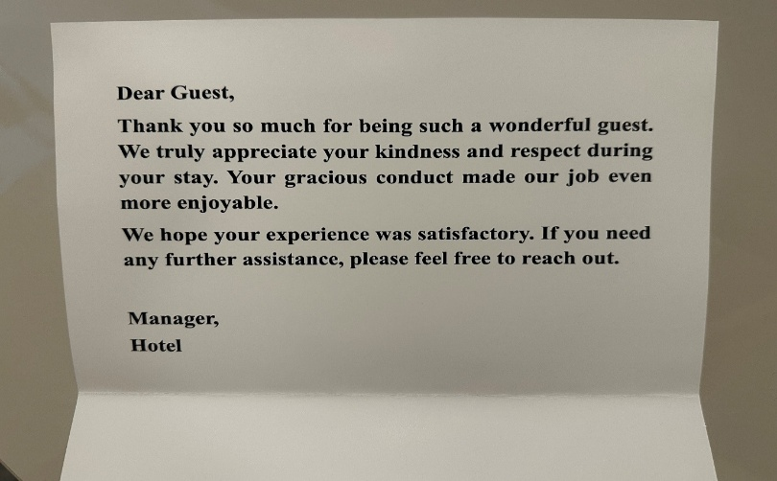

Face-to-face channel and gratitude absent
Imagine you decide to treat yourself to a nice vacation and check into a hotel. As you enjoy your stay, you appreciate the accommodation and the overall service quality. After completing your stay, just as you are about to leave, the manager, along with the bill, hands you a card containing the following message:

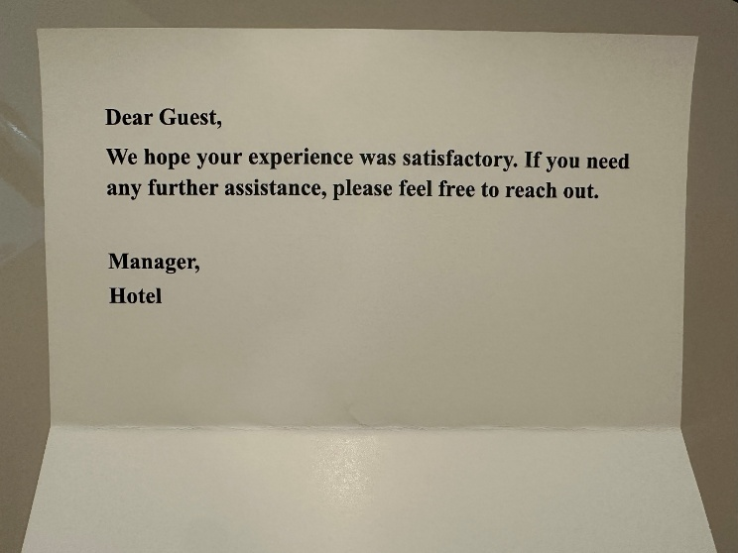

Digital channel and gratitude present
Imagine you decide to treat yourself to a nice vacation and check into a hotel. As you enjoy your stay; you like the accommodation and the overall service quality. After completing your stay, just when you are about to leave, the manager informs you that the bill has been sent to you online. When you check your email immediately, you find the bill accompanied by the following gratitude message:

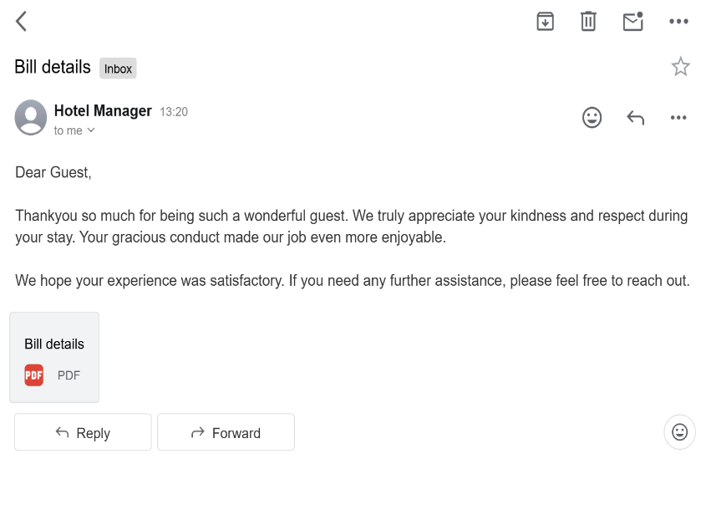
Digital channel and gratitude absent
Imagine you decide to treat yourself to a nice vacation and check into a hotel. As you enjoy your stay; you like the accommodation and the overall service quality. After you've completed your stay, just when you are about to leave, the manager informs you that the bill has been sent to you online. When you check your email immediately, you find the bill accompanied by the following message:

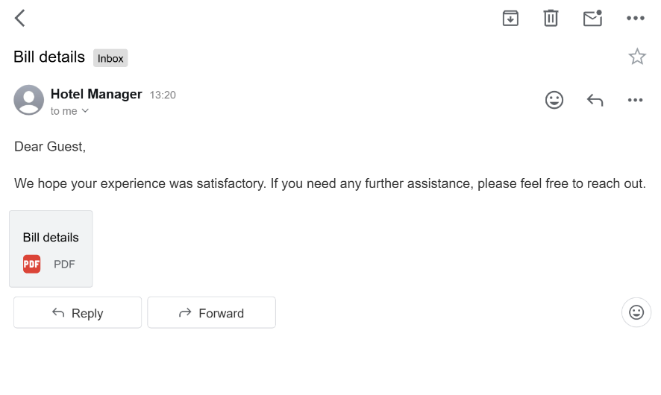
Study 5 Stimuli
Latency absent (immediately) and gratitude present
Imagine you visit a home décor store to find the perfect item for your home. After browsing, you purchase an item and leave the store, satisfied with the overall experience. Just as you leave the store, you receive an email from the store. You open the mail and see the following message.

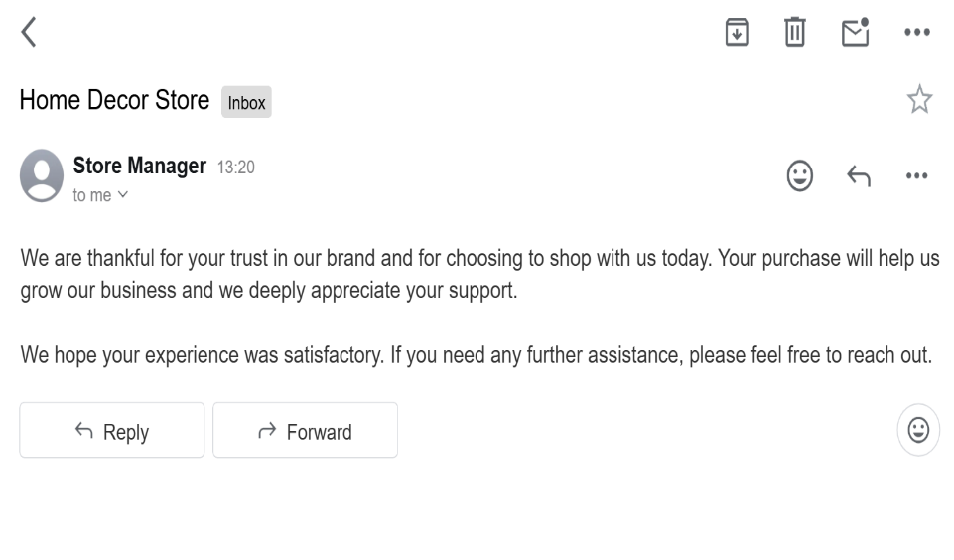
Latency absent (immediately) and gratitude absent
Imagine you visit a home décor store to find the perfect item for your home. After browsing, you purchase an item and leave the store, satisfied with the overall experience. Just as you leave the store, you receive an email from the store. You open the mail and see the following message.

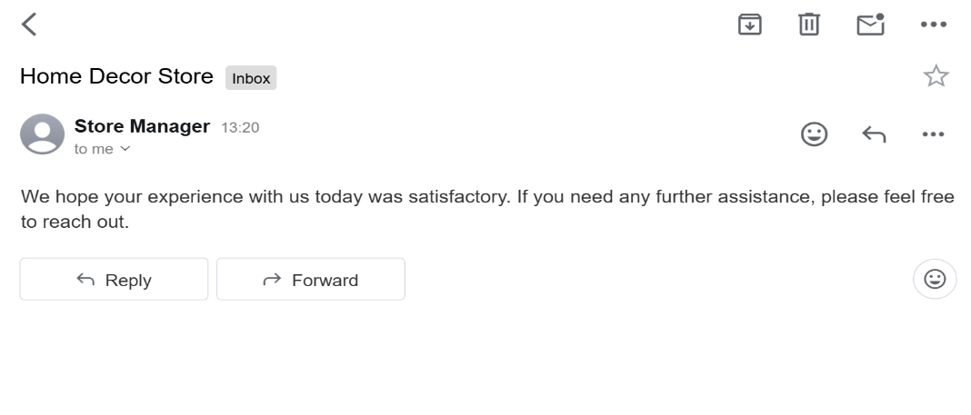
Latency present (delayed) and gratitude present
Imagine you visit a home décor store to find the perfect item for your home. After browsing, you purchase an item and leave the store, satisfied with the overall experience. A week after your purchase from the store, you receive an email from the store. You open the email and see the following message.
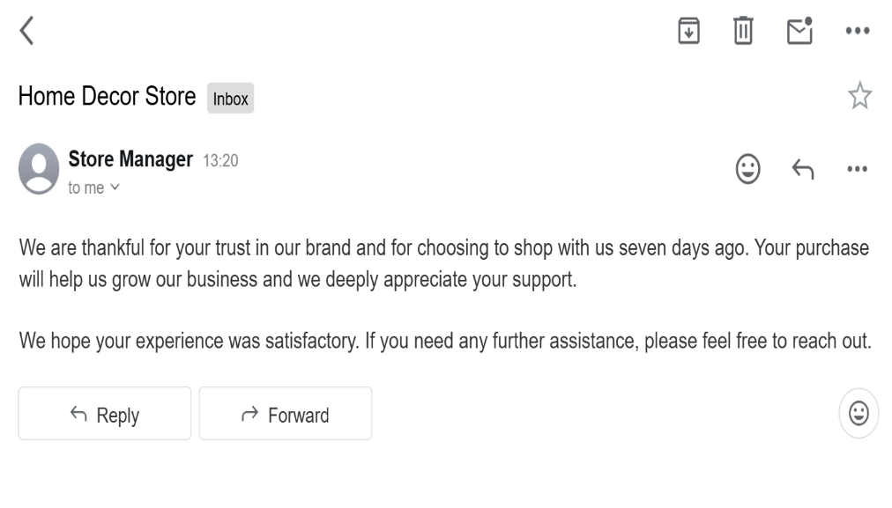
Latency present (delayed) and gratitude absent
Imagine you visit a home décor store to find the perfect item for your home. After browsing, you purchase an item and leave the store, satisfied with the overall experience. A week after your purchase from the store, you receive an email from the store manager. You open the email and see the following message on your screen.

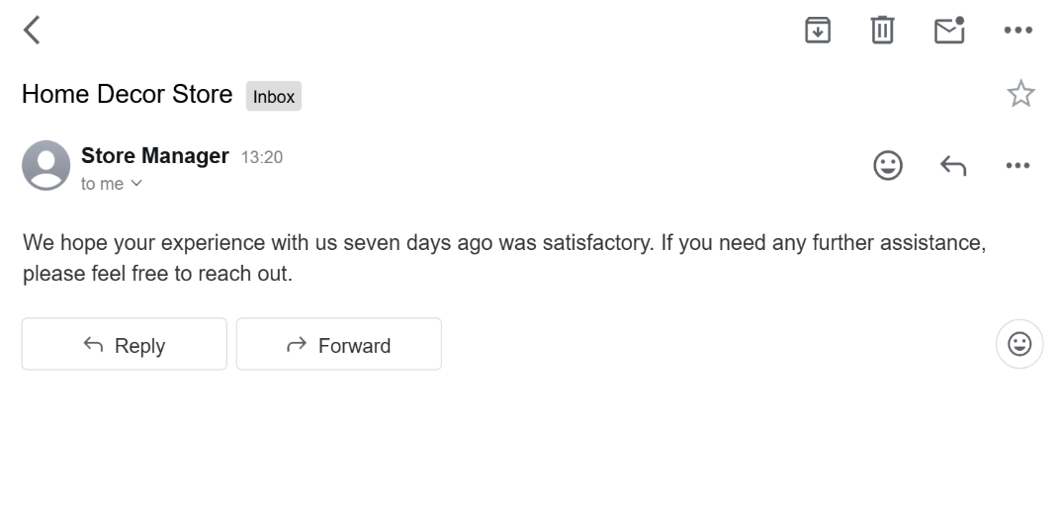
Web Appendix 3 Stimuli

Gratitude-present
Thank you so much for choosing to dine with us today. We are grateful for the opportunity to serve you. We truly appreciate your support. We hope your experience was enjoyable. If you need any assistance, please let us know.

Gratitude-absent
We hope your experience was enjoyable. If you need any assistance, please let us know.

Web Appendix 4 Stimuli

Gratitude Present and expressed by Manager

Imagine you visit a furniture store to find the perfect coffee table for your home. As you browse through the collection, you appreciate the quality, style, and the overall shopping experience. After you've selected your item and made your purchase, just as you are about to leave, the store manager approaches you to express their gratitude and says the following words to you:

Thank you so much for choosing to shop with us. We are truly grateful for your trust in our brand. Your visit will help us grow our business and we deeply appreciate your support.

We hope your shopping experience was enjoyable. If you need any further assistance, please feel free to reach out.

Gratitude Absent and expressed by Manager

Imagine you visit a furniture store to find the perfect coffee table for your home. As you browse through the collection, you appreciate the quality, style, and the overall shopping experience. After you've selected your item and made your purchase, just as you are about to leave, the store manager approaches you and says the following words to you:

We hope your shopping experience was enjoyable. If you need any further assistance, please feel free to reach out.
Gratitude Present and expressed by Salesperson

Imagine you visit a furniture store to find the perfect coffee table for your home. As you browse through the collection, you appreciate the quality, style, and the overall shopping experience. After you've selected your item and made your purchase, just as you are about to leave, the store salesperson approaches you to express their gratitude and says the following words to you:

Thank you so much for choosing to shop with us. We are truly grateful for your trust in our brand. Your visit will help us grow our business and we deeply appreciate your support.

We hope your shopping experience was enjoyable. If you need any further assistance, please feel free to reach out.

Gratitude Absent and expressed by Salesperson

Imagine you visit a furniture store to find the perfect coffee table for your home. As you browse through the collection, you appreciate the quality, style, and the overall shopping experience. After you've selected your item and made your purchase, just as you are about to leave, the store salesperson approaches you and says the following words to you:

We hope your shopping experience was enjoyable. If you need any further assistance, please feel free to reach out.

Web Appendix 2 Study Measures

Brand relationship quality (Quaye et al., 2022) (Study 2, 3, 4, 5, Web Appendix 3 and 4)

- This brand treats me like a special guest rather than just another customer.
- This brand makes me feel good and enhances my self-esteem.
- To what extent do you feel close to this brand.
- This brand means a lot to me.

Brand relationship quality (Nyffenegger et al., 2015; Couder and Valette-Florence, 2024) (Web Appendix 4)

Cold BRQ

Satisfaction
- I am consistently satisfied with my decision to choose this furniture store
- I am completely satisfied with this store
- This furniture brand offers exactly what I expect from a furniture store

Trust
- I rely on this furniture store
- It is a safe furniture store
- It is an honest furniture store

Hot BRQ

Commitment
- It can count on me to always be there
- I will stay with it through good times and bad
- Compared to other stores, I feel strongly connected to this furniture store

Intimacy
- I feel emotionally attached to this furniture store
- There are times when I really long to purchase from this furniture store

Passion
- I feel like something’s missing when I haven’t purchased from this furniture store in a while

Email request (Study 1)
- If you’re interested in receiving store updates or newsletters, you may leave your
email address here; however, this is entirely optional.

Perceived brand sincerity (Sung and Lee, 2023) (Study 2, 3, 4, 5,)
To what extent do you think this brand is
- Sincere.
- Caring.
- Compassionate.
- Beneficial to you.
Brand Loyalty (Sung and Kim, 2010) (Study 2)
- I intend to keep purchasing this brand.
- I would be willing to pay a higher price for this brand over other brands.
- I am committed to this brand.
- I will choose this brand the next time I shop.

Brand Advocacy (Anouk et al., 2021) (Study 2)
- I will recommend this brand to others.
- I will encourage friends and relatives to visit this brand in future.
- I will give advice to others regarding this brand.

Trait Gratitude (McCullough et al., 2002) (Web Appendix 4)
- I have so much in life to be thankful for
- I am grateful to a wide variety of people
- If I had to list everything that I feel grateful for, it would be a long list

Manipulation check for gratitude (Study 2, 3, 4, 5, Web Appendix 3 and 4)
- This brand expressed gratitude to me
- This brand expressed thanks to me

Realism (Study 2, 3, 4, 5, Web Appendix 3 and 4)
- The scenario is realistic
- The scenario is believable

Manipulation check for service experience stage (Study 3)
- The manager interacted with the guest in the scenario in the: beginning, ending

Manipulation check for interaction channel (Study 4)
- In the scenario, the bill was given to the customer: face-to-face, digital (email)

Attention check for ending stage of service experience (Study 4)
- The email/card was received immediately after checkout.

Manipulation check for latency (Study 5)
- The email from the store manager was received immediately.
- The email from the store manager was received a week later.

Manipulation check for source of brand gratitude (Web Appendix 4)
- Who delivered the message in the scenario as you were about to leave: manager vs. salesperson
- I perceive that the manager has greater authority and decision-making power than the store salesperson

Demographic Information (Study 2, 3, 4, 5, Web Appendix 3 and Web Appendix 4)

- Gender: Male/ Female/ Others
- Education: Less than High school/ High school diploma or GED/ Some college or associate degree/ Bachelor’s Degree (e.g. BA, BS)/ Graduate or Professional degree
- Age

Web Appendix 3. Brand gratitude and BRQ
Web Appendix 3 extends Study 1 by establishing the generalizability of the brand gratitude effect in a U.S. restaurant dining context.

Method

A total of 110 U.S. participants (65.45% female; M_{age} = 39.37 years) were recruited via Prolific Academic and randomly assigned to one of two conditions in a single-factor (brand gratitude: present vs. absent) between-subjects design. The study utilized a vignette-based approach in a restaurant dining context. In the gratitude-present condition, participants read a scenario where, upon settling the bill, the manager approached the table to explicitly express brand gratitude for their visit. Conversely, in the gratitude-absent condition, the manager simply inquired if further assistance was required, omitting any expression of gratitude (see Web Appendix 1 for study stimuli).

Following the manipulation, participants completed a four-item BRQ scale (α = 0.93) adapted from Quaye et al. (2022). Participants then answered a two-item manipulation check (r = 0.89) assessing perceived gratitude and a two-item realism check (r = 0.90). All measures were recorded on 7-point Likert scales. The study concluded with the collection of demographic data (age and gender) (see Web Appendix 2 for study measures).

Results

Manipulation check. The gratitude manipulation was successful, with participants in the gratitude-present condition reporting significantly higher levels of gratitude than those in the gratitude-absent condition (M_{present} = 6.25, SD = 1.10 vs. M_{absent} = 5.53, SD = 1.26, t₁₀₈ = 3.18, p = 0.002, Cohen’s d = 0.609). Furthermore, a one sample t-test against the scale mid-point (4.0) confirmed that the scenarios were perceived as moderately realistic (M = 4.71, SD = 1.41, t (109) = 5.34, p = .000, Cohen’s d = 0.504).

Test of H₁. A univariate analysis of variance (ANOVA) was conducted to test the effect of brand gratitude on BRQ. The results revealed a significant main effect (F (1,108) = 16.71, p = .000, partial η² = .134), supporting H₁. Specifically, participants in the gratitude-present condition (M = 5.43, SD = 1.16) reported higher BRQ than those in the gratitude-absent condition (M = 4.48, SD = 1.27) (see Web Appendix Figure 1).

The effect of brand gratitude on BRQ remained significant (F(1,106) = 18.50, p = 0.000, partial η² = 0.149) even after including covariates (age: p = 0.649, gender: p = 0.192).

Discussion

The findings from Web Appendix 3 further confirm the effect of brand gratitude on BRQ through a controlled, vignette-based experiment in a U.S. context. While these results provide robust validity and generalizability for H₁, they do not account for individual differences in trait gratitude or potential source effects related to who delivered the brand gratitude to consumers. To address these gaps, Web Appendix 4 study was carried out.

Web Appendix 4. Brand Gratitude, BRQ, Source, and Trait Gratitude

Web Appendix 4 extends Study 1 in four distinct ways. First, it examines whether the source of the gratitude (manager vs. salesperson) influence the effectiveness of brand gratitude. While brand gratitude was conveyed by store employees in Study 1, it was offered by a manager in the study detailed in Web Appendix 3, both demonstrating that expression of brand gratitude increases BRQ. However, we did not compare whether the relational outcomes of brand gratitude differ across actors in different organizational position. Previous research suggests that social influence is often driven by the power and organizational position of the actor (Merlo, 2011). Consequently, this study explores whether source of brand gratitude impacts BRQ.

Second, this study enhances methodological rigor by validating the effectiveness of brand gratitude using an established, multidimensional measure of BRQ (Nyffeneger et al., 2015) along with the unidimensional measure used in Web Appendix study 3. Using alternative operationalizations of the dependent variable improves robustness and construct validity (Locke, 2012) (see Web Appendix 2 for measures).

Third, this study shifts the research setting from US to India to examine the generalizability of the study findings in a culturally different setting. India differs in power distance and individualism (Zhang et al., 2010) to U.S., which may shape how consumers respond to brand gratitude.

Finally, this study controls for individual trait of gratitude disposition. Gratitude disposition (McCullough et al., 2002) reflects a stable tendency to experience and express gratitude which may independently influence relationship outcomes. By controlling for its effect, this study isolates the effect of brand gratitude on BRQ and rule out alternative trait-based explanations.

Method

Two hundred and twenty-four participants (43.30% female, M_{age} = 33.79 years) were recruited from Prolific. The study employed a 2 (gratitude: absent vs. present) × 2 (organizational position: manager vs. salesperson) between-subjects design. Participants were randomly assigned to one of these four conditions.

Participants were informed that the session involved two unrelated studies. In the first section, gratitude disposition (α = 0.84) was measured using items adapted from McCullough et al. (2002). In the second section, participants imagined purchasing an item from a furniture store. In the gratitude-present condition, either the manager or salesperson approached the customer to express gratitude for the purchase. In the gratitude-absent condition, the manager or salesperson simply asked if the shopping experience was enjoyable and if any further assistance was required.

Following the scenario, participants completed measures of BRQ. This included the four-item unidimensional scale (α = 0.87) adapted from Quaye et al. (2022) as well as the multidimensional scale (α = 0.92) adapted from Nyffeneger et al. (2015) and Couder and Valette-Florence (2024). This multidimensional scale of BRQ consisted of 12 items capturing five first-order dimensions of satisfaction and trust (reflecting cold BRQ) and commitment, intimacy, and passion (reflecting hot BRQ). Participants then completed manipulation check questions for gratitude and source, perceived authority of the source, realism, and demographic questions (age, gender, and education).

Results

Manipulation check. The manipulations were successful. Participant in the gratitude-present condition reported significantly higher perceptions of gratitude (M = 6.19, SD = 0.80) compared to the absent condition (M = 5.78, SD = 0.89, t₂₂₂ = 3.57, p = 0.000, Cohen’s d = 0.484).

A chi square test confirmed that participants correctly identified the source of interaction. Participants successfully identified the manager (yes = 100, no = 12, χ² (1) = 69.14, p = .000). and the salesperson (yes = 104, no = 8, χ² (1) = 82.28, p = .000). A one-sample t-test against the scale midpoint (4) confirmed that participants perceived the manager as having greater authority and decision-making power than the salesperson (M = 5.99, SD = 0.98, t (223) = 30.41, p = .000, Cohen’s d = 2.031). Together, these results confirm that participants correctly distinguished between the source expressing gratitude in the scenario. Furthermore, participants assessed managers as possessing greater power and authority in the organization compared to salesperson, confirming the successful manipulation of organizational position.

Additionally, participants perceived the scenarios as highly realistic (M = 5.76, SD = 1.00, test mid-scale = 4.0, t (223) = 26.33, p = .000, Cohen’s d = 1.760).

The two BRQ scales showed high correlation (r = 0.76).

Testing H₁: A two-way ANOVA on BRQ, measured using Quaye et al. (2022), showed a significant main effect of brand gratitude (M_{present} = 5.59, SD = 0.95 vs. M_{absent} = 4.81 , SD = 1.33 F₂₂₀ = 25.73, p = 0.000, partial η² = 0.105) and organizational position (M_{manager} = 5.36 , SD = 1.15 vs. M_{salesperson} = 5.05 , SD = 1.22 , F₂₂₀ = 4.00, p = 0.047, partial η² = 0.018). No interaction effect between gratitude and organizational position was observed (F₂₂₀ = 0.61, p = 0.435, partial η² = 0.003).

Another ANOVA with BRQ, measured using Nyffeneger et al. (2015) and Couder and Valette-Florence (2024), revealed a similar pattern. A significant main effect of gratitude (M_{present} = 5.36, SD = 0.88 vs. M_{absent} = 4.84, SD = 1.02, F₂₂₀ = 16.88, p = 0.000, partial η² = 0.071) and organizational position (M_{manager} = 5.27, SD = 0.99 vs. M_{salesperson} = 4.93, SD = 0.96, F220 = 7.15, p = 0.008, partial η² = 0.032) was observed on BRQ. However, no significant interaction effect of gratitude and organizational position was observed (F220 = 0.747, p = 0.388, partial η² = 0.003).

Moderated mediation: We conducted a moderation analysis using PROCESS Model 1 with 5,000 bootstrapped resamples (Hayes, 2018) to examine whether the effect of condition on BRQ depended on the source. The results indicated a positive and significant main effect of condition (b = 0.90, SE = 0.22, 95%CI [0.46, 1.34]). Importantly, the interaction between gratitude and the source was not significant (indirect = −0.26, SE = 0.31, 95%CI [−0.87, 0.35]), suggesting that the effect of gratitude on BRQ did not differ based on the source.

Repeating the analysis using an alternative BRQ scale (Nyffeneger et al., 2015: Couder and Valette-Florence, 2024) yielded the same pattern of results. The main effect of gratitude was positive and significant (b = 0.47, SE = 0.18, 95%CI [0.10, 0.83]). In contrast, the interaction was not significant (indirect = 0.07, SE = 0.26, 95%CI [−0.44, 0.57]), indicating that the effect of condition remained consistent across moderator levels.

Including covariates. Including covariates (gratitude disposition: F217= 22.09, p = .000, η² = 0.092; age F217= 4.10, p = 0.044, η² = 0.019; gender: F217= 0.21, p = 0.646, η² = 0.001) did not change the significant of the effects for BRQ measured from Quaye et al. (2015) (gratitude: F217 = 27.26, p = 0.000, η² = 0.011; organizational position: F217= 7.04, p = 0.009, η² = 0.031, and interaction effect F217 = 2.61, p = 0.107, η² = .012).

Similarly, including covariates (gratitude disposition: F217 = 13.53, p = 0.000, η² = 0.059; age: F217 = 1.89, p = 0.170, ηp² = 0.009; gender: F217 = 0.33, p = 0.563, η² = 0.002) did not change the results for BRQ measure adapted from (Nyffeneger et al.,2015; Couder and Valette-Florence, 2024), (gratitude: F217 = 17.36, p = 0.000, η² = 0.074; organizational position, F217 = 9.89, p = 0.002, η² = 0.044; and interaction effect: F217 = 0.05, p = 0.815, η² = 0.000).

Discussion

The findings of Web Appendix 4 highlight that the effect of brand gratitude expressions is robust across cultural contexts, including among Indian participants. Furthermore, this study establishes the robustness and validity by exploring the effects of brand gratitude on BRQ measured using two different scales. Importantly, the findings suggest that the effectiveness of gratitude depends on being expressed in person rather than by the source. Lastly, by controlling for consumers’ dispositional gratitude, this study rules out the role of trait-based factors in explaining the effect of brand gratitude on BRQ.

References

Couder, J. and Valette-Florence, P., 2024. How do customers experience terroir? An investigation of its ability to increase brand relationship quality. Journal of Business Research, 181, p.114712.

Merlo, O., 2011. The influence of marketing from a power perspective. European Journal of Marketing, 45(7/8), pp.1152-1171.

Locke, E.A., 2012. Construct validity vs. concept validity. Human Resource Management Review, 22(2), pp.146-148.

Zhang, Y., Winterich, K.P. and Mittal, V., 2010. Power distance belief and impulsive buying. Journal of Marketing Research, 47(5), pp.945-954.

McCullough, M.E., Emmons, R.A. and Tsang, J.A., 2002. The grateful disposition: a conceptual and empirical topography. Journal of personality and social psychology, 82(1), p.112.

Nyffenegger, B., Krohmer, H., Hoyer, W.D. and Malaer, L., 2015. Service brand relationship quality: hot or cold?. Journal of Service Research, 18(1), pp.90-106.

